<https://www.youtube.com/watch?v=jBmBb-je4Lg>

Creating Cartoon Water Effect – Using PBR Graph

Make a custom shader. Create a folder to store custom shaders.

Right click on the project pane , > create, shader > PBR Graph. Rename the New Shader Graph to something relevant. Double click on the shader graph icon. This opens up a blackboard with PBR Master node. Click on the settings wheel, click on surface, change to transparent. Another node can be seen, like the figure on the left. Click on the **+** , to create a new property, select color. Rename it if required. Select a colour as the default base colour, set the default Mode as HDR, for controlling color intensity. Drag this node onto the blackboard. Connect to Albedo(3) on the PBR Graph master. Right click on the blackboard editor, click create node, search for Voronoi node. Connect to Emission input on PBR Graph.

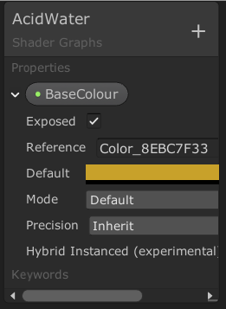

Create Time node, right click on blackboard, click create and search for time. Create Multiply mode, following the method described above. Connect time(1) to Multiply A(1).

Create Vector1 by clicking on the Shader Graphs box. Call it something relevant, e.g. RippleSpeed, drag onto blackboard and connect it to Multiply B(1). Connect out(1) on Multiply to Angle OffSet on Voronoi node. Set the default value for RippleSpeed to be 1.

Create another Multiply node, connect it to Voronoi node, by connecting out(1) on Voronoi to A(1) on Multiply. Create another Color property, change default property to HDR and select another colour. Change the name to RippleColour. Drag this onto the blackboard and connect onto the second Multiply node. RippleColour property connected to B(1) on Multiply node. Connect this Multiply node to Emission on PBR master. Break connection from Voronoi node to Emission as the Voronoi is still connected through the Multiply node.

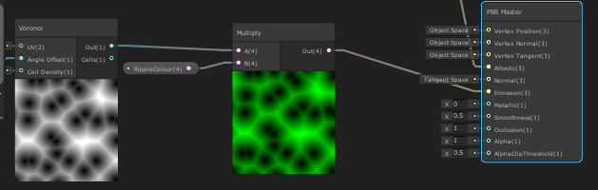

Connections should look like the above.

Create another Vector 1 property and call it RippleScale, connect to the cell property on the Voronoi node. Select a default value of 3 for RippleScale. From time to time select save Asset, which is located on the top left of the blackboard.

Can create a material from this shader. Right click on the shader and select material. Name it something meaningful. Drag it to a Materials folder.

Create a Radial Shear node and connect it to the UV input of the Voronoi node. On Radial Shear decrease Strngth X and Y to 2, which results in a slight distortion.

Need to add a Power node and connect it up to Voronoi and Multiply.

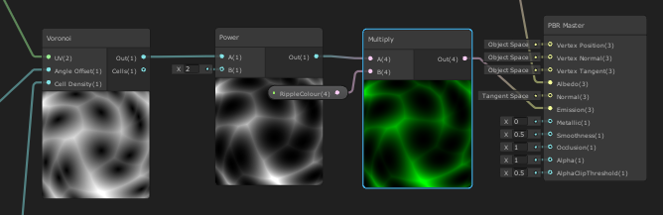

Create a Vector 1 property, rename it as RippleDissolve, set default to 5. Connect to the B input of the Power node. Make sure the exposed option is ticked in property.

Create 2 more Vector 1 properties, called Metallic and Gloss respectively. Connect them to Metallic and Smoothness on the PBR Master. Set the values to 1 for Metallic and .175 for Gloss, these values can be adjusted in the Material as the game is in play mode to see how these effects look.

Create two more nodes, Normal from Height, connect it to the out of Multiply, and a Normal Strength node to control the strength of the Normals.

Create a Vector1 property call it NormalStrength and connect it to NormalStrength node.

Connect this to Normal to Normal on PBR Master.