**Main.m**

**Test #1** normal Playthrough (no shop access)

**Conclusion:** I’ve played up to 10 levels and no errors or unusual behaviours occurred.

**Test #2** High Level Test

**Test Cases**: Load levels: 1, 10, 50, 100, 200, 300, 400x 500

**Output**: Level 1, 10, 50, and 100 all loaded in a reasonable timeframe.

Level 200 took a bit longer to load (~2s)

Level 300: took long to load (~10s)

Level 400: took insane amount of time (~30s)

Level 500: Couldn’t load due to out of memory

**Conclusion**: there is theoretically a ‘limit’ to this game, since you can run out of memory or time out pretty easily in a high-level language like MATLAB. Safe to say no one would willingly play a level like that anyways.

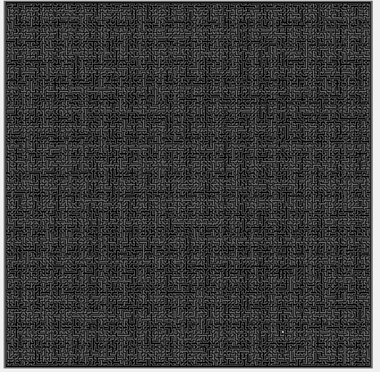Level 400 maze generation

**Test #3** Shop test cases (Input spam)

**Test Case:** Spamming a button (specifically the ‘Toggle BGM’ button)

**Output:** The program becomes buggy and stops working until it works out all the information has been processed sent from the button callback function.

**Conclusion**: Since ‘soundPlayer()’ is already kind of a buggy function, it took extra time to process the ‘Toggle BGM’ button being spammed, hence pausing all other user input. This doesn’t happen with the ‘Complete Now!’ button, which is always instant.

**Test #4** Player leave Array

**Test Case:** Checks if a player can leave the array to throw an error.

**Output**: Turning on ghost mode, the player can walk out the matrix, throwing and index error.

**Conclusion:** Without ghost mode, it’ll be mathematically impossible to leave the array (since you cant walk past the border), but I forgot to check for that with ghost mode.

**Test #5** Unsafely quit program

**Test Case:** Exit out the program by clicking out of the window.

**Output:** Once you quit the maze array

**Conclusion:** It seems that it’ll throw an error after you quit the maze array, since that has been set to be the main figure which collects user input. Now, you must use ‘X’ on your keyboard to quit without having any issues.