Hotel Booking Data Analysis
Final Project report · Data Processing with Python · HAMK
Group members: Anup Kandel, Sandesh Bishokarma, Sushant Koirala, Tanka Raj Aryal
October 2026

1. Context and research questions
What one row represents: one hotel booking (kept or cancelled), with its dates, length of stay, guests, booking channel, deposit type and average daily rate (ADR, €).
Population and period: bookings at a city hotel in Lisbon and a resort hotel in the Algarve, Portugal, with arrivals from July 2015 to August 2017. The file is a 1,000-booking sample of the Hotel Booking Demand dataset (António, de Almeida & Nunes, 2019).
Purpose: to help hotel management understand which bookings are more likely to be cancelled and how demand differs between the two hotels, so they can plan capacity, deposits and pricing.
Research questions:
- RQ1. Do cancellation rates differ between the City Hotel and the Resort Hotel? (categorical comparison)
- RQ2. Is lead time (days between booking and arrival) associated with cancellation? (numerical variable)
- RQ3. How does booking volume vary by arrival month for each hotel? (time pattern)

2. Data and method
We used Python with Pandas and Matplotlib in a Jupyter notebook (Hotel_Booking_Final_Project.ipynb), which runs from top to bottom without errors. The original data frame (hotel_raw) was kept unchanged and all cleaning was done on a copy (hotel). We created four derived variables: arrival_date (a real date), total_nights (weekend + weekday nights), total_guests (adults + children + babies) and estimated_booking_value (ADR × total nights), plus helper columns such as a text cancellation status and lead-time bands.
Methods: counts and percentages for categorical variables; n, mean, median, standard deviation, min and max for numerical variables; a crosstab (hotel × cancellation) with row percentages; groupby aggregation (lead time by cancellation status and by lead-time band); and monthly booking counts per hotel, with a separate check of 2016, the only complete year.

3. Data quality and cleaning
The raw file has 1,000 rows and 20 columns. We checked the eight issues required in the brief. After cleaning, 997 bookings remain (3 removed).
Issue checked | Evidence | Decision | Reason
Missing country | 2 rows | Fill with "Unknown" | Country is not used in our RQs; keeps the rows.
Exact duplicates | 26 rows (Groups / Offline TA/TO) | Keep | No booking ID; group bookings are often entered as identical rows.
Invalid dates | 0 rows | No action | All dates convert correctly.
Negative values | 0 rows | No action | No negative numbers found.
Zero total guests | 3 rows (0 nights, 0 €) | Remove | Not a real stay; placeholder records.
Zero total nights | 5 rows (3 overlap) | Remove 3, keep 2 | Remaining 2 have guests; could be day use.
Unusual lead_time | 28 rows > 364-day fence; max 542 | Keep | Rare but possible; central to RQ2.
Unusual ADR | 25 high (max 304 €), 15 at 0 € | Keep | Peak-season prices and free stays are real.

4. Individual variables
The City Hotel accounts for 64.1 % of bookings. Most bookings need no deposit (88.1 %); Non Refund deposits are 11.6 % and Refundable only 0.3 %. Lead time is strongly right-skewed (median 71 days, mean 105, max 542), so the median describes a typical booking better than the mean. The ADR is closer to symmetric around a median of about 95 €, with a few free stays and some high-season rates above 250 €.
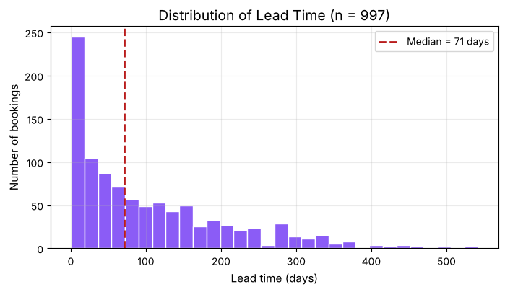
Figure 2. Distribution of lead time (numerical distribution).

5. Results

RQ1: Cancellation by hotel
Denominator: all bookings for that hotel. City Hotel bookings were cancelled in 43.7 % of cases (279 of 639), compared with 24.3 % (87 of 358) at the Resort Hotel, a gap of about 19 percentage points. All 116 Non Refund bookings were cancelled, which is unusual and is reported with caution.
Hotel | Bookings | Cancelled | Cancellation rate
City Hotel | 639 | 279 | 43.7 %
Resort Hotel | 358 | 87 | 24.3 %
Total | 997 | 366 | 36.7 %

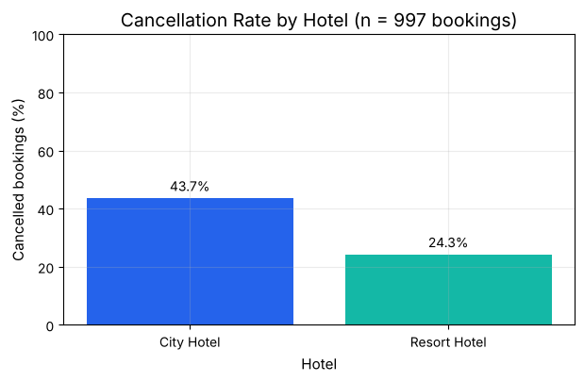
Figure 1. Cancellation rate by hotel (categorical comparison).

RQ2: Lead time and cancellation
Cancelled bookings were made much further ahead: median lead time 117 days compared with 48 days for kept bookings. The cancellation rate rises from 14.0 % for bookings made within a week of arrival to 64.3 % for bookings made more than a year ahead (only 28 bookings in that band). This is an association, not proof that booking early causes cancellation.
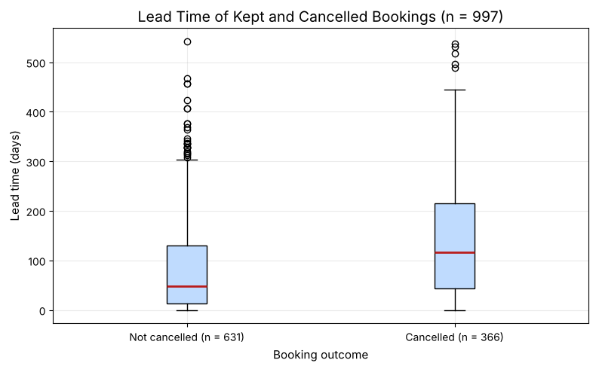
Figure 3. Lead time of kept and cancelled bookings (grouped comparison).

RQ3: Bookings by arrival month
Across all years, bookings are highest in May (126), August (115) and July (111) and lowest in January (44) and November (50), and the City Hotel has more arrivals than the Resort Hotel in every month. However, only July and August appear in all three years of the sample. In 2016, the one complete year, the busiest months were May (61) and October (57), so the summer peak is largely caused by the uneven coverage of years.
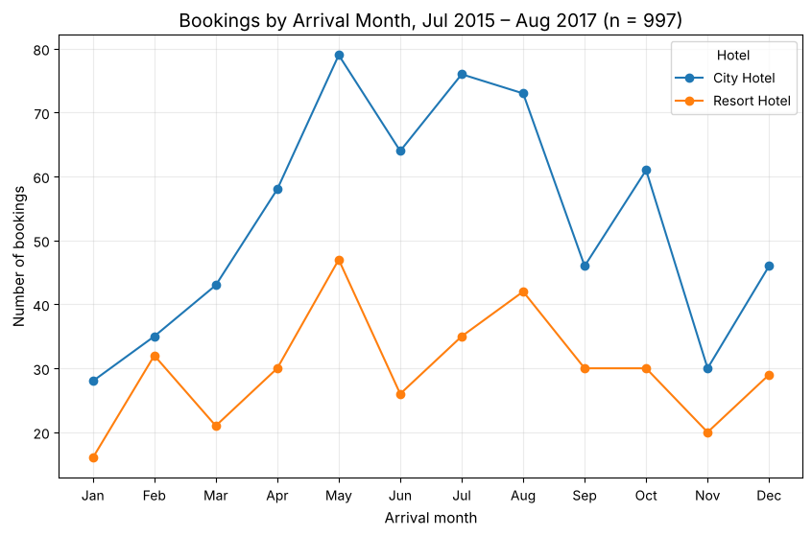
Figure 4. Bookings by arrival month for each hotel (time-based, multi-group).

6. Conclusions

Answers to the research questions
- RQ1: Yes: City Hotel bookings were cancelled much more often (43.7 %) than Resort Hotel bookings (24.3 %).
- RQ2: Yes: lead time is clearly associated with cancellation (median 117 vs 48 days; rate rises from 14.0 % to 64.3 % across lead-time bands).
- RQ3: The City Hotel is busier in every month and January and November are quietest; the apparent July–August peak is mostly an effect of uneven year coverage.

Key findings
- More than a third of all bookings (36.7 %) were cancelled.
- The City Hotel has both a higher cancellation rate and a higher median daily rate (100 € vs 77 €).
- Resort guests stay longer (4.2 vs 3.0 nights on average), so median booking values are almost the same at both hotels (about 270 €).
- All 116 Non Refund bookings were cancelled, a pattern that should be checked at the source.

Limitations and cautions
- The data is a 1,000-booking sample from two hotels in 2015–2017, so results may not apply to other hotels or years.
- The years are incomplete (2015: Jul–Dec, 2017: Jan–Aug), which inflates July–August in the all-years totals.
- All results are associations, not causes; differences between the hotels may be explained by lead time or booking channel.
- Cleaning choices (keeping duplicates and 0 € rates) are judgement calls; removing duplicates changes the overall cancellation rate only slightly.

Recommendation
Treat bookings made far in advance, especially at the City Hotel, as a higher cancellation risk, for example by sending a confirmation reminder a few weeks before arrival, and plan seasonal capacity from complete years of data.

Next question
Why do guests cancel (a better price elsewhere, changed plans, a smaller group)? The data has no cancellation reason or cancellation date, so this cannot be answered with the supplied variables.

7. Exported files
- outputs/hotel_bookings_cleaned.csv: the cleaned dataset (997 rows, 29 columns, including the four derived variables).
- outputs/hotel_booking_summary.csv: one row per hotel with bookings, cancellation rate (%), median lead time and median daily rate.
Both files were read back into Python and their shape and key columns were verified.

Group contributions
Member | Main responsibility
Tanka Raj Aryal | Context, imports, loading and inspection, data-quality checks and cleaning log; report assembly
Sushant Koirala | Derived variables, individual-variable analysis, numerical-distribution figure; video editing
Sandesh Bishokarma | RQ1 crosstab, RQ2 groupby analysis, Figures 1 and 3; led the kickoff and conclusions
Anup Kandel | RQ3 time analysis, Figure 4, merging the notebook, exports and submission

Reference
António, N., de Almeida, A. & Nunes, L. (2019). Hotel booking demand datasets. Data in Brief, 22, 41–49.

