Relationships: cancellations by hotel and by lead time
Report section by Sandesh Bishokarma (RQ1 and RQ2)

Research questions
- RQ1 (categorical comparison): Do cancellation rates differ between the City Hotel and the Resort Hotel?
- RQ2 (numerical variable): Is lead time, the number of days between booking and arrival, associated with cancellation?

Method
For RQ1 we made a crosstab of hotel type against cancellation status, with counts and row percentages. Each percentage is out of all bookings of that hotel, so the two hotels can be compared even though the City Hotel has almost twice as many bookings. As an extra check we made the same table for deposit type.
For RQ2 we grouped the bookings by cancellation status and calculated the count, mean, median and standard deviation of lead time. Because lead time is right-skewed, we mainly compare medians. We also split lead time into six bands with pd.cut and calculated the share of cancelled bookings in each band. Both questions have a chart: a bar chart for RQ1 and a box plot for RQ2.

RQ1 findings
Hotel | Cancelled | Not cancelled | Total | Cancelled (%)
City Hotel | 279 | 363 | 642 | 43.5 %
Resort Hotel | 87 | 271 | 358 | 24.3 %
All bookings | 366 | 634 | 1,000 | 36.6 %

City Hotel bookings were cancelled much more often than Resort Hotel bookings: 43.5 % against 24.3 %, a gap of about 19 percentage points. The deposit-type table showed one unusual result: all 116 Non Refund bookings were cancelled, while only 28.4 % of No Deposit bookings were. Guests rarely cancel bookings they cannot get refunded, so this may come from how the original data was recorded, and we do not build conclusions on it.
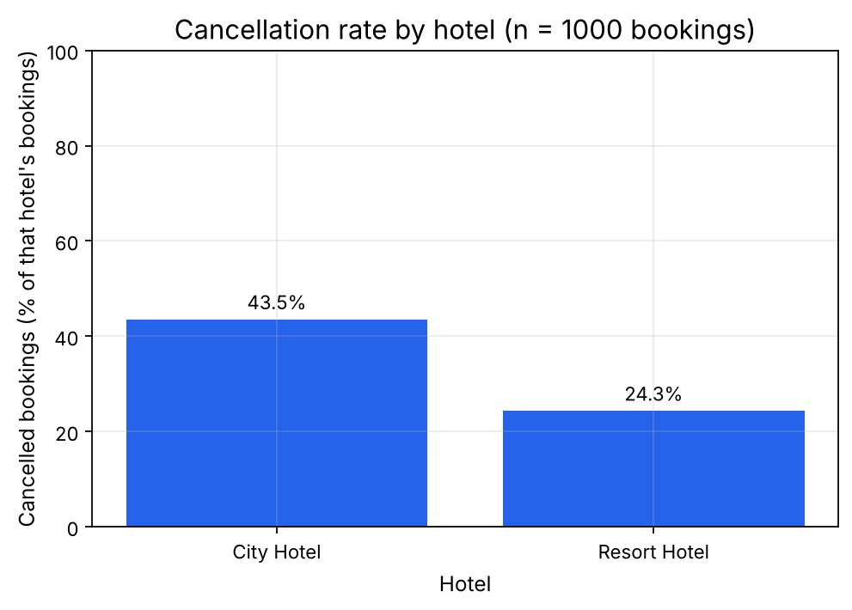
Figure 1. Cancellation rate by hotel (n = 1,000 bookings).

RQ2 findings
Booking outcome | Bookings | Median (days) | Mean (days) | Std (days)
Not cancelled | 634 | 48 | 83.5 | 93.9
Cancelled | 366 | 117 | 142.5 | 116.2

Cancelled bookings were made much further in advance. Their median lead time was 117 days, more than twice the 48 days of kept bookings. The cancellation rate rose in every lead-time band: 13.8 % for bookings made 0–7 days ahead, 26.5 % (8–30 days), 34.0 % (31–90), 42.7 % (91–180), 56.0 % (181–365) and 64.3 % for bookings made more than a year ahead. The last band has only 28 bookings, so its exact value is less reliable.
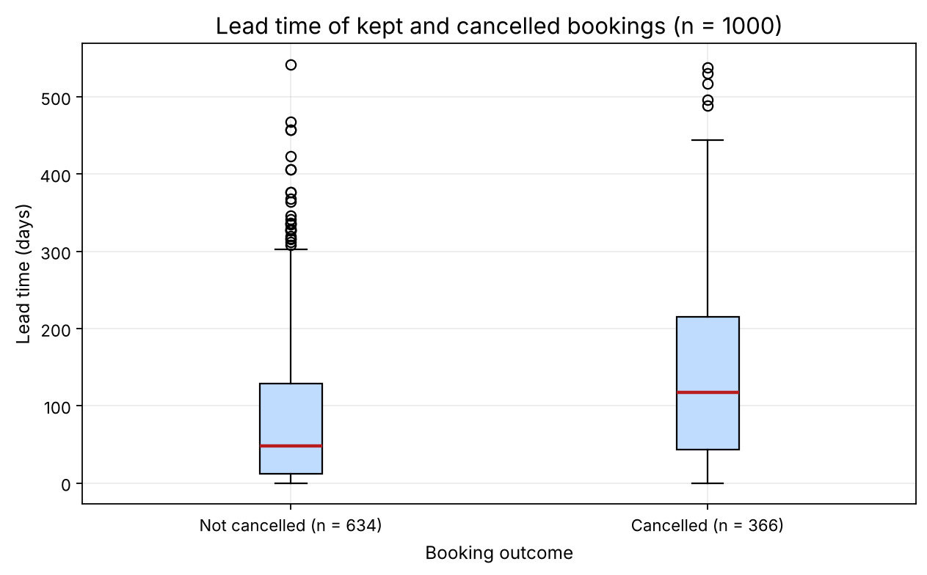
Figure 2. Lead time of kept and cancelled bookings (n = 1,000). The red line is the median.

Interpretation and cautions
- Both results are associations, not causes. For example, Groups bookings are made early (median 158 days) and are often cancelled (57 %), so the booking channel could explain part of both patterns.
- The City Hotel's higher cancellation rate may also be linked to its different customers and longer lead times, which we did not separate in this analysis.
- The numbers in this section use all 1,000 bookings. They will change slightly after the cleaning step (3 bookings with no guests are removed), so the final values come from the finished notebook.

