Table of contents

Contents

2 Motivation 1

2.1 [self.name/] 1

2.2 [self.name/] 1

2.3 [self.name/] 1

# Motivation

In this chapter, stakeholders, drivers, goals and other things that influences the initiative are documented. The chapter can be seen as a vision guiding all other parts and its purpose is to give the reader a background and general understanding for what is wanted to be achieved.

## Stakeholders

Stakeholders are the primary roles with a clear interest in the initiative. Different stakeholders interests are driven by different motivators, so called "drivers".

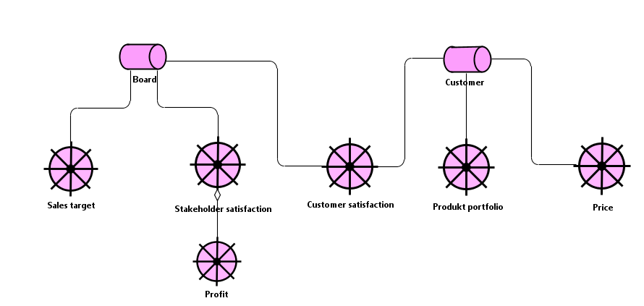

*Diagram: Stakeholder view*

## Business goals

Business goals are the the "things" that the organization as a whole wants to achieve with the current initative. Goals are derived and related to drivers.

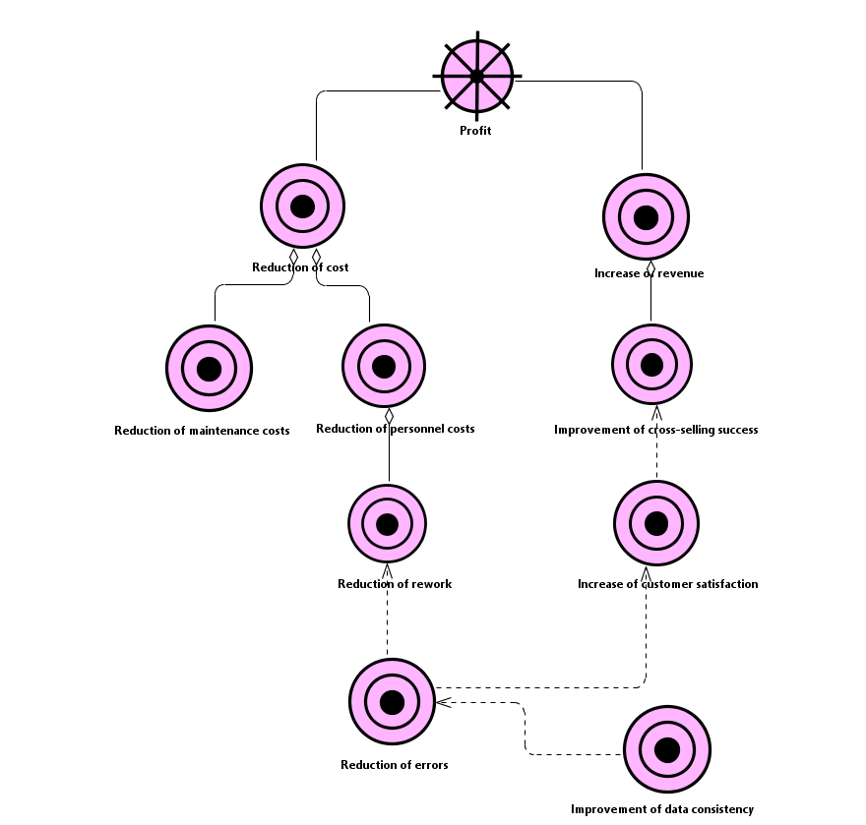

*Diagram: Business Goals Associated with the Driver Profit*

## Principles

Principles are formulations that help to guide the initiative to reach the wanted goals. In all cases where a hard decision has to be made regarding choices for the realization of the solution, the principles are revisited for help.

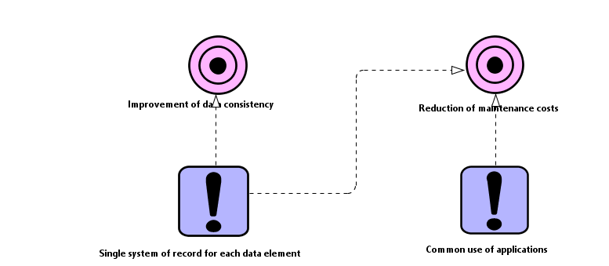

*Diagram: Principles View*

# Business

The business layer captures what changes are needed for the business to be able to reach the wanted goals. Here we find things such as business processes, business functions etc, all related to the initiative and needed to be changed.

## Organization

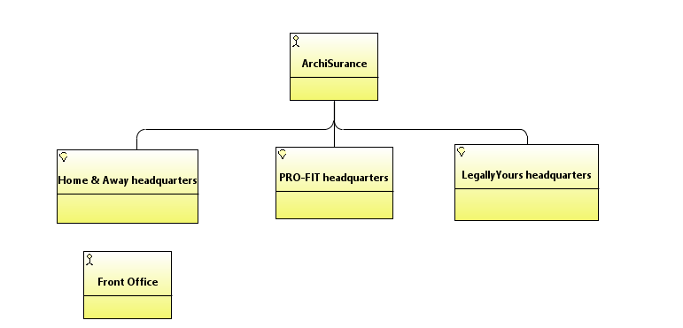

*Diagram: NewArchiMateBusinessDiagram*