Help for LibreWeb ( version 1.0.7 )

LibreWeb is an extension for LibreOffice, that catches
textual or numeric data from internet, then insert it in a Calc document.
Tested only on Windows.

Restrictions:
At this moment LibreWeb works correctly only with web-sites, that doesn't need
user authentication ( like facebook, your bank site etc ).
Also it is impossible to work with smart sites, like google translate, because they use
a JavaScript code to filtrate programs like LibreWeb amoung real users.
Maybe in future the things will change...

First you have to understand a basic idea of what a web page is.
Each page that your browser opens is a text file, ending with .html.
It contains a lot of tags: tags for links, tag for text, tag for images and so.
For more on tags search on google or wikipedia.

Many of this tags are nesting other tags, so you have to go ahead and find the final
tag, that shows the needing information.
Fortunately, each modern browser allows to view the source code of visited pages.
For example, open a web page with Chrome, maybe https://www.openoffice.org/

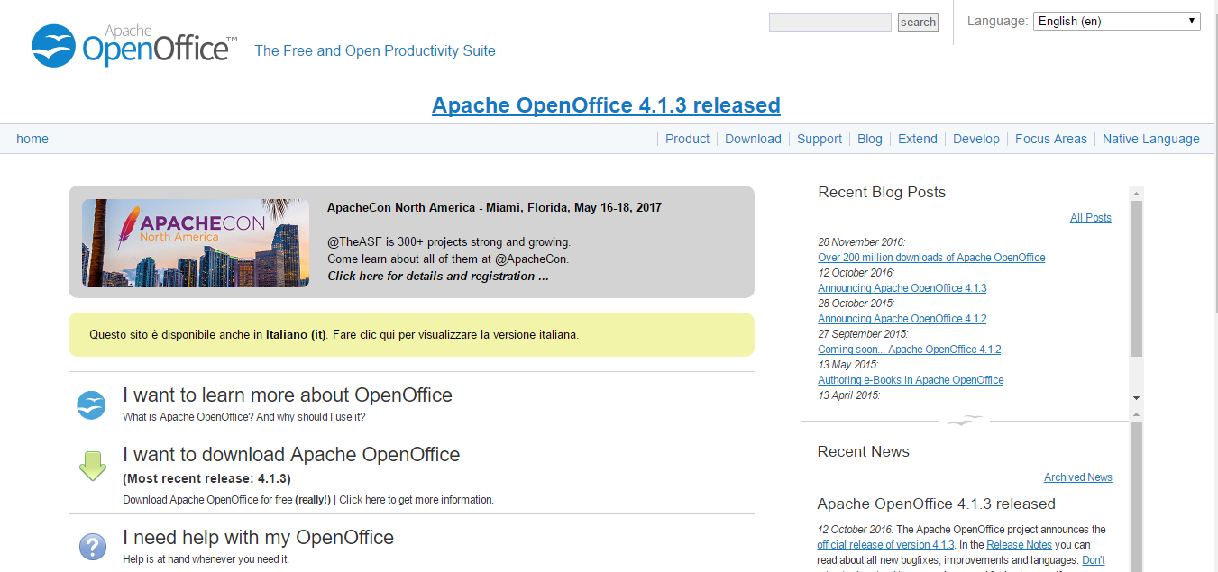

and put the mouse on the expression Apache OpenOffice 4.1.3 released. After make a right-click and in the context menu chose Inspect (or something similar).
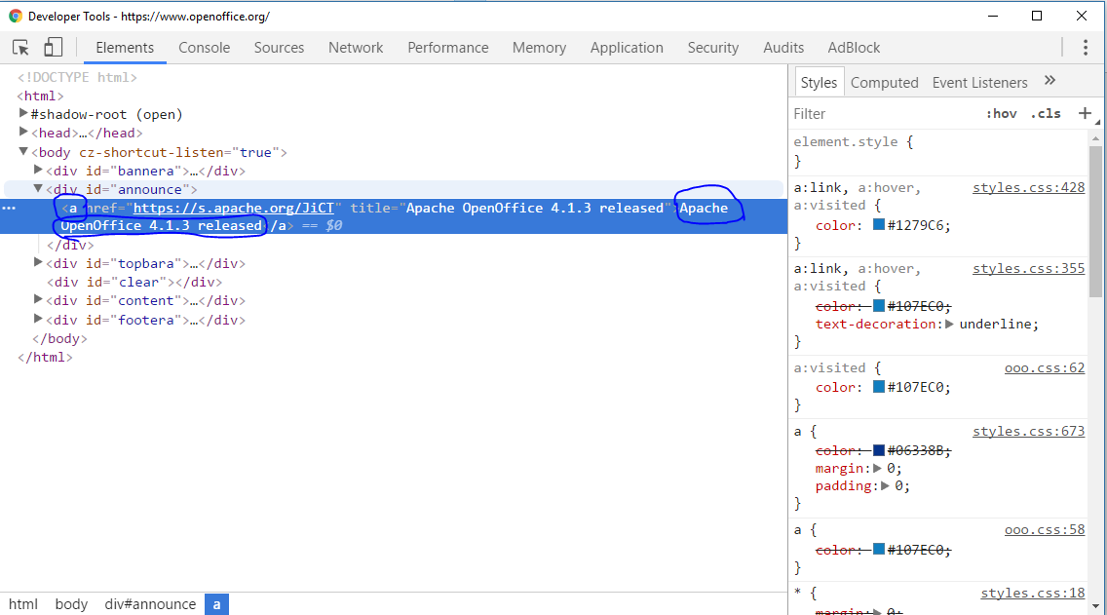

It is important to do this with mouse, because in this case you will get a new window,
with emphasized string, that is our needing tag.
Character “a” means a link and inside this tag is our target text.
You have to remember the name of the tag, in this case it is a.

LibreWeb comes in two versions, one for user with root rights and other normal.
Feel free to try both, because surely one will give you some error at start.
Just uninstall it, after go ahead and install the second one.

LibreWeb menu

1.Start service
If current document contains previously saved data, the cells will get filled,
according to saved settings.

2.Set data
Opens a dialog, that helps to save correctly web tags.
- In the first text field you must insert a valid URL.
- In section Tag Control, there is also a text field. Insert the name of target tag, in our case a.
- Then try to Check URL. You will get an error message if tag is not supported or URL is wrong, else ListBox, in Tag Control section, turns enable ( disabled by default), that means LibreWeb has found values.
- Just scroll Items of ListBox, and field Tag Result will display the content of that tag.In this example is the first a tag (number 0).
- In section Sheet Control choose the cell where will be displayed the result,( set the Column and the Row).
- Select a type of inserted data, for the moment you can choose between String and Value.
- Of course save the settings, Save button.
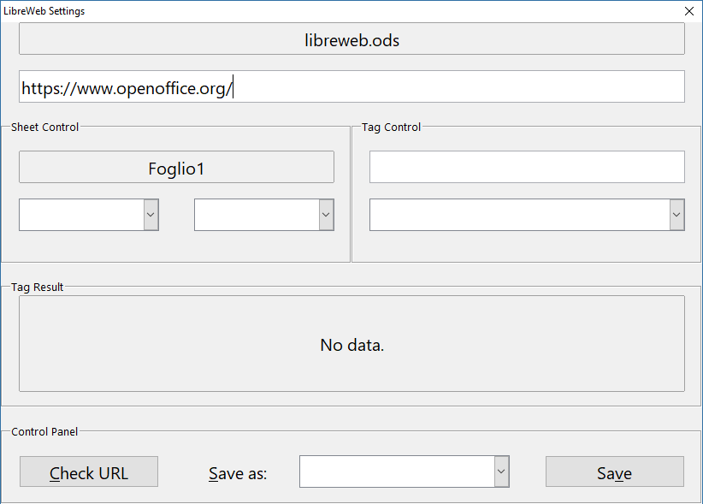

3.Import old data
This command allows to import web data, that has been created with a previous
version of LibreWeb and saved under user folder.
Once imported, data is stored to current document and deleted from user directory.

4.Check SSL module
Unfortunately some version of LibreOffice comes with a broken ssl module.
Due to this issue, the LibreWeb may works incorrect.
To check the integrity of installed ssl module, just use this command.
If SSL module is broken LibreWeb will not work.
Of course there is a solution.

5.Check for updates
Check if there is update for LibreWeb.

6.Read help
Open offline help file.

7.Send me an email
Send me a comment or suggestion, using your email client.

8.Visit forum
Open a dedicated forum.

9.Donate
If someone wants to support develop of LibreWeb, this is the right place, and
I would like to thanks in advance.Sincerly.

10. About
About window, shows the current version.

Features, that may be present in the next versions

- Edit data.
Would be nice to have an editor for saved web settings

- More portability
Another step towards portability it is having possibility to incorporate
LibreWeb reader into any Calc document, to share (and run )
the last one without needing to install full LibreWeb extension.

