OpenStudio Version 2.3.0

Release Notes – 9/30/2017

These release notes describe version 2.3.0 of the OpenStudio software suite developed by the National Renewable Energy Laboratory (NREL), Buildings and Thermal Systems, Commercial Buildings Research Group, Tools Development Section, and associated collaborators. The notes are organized into the following sections:

* Where to Find OpenStudio Documentation
* Installation Notes
* Overview

# Where to Find OpenStudio Documentation

* OpenStudio release documentation, including these release notes, tutorials, and other user documentation, is available at <https://www.openstudio.net/>.
* C++ API documentation is available at <https://openstudio-sdk-documentation.s3.amazonaws.com/index.html>.
* Measure development documentation is available at <http://nrel.github.io/OpenStudio-user-documentation/reference/measure_writing_guide/>.

# Installation Notes

OpenStudio is supported on Windows 7 – Windows 10, OS X 10.10 – 10.11, and 64-bit Ubuntu 14.04.

OpenStudio 2.3.0 supports EnergyPlus Release 8.8.0, which is bundled with the OpenStudio installer. It is no longer necessary to download and install EnergyPlus separately. Other builds of EnergyPlus are not supported by OpenStudio 2.3.0.

OpenStudio 2.3.0 supports Radiance 5.0.a.12, which is bundled with the OpenStudio installer; users no longer have to install Radiance separately, and OpenStudio will use the included Radiance version regardless of any other versions that may be installed on the system. Other builds of Radiance are not supported by OpenStudio 2.3.0.

## Installation Steps

* The OpenStudio SketchUp Plug-in requires [SketchUp 2017](http://www.sketchup.com/) (not available for Linux). The OpenStudio SketchUp Plug-in does not support older versions of SketchUp.
  + If the OpenStudio Plug-in does not automatically load in SketchUp, open the Window->Preferences->Extensions window in SketchUp and enable the OpenStudio plug-in if it is listed.
* Download and install [OpenStudio](https://www.openstudio.net/downloads). Select components for installation.
* Setup a Building Component Library (BCL) account to access online building components and measures. [View instructions on how to setup your account and configure the key in OpenStudio](http://nrel.github.io/OpenStudio-user-documentation/getting_started/getting_started/).

# Overview

The [OpenStudio Geometry Editor](https://github.com/NREL/openstudio-geometry-editor) is a new, open source software module that developers can leverage to produce building energy modeling UIs that include geometry creation. The OpenStudio Geometry Editor is meant to cover simple building geometry use cases only. More complex building geometry is best developed in a full featured CAD tool and exported to gbXML for building energy modeling. The OpenStudio Geometry Editor is implemented in JavaScript with minimal dependencies, allowing it to be integrated into a wide range of applications. The OpenStudio Geometry Editor reads and writes a custom [floorplan.json](https://raw.githubusercontent.com/NREL/openstudio-geometry-editor/develop/schema/geometry_schema.json) JSON file format. New methods have been added to the OpenStudio SDK, which can translate this file format to OSM. Additionally, new methods have been added to the SDK, which allows two OpenStudio Models to be merged. These new methods are demonstrated by integrating the Geometry Editor directly within the OpenStudio Application. The OpenStudio Geometry Editor and integration within the OpenStudio Application are experimental, and are not recommended for production workflows. However, we invite users to try these software components out and provide feedback to help us make them better for use by third party developers.  Instructions for use are at: <http://nrel.github.io/OpenStudio-user-documentation/reference/geometry_editor/>

**DView**

Historically, DView has been used for residential building modeling data visualization. DView is now being released with OpenStudio.

**Troubleshooting**

Several users have reported graphics issues with the Geometry and Results tabs within the OpenStudio Application.  In many cases, adjusting power saving settings of the graphics cards has resolved these issues.  For computers with NVIDA graphics cards, you can access these settings via the NVIDIA Control Panel under “3D Settings”->”Manage 3D Settings”.  In this panel, make sure that “Preferred graphics processor” is set to “High-performance NVIDIA processor”.

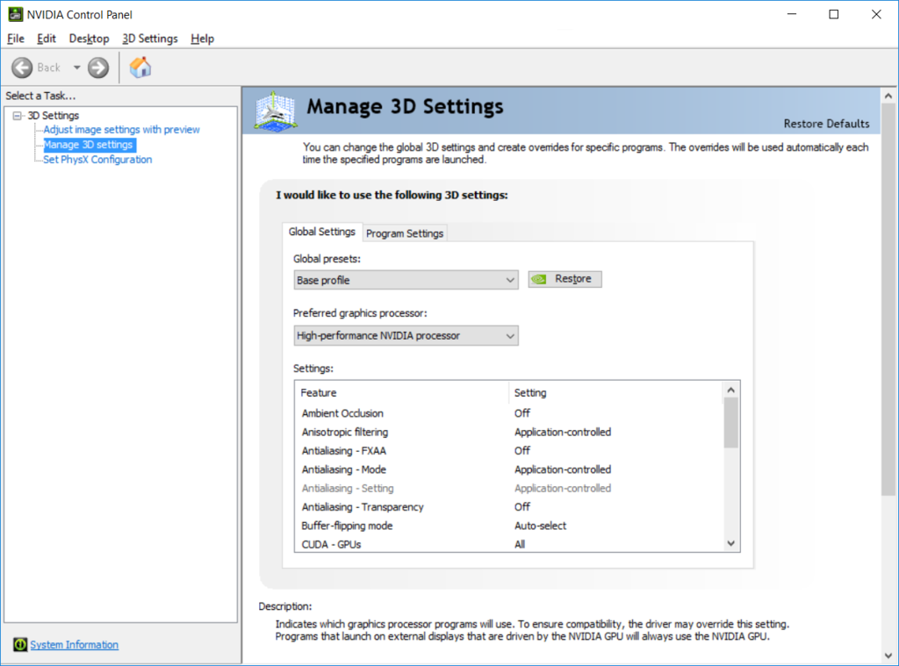

## Issue Statistics Since Previous Release

* 111 new issues were filed since the 2.2.0 release of OpenStudio (not including opened pull requests).
* 154 issues were closed since the 2.2.0 release of OpenStudio (not including closed pull requests).