Palm Beach County

Lion Country Safari

2003 Lion Country Safari Rd, Loxahatchee, Fl. 33470

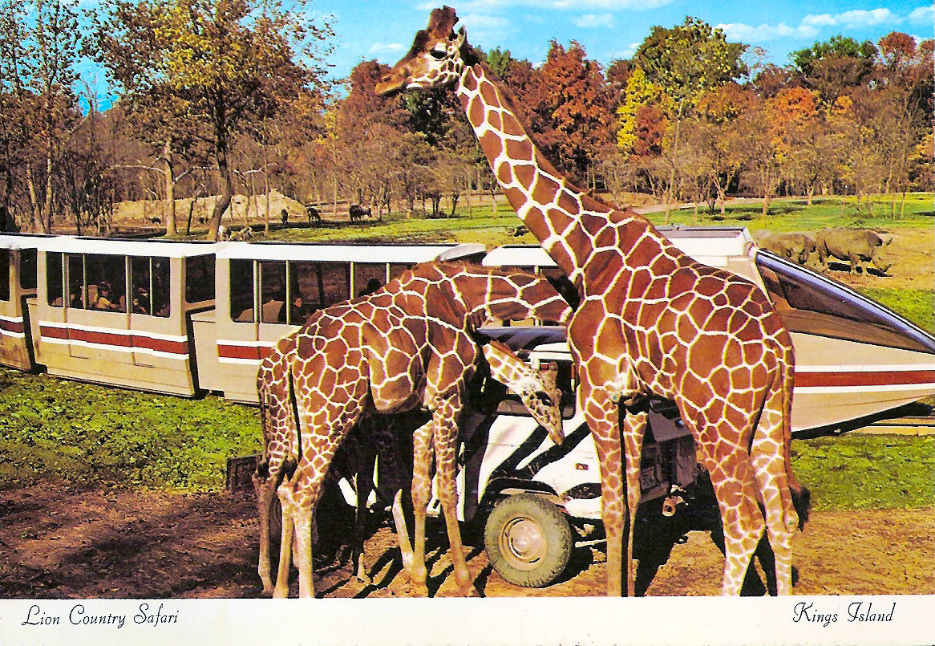

Description: Lion Country Safari is a drive-through safari park and walk-through amusement park located in Loxahatchee, in Palm Beach County, Florida. Founded in 1967, it claims to be the first 'cageless zoo' in the United States. Great fun for the whole family of all ages!

CityPlace

700 S. rosemary Ave., West Palm Beach, Fl. 33401

(561)820-0074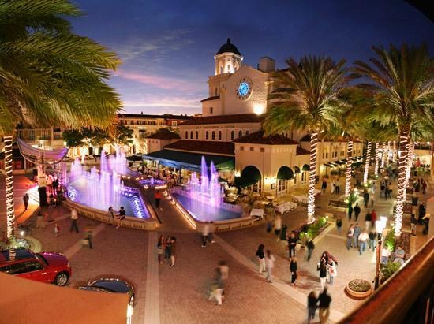

Description: CityPlace is an upscale lifestyle center in downtown West Palm Beach, Florida along South Rosemary Avenue. Besides shops, movies and restaurants, the center also includes rental apartments, condos, and offices. Amazing atmosphere for a night out on the town!

Rapids Water Park

2489 Port W Blvd, Riviera Beach, Fl. 33407

(561)848-6272

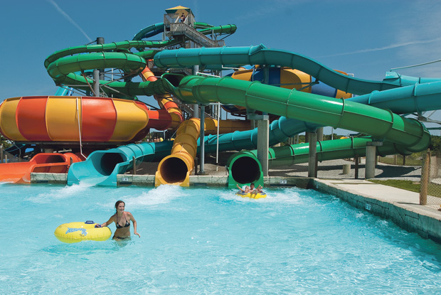

Description: 12-acre outdoor venue boasts a range of waterslides, a wave pool & lazy river, plus casual eateries. South Florida's LARGEST water park featuring 35 water slides from mild- to- wild and over 30 acres of action-packed attractions.

Broward County

Butterfly World

3600 West Sample Rd., Coconut Creek, Fl. 33073

(954)977-4434

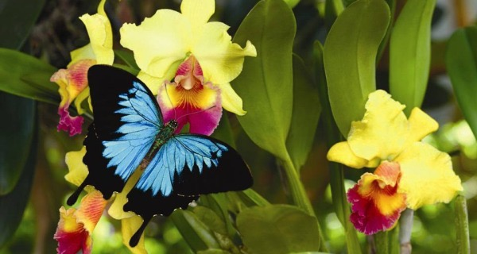

Decsription: Butterfly World, opened in 1988, and is the largest butterfly park in the world, and the first park of its kind in the Western Hemisphere. Acquiring three acre tropical landscape where you can observe butterflies in their natural habitat. This live exhibit features hundreds of free-flying butterflies and birds from all around the world.

Broward Regional Park and Stadium

3700 NW 11th Place, Lauderhill, Fl. 33311

(954)357-5400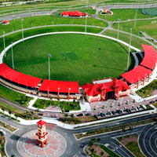

Description: Central Broward Regional Park and Stadium is a large municipal park in Lauderhill, Florida, owned and operated by Broward County. A park that offers picnic shelters, meeting rooms, boat rentals and much more, including the newly built Tropical Splash Water Park.

Seminole Hard Rock Hotel and Casino Hollywood

1 Seminole Way, Hollywood, Fl. 33314

(866)502-7529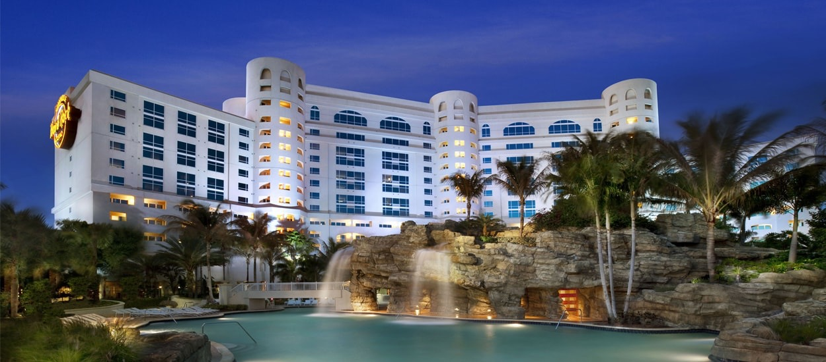

Description: Seminole Hard Rock Hotel & Casino is South Florida’s ultimate destination for fun and entertainment. If you’re ready to escape, they’re ready to customize your rock star experience.The AAA Four-Diamond rated Seminole Hard Rock Hotel & Casino in Hollywood offers 500 rock star suites, signature and award-winning restaurants, a 5,500-seat Hard Rock Live arena featuring performances from today’s most popular musicians and comedy acts, a 4.5 acre tropical pool oasis & Beach Club, a full-service Rock Spa, fitness center, high-energy nightlife, boutique shopping and convention space. This is why Seminole Hard Rock is Where Rock Royalty Lives.

Dade County

Zoo Miami

1 Zoo Blvd/ 12400 SW 152nd St., Miami, Fl. 33177

(305)251-0400

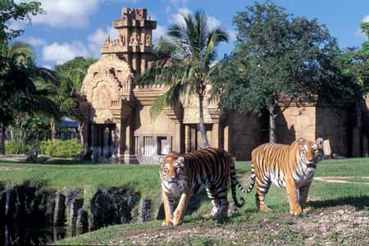

Description: Zoo Miami is the largest and oldest zoological garden in Florida, and the only tropical zoo in the United States. Spread over 300 acres, this zoo contains rare species, exhibits, tropical plants, and children’s area. This is why Zoo Miami is fun for the whole family.

Miami Seaquarium

4400 Rickenbacker Causeway, Key Biscayne, Fl. 33149

(305)261-5705

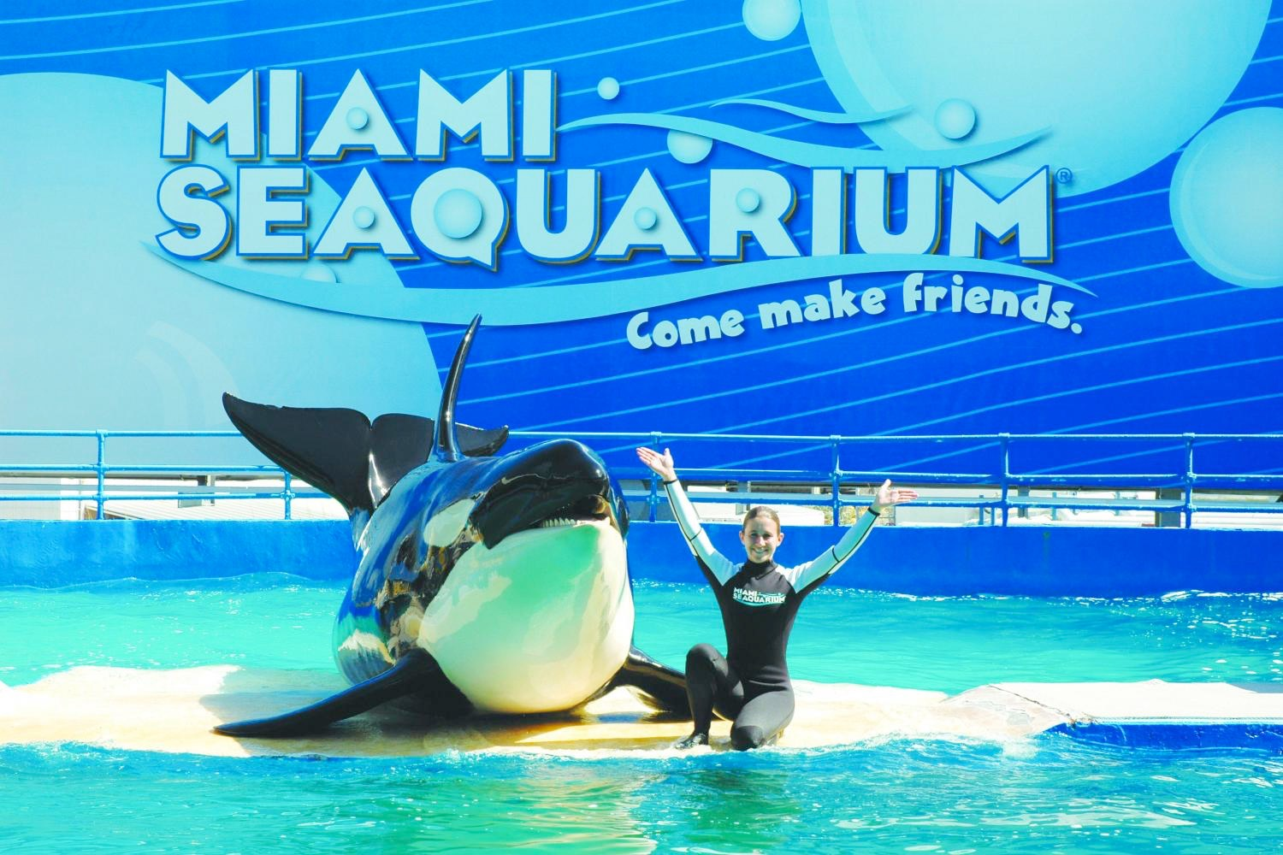

Description: The Miami Seaquarium is a 38-acre oceanarium located on the island of Virginia Key in Biscayne Bay, founded in 1955, it is the oldest oceanarium in the United States. This complex hosts shows, sealife displays and kids’ playground, plus dolphin rides.

Marlins Park

501 Marlins Way, Miami, Fl. 33125

(305)480-1300

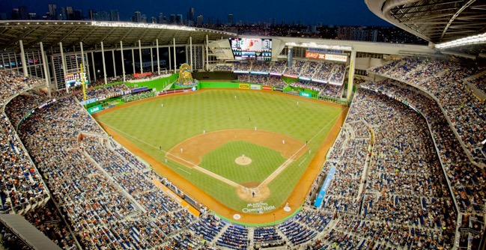

Description: Marlins Park is a baseball park that is the current home of the Miami Marlins, the city's Major League Baseball franchise. This Park has an air conditioned stadium with a retractable roof, it also features multiple cuisines, artwork and tours. Outdoor fun for the entire family