Palm Beach County Museums:

* Boca Raton Museum of Art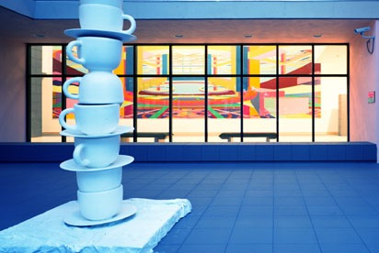

501 Plaza Real, Boca Raton,Fl. 33432

(561) 392-2500

Description:The Boca Museum of Art is a leading cultural institution in South Florida, achieving international recognition for its dynamic changing exhibitions and distinguished permanent collection.

* Norton Museum of Art

1451 South Olive Avenue, West Palm Beach, Fl. 33401

(561)832-5196

Description:The Norton is known for its exhibitions and collection of American, Chinese, Contemporary, and European Art – and Photography. From its fou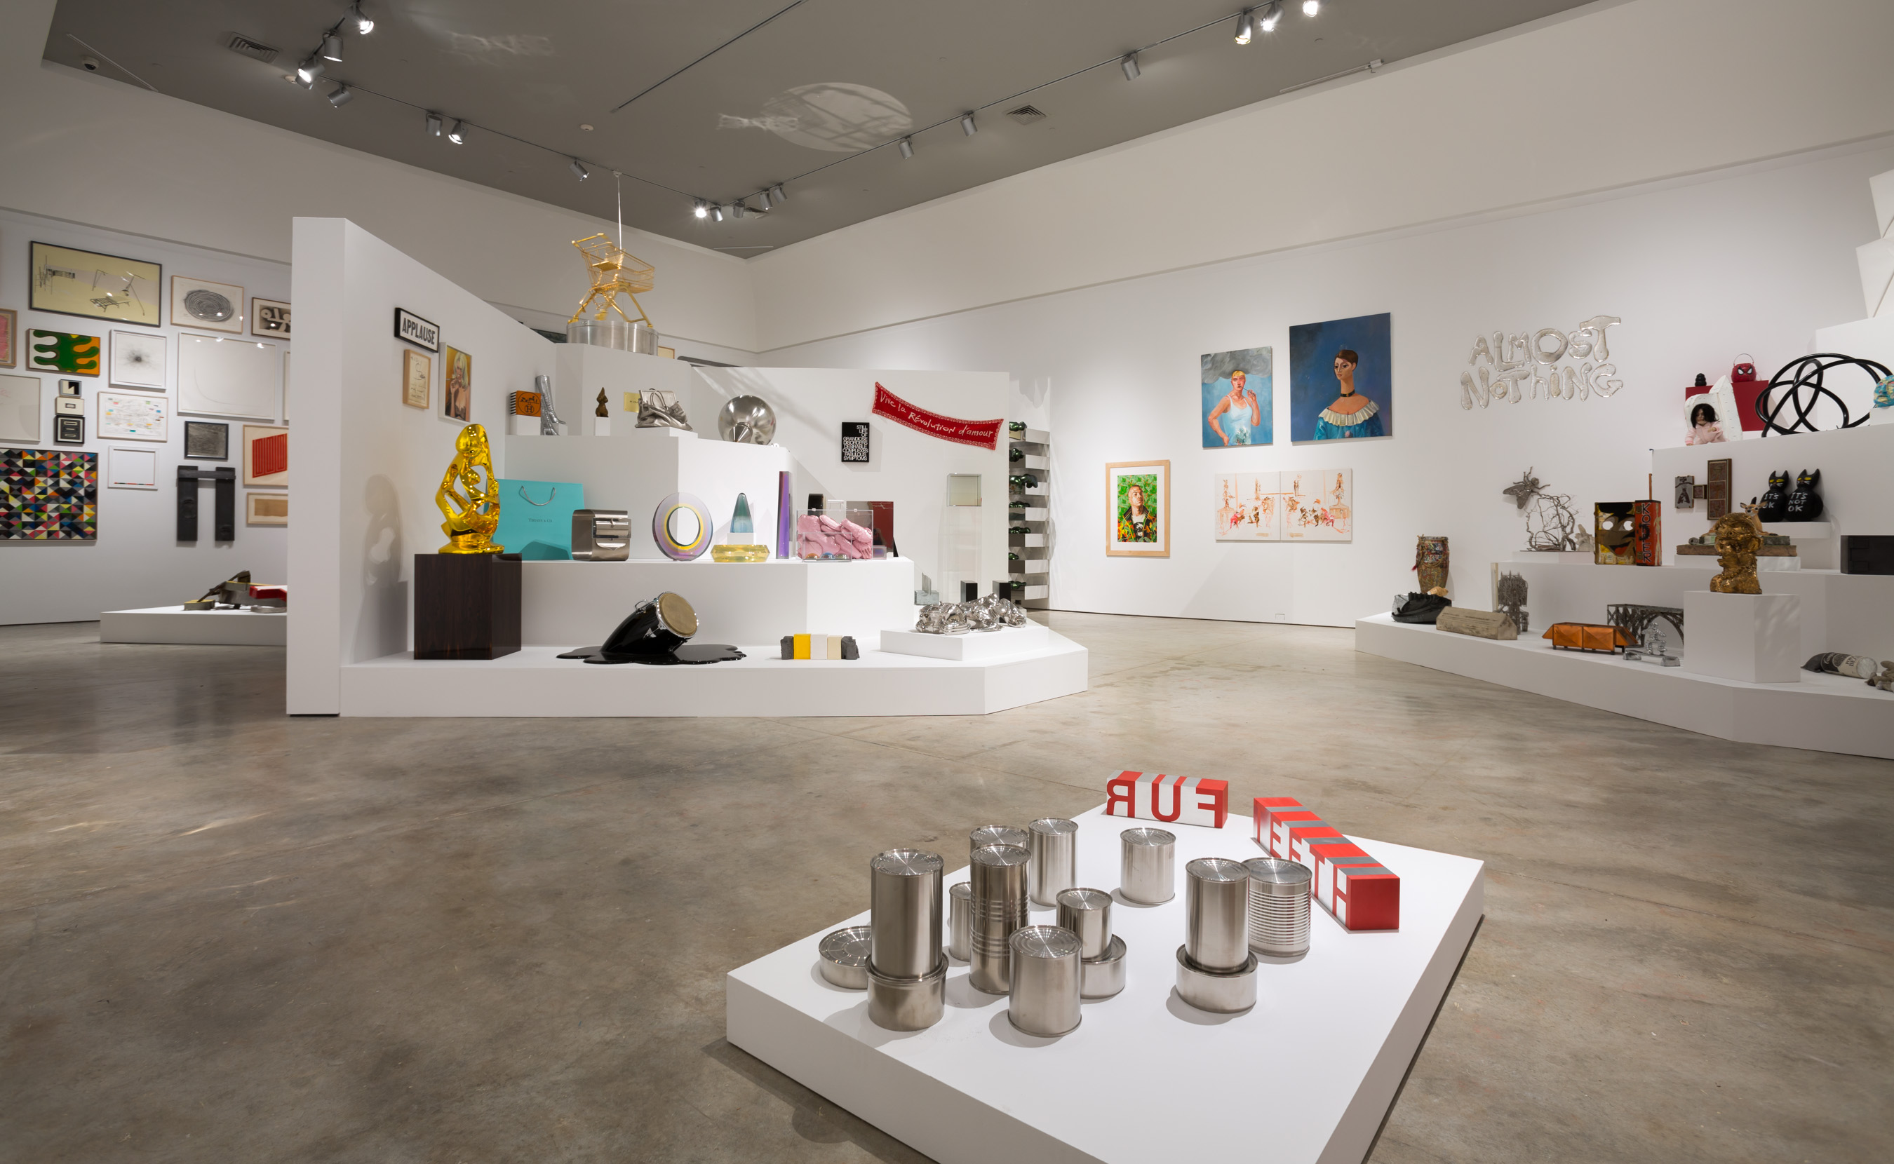nding in 1941, the Museum has been acclaimed for masterpieces by Gaugin, Monet, Picasso, and many others. Its Chinese Collection is among the best in the world, and its Photography Collection spans decades

* Boca Express Train Museum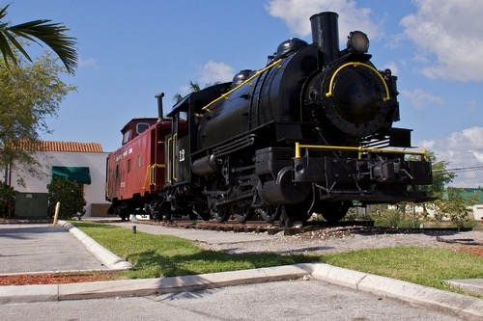

747 South Dixie Highway, Boca Raton, Fl. 33432

(561)395-6766

Description:Experience a nostalgic tour about the glamorous days of train travel via living history interpreters. Come aboard as a passenger and meet the train crew members at work! The tour begins in the historic FEC train depot and continues after boarding the two 1947 Seaboard Air Line streamlined rail cars.

Broward County Museums:

* Art and Culture Center of Hollywood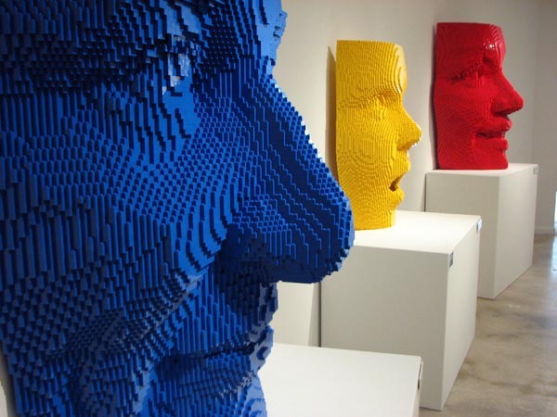

1650 Harrison St.,Hollywood, Fl. 33020

(954)921-3274

Description:The Art and Culture Center of Hollywood presents contemporary gallery exhibitions, live stage performances, and high-quality education programs for adults and children. The Center fosters a creative environment where new and challenging work can flourish through programs that reflect the highest standards of artistry and diversity.

* International Swimming Hall of Fame Museum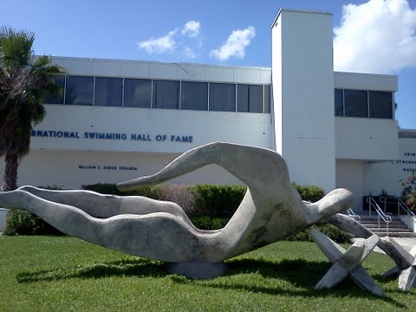

One Hall of Fame Dr., Fort Lauderdale, Fl. 33316

(954)462-6536

Decsription: The International Swimming Hall of Fame museum, is a museum which displays and awards swimming legends. The mission of the International Swimming Hall of Fame’s mission is to promote the benefits and important of swimming as a key to fitness, good health, and quality of life.

* Museum of Discovery and Science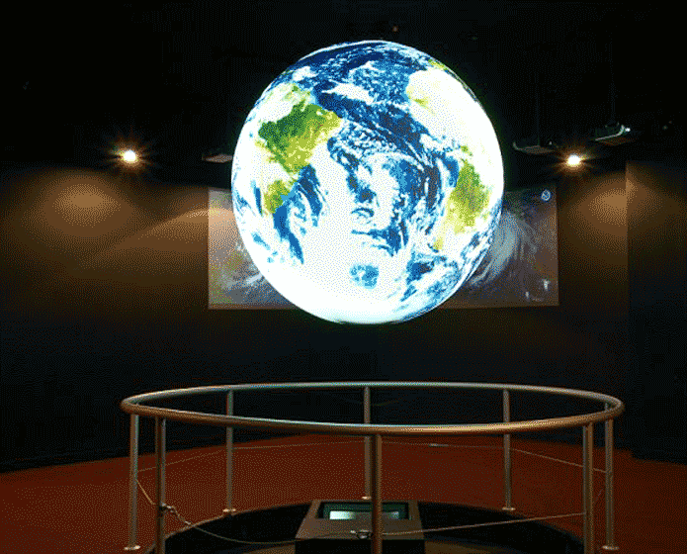

401 SW 2nd st., Fort Lauderdale, Fl. 33312

(954)467-6637

Description: One of the world class museums has just recently added five new exhibit areas, including Otters at Play, Everglades Airboat Adventure, Prehistoric Florida, Florida Water Mysteries and Storm Center. This new major expansion is more than double the Museum of Discovery and Science previous exhibit space. Museum of Discovery and Science offers a more dynamic hands-on explorations.

Dade County:

* Holocaust Memorial Miami Beach

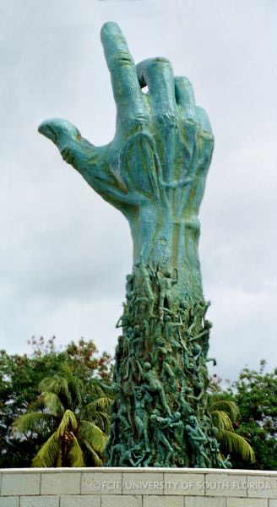

1933-1945 Meridian Avenue, Miami Beach,Fl.

(305)538-1663

Description: The large circular plaza in Miami Beach serves as a tribute to the six million Jewish victims of the Nazis during World War II.The structure, which took four years to construct, represents the pain, despair and anguish of the Holocaust experience. Surrounding the memorial are photographic murals and a reflection pool.

* Miami Children’s Museum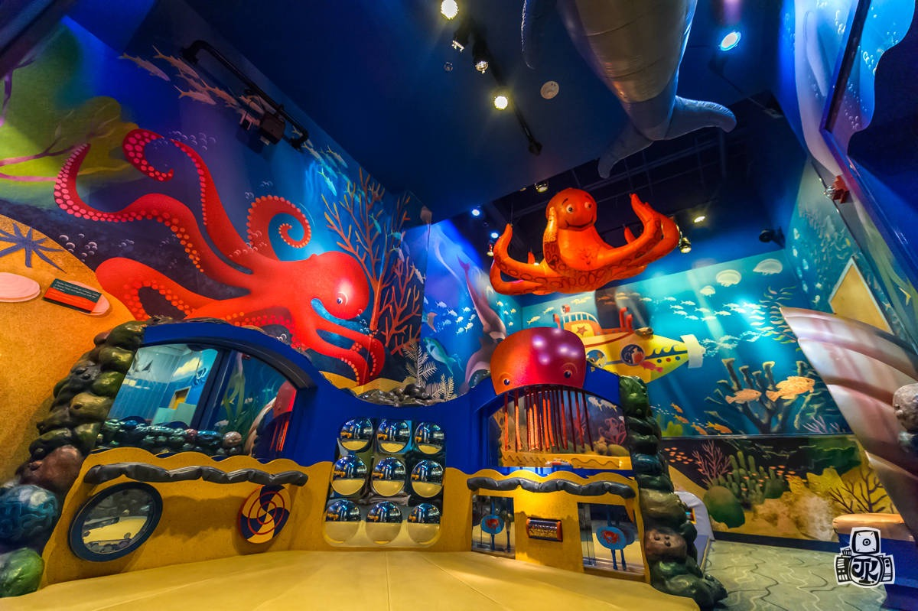

980 MacArthir Crossway, Miami, Fl.

(305)373-5437

Description: Miami Children’s Museum was established in 1983 as the Miami Youth Museum. Today, it is recognized as one of the 10 largest children’s museums in the country and the only children’s museum in Miami-Dade County.The building represents the elements of the world; earth, wind, water and fire. Miami Children’s Museum’s mission is to promote youth and education.

* Bass Museum of Art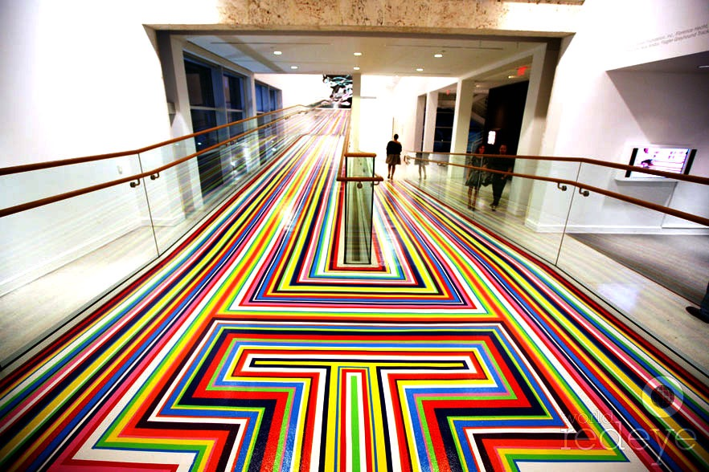

2100 Collins Avenue, Miami Beach, Fl.

(305)673-7530

Description: Open since 1963, Bass Museum of Art has brought international fine arts straight to Miami Beach. The vast variety of fine art covers regions like Japanese woodblock print, Latin American Paintings, and even Rococo court paintings. This museum also features outdoor contemporary sculptures.