DEPARTMENT OF ELECTRICAL & ELECTRONIC ENGINEERING
Experiment No. : 5
Experiment Name: Steady State error Analysis using MATLAB
OBJECTIVES
  - Understanding the basic principle to evaluate Steady State error of systems.
  - Evaluate system type &observe TIME RESPONSE in MATLAB.
  - Observe a practical application of system response & determine the value of gain & response of different input.

PRELAB WORK:
- Read this laboratory tutorial carefully before coming to the laboratory class, so that you know what is required.
- Try to follow the lectures of EEE 4701.
- Familiarize yourself with relevant MATLAB functions and codes necessary for this experiment.

Objective 1.1-Understanding the basic principle to evaluateSteady State error of systems.
Introduction
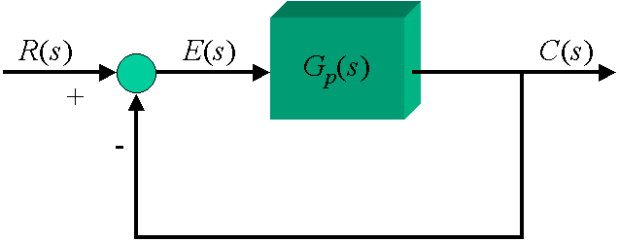
The single-loop, unity-feedback block diagram present below will be used throughout this example to represent the problem under consideration. With unity feedback, the reference input R(s) can be interpreted as the desired value of the output, and the output of the summing junction, E(s), is the error between the desired and actual output values. The behavior of this error signal as time t goes to infinity (the steady-state error) is the topic of this example.

The Final Value Theorem of Laplace Transforms will be used to determine the steady-state error. The one very important requirement for using the Final Value Theorem correctly in this type of application is that the closed-loop system must be BIBO stable, that is, all poles of the closed-loop transfer function C(s)/R(s) must be strictly in the left-half of the s-plane.
The forms of the steady-state errors described in theory classes will be illustrated for Types 0, 1, and 2 systems in this example. Unit step and ramp signals will be used for the reference input since they are the ones most commonly specified in practice. The transfer functions for the Type 0 and Type 1 systems are identical except for the added pole at the origin in the Type 1 system. The transfer function for the Type 2 system (in addition to another added pole at the origin) is slightly modified by the introduction of a zero in the open-loop transfer function. This is necessary in order for the closed-loop system to be stable, a requirement when investigating the steady-state error. The gain in the open-loop transfer function will take on 5 different values to illustrate the effects of gain on steady-state error. The transfer functions in Bode form are:
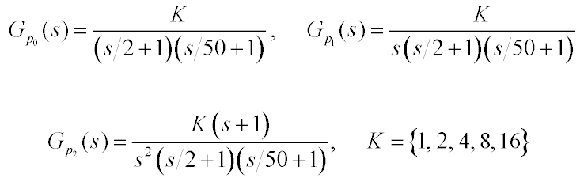

Objective 1.2-Evaluate system type & the observe TIME RESPONSE in MATLAB.
Type 0 System -- The steady-state error for a Type 0 system is infinitely large for any type of reference input signal in the class of signals described above except for the step input. When the reference input is a step, the Type 0 system produces a constant output in steady-state, with an error that is inversely related to the position error constant. The reason for the non-zero steady-state error can be understood from the following argument. The step input is a constant signal for all time after its initial discontinuity. Therefore, in steady-state the output and error signals will also be constants. The effective gain for the open-loop system in this steady-state situation is K_{x}, the "DC" value of the open-loop transfer function. Since c_{ss} = K_{x}e_{ss}, if the value of the error signal is zero, then the output signal will also be zero. However, if the output is zero, then the error signal could not be zero (assuming that the reference input signal has a non-zero amplitude) since e_{ss} = r_{ss} - c_{ss}. Thus, equilibrium is reached between a non-zero error signal and the output signal that will produce that same error signal for a constant input signal, with the equilibrium value being determined by K_{x}.
When the reference input signal is a ramp function, the form of steady-state error can be determined by applying the same logic described above to the derivative of the input signal. Remembering that the input and output signals represent position, then the derivative of the ramp position input is a constant velocity signal. As shown above, the Type 0 signal produces a non-zero steady-state error for a constant input; therefore, the system will have a non-zero velocity error in this case. The system position output will be a ramp function, but it will have a different slope than the input signal. This difference in slopes is the velocity error. Since there is a velocity error, the position error will grow with time, and the steady-state position error will be infinitely large.
The plots for the step and ramp responses for the Type 0 system error characteristics given below.
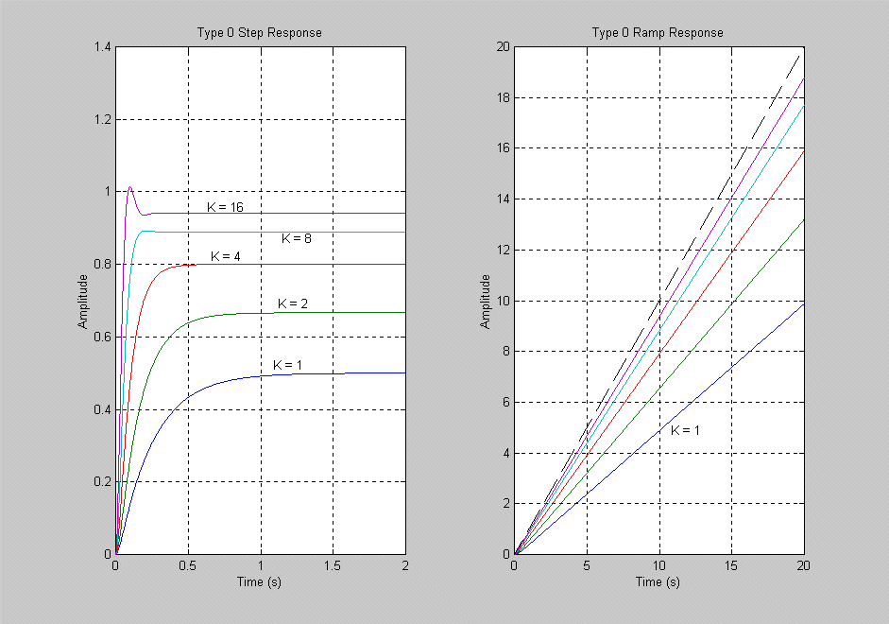
The steady-state errors are the vertical distances between the reference input and the outputs as t goes to infinity. Notice that the steady-state error decreases with increasing gain for the step input, but that the transient response has started showing some overshoot. Therefore, the increased gain has reduced the relative stability of the system (which is bad) at the same time it reduced the steady-state error (which is good). The dashed line in the ramp response plot is the reference input signal. As the gain is increased, the slopes of the ramp responses get closer to that of the input signal, but there will always be an error in slopes for finite gain, so the steady-state error for the Type 0 system will always be infinitely large with a ramp input.
Type 1 System -- The steady-state error for a Type 1 system takes on all three possible forms when the various types of reference input signals are considered. When the input signal is a step, the error is zero in steady-state this is due to the 1/sintegrator term in G_{p}(s). This integrator can be visualized as appearing between the output of the summing junction and the input to a Type 0 transfer function with a DC gain of K_{x}. Any non-zero value for the error signal will cause the output of the integrator to change, which in turn causes the output signal to change in value also. This causes a corresponding change in the error signal. As long as the error signal is non-zero, the output will keep changing value. When the error becomes zero, the integrator output will remain constant at a non-zero value, and the output will be K_{x} times that value. But that output value c_{ss}was precisely the value that made e_{ss} equal to zero. Therefore, no further change will occur, and an equilibrium condition will have been reached, for which the steady-state error is zero.
When the input signal is a ramp function, the desired output position is linearly changing with time, which corresponds to a constant velocity. The Type 1 system will respond to a constant velocity command just as it does to a step input, namely, with zero steady-state error. Thus, the steady-state output will be a ramp function with the same slope as the input signal. There will be zero steady-state velocity error. However, there will be a non-zero position error due to the transient response ofG_{p}(s).
For parabolic, cubic, and higher-order input signals, the steady-state error is infinitely large. For example, with a parabolic input, the desired acceleration is constant, and this can be achieved with zero steady-state error by the Type 1 system. However, there will be a velocity error due to the transient response of the system, and this non-zero velocity error produces an infinitely large error in position as t goes to infinity.
The plots for the step and ramp responses for the Type 1 system characteristics of steady-state error given below.
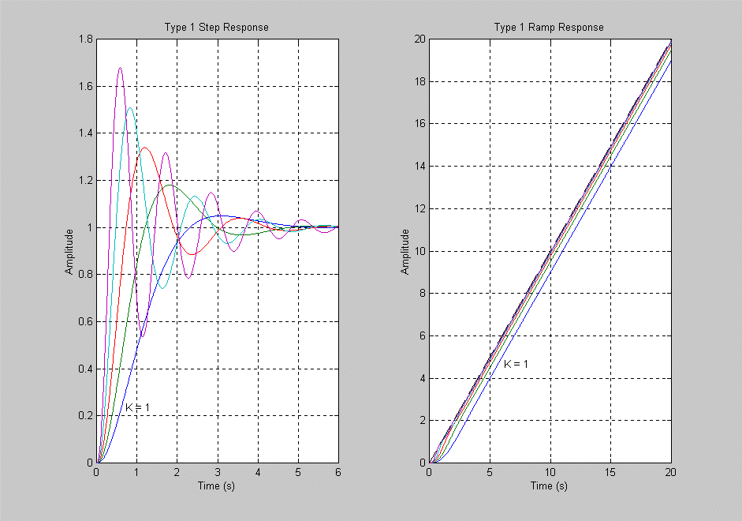
For the step input, the steady-state errors are zero, regardless of the value of K. Although the steady-state error is not affected by the value of K, it is apparent that the transient response gets worse (in terms of overshoot and settling time) as the gain is increased. Since G_{p1}(s) has 3 more poles than zeros, the closed-loop system will become unstable at some value of K; at that point the concept of steady-state error no longer has any meaning. In the ramp responses, it is clear that all the output signals have the same slope as the input signal, so the position error will be non-zero but bounded. As the gain increases, the value of the steady-state error decreases. By considering both the step and ramp responses, one can see that as the gain is made larger and larger, the system becomes more and more accurate in following a ramp input, until the gain is made so large that the system becomes unstable and accuracy becomes non-existent.
Type 2 System -- The logic used to explain the operation of the Type 1 system can be applied to the Type 2 system, taking into account the second integrator in G_{p}(s). The two integrators force both the error signal and the integral of the error signal to be zero in order to have a steady-state condition. This produces zero steady-state error for both step and ramp inputs. With a parabolic input signal, a non-zero, finite steady-state error in position is achieved since both acceleration and velocity errors are forced to zero. For higher-order input signals, the steady-state position error will be infinitely large.
The plots for the step and ramp responses for the Type 2 system shows below the zero steady-state errors achieved.
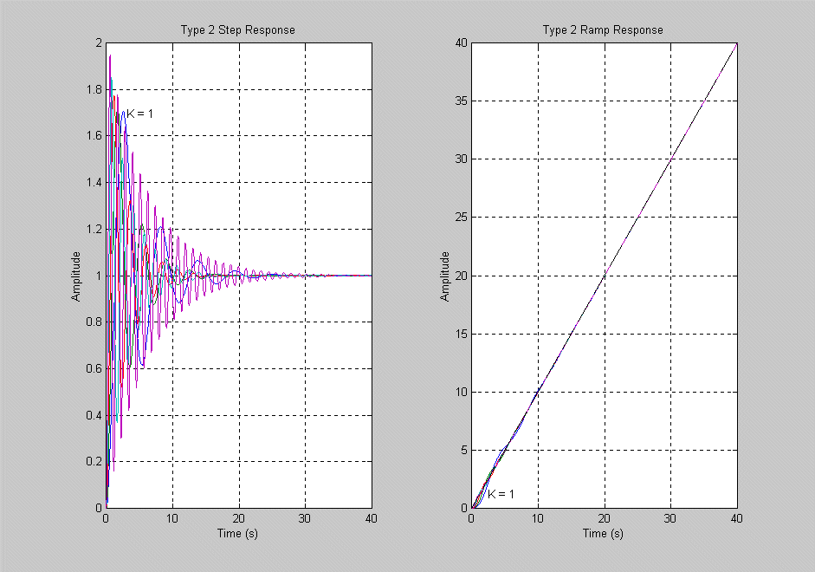
Also noticeable in the step response plots is the increases in overshoot and settling times. The relative stability of the Type 2 system is much less than with the Type 0 and Type 1 systems. As mentioned previously, without the introduction of a zero into the transfer function, closed-loop stability would have been lost for any gain value.
MATLAB program
K = [1 2 4 8 16];
ts0 = linspace(0,2,1001);
ts1 = 3*ts0;
ts2 = 20*ts0;
tr0 = 10*ts0;
tr1 = tr0; tr2 = 2*tr0;
n0 = 1; n1 = n0;
n2 = [1 1];
d0 = conv([1/2 1],[1/50 1]);
d1 = [d0 0]; d2 = [d1 0];
for i = 1:length(K)
for i1 = 1:3
eval(['[n,d] = cloop(K(i)*n' num2str(i1-1) ',d' num2str(i1-1) ',-1);'])
eval(['ys' num2str(i1-1) '(:,' num2str(i) ') = step(n,d,ts' num2str(i1-1) ');']);
eval(['yr' num2str(i1-1) '(:,' num2str(i) ') = step(n,[d 0],tr' num2str(i1-1) ');'])
end
end
for
i = 1:3
eval(['ts = ts' num2str(i-1) ';']);
eval(['ys = ys' num2str(i-1) ';']);
eval(['tr = tr' num2str(i-1) ';']);
eval(['yr = yr' num2str(i-1) ';']);
figure(i),clf,set(i,'Position',[62 50 942 660]),...
subplot(121),...
plot(ts,ys),grid,xlabel('Time (s)'),ylabel('Amplitude'),...
name = ['Type ' num2str(i-1) ' Step Response'];title(name),...
subplot(122),...
plot(tr,yr,[0 max(tr)],[0 max(tr)],'k--'),grid,...
xlabel('Time (s)'),ylabel('Amplitude'),...
name = ['Type ' num2str(i-1) ' Ramp Response'];title(name),...
end
figure(1),subplot(121),text(1.2,0.52,'K = 1'),text(1.2,0.7,'K = 2'),text(1.2,0.82,'K = 4'),...
text(0.7,0.87,'K = 8'),text(1.2,0.96,'K = 16'),subplot(122),text(7,3,'K = 1')
figure(2),subplot(121),text(0.5,0.1,'K = 1'),subplot(122),text(2.5,1,'K = 1')
figure(3),subplot(121),text(3,1.7,'K = 1'),subplot(122),text(3,1,'K = 1')

Objective 1.3-Observe a practical application of system response & determine the value of gain & response of different input.
A space telescope is to be launched to carry out astronomical experiments [1]. The pointing control system is desired to achieve 0.01 minute of arc and track solar objects with apparent motion up to 0.21 minute per second. The system is illustrated in Figure 1. The control system is shown in Figure 2. Assume that τ₁= 1 second and τ₂= 0 (an approximation).
Using MATLAB do the following:
1) Determine the gain K=K₁K₂ required so that the response to a step command is as rapid as reasonable with an overshoot of less than 5%
2) Determine the steady-state error of the system for a step and a ramp input
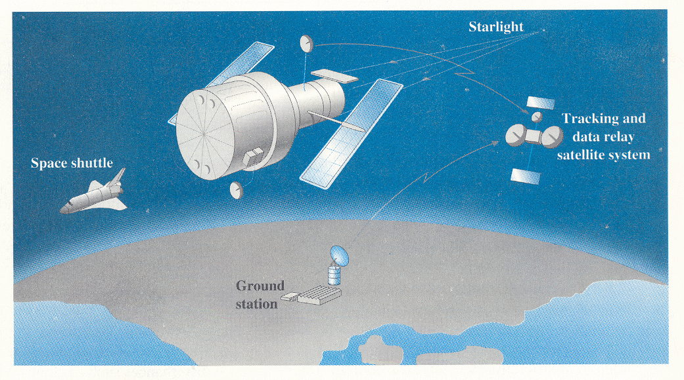
Figure 1
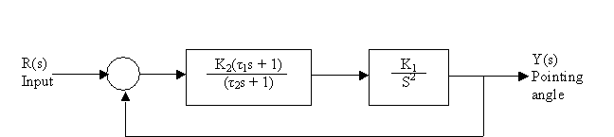

Figure 2
Part 1)
The step responses for K1 and K2 values ranging from 1 to 5 are plotted. From these, the characteristics can be viewed to find those which yield the best rise time with overshoot less than 5%. Since it is also required that the rise time be reasonable, the fastest system may not be the most suitable.
Part 1) MATLAB CODE
%Determine the gain K=K₁K₂ required so that the response to a step command is as rapid as reasonable with an overshoot of less than 5%
clc;
close all;
clear all;
tau1=1;
tau2=0;
%----------------------------------------------------------------
% Controller, G1(s) and Graphical Output
%----------------------------------------------------------------
K2=[1:1:5];
K1=[1:1:5];
num=[tau1 1]; % define tau of numerator of Controller
dent1=[tau2 1]; % define denominator of Controller
dent2=[1 0 0]; % define denominator of G₁(s)
for n2=1:length(K2) % iterate through each value of K2
num1=K2(n2)*num; % define numerator of Controller
T1=tf(num1, dent1); % create transfer function of Controller
for n1=n2:length(K1) % iterate through each value of K1
num2=K1(n1); % define numerator of G₁(s)
T2=tf(num2, dent2); % create transfer function of G₁(s)
G=T1*T2; % create open-loop transfer function
T=feedback(G,1); % create closed-loop transfer function
figure
step(T) % graphical representation of step response
title(['Step Response with K1= ' num2str(K1(n1)) ' and K2= ' , num2str(K2(n2))])
end
end
Part_1) RESULTS
Below is an extract of the results generated by the MATLAB program. We can see the first graph, with K1=5 and K2=2 has an overshoot more than 5% which doesn't meet the specifications for the question.
The value of gain K=K₁K₂=10 and the transfer function is equal to:
Transfer function:
10 s + 10
---------------
s^2 + 10 s + 10
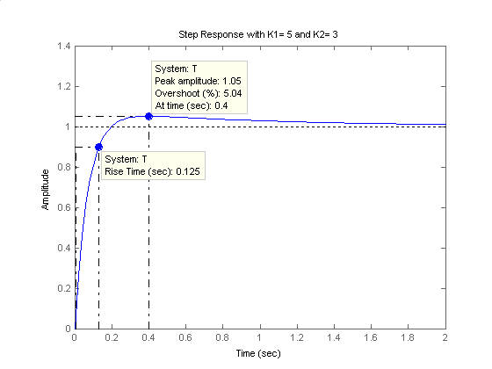
The function considered to best meet all requirements for the problem, has K1=4 and K2=4. Here the percentage overshoot is 4.78%, which is less than the 5% required, and the rise time is only 0.118 seconds. The value of gain K=K₁K₂=16 and the transfer function is equal to:
Transfer function:
16 s + 16
------------------------
s^2 + 16 s + 16
Below is the corresponding graph:
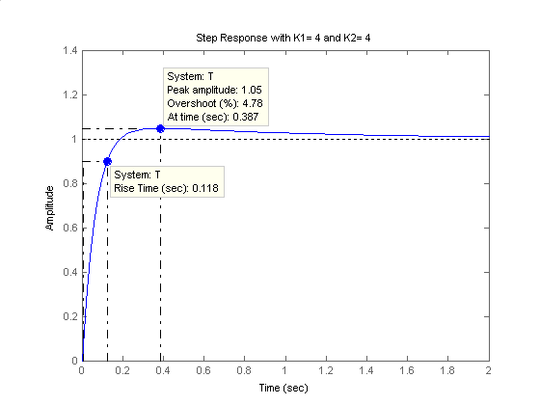
The third graph included here is an example of results where the overshoot and fast rise time requirements are met, however the rise time is likely to be too fast for the telescope.
The value of corresponding gain K=K₁K₂=20 and the transfer function is equal to:
Transfer function:
20 s + 20
---------------
s^2 + 20 s + 20
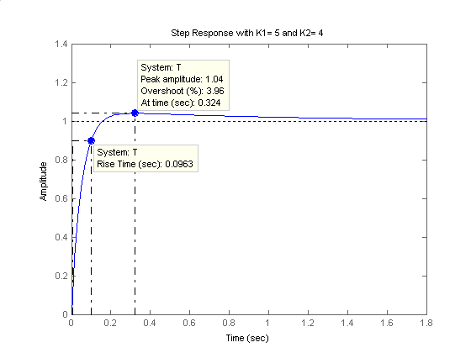
Part 2)
%Determine steady-state error of the system for a step and a ramp input
clc;
close all;
clear all;
tau1=1;
tau2=0;
%----------------------------------------------------------------
% Controller, G1(s) and Graphical Output
%----------------------------------------------------------------
K2=4;
num=[tau1 1]; % define tau of numerator of Controller
K1=4;
num1=K2*num; % define numerator of Controller
dent1=[tau2 1]; % define denominator of Controller
T1=tf(num1, dent1); % create transfer function of Controller
num2=K1; % define numerator of G₁(s)
dent2=[1 0 0]; % define denominator of G₁(s)
T2=tf(num2, dent2); % create transfer function of G₁(s)
G=T1*T2;
T=feedback(G,1);
figure
[y1, t1] = step(T);
step(T); % graphical representation of step response
figure
plot(t1, 1-y1); % graphical representation of steady-state error for a step input
title('Steady-State Error of the System for a Step Input');
xlabel('Time (sec)');
ylabel('Error');
num3=1; % define numerator of input signal
dent3=[1 0]; % define denominator of input signal
T3=tf(num3, dent3); % create transfer function of input signal
figure
[y2, t2] = step(T*T3);
step(T*T3); % graphical representation of ramp response
title('Ramp Response');
figure
plot(t2, t2-y2); % graphical representation of steady-state error for a ramp input
title('Steady-State Error of the System for a Ramp Input');
xlabel('Time (sec)');
ylabel('Error');
Part_2) RESULTS
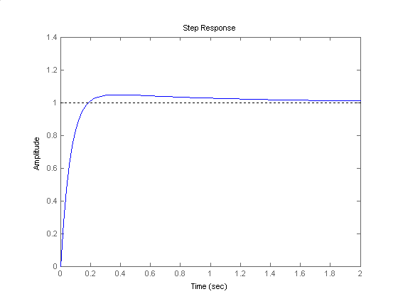
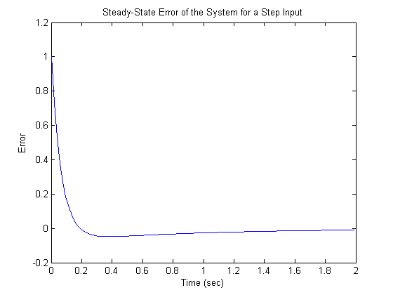

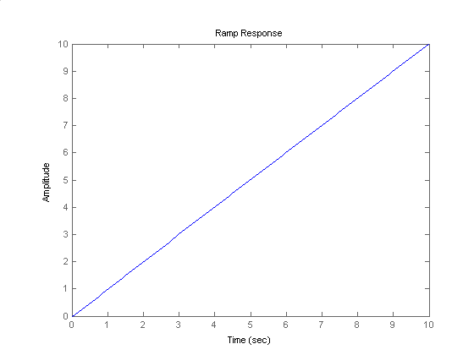
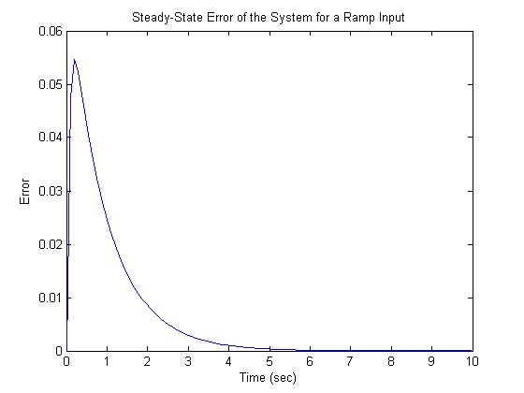

Lab Task
Task 1: Below here we have a system
R(s) + $\frac{K(S+ID)(S+ID+2)}{S^{2}(S+4)(S+ID+10)(S+ID+15)}$ C(s)
-
$\frac{(S+1)}{(S+6)(S+10)}$
Identify the system with logical explanation & evaluate time response of the system using appropriate input in MATLAB program.
Task 2: Determine the gain K=K₁K₂ of objective 1.3 of this experiment required so that the response to a step command is as rapid as reasonable with an overshoot of less than (ID%+10%).
Report preparation
Please prepare your report with yourself & don’t try to copy. Report should cover the following Topics:
- Objective
- Apparatus/Utility software:
- Description of Task:
- MATLAB code & Result:
- Analysis of Each output:
- Discussion:
Reference
[1] L.E. Ryan, "Control of an Impact Printer Hammer," ASME Journal of Dynamic Systems, March 1990, pp. 69

