Multisim simulation:
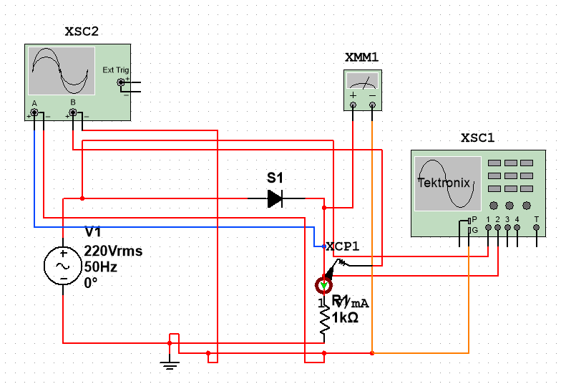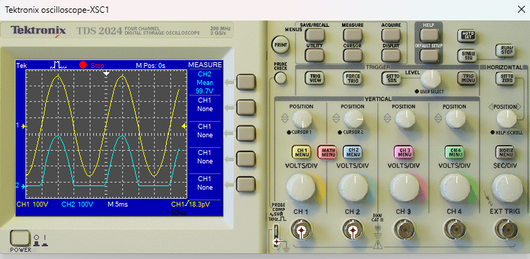
Fig: 1.3 (a,b) : Half wave rectifier with R load and output waevforms (R=1K ohm)
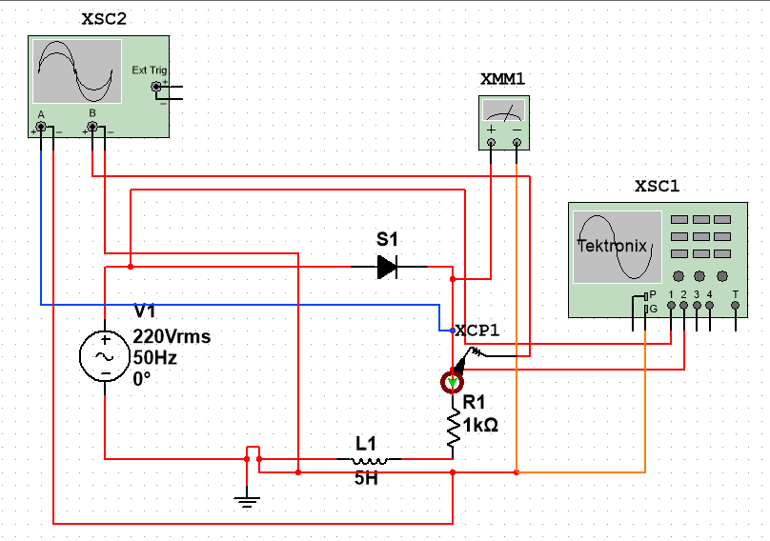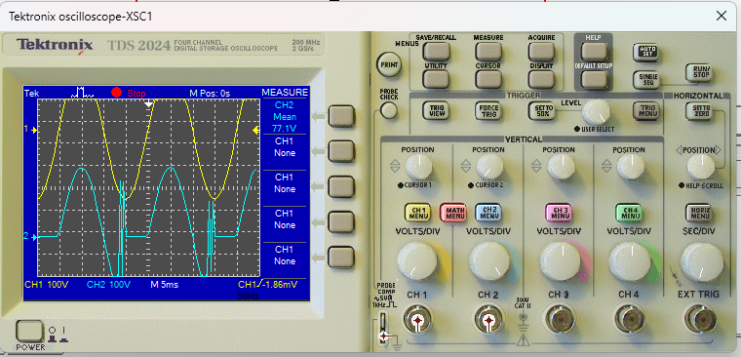
Fig: 1.3 (c,d) : Half wave rectifier with R-L load and output waevforms (R=1k ohm,L=5H)
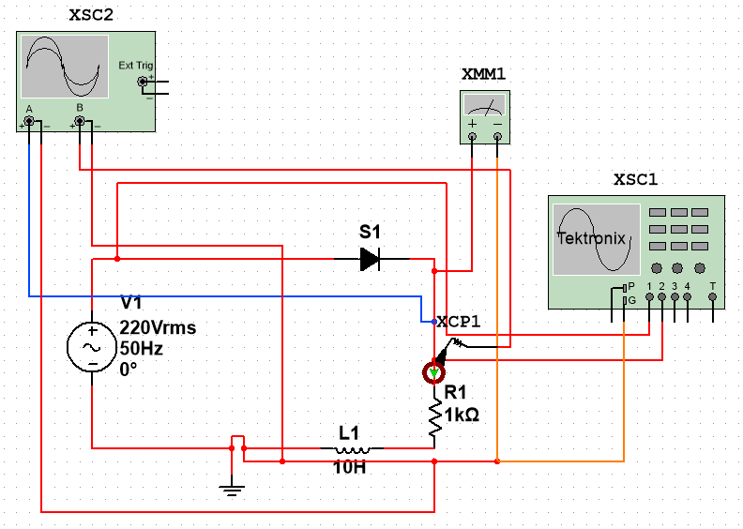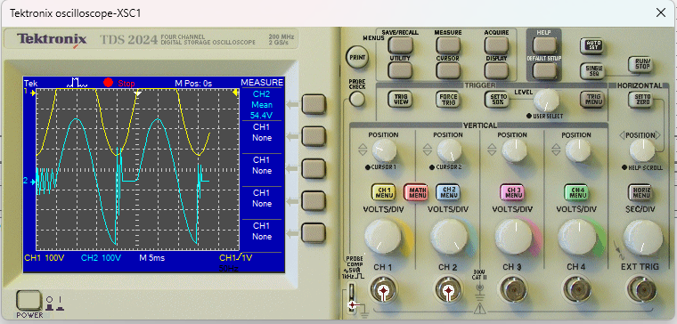
Fig: 1.3 (e,f) : Half wave rectifier with R-L load and output waevforms (R= 1K ohm, L= 10H)
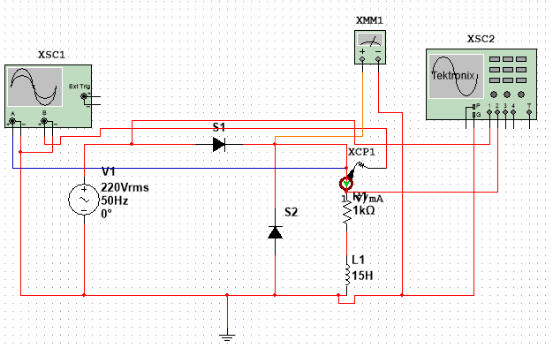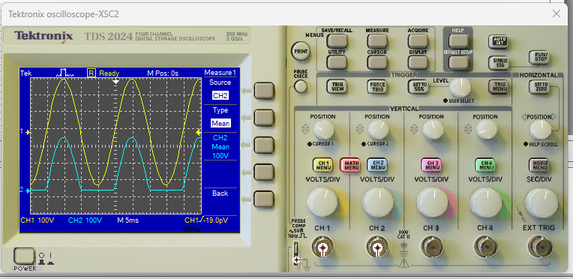
Fig: 1.3 (g,h) : Half wave rectifier with R-L load and output waevforms (R= 1K ohm, L= 15H) with Freewheeling diode

