1. Objective
- To understand the basic concept of time response of dynamic systems.
- To observe system response for different inputs like step, impulse, ramp, and parabolic.
- To determine important system parameters such as rise time, settling time, peak time, and natural frequency.
- To compare theoretical results with MATLAB simulation results.
2. Apparatus / Utility Software
- Computer or Laptop
- MATLAB Software
- Control System Toolbox
- Notebook and calculator
3. Description of Task :
In this experiment, the main focus is to analyze the time response of different dynamic systems using MATLAB and to understand how system parameters affect the overall behavior. The experiment is divided into three main tasks, each designed to develop both theoretical understanding and practical skills.
Task 1: Time Response of a Second-Order System
In this task, a second-order transfer function is given in the Laplace domain:
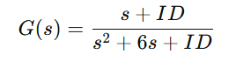
Here, the value of ID is taken as the last two digits of the student ID, which makes the system unique for each student.
First, the numerator and denominator of the transfer function are defined in MATLAB using polynomial coefficient vectors. Then, the transfer function model is created using the tf() function.
After forming the system, the time response of the system is analyzed by applying different types of inputs:
- Step input: to observe how the system behaves when a sudden constant input is applied.
- Impulse input: to study the system’s reaction to a very short-duration input.
A suitable time range is selected to clearly visualize the system behavior. Using MATLAB plotting functions, the response curves are generated. From these plots, important characteristics such as rise behavior, oscillation, and settling nature are observed.
This task mainly helps in understanding how a second-order system responds over time and how its mathematical form affects its output behavior.
Task 2: Response of a Unity Feedback System
In this task, a more complex system is considered. The given open-loop transfer function is:
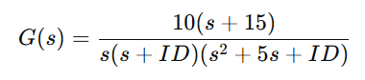
First, the numerator and denominator polynomials are constructed in MATLAB. Since the denominator contains multiple factors, convolution is used to combine them into a single polynomial expression.
After forming the open-loop transfer function, a unity feedback system is created using the feedback() function. This converts the open-loop system into a closed-loop system, which is more realistic in practical control applications.
Next, the step response of the closed-loop system is plotted. This helps in understanding how feedback influences system performance, such as reducing overshoot and improving stability.
In addition, Partial Fraction Expansion (PFE) is performed using the residue() function. This breaks the transfer function into simpler fractions, making it easier to analyze the system in the time domain.
The main purpose of this task is to:
- Understand the effect of feedback on system response
- Analyze higher-order systems
- Learn how to simplify complex transfer functions
Task 3: Determination of System Parameters
In this task, the same system from Task 1 is used again to calculate important time-domain parameters.
First, the transfer function is defined in MATLAB. Then, the stepinfo() function is used to extract key system characteristics automatically. These include:
- Rise Time: time taken for the output to rise from a lower percentage to a higher percentage of its final value
- Peak Time: time at which the system reaches maximum overshoot
- Settling Time: time required for the system to stabilize within a specific tolerance range
These parameters are very important in control system design because they describe how fast and how accurately a system responds.
Additionally, the natural frequency of the system is calculated theoretically using the standard formula: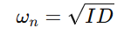​
This value indicates how quickly the system oscillates.
Finally, the MATLAB results are compared with theoretical expectations to verify correctness and consistency.

4. MATLAB code & Result:
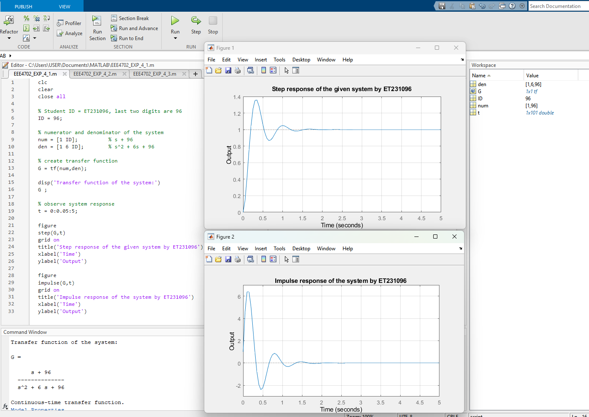
Fig. 4.1: MATLAB representation of Task-1 showing the system transfer function in the Editor Window, execution in the Command Window, and the corresponding output response graph.
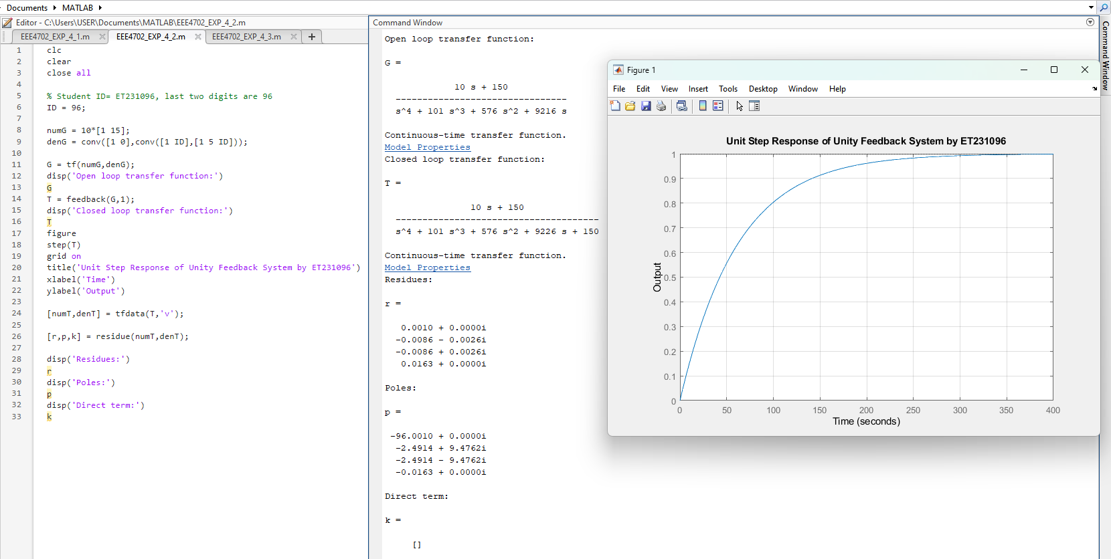
Fig. 4.2: MATLAB representation of Task-2 showing both the analytical and computational unit-step responses of a unity-feedback system in the Editor Window, execution in the Command Window, and the corresponding output response graph.
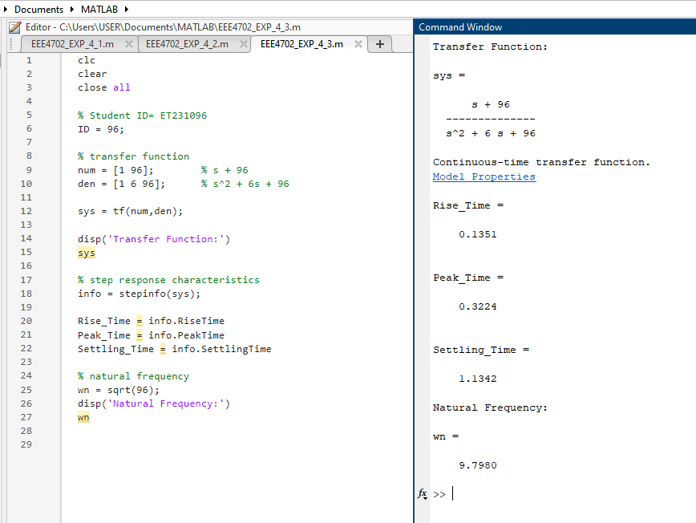
Fig. 4.3: MATLAB representation of Task-3 showing the program for calculating natural frequency, peak time, settling time, and rise time in the Editor Window and its execution in the Command Window.
5. Analysis of Each Output
Task 1: Analysis of Second-Order System Response
In this task, the system is a second-order transfer function. After running the MATLAB code, several outputs such as transfer function, step response, and impulse response are obtained. Each output gives important information about system behavior.
1. Transfer Function Interpretation:
The transfer function has a second-order denominator, which indicates that the system can show oscillatory behavior. The numerator contains a first-order term, which introduces a zero in the system. This zero affects the shape of the response, especially at the initial stage.
2. Nature of the System:
Since the denominator is of the form 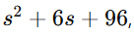 the system can be compared with the standard second-order form. From this, it can be understood that the system has damping. The value of damping determines whether the system is underdamped, critically damped, or overdamped. In this case, the system is underdamped, so oscillations are expected.
3. Step Response Analysis:
From the step response graph, the following observations can be made:
- At the beginning, the output starts from zero because there is no initial energy stored in the system.
- The output then rises quickly due to the applied step input.
This behavior indicates that the system is stable because the oscillations die out over time.
4. Impulse Response Analysis:
The impulse response shows how the system reacts to a very short-duration input. From the graph:
- The response starts with a sudden peak because the impulse input is very high for a short time.
- After the initial peak, the output decreases rapidly.
- The response may show slight oscillations depending on system damping.
- Eventually, the output approaches zero, which confirms system stability.
Impulse response is useful because it shows the natural behavior of the system without continuous input.
5. Stability Consideration:
The poles of the system are obtained from the denominator. Since all coefficients are positive, the poles lie in the left half of the complex plane. This ensures that the system is stable. The presence of complex poles explains the oscillatory nature of the response.
6. Effect of Zero:
The zero in the numerator affects how quickly the system initially responds. It can increase the speed of response but may also increase overshoot. Therefore, the zero plays an important role in shaping the transient response.
Task 2: Analysis of Unity Feedback System
This task involves a higher-order system and includes feedback, which makes the analysis more practical.
1. Open-Loop vs Closed-Loop System:
Initially, the system is open-loop, meaning there is no feedback. After applying unity feedback, the system becomes closed-loop. This significantly changes the behavior of the system.
2. Closed-Loop Transfer Function:
The closed-loop transfer function represents the actual working system. It is obtained using the feedback() function in MATLAB. This function automatically combines the open-loop system with feedback.
3. Step Response Analysis:
From the step response of the closed-loop system:
- The output starts from zero and begins to rise.
- Compared to an open-loop system, the response is smoother and more controlled.
- Overshoot is reduced due to the presence of feedback.
- The system reaches steady-state faster.
This shows that feedback improves system performance and stability.
4. Pole Analysis:
Poles are calculated from the denominator of the closed-loop system. These poles determine system behavior:
- If all poles have negative real parts, the system is stable.
- If poles are complex, oscillations occur.
From MATLAB results, poles are located in the left half plane, which confirms that the system is stable.
5. Residue Analysis (PFE):
The residue() function breaks the transfer function into simpler fractions. Each term has the form:
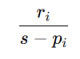
Here:
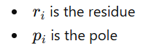
Each term corresponds to an exponential component in time domain.
Interpretation:
- Larger residue → stronger effect on output
- Smaller residue → weaker contribution
This helps in understanding which part of the system dominates the response.
6. Direct Term Analysis:
The direct term represents polynomial part of the expansion. If it exists, it indicates that numerator order is equal or higher. In this system, the direct term is either zero or very small, meaning the system is mostly proper.
Task 3: Analysis of System Parameters
In this task, important time-domain parameters are calculated using MATLAB and theoretical formulas.
1. Rise Time Analysis:
Rise time indicates how quickly the system output reaches near its final value. From MATLAB output:
- A small rise time means the system responds quickly.
- A large rise time indicates a slower system.
This parameter is important in applications where speed is required.
2. Peak Time Analysis:
Peak time is the time at which the system reaches its maximum value. It is directly related to oscillation. A smaller peak time means the system reaches maximum value quickly.
3. Settling Time Analysis:
Settling time is one of the most important parameters. It shows how long the system takes to stabilize within a certain range (usually ±2%).
- Small settling time → fast and efficient system
- Large settling time → slow system
From the MATLAB result, settling time confirms whether the system is suitable for practical use.
4. Natural Frequency Analysis:
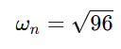​
Natural frequency determines how fast the system oscillates. A higher natural frequency means faster oscillation and quicker response.
So, system design requires a balance between speed and stability.

6. Discussion :
In this experiment, the time response of different systems was analyzed using MATLAB. The experiment helped to clearly understand how a system behaves when different inputs are applied. From Task 1, it was observed that second-order systems can show oscillatory behavior depending on system parameters. The step and impulse responses provided a clear visual understanding of system dynamics. In Task 2, the effect of feedback was studied, and it was seen that feedback improves system performance by making the response more stable and controlled. The use of Partial Fraction Expansion helped to break down complex transfer functions into simpler parts, which made analysis easier. In Task 3, important system parameters like rise time, peak time, and settling time were calculated, which are very useful in real engineering applications. The comparison between theoretical and MATLAB results showed that MATLAB is a very powerful and accurate tool for analyzing control systems. Overall, this experiment improved understanding of system stability, time response, and the importance of system parameters in designing efficient systems.

