Multisim simulation :
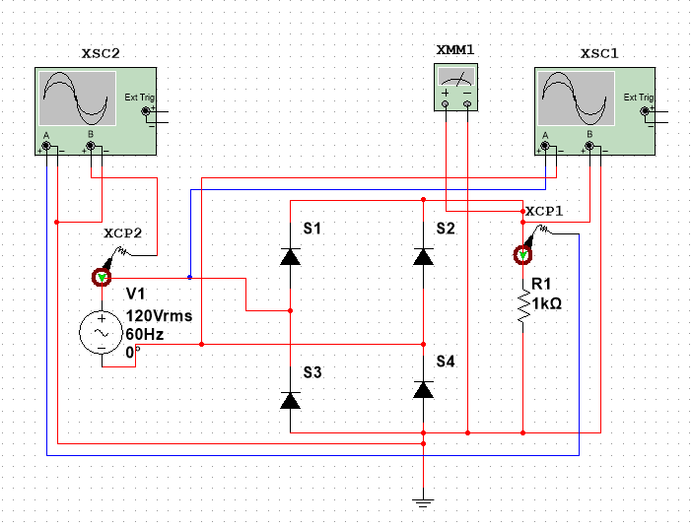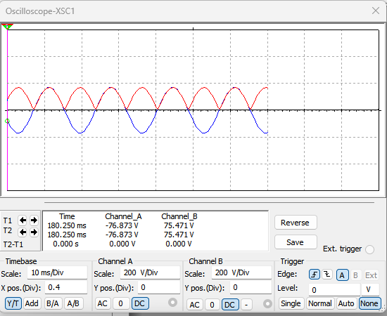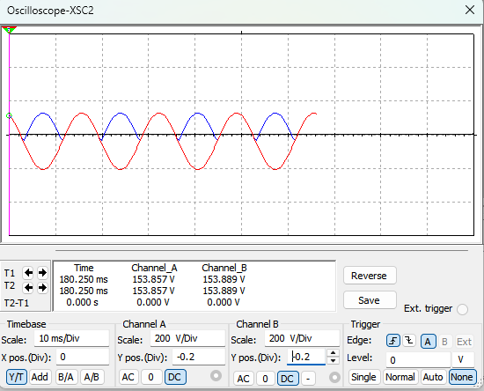
Fig. 2.3(a): Full-wave bridge rectifier with R = 1 kΩ load.ㅤㅤㅤFig. 2.3(b): $V_{in}$ and $V_{o}$ waveforms.ㅤㅤㅤ ㅤFig. 2.3(c): $I_{o}$ and $I_{s}$ waveforms.
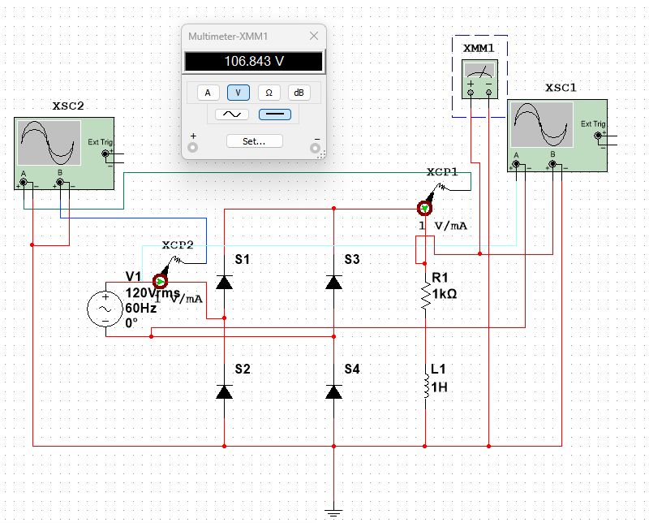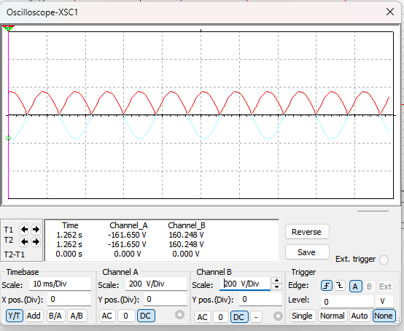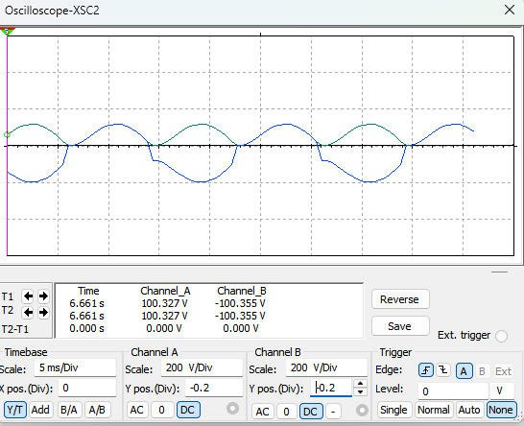
Fig. 2.3(d): Full-wave bridge rectifier with load R=1 kΩ,L=1H.ㅤㅤㅤFig. 2.3(e): $V_{in}$ and $V_{o}$ waveforms.ㅤㅤㅤ ㅤFig. 2.3(f): $I_{o}$ and $I_{s}$ waveforms.
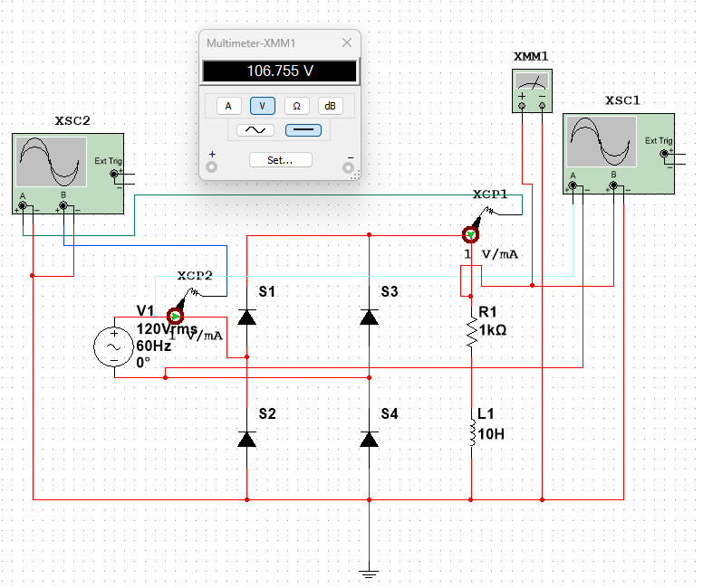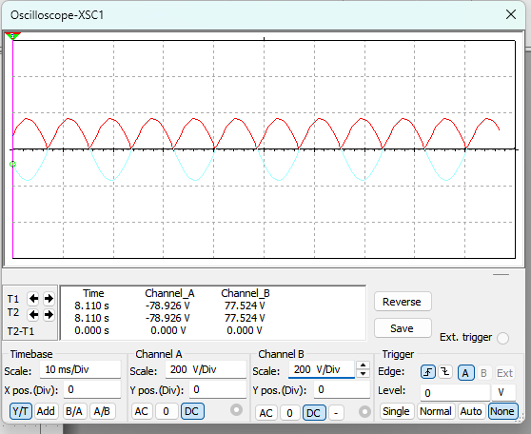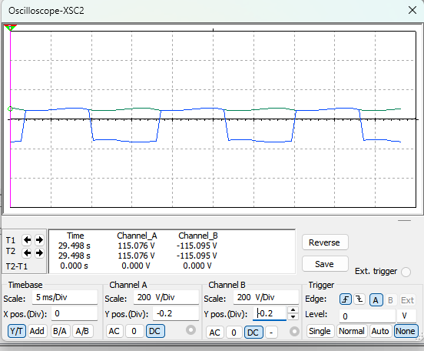
Fig. 2.3(g): Full-wave bridge rectifier with load R=1 kΩ,L=10 H.ㅤㅤㅤFig. 2.3(h): $V_{in}$ and $V_{o}$ waveforms.ㅤㅤㅤ ㅤFig. 2.3(i): $I_{o}$ and $I_{s}$ waveforms
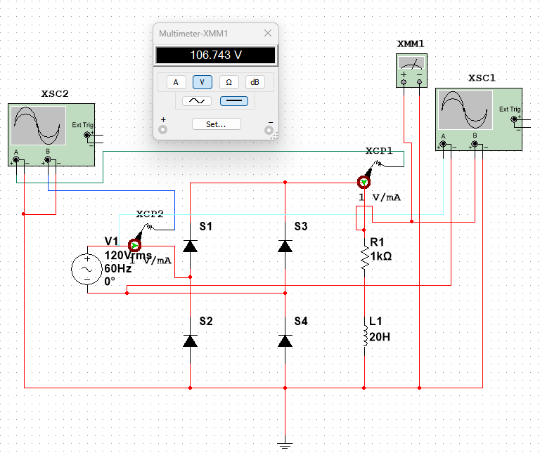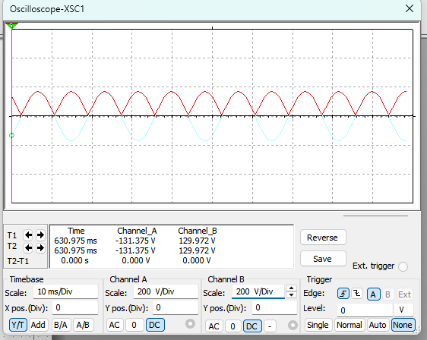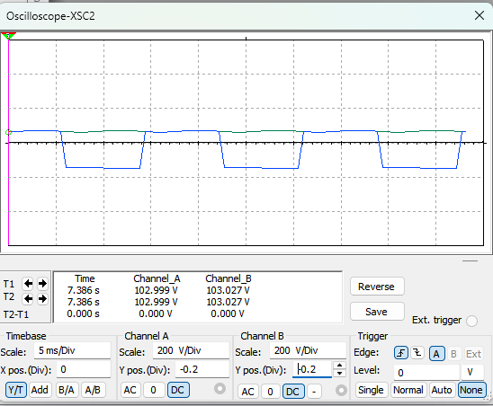
Fig. 2.3(j): Full-wave bridge rectifier with load R=1 kΩ,L=20 H.ㅤFig. 2.3(k): $V_{in}$ and $V_{o}$ waveforms.ㅤㅤㅤㅤFig. 2.3(l): $I_{o}$ and $I_{s}$ waveforms

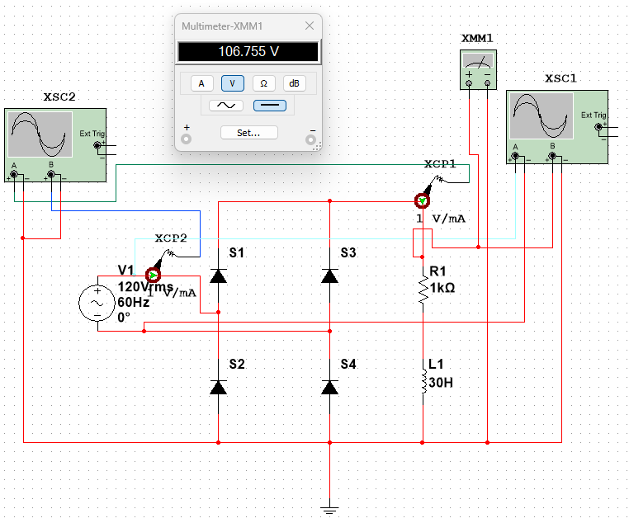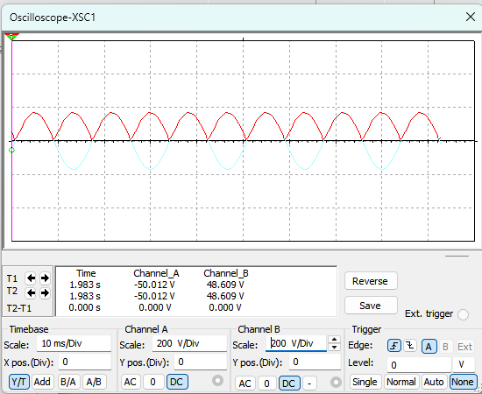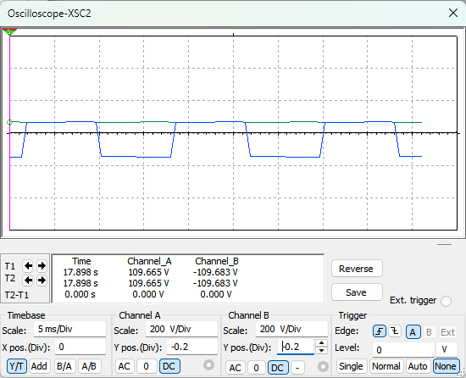
Fig. 2.3(m): Full-wave bridge rectifier with load R=1 kΩ,L=30H.ㅤFig. 2.3(n): $V_{in}$ and $V_{o}$ wavefor ㅤㅤㅤFig. 2.3(o): $I_{o}$ and $I_{s}$ waveforms
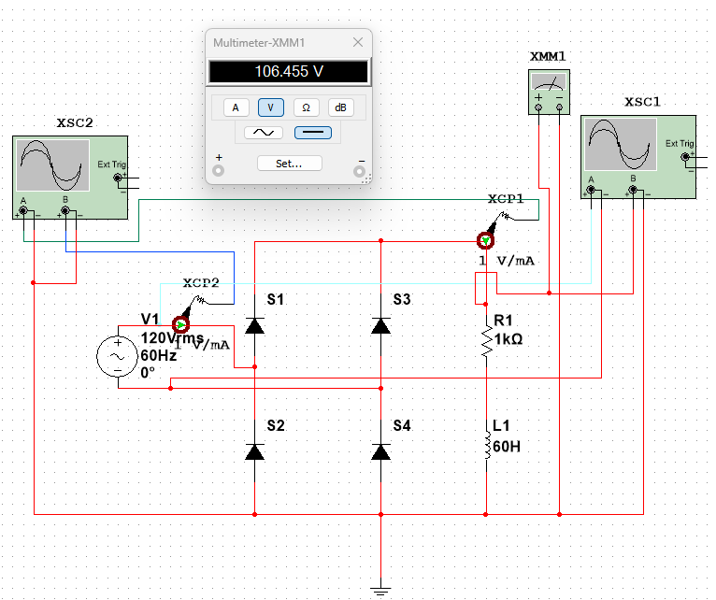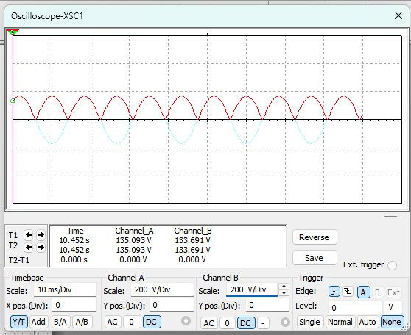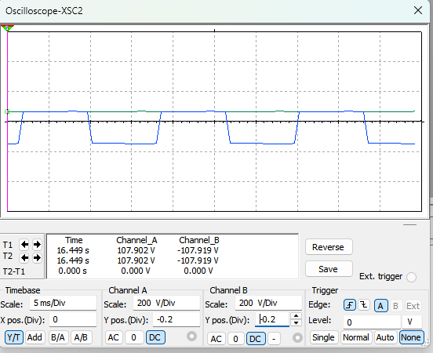
Fig. 2.3(p): Full-wave bridge rectifier with load R=1 kΩ,L=60H.ㅤㅤㅤFig. 2.3(q): $V_{in}$ and $V_{o}$ waveforms.ㅤㅤㅤ ㅤㅤㅤFig. 2.3(r): $I_{o}$ and $I_{s}$ waveforms
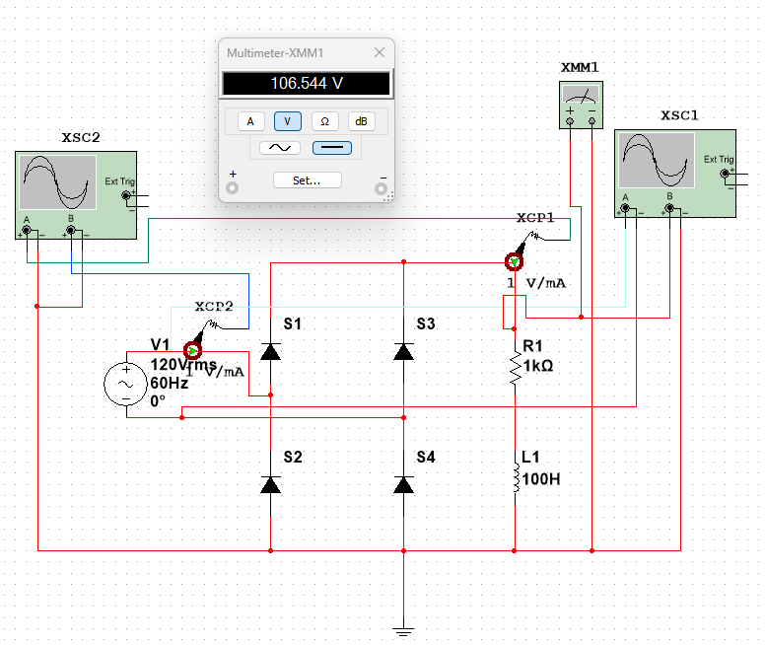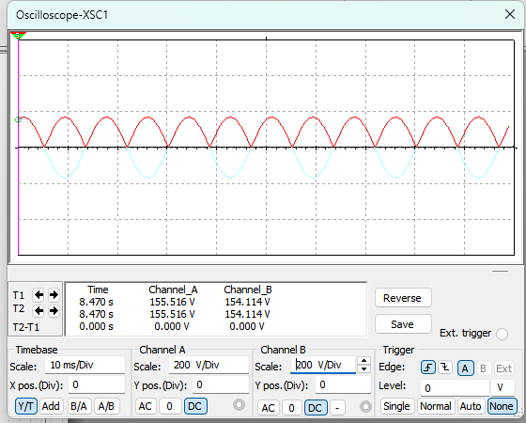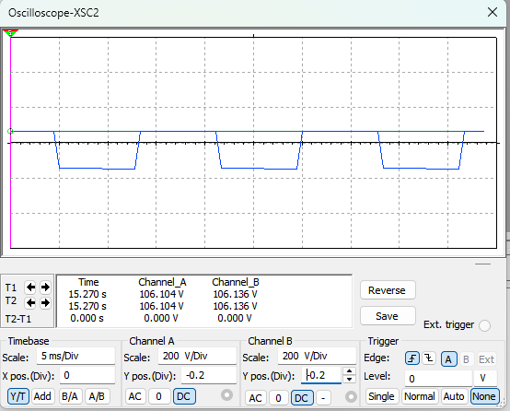
Fig. 2.3(s): Full-wave bridge rectifier with load R=1 kΩ,L=100 H.ㅤFig. 2.3(t): $V_{in}$ and $V_{o}$ waveforms.ㅤㅤㅤFig. 2.3(u): $I_{o}$ and $I_{s}$ waveforms

