1. Objective:
The objectives of this experiment are:
- To understand the concept of the Routh–Hurwitz stability criterion.
- To determine the stability of a system using the characteristic equation.
- To construct the Routh table for the given polynomial equation.
- To analyze the sign changes in the first column of the Routh table.
- To verify the theoretical stability result using MATLAB programming.
- To compare the theoretical calculation and computational result.
2. Apparatus / Utility Software:
The following tools and software were used in this experiment:
- Computer or Laptop
- MATLAB Software
- MATLAB Command Window
- Control System mathematical concepts
- Routh–Hurwitz stability criterion
3. Description of Task:
In this experiment, the stability of a system is determined using the Routh–Hurwitz stability criterion.
The characteristic equation depends on the last two digits of the student ID.
Student ID = ET231096
Last two digits = 96
Since 96 is an even number, the following characteristic equation is used:

${ID s}^{4}+({ID-1)s}^{3}+({ID-2)s}^{2}+ \left(ID-3\right)s+(ID-4) =0$

Substituting ID = 96, we obtain:
${96s}^{4}+{95s}^{3}+{94s}^{2}+93s+92=0$
Now the coefficients of the polynomial are:
96, 95, 94, 93, 92
Complete Routh Table

Power of s | Column 1 | Column 2 | Column 3
S⁴ | 96 | 94 | 92
S³ | 95 | 93 | 0
S² | 0.02105 | 92 | 0
S¹ | Negative | 0 | 0
S⁰ | 92 | 0 | 0
4. MATLAB code & Result:
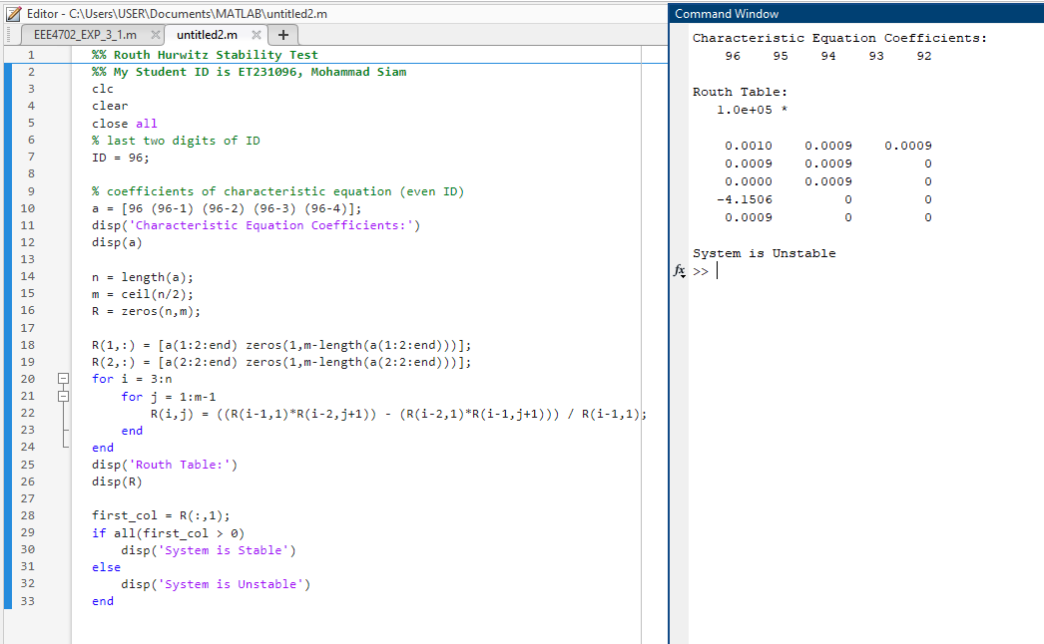

5. Analysis of Each Output:

- First, MATLAB displays the coefficients of the characteristic equation. These coefficients are derived from the student ID value which is 96.
- Next, MATLAB generates the Routh table using the determinant formula. The first two rows are created directly from the coefficients of the polynomial equation.Then, MATLAB calculates the remaining rows using the standard Routh–Hurwitz formula. Each element is obtained from the previous two rows of the table.
- After constructing the Routh table, MATLAB examines the first column values. According to the Routh–Hurwitz stability theorem, the number of sign changes in the first column indicates the number of roots located in the right half of the s-plane.In this case, the first column contains both positive and negative values. Therefore, a sign change occurs, which means that at least one root lies in the right half of the complex plane.
Because of this sign change, the system is not stable.
6. Discussion
In this experiment, the stability of a system was analyzed using the Routh–Hurwitz stability criterion. The characteristic equation was formed based on the last two digits of the student ID number. Since the ID value was even, the fourth-order polynomial equation was used. The Routh table was constructed both theoretically and by using MATLAB. From the theoretical calculation, it was observed that the first column of the Routh table contained a sign change. According to the Routh–Hurwitz theorem, the presence of a sign change indicates that some of the system poles lie in the right half of the complex plane. This means that the system is unstable. The MATLAB program also produced the same result, which confirms the theoretical analysis. Therefore, it can be concluded that the Routh–Hurwitz criterion is an effective method for determining the stability of linear control systems.

