MATLAB Representation of EXP:5
TASK :1
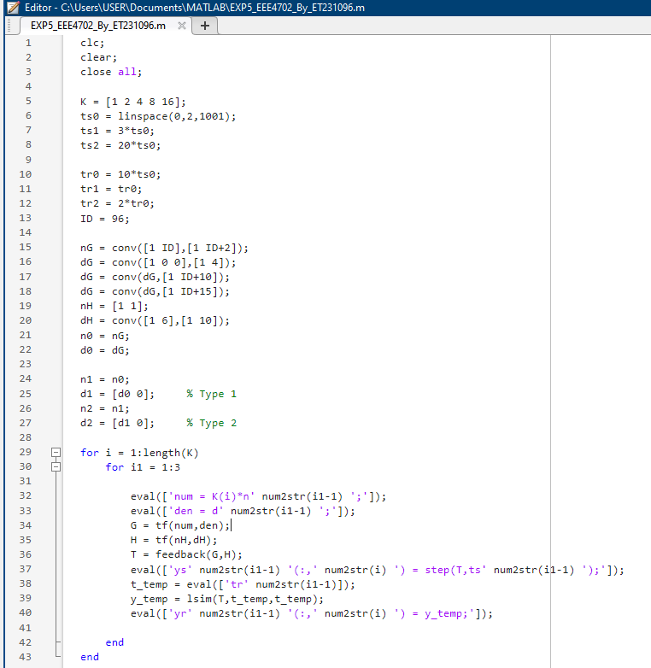
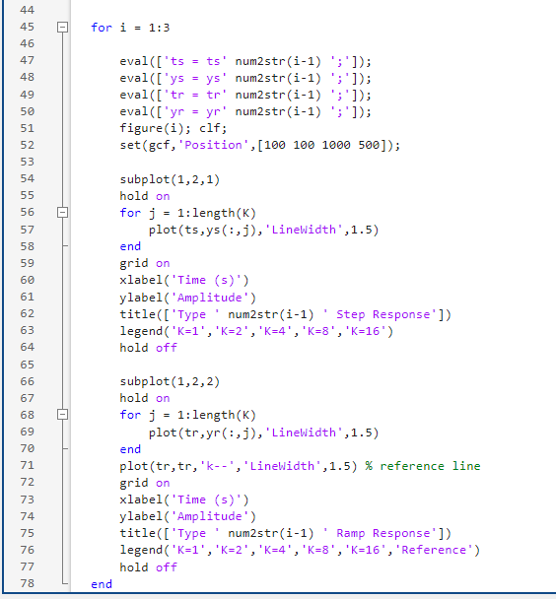
Fig 4.1 Steady State error Analysis using MATLAB Code task 1
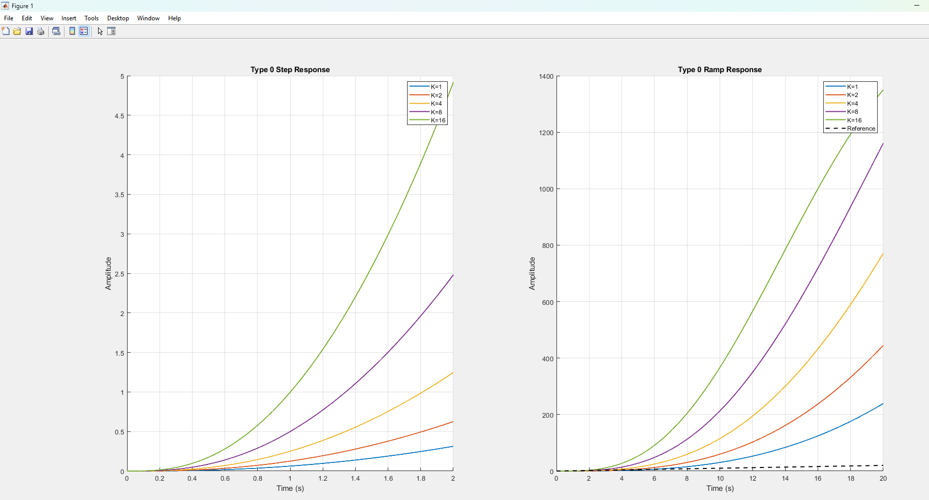
Fig 4.2 Step Response and Ramp Response Characteristics of Type 0
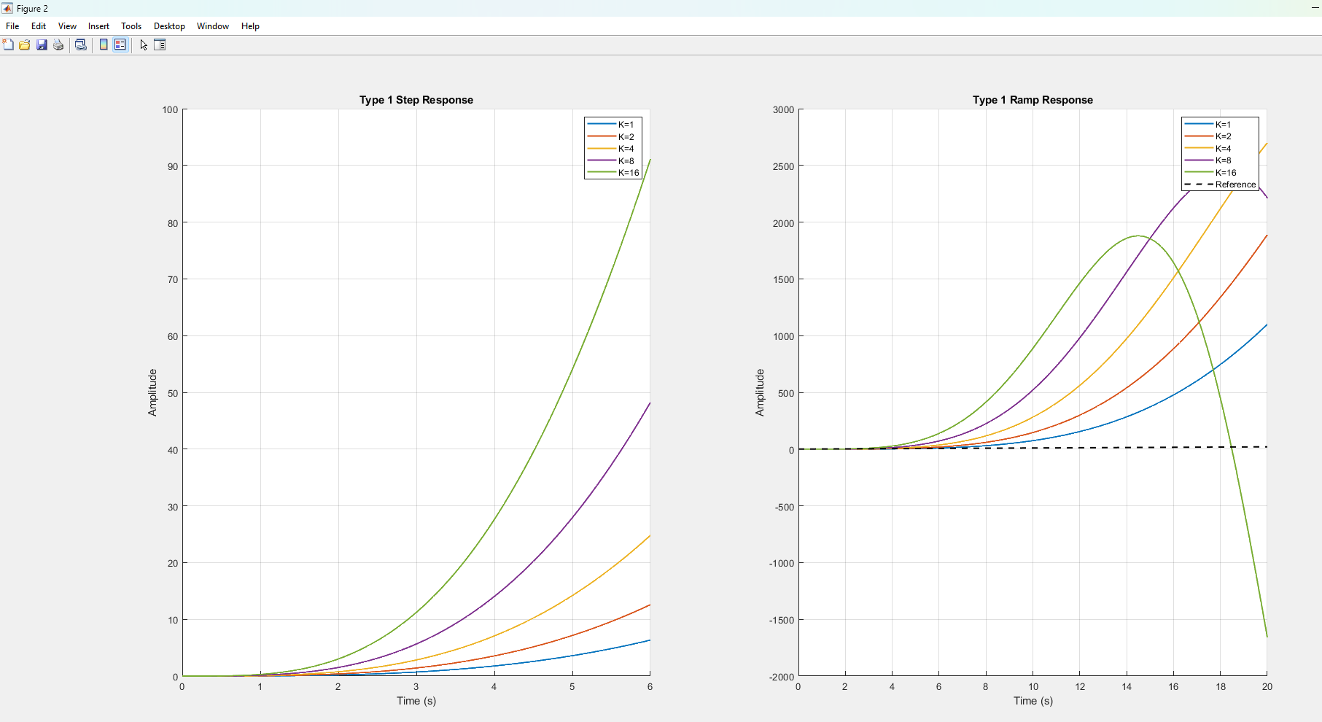
Fig 4.3 Step Response and Ramp Response Characteristics of Type 1
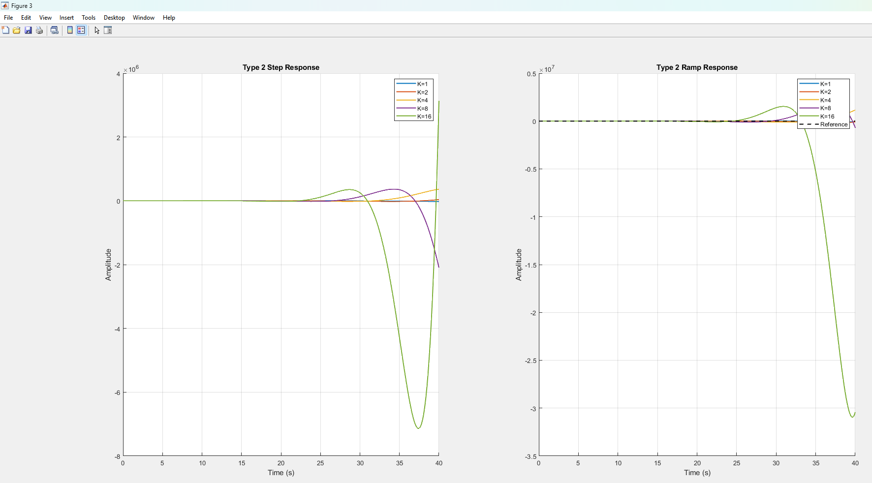
Fig 4.4 Step Response and Ramp Response Characteristics of Type 2

TASK 2
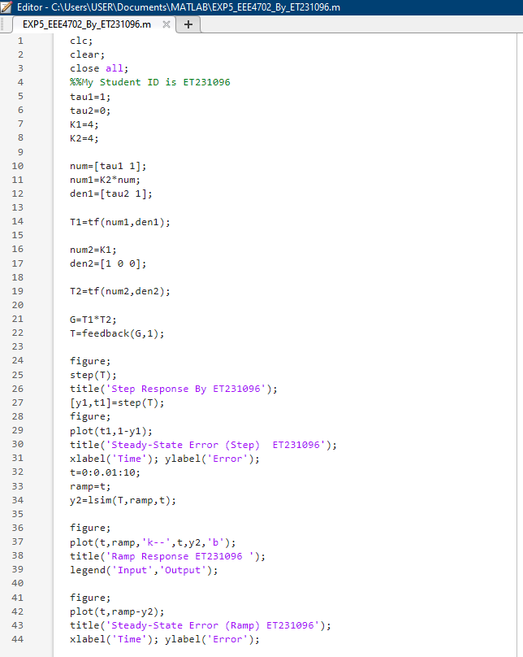
Fig 5.5 Steady State error Analysis using MATLAB code task 2
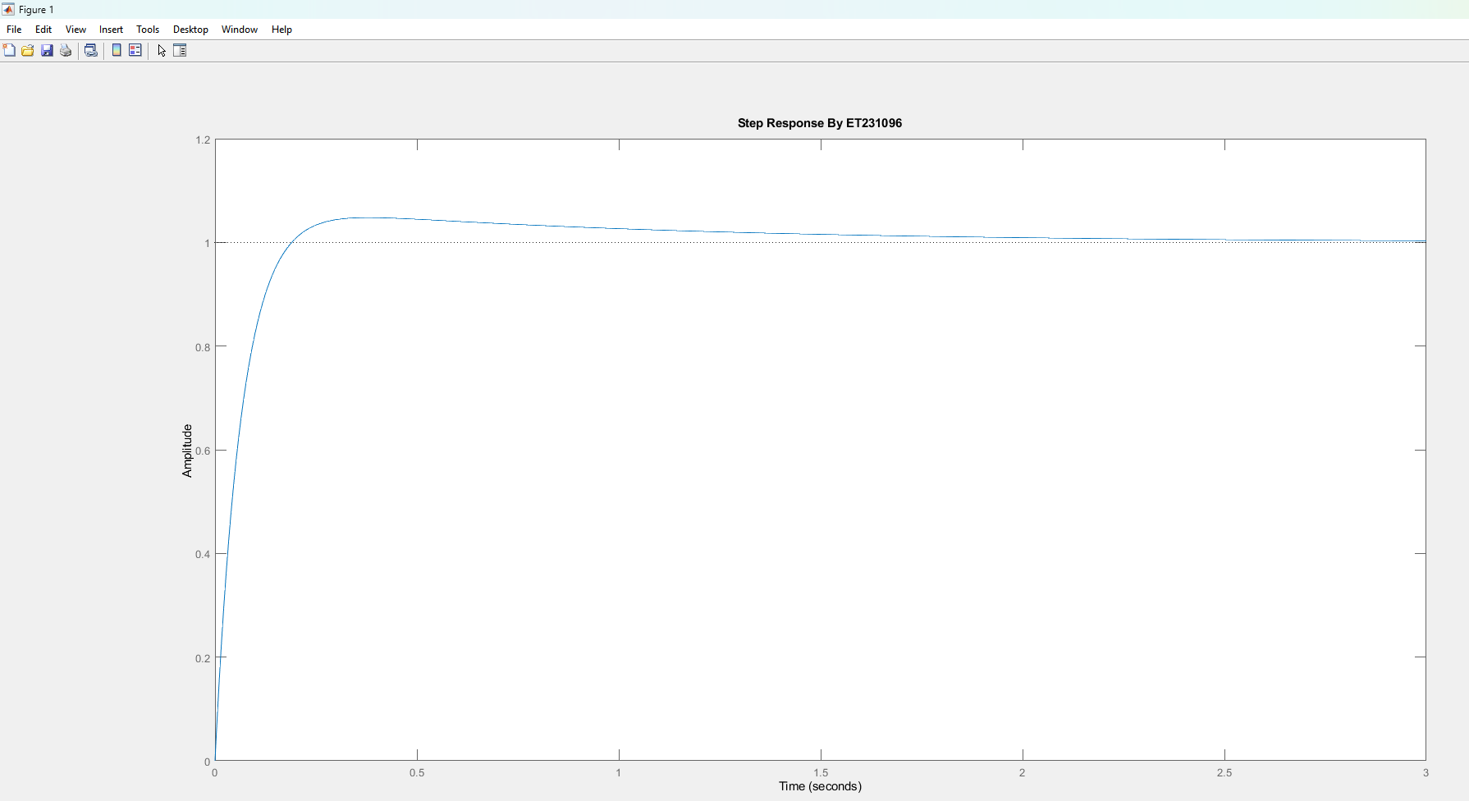
Fig 5.6 Step Response Characteristics

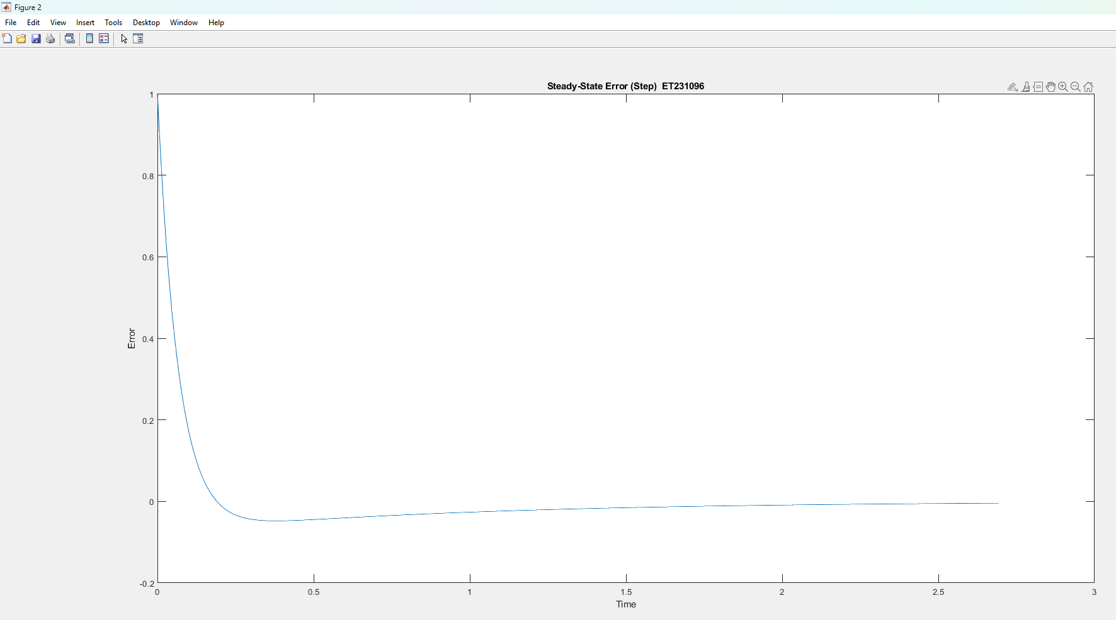
Fig 5.7 Steady state error Waveform
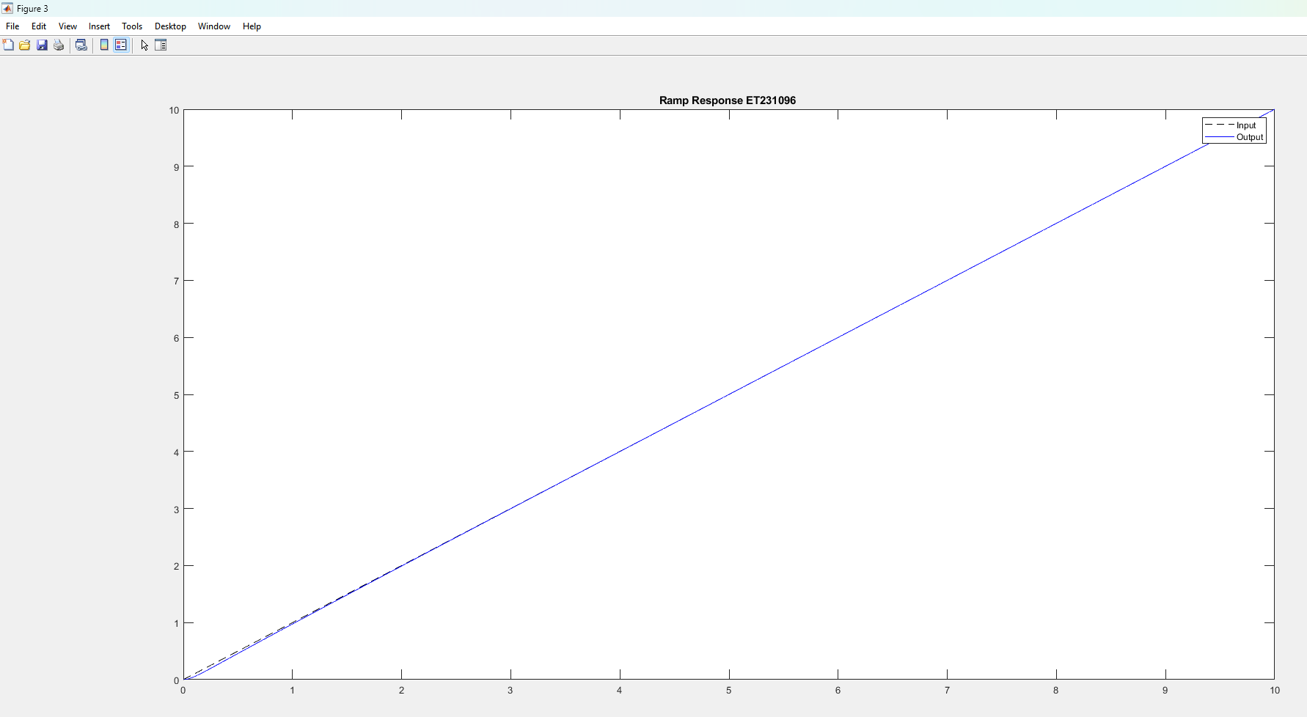
Fig 5.8 Ramp Response Waveform
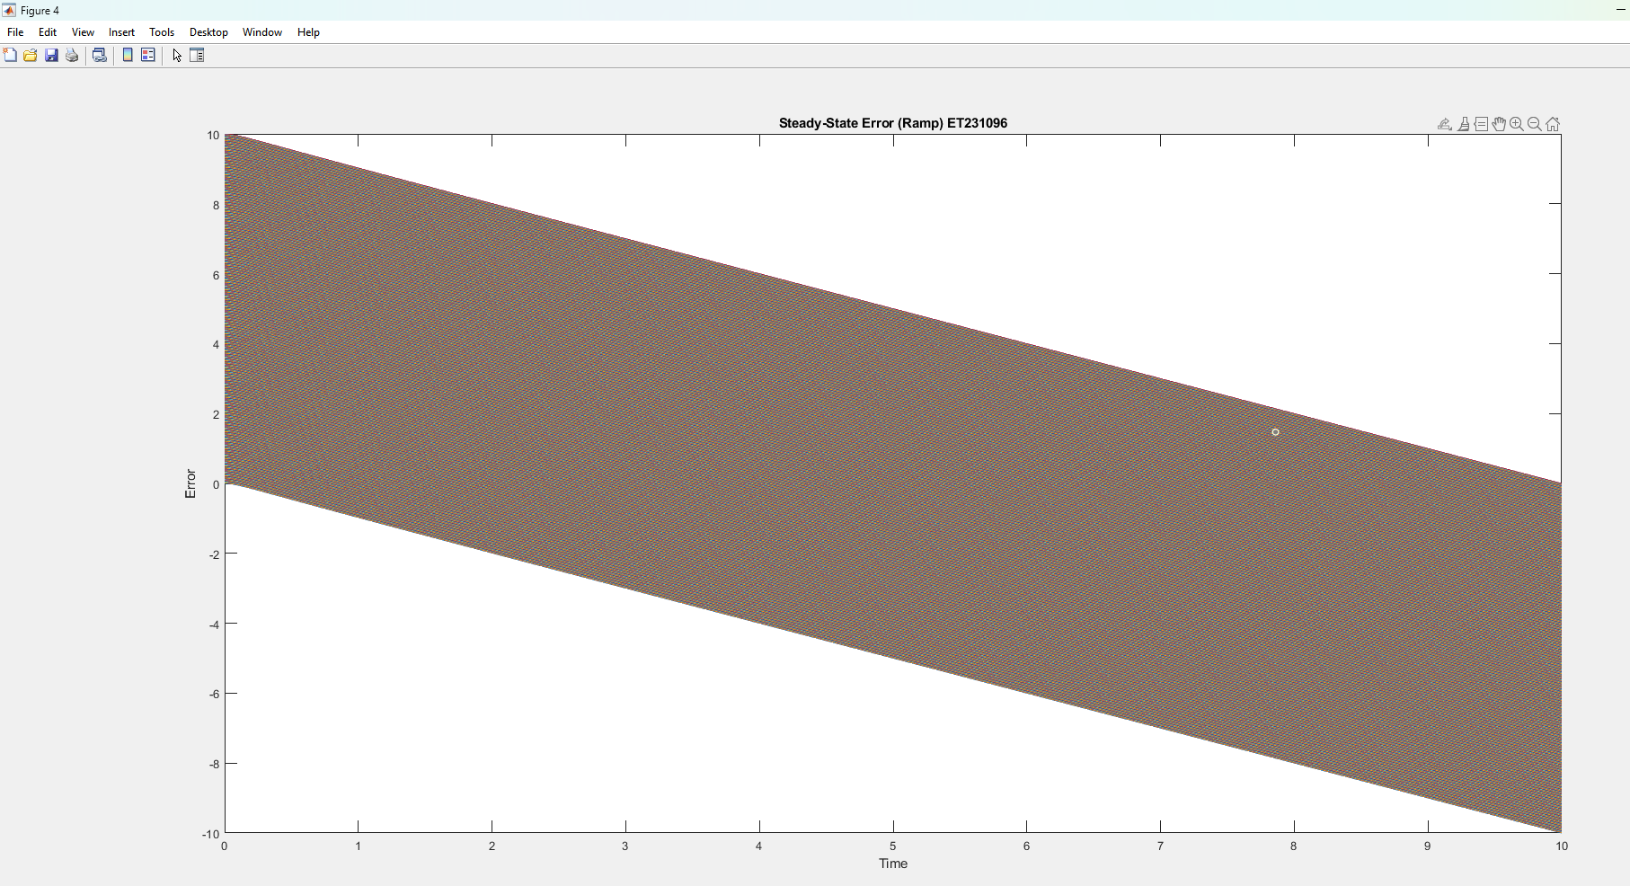
Fig 5.9 Steady state error (Ramp) Waveform

