Multisim Simulation:
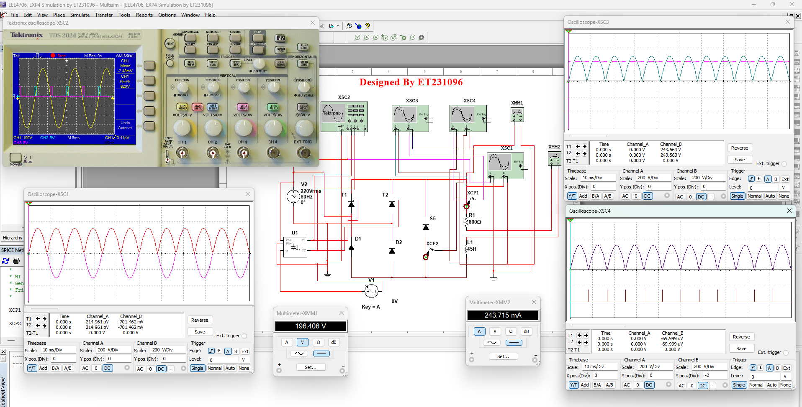
Fig. 4.4(a): Circuit diagram and output waveform of single-phase semi-converter when $α=0$. XSC1:$V_{in} Vs V_{o}$ Characteristics, XSC2: $V_{in}$ vs integrating signal Characteristics, XSC3: $V_{o} Vs I_{o}$ Characteristics, XSC4: $V_{o} Vs I_{Dm}$ Characteristics.
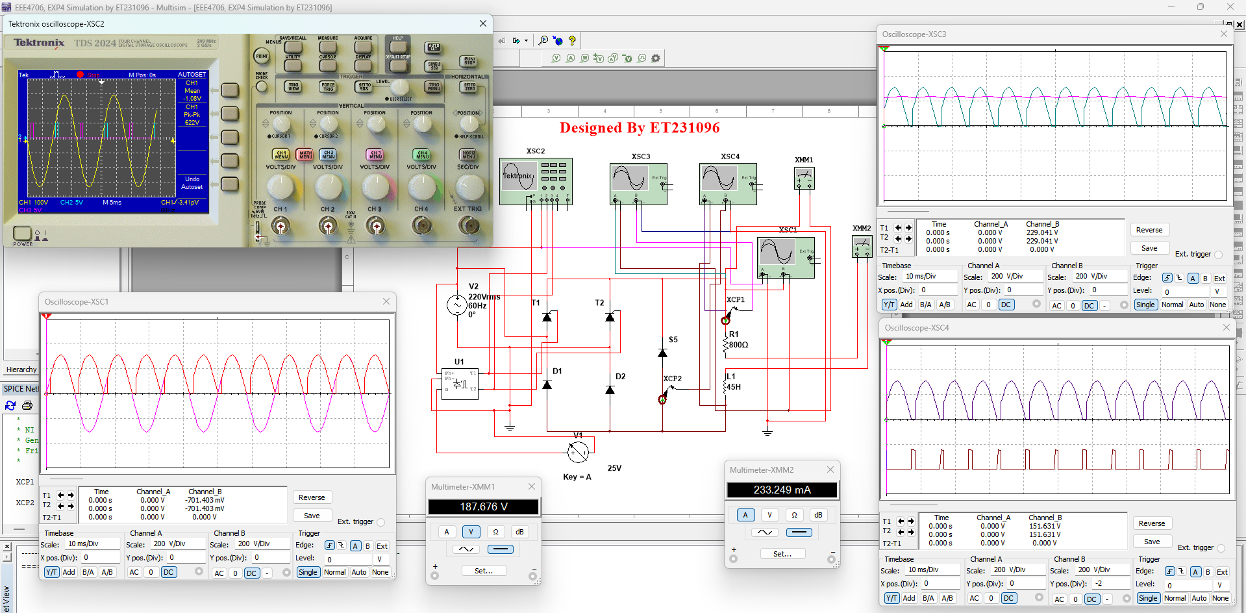
Fig. 4.4(b): Circuit diagram and output waveform of single-phase semi-converter $α=25$ . XSC1:$V_{in} Vs V_{o}$ Characteristics, XSC2: $V_{in}$ vs integrating signal Characteristics, XSC3: $V_{o} Vs I_{o}$ Characteristics, XSC4: $V_{o} Vs I_{Dm}$ Characteristics.
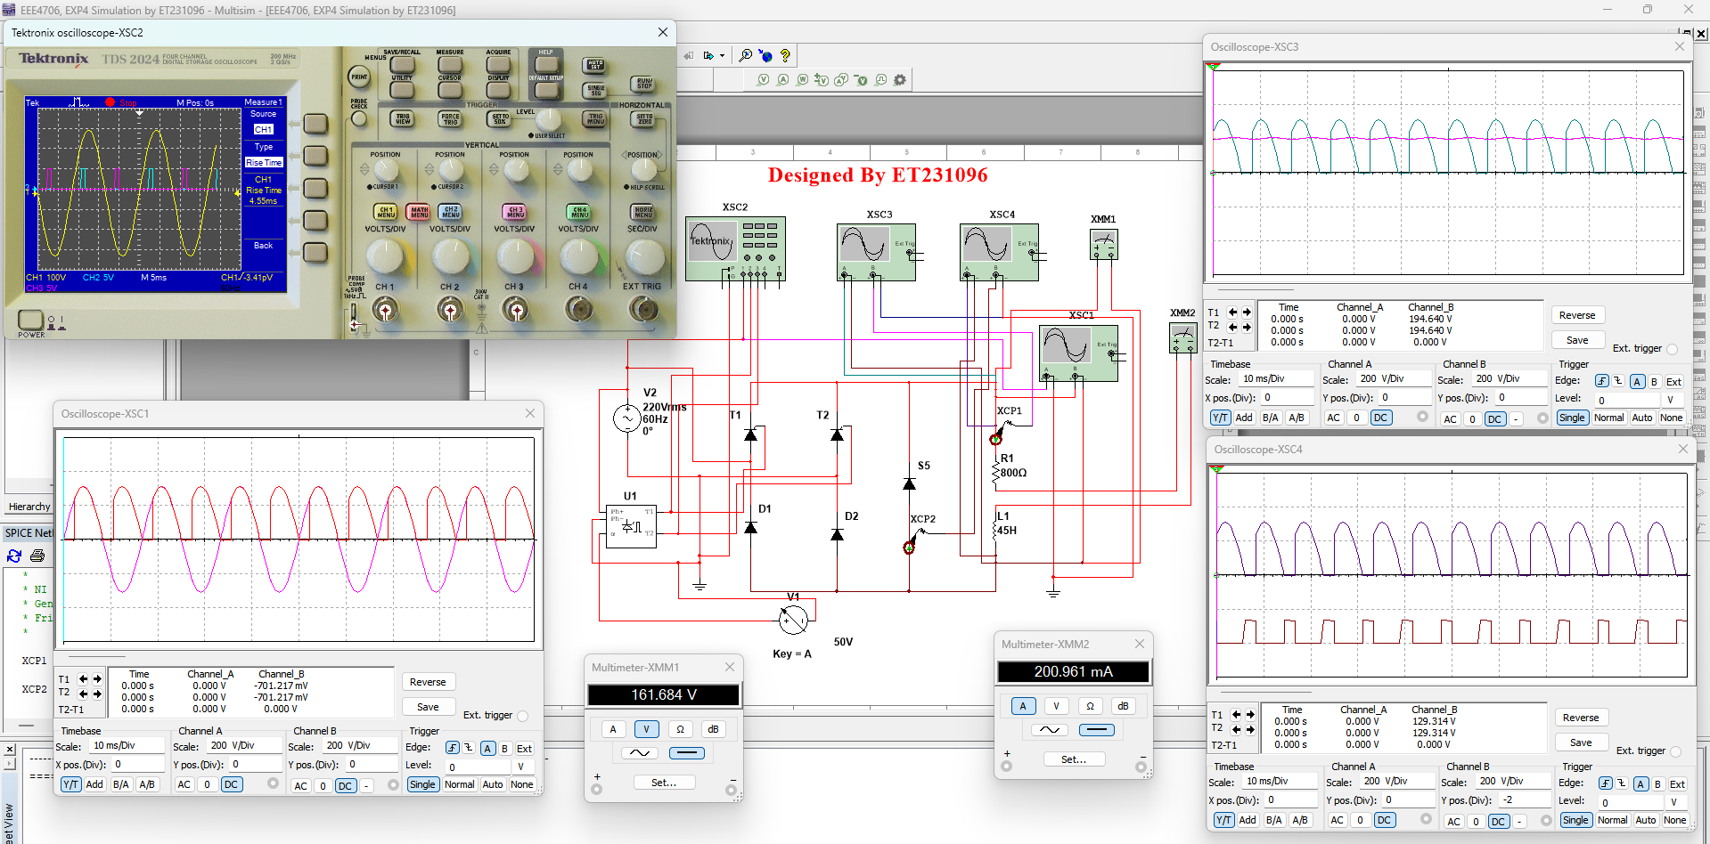
Fig. 4.4(c): Circuit diagram and output waveform of single-phase semi-converter $α=50$ . XSC1:$V_{in} Vs V_{o}$ Characteristics, XSC2: $V_{in}$ vs integrating signal Characteristics, XSC3: $V_{o} Vs I_{o}$ Characteristics, XSC4: $V_{o} Vs I_{Dm}$ Characteristics.
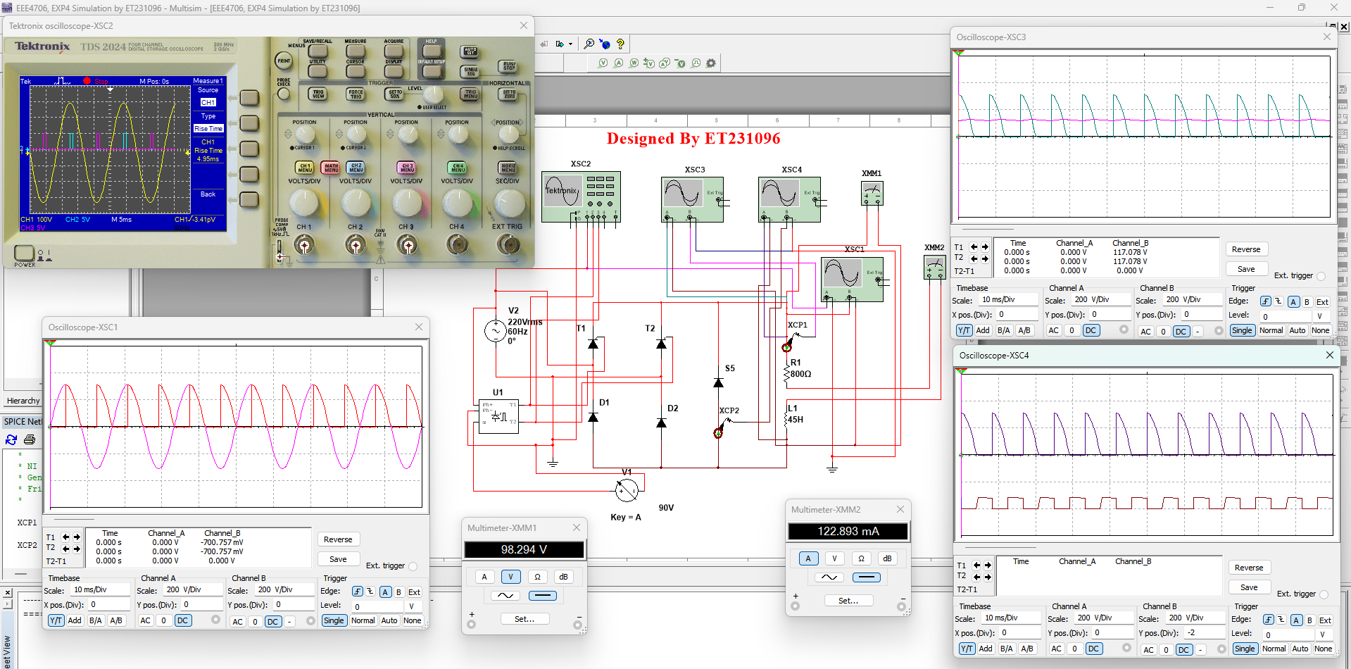
Fig. 4.4(d): Circuit diagram and output waveform of single-phase semi-converter $α=90$ . XSC1:$V_{in} Vs V_{o}$ Characteristics, XSC2: $V_{in}$ vs integrating signal Characteristics, XSC3: $V_{o} Vs I_{o}$ Characteristics, XSC4: $V_{o} Vs I_{Dm}$ Characteristics.
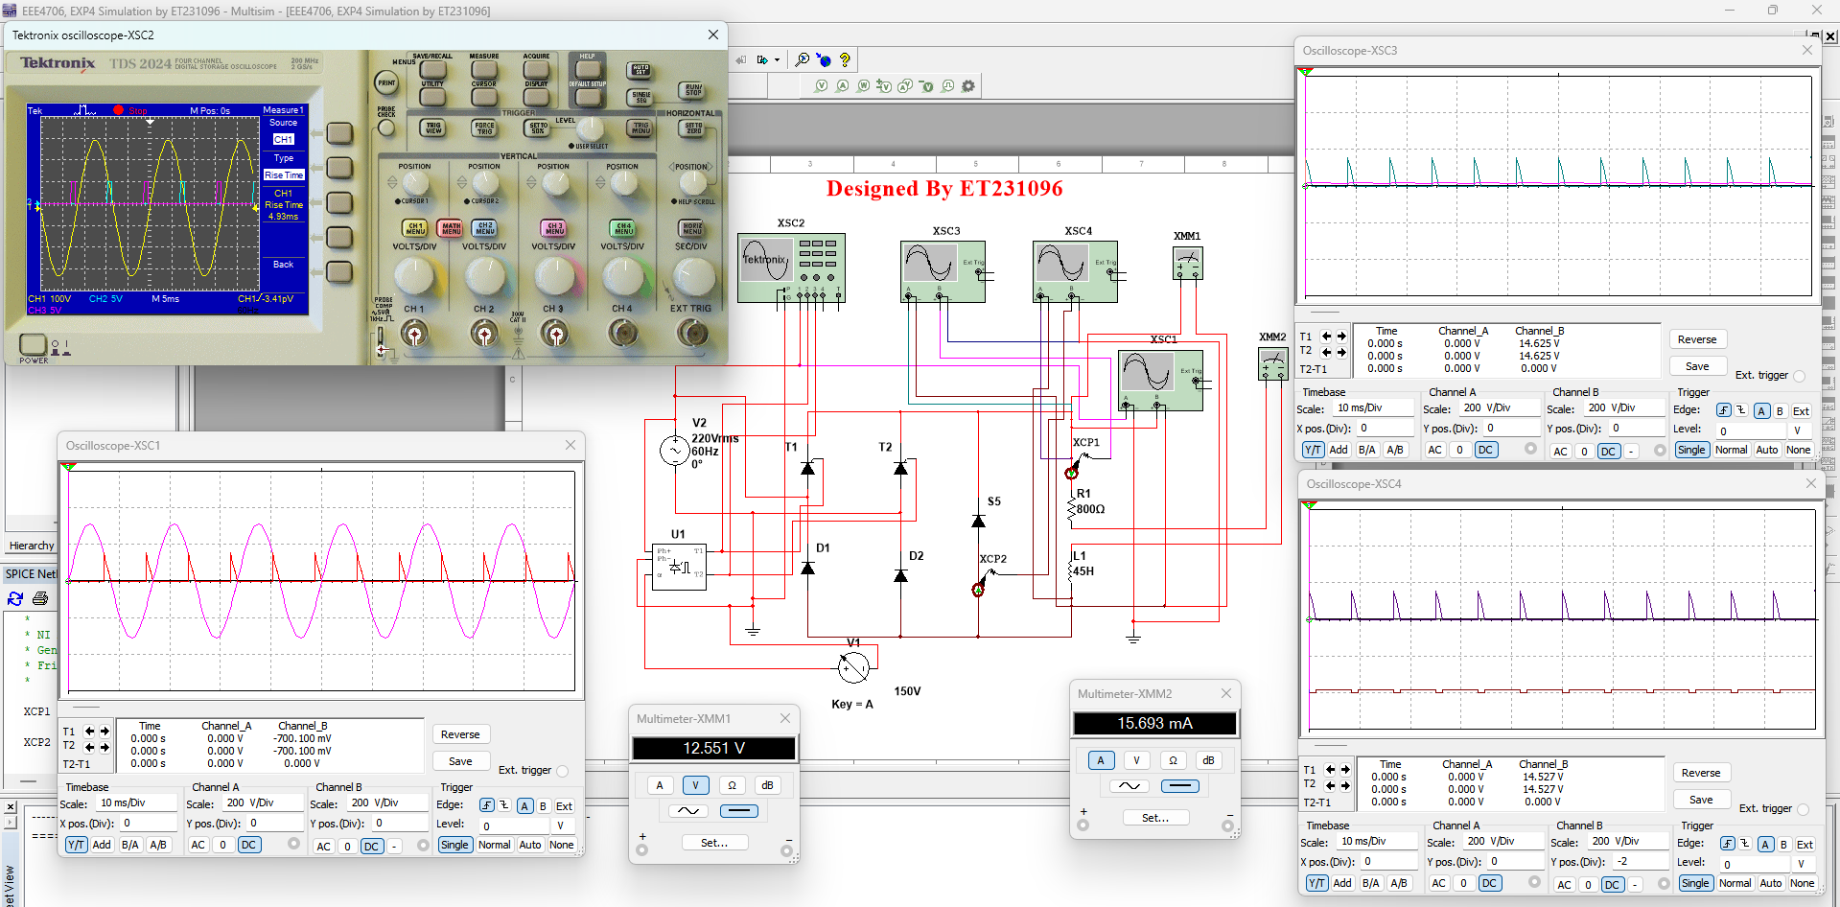
Fig. 4.4(e): Circuit diagram and output waveform of single-phase semi-converter $α=150$ . XSC1:$V_{in} Vs V_{o}$ Characteristics, XSC2: $V_{in}$ vs integrating signal Characteristics, XSC3: $V_{o} Vs I_{o}$ Characteristics, XSC4: $V_{o} Vs I_{Dm}$ Characteristics.
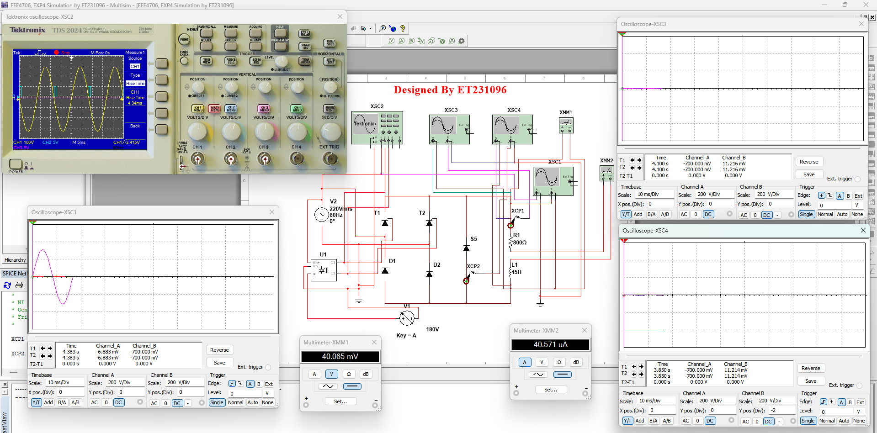
Fig. 4.4(f): Circuit diagram and output waveform of single-phase semi-converter $α=180$ . XSC1:$V_{in} Vs V_{o}$ Characteristics, XSC2: $V_{in}$ vs integrating signal Characteristics, XSC3: $V_{o} Vs I_{o}$ Characteristics, XSC4: $V_{o} Vs I_{Dm}$ Characteristics.

