Activity03 : Log Analysis
Part I. Can you find people trying to break into the servers?
Answer the following questions and provide evidence with your answer.
Q1. How many hackers are trying to get access to our servers? And how many
attempts are there? Explain/define how you count distinct hackers.
Answer Number of distinct hackers = 185
Number of attempts = 33253
Method to count distinct hackers show in image below.
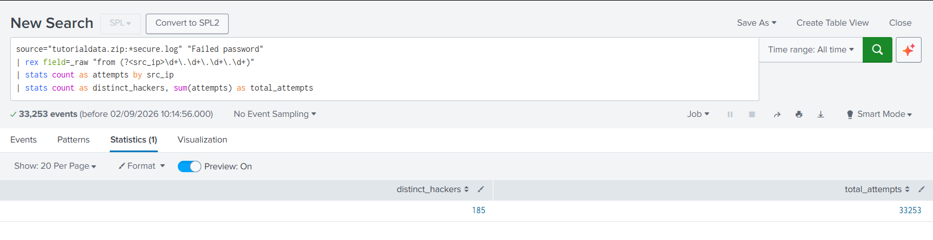
Q2. What time do hackers appear to try to hack our servers?
20:29
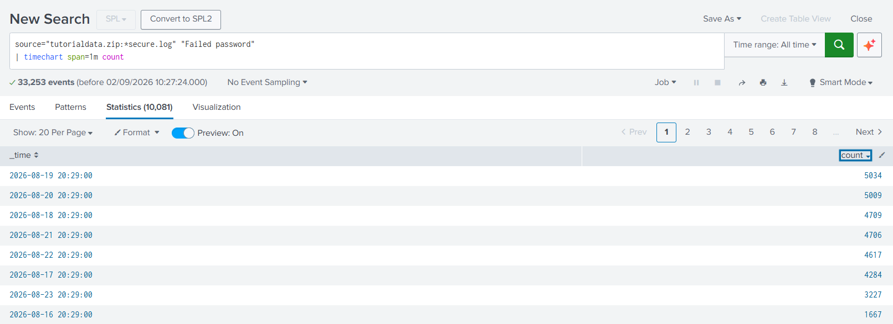
Q3. Which server (mailsv, www1, www2, www3) had the most attempts?
From the image below it shows that www1 had the most attempts.
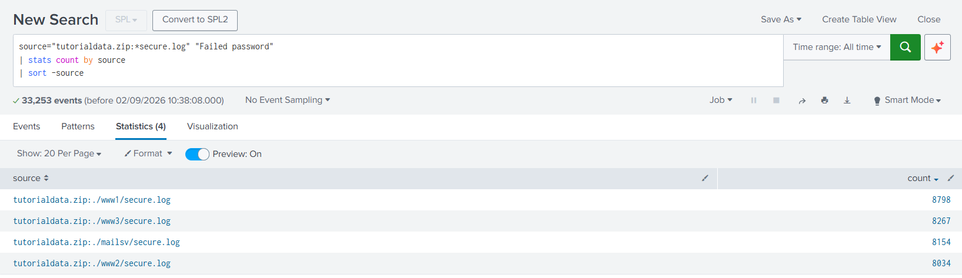

Q4. What is the most popular account that hackers use to try to break in?
root
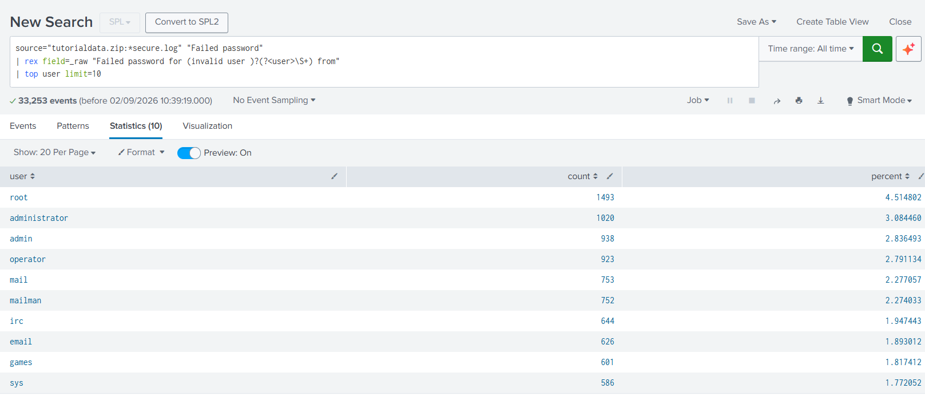

Part II. Sensitive Files on Web Servers
Q5. Can you find attempts to get access to sensitive information from our web
servers? How many attempts were there?
Yes. There are attempts to access potentially sensitive information on the web servers, as indicated by unusual HTTP status codes such as 403 (Forbidden), 404 (Not Found) in the access logs. Requests resulting in 403 suggest attempts to access restricted resources, while repeated 404 responses may indicate users or automated clients probing for files or directories that do not exist. The presence of these abnormal status codes, especially when associated with suspicious or sensitive-looking URLs, provides evidence of attempts to access potentially sensitive information.
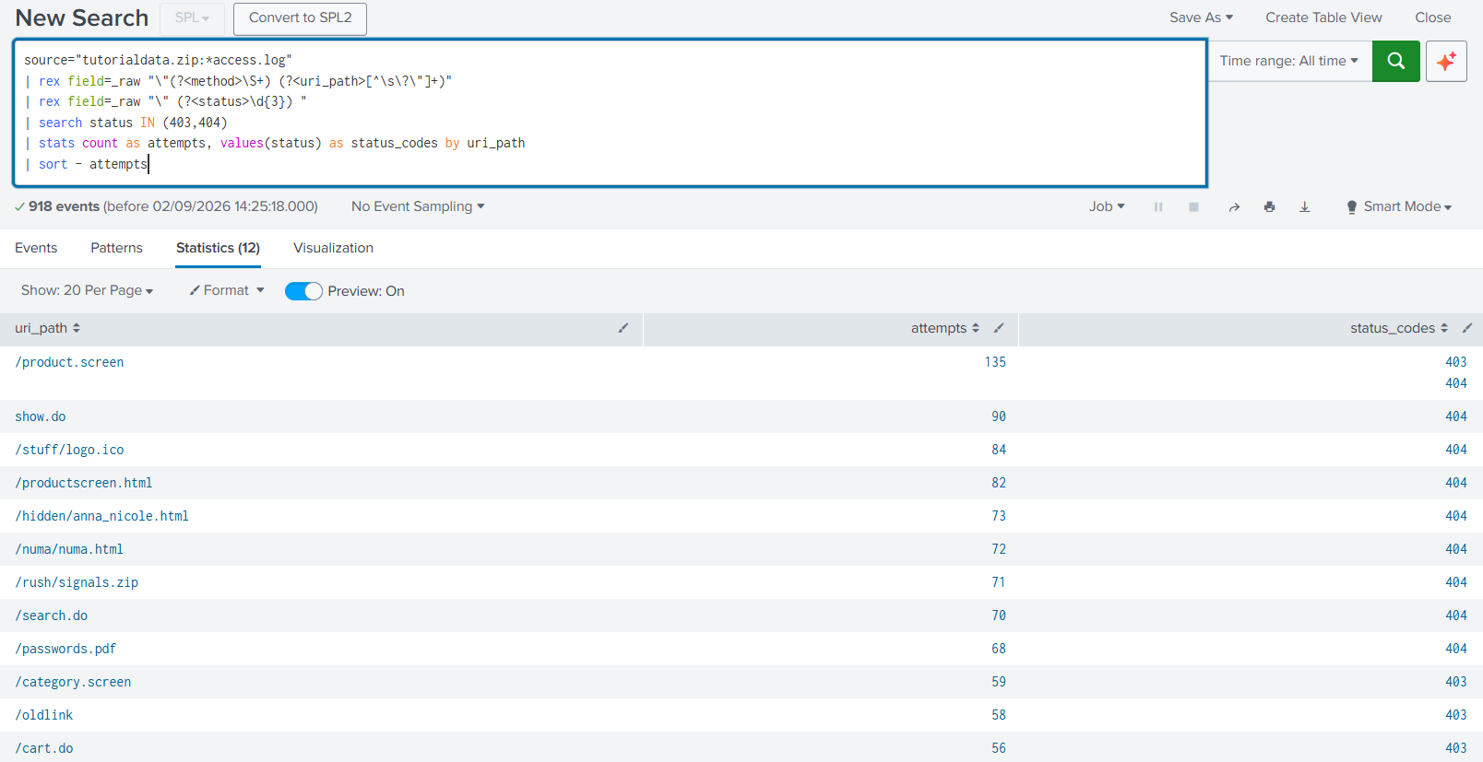

Q6. What resource/file are hackers looking for?
From Q5, you can see some sensitive files that hackers may be looking for. Such as
- /hidden/anna_nicole.html
- /numa/numa.html
- /rush/signals.zip
- /password.pdf
Part III. Are there bots crawling our websites?
Q7. Can you find any bots crawling our websites?
Yes, I query all user agent that including word “bot” and found this.
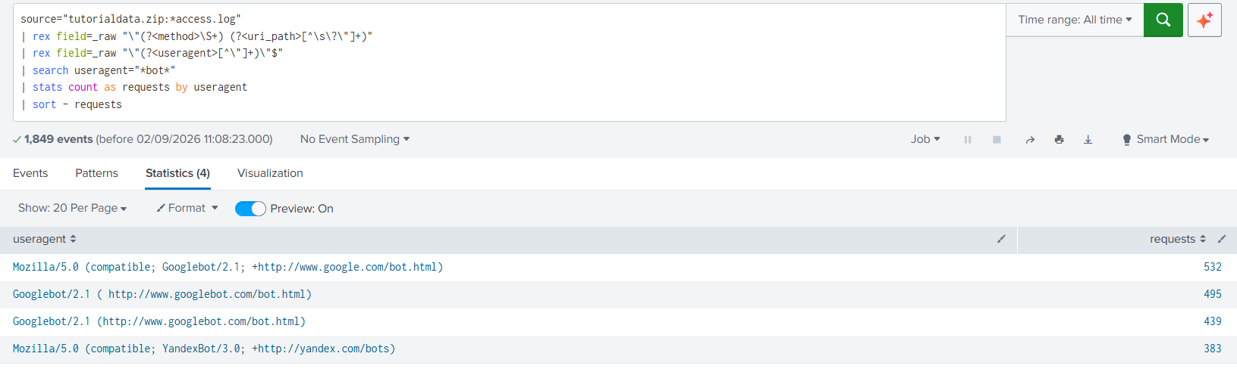

Q8. What are they doing on the site? (Hint: Look for User-Agent in the web
access.logs.)
The bots are crawling the website to collect information and build an index for search engines. Their User-Agent identifies them as automated crawlers, which systematically visit and retrieve web pages so that the content can be indexed and made searchable by users.
