1. Create MySql database named adta.[same as db.name inside “resources/config.properties” file]

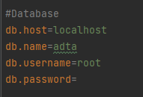

1. Load the .sql file to that database. [If multiple .sql file load the latest one]

|  |  |  |
| --- | --- | --- |
| Database File Name | GUI_IO_description_Rev | Project Version |
| adta_2024_06_11.sql | 18 | 1.0.31 |
|  |  |  |
|  |  |  |
|  |  |  |