**C.1 - Ratio of offers versus requests.**

*select 1.0*(select count(o) from Offer o)/count(r) from Request r;*



**C.2 - Average number of offers and request per customer**

*select avg(c.deals.size) from Customer c;*



**C.3 - Average number of applications per offer or request.**

*select avg(d.applies.size) from Deal d;*



**C.4 - The customer who has more applications accepted**

*select a.customer from ApplyFor a where a.status='ACCEPTED' group by a.customer having count(a)>=all(select count(a2) from ApplyFor a2 where a2.status='ACCEPTED' group by a2.customer);*

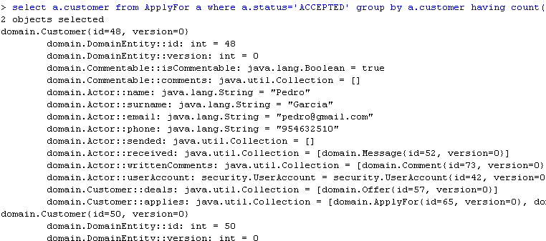

**C.5 - The customer who has more applications denied**

*select a.customer from ApplyFor a where a.status='DENIED' group by a.customer having count(a)>=all(select count(a2) from ApplyFor a2 where a2.status='DENIED' group by a2.customer);*

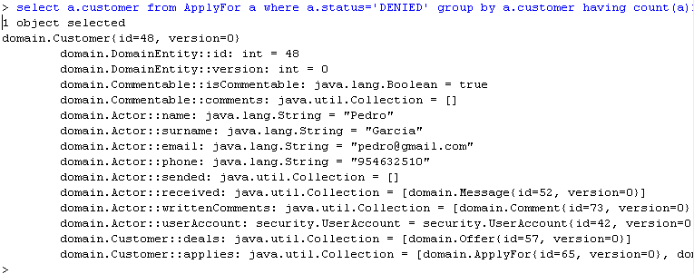

**B.1 - Average number of comments per actor, offer, or request**

*select avg(c.comments.size) from Commentable c;*



**B.2 - Average number of comments posted by administrators and customers**

*select avg(a.writtenComments.size) from Actor a;*



**B.3 - The actors who have posted ±10% the average number of comments per ac-tor.**

*select a from Actor a where a.writtenComments.size>=(select avg(a.writtenComments.size) from Actor a)*0.1;*

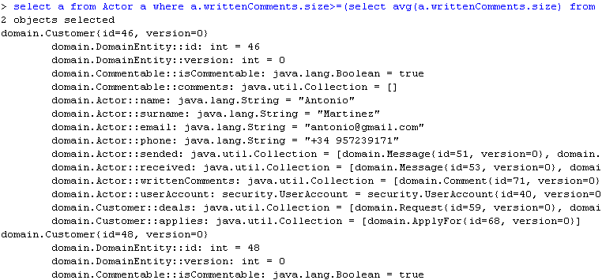

*select a from Actor a where a.writtenComments.size<=(select avg(a.writtenComments.size) from Actor a)*0.1;*

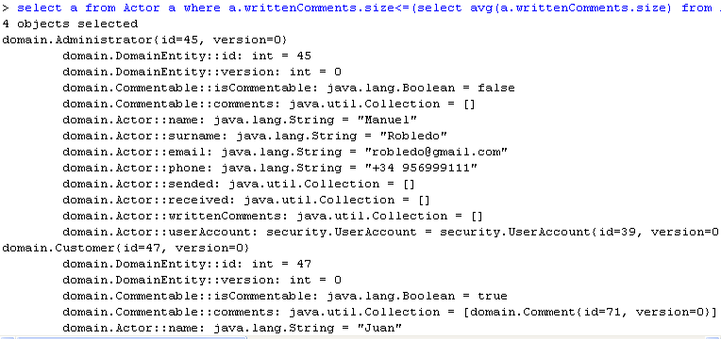

**A.1 - The minimum, the average, and the maximum number of messages sent per actor**

*select min(a.sended.size), avg(a.sended.size), max(a.sended.size) from Actor a;*



**A.2 - The minimum, the average, and the maximum number of messages received per actor**

*select min(a.received.size), avg(a.received.size), max(a.received.size) from Actor a;*



**A.3 - The actors who have sent more messages**

*select a from Actor a where a.sended.size=(select max(a2.sended.size) from Actor a2);*

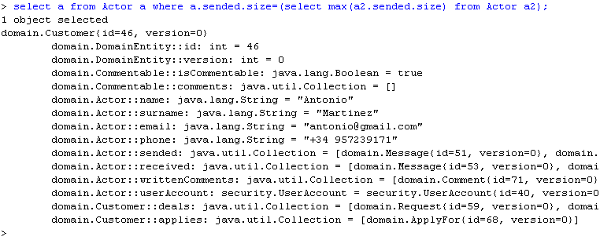

**A.4 - The actors who have got more messages**

*select a from Actor a where a.received.size=(select max(a2.received.size) from Actor a2);*

