Task completed:

| Date started | Date completed |
| --- | --- |
| 15/10/2018 | 18/04/2019 |

Analysis

Try and create 3 or more key success criteria for your program.

**Success Criteria:**

1. Gives the user a menu to view the rules and leaderboard.
2. Allows two players to enter their details, which are then authenticated to ensure that they are authorised players.
3. Allows each player to roll two 6-sided dice.
4. Calculates and outputs the points for each round and each player’s total score.
5. Allows the players to play 5 rounds.
6. If both players have the same score after 5 rounds, allows each player to roll 1 die each until someone wins.
7. Outputs who has won at the end of the 5 rounds.
8. Stores the winner’s score, and their name, in an external file.
9. Displays the score and player name of the top 5 winning scores from the external file.
10. Where appropriate, input from the user should be validated.

Design

* *You may like to create a flow chart which will show broadly how your program will work. If so include your flow chart in this section.*
* *You must create pseudocode for a part of your program (minimum of 15 lines)*

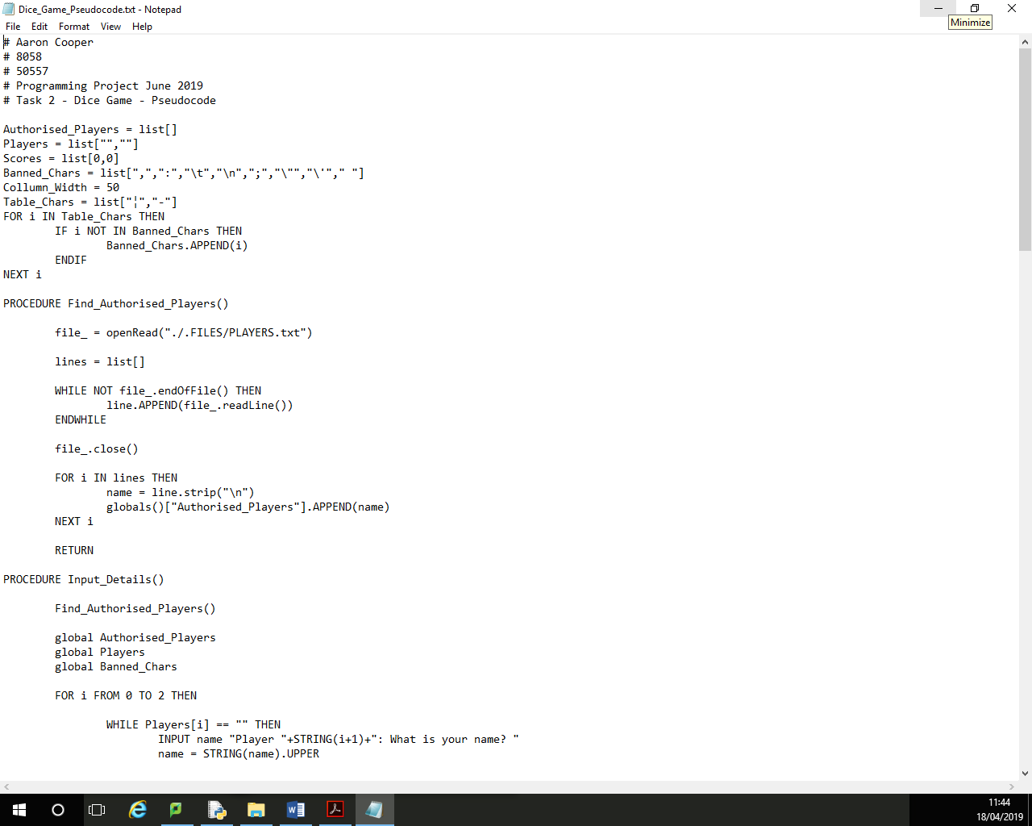  
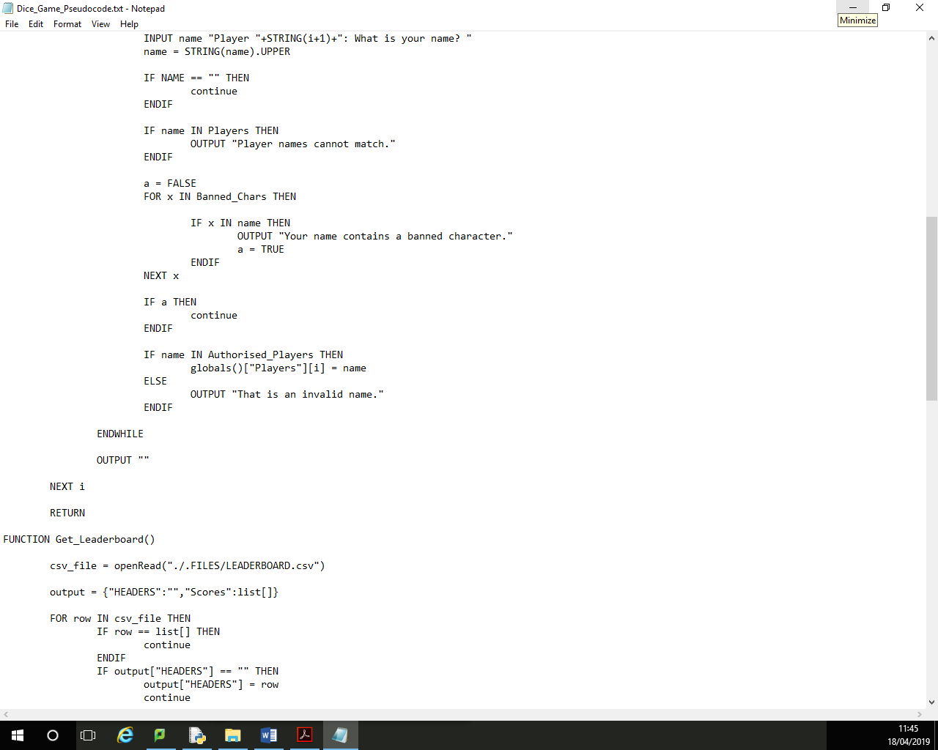  
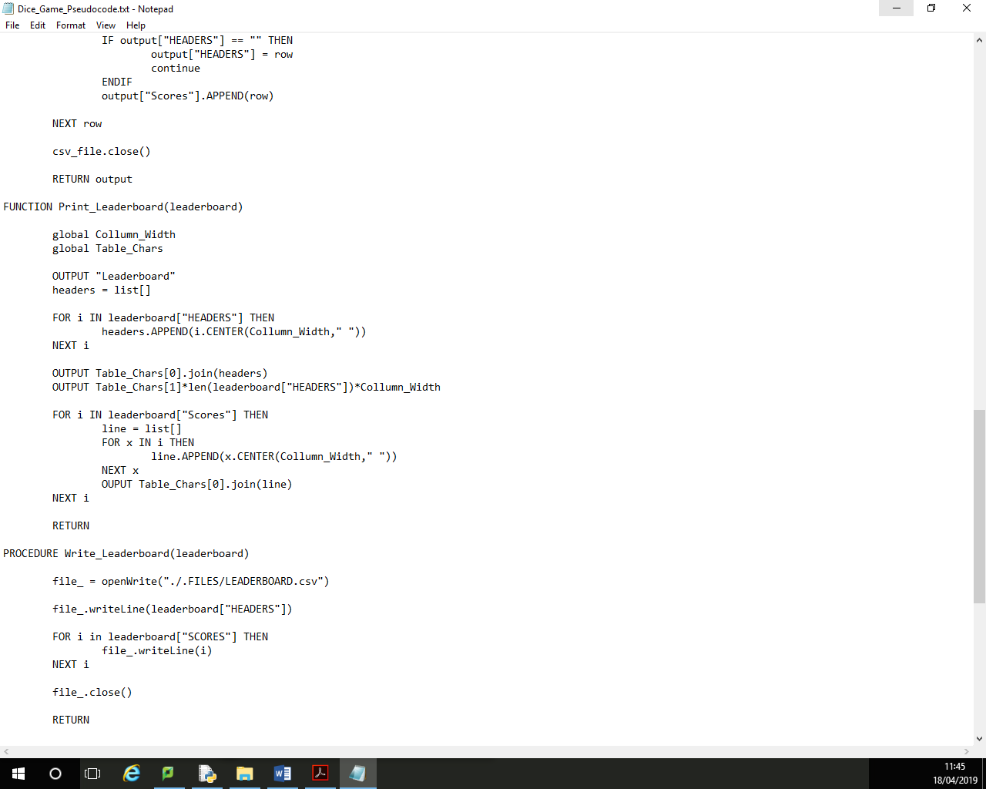  
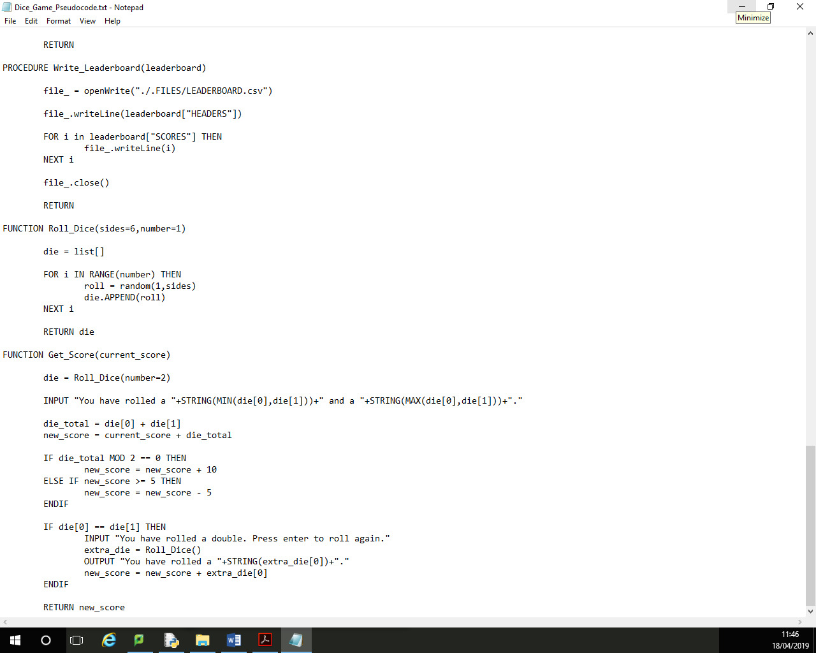

|  |  |  |  |  |  |  |  |  |  |
| --- | --- | --- | --- | --- | --- | --- | --- | --- | --- |
| Output | Input | Variables | | | | | | | |
| Players[0] | Players[1] | Die[0] | Round | Die[1] | Total | Score[0] | Score[1] |
| Player 1: What is your name? | Aaron | Aaron | N/A | N/A | N/A | N/A | N/A | N/A | N/A |
| Player 2: What is your name? | Bob | Aaron | Bob | N/A | N/A | N/A | N/A | N/A | N/A |
| Round 1: | [Enter] | Aaron | Bob | N/A | 1 | N/A | N/A | 0 | 0 |
| AARON, press enter to roll your dice. | [Enter] | Aaron | Bob | N/A | 1 | N/A | N/A | 0 | 0 |
| You have rolled a 3 and a 4. | [Enter] | Aaron | Bob | 3 | 1 | 4 | 7 | 2 | 0 |
| Your score is now 2.  BOB, press enter to roll your dice. | [Enter] | Aaron | Bob | N/A | 1 | N/A | N/A | 2 | 0 |
| You have rolled a 2 and a 3. | [Enter] | Aaron | Bob | 2 | 1 | 3 | 5 | 2 | 0 |
| Your score is now 0.  AARON, press enter to roll your dice. | [Enter] | Aaron | Bob | N/A | 2 | N/A | N/A | 2 | 0 |

|  |  |  |  |  |
| --- | --- | --- | --- | --- |
| Selections | | | | |
| Total % 2 == 0 | Die[0] == Die[1] | Round < 5 | Score[0] > Score[1] | Score[0] < Score[1] |
| N/A | N/A | N/A | N/A | N/A |
| N/A | N/A | N/A | N/A | N/A |
| N/A | N/A | True | False | False |
| N/A | N/A | True | False | False |
| False | False | True | True | False |
| N/A | N/A | True | False | False |
| False | False | True | True | False |

Task

Roll Dice

Players Input Details

Calculates Score

5 Rounds

Post-Game

Outputs winner

Store winner and score in an external file

Adds Dice

Checks if total is even or odd

Test design

* *Think of tests that you can carry out to see if your system works*
* *Remember to try and use normal, boundary and erroneous tests.*
* *If you wish to, you may add more tests to the table.*

**My tests:**

|  |  |  |  |  |
| --- | --- | --- | --- | --- |
| Test | What am I testing? | What data will I use? | Normal/Boundary/Erroneous? | Expected Result |
| 1 | Name Input | Aaron | Valid - Normal | Game continues and asks for second name |
| 2 | Name Input | David | Invalid - Normal | Game states that the name is invalid and asks for the name again |
| 3 | Name Input | ¦\’ | Invalid - Normal | Game states that the name contains a banned character and asks for the name again |
| 3 (Repeated After Change) | Name Input | ¦\’ | Invalid - Normal | Game states that the name contains a banned character and asks for the name again |
| 4 | Name Input | 123 | Invalid - Erroneous | Game states that the name is invalid and asks for the name again |

**My test screenshots:**

Development

* *Copy and paste your code into this section*
* *Remember to try and add comments to your code to make it more readable!*

**My program code:**

Development 1 – 18/10/2018  
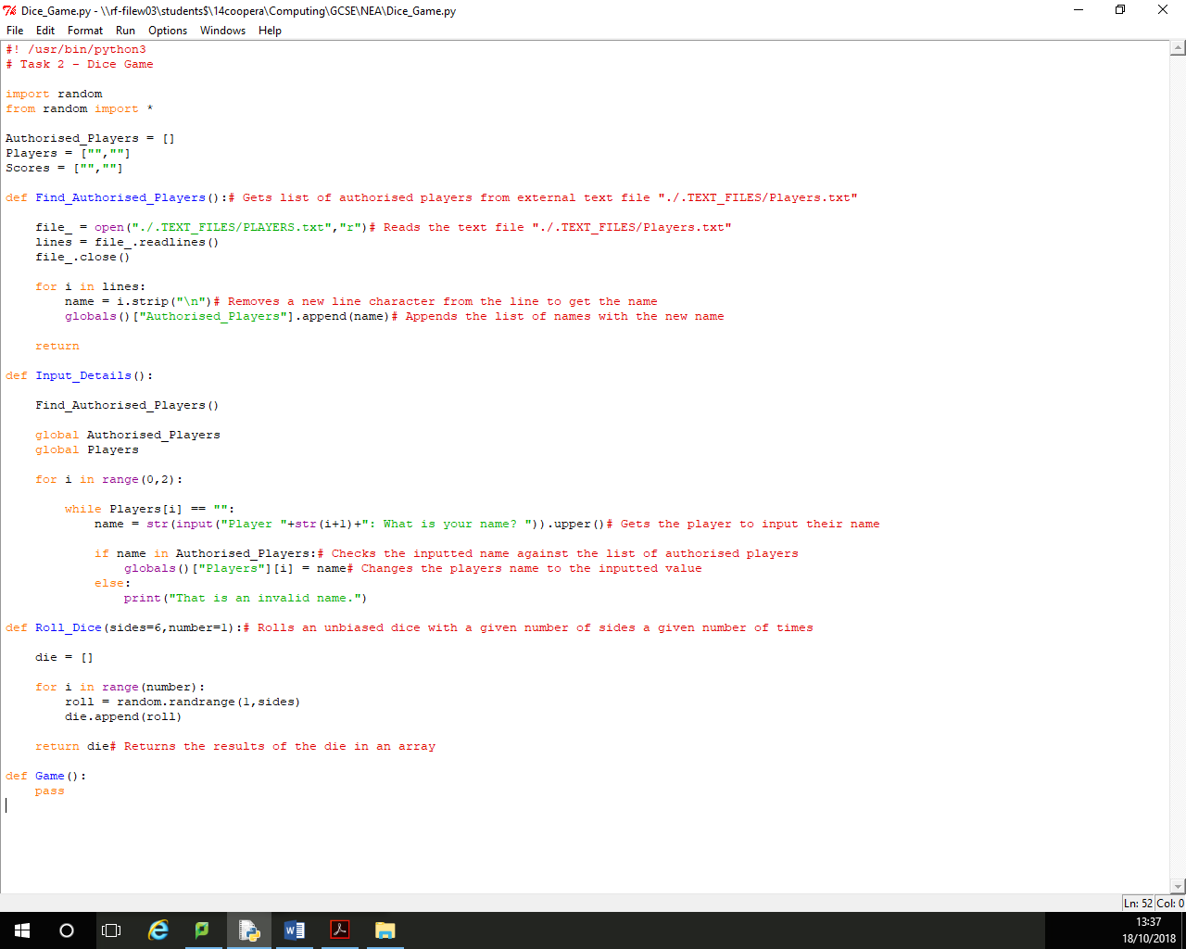

Development 2 – 23/10/2018  
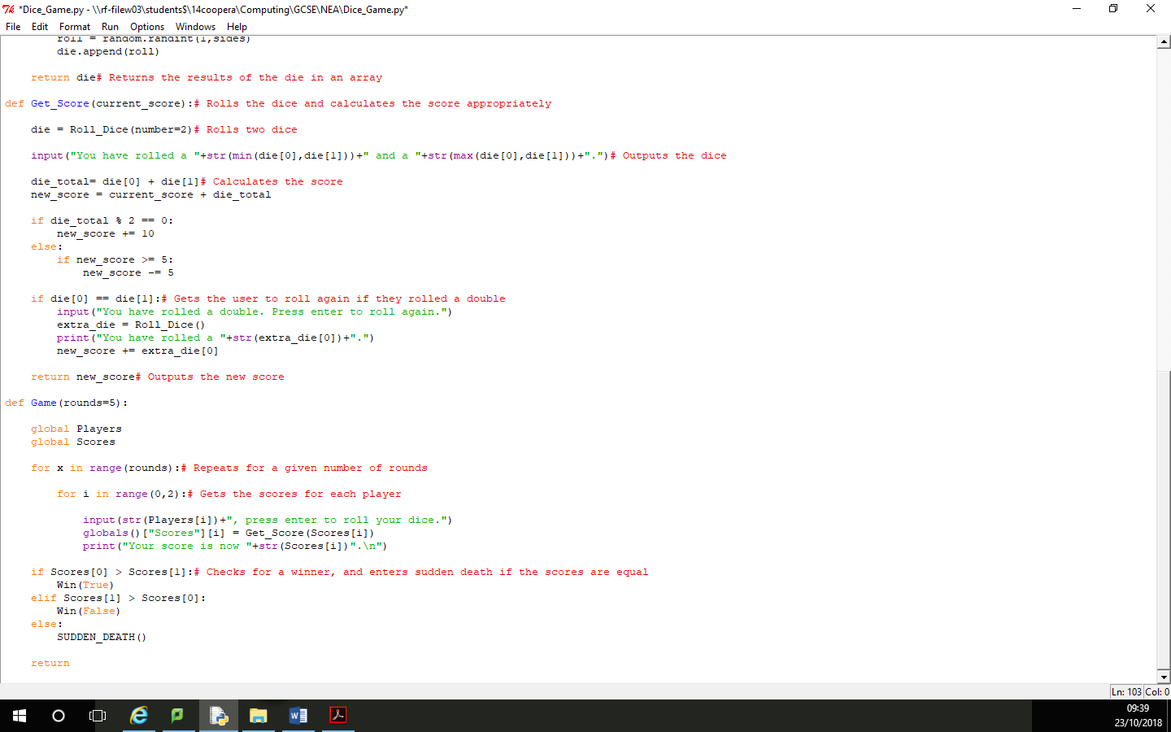

Development 3 – 25/10/2018  
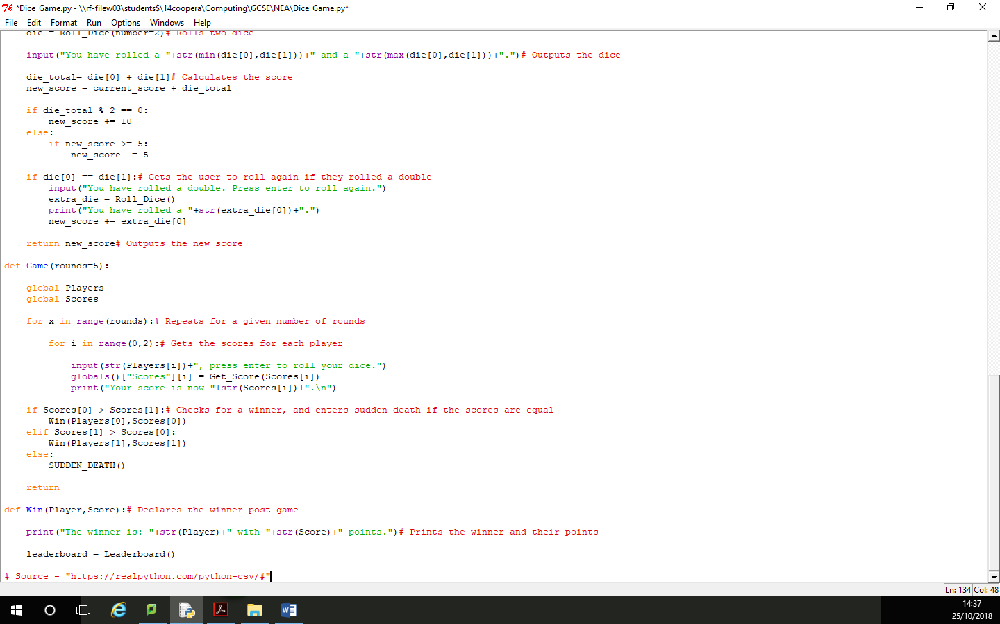

Development 4 – 5/11/2018  
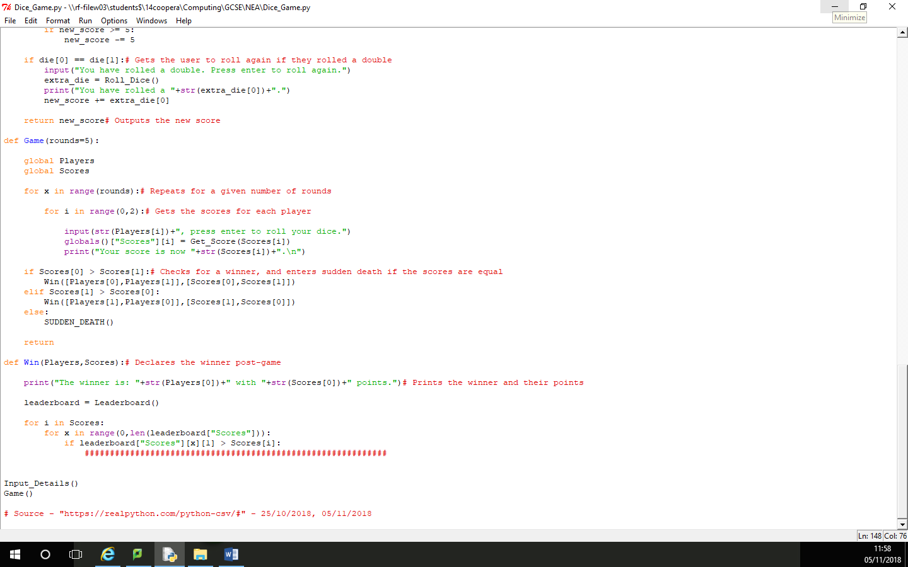

Development 5 – 14/11/2018  
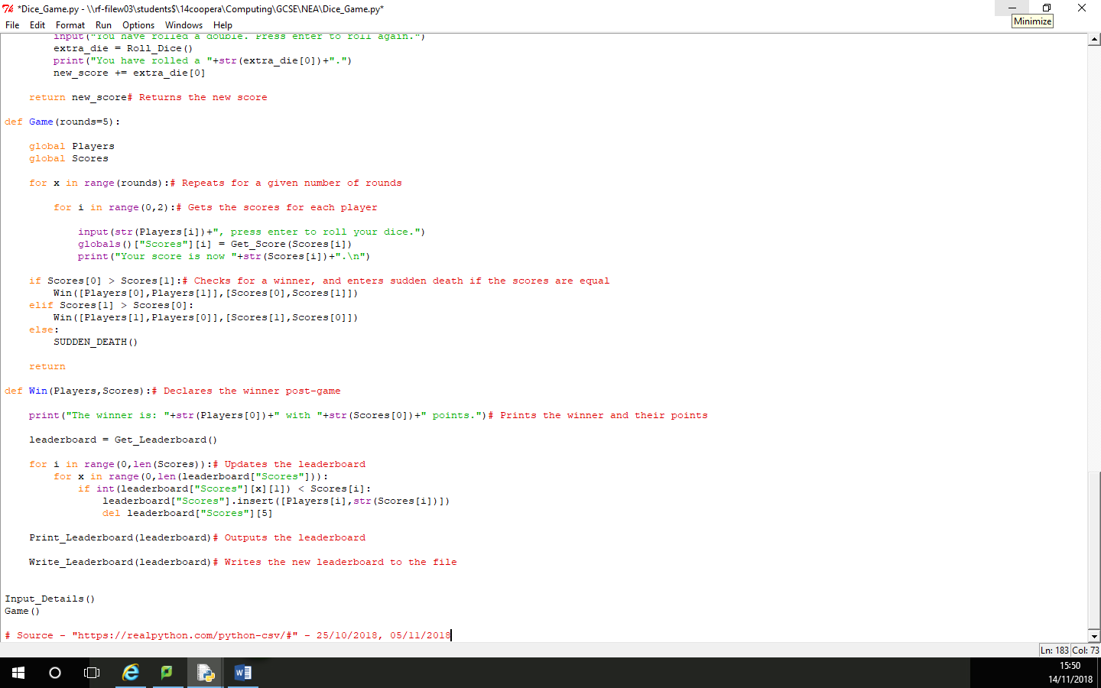

Development 6 – 15/11/2018  
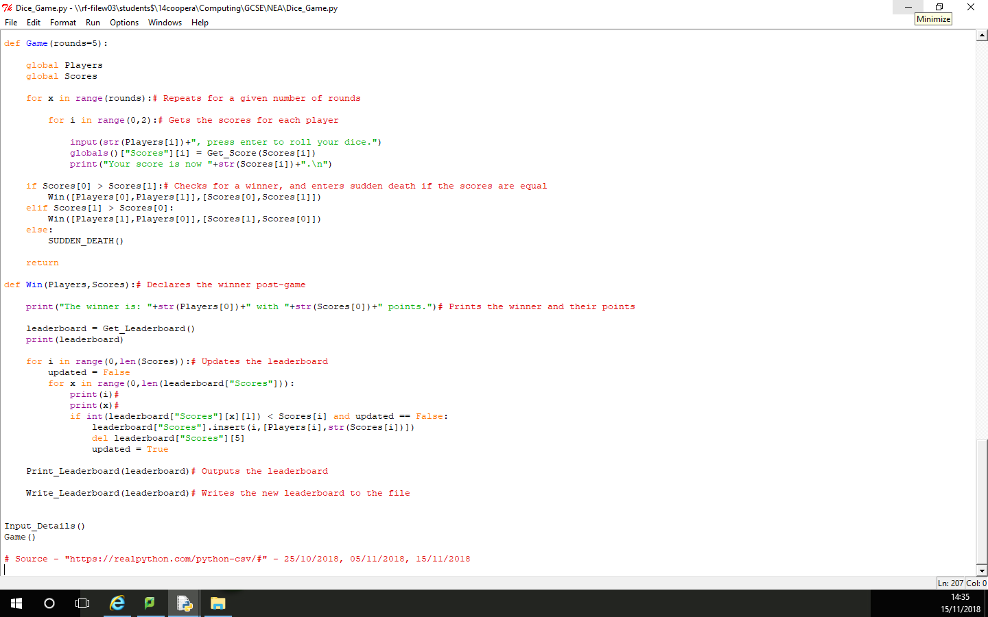

Development 7 – 19/11/2018  
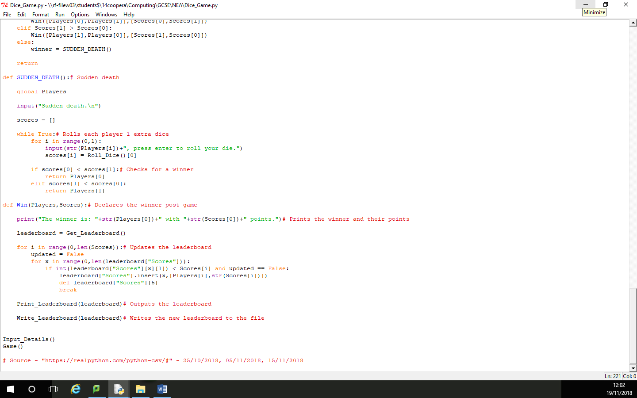

Development 8 – 21/11/2018  
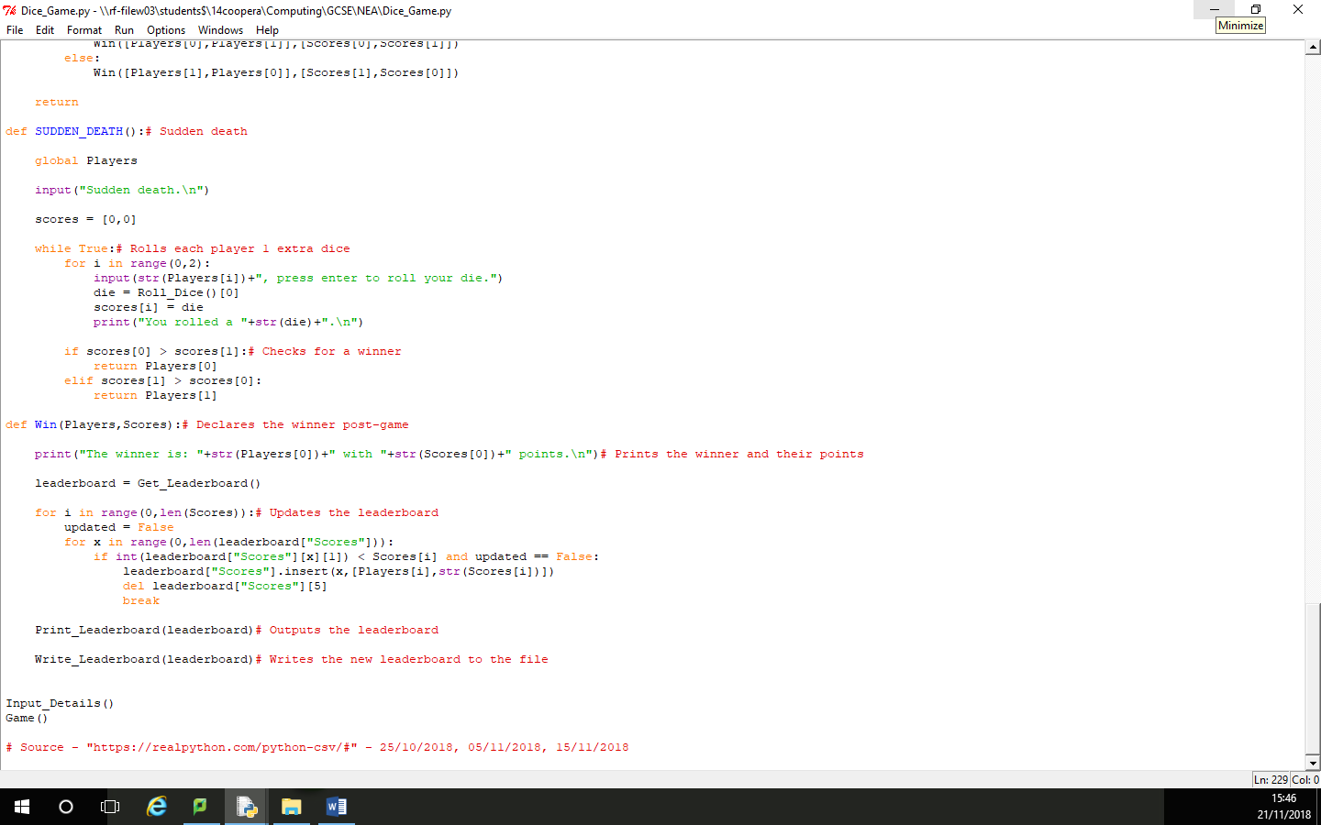

Development 9 – 27/11/2018  
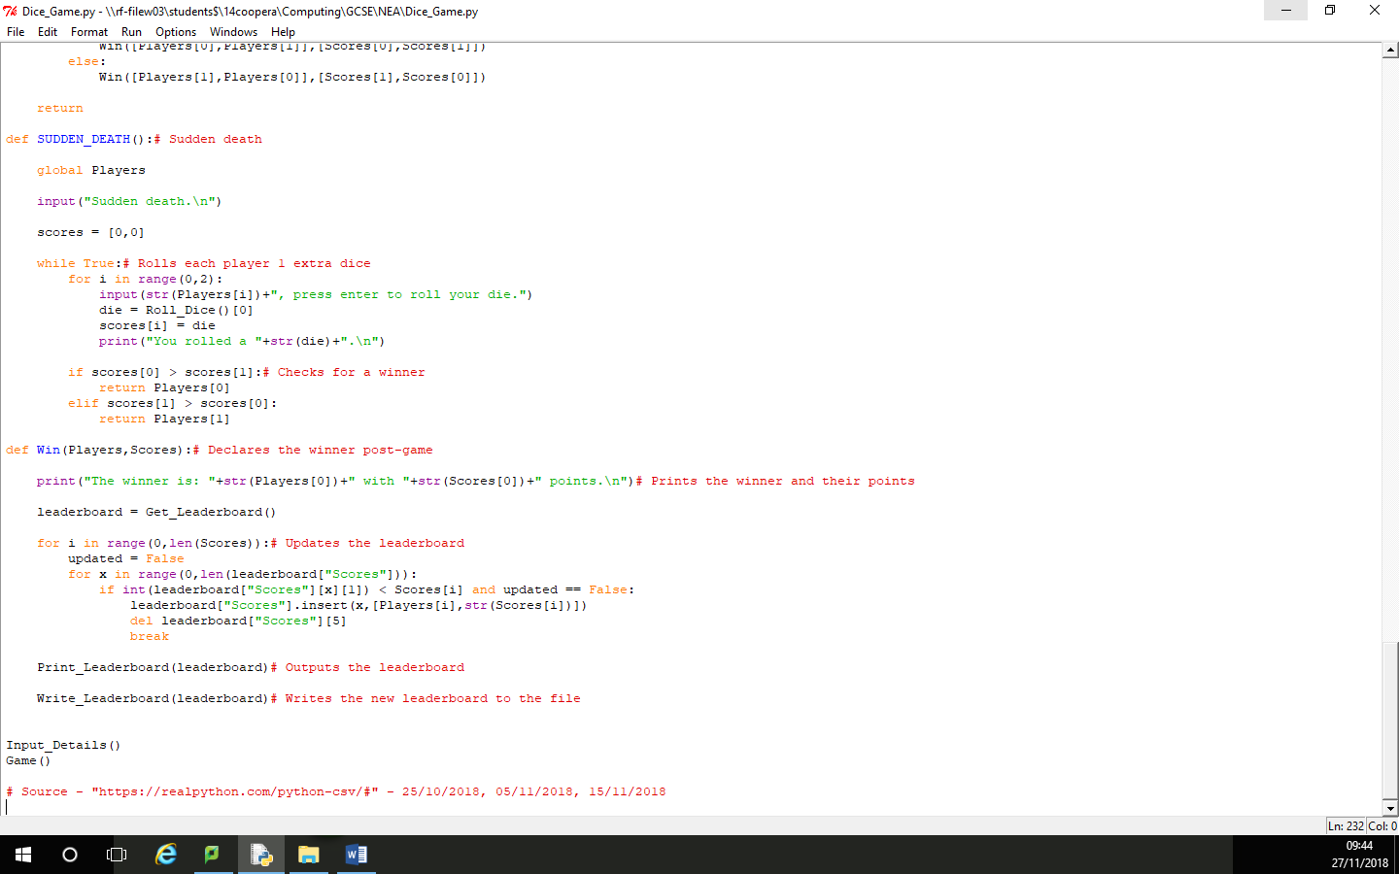

Development 10 – 28/11/2018  
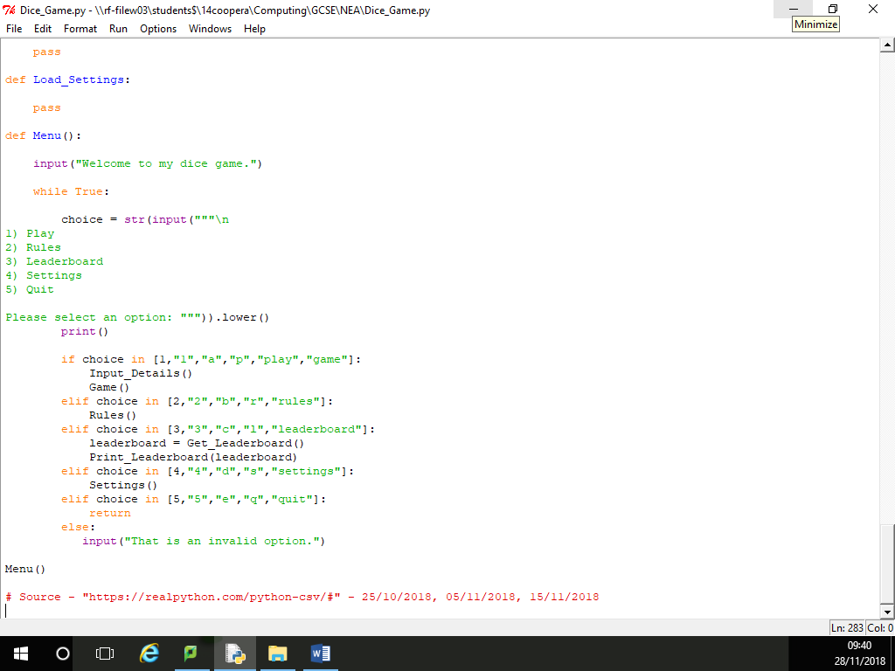

Development 11 – 28/11/2018  
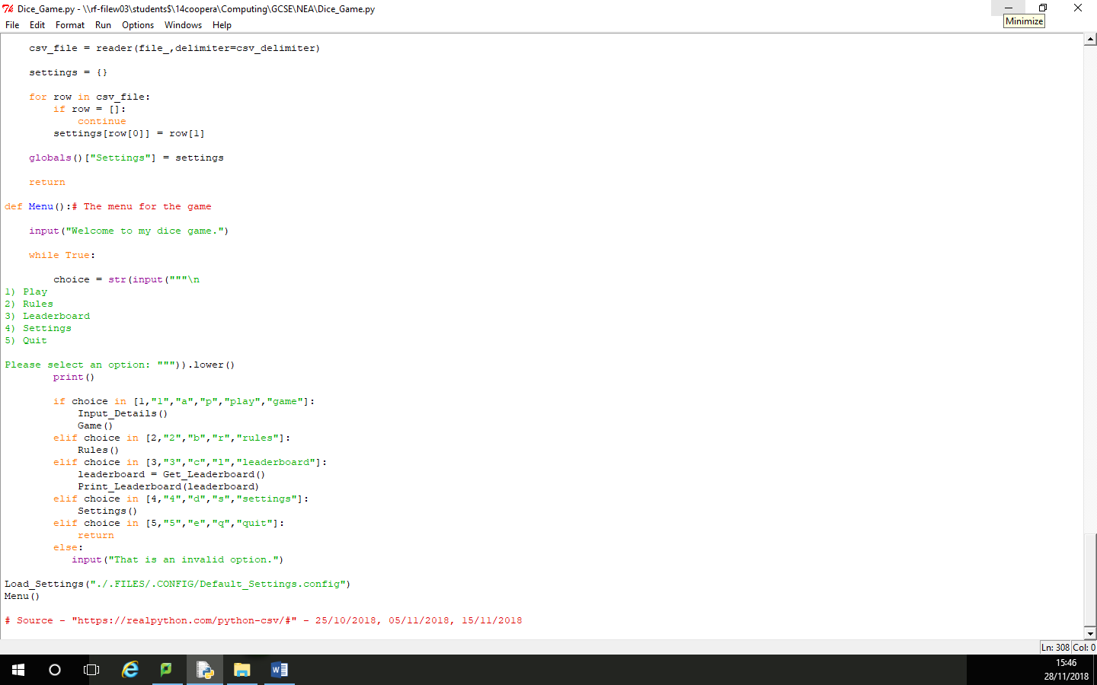

Development 12 – 29/11/2018  
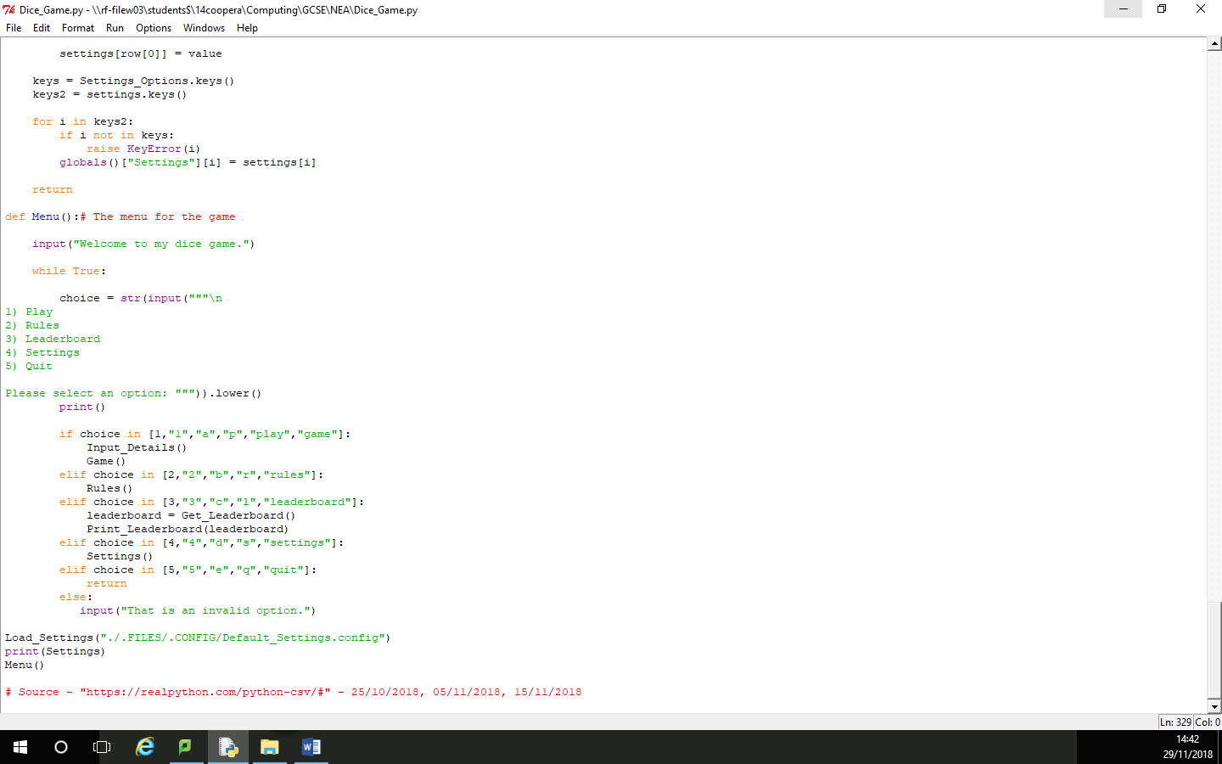

Development 13 – 3/12/2018  
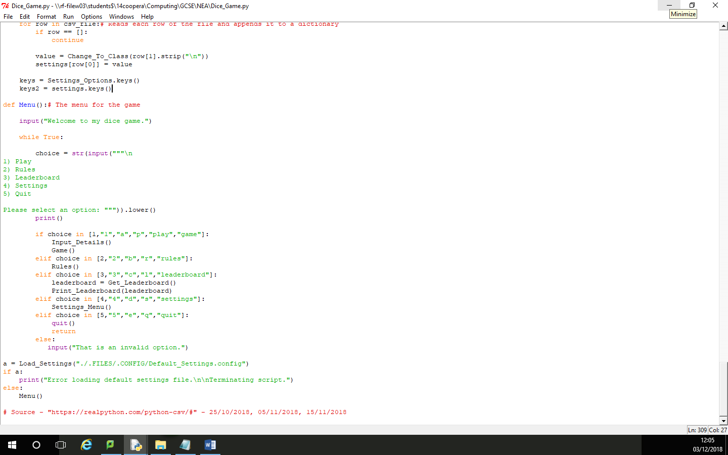

Development 14 – 11/12/2018  
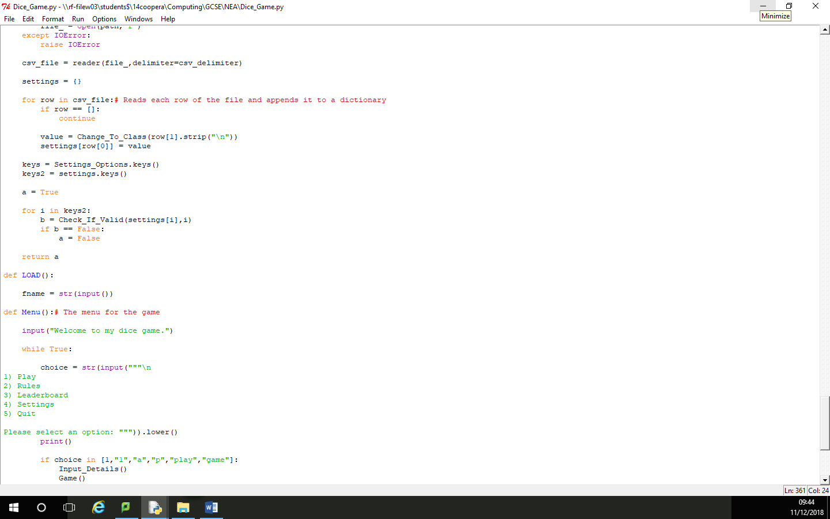

Development 15 – 12/12/2018  
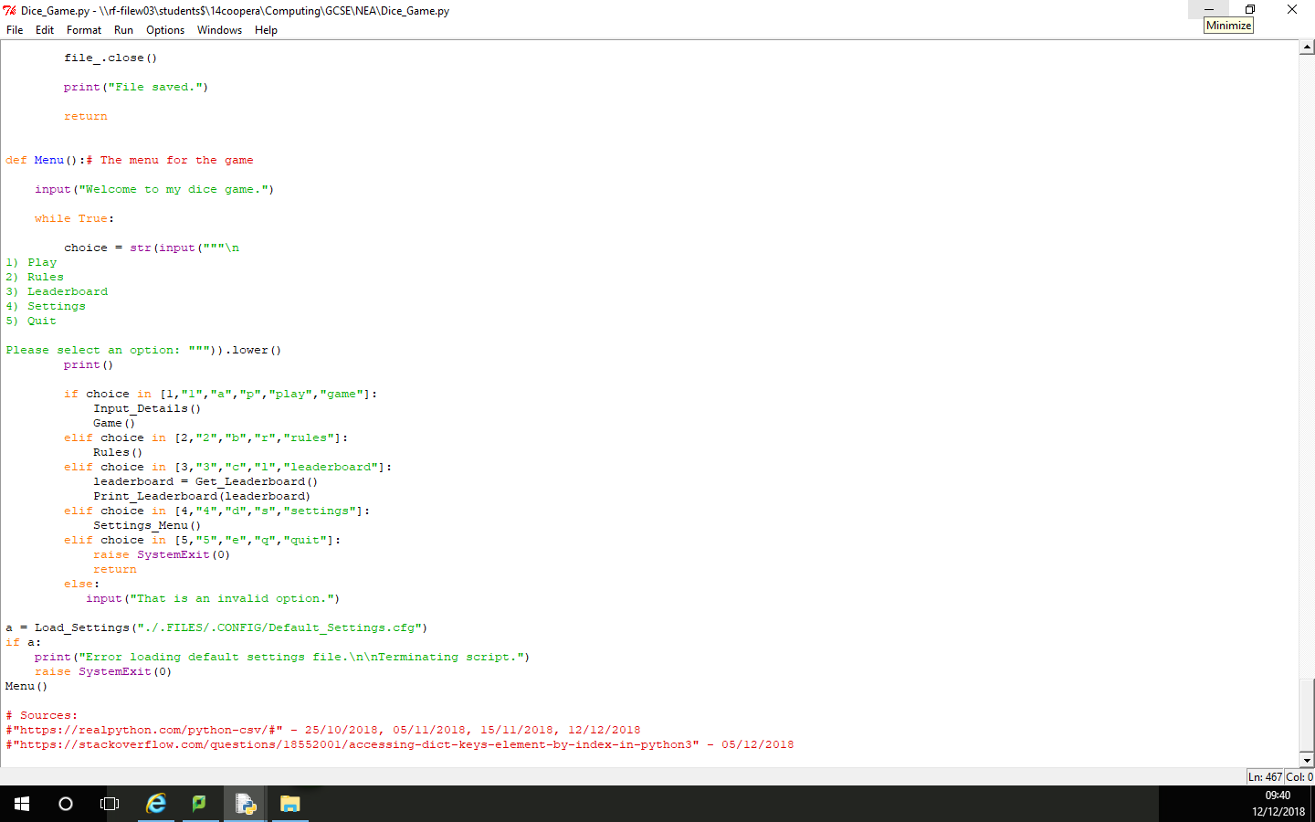

Development 16 – 12/12/2018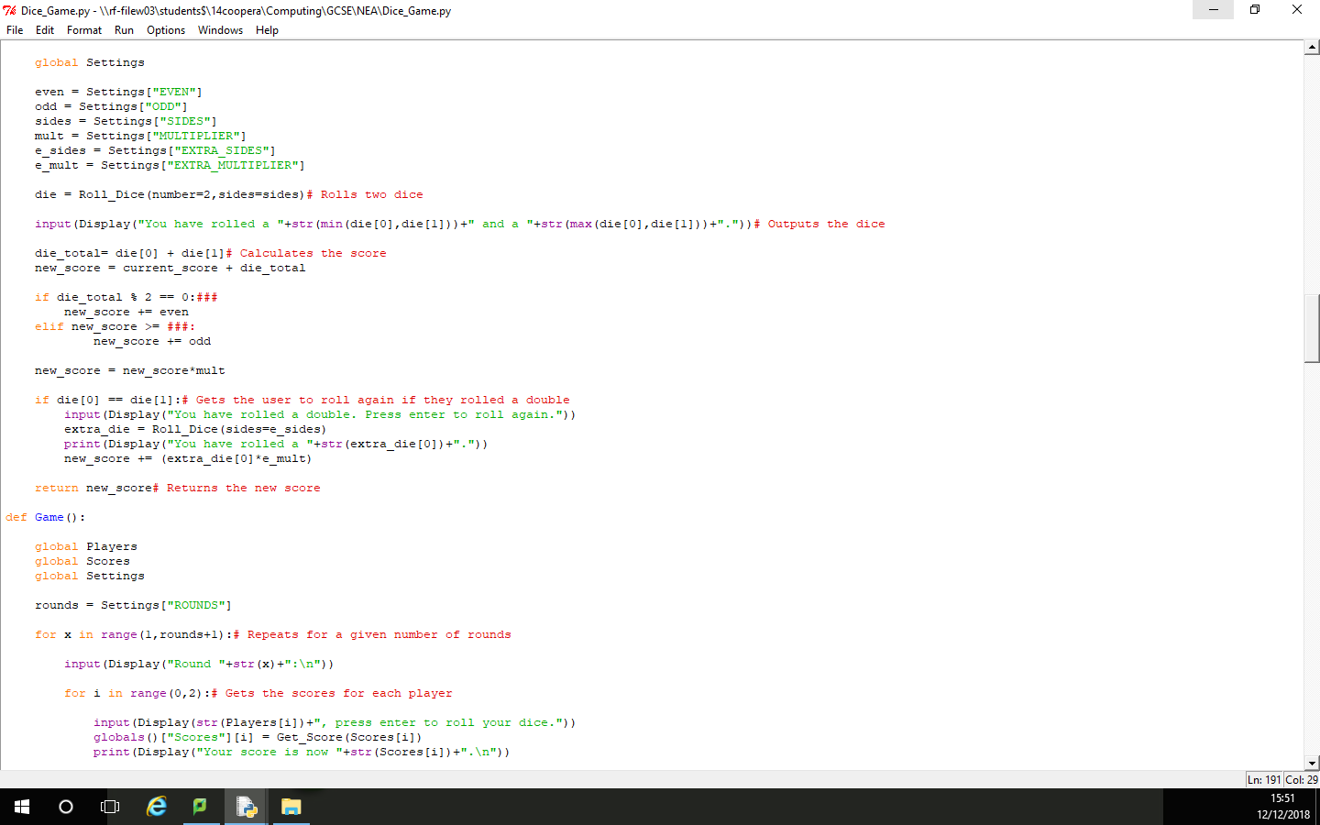

Development 17 – 19/12/2018  
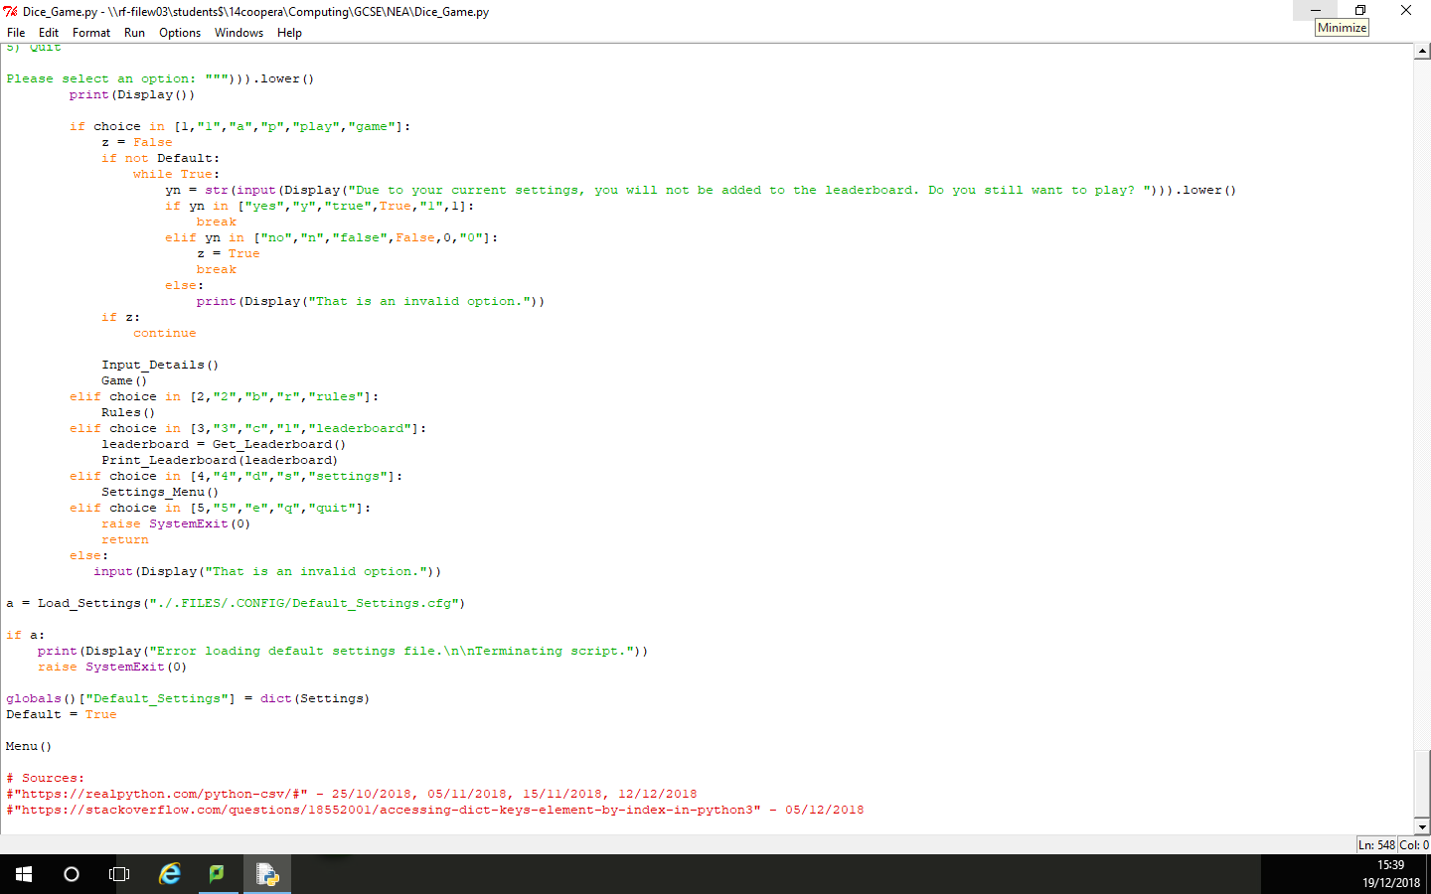

Testing

* *Show you have completed the tests you thought of*
* *Identify if you needed to make changes to your program*
* *Include the screenshots of the tests*

**My tests:**

|  |  |  |  |  |
| --- | --- | --- | --- | --- |
| Test | What am I testing? | Expected result | Pass/Fail | Do I need to change my program? If so, how? |
| 1 | Name Input | Game continues and asks for second name | Pass | N/A |
| 2 | Name Input | Game states that the name is invalid and asks for the name again | Pass | N/A |
| 3 | Name Input | Game states that the name contains a banned character and asks for the name again | Fail | End loop after one banned character is found |
| 3 (Repeated After Change) | Name Input | Game states that the name contains a banned character and asks for the name again | Pass | N/A |
| 4 | Name Input | Game states that the name is invalid and asks for the name again | Pass | N/A |

**My test screenshots:**

Test 1 – Pass  
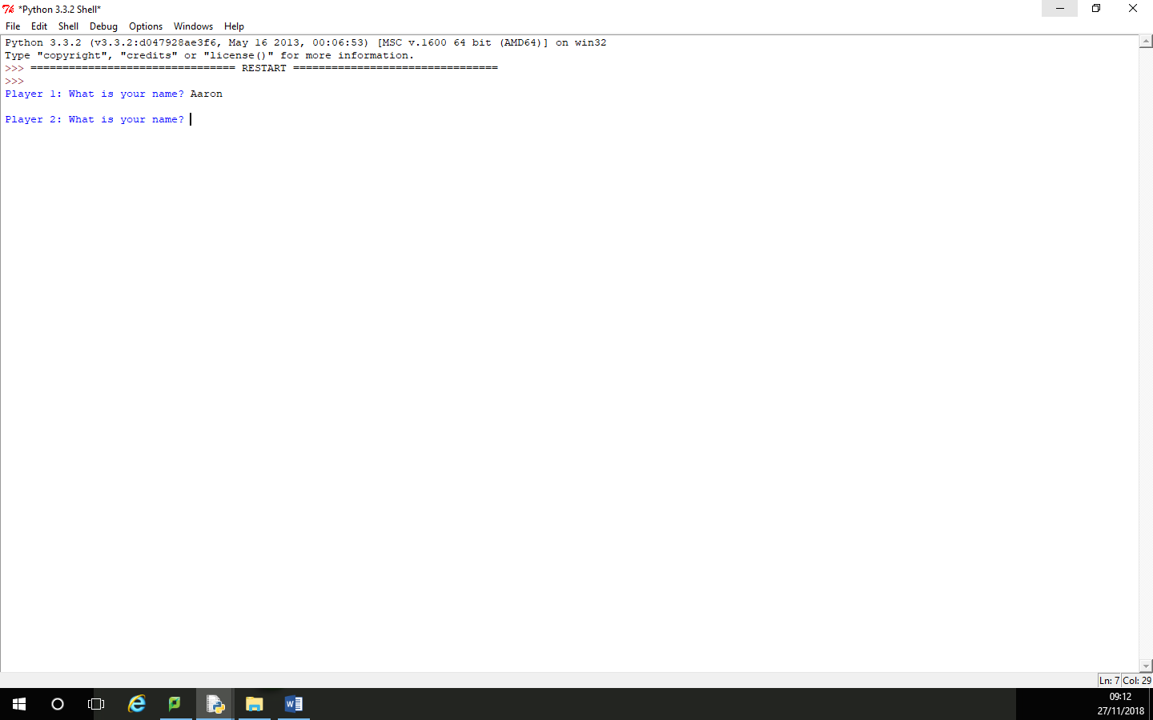

Test 2 – Pass  
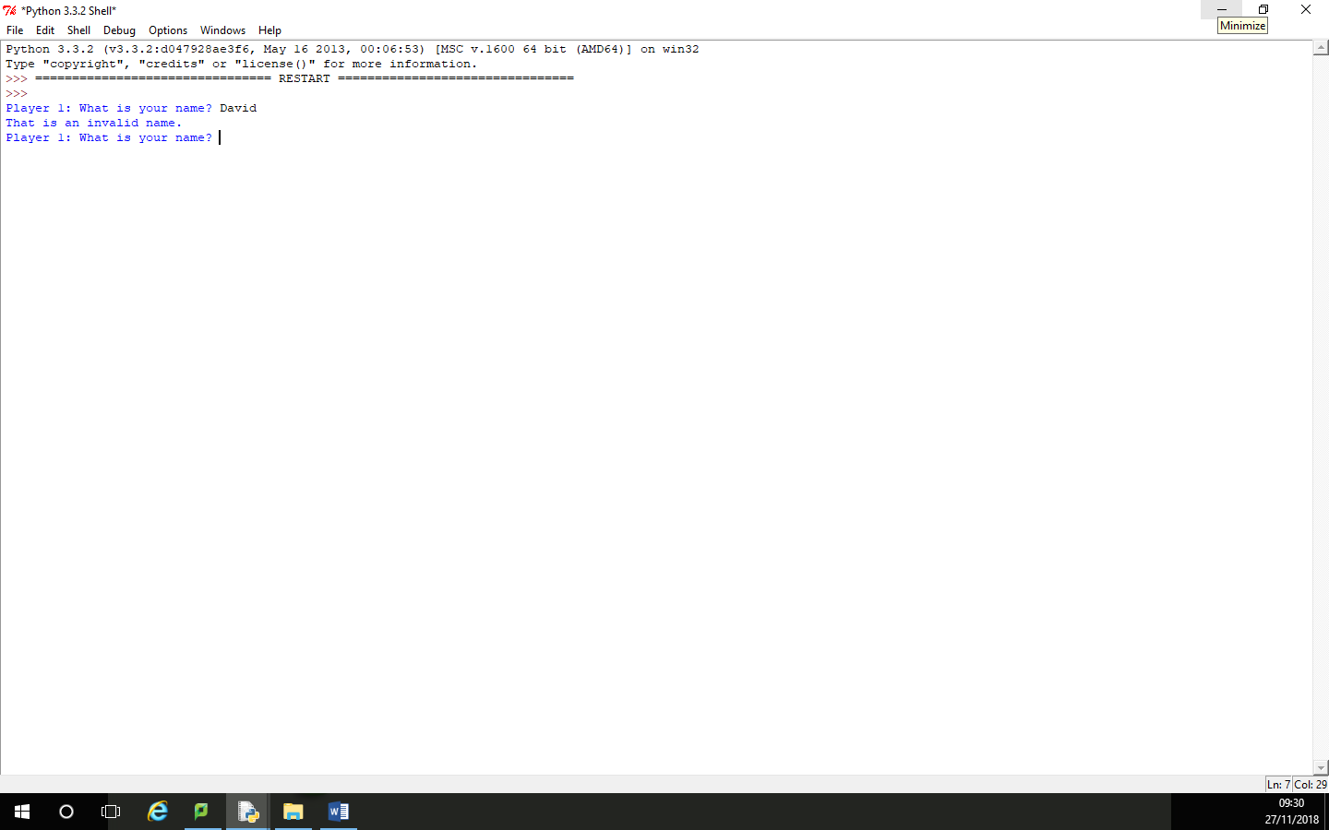

Test 3 – Fail  
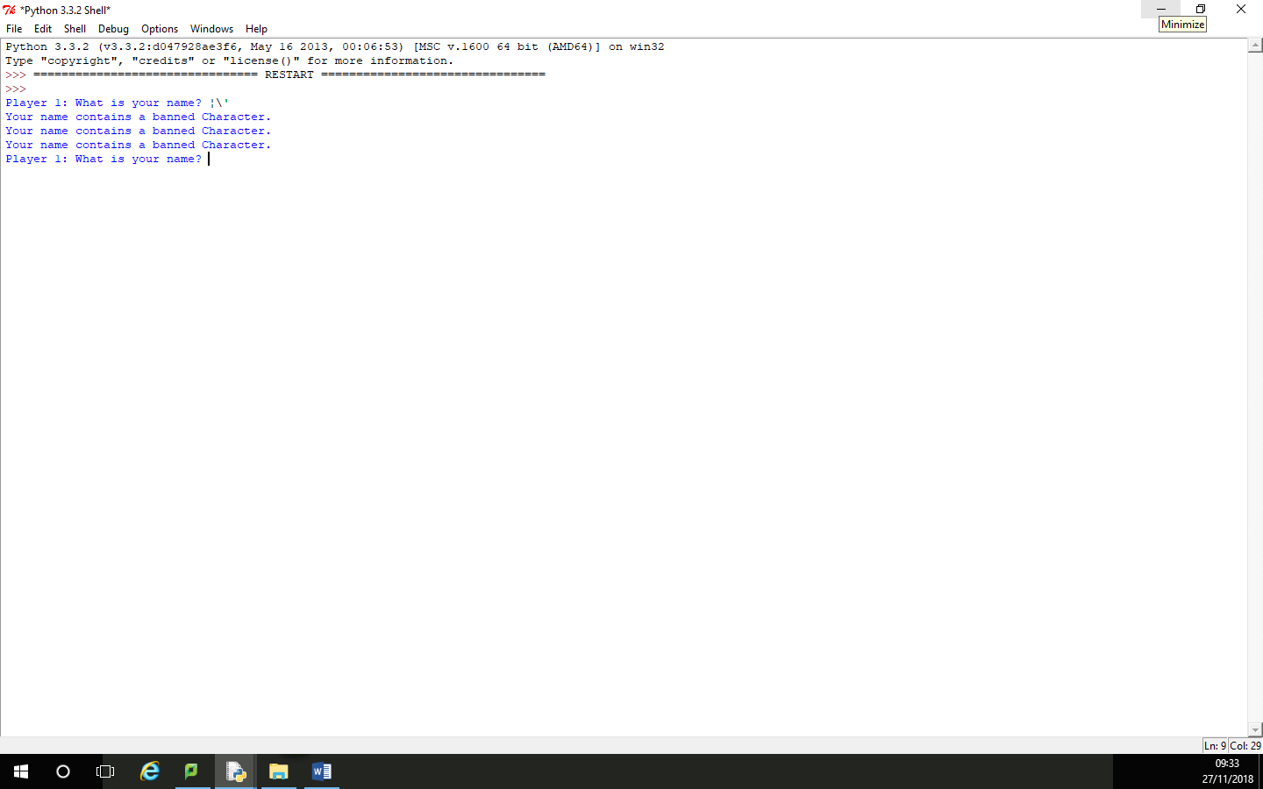

Test 3 (Repeated After Change) – Pass  
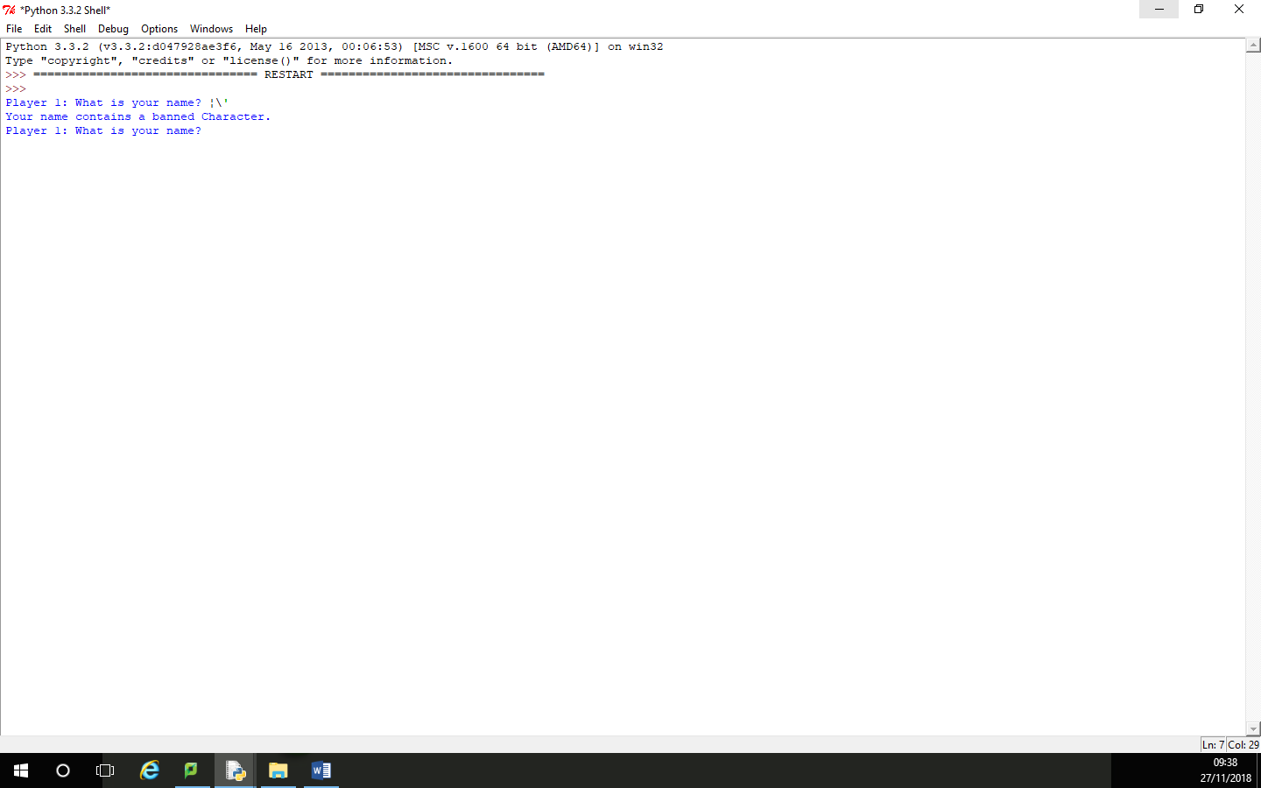

Test 4 – Pass  
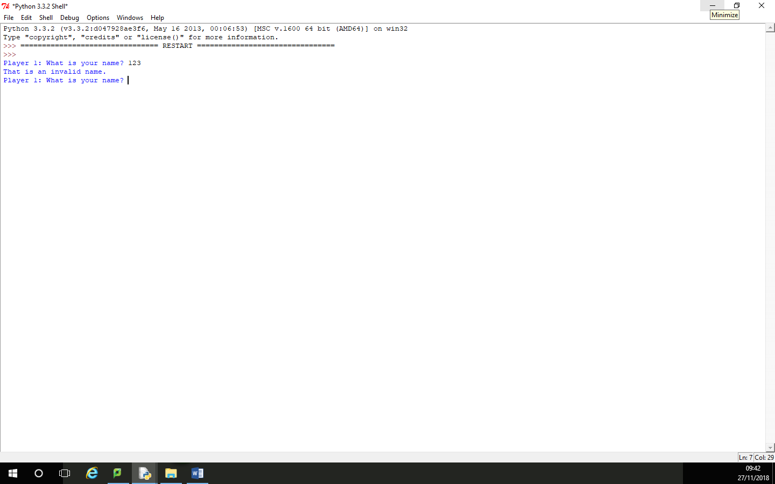

Evaluation

* Evaluate how successful your program was. You may find it useful to refer back to your tests
* You should reflect on any new skills you have developed

This section should be approximately 200-500 words.

**How successful was my program?**

I coded my program using Python 3.3.2.

I believe that my program was highly successful for a number of different reasons. The first was that my program completed the task fully, with full validation and a working leader board. For example, when the user enters their name, the name must match one from a set list in an external text file otherwise the game tells the user that they have entered an invalid name and asks the user again. I also believe that my interface is easy to use, with the main menu accepting a variety of number, letter and string input in any case to select an option. The main reason that I believe my program was successful was the number of additional features that I added to my program. Some of these include the main menu, which I think gives the game a professional feel. I also chose to include a rules and a settings menu, which allowed the user to edit some of the settings in the game and then save them into an external file for later use. As some of these settings affected the gameplay, the user was then prevented from creating new high scores when these settings were modified. The user is also able to view the leader board from the main menu, allowing them to view the highest scores achieved.

I think that my code could be made better by adding a more visual interface as they are more user friendly. I could have implemented this feature by using the python modules “turtle” or “tkinter”. These would be the best to use as they come installed with the idle shell, which is a commonly used shell for editing and running python scripts. I could also have tried to compile my script, which would have made it more accessible as it could have been run on any computer without the requirement of it having a python shell installed.

**What new skills have I developed?**

I have gained a number of abilities while completing this assessment. The main one was the ability to read, write and edit csv files within python. I have accomplished this by using the “csv” module, which is a commonly installed module within python.