NOTES ON USING THIS TEMPLATE:

* Adapt this starter document to suit your needs. There may be some pieces that just don’t fit or something you’d like to include may be missing.
* Of course, update the branding to match your own.
* Most of the supporting visual examples were created in another program and pasted into this document.
* Text in enclosed in brackets, like <this>, contains placeholders, word choices, or instructions. Don’t forget to put real content in them or delete the instructions.

**<Client Name>**

Strategic Alignment Summary



# Introduction

## About This Document

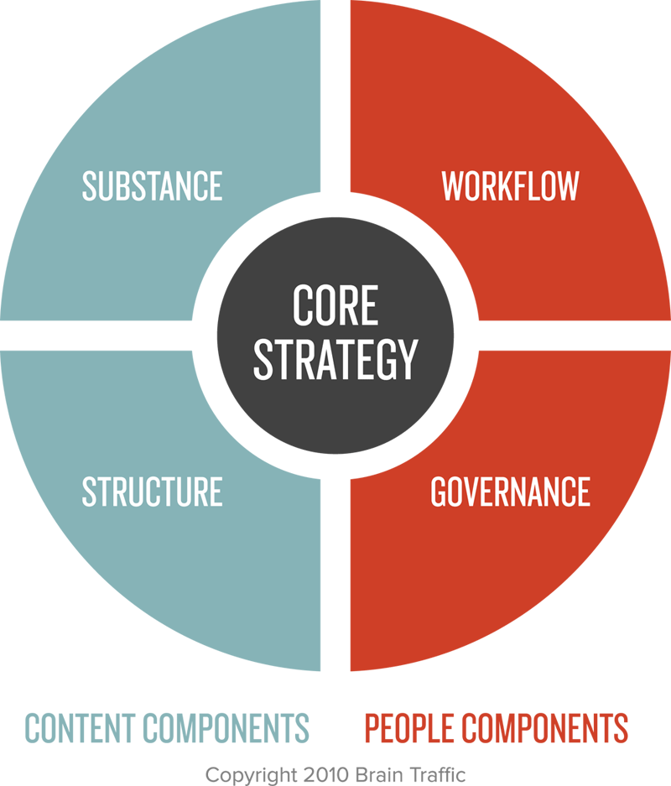Our approach to content strategy consists of a core strategy with recommendations on four key components:

• **Substance:** What kind of content do <you/we> need, and what messages does it need to communicate to <your/our> audience?

• **Structure**: How is content best prioritized, organized, and displayed?

• **Workflow**: What are the optimal processes, tools, and human resources required to support <your/our> content work?

• **Governance:** How are key decisions about content and content strategy made?

This document sets the state for effective content strategy recommendations and helps ensure that <your/our> content is useful, usable, purposeful, and profitable. Its purpose is to align your stakeholders on the following factors:

• Business goals and content objectives

• Challenges or opportunities that <your/our> content strategy must address

The information and insights in this document were derived from the discovery phase. To arrive at our findings, we <did these activities>.

### Next Steps

• <Next step in project process, such as when feedback is due>

• <Next step in project process, such as when revisions will be made>

• <Next step in project process, such as what comes after this document>

## Business Goals

Based on information during discovery, we’ve summarized your business goals and related content objectives as follows:

|  |  |
| --- | --- |
| Business Goals | Content Objectives |
| <Business goal, such as: Attract new members.> | * <Related content objective, such as: Demonstrate the value the association provides for professionals just entering the profession or industry. > * <Related content objective, such as: Describe the benefits of becoming a member of the association.> |
| <Business goal, such as: Retain new members beyond the first year.> | * <Related content objective, such as: Showcase content created by members, for members.> * <Related content objective, such as: Demonstrate how long-term members of the organization have advanced the profession.> |
| <Business goal, such as: Increase purchases of publications and training among prospective members and existing members.> | * <Related content objective, such as: Drive visitors from free and member-only content to value-added paid content on the same topic.> * <Related content objective, such as: Learn visitors’ demographics, interests, and preferences to automatically serve up content they are likely to find relevant.> |

## Audience Definition

Based on our discovery activities, we’ve prioritized the audiences for your <website/property/organization> as follows:

**Primary audiences**

• <Audience descriptor, such as warm prospect>

• <Audience descriptor, such as current customer>

**Secondary audiences**

• <Audience descriptor, such as information seeker>

• <Audience descriptor, such as lapsed customer>

**Tertiary audiences**

• <Audience descriptor, such as media>

• <Audience descriptor, such as students>

Within the primary audience groups, we’ve identified the following segments:

|  |  |  |
| --- | --- | --- |
|  | **<Segment name>** <Description of segment> |  |
|  | **<Segment name>** <Description of segment> |
|  | **<Segment name>** <Description of segment> |
|  | **<Segment name>** <Description of segment> |

## Content Objectives and User Needs

Based on <these discovery activities>, we’ve mapped the user needs of your primary audiences to your content objectives, and noted some preliminary considerations for your content strategy.

|  |  |
| --- | --- |
| <Content objective—Duplicate this chart for each objective> | |
| **Use Cases** | **Calls to Action** |
| <Three point use case, such as: I am a parent whose child broke a permanent tooth and need to find a pediatric dentist who can get him in right away> | <Primary call to action, such as: Request an emergency appointment> |
| <Three point use case, such as: I am a parent whose child broke a permanent tooth and need to find a pediatric dentist who can get him in right away> | <Primary call to action, such as: Request an emergency appointment> |
| <Three point use case, such as: I am a parent whose child broke a permanent tooth and need to find a pediatric dentist who can get him in right away> | <Primary call to action, such as: Request an emergency appointment> |
| **Considerations** | |
| * <Preliminary consideration about content or the experience, such as: We will likely want to provide a touch-to-call option as well as an online form to request an appointment and make sure it’s clear when appointments are available.> * <Preliminary consideration about content or the experience, such as: We will likely want to provide a touch-to-call option as well as an online form to request an appointment and make sure it’s clear when appointments are available.> * <Preliminary consideration about content or the experience, such as: We will likely want to provide a touch-to-call option as well as an online form to request an appointment and make sure it’s clear when appointments are available.> | |

## Summary of <Opportunities/Challenges>

During our discovery activities, we uncovered several <opportunities/challenges> that <your/our> content strategy should help <you/us> address. They are summarized here, and we’ll go into more detail about each next.

• <Opportunity statement, such as: Organize content to move visitors along a path from non-member to member in ways that incrementally demonstrate our value.>

• <Opportunity statement, such as: Organize content to move visitors along a path from non-member to member in ways that incrementally demonstrate our value.>

• <Opportunity statement, such as: Organize content to move visitors along a path from non-member to member in ways that incrementally demonstrate our value.>

# Key <Challenges/Opportunities>

Opportunity: <Add a section for each opportunity>

<Opportunity statement, such as: Define the content product to ensure what we publish and curate helps us attract and retain members by helping industry professionals excel in their jobs and build their reputations in the industry.>

<Opportunity summary, such as: One of the biggest revenue drivers for our company is membership dues, thus making member acquisition and retention a key business goal. The primary way we provide value to members is through content that helps them excel in their jobs and build their reputations in the industry.

Based on our research with users, we’re not providing or soliciting the kind of content that members and prospective members believe is helping them excel or giving them opportunities to demonstrate their expertise. Our content strategy must define what content we need to produce and curate to take advantage of the opportunities to convert non-members to members and members to long-term members.>

### <Evidence heading, such as: Content Engagement—add as many sections as necessary>

<Evidence or insights related to opportunity, such as: During the discovery phase, we learned that non-member users of your website typically end up at the site after doing an Internet search on a particular topic. Once there, they discover the resources available on your primary site and your training opportunities and paid publications.

Most users interact with the free content without becoming a member, and there are few calls to action to do so within the content. Those who attend a training are often awarded a year-long membership with their purchase, and their content engagement does increase once they are members. Over time, long-term members are more likely to contribute content than they are to consume it.

When we layered your analytics data with the data from your website satisfaction survey, we found that approximately 45 percent of the people who visit your site each month are first-time visitors, who are not currently members. An additional 25 percent are repeat visitors who have not joined the organization. The remaining 30 percent are visitors who visit the site more than once per month.

First-time visitors typically visit one or two pages. While repeat, non-member visitors tend to explore more content on each visit. Repeat visitors, who are also members, tend to view news content most frequently.>

### Implications for Content

<The content strategy and specifications will define the appropriate calls to action for non-members to explore more content or join the organization and for members to contribute content and re-up their membership. In the following example, the calls to action are geared for a logged-in member whose membership will expire in the next 60 days.>

