Created in the cloud with Aspose.Words for Cloud. http://www.aspose.com/products/words/cloud

# How to Prepare for a Session?

Published Date : April 17, 2015



## How to Prepare for a Session?

* Prepare a list of questions you would like your subconscious (High Self or however you term the collective consciousness we are tapping into) to answer. Make one list of physical/health questions you have a separate list of personal/life questions you want answered. Bring these with you to your session. We don’t need to see them ahead of time. If you have a long list of questions please put your most important questions at the top of each list. Our goal is to get every question answered but we work with a two hour window where you are hypnotized. In that time frame we are inducing you, exploring past lives, and accessing your High Self to answer questions and then bringing you out.
* Your intention to having a great session is key! Once you have made the decision to have a Quantum Healing Hypnosis Technique session, your High Self is preparing and getting ready to have a wonderful session. Repeat this statement daily: “I easily connect with my subconscious!” it is important.
* If you meditate, do so the morning or day of your appointment to help clear your mind. If you don’t meditate, then do something that puts you in a calm place like taking a walk or listening to some soothing music.  And repeat, “I easily connect with my subconscious!”
* Eliminate or limit caffeine the day of your session. The less the better.
* Refrain from Alcohol 24 hours prior to the session.
* Eat well but light before you come in. Our session could go 4 hours or longer.
* Your session will be audio-recorded for your convenience and I will send you a copy by email. If you have your own recording device, feel free to bring it. It is very important to listen to your recording following the session. You may remember some, all, or none of what took place, it will also enhance integration of the information into your life.
* This is a private session. Even though spouses/partners/friends want to be with you to witness this amazing event it is a place where you need to feel completely safe that your confidentiality in all matters is observed. Because of this, no one else is allowed in your session. You may share your recording or any memories or thoughts at your discretion.

### Sample questions:

* How may I experience more health/happiness/balance/abundance etc. in my life?
* Why am I experiencing this physical discomfort/disease and how may I experience wellness?
* What lifestyle or dietary changes would most benefit me now?
* How can I become more self aware?
* What is my biggest obstacle to moving forward?
* Why do I experience this difficulty in my relationship with my partner/parent/sibling/child etc?
* Is there any contract that I have that needs to be broken or karma to release at this time?
* Why do I have this particular fear/phobia that prevents me from enjoying life?
* How may I move in a more purposeful direction in my work/relationship/lifestyle?
* How may I open to my spiritual/creative gifts?
* Do I have a Guardian Angel or Spiritual Guide whom I may meet?
* What may I do to more fully align to Divine Will and how may this be expressed in my life?

# How Quantum Healing Works?

Published Date : April 14, 2015



## How Quantum Healing Works?

Over the course of her career, Dolores had conducted sessions with clients where the physical healing that occurs had been challenging for even her to comprehend. She had been teaching her technique to students all over the world for a decade and many write back detailing miraculous accounts of a similar nature.

Before detailing this list of what is possible in terms of healing, it must be stated that healing can only occur if an individual wants to be healed and if it does not interfere with the goals of their lifetime. We are infinite souls who have incarnated on Earth for our own individual experiences.

The Subconscious of a blind person would not heal his sight if being blind was one of the key aspects of his life he agreed to experience. Nor would it heal a physical problem someone had created through the lack of care for their body if they had not yet learned the lesson to love and respect their body. It is very literal in its thinking. Are you beginning to understand the logic?

There are no guarantees, but these were some of the remarkable results* Dolores and her QHHT Practitioners alike have experienced with clients during a session:

* Cancer of all types at various stages being cured
* Cartilage being reconstructed between joints
* AIDS being cured and eradicated from the body
* Heart conditions being healed, afterwards surgery is no longer required
* Deteriorated livers being regenerated and restored to full function
* Damaged kidneys being regenerated and restored to full function
* Open flesh wounds being regenerated with no scarring
* Migraines being explained and their root causes removed
* 20/20 vision being restored where people no longer need corrective vision
* Diabetes being cured and the causes for it explained
* Intestinal problems being cured
* Lower and middle back problems being cured
* Neck and shoulder pains being removed
* Lung associated problems being cured
* Skin problems

#### Nothing is beyond the realm of possibility. There are no limitations, except the limits of your own imagination.

* *Source: http://www.dolorescannon.com*

# What is The Subconscious?

Published Date : February 28, 2015



## What is The Subconscious?

### As defined by Dolores Cannon

The Subconscious is a suitable label given the context of Dolores’ work; however, religions and spiritual teachers alike have attempted to identify and label this larger part of ourselves throughout history using a variety of different labels: the Higher Self, the Oversoul, Christ Consciousness, Higher Consciousness, the Universal Mind and Oneness for example. The Subconscious has stated to Dolores that it does not care what we call it, it simply Is and is willing to work with those with a pure heart and true intent.

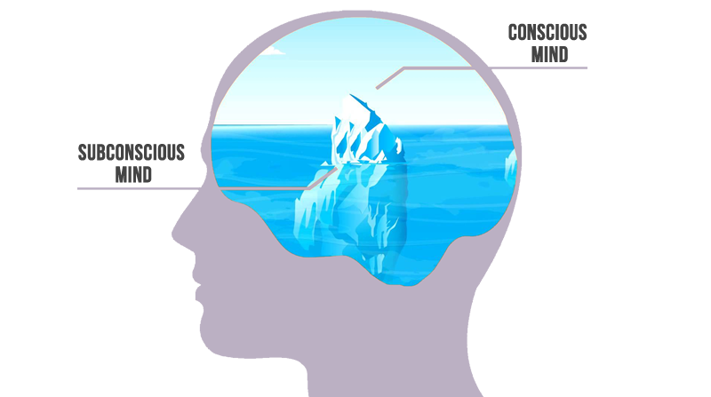

#### This concept is extremely challenging to even consider at first and many will reject it as either illogical or irrational.

#### Working with the Subconscious

Dolores’ main objective was always to help improve the lives of the clients she worked with. Therefore, the purpose of working with the Subconscious is always to help an individual to the greatest extent possible in whatever capacity possible. This help can come in many different ways.

The Subconscious knows everything there is to know about an individual and the life they are living now, so one of the first actions taken by the QHHT Practitioner is to ask the Subconscious the questions an individual has about their own life. Obtaining this information on behalf of the individual is crucial to the healing aspect of the technique as it provides them with comfort, support and greater understanding in many different areas of their life. The Subconscious will only choose to share information that is appropriate at the time and information that will only be of benefit to the individual.

The explanation the Subconscious gives for why we experience disease will most certainly challenge the belief systems of many people in our current medical and scientific paradigms. As we move through this time of great change and transition, many people are indeed stretching their belief systems to incorporate new ideas and concepts by seeking out alternative information that mainstream science has either dispelled or ignored. Many long held paradigms of accepted thought are beginning to crumble and are slowly being replaced by concepts and ideas that can no longer be suppressed as a result of the Internet and instantaneous communication all over the world. In order to understand the Subconscious and this component of Dolores’ QHHT technique, you will have to stretch your belief system to enable you to understand the following concepts in the context they are given.

#### Quantum Physics Advancements

The myriad of advances in Quantum Physics over recent decades have triggered a snowballing body of evidence supporting the notion that the thoughts that we predominantly think dictate the reality we experience. In fact, a large body of scientific evidence now exists which proves that thought has a direct, measurable effect on physical matter.

This is simple to understand when one considers that all matter is just energy vibrating at different frequencies. Thought is the projection of energy and we have evolved to a point where we have conscious control over our thoughts and what we think. The spoken words ‘I love you’ and ‘I hate you’ are the physical projects of thought energy. Now think about the effect those phrases have on the physical bodies of whom you may say them to.

The goal here is not to convince you of anything you are not ready to accept, nor is it to persuade you to reject anything you are not ready to disregard, it is simply to provide you with a platform upon which you can understand how Dolores’ QHHT technique works and how the results it achieves are possible.

# About Quantum Healing Hypnosis

Published Date : February 1, 2015



## What Is QHHT and how may I benefit?

### Quantum Healing Hypnosis Technique

Most healing with Quantum Healing Hypnosis Technique happens at a **Theta** [level of consciousness.](http://www.mindvalleyacademy.com/blog/mind/brain-waves) Theta level is like when we are just drifting off and just awakening from sleep. It’s the time when we are tuned into the soul, yet are still aware, as intuitive images, sensations and memories are drifting through our minds.

During a session we access the subconscious at this Theta level, to release information that you would like to find to help you move forward in life in so many areas. A lot of our fears, pains and blockages are held at the deep subconscious level, and by accessing them, they are brought to light, acknowledged and released. Many of our hidden gifts, talents and longings are awaiting to be unlocked.

#### There are Five States of Consciousness

**Beta** – the normal waking state.  
**Alpha** – the state we enter when we daydream. Light hypnosis.  
**Theta** – a deep state of peaceful awareness, just before dreaming. This is the state we tap into with QHHT when we are still awake and consciously aware.  
**Delta** – the sleep state.  
**Gamma** – a state associated with peak concentration, high levels of cognitive functioning, sudden bursts of insight and creativity.

The border between Alpha and Theta is the gateway to the sub-conscious mind. This is the level at which the mind reaches **optimal visualization capacity.**

## Brainwaves

* Beta
* Alpha
* Theta
* Delta