Created in the cloud with Aspose.Words for Cloud. http://www.aspose.com/products/words/cloud

# How to Prepare for the Session?

Published Date : April 17, 2015



## How to Prepare for a Session?

* Prepare a list of questions you would like your Subconscious, (your Higher Self or however you term the collective consciousness we are tapping into) to answer. If you have a long list of questions put your most important questions at the top of the list. Our goal is to get every question answered but we work within a two hour window (not more) when you are hypnotised. In that time frame we are inducing you, exploring past lives, and accessing your High Self to answer questions and then bringing you out.
* Your intention to having a great session is key! Once you have made the decision to have a QHHT® session, your Higher Self is preparing and getting ready to have a wonderful session. Repeat this statement daily: “I easily connect with my subconscious!” It will accelerate the process.
* If you meditate, do so on the day of your appointment to help clear your mind. If you don’t meditate, then do something that puts you in a calm place like taking a walk or listening to some soothing music. And repeat, “I easily connect with my subconscious!”
* Eliminate or limit caffeine the day of your session. The less the better.
* Refrain from alcohol 24 hours prior to the session.
* Eat well but light before you come in. Our session could go 4 hours or longer.
* Your session will be audio-recorded for your convenience and I will send you a copy by email. If you have your own recording device, feel free to bring it.You may remember some, all, or none of what took place. It is very important to listen to your recording after the session. This will enhance integration of the information into your life.
* This is a private session. Even if your partner or friend wants to be with you to witness this amazing event it is a place where you need to feel completely sure that your confidentiality in all matters is respected. Because of this, no one else is allowed to attend your session. After the session you may share your recording and any memories or thoughts at your discretion.

### Sample questions:

* How may I experience more health/happiness/balance/abundance etc. in my life?
* Why am I experiencing this physical discomfort/disease and how may I experience wellness?
* What lifestyle or dietary changes would most benefit me now?
* How can I become more self aware?
* What is my biggest obstacle to moving forward?
* Why do I experience this difficulty in my relationship with my partner/parent/sibling/child etc?
* Is there any contract that I have that needs to be broken or karma to release at this time?
* Why do I have this particular fear/phobia that prevents me from enjoying life?
* How may I move in a more purposeful direction in my work/relationship/lifestyle?
* How may I open to my spiritual/creative gifts?
* Do I have a Guardian Angel or Spiritual Guide whom I may meet?
* What may I do to more fully align to Divine Will and how may this be expressed in my life?

# How Is Quantum Healing Possible?

Published Date : April 14, 2015



## How Is Quantum Healing Possible?

It is common knowledge that our bodies can heal without being cured by some external medicine. It happens all the time. For example when we have a minor cut on our hand the wound is healed within days. In most cases such healing is a process that takes some time and we can observe different stages in that process. We say that our body healed itself and we do not consider this to be a miracle of any sort. We accepted long time ago that the body can do this by itself – or so we believe. Anyway, this is *not* a quantum healing.

The word Quantum in the QHHT® refers to shifting a person (or part of it) from one state (dis-eased) to another state (healed) *without any apparent transitional stages.* Yes, such [quantum movements](https://phys.org/news/2017-03-quantum-movement-electrons-atomic-layers.html) happen all the time too. In my case this is how I was healed from dependency of smoking – after my first QHHT session I had no need or wish for cigarettes anymore.

Dolores Cannon had conducted sessions with clients where the amount of physical healing had been really challenging to comprehend. She had been teaching her technique to students all over the world for a decade and many wrote back about “miraculous” healing in their sessions. Healings experienced during QHHT® sessions are documented in the [Convoluted Universe](http://dolorescannon.com/latest-books/) books series while a shortlist of healed diseases is summarized at the bottom of [this page at the QHHT® web site.](https://www.qhhtofficial.com/about-us)

How exactly the QHHT® healing works is still a mystery to our conscious minds. Nevertheless, the fact is that it works. One way to explain it simplistically and get over it is: traditional medicine knows that diseases can have a psychosomatic origin. Meaning they originate in our psyche and are subsequently propagated to our physical body. Well if our psyche is so powerful that it can generate diseases, it is not so hard to accept that it is equally powerful to undo (i.e. heal) them.

It must be stated though that *healing can only occur when an individual wants to be healed and if it does not interfere with the goals of their lifetime.*

For example [The Subconscious](http://www.12densities.com/en/assets/what-is-the-subconscious/) of a blind man would not heal his sight if being blind was a key aspect of his life he agreed to experience. Nor would it heal a physical problem someone created due to lack of care for their body – if they had not yet learned the lesson to love and respect their body. For these reasons I am not suggesting that Quantum Healing is a cure that will heal every disease in every person. It is worth considering it though while everyone uses their own judgment based on their beliefs and state of mind.

We are infinite souls who have incarnated on Earth for our own individual experiences.

#### Nothing we can imagine is beyond the realm of possibility. There are no limitations, except the limits of our own imagination.

# So What is The Subconscious?

Published Date : February 28, 2015



## What is The Subconscious?

### As defined by Dolores Cannon

The Subconscious in QHHT® is a suitable label given in the context of this practice. Dolores started using the term in the early days of her work and the term stayed until today. Throughout history religions and spiritual teachers have identified and labeled this larger part of ourselves using a variety of different names such as: the Higher Mind, the Higher Self, the Oversoul, Christ Consciousness, Higher Consciousness, the Universal Mind, Oneness… Different people prefer using different terms. For instance my personal preference is “The Higher Mind”. Anyway the Subconscious has stated to Dolores that it does not care what we call it, it simply *is* and is willing to work with those with a pure heart and true intent.

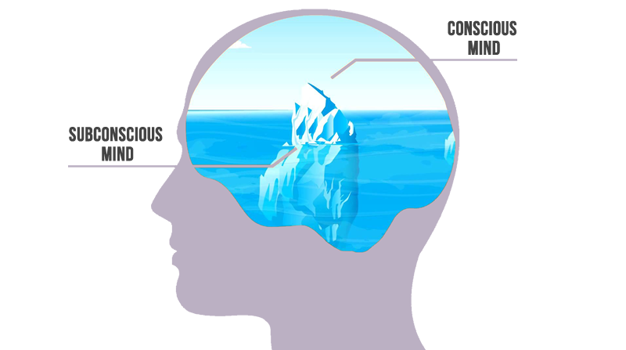

#### This concept is extremely challenging to even consider at first and many will reject it as either illogical or irrational.

#### Working with the Subconscious

The purpose of working with the Subconscious in QHHT® is always to help an individual to the greatest extent possible in any relevant capacity. This help can come in many different ways.

The Subconscious knows everything there is to know about an individual and the life they are living now, so one of the actions taken by the QHHT® Practitioner is to ask the Subconscious the questions an individual has about their own life. Obtaining this information on behalf of the individual is crucial to the healing aspect of the technique as it provides them with comfort, support and greater understanding in many different areas of their life. The Subconscious will only share information that is appropriate at the time and beneficial to the individual.

The explanations that the Subconscious gives about why we experience disease will most certainly challenge the [belief systems](https://en.wikipedia.org/wiki/Belief) of many people in our current medical and scientific paradigms. As we move through this time of great change and transition, many people are indeed stretching their belief systems to incorporate new ideas and concepts by seeking out alternative information that mainstream science has either dispelled or ignored. Many long held [paradigms of accepted thought](https://en.wikipedia.org/wiki/Paradigm_shift) are beginning to crumble and are slowly being replaced by concepts and ideas that can no longer be suppressed as a result of the Internet and instantaneous communication all over the world.

#### Quantum Physics Advancements

The myriad of advances in [Quantum Physics](https://en.wikipedia.org/wiki/Quantum_mechanics) over recent decades have triggered a snowballing body of evidence supporting the notion that the thoughts that we predominantly think dictate the reality we experience. In fact, a large body of scientific evidence now exists which proves that thought has a direct, measurable effect on physical matter.

This is simple to understand when one considers that all matter is just [energy vibrating at different frequencies.](http://energyfanatics.com/2013/03/19/how-frequency-vibration-create-structures-matter-life/) Thought is energy too and we have evolved to a point where we have conscious control over our thoughts and what we think. The spoken words ‘I love you’ and ‘I hate you’ are the physical projections of thought energy. Now think about the effect those phrases have on the physical bodies of whom you may say them to.

The goal here is not to convince you of anything you are not ready to accept, nor is it to persuade you to reject anything you are not ready to disregard, it is simply to provide you with a platform upon which you can understand how the QHHT® works and how the results it achieves are possible.

# How Does It Work?

Published Date : February 1, 2015



## How Quantum Healing Hypnosis Technique℠ Works

### and How It Benefits People?

Most important part of work in QHHT® takes place at a **Theta** [level of consciousness.](http://www.mindvalleyacademy.com/blog/mind/brain-waves) We are frequently on Theta level – every time when we are falling to or awakening from sleep, we are there. At this time we are tuned into our soul, yet still aware, as intuitive images, sensations and memories are drifting through our minds.

During the session we access [The Subconscious](http://www.12densities.com/en/assets/what-is-the-subconscious/) at this Theta level, to get information that a person would like to find to help them move forward in life. A lot of our fears, pains and blockages are held at the deep subconscious level. By accessing them, they are brought to light, acknowledged and released. Many of our hidden gifts, talents and longings are awaiting to be unlocked.

#### There are Five States of Consciousness

**Beta** – the normal waking state.  
**Alpha** – the state we enter when we daydream. Light hypnosis.  
**Theta** – a deep state of peaceful awareness, just before dreaming. This is the state we tap into with QHHT® when we are still awake and consciously aware.  
**Delta** – the sleep state.  
**Gamma** – a state associated with peak concentration, high levels of cognitive functioning, sudden bursts of insight and creativity.

The border between Alpha and Theta is the gateway to the sub-conscious mind. This is the level at which the mind reaches *optimal visualization capacity.*

## Brainwaves

* Beta
* Alpha
* Theta
* Delta