Swiss Perl Workshop 2019

Sponsor Prospectus
The Swiss Perl Workshop (SPW) is an annual event that brings together Perl developers from Switzerland, Germany, France, and beyond.  Now in its 6th year, it is an event run by volunteers from the Perl community that is free to attend for private attendees; this is only possible with the generous support of sponsors. This prospectus gives more details of the event and sponsorship packages available. | 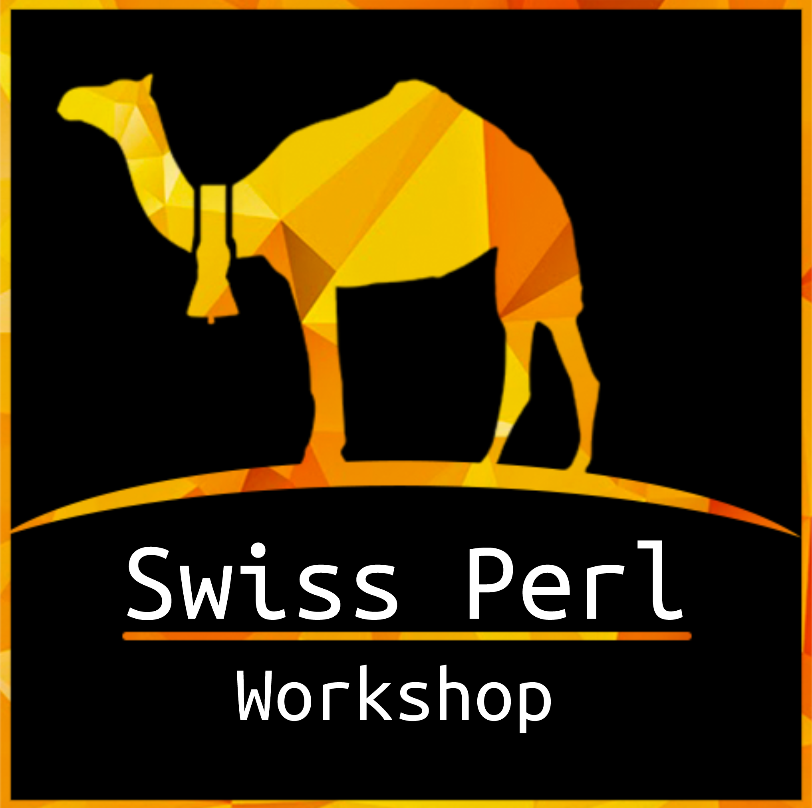
The Workshop

SPW is a two day event, with two tracks of technical talks and a range of workshops and training sessions, aimed at both beginner and experienced developers.

We anticipate up to 50 attendees, and while most are from Switzerland, we also get developers from surrounding countries. Switzerland is recognised as having a strong and vibrant open source community, and SPW is one of the key events on its calendar.

This year SPW is being held on Friday 16th August and Saturday 17th August in Olten.

Why sponsor the Swiss Perl Workshop?

Sponsor the Swiss Perl Workshop to get a real community audience for Perl related topics and present your company or association. You will get in touch with the Perl community directly and meet many developers face to face:

- Demonstrate your support for the Perl language and nurture your relationship with the local developer community.

- As a service provider, increase your brand’s visibility to a targeted audience.

- As an employer, raise awareness for your company and roles, interacting with engaged developers to increase your recruitment profile.

- Beyond your visibility on the day, we’ll work to promote you to a wider audience through blogging, talk videos, Twitter and other social media channels.

Sponsorship levels

Each level of sponsorship package is designed to maximise your company’s exposure to
those attending SPW and the wider Perl community.

- All sponsor blog posts will be promoted in the Perl Weekly, a newsletter that goes to thousands of Perl developers each week.

- All sponsors will be thanked at the event, and all attendees blogging about it afterward will be asked to thank all sponsors.

What could you sponsor?

You could sponsor any of the following items:

- Attendees dinner
- Drinks & catering during the event
- Travel & hotel costs for international visitors
- T-shirts or coffee/tea breaks
- Conference dinner and drinks

Or you could become a general sponsor. We have three packages:

Bronze: CHF 300 (€300)

- Logo, link, and paragraph of information about you on our website
- Logo included on video recordings of talks
- Mentions during the opening and closing speeches
- Mentions in blog posts on blogs.perl.org

Silver: CHF 500 (€500)

- Bronze Sponsor package and ...
- The option of displaying promotional material at the venue
- Free business tariff attendance for 1 person

Gold: CHF 1000 (€1000)

- Silver Sponsor package and ...
- Plus 2 more business attendees
- 5 minute presentation of your business

Additional sponsorship opportunities

If the above packages don’t meet your needs we’re happy to work with you on a
custom sponsorship package: get in touch & propose something!

Community rates also available.

Contact information

Lee Johnson - spw@perl-workshop.ch

