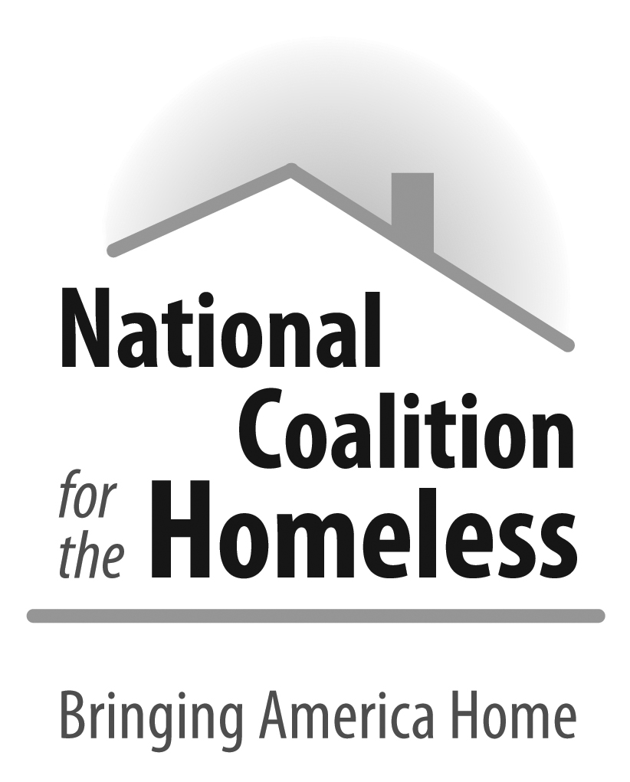

2016 Voter Registration Factsheet for Organizations

Overcoming Agency Resistance:
501(c)(3) organizations can operate voter registration drives if they do so in a non-partisan manner, meaning in a non-discriminatory way that does not show any bias towards or against any particular political group.

If you are not in a position to conduct an actual voter registration drive you can help register voters as part of your regular work.
- Ensure that voter registration forms are readily available to those accessing services, or integrate registration into your intake process.
- Combine voter registration drive with a candidate volunteer day or issue forum, which will also bring media coverage to your organization
Incorporating Voter Registration into the Intake Process:
- Appoint a Voter Registration Coordinator
  - The Coordinator will: contact the county election office or the Secretary of State’s office to get information on how to conduct voter registration during the intake process
    - How to contact your local election office : http://www.eac.gov/voter_resources/contact_your_state.aspx
  - Train the front desk staff on how to register voters and assist in voter registration based on the information you obtained from the county elections office or the Secretary of State’s office
  - Coordinate the collection of voter registration data with the staff, including the number of voters the staff registered and the contact information for those registered
- Make Voter Registration Pat of Your Intake and Publicize It
  - Post signs stating that clients have the right to vote, may register to vote here, and that they may use your organization’s address as a mailing address when registering to vote
  - Ask whether the person has moved, changed names, been arrested, or done anything that could alter his/her status as a registered voter
- Offer Clients Help in Filling Out Voter Registration Forms
  - Based on the voter registration information you receive from your county elections office, train staff to determine eligibility to voters, assist those registering to vote, and address issues that may arise such as problems with identification documents
- Keep Track of Voter Registration Statistics
  - Keep track of how many clients register to vote, are currently registered to vote, or do not want to vote
    - Manual with form on how many individuals you have registered : http://nationalhomeless.org/wp-content/uploads/2013/12/Manual_2012.pdf
Conducting a Successful Voter Registration drive:
- Develop a plan for your drive- what you mean to develop a plan
  - Appoint one person or a group of people to head up organization of the drive
  - Decide the day (do it on a special day to increase numbers), location, and time for your voter registration drive
- Prepare for and publicize the drive
  - Obtain necessary registration materials like forms, pens and clipboards, create flyers and poster to publicize the drive
  - Recruit some volunteers or other staff to help out with registration
- Conduct the registration drive
  - Be ready to answer questions that people may have about registering
  - Check to see if the forms are filled out correctly, and offer to mail the completed forms
- Get out the Vote
  - Put flyers up in your organization to remind your clients to vote on Election Day
  - Help educate newly registered voters about the voting process
  - Offer transportation to the polling place
Leading Up to Election Day:
- Hang signs in shelters telling the open hours and location (with a map) of the designated polling place if registered at the shelter
- Frequent reminders can increase incentive for homeless persons to go to the polls on Election Day
- Provide information about absentee ballot and early voting requirements and deadlines for your state
- Print newsletter or flyers about the candidates and issues and distribute them in shelters shortly before Election Day
- Hold a candidate’s forum so that people can become more familiar with candidates and their positions
On Election Day:
- Have a shelter designated as polling place
- Have volunteers on call to walk or drive clients or shelter residents to the polling places
- Arrange for a church or school bus to shuttle people to the election site throughout the day
- Encourage taxi companies and other forms of public transportation to provide free rides to the polling places
Voter Identification Laws in Effect in 2016:
- Definitions of each type of ID can be found here: http://www.ncsl.org/research/elections-and-campaigns/voter-id.aspx#Table 1 ; BallotPedia: https://ballotpedia.org/Voter_identification_laws_by_state#tab=Details_by_state
Strict Photo ID | Strict Non-Photo ID | Photo ID Requested | ID Requested/ Photo Not Required | No Document Required
 |  | Alabama
 |  |  | Alaska
 | Arizona
 |  |  | Arkansas
 |  |  |  | California
 |  |  | Colorado
 |  |  | Connecticut
 |  |  | Delaware
 |  |  |  | District of Columbia
 |  | Florida
Georgia
 |  |  |  | Guam
 |  | Hawaii
 |  | Idaho
 |  |  |  | Illinois
Indiana
 |  |  |  | Iowa
Kansas
 |  |  | Kentucky
 |  | Louisiana
 |  |  |  | Maine
 |  |  |  | Maryland
 |  |  |  | Massachusetts
 |  | Michigan
 |  |  |  | Minnesota
Mississippi
 |  |  | Missouri
 |  |  | Montana
 |  |  |  | Nebraska
 |  |  |  | Nevada
 |  |  | New Hampshire
 |  |  |  | New Jersey
 |  |  |  | New Mexico
 |  |  |  | New York
 |  | North Carolina
North Dakota
 | Ohio
 |  |  | Oklahoma
 |  |  |  | Oregon
 |  |  |  | Pennsylvania
 |  |  |  | Puerto Rico
 |  | Rhode Island
 |  |  | South Carolina
 |  | South Dakota
Tennessee
Texas
 |  |  |  | US Virgin Islands
 |  |  | Utah
 |  |  |  | Vermont
Virginia
 |  |  | Washington
 |  |  |  | West Virginia
Wisconsin
 |  |  |  | Wyoming

Other Links
Voter Identification Requirements by State : http://www.ncsl.org/research/elections-and-campaigns/voter-id.aspx
Voter Registration Manual : http://nationalhomeless.org/wp-content/uploads/2013/12/Manual_2012.pdf
Registration information, voting forms and other information : http://projectvote.org/?gclid=CjwKEAjwq6m3BRCP7IfMq6Oo9gESJACRc0bN-YvJXD_xOi3xKEypigH-CzHcQqBw2Z6Gx4fWuXNVCxoCP8zw_wcB
Nonprofit Vote http://www.nonprofitvote.org/voting-in-your-state.html?gclid=CjwKEAjwq6m3BRCP7IfMq6Oo9gESJACRc0bNCgtLscSRalOGyzu_43Y5GbYHtmLRgfttu78X0okr1hoCT2bw_wcB

