**Overview**

The robot itself is going to be explained over several sections detailing its hardware components, software used and how it all links together and functions.

There are a couple of modes that can be set in order to impact the behavior of the robot:

* Manual Mode
* Auto Mode

**Hardware**

Below is a list of hardware components that are hooked together to give the robot several abilities, their names, functions and responsibilities.

**Main Board:**

A Raspberry Pi 3 Model B was purposed and programmed to function as the “brain” of the robot, which is connected to many hardware components.

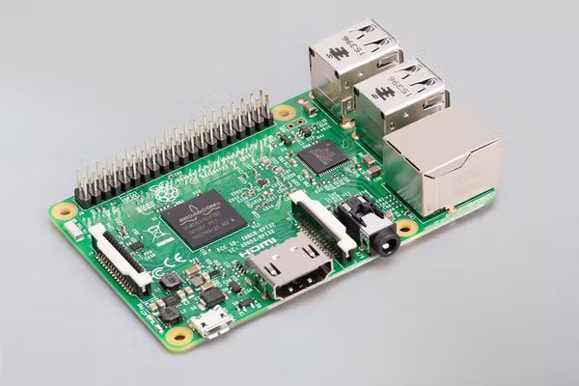

Its responsibilities include:

* Camera recording.
* Image processing.
* Making decisions. **(Auto Mode)**
* Streaming info to the remote controller.
* Receiving commands from the remote controller.

More on this will come later.

**Motors Board:**

As explained earlier there are many motors and moving parts within the robot which calls for a central controlling mechanism, hence the inclusion of an Arduino Nano inside the build which is used for that very specific reason.

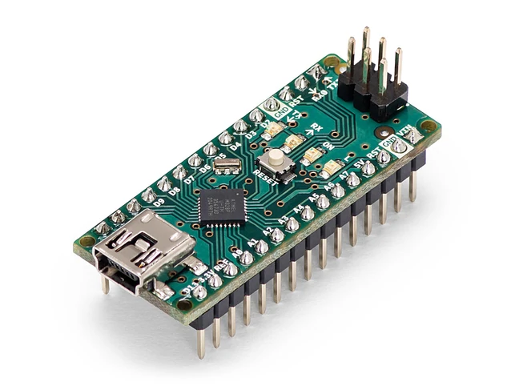

It exposes an interface which is accessed via commands that are sent over the serial bus from the Main Board.

Those commands primarily control:

* Moving each motor separately. Clockwise and counterclockwise.
* Modifying the speed of each motor separately.
* Moving each arm motor separately.
* Modifying the speed of each arm motor separately.

**Ultrasonic Sensors:**

2 Ultrasonic Sensors are equipped for navigational purposes.

They’re mounted on the front-left and front-right facing corners of the robot.

Their responsibilities are:

* scanning ahead of the robot.
* aiding in the perpendicular alignment to any obstacles intended to be climbed over.

**Gyroscope Sensor:**

a Gyroscope Sensor is mounted and primarily used to detect if the robot has turned upside down in which case a shutdown protocol is initiated.

**Camera:**

A Raspberry Pi Camera Rev 1.3 is mounted to scan the surroundings which is used for object detection, more on this below.

**Remote Controller:**

A Raspberry Pi Zero W is used to drive the other components including a

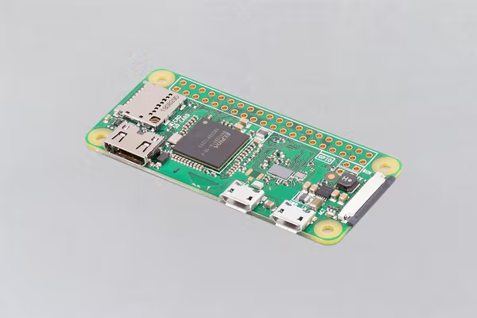 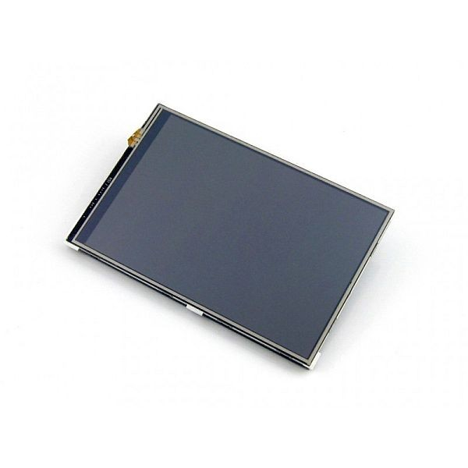

**Software**

Following the hardware above obviously comes the software, which “glues“ it all together.

Trivials aside such as sending and receiving data from the remote controller the main talk of this section is how object detection works and how it is implemented.

**Object Detection:**

Within the main board a Convolutional Neural Networks (CNN) had to be implemented in order to process the visuals the camera provides and detects the objects in sight.

Lets start with a surface level explanation of how a CNN is able to recognize objects.

But as it’s usually the case with these things solving the simplest possible version of a given problem is key here.

What’s the simpler version of detecting objects? Detecting glyphs, numerical digits to be precise.

Lets look at this from a higher point of view, a CNN or any neural network for that matter is a black box that takes input and produces output.

And in our case the input is an image of the environment or in the simpler version an image of a handwritten numeric digit.

And the output will obviously be the detected digit itself.

Now different Neural Networks implement the insides of the previously alluded “black box” however the one implemented within the robot is a CNN.

...