**Sprint 2 challenge**

**Task 1**

select count(employee_id) from employees;

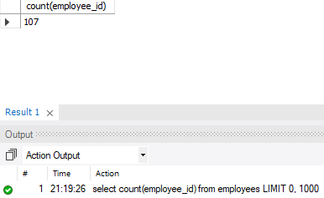

**Task 2**

select department_id, count(employee_id) from employees group by department_id;

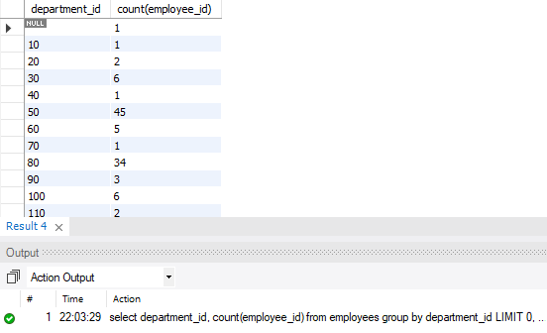

**Task 3**

select first_name, salary from employees where salary > 6000;

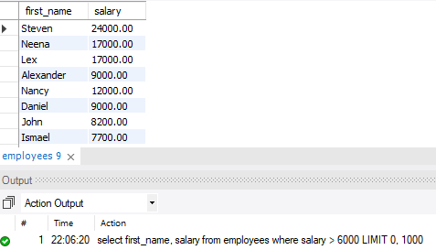

**Task 4**

select count(employee_id) from employees where salary > 20000;

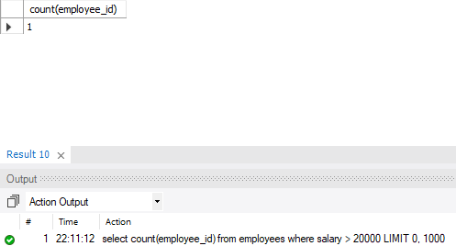

**Task 5**

select * from employees where commission_pct is not null; -- alt 1

select * from employees where commission_pct >= 0; -- alt 2

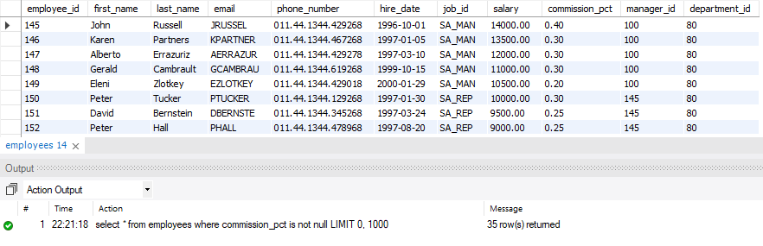

**Task 6**

select concat(first_name, ' ', last_name) as "fullname" from employees where commission_pct is null;

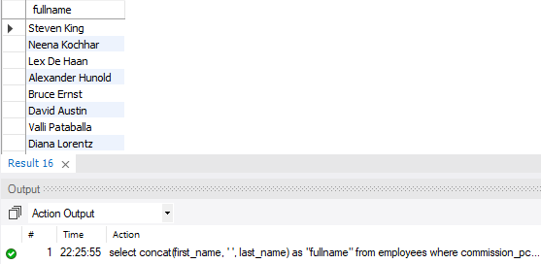

**Task 7**

select employee_id as "Employee ID", concat(first_name, ' ', last_name) as "Employee Full Name", email as "Email ID", phone_number as "Contact Number"

from employees

where commission_pct is not null;

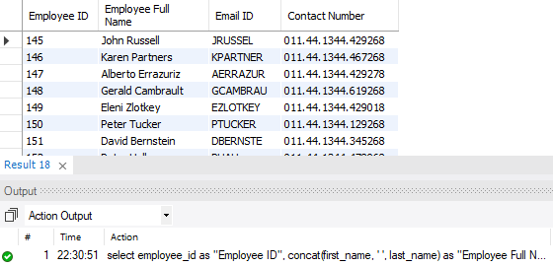

**Task 8**

select max(salary), department_id from employees group by department_id limit 3;

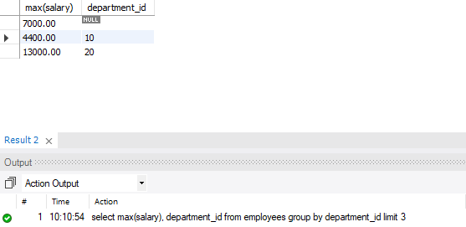

**Task 9**

select * from employees where job_id like '%clerk';

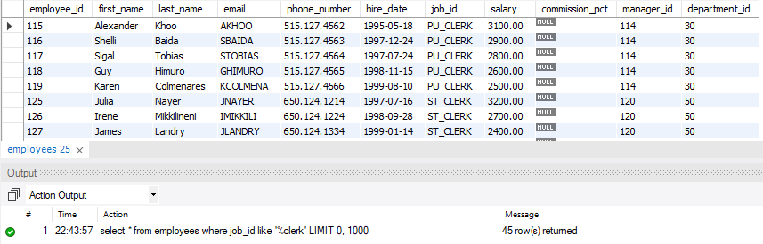

**Task 10**

select count(employee_id), avg(salary) from employees where job_id like '%clerk%';

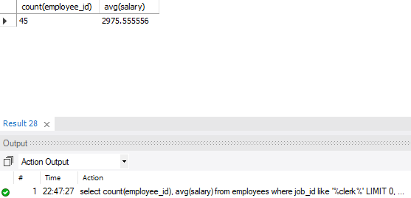

**Task 11**

select department_id, count(employee_id) from employees where salary between 7000 and 10000 group by department_id;

