**Sprint 2 practice**

**Task 1**

select * from salespersons where salesperson_city = "london";

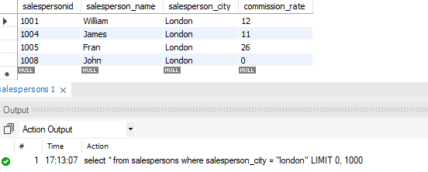

**Task 2**

select * from salespersons where commission_rate = 0;

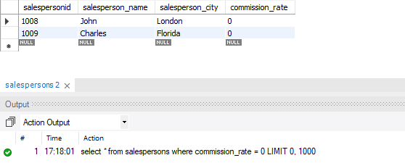

**Task 3**

select * from salespersons order by commission_rate desc limit 3;

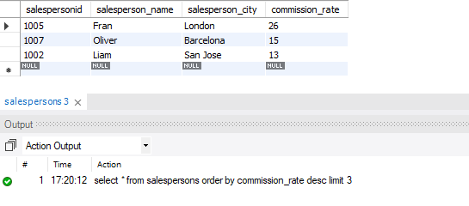

**Task 4**

select avg(commission_rate) from salespersons;

select * from salespersons where commission_rate < (select avg(commission_rate) from salespersons); -- task 4 alt method 1

select * from salespersons where commission_rate < 10.8750; -- task 4 alt method 2

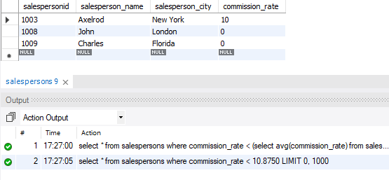

**Task 5**

select avg(commission_rate) from salespersons;

select * from salespersons where commission_rate < (select avg(commission_rate) from salespersons) and salesperson_city = "london"; -- task 5 alt method 1

select * from salespersons where commission_rate < 10.8750 and salesperson_city = "london"; -- t5 alt method 2

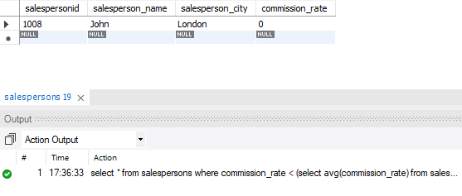

**Task 6**

select * from salespersons where salesperson_city = "florida" and salesperson_city = "barcelona" and salesperson_city = "san jose";

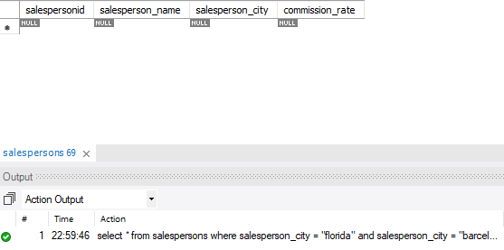

**Task 7**

select min(c_rating) from customers;

select * from customers where c_rating = 100; -- task 7 alt method 1

select * from customers where c_rating <= (select min(c_rating) from customers); -- task 7 alt method 2

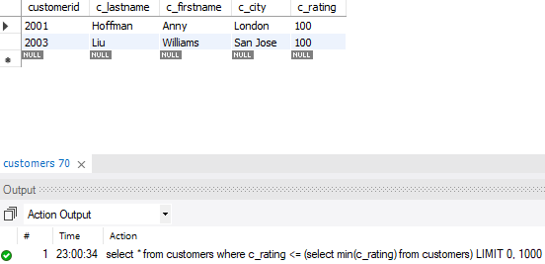

**Task 8**

select max(c_rating) from customers;

select * from customers where c_rating = 300; -- task 8 alt method 1

select * from customers where c_rating >= (select max(c_rating) from customers); -- task 8 alt method 2

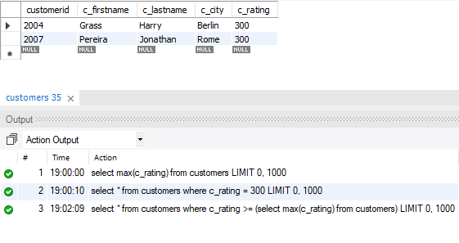

**Task 9**

select max(c_rating) from customers;

select c_city from customers where c_rating = 300; -- alt 1

select c_city from customers where c_rating >= (select max(c_rating) from customers);-- alt 2

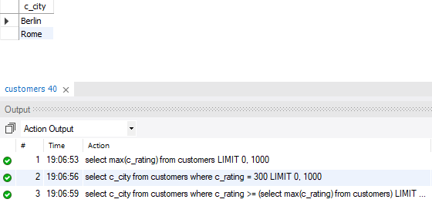

**Task 10**

select * from customers order by c_rating desc;

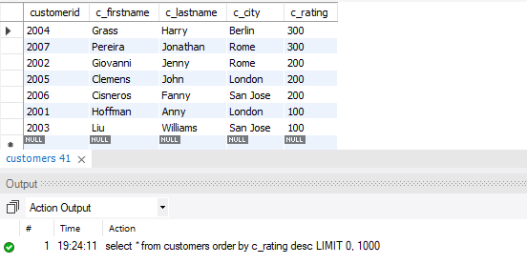

**Task 11**

select concat(c_firstname, ' ', c_lastname) as "Name" from customers where c_firstname like 'J_n%';

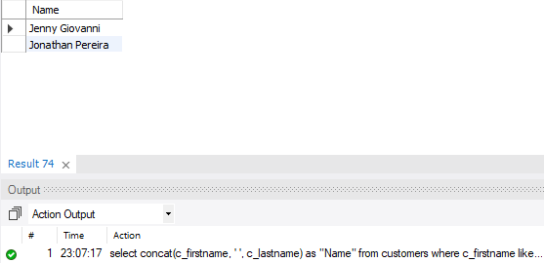

**Task 12**

select avg(amount) as "average amount", max(amount) as "maximum amount" from orders;

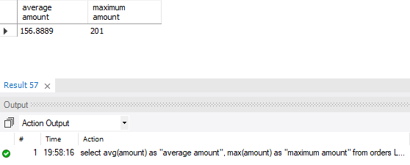

**Task 13**

select count(*) from orders;

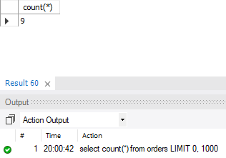

**Task 14**

select month(orderdate), sum(amount), avg(amount) from orders group by month(orderdate);

