**-- task 1.1**

select name from country where code in ("usa", "gbr", "are");

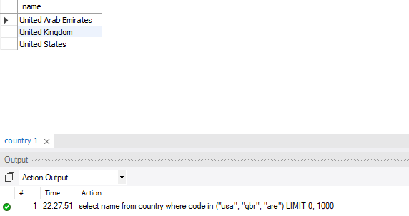

**-- task 1.2**

select avg(population) as 'World_Average' from (select continent, sum(population) population from country group by continent) AveragePop;

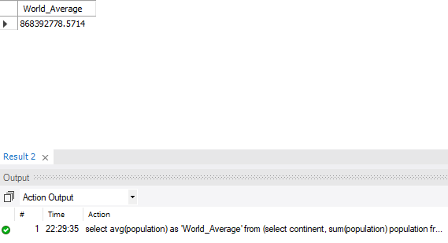

**-- task 1.3**

select name, continent from country where code in (select countrycode from countrylanguage where language = "french" and continent = "europe");

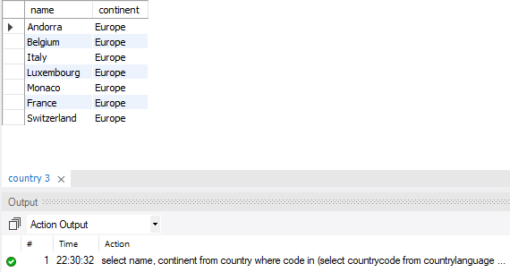

**-- task 1.4**

select name, population, continent from country task8country1 where population >= all (select population from country task8country2 where task8country1.continent = task8country2.continent);

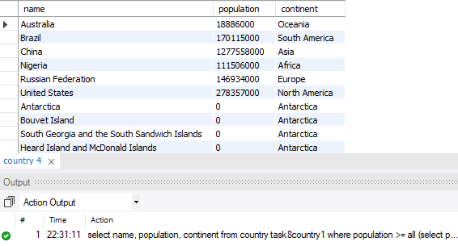

**-- task 2.1**

select film_id, count(inventory_id) from inventory where film_id in (select film_id from film where title = "brotherhood blanket" or title = "soup wisdom") group by film_id;

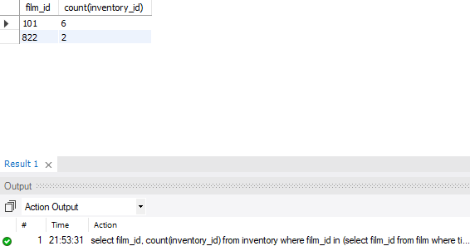

**-- task 2.2**

select (select (select name from category where category.category_id = film_category.category_id) from film_category where inventory.film_id = film_category.film_id) as genre, count(inventory_id) from inventory group by genre;

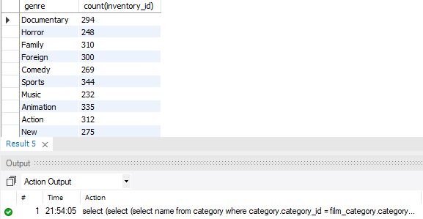

**-- task 2.3**

select concat(first_name, ' ', last_name) as "Name", (select sum((select replacement_cost from film where film.film_id = film_actor.film_id)) from film_actor where actor.actor_id = film_actor.actor_id group by actor_id) as replacement_cost from actor order by replacement_cost desc limit 3;

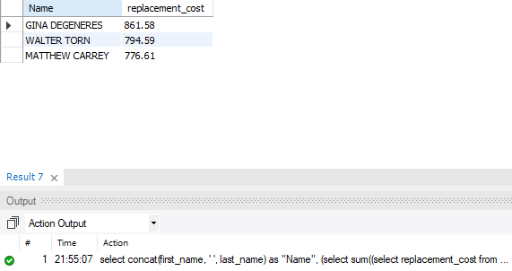

**-- task 2.4**

select (select (select name from category where category.category_id = film_category.category_id) from film_category where inventory.film_id = film_category.film_id) as genre, count(inventory_id) * sum((select replacement_cost from film where film.film_id = inventory.film_id)) as total_sales from inventory group by genre;

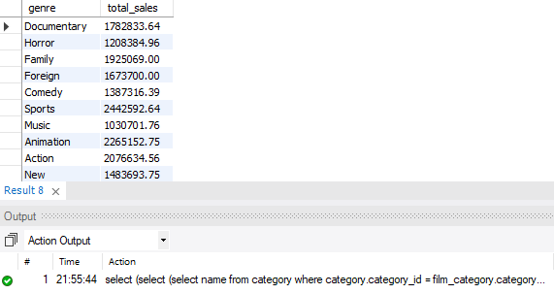

**-- task 2.5**

select * from (select category.name, (select sum(amount) as totalsales from payment where rental_id in (select rental_id from rental where inventory_id in (select inventory_id from inventory where film_id in (select film_id from film_category where category.category_id = film_category.category_id)))) "totalsales" from category order by totalsales desc limit 10) a into outfile 'C:/ProgramData/MySQL/MySQL Server 8.0/Uploads/filename2.csv' fields terminated by ',' lines terminated by '\n';



