**R Installation Guide (Mac)**

**Step 1 – Install base R**

* Download the R installer from <https://cran.r-project.org/bin/macosx/>

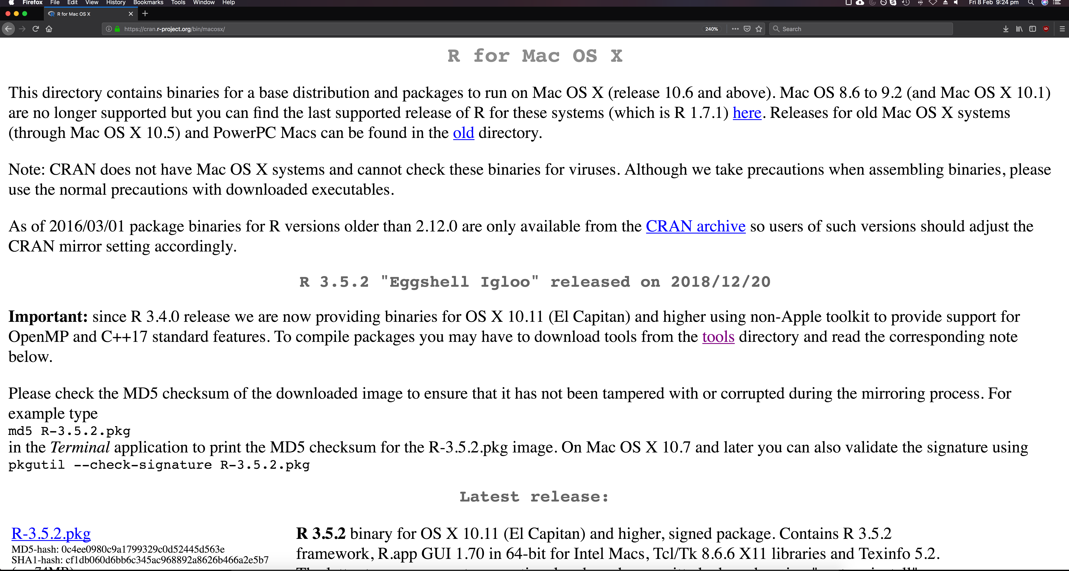

* Run the installer

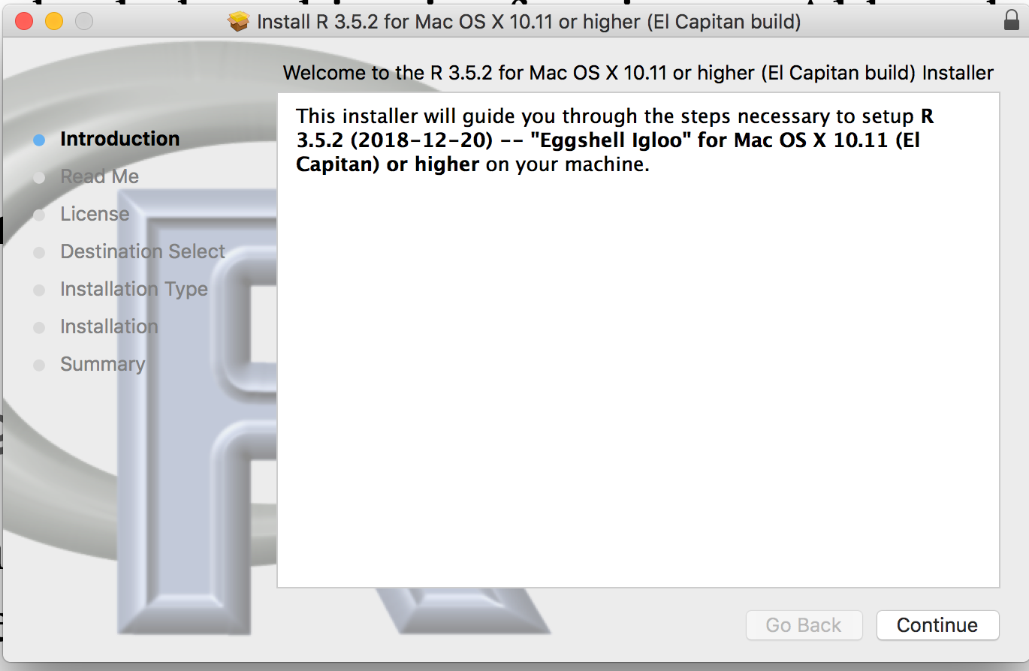 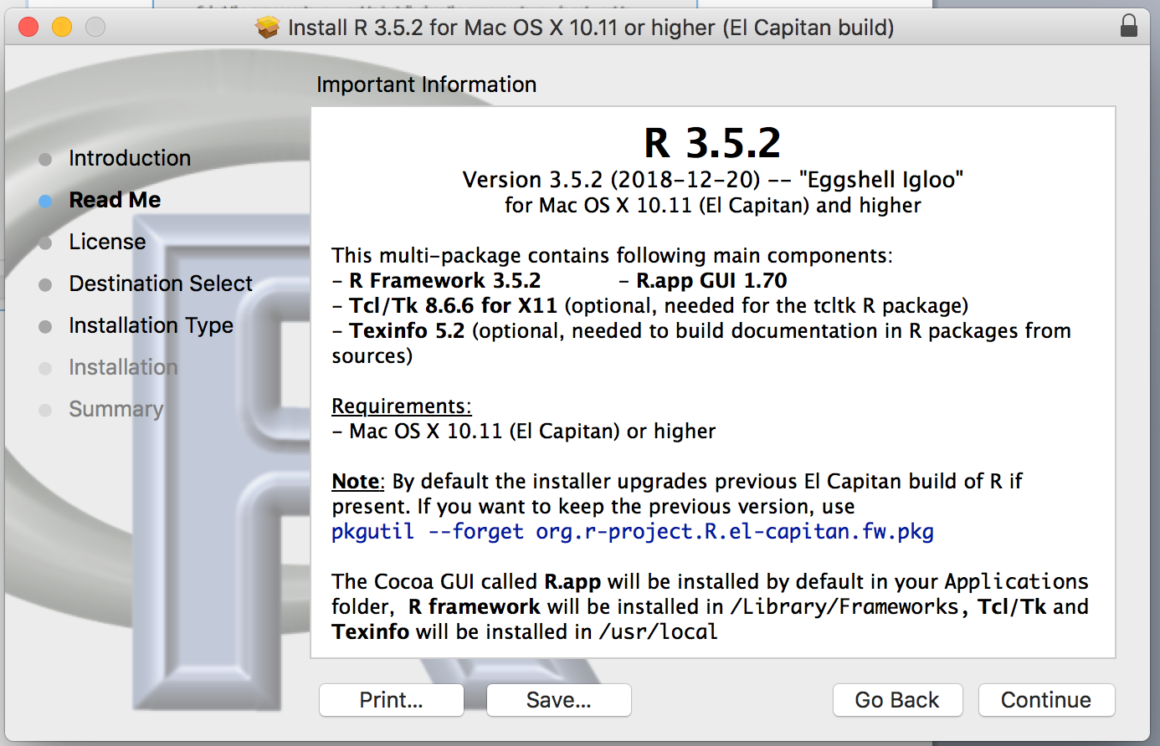

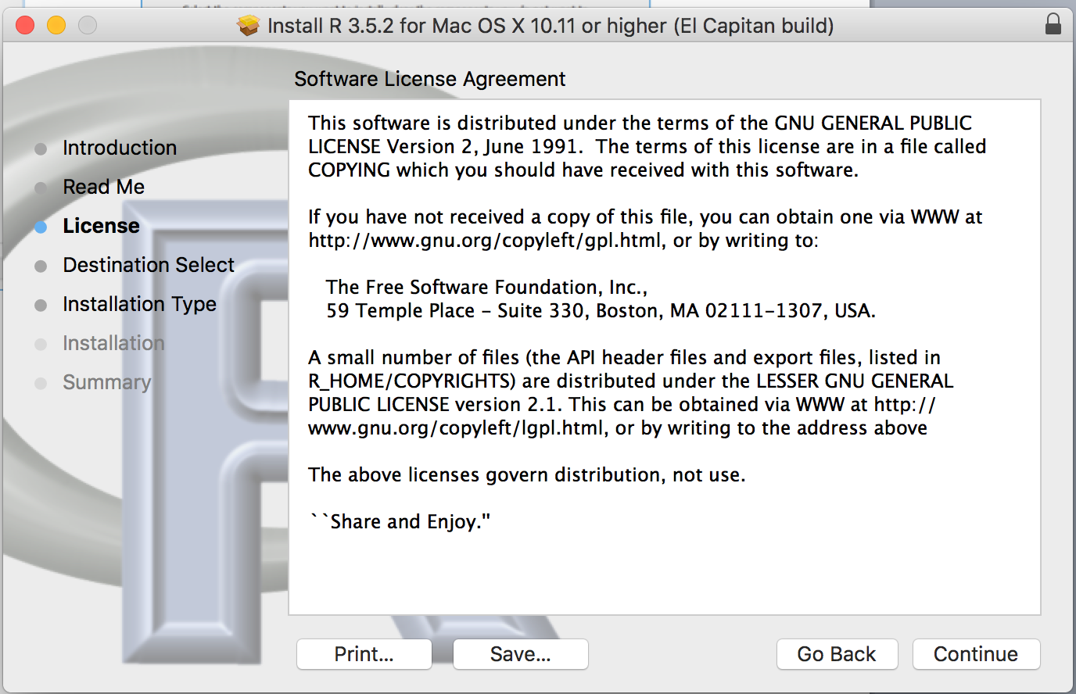 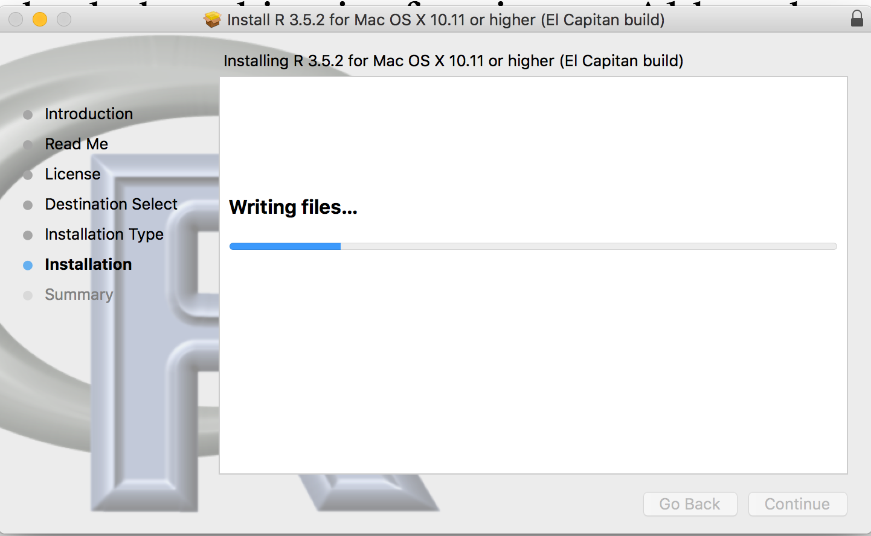

­­­­­

**Step 2 – Install RStudio**

RStudio is an open source development environment for R. It adds functionality to make R coding easier and faster.

* Download the RStudio installer from <https://www.rstudio.com/products/rstudio/download/>

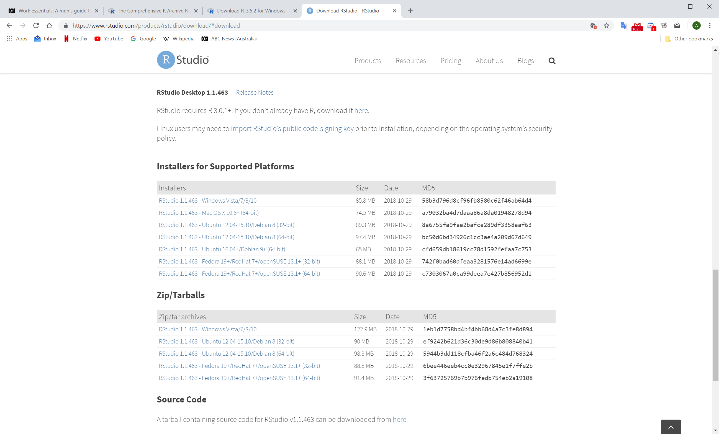

* Install RStudio (drag RStudio icon to Applications)

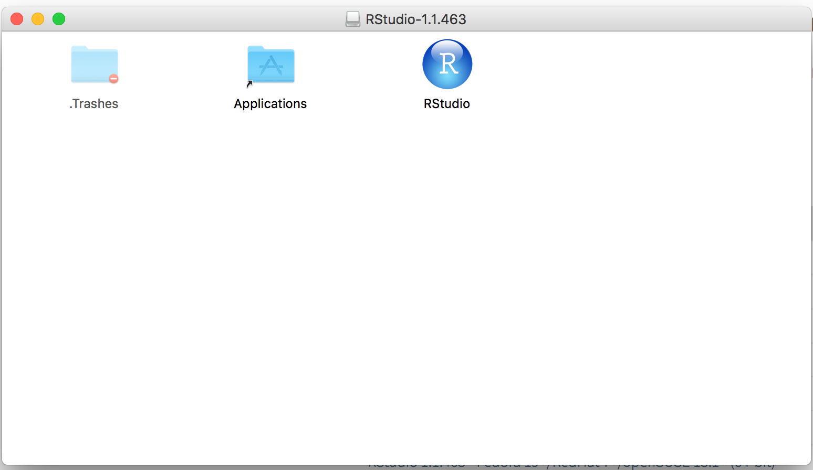

**Step 3 – Open Rstudio**

* Open RStudio

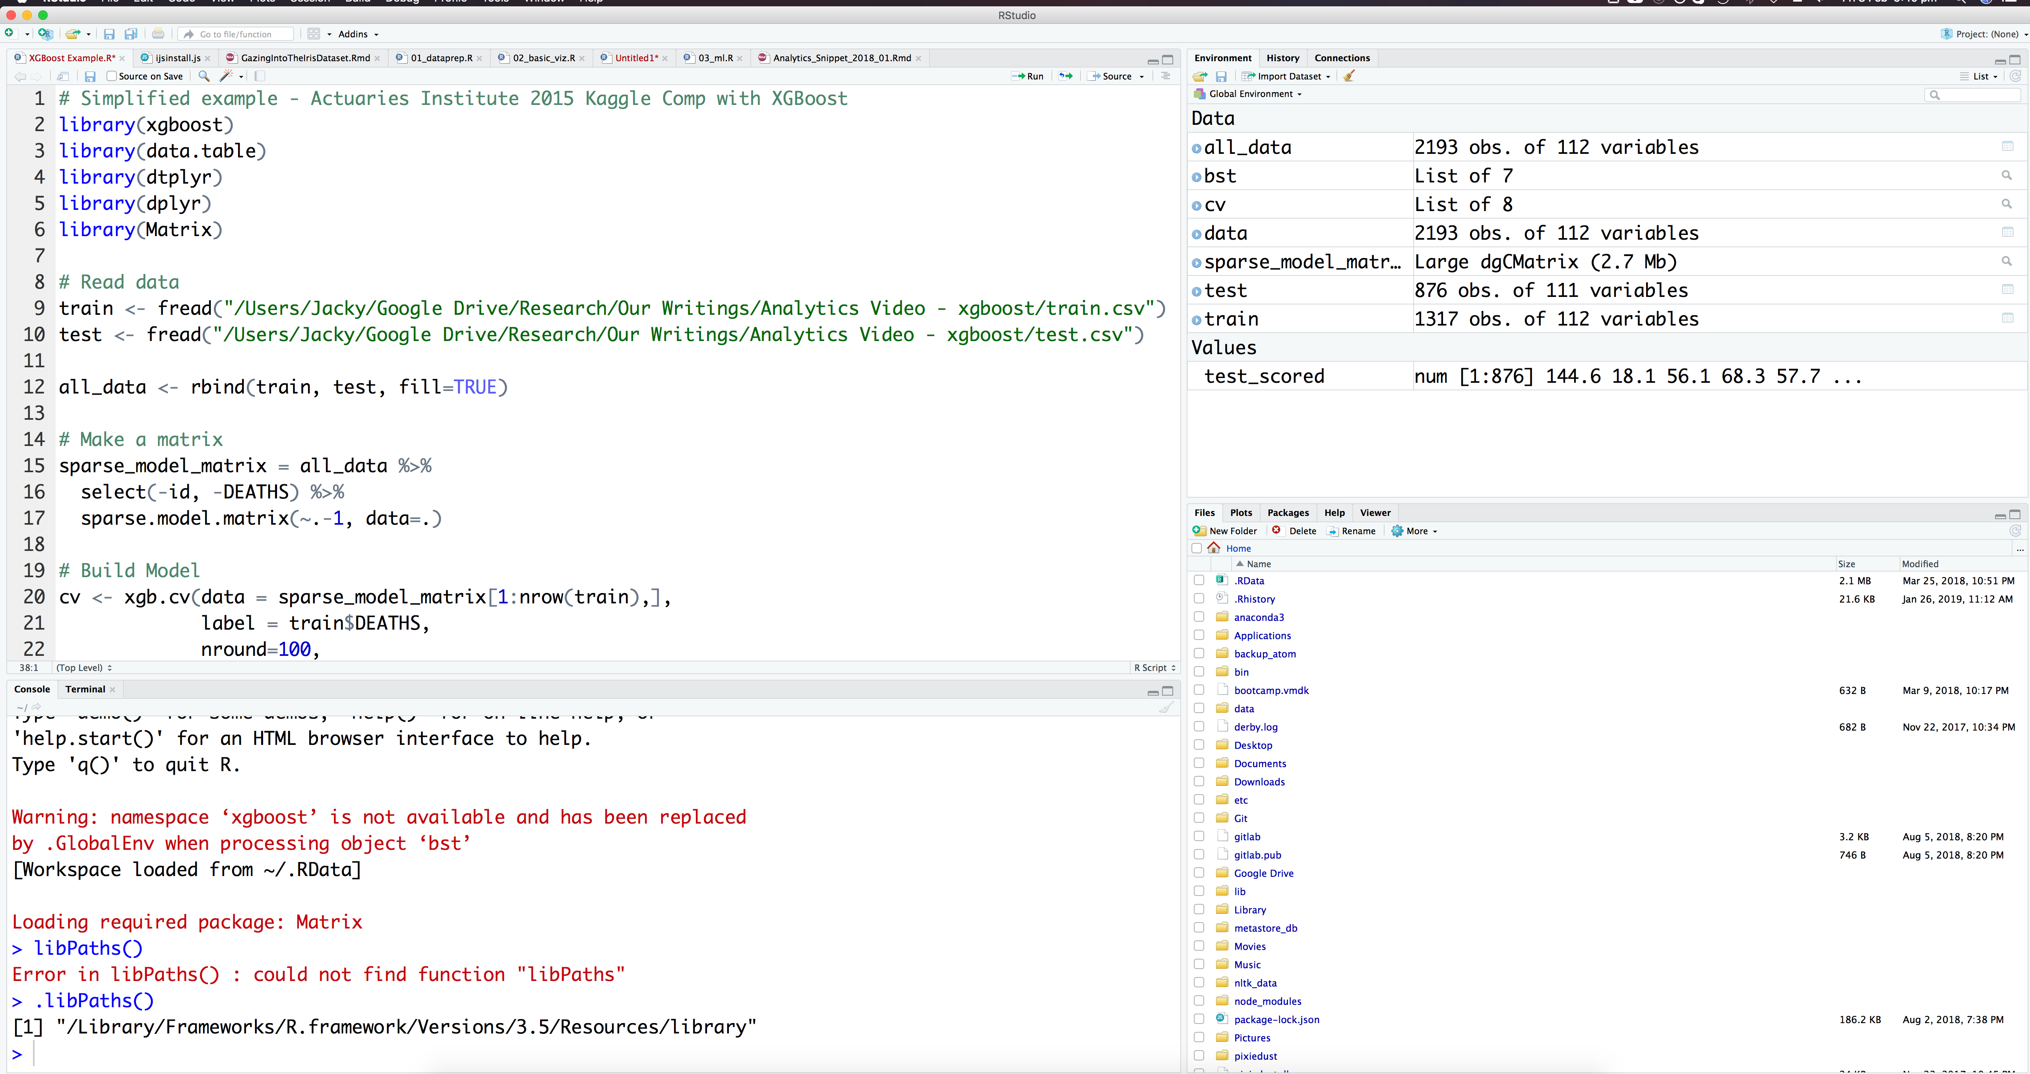

R Console

Code Editor

You can customise the appearance of the editor in the menu: Rstudio > Preferences. This includes font size, dark themes and even the layout.

**Step 4 – Install the packages for this workshop**

* The “install.packages” command will download and install R packages
* Packages that require other packages will install all dependencies at once
* This workshop will use the following packages:
* randomForest
* DALEX
* caret
* ggplot2
* reshape2

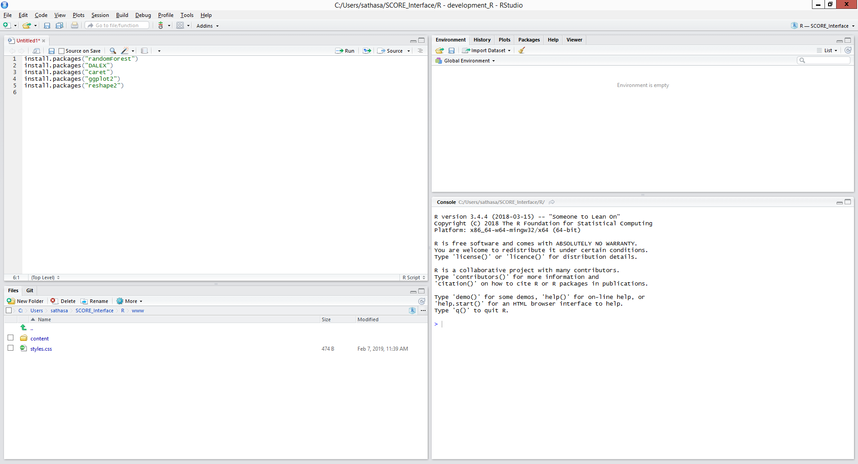

* Run “install.packages(<<package name>>)” for each of the packages listed above
* This will download and install the packages into your library
* Finally, run the “library(<<package name>>)” command to load the library into your R session

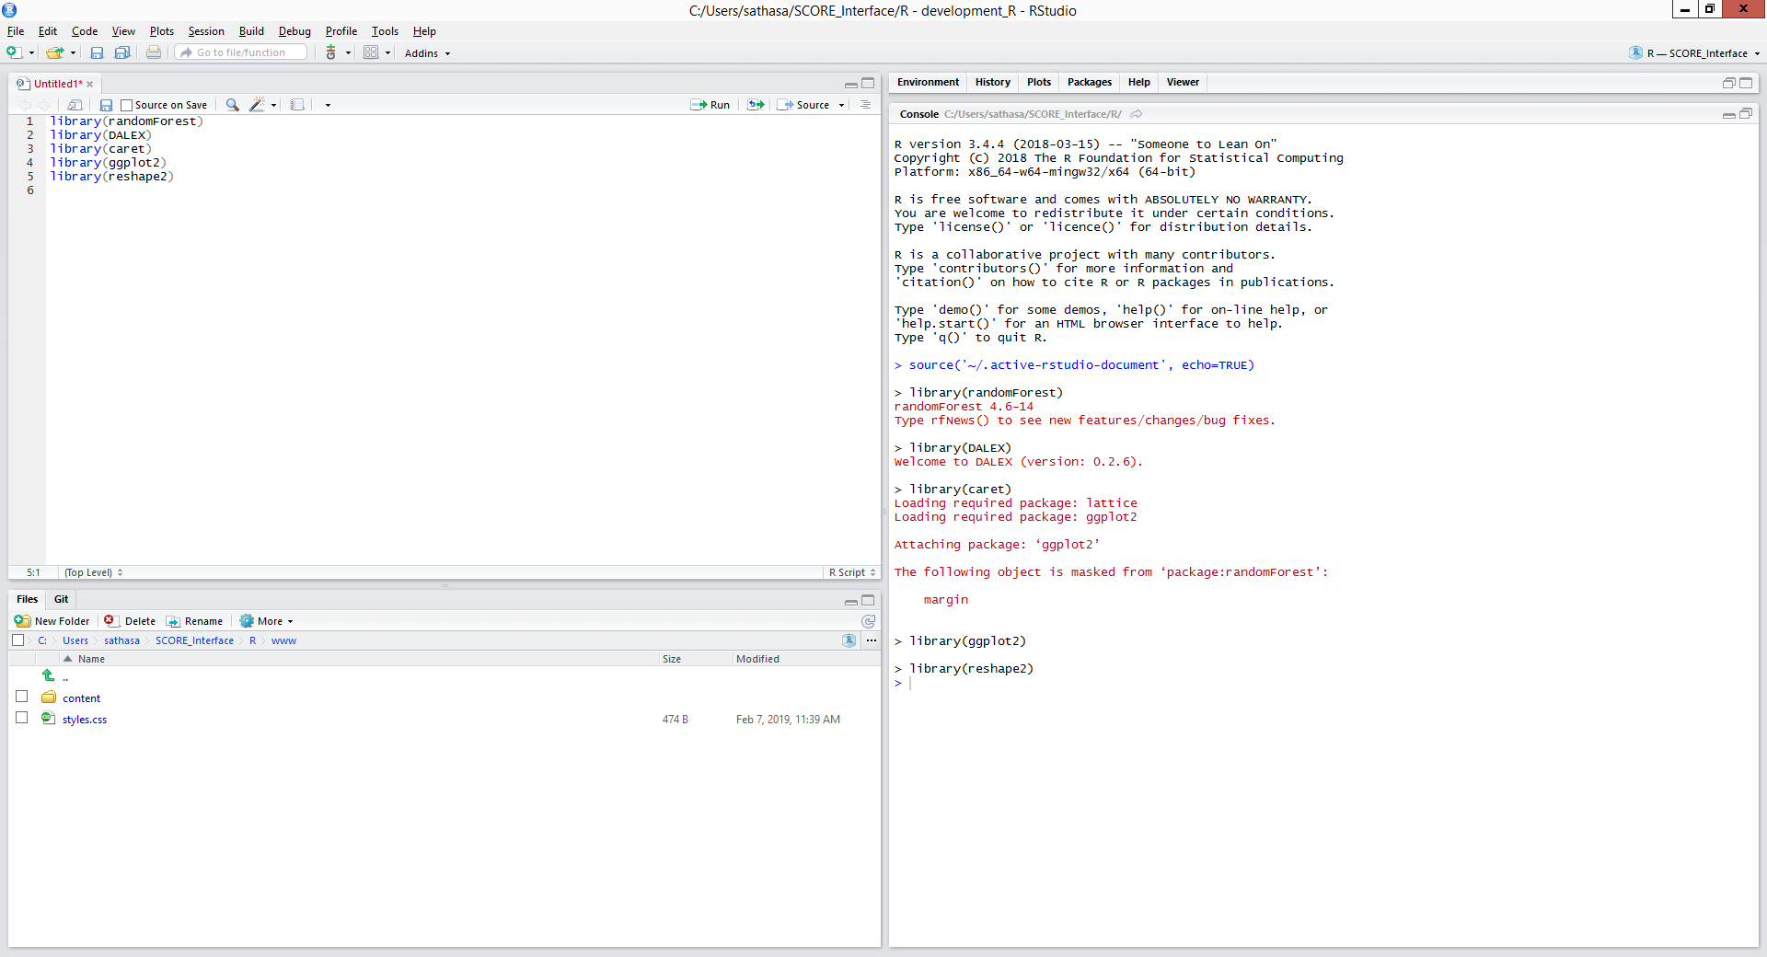

You can use the sessionInfo() command to list out the packages your R session has attached.

