**R Installation Guide**

**Step 1 – Install base R**

* Download the R installer from <https://cran.r-project.org/bin/windows/base/>

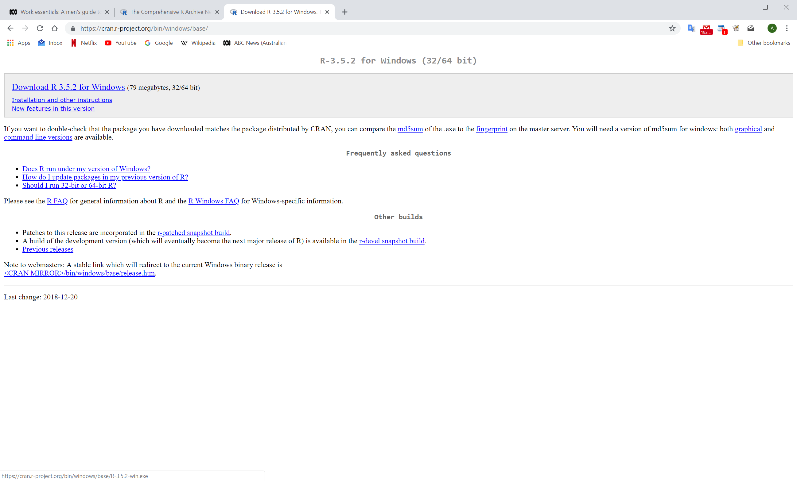

* Run the installer

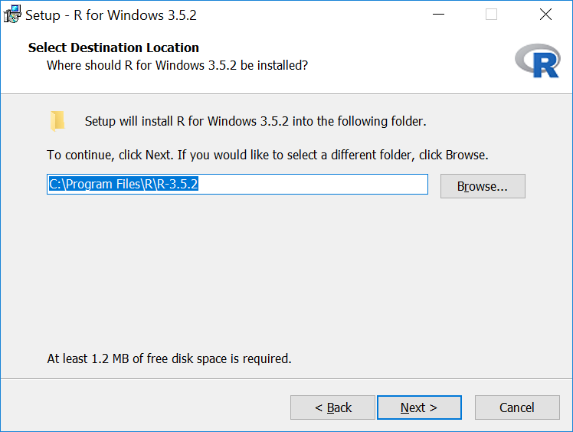 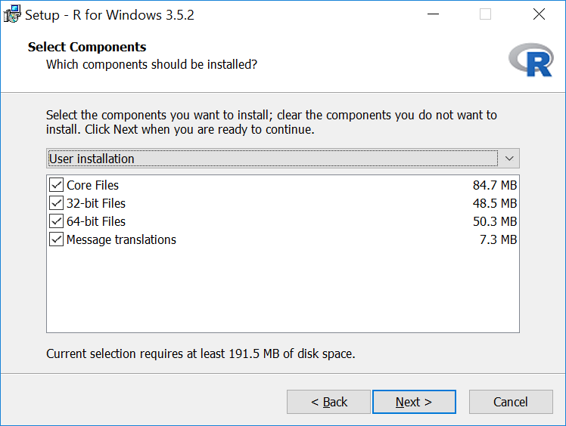

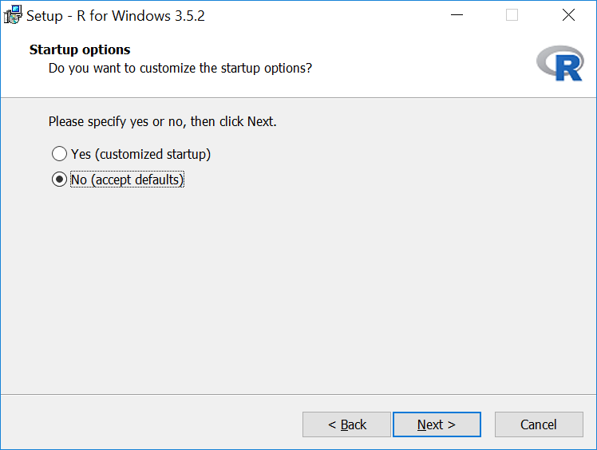 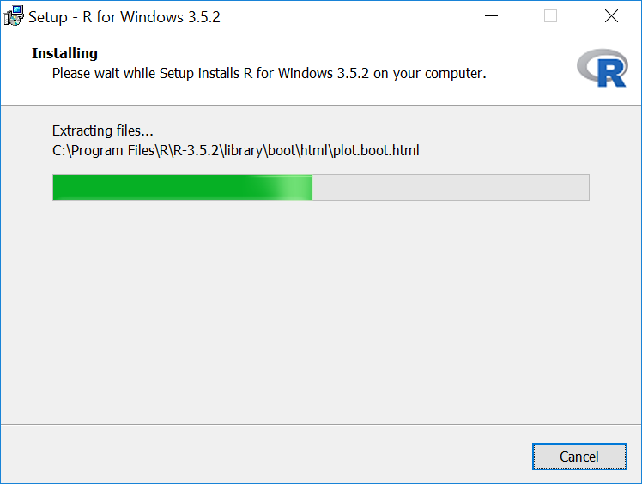

**Step 2 – Install RStudio**

RStudio is an open source development environment for R. It adds functionality to make R coding easier and faster.

* Download the RStudio installer from <https://www.rstudio.com/products/rstudio/download/#download>

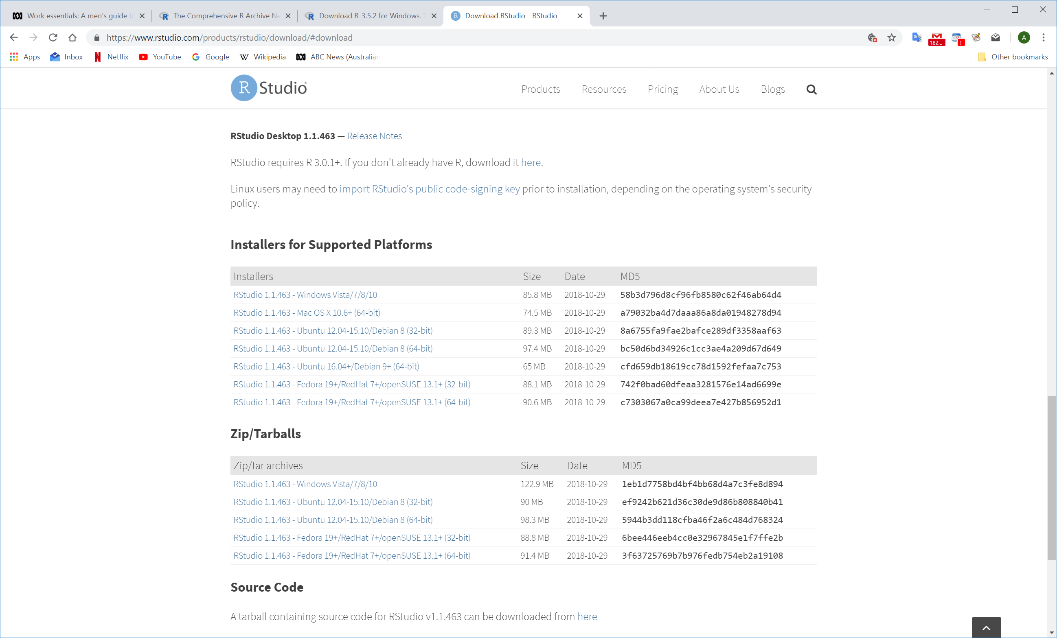

* Install RStudio

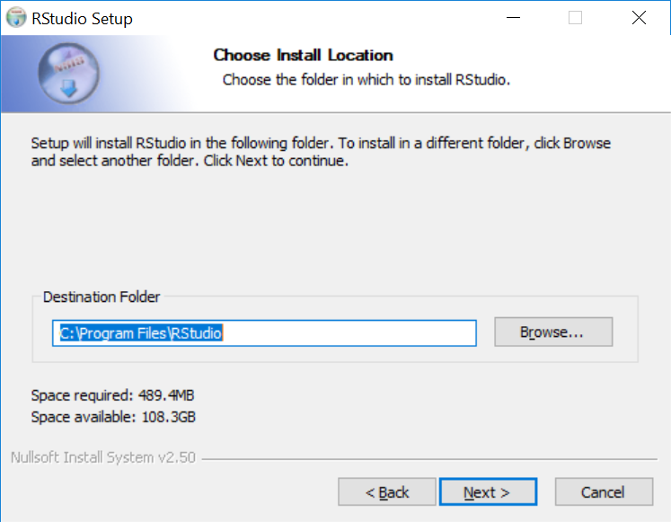

**Step 3 – Setup package installation location**

* Open RStudio

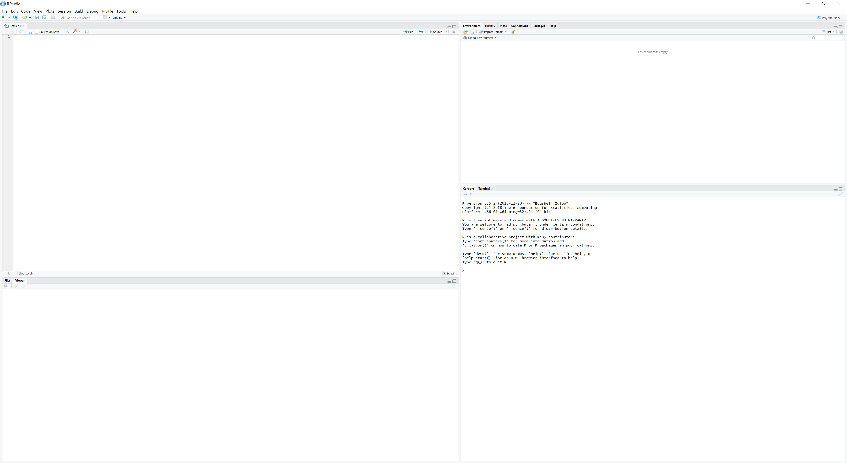

* Type “.libPaths()” into the code editor and run

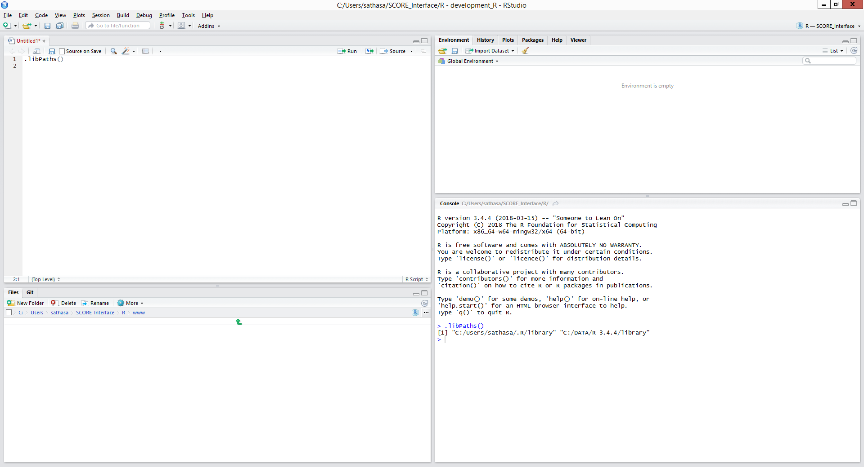

R Console

Code Editor

Packages are additional functions and tools that extend R’s functionality. They are critical to making full use of R and RStudio.

The file paths listed in the console from the .libPaths() command are the locations that external R packages will install to. The default location is usually where R was installed – you can change this in one of two ways:

* Run the .libPaths(<<path>>) command with your desired library path
* Set the R_LIBS_USER environment variable with your path:

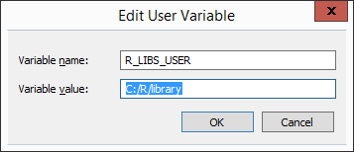

**Step 4 – Install the packages for this workshop**

* The “install.packages” command will download and install R packages
* Packages that require other packages will install all dependencies at once
* This workshop will use the following packages:
* randomForest
* DALEX
* caret
* ggplot2
* reshape2

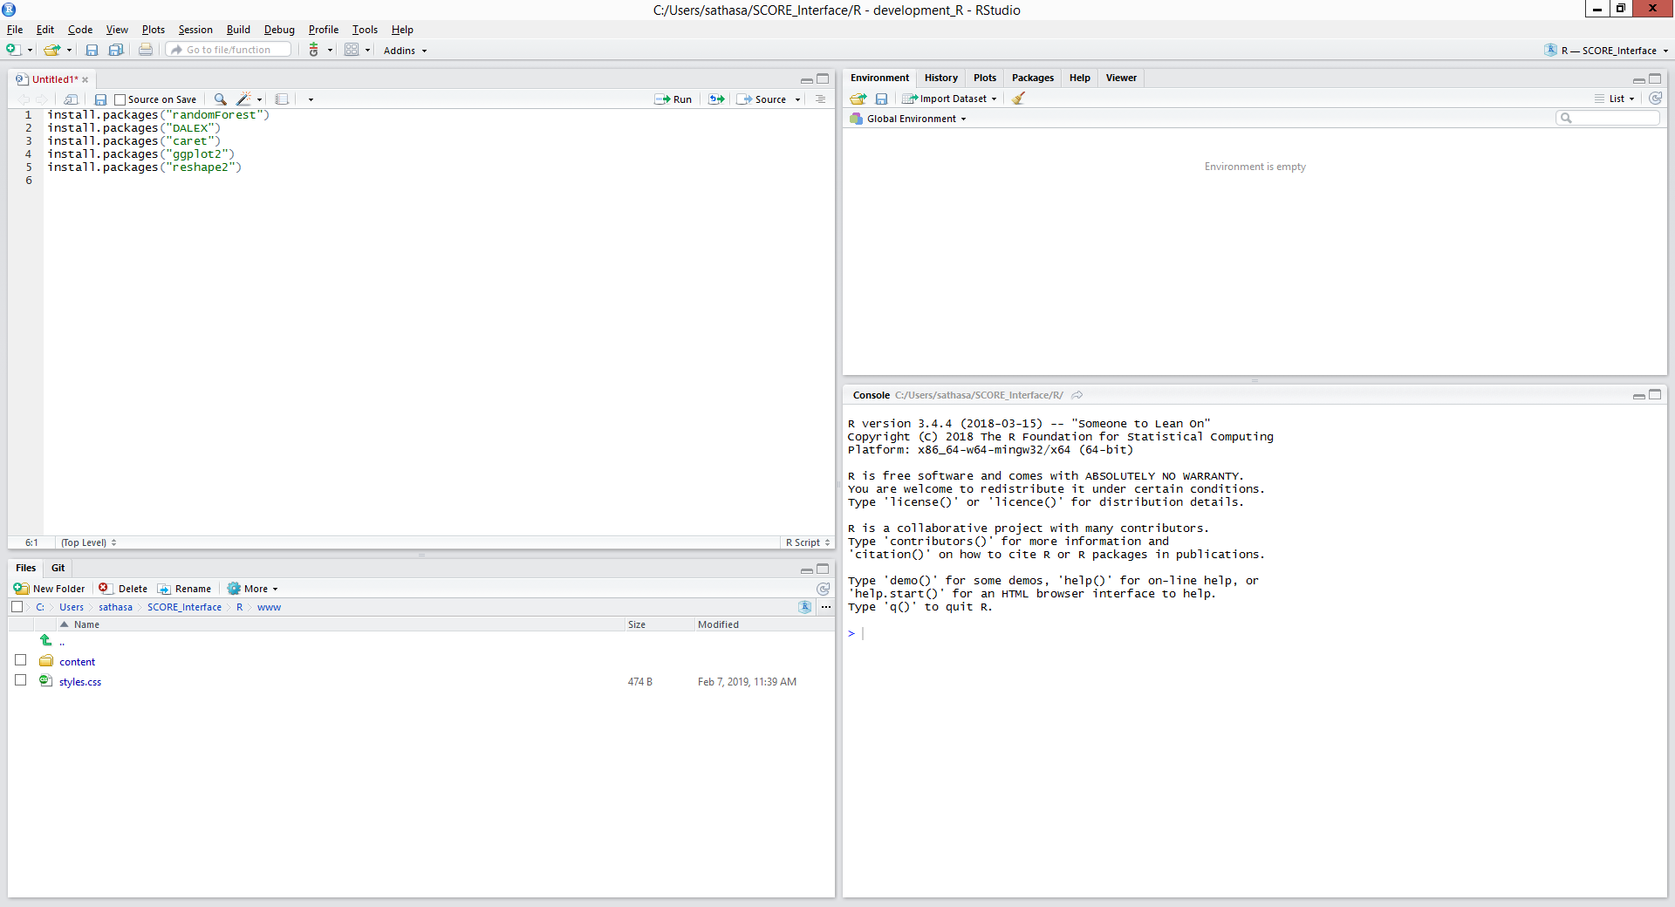

* Run “install.packages(<<package name>>)” for each of the packages listed above
* This will download and install the packages into your library
* Finally, run the “library(<<package name>>)” command to load the library into your R session

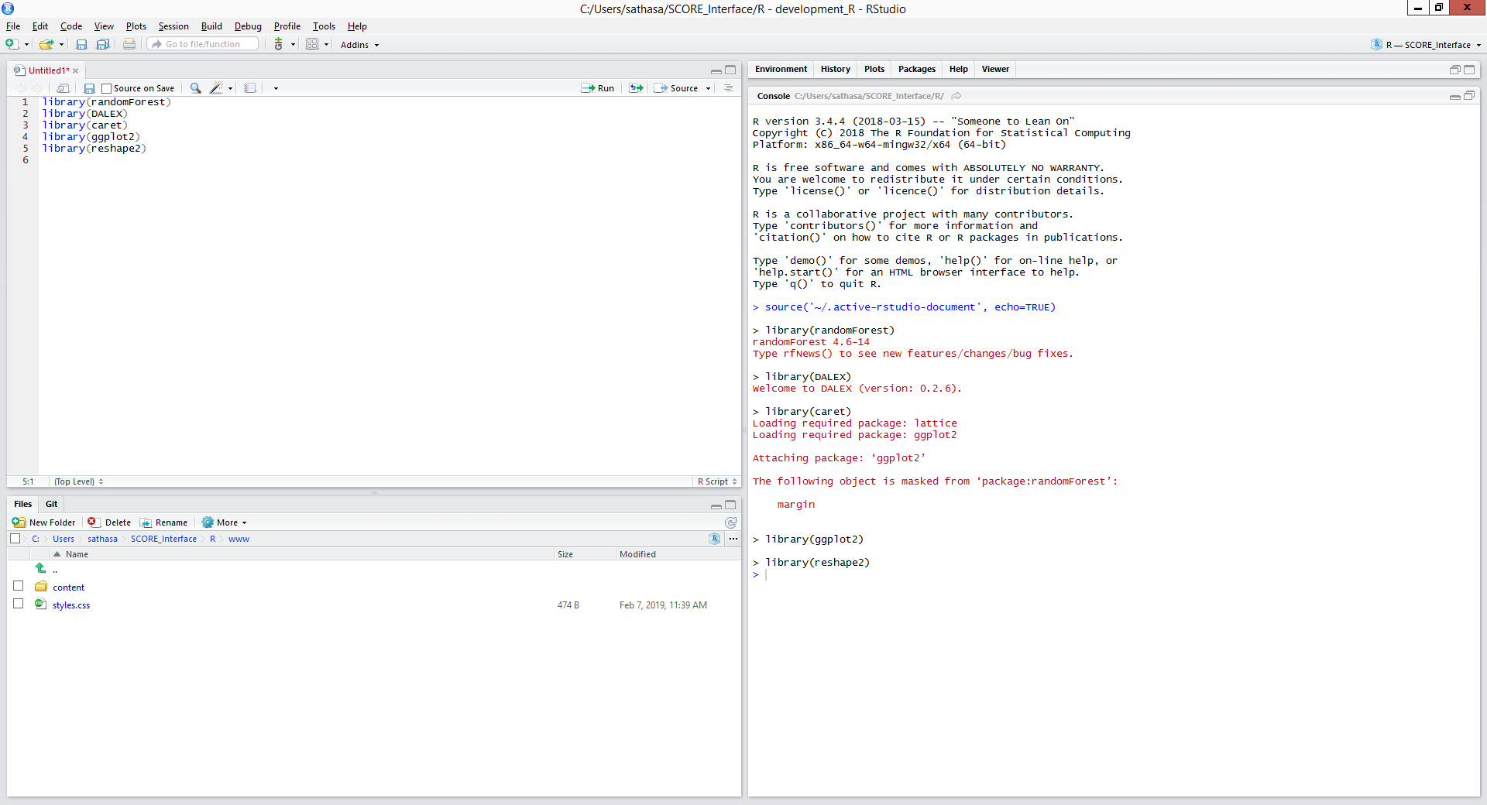

You can use the sessionInfo() command to list out the packages your R session has attached.

