Welcome to the R Case Study Prep Workshop!

This document will help you to get ready for the session being held on the February 28th (5:30pm-7:30pm), as well as the subsequent case study workshop on the 20th of March (3:30pm-7:30pm).

1. You will need to install R and RStudio.

Click here for the Windows guide, and here for the Mac guide.

1. Please complete the [Datacamp intro course on R](https://www.datacamp.com/courses/free-introduction-to-r). This will probably take 1-2 hours.
2. Bring your laptop to the session on 28th Feb! We will be covering the basics of how to prepare data, visualisations and machine learning.

If you have trouble with any of the following instructions, please post on the discussion forum! Your fellow attendees will be able to help out. The mentors running the workshops will also be monitoring the forums to provide further guidance if needed.

**R Installation Guide (Windows)**

**Step 1 – Install base R**

* Download the R installer from <https://cran.r-project.org/bin/windows/base/>

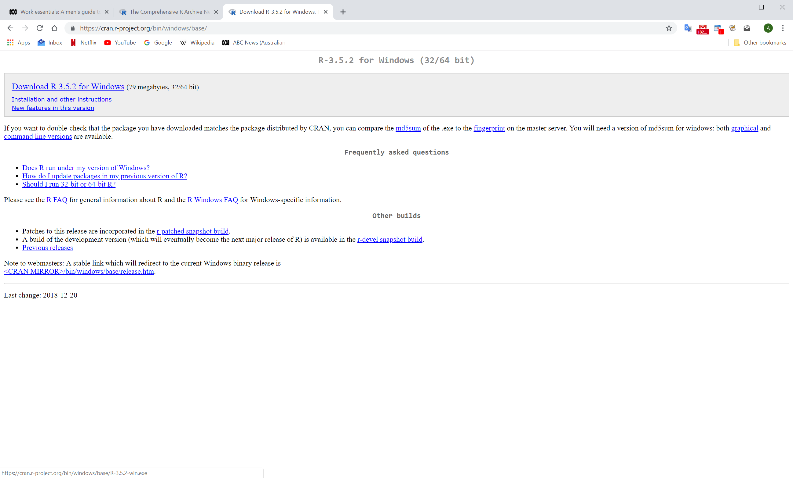

* Run the installer

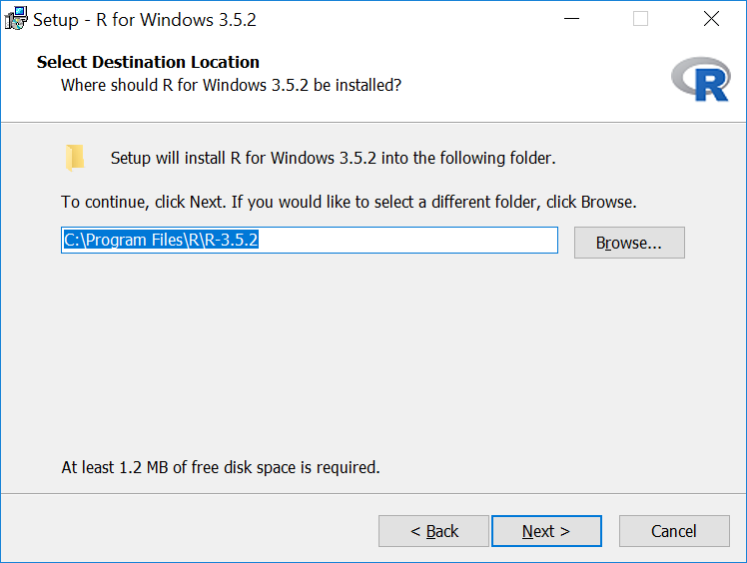 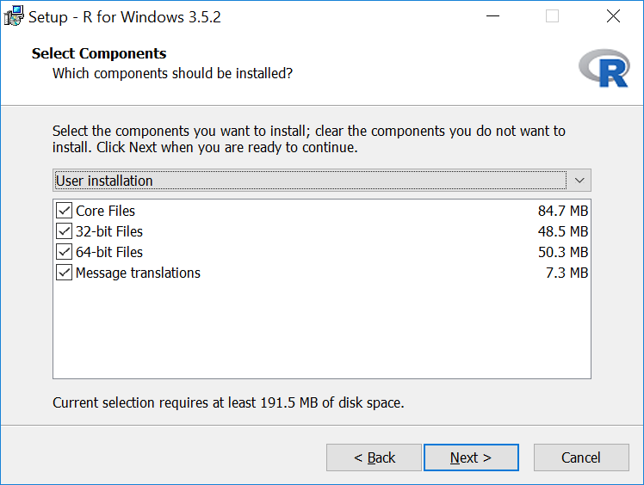

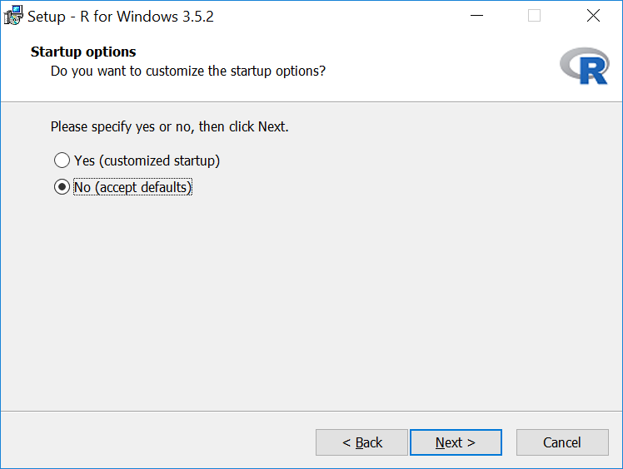 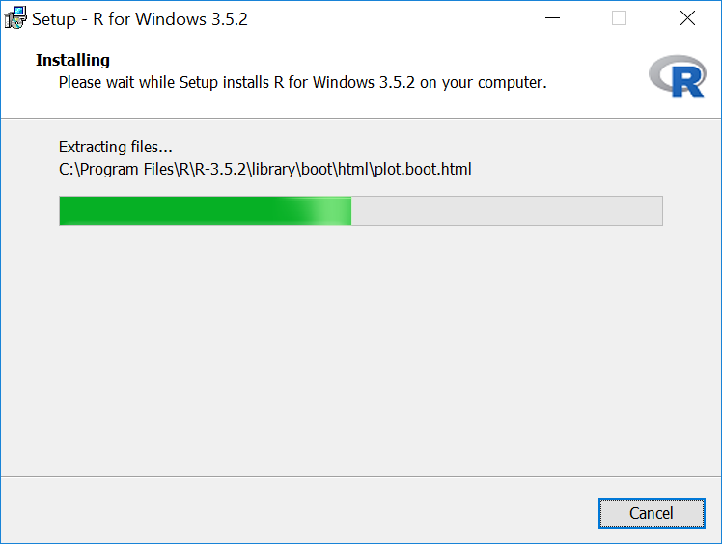

**Step 2 – Install RStudio**

RStudio is an open source development environment for R. It adds functionality to make R coding easier and faster.

* Download the RStudio installer from <https://www.rstudio.com/products/rstudio/download/#download>

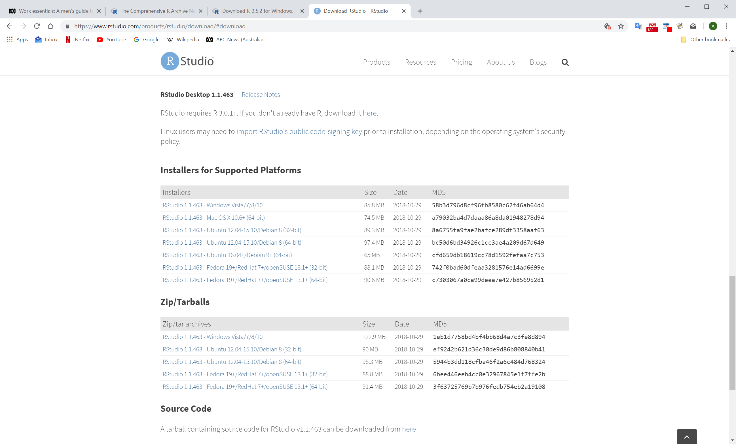

* Install RStudio

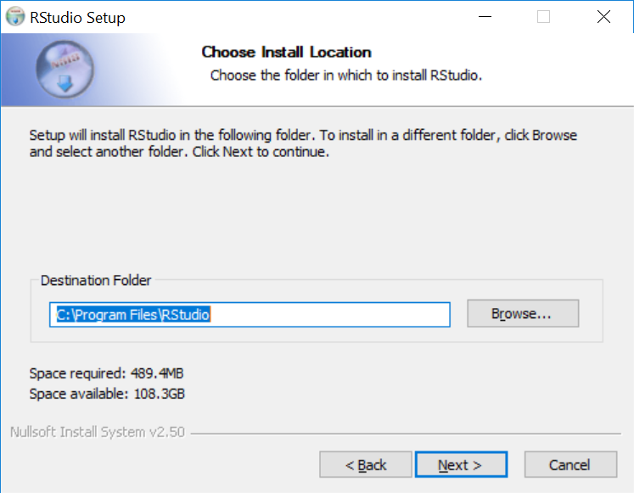

**Step 3 – Setup package installation location**

* Open RStudio

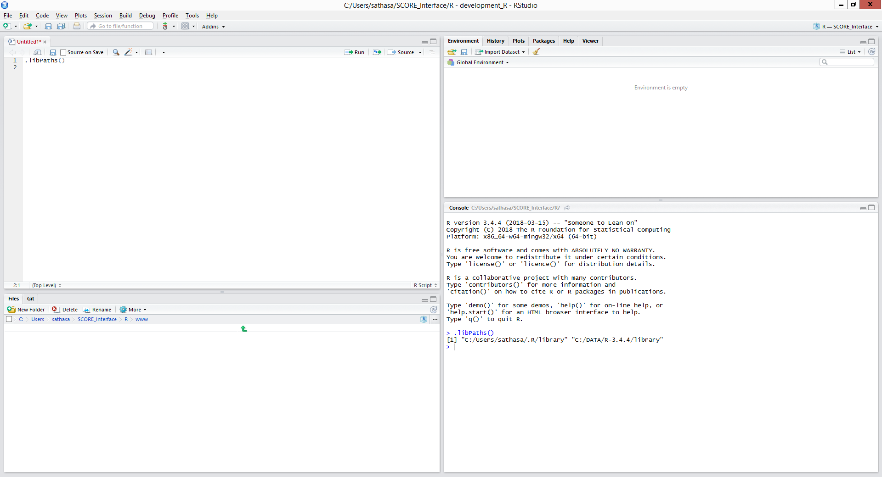

R Console

Code Editor

Packages are additional functions and tools that extend R’s functionality. They are critical to making full use of R and RStudio.

**Step 4 – Install the packages for this workshop**

* The “install.packages” command will download and install R packages
* Packages that require other packages will install all dependencies at once
* This workshop will use the following packages:
* randomForest
* DALEX
* caret
* ggplot2
* reshape2
* knitr
* flexdashboard

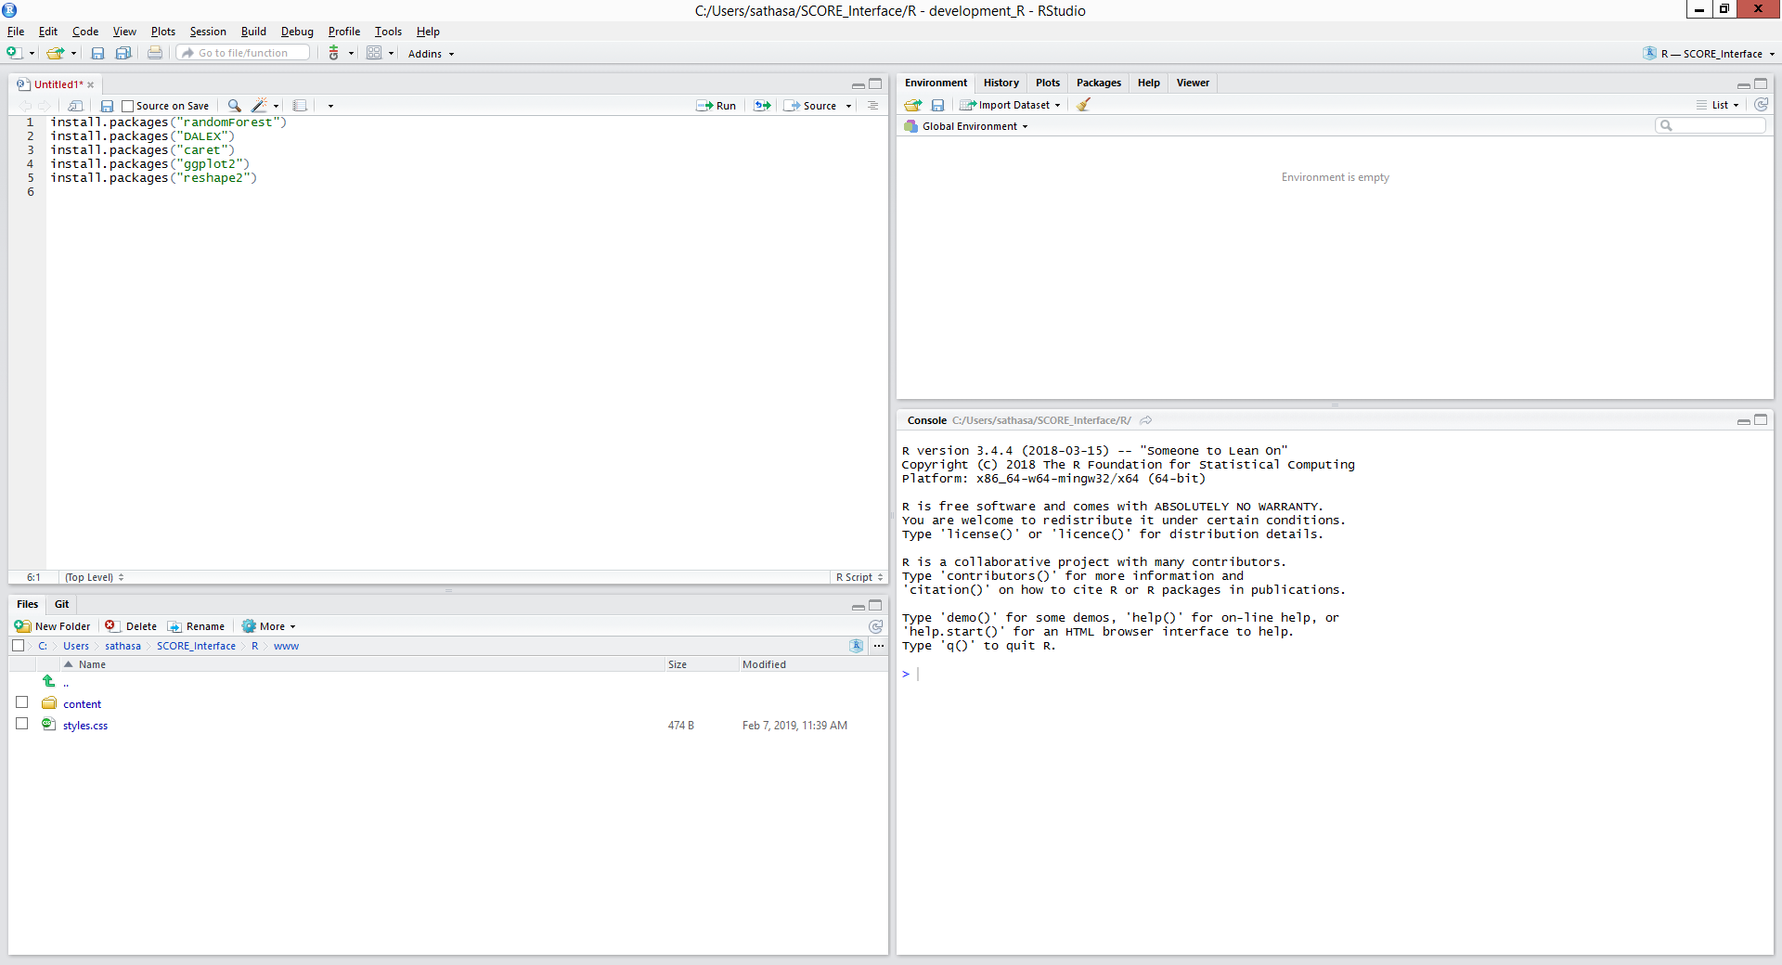

* Run “install.packages(<<package name>>)” for each of the packages listed above
* This will download and install the packages into your library
* Finally, run the “library(<<package name>>)” command to load the library into your R session

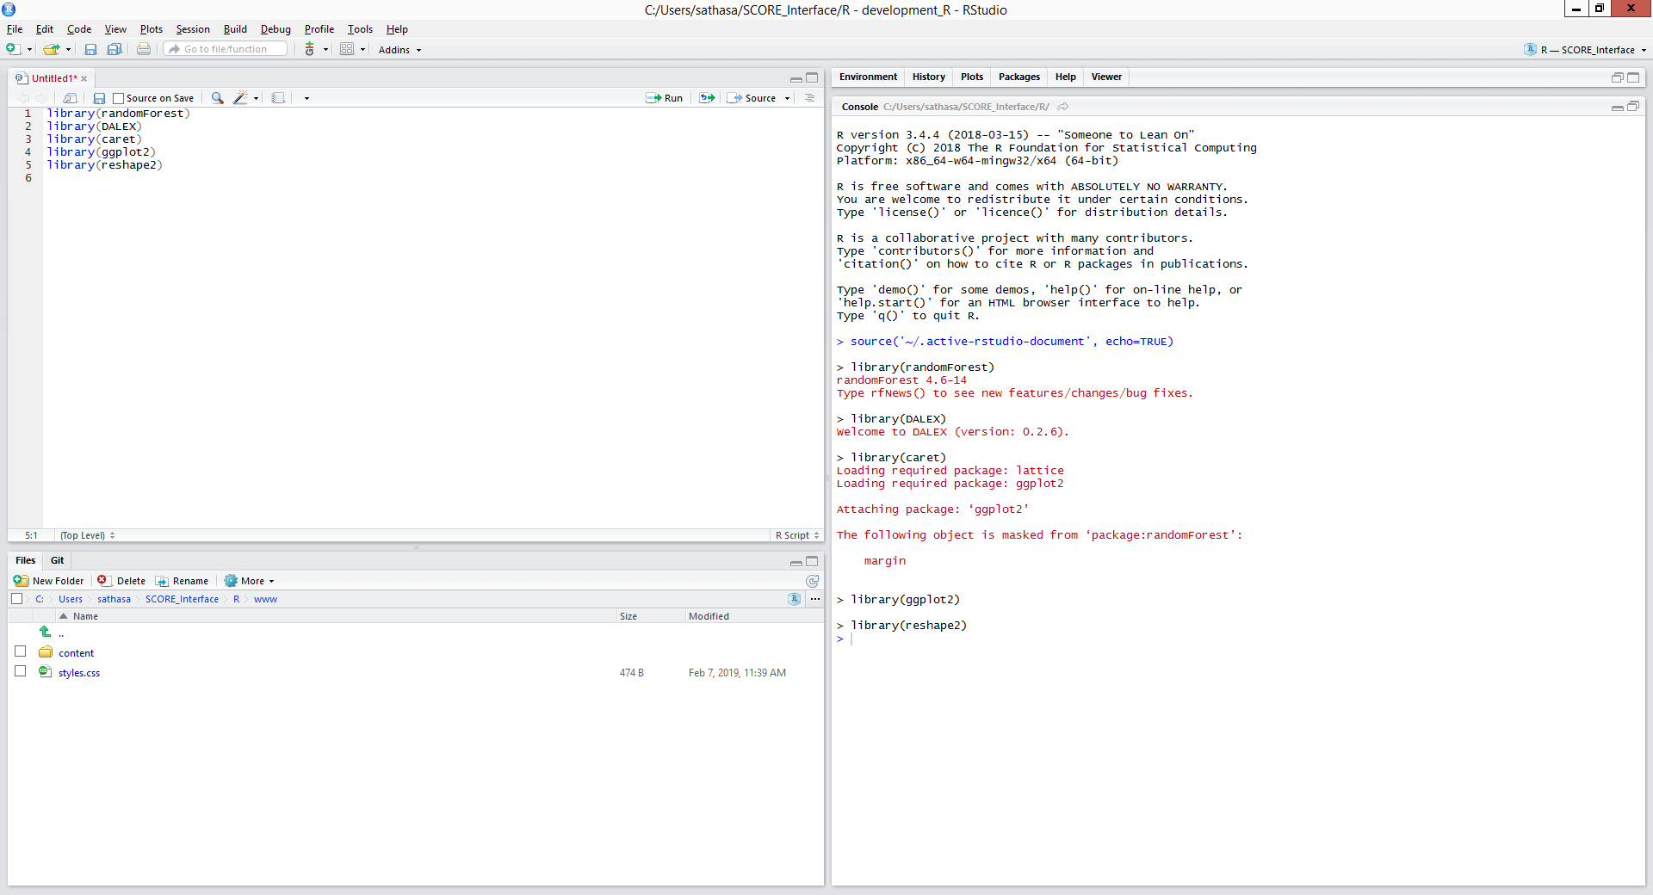

You can use the sessionInfo() command to list out the packages your R session has attached.

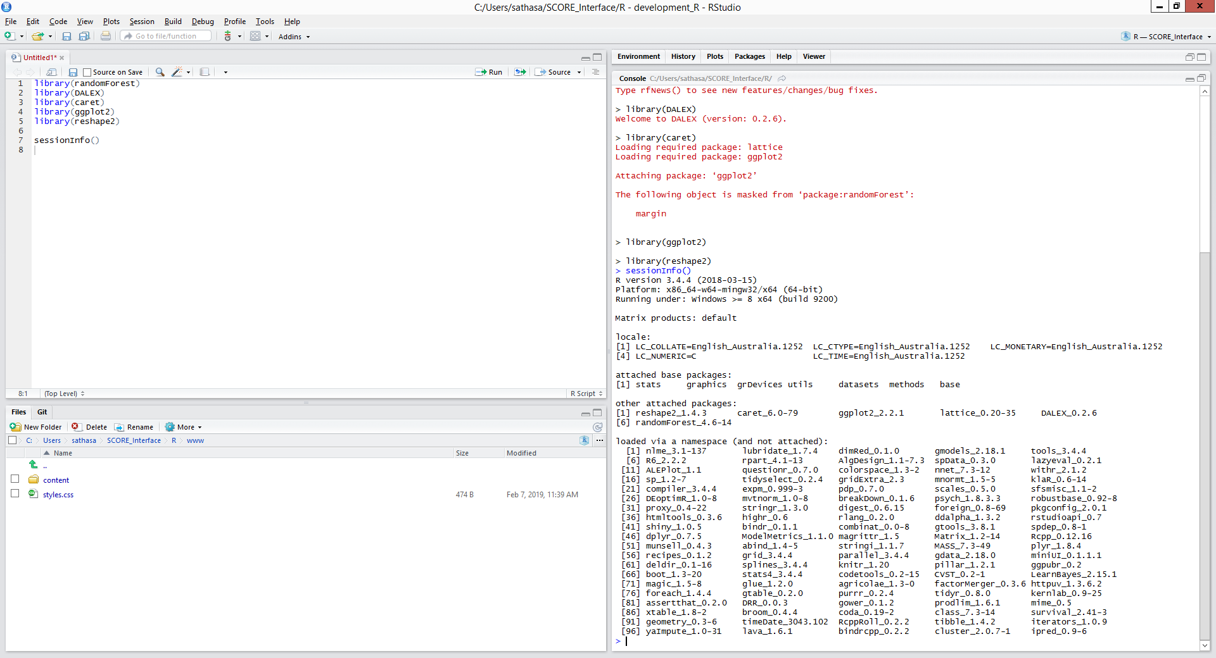

**R Installation Guide (Mac)**

**Step 1 – Install base R**

* Download the R installer from <https://cran.r-project.org/bin/macosx/>

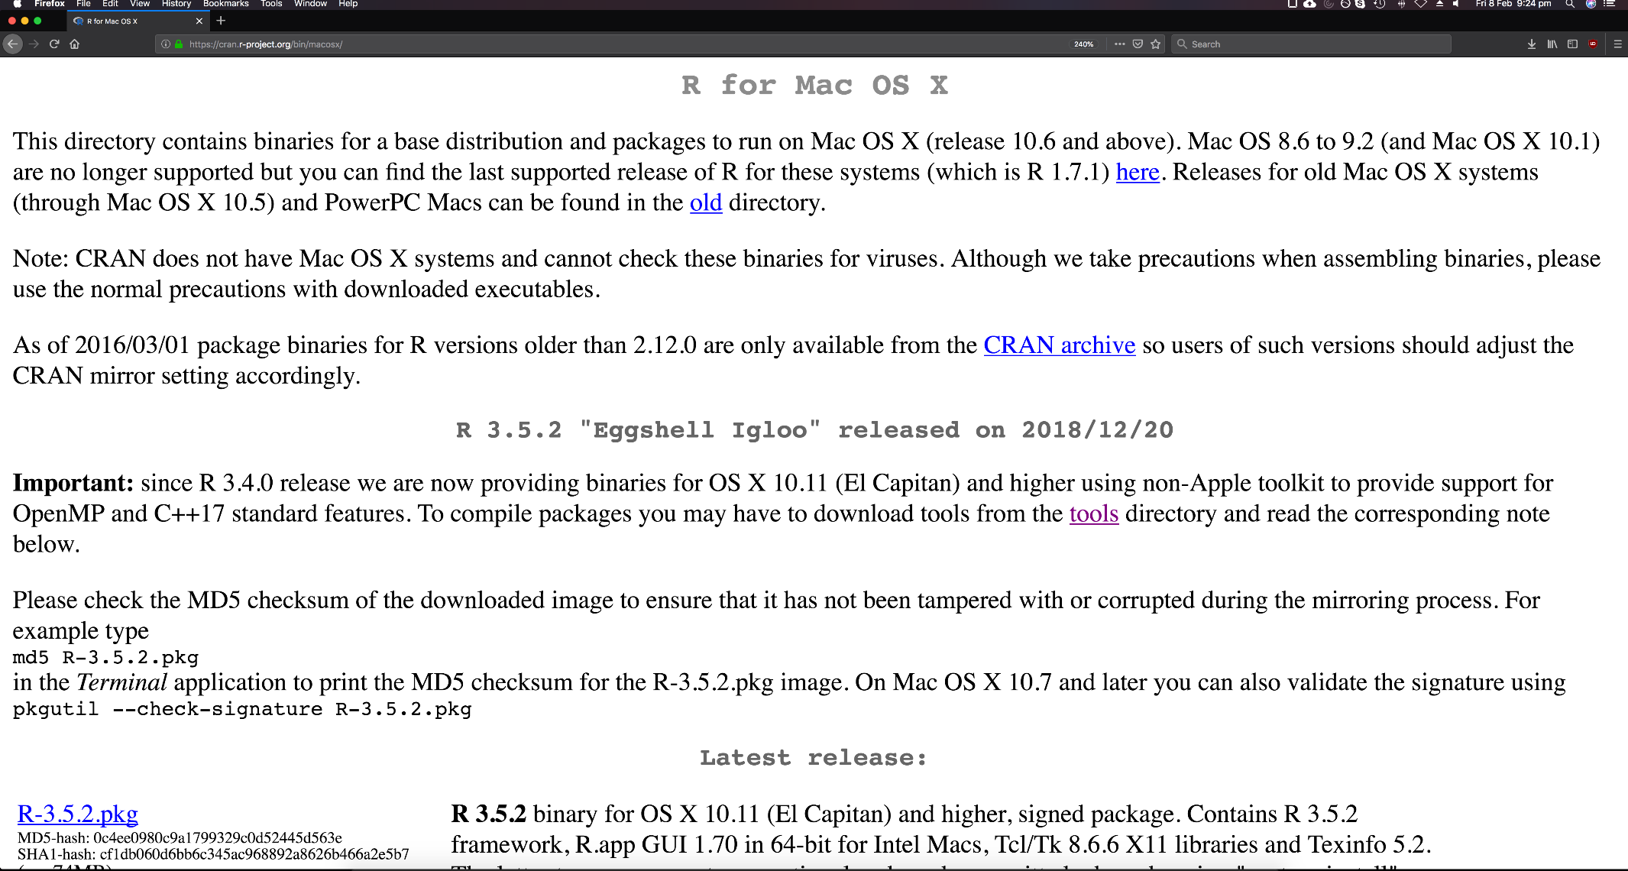

* Run the installer

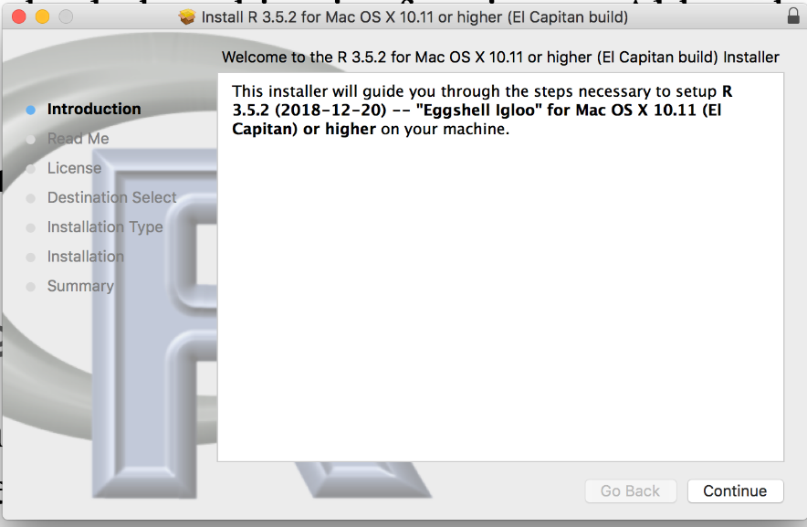 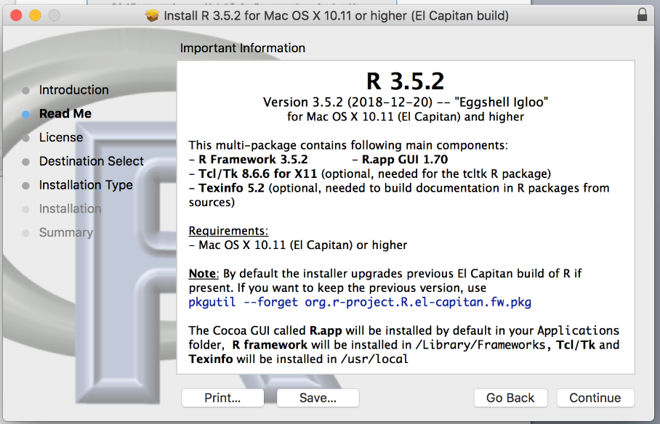

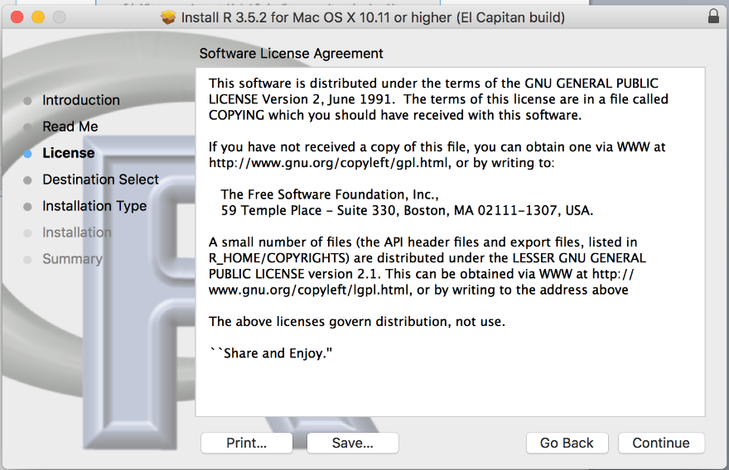 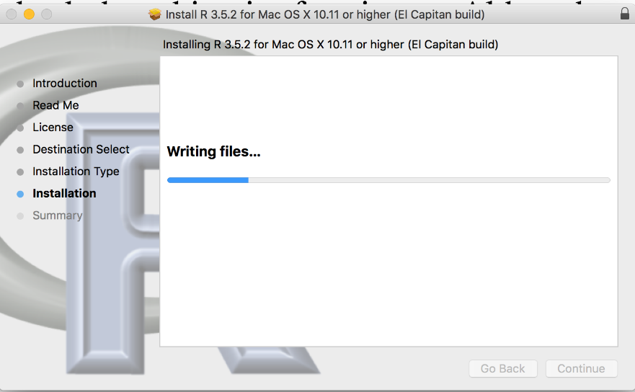

­­­­­

**Step 2 – Install RStudio**

RStudio is an open source development environment for R. It adds functionality to make R coding easier and faster.

* Download the RStudio installer from <https://www.rstudio.com/products/rstudio/download/>



* Install RStudio (drag RStudio icon to Applications)

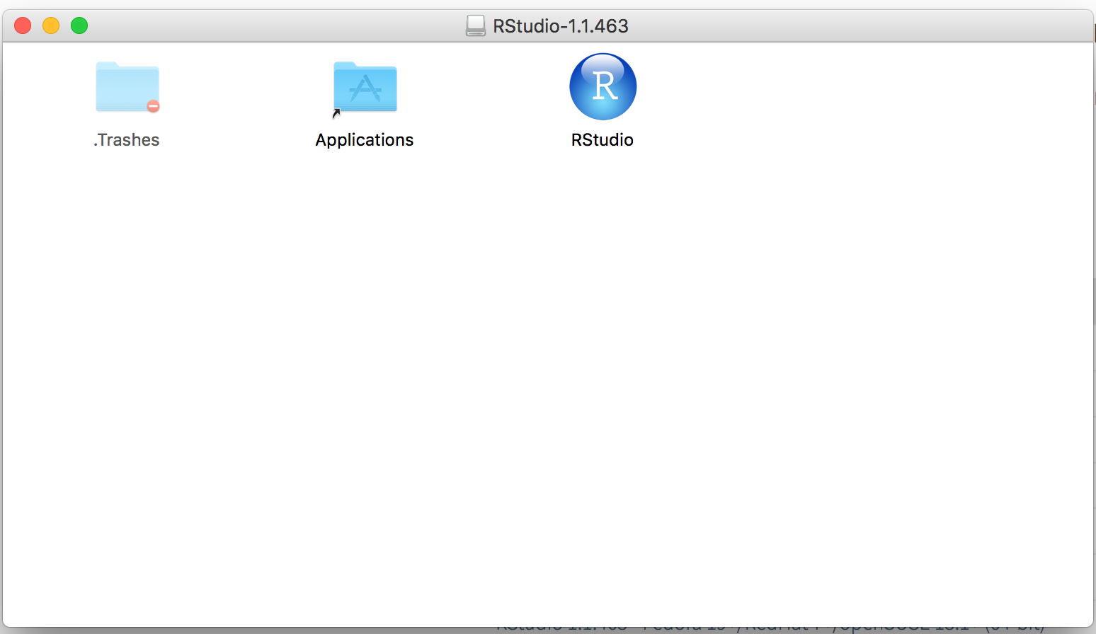

**Step 3 – Open Rstudio**

* Open RStudio

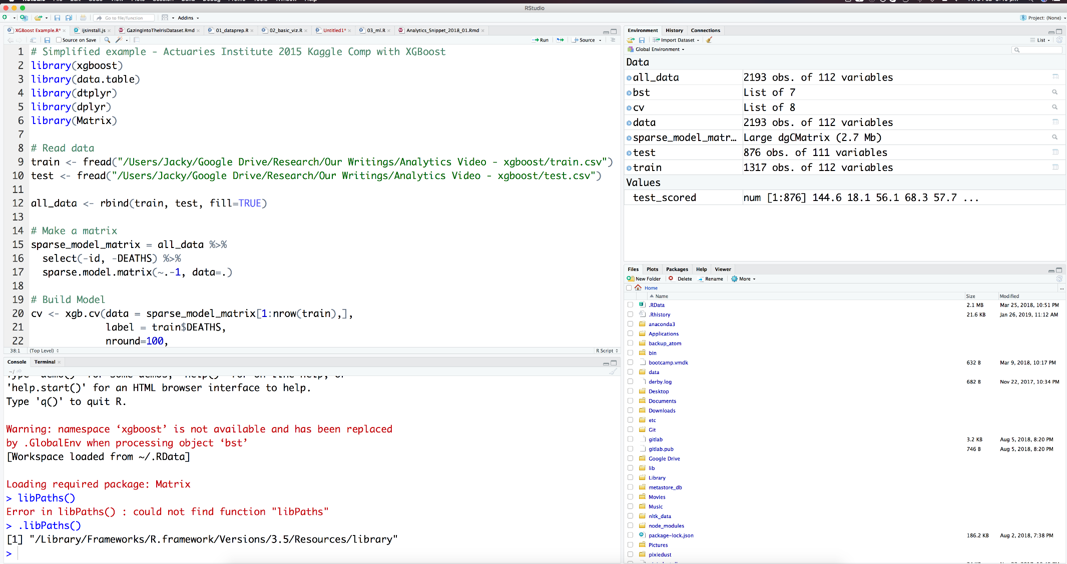

R Console

Code Editor

You can customise the appearance of the editor in the menu: Rstudio > Preferences. This includes font size, dark themes and even the layout.

**Step 4 – Install the packages for this workshop**

* The “install.packages” command will download and install R packages
* Packages that require other packages will install all dependencies at once
* This workshop will use the following packages:
* randomForest
* DALEX
* caret
* ggplot2
* reshape2
* knitr
* flexdashboard



* Run “install.packages(<<package name>>)” for each of the packages listed above
* This will download and install the packages into your library
* Finally, run the “library(<<package name>>)” command to load the library into your R session



You can use the sessionInfo() command to list out the packages your R session has attached.

