Technical Note

On implementing backpropagation with moment neural network in MATLAB

Yang Qi

**Table of content**

1. General set-up
2. Derivation of backpropagation
3. Efficient MATLAB implementation for the activation function
4. **General set-up**

Schematics

$$... →\left(μ_{j}^{n-1},ν_{j}^{n-1},ρ_{jj^{'}}^{n-1}\right)\underset{→}{w_{ij}^{k}}\left({\overline{μ}}_{i}^{n},{\overline{ν}}_{i}^{n}\right)\underset{→}{ϕ}\left(μ_{i}^{n},ν_{i}^{n},ρ_{ii^{'}}^{n}\right)→…$$

Some notations:

$μ$ is the mean firing rate

$ν=σ^{2}$ is the variance of firing rate

$ρ$ is the correlation coefficient (for neurons within the same layer)

Layer index = n

Neuron index (in layer n-1) = j

Neuron index (in layer n) = i

Neuron index (in layer n+1) = k

I use redundant notation for the sake of clarity.

Also, I use prime ( $i$ and $i'$) for neurons in the same layer to improve clarity.

A complicated activation function: $ϕ$

Loss function $E\left(y;μ,ν\right)$ where y is the target value, and assume it does not depend on rho.

(More about loss function later)

Forward equations

$${\overline{μ}}_{i}^{n}=∑w_{ij}^{n}μ_{j}^{n-1}⇒\frac{∂{\overline{μ}}_{i}^{n}}{∂w_{ij}^{n}}=μ_{j}^{n-1}, \frac{∂{\overline{μ}}_{i}^{n}}{∂μ_{j}^{n-1}}=w_{ij}^{n}$$

$${\overline{ν}}_{i}^{n}=\sum_{j,j^{'}}{w_{ij}^{n}σ_{j}^{n-1}ρ_{jj^{'}}^{n-1}w_{ij^{'}}^{n}σ_{j^{'}}^{n-1}}$$

For a first approximation, we force $ρ_{jj^{'}}=δ_{jj^{'}}$ for all layers, then

$${\overline{ν}}_{i}^{n}=\sum_{j}{{\left(w_{ij}^{n}\right)}^{2}ν_{j}^{n-1}}⇒\frac{∂{\overline{ν}}_{i}^{n}}{∂w_{ij}^{n}}=2w_{ij}^{n}ν_{j}^{n-1}$$

$$\frac{∂{\overline{ν}}_{i}^{n}}{∂ν_{j}^{n-1}}={\left(w_{ij}^{n}\right)}^{2}$$

For general correlation, use matrix notation

$$\overline{ν}=x^{T}Σx, {\left[x\right]}_{ij}=w_{ij}^{n}\sqrt{ν_{j}^{n-1}}$$

Then

$$\frac{∂\overline{ν}}{∂w_{ij}}=\frac{∂\overline{ν}}{∂x}\frac{∂x}{∂w_{ij}}=x^{T}\left(Σ+Σ^{T}\right)\frac{∂x}{∂w_{ij}}={\left[w_{ij}ν_{j}\right]}^{T}\left(Σ+Σ^{T}\right)$$

(not sure about here… maybe better use Einstein’s notation)

Loss/error/cost function

$$E=∑\frac{1}{2}{\left(μ_{i}-X_{i}\right)}^{2}+\frac{1}{2}λ{\left(ν_{i}-Y_{i}\right)}^{2}$$

Or maybe I should use std instead of var to keep the balance

$$E=∑\frac{1}{2}{\left(μ_{i}-X_{i}\right)}^{2}+λ{\left(\sqrt{ν_{i}}-\sqrt{Y_{i}}\right)}^{2}$$

Note the second term,

$$E_{ν}=∑{\left(\sqrt{ν_{i}}-\sqrt{Y_{i}}\right)}^{2}=∑ν_{i}+Y_{i}-2\sqrt{ν_{i}Y_{i}}$$

$$⇒\frac{∂E_{ν}}{∂ν_{i}}=1-{\left(ν_{i}Y_{i}\right)}^{-\frac{1}{2}}Y_{i}=1-\sqrt{\frac{Y_{i}}{ν_{i}}}$$

1. **Derivation of backpropagation**

General derivation (Eq.1)

$$\frac{∂E}{∂w_{ij}^{n}}=\frac{∂E}{∂μ_{i}^{n}}\frac{∂μ_{i}^{n}}{∂w_{ij}^{n}}+\frac{∂E}{∂ν_{i}^{n}}\frac{∂ν_{i}^{n}}{∂w_{ij}^{n}}$$

$$=\frac{∂E}{∂μ_{i}^{n}}\left(\frac{∂μ_{i}^{n}}{∂{\overline{μ}}_{i}^{n}}\frac{∂{\overline{μ}}_{i}^{n}}{∂w_{ij}^{n}}+\frac{∂μ_{i}^{n}}{∂{\overline{ν}}_{i}^{n}}\frac{∂{\overline{ν}}_{i}^{n}}{∂w_{ij}^{n}}\right)+\frac{∂E}{∂ν_{i}^{n}}\left(\frac{∂ν_{i}^{n}}{∂{\overline{μ}}_{i}^{n}}\frac{∂{\overline{μ}}_{i}^{n}}{∂w_{ij}^{n}}+\frac{∂ν_{i}^{n}}{∂{\overline{ν}}_{i}^{n}}\frac{∂ν_{i}^{n}}{∂w_{ij}^{n}}\right)$$

$$=\left[\frac{∂E}{∂μ_{i}^{n}}\frac{∂μ_{i}^{n}}{∂{\overline{μ}}_{i}^{n}}+\frac{∂E}{∂ν_{i}^{n}}\frac{∂ν_{i}^{n}}{∂{\overline{μ}}_{i}^{n}}\right]\frac{∂{\overline{μ}}_{i}^{n}}{∂w_{ij}^{n}}+\left[\frac{∂E}{∂μ_{i}^{n}}\frac{∂μ_{i}^{n}}{∂{\overline{ν}}_{i}^{n}}+\frac{∂E}{∂ν_{i}^{n}}\frac{∂ν_{i}^{n}}{∂{\overline{ν}}_{i}^{n}}\right]\frac{∂{\overline{ν}}_{i}^{n}}{∂w_{ij}^{n}}$$

First, if n is the output layer, $\frac{∂E}{∂μ_{i}^{n}}$ and $\frac{∂E}{∂ν_{i}^{n}}$ can be directly calculated (Eq.2)

$$\frac{∂E}{∂μ_{i}}=μ_{i}-X_{i}$$

$$\frac{∂E}{∂ν_{i}}=λ\left(ν_{i}-Y_{i}\right)$$

Next, if n is a hidden layer:

$$\frac{∂E}{∂μ_{i}^{n}}=\sum_{k}{\left(\frac{∂E}{∂μ_{k}^{n+1}}\frac{∂μ_{k}^{n+1}}{∂μ_{i}^{n}}+\frac{∂E}{∂ν_{k}^{n+1}}\frac{∂ν_{k}^{n+1}}{∂μ_{i}^{n}}\right)}$$

$$=\sum_{k}{\left(\frac{∂E}{∂μ_{k}^{n+1}}\left[\frac{∂μ_{k}^{n+1}}{∂{\overline{μ}}_{k}^{n+1}}\frac{∂{\overline{μ}}_{k}^{n+1}}{∂μ_{i}^{n}}+\frac{∂μ_{k}^{n+1}}{∂{\overline{ν}}_{k}^{n+1}}\frac{∂{\overline{ν}}_{k}^{n+1}}{∂μ_{i}^{n}}\right]+\frac{∂E}{∂ν_{k}^{n+1}}\left[\frac{∂ν_{k}^{n+1}}{∂{\overline{μ}}_{k}^{n+1}}\frac{∂{\overline{μ}}_{k}^{n+1}}{∂μ_{i}^{n}}+\frac{∂ν_{k}^{n+1}}{∂{\overline{ν}}_{k}^{n+1}}\frac{∂{\overline{ν}}_{k}^{n+1}}{∂μ_{i}^{n}}\right]\right)}$$

Note terms with blue highlight is zero so above simplifies into:

$$\frac{∂E}{∂μ_{i}^{n}}=\sum_{k}{\left(\frac{∂E}{∂μ_{k}^{n+1}}\frac{∂μ_{k}^{n+1}}{∂{\overline{μ}}_{k}^{n+1}}+\frac{∂E}{∂ν_{k}^{n+1}}\frac{∂ν_{k}^{n+1}}{∂{\overline{μ}}_{k}^{n+1}}\right)\frac{∂{\overline{μ}}_{k}^{n+1}}{∂μ_{i}^{n}}}$$

Define:

$$δ_{k}^{n+1}=\frac{∂E}{∂μ_{k}^{n+1}}\frac{∂μ_{k}^{n+1}}{∂{\overline{μ}}_{k}^{n+1}}+\frac{∂E}{∂ν_{k}^{n+1}}\frac{∂ν_{k}^{n+1}}{∂{\overline{μ}}_{k}^{n+1}}$$

Then we have,

$$\frac{∂E}{∂μ_{i}^{n}}=\sum_{k}{δ_{k}^{n+1}}w_{kj}^{n+1}$$

Similarly,

$$\frac{∂E}{∂ν_{i}^{n}}=\sum_{k}{\left(\frac{∂E}{∂μ_{k}^{n+1}}\frac{∂μ_{k}^{n+1}}{∂ν_{i}^{n}}+\frac{∂E}{∂ν_{k}^{n+1}}\frac{∂ν_{k}^{n+1}}{∂ν_{i}^{n}}\right)}$$

$$=\sum_{k}{\left(\frac{∂E}{∂μ_{k}^{n+1}}\left[\frac{∂μ_{k}^{n+1}}{∂{\overline{μ}}_{k}^{n+1}}\frac{∂{\overline{μ}}_{k}^{n+1}}{∂ν_{i}^{n}}+\frac{∂μ_{k}^{n+1}}{∂{\overline{ν}}_{k}^{n+1}}\frac{∂{\overline{ν}}_{k}^{n+1}}{∂ν_{i}^{n}}\right]+\frac{∂E}{∂ν_{k}^{n+1}}\left[\frac{∂ν_{k}^{n+1}}{∂{\overline{μ}}_{k}^{n+1}}\frac{∂{\overline{μ}}_{k}^{n+1}}{∂ν_{i}^{n}}+\frac{∂ν_{k}^{n+1}}{∂{\overline{ν}}_{k}^{n+1}}\frac{∂{\overline{ν}}_{k}^{n+1}}{∂ν_{i}^{n}}\right]\right)}$$

$$=\sum_{k}{\left(\frac{∂E}{∂μ_{k}^{n+1}}\frac{∂μ_{k}^{n+1}}{∂{\overline{ν}}_{k}^{n+1}}+\frac{∂E}{∂ν_{k}^{n+1}}\frac{∂ν_{k}^{n+1}}{∂{\overline{ν}}_{k}^{n+1}}\right)\frac{∂{\overline{ν}}_{k}^{n+1}}{∂ν_{i}^{n}}}$$

Define,

$$γ_{k}^{n+1}=\frac{∂E}{∂μ_{k}^{n+1}}\frac{∂μ_{k}^{n+1}}{∂{\overline{ν}}_{k}^{n+1}}+\frac{∂E}{∂ν_{k}^{n+1}}\frac{∂ν_{k}^{n+1}}{∂{\overline{ν}}_{k}^{n+1}}$$

Then we have,

$$\frac{∂E}{∂ν_{i}^{n}}=\sum_{k}{γ_{k}^{n+1}{\left(w_{ki}^{n+1}\right)}^{2}}ν_{i}^{n}$$

[NB. Error corrected on 2020.7.8]

From Eq.1,

$$\frac{∂E}{∂w_{ij}^{n}}=δ_{i}^{n}\frac{∂{\overline{μ}}_{i}^{n}}{∂w_{ij}^{n}}+γ_{i}^{n}\frac{∂{\overline{ν}}_{i}^{n}}{∂w_{ij}^{n}}=δ_{i}^{n}μ_{j}^{n-1}+γ_{i}^{n}\left(2w_{ij}^{n}ν_{j}^{n-1}\right)$$

Match coefficients with that in Eq.1 we get a 2D recursive formula,

$$δ_{i}^{n}=\sum_{k}{δ_{k}^{n+1}}w_{ki}^{n+1}\frac{∂μ_{i}^{n}}{∂{\overline{μ}}_{i}^{n}}+\sum_{k}{γ_{k}^{n+1}{\left(w_{ki}^{n+1}\right)}^{2}}ν_{i}^{n}\frac{∂ν_{i}^{n}}{∂{\overline{ν}}_{i}^{n}}$$

$$γ_{i}^{n}=\sum_{k}{δ_{k}^{n+1}}w_{ki}^{n+1}\frac{∂μ_{i}^{n}}{∂{\overline{ν}}_{i}^{n}}+\sum_{k}{γ_{k}^{n+1}{\left(w_{ki}^{n+1}\right)}^{2}}ν_{i}^{n}\frac{∂ν_{i}^{n}}{∂{\overline{ν}}_{i}^{n}}$$

In matrix notation,

$$\left[\begin{matrix}δ_{i}^{n} & γ_{i}^{n}\end{matrix}\right]=\left[\begin{matrix}\sum_{k}{δ_{k}^{n+1}}w_{ki}^{n+1} & \sum_{k}{γ_{k}^{n+1}{\left(w_{ki}^{n+1}\right)}^{2}}ν_{i}^{n}\end{matrix}\right]\left[\begin{matrix}\frac{∂μ_{i}^{n}}{∂{\overline{μ}}_{i}^{n}} & \frac{∂μ_{i}^{n}}{∂{\overline{ν}}_{i}^{n}} \\ \frac{∂ν_{i}^{n}}{∂{\overline{μ}}_{i}^{n}} & \frac{∂ν_{i}^{n}}{∂{\overline{ν}}_{i}^{n}}\end{matrix}\right]$$

The square matrix here is the Jacobian matrix of the activation function $ϕ$. If n+1 is the output layer, then the colored vectors can be calculated direct from the loss function (Eq2).

1. **Efficient MATLAB implementation for the activation function**

Activation function is the mapping:

$$ϕ:\left({\overline{μ}}_{i}^{n},{\overline{ν}}_{i}^{n}\right)→\left(μ_{i}^{n},ν_{i}^{n}\right)$$

In the following we give its definition and numerical implementation.

$$A_{i}^{n}\left({\overline{μ}}_{i}^{n},{\overline{ν}}_{i}^{n};y\right)=\frac{yL-{\overline{μ}}_{i}^{n}}{\sqrt{L{\overline{ν}}_{i}^{n}}}$$

$$∂_{\overline{μ}}A_{i}^{n}=\frac{-1}{\sqrt{Lν_{i}^{n}}}, ∂_{\overline{ν}}A_{i,}^{n}=-\frac{1}{2}\frac{yL-{\overline{μ}}_{i}^{n}}{\sqrt{L}}{\left({\overline{v}}_{i}^{n}\right)}^{-\frac{3}{2}}$$

[2020.7.2: highlighted term was wrong in the code, now corrected]

For clarity, denote:

$$A_{i,th}^{n}=A_{i}^{n}\left({\overline{μ}}_{i}^{n},{\overline{ν}}_{i}^{n};V_{th}\right), A_{i,rest}^{n}=A_{i}^{n}\left({\overline{μ}}_{i}^{n},{\overline{ν}}_{i}^{n};V_{rest}\right)$$

Then the activation function $ϕ$ is given by as:

$$\left\langle T_{i}^{n}\right\rangle =\frac{2}{L}\int_{A_{i,rest}^{n}}^{A_{i,th}^{n}}{g\left(x\right)dx}$$

$$var\left(T_{i}^{n}\right)=\frac{4}{L^{2}}\int_{A_{i,rest}^{n}}^{A_{i,th}^{n}}{h\left(x\right)dx}$$

$$μ_{i}^{n}=\frac{1}{\left\langle T_{i}^{n}\right\rangle +T_{ref} }$$

$$ν_{i}^{n}=\frac{var\left(T_{i}^{n}\right)}{{\left\langle T_{i}^{n}+T_{ref}\right\rangle }^{3}}=var\left(T_{i}^{n}\right){\left(μ_{i}^{n}\right)}^{3}$$

[Note Tref was missing in Feng’s paper. It makes quite a big difference for small T! Reason Tref should be included: Suppose input mean and var is fixed => var T is fixed. Now imagine Tref increases to infinity. The variance of firing rate should vanish if Tref is included and it should be constant otherwise. Clearly the latter is false as virtually no spike should be observed.]

**Numeric implementation for g(x) and its integral**

$$g\left(x\right)=\exp\left(x^{2}\right)\int_{-∞}^{x}{\exp\left(-u^{2}\right)du}$$

This function is monotonic and it converges to zero for $x→0$ and diverges for $x→∞$. Numerically this integral presents a $∞⋅0$ type of instability. To fix this, observe

$$g\left(x\right)=\frac{\sqrt{π}}{2}\exp\left(x^{2}\right)\operatorname{erfc}\left(-x\right)=\frac{\sqrt{π}}{2}\operatorname{erfcx}\left(-x\right)$$

where erfcx is the “scaled complementary error function”, which has a built-in MATLAB function specifically design to avoid numerical overflow. The integration is simply handled by MATLAB built-in function integral to achieve specified error tolerance.

**Numeric implementation for h(x)**

$$h\left(x\right)=\exp\left(x^{2}\right)\int_{-∞}^{x}{\exp\left(-u^{2}\right)g^{2}\left(u\right)du}$$

$$=\frac{π}{4}\int_{-∞}^{x}{\exp\left(x^{2}-u^{2}\right){erfcx}^{2}\left(-u\right)du}$$

The integrant function over the (x,u) plane is shown below, with the shaded area marking the domain of integration.

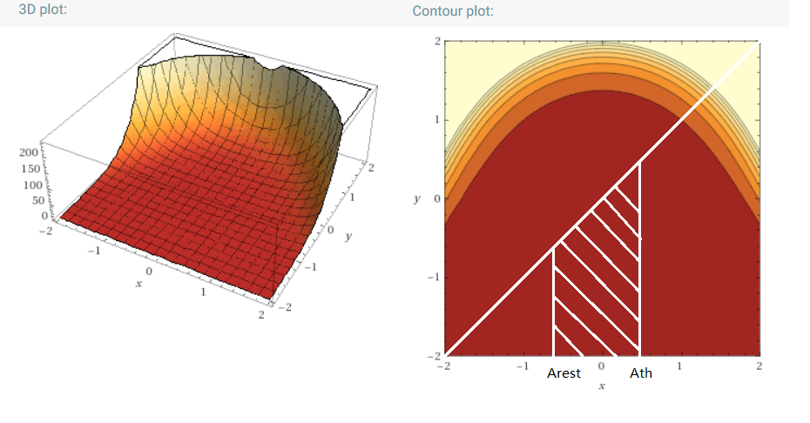

I implement the integrant numerically using the form:

**exp[(x+u)*(x-u)]*[erfcx(-u)]^2**

which provides the best numeric stability. The integration is handled by MATLAB built-in function integral2.

Note that in all of the above, the integrals are guaranteed to be well behaved when $\overline{μ}≥0$, that is, when $A_{rest}<A_{th}≤0$. However, when $\overline{μ}<0$ the integrals may blow up, especially when $\overline{σ}≪1$. This is just how the function behaves not due to numerical implementation. Luckily this shouldn’t be an issue for biologically plausible values of $\overline{μ}$.

**Jacobian matrix of the activation function**

Note since this part is all element-wise operations, we drop the layer and neuron indices for clarity.

$$J=\left[\begin{matrix}\frac{∂μ}{∂\overline{μ}} & \frac{∂μ}{∂\overline{ν}} \\ \frac{∂ν}{∂\overline{μ}} & \frac{∂ν}{∂\overline{ν}}\end{matrix}\right]=\left[\begin{matrix}-μ^{2}∂_{\overline{μ}}\left\langle T\right\rangle & -μ^{2}∂_{\overline{ν}}\left\langle T\right\rangle \\ \left[∂_{\overline{μ}}var\left(T\right){\left\langle T\right\rangle }^{-3}-3var\left(T\right){\left\langle T\right\rangle }^{-4}∂_{\overline{μ}}\left\langle T\right\rangle \right] & \left[∂_{\overline{ν}}var\left(T\right){\left\langle T\right\rangle }^{-3}-3var\left(T\right){\left\langle T\right\rangle }^{-4}∂_{\overline{ν}}\left\langle T\right\rangle \right]\end{matrix}\right]$$

$$=\left[\begin{matrix}-μ^{2}∂_{\overline{μ}}\left\langle T\right\rangle & -μ^{2}∂_{\overline{ν}}\left\langle T\right\rangle \\ \left[∂_{\overline{μ}}var\left(T\right)μ^{3}-3var\left(T\right)μ^{4}∂_{\overline{μ}}\left\langle T\right\rangle \right] & \left[∂_{\overline{ν}}var\left(T\right)μ^{3}-3var\left(T\right)μ^{4}∂_{\overline{ν}}\left\langle T\right\rangle \right]\end{matrix}\right]$$

where

$$∂_{\overline{μ}}\left\langle T\right\rangle =\frac{2}{L}\left[g\left(A_{th}\right)\frac{∂A_{th}}{∂\overline{μ}}-g\left(A_{rest}\right)\frac{∂A_{ref}}{∂\overline{μ}}\right]$$

$$∂_{\overline{ν}}\left\langle T\right\rangle =\frac{2}{L}\left[g\left(A_{th}\right)\frac{∂A_{th}}{∂\overline{ν}}-g\left(A_{rest}\right)\frac{∂A_{ref}}{∂\overline{ν}}\right]$$

$$∂_{\overline{μ}}var\left(T\right)=\frac{4}{L^{2}}\left[h\left(A_{th}\right)\frac{∂A_{th}}{∂\overline{μ}}-h\left(A_{rest}\right)\frac{∂A_{ref}}{∂\overline{μ}}\right]$$

$$∂_{\overline{ν}}var\left(T\right)=\frac{4}{L^{2}}\left[h\left(A_{th}\right)\frac{∂A_{th}}{∂\overline{ν}}-h\left(A_{rest}\right)\frac{∂A_{ref}}{∂\overline{ν}}\right]$$

where the derivatives of A is given earlier. In MATLAB I implement J as a N x 2 x 2 array.

**Visualization of the activation function and its partial derivatives.**

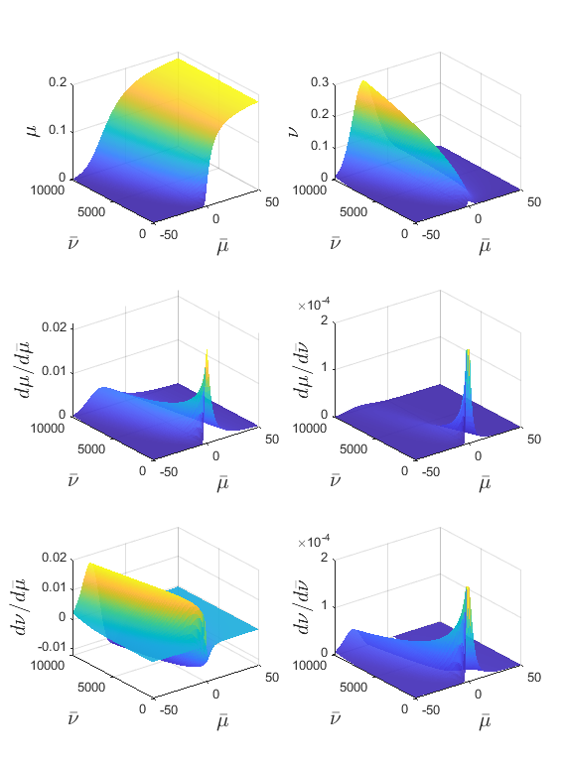

NB. Output $μ<\frac{1}{T_{ref}}=0.2$ kHz; output $ν=σ^{2}≤0.2853$ kHz^2. The dynamic range of the activation function is limited therefore target output requires tuning for regression problem.

Ideally keep target as well as the output of each layer to be $μ≈0.1$ kHz and $ν≈0.1$ kHz^2.

Similarly, the input and the weights should be adjusted so the

Note NaN values when $\overline{ν}→0$ or when $\overline{ν}$ is small while $\overline{μ}≪0$

Small variance cases would result in numeric instability and it should be replaced by either interpolation or theoretical sigmoid (how).

[plotted with maf_validation.m]

Compare above semi-analytical partial derivatives with numerical ones:

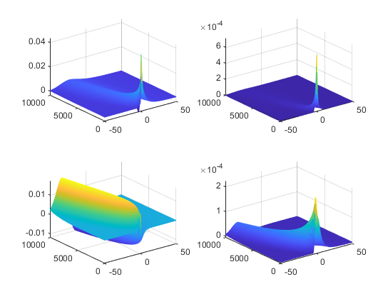

[2020.7.2] Derivatives with **with respect to $\overline{ν}$ was off by an order of magnitude (due to mistake in dA/dv). Now fixed.**

Note on the case when $\overline{ν}=0$:

Underlying assumption of diffusion approximation is broken down, and output is simply periodic spikes.

Solve the equation,

$$\frac{dV}{dt}=-L\left(V-V_{rest}\right)+\overline{μ}$$

We have:

$$μ=\frac{1}{T_{ref}+\frac{1}{L}\log{\frac{\overline{μ}}{\overline{μ}-LΔV}}}=\frac{1}{5+20\log{\frac{\overline{μ}}{\overline{μ}-1}}}$$

[for $\overline{μ}≥LΔV$, and 0 otherwise]

$$ν=0$$

$$\frac{∂μ}{∂\overline{μ}}=\frac{ΔVμ^{2}}{x\left(x-LΔV\right)}$$

$$\frac{∂μ}{∂\overline{ν}}=\frac{∂ν}{∂\overline{μ}}=\frac{∂ν}{∂\overline{ν}}=0$$

Not entirely sure about the last equation here…

Use these values whenever any of it contains NaN. But will this make backprop any better? Note at $\overline{μ}$, the slope of $μ$ is infinite! Could make things worse…

Validation of above formula:

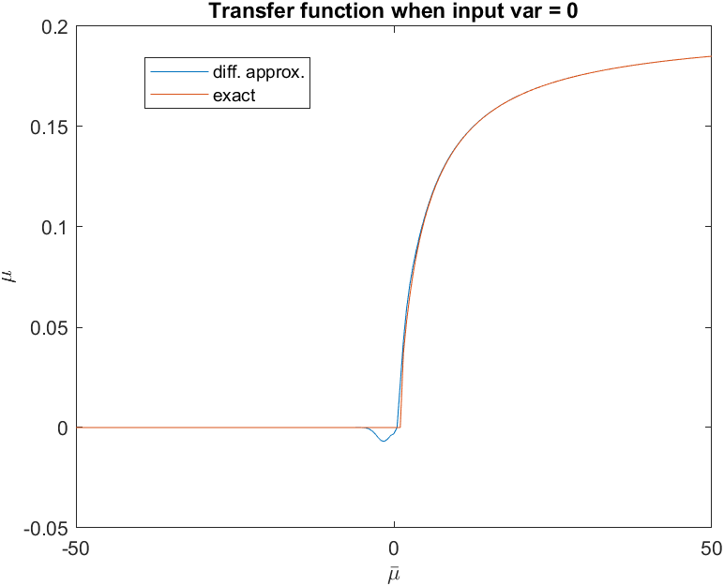 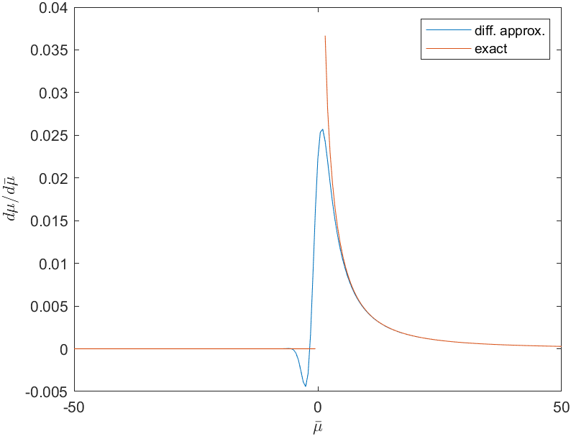

Finally putting the pieces of the puzzle together.

Update rule

$$Δw_{ij}^{n}=-α\frac{∂E}{∂w_{ij}^{n}}+ηΔw_{ij}^{n}(N-1)$$

where $α$ is the learning rate and $η$ is the moment.

How to adjust hyperparameters

Two conditions must be met when choosing hyperparameters:

$\overline{ν}={\overline{σ}}^{2}≫1$

This condition ensures that the integrals in the activation function converges (in the analytical sense). When $\overline{σ}→0$, the activation function actually blows up if it also happens that $\overline{μ}<1$.

This condition is quite easy to satisfy as long as the correlation matrix has predominantly positive entries.

$\left|\overline{μ}\right|<5$

The activation function flattens out outside this range, which may result in flat gradients thus vanishing changes in the weights.

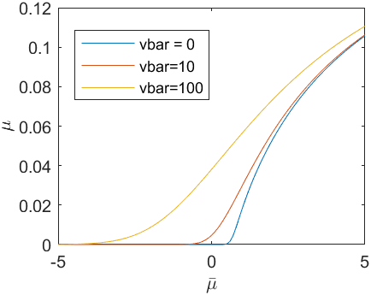

One way to satisfy this condition is by having a balanced network such that the number of excitatory neurons and the number of inhibitory neurons are roughly the same.

If the layer has only excitatory neurons (such as the input layer), then the following tweak can be used. Assume $\overline{μ}=Wμ$ and each entry $w>0$ in the weight matrix is independent and identically distributed r.v. according to some distribution, and also assume that the number of neurons is large. Then we require,

$$E\left[w\right]E\left[μ\right]<\frac{5}{N}$$

where N is the number of presynaptic neurons. To proceed, suppose that the presynaptic neural activation has a well-behaved mean value of $E\left[μ\right]=0.05$

About transduction factor for input images

The grayscale values (range between 0 and 1) of the pixels in the raw images of MNIST has a mean value of approximately 0.25. A transduction factor of **0.02** is sufficient to bring it to the desired $E\left[μ\right]=0.05$.

Similarly for output target, scale it to $E\left[μ\right]=0.05$.

**Loss function: MSE**

$$E=\frac{1}{2}∑{\left(μ_{i}-X_{i}\right)}^{2}+λ∑{\left(\sqrt{ν_{i}}-\sqrt{Y_{i}}\right)}^{2}$$

This is bad for classification problem with one-hot target.

**Softmax cross-entropy loss**

$$E=-\log\left(\frac{\exp{μ_{t}}}{\sum{\exp\left(μ_{i}\right)}}\right)-\log\left(\frac{\exp{ν_{t}}}{\sum{\exp\left(ν_{i}\right)}}\right)$$

Where $t∈\left\{0,1,…,9\right\}$ is the target label.

$$\frac{∂E}{∂μ_{t}}=\frac{\exp{μ_{t}}}{\sum{\exp{μ_{j}}}}-1$$

$$\frac{∂E}{∂μ_{i≠t}}=\frac{\exp{μ_{i}}}{\sum{\exp{μ_{j}}}}$$

Result works similarly for $ν_{i}$.

Alternatively,

$$E=-\log\left(\frac{\exp\left(μ_{t}+λν_{t}\right)}{\sum{\exp\left(μ_{i}+λν_{i}\right)}}\right)$$

$$\frac{∂E}{∂μ_{t}}=\frac{\exp\left(μ_{t}+λν_{t}\right)}{\sum{\exp\left(μ_{j}+λν_{j}\right)}}-1$$

$$\frac{∂E}{∂μ_{i≠t}}=\frac{\exp\left(μ_{i}+λν_{i}\right)}{\sum{\exp\left(μ_{j}+λν_{j}\right)}}$$

By chain rule, just multiply by $λ$ to get the derivative with respect to $ν$.

**Custom cross-entropy loss?**

Since mu and var are already probabilistic, I should replace softmax with a custom probability.

$$E=-\sum{t_{i}\log\left(f_{i}\left(\overset{⃑}{μ}\right)\right)}$$

Where $f$ is, for instance, a Gamma distribution. [?]

Assuming output neurons fire independently, then f is separable.

$$f_{i}\left(x\right)=\frac{x^{α-1}\exp\left(-\frac{x}{θ}\right)}{Γ\left(α\right)θ^{α}}$$

Which has mean $μ=αθ$ and variance $ν=αθ^{2}$. I actually don’t need x here…

(NB the original softmax function is a probability across output neurons, not over the values of output variables; If I use this Gamma distribution then I have imposed a stronger condition)

POINT: x here is the spike count! I want to match my spike count to the target!

Use Poisson for now?

Interpreting the cross-entropy loss as minimizing the KL divergence between 2 distributions

Referene:

<https://gombru.github.io/2018/05/23/cross_entropy_loss/>

<https://rohanvarma.me/Loss-Functions/>

Regarding correlation map

Let $ρ$ the correlation matrix of the first layer be a random positive definite matrix, and let $w_{ij}σ_{j}$ of the first layer be normally distributed. We calculate correlation matrix of the next layer and observe how it changes with the mean and std of $w_{ij}σ_{j}$.

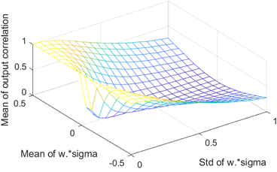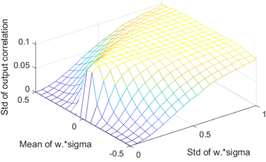

（sorry the x and y-axes in above figures should be swapped)

A number of observations:

1. The mean of the output correlation is always positive.
2. The std of the output correlation has an upper bound of approx. 0.12, which is slightly bigger than the std of the input correlation of 0.1. Implication: as long as the $w_{ij}σ_{j}$ has a high variance, the std of output correlation should not vanish. [Vanish means all entries in rho become the same value]
3. Unfortunately, the output correlation matrix is not positive definite for nearly all explored cases (which means that the variance calculated using these correlation matrices may become negative)

Regarding scaling of the activation function (nondimensionalization)

[Discarded: below results are incorrect since Tref is not included in the calculation of $ν$]

We are interested in the upper and the lower bound on the activation function (in the limiting cases)

First it is trivial to show that both $μ$ and $ν$ (the output) are greater than zero.

Suppose $\overline{ν}≫1$, and $\overline{μ}→+∞$, we get,

$$\lim_{\overline{μ}→+∞}\left\langle T\right\rangle →\lim_{a→-∞}\frac{2}{L}\int_{-a}^{-a+\frac{1}{\overline{ν}\sqrt{L}}}{g\left(x\right)dx}=\frac{2}{L\overline{ν}\sqrt{L}}\lim_{a→-∞}g\left(a\right)$$

Note the asymptotic expansion as $x→-∞$:

$$g\left(x\right)=\frac{\sqrt{π}}{2}\exp\left(x^{2}\right)\operatorname{erfc}\left(-x\right)→-\frac{1}{2x}$$

Therefore,

$$\left\langle T\right\rangle →\frac{1}{L\overline{ν}\sqrt{L}}\frac{1}{-x}$$

$$μ→\frac{1}{T_{ref}}=200 Hz$$

For the variance the situation is a bit more complicated. From numeric evaluation it can be shown that the following limit exists,

$$K=\lim_{\overline{μ}→+∞}{\frac{ν}{\overline{ν}}}≈0.01252$$

To find this limit, again perform the following expansion:

$$\lim_{\overline{μ}→+∞}var\left(T_{i}^{n}\right)=\lim_{a→-∞}\frac{4}{L^{2}}\int_{-a}^{-a+\frac{1}{\overline{ν}\sqrt{L}}}{h\left(x\right)dx}=\frac{4}{L^{2}\overline{ν}\sqrt{L}}\lim_{a→-∞}h\left(a\right)$$

$$\lim_{x→-∞}h\left(x\right)=\lim_{x→-∞}\frac{\int_{-∞}^{x}{\exp\left(-u^{2}\right)g^{2}\left(u\right)du}}{\exp\left(-x^{2}\right)}=\lim_{x→-∞}\frac{\exp\left(-x^{2}\right)g^{2}\left(x\right)}{\exp\left(-x^{2}\right)\left(-2x\right)}$$

$$=\lim_{x→-∞}\frac{2g\left(x\right)g^{'}\left(x\right)}{-2}=-\lim_{x→-∞}g\left(x\right)g^{'}\left(x\right)$$

Where

$$g^{'}\left(x\right)=\frac{d}{dx}\left[\exp\left(x^{2}\right)\int_{-∞}^{x}{\exp\left(-u^{2}\right)du}\right]=2x\exp\left(x^{2}\right)\int_{-∞}^{x}{\exp\left(-u^{2}\right)du}+\exp\left(x^{2}\right)\exp\left(-x^{2}\right)=2xg\left(x\right)+1$$

$$\lim_{x→-∞}h\left(x\right)=\lim_{x→-∞}\frac{1}{2x}\left[2xg\left(x\right)+1\right]=\lim_{x→-∞}g\left(x\right)→-\frac{1}{2x}$$

Therefore,

$$ν=\frac{var\left(T_{i}^{n}\right)}{{\left\langle T\right\rangle }^{3}}→\frac{\frac{4}{L^{2}\overline{ν}\sqrt{L}}\frac{1}{-2x}}{{\left[\frac{1}{L\overline{ν}\sqrt{L}}\frac{1}{-x}\right]}^{3}}=$$

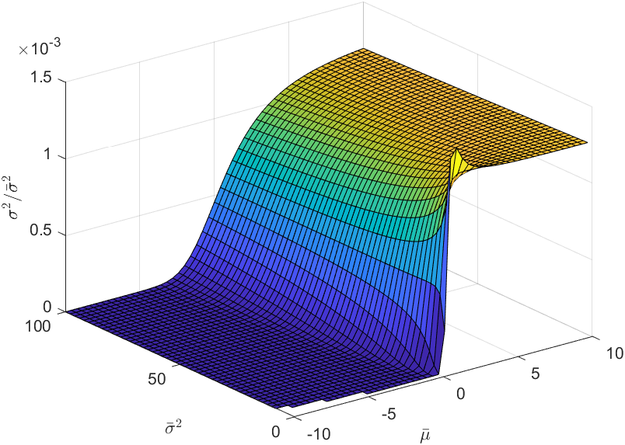

Numeric evaluation of activation function is extremely stable over a wide range of input values. I don’t understand how warning for infinity or nan could occur. Where did it appear?

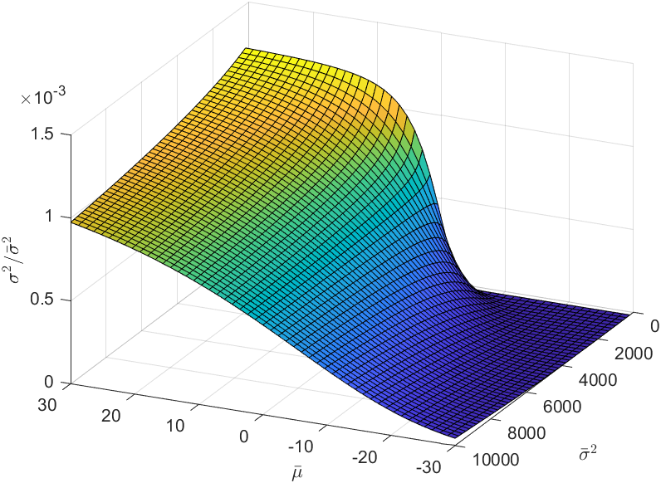

Training results

Case 1: MNIST. Train only 8 images over 1000 epoch

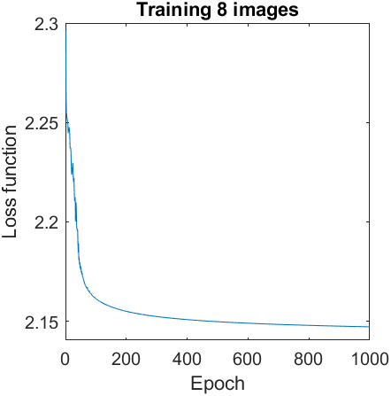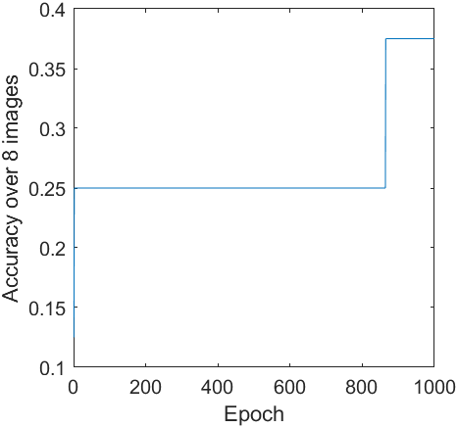

0001_mnist_8_images_test.mat

Improved results over 1e4 epoch.

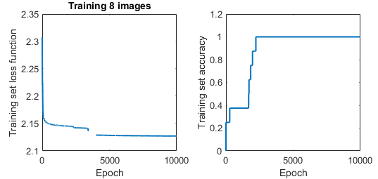

Test set of 80 images show that the test accuracy is: **0.425** (note since only 8 training samples are used whereas there are a total of 10 digits, theoretical max accuracy is 0.8)

During the training, the loss function end up with NaN due to failed numerical integration of certain samples. But for some reason it recovered shortly afterwards (probably dW who are NaN has being treated as 0 so other ‘healthy’ samples can continue push for learning.)

**Training MNN for optimal Bayesian inference**

$$μ_{3}=\frac{ν_{2}}{ν_{1}+ν_{2}}μ_{1}+\frac{ν_{1}}{ν_{1}+ν_{2}}μ_{2}$$

$$ν_{3}=\frac{ν_{1}ν_{2}}{ν_{1}+ν_{2}}$$

0002_reg_8x10_samples.mat

Randomly generated 80 samples (10 minibatches each with size 8).

Then target scaled appropriately such that

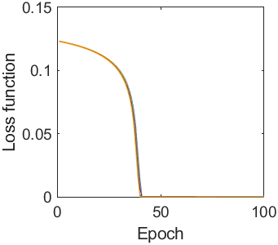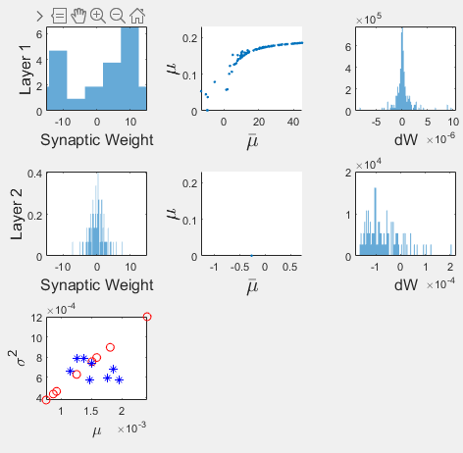

The loss can be reduced without much problem. However, the output won’t hit exactly the target and the relative error remains high. It seems that output mean and var are highly correlated.

Regarding the optimal operation range for MNN

The dynamic range of the activation function is limited. It’s a good idea to tune the network to operate in optimal range (especially so for regression-type training).

Red dashed line: Poisson output (is this line invariant for different time window used for spike count?)

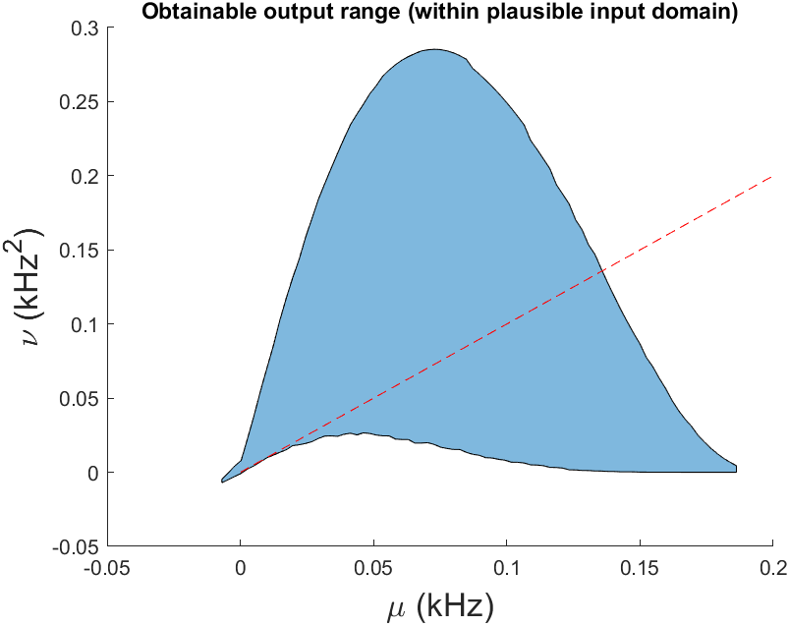

[plotted with output_uv_analysis.m]

Regression

u1 = 0.1; %kHz, must be in biologically plausible range

u2 = 0.05;

v1 = 0.1;

v2 = 0.25 + 0.1*randn;

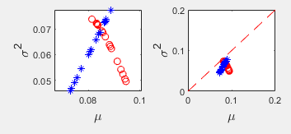

Another regression

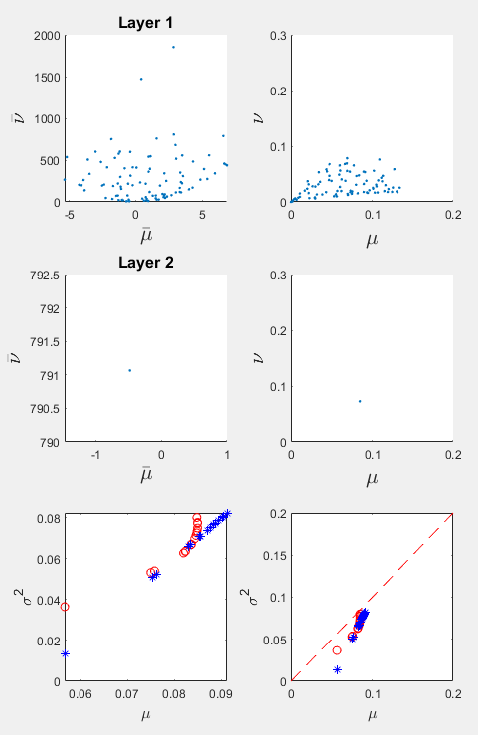

[0006_reg_16x600_samples.mat]

Regarding vanishing gradient

<https://tungmphung.com/sigmoid-tanh-activations-and-their-loss-of-popularity/#:~:text=The%20sigmoid%20and%20tanh%20activation%20functions%20were%20very,post%2C%20we%20explore%20the%20reasons%20for%20this%20phenomenon.>

Batch normalization

$$ψ:x→y$$

$$ϕ:y→z$$

Where $x=\left(\overline{μ},\overline{ν}\right)$ is the neural activity of neurons within a layer across minibatches.

To take full advantage of the tensor notation, we write

$$x_{iαm}$$

Where $i$ is the neural index (within a layer), $α$ is the batch index, and $m∈\left(1,2\right)$ is the moment index.

A note on MATLAB implementation:

Index m = 1,2 will be given separated variable names

Index $i,α$ will be a matrix

The forward pass is:

$$z_{iαm}=ϕ\left(y_{iαm}\right)$$

$$y_{iαm}=γ_{im}\left(\frac{{x_{iαm}-\left\langle x_{iβm}\right\rangle }_{β}}{\sqrt{{var}_{β}x_{iβm}}}\right)+β_{im}$$

The backward pass

$$\frac{∂z_{iαm}}{∂x_{iβn}}=\frac{∂z_{iαm}}{∂y_{iγl}}\frac{∂y_{iγl}}{∂x_{iβn}}$$

Where repeated indices (except i since normalization is occurs for each neuron) are summed over.