

El Niño 2026–27 and malaria risk in Africa: forecast rainfall and temperature anomalies alongside Plasmodium falciparum prevalence by district
Multi-model seasonal forecasts for November 2026 to March 2027, summarized for 5,340 subnational administrative units

Report of 29 October 2026
Table of Contents
Summary 3
1 Introduction 3
2 Data 3
3 Methods 4
Forecast processing 4
District summaries 4
4 Results 4
Malaria burden 4
Rainfall 5
Temperature 7
Overlap with high burden 7
5 Discussion 8
References 8

Summary
We combined the October 2026 seasonal forecasts from the nine centers of the Copernicus Climate Change Service (C3S) multi-system with the Malaria Atlas Project's 2025 estimates of Plasmodium falciparum prevalence in children aged 2–10 years (PfPR_{2–10}) for 5,340 subnational units across Africa. The forecast is wetter than normal over the Greater Horn of Africa and the East African highlands, especially in November, drier from Angola to Mozambique and over Madagascar from December to March, and warmer than the 1993–2016 reference everywhere, by 1.5 °C on average in malaria-endemic districts. Of the 311 million people in districts with PfPR_{2–10} of 25% or more, 47 million face a wetter season, mainly in Uganda and Burundi, and 36 million a drier one, mainly in Mozambique and Malawi. In the Ethiopian highlands, 16 million people in endemic districts face warming of 2 °C or more with above-normal rainfall, a combination linked to past epidemics. The results are a screening tool for surveillance and preparedness, not a forecast of malaria cases.

Introduction
Malaria transmission is sensitive to climate. Rainfall creates the standing water in which Anopheles mosquitoes breed, and temperature governs how quickly mosquitoes develop, how long they survive and how fast the parasite matures inside them. P. falciparum transmission is possible roughly between 16 and 34 °C and peaks around 25 °C (Mordecai et al., 2013), so warming raises transmission potential where cool temperatures normally limit it, as in the East African highlands. El Niño typically brings wetter short rains to East Africa from October to December, a drier rainy season to southern Africa from December to March, and warmer conditions across much of the continent. Past events were followed by highland malaria epidemics, notably in southwestern Uganda in 1997–98 (Lindblade et al., 1999; Kovats et al., 2003).
El Niño's intensity is a single Pacific sea surface temperature index, but malaria programs need its local expression in rainfall and temperature, which dynamical seasonal models simulate together with other drivers such as the Indian Ocean Dipole. This report sets those forecast anomalies alongside current malaria burden for every second-level administrative unit (district) in Africa, for the forecast initialized in October 2026.

Data
Five openly available inputs are downloaded and processed by a single R script, africa_enso_vs_pfpr_adm2.R, which can be rerun each month as new forecasts are issued (Table 1). Each C3S center expresses its anomalies relative to its own 1993–2016 hindcast climate, which removes model bias before averaging. The Malaria Atlas Project models PfPR_{2–10} only within the limits of stable transmission, so high-altitude and desert pixels carry no value rather than zero. CGAZ (Runfola et al., 2020) gives neighboring countries a single shared border and treats Western Sahara, Abyei and Koualou as disputed units.
Table 1. Inputs to the analysis.
Input | Source and version | Resolution | Use
Rainfall forecast | C3S multi-system ensemble-mean precipitation anomaly from nine centers (ECMWF, UK Met Office, Météo-France, DWD, CMCC, NCEP, JMA, ECCC, BoM), October 2026 initialization | 1°, monthly | Anomaly for November 2026 to March 2027
Temperature forecast | Same dataset, ensemble-mean 2 m temperature anomaly | 1°, monthly | Anomaly for the same months
Malaria burden | Malaria Atlas Project PfPR_{2–10}, release 202608, year 2025, with lower and upper bounds | 5 km | District malaria burden
Population | WorldPop R2025A, constrained and UN-adjusted, 2025 | 1 km | PfPR weights and district totals
Boundaries | geoBoundaries CGAZ, second level (first level for Libya and Mauritius) | Vector | 5,340 units of analysis

Methods

Forecast processing
The script first checks the Climate Data Store catalog for the model version each center has published, so that a model upgrade cannot silently drop a center. It requests the ensemble-mean anomaly for each variable and center, accepts a file only if it holds one layer per lead month, and tracks queued requests so that a rerun collects them rather than resubmitting. The nine centers are aligned on a common 1° grid and averaged with equal weight. Precipitation is converted from m/s to mm/day, and temperature anomalies in kelvin equal degrees Celsius. The season anomaly is the mean of the five months. All 18 forecast files (two variables from nine centers) were used.

District summaries
Rainfall and temperature anomalies are area-weighted means over each district. PfPR_{2–10} is a population-weighted median, reflecting prevalence where people live. WorldPop counts are summed, not interpolated, onto the 5 km PfPR grid, which preserves totals (1,531 and 1,529 million), and each pixel is weighted by its population and by the share of it inside the district, for the central estimate and both bounds. Districts with less than 25% of their population inside the transmission limits receive no value, so that a few border pixels cannot stand in for a whole district. The boundaries have no overlaps and 8 km² of gaps, against 85,000 km² and 33,000 km² with per-country files. Below, a district is malaria-endemic if its PfPR_{2–10} is 1% or more and high-burden if it is 25% or more; a season rainfall anomaly of at least +0.5 mm/day is wetter, and one of −0.5 mm/day or less is drier.

Results

Malaria burden
Of the 5,340 units, 4,022 are malaria-endemic, with 1,198 million people and a population-weighted mean PfPR_{2–10} of 17.7% (Figure 1). The 1,246 high-burden districts hold 311 million people, most of them in Nigeria (71 million), the Democratic Republic of the Congo (58 million), Uganda (24 million) and Angola (22 million). District values exceed 60% in northern Angola, northern Zambia and southern Democratic Republic of the Congo. The 1,125 units without an estimate are mostly malaria-free, including North Africa, most of South Africa and highland cores such as Addis Ababa and Nairobi.
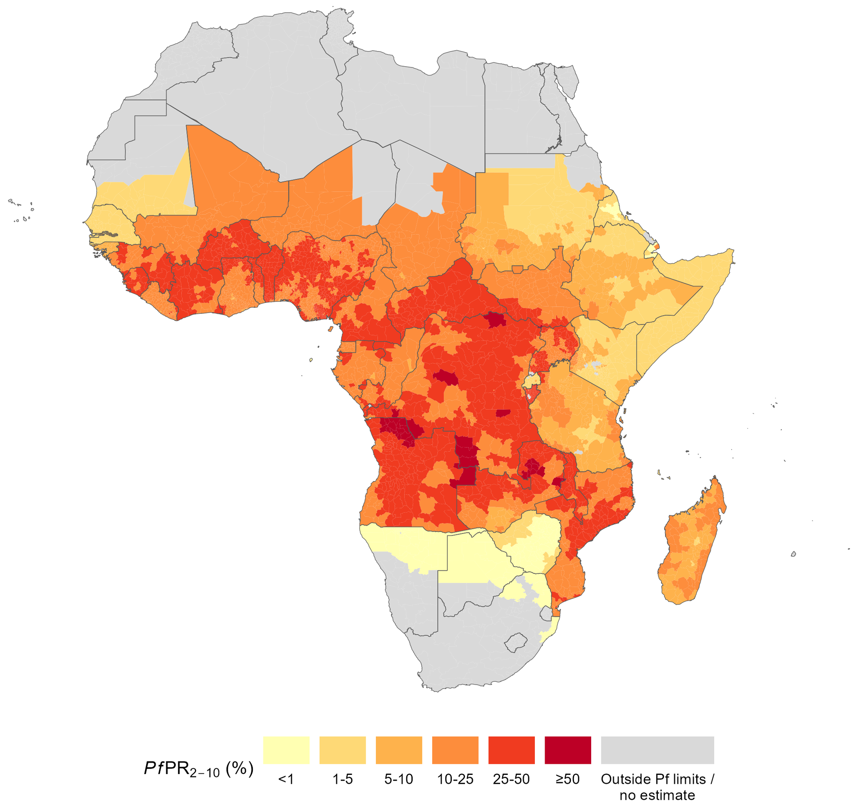
Figure 1. Population-weighted median PfPR_{2–10} by district, 2025 (Malaria Atlas Project release 202608). Gray units have most of their population outside the limits of stable transmission, or no estimate.

Rainfall
The rainfall forecast shows the canonical El Niño pattern (Table 2, Figure 2). In November, endemic districts of the Greater Horn and East African highlands are forecast to be 1.15 mm/day wetter on average, and 225 million people live in endemic districts with a November anomaly of +1 mm/day or more. From December, a dry signal develops from Angola to Mozambique, and Madagascar is markedly drier in January (−1.55 mm/day). Over the season, 21% of the endemic population lives in wetter districts and 9% in drier ones. West Africa and the Sahel, in their dry season, change little.
Table 2. Forecast anomalies in malaria-endemic districts (PfPR_{2–10} of 1% or more) by region, population-weighted; rainfall in mm/day, temperature in °C.
Region | Pop. (M) | PfPR (%) | Rain Nov | Rain Jan | Rain season | Pop. wetter (%) | Pop. drier (%) | Temp. season
Greater Horn and East African highlands | 358.4 | 10.4 | +1.15 | +0.27 | +0.56 | 62 | 0 | +1.53
Southern belt, Angola to Mozambique | 119.8 | 25.5 | −0.45 | −0.45 | −0.46 | 3 | 62 | +1.56
Madagascar | 32.0 | 9.0 | −0.36 | −1.55 | −0.85 | 0 | 92 | +1.33
Central Africa | 156.8 | 25.1 | +0.24 | +0.17 | +0.20 | 15 | 1 | +1.57
West Africa and the Sahel | 479.2 | 20.6 | +0.18 | −0.04 | −0.05 | 0 | 0 | +1.55
Other | 51.3 | 5.1 | 0.00 | 0.00 | 0.00 | 0 | 0 | +1.14
All malaria-endemic districts | 1,197.6 | 17.7 | +0.39 | 0.00 | +0.11 | 21 | 9 | +1.52
Greater Horn and East African highlands: Burundi, Djibouti, Eritrea, Ethiopia, Kenya, Rwanda, Somalia, South Sudan, Tanzania, Uganda. Southern belt: Angola, Botswana, Eswatini, Malawi, Mozambique, Namibia, South Africa, Zambia, Zimbabwe. Central Africa: Cameroon, Central African Republic, Congo, DR Congo, Equatorial Guinea, Gabon. West Africa and the Sahel: Benin, Burkina Faso, Chad, Côte d'Ivoire, Gambia, Ghana, Guinea, Guinea-Bissau, Liberia, Mali, Mauritania, Niger, Nigeria, Senegal, Sierra Leone, Togo. Other: Sudan, Comoros, São Tomé and Príncipe, Abyei, Koualou.
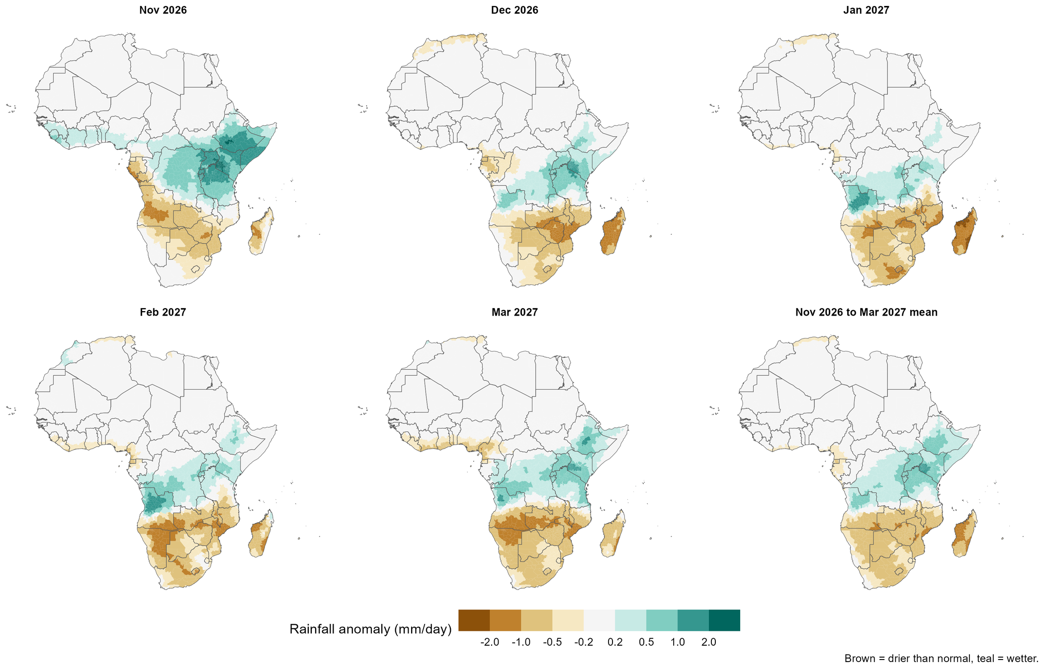
Figure 2. Forecast rainfall anomaly by district for each month from November 2026 to March 2027, and the season mean (C3S multi-system ensemble mean of nine centers, initialized October 2026).

Temperature
Every district is forecast to be warmer than the 1993–2016 reference in every month (Figure 3), with the median anomaly rising from 1.1 °C in November to 1.8 °C in March. Warming is strongest, above 2.5 °C in February and March, over the Sahara, the Sahel interior and the Kalahari, and weakest along the East African coast. Among endemic districts, 92 with 32 million people face a season anomaly of 2 °C or more, 20 million of them in the Ethiopian highlands, followed by Angola (3.4 million), South Sudan (1.9 million) and Zambia (1.7 million).
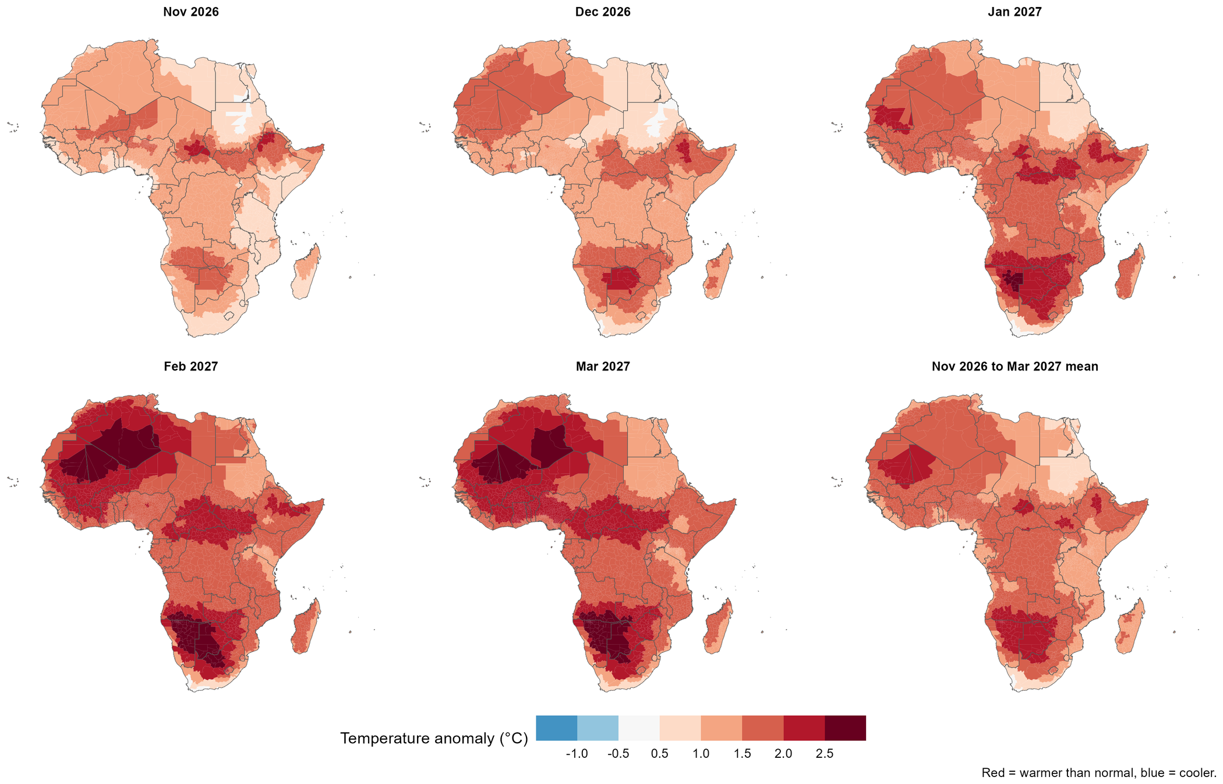
Figure 3. Forecast 2 m temperature anomaly by district for each month from November 2026 to March 2027, and the season mean, relative to the 1993–2016 hindcast climate (C3S multi-system ensemble mean of nine centers).

Overlap with high burden
Most of the high-burden population (228 million) is in districts with a near-normal rainfall forecast, led by Nigeria and the Democratic Republic of the Congo (Table 3). Forty-seven million people live in high-burden districts forecast to be wetter, mainly in Uganda and Burundi, and 36 million in high-burden districts forecast to be drier, mainly in Mozambique and Malawi. All three groups are forecast to be 1.5–1.6 °C warmer than normal. Wetter and warmer conditions coincide most clearly in the East African highlands, where 154 endemic districts in Ethiopia, Uganda, Kenya, Rwanda and Burundi, with 111 million people, are forecast to be at least 0.2 mm/day wetter and 1.5 °C warmer over the season. In Ethiopia, 16 million of the 20 million people in districts warming by 2 °C or more also face above-normal rainfall, on a low baseline PfPR_{2–10} of about 5% typical of epidemic-prone, unstable transmission.
Table 3. High-burden districts (PfPR_{2–10} of 25% or more) by forecast season rainfall anomaly.
Season rainfall forecast | Districts | Population (M) | Temp. season (°C) | Largest populations (M)
Wetter (+0.5 mm/day or more) | 228 | 46.7 | +1.50 | Uganda 23.3; Burundi 12.4; DR Congo 5.6; Angola 3.9
Near normal (−0.5 to +0.5 mm/day) | 898 | 227.7 | +1.60 | Nigeria 71.4; DR Congo 52.3; Burkina Faso 19.4; Côte d'Ivoire 18.1
Drier (−0.5 mm/day or less) | 120 | 36.3 | +1.56 | Mozambique 15.7; Malawi 13.6; Zambia 4.1; Angola 2.6
All high-burden districts | 1,246 | 310.7 | +1.58

Discussion
The forecast reproduces the expected El Niño footprint. Where it overlaps high malaria burden, it points to districts for closer surveillance and preparedness: high-burden Uganda and Burundi under a wetter forecast, Mozambique and Malawi under a drier one, and the epidemic-prone Ethiopian highlands under combined warming and above-normal rainfall. The direction of the effect is not fixed. Wetter conditions can multiply breeding sites, but heavy rain can also flush larvae away; drier conditions can reduce transmission, but can increase it where people store water or rivers shrink into pools. Local ecology and routine surveillance data are needed to interpret each case, and malaria typically lags rainfall by one to three months. The main limitations are:
- Warming trend. Anomalies are relative to 1993–2016, so part of the warmth reflects long-term warming rather than El Niño alone, although the full anomaly still matters for transmission.
- Forecast skill. Seasonal forecasts are probabilistic and the ensemble mean smooths out extremes. Skill is higher for temperature than rainfall, and highest for rainfall in East Africa in October–December and southern Africa in December–February.
- Absolute anomalies. A given anomaly in mm/day is a larger relative change in dry districts and months, so anomalies in dry areas are understated.
- Resolution. On the 1° forecast grid (about 110 km), small neighboring districts share values.
- Malaria estimates and boundaries. PfPR is modeled, with bounds in the output table. The generalized CGAZ coastline leaves about 12 million coastal residents (0.8%) outside every unit, mostly in North Africa and small island states, and official program boundaries should replace geoBoundaries units for country work.
We recommend rerunning the analysis with each monthly forecast while the El Niño evolves, and extending it with model agreement on the sign of each anomaly, percent-of-normal rainfall and a ranked watchlist of districts linked to routine surveillance.

References
Copernicus Climate Change Service. Seasonal forecast anomalies on single levels (seasonal-postprocessed-single-levels), October 2026 initialization. Climate Data Store. Accessed 28 October 2026.
Kovats RS, Bouma MJ, Hajat S, Worrall E, Haines A (2003). El Niño and health. The Lancet 362: 1481–1489.
Lindblade KA, Walker ED, Onapa AW, Katungu J, Wilson ML (1999). Highland malaria in Uganda: prospective analysis of an epidemic associated with El Niño. Transactions of the Royal Society of Tropical Medicine and Hygiene 93: 480–487.
Malaria Atlas Project. Plasmodium falciparum parasite rate (PfPR_{2–10}), release 202608. Accessed with the malariaAtlas R package, October 2026.
Mordecai EA, Paaijmans KP, Johnson LR, et al. (2013). Optimal temperature for malaria transmission is dramatically lower than previously predicted. Ecology Letters 16: 22–30.
Runfola D, Anderson A, Baier H, et al. (2020). geoBoundaries: a global database of political administrative boundaries. PLoS ONE 15: e0231866.
WorldPop. Global 2015–2030 population, release R2025A, constrained and UN-adjusted, 1 km. University of Southampton. Accessed October 2026.

