LEAP hand v1 https://v1.leaphand.com/
Developed by Kenneth Shaw Ananye Agrawal Deepak Pathak from Carnegie Mellon University
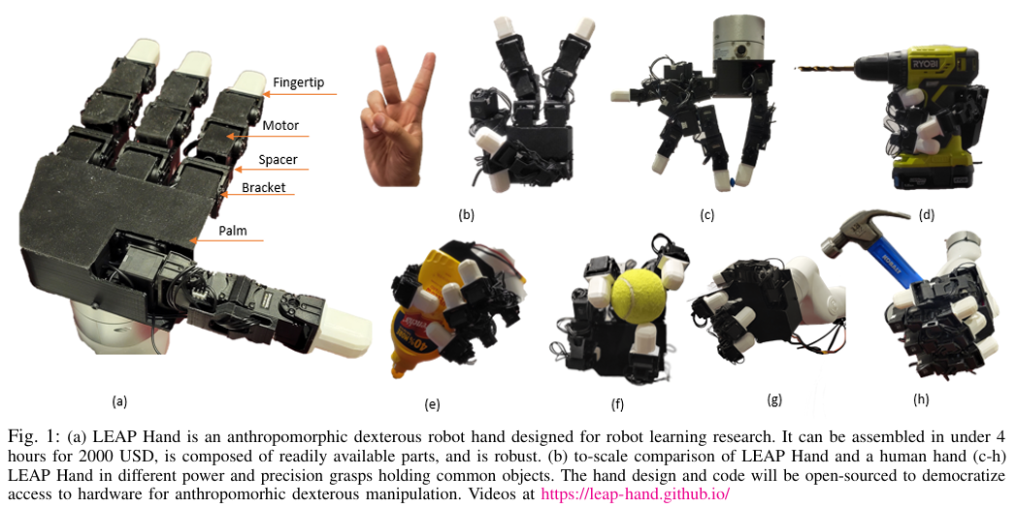

BOM https://v1.leaphand.com/parts
Part Name | Quantity | Material | Description
DYNAMIXEL XC330-M288-T | 16 | N/A | Full Dynamixel motor for fingers and thumb
DYNAMIXEL FPX330-H101 | 11 | N/A | Dynamixel protective components
DYNAMIXEL FPX330-S101 | 10 | N/A | Dynamixel protective components
DYNAMIXEL FPX330-S102 | 6 | N/A | Dynamixel protective components
DYNAMIXEL U2D2 | 1 | N/A | USB adapter for Dynamixel servos
M3 6mm 3D printer inserts | 5 | N/A | Fasteners for assembly
M2 6mm 3D printer inserts | 24 | N/A | Fasteners for assembly
M2 8mm screws | 16 | N/A | Fasteners for assembly
M2 10mm screws | 24 | N/A | Fasteners for assembly
M2 6mm screws | 4 | N/A | Fasteners for assembly
M3 6mm screws | 5 | N/A | Fasteners for assembly
Ninjaflex Edge (100g) | 1 | N/A | Flexible fingertip material
14 AWG 5V Cable | 1 | N/A | Wiring for power supply
Palm Lower | 1 | MJF | 3D printed palm component
Palm Upper | 1 | MJF | 3D printed palm component
Cable Spacer | 5 | MJF | 3D printed cable guide
MCP Bracket | 3 | MJF | 3D printed bracket for MCP joints
DIP Spacer | 3 | MJF | 3D printed spacer
Fingertip (Soft or Hard) | 4 | MJF | 3D printed fingertip

Design Notes

Design goals that drive the whole architecture
The creators are explicit that the hand is designed for robot learning research, so their priorities are not to compete with commercial robot hands like those from Shadow Robotics.
- Low cost + fast build: assembled in under 4 hours for under $2000 using readily available parts. Which is 1/8th the cost of the Allegro Hand and 1/50th to that of ShadowHand. LEAP Hand is designed to be modular. This allows key features of the robot hand to be changed, such as the length or number of fingers and the distances between each of the fingers in the palm for particular learning tasks or for analysis. Additionally, the modularity makes the hand easily repairable with only a few distinct parts.
- Robust to abuse: learning (teleop, behaviour cloning, reinforcement learning) is notoriously harsh on hardware, including collisions when mounted on an arm. They rely on inexpensive ($10) off-the shelf professionally extruded reinforced plastic brackets from Robotis that are designed to withstand wear and tear. They only print the palm and smaller wire guide spacers using a commercial3Dprinter.
- Anthropomorphic kinematics for transfer from humans: they repeatedly motivate human-likeness as enabling easier mapping from human demonstrations/video/teleop.
These goals explain many downstream DFM/DFA choices: direct-drive instead of tendons, modularity, off-the-shelf structural parts, torque/current limiting, and an explicitly human-analog joint layout.

Kinematic design principle: “keep dexterity across poses”
A central “why” in the paper is that many direct-driven hands lose useful motion depending on finger posture (extended vs flexed). They propose a universal abduction–adduction (ab/ad) mechanism to avoid that:
- Prior designs fix the ab/ad axis to the palm, which becomes ineffective when the finger aligns with that axis in certain poses.
- LEAP’s key idea: move the ab/ad axis into the first finger-joint frame and keep it perpendicular so ab/ad remains effective in all finger configurations (extended and flexed). This basically avoids configuration-dependent loss of DoF by choosing joint axes that remain well-conditioned across the workspace.

Anthropomorphism as a “design for learning” principle
They justify anthropomorphic layout not as aesthetics, but as a practical learning interface:
- Human-like joints make it possible to directly map human joint angles for teleoperation, rather than relying on less intuitive optimisation-based retargeting (which they say is needed for Allegro due to morphology mismatch).
- They evaluate thumb opposability volume (workspace intersection of thumb with fingers) as a proxy for real grasp versatility, and design for a larger/evenly spread opposability region. They’ve optimised morphology for human demonstration compatibility (retargeting simplicity) and for thumb–finger opposability.

Design for manufacture (DFM): “print what’s okay to be plastic; buy what must be strong”
They draw a clear manufacturing boundary:
- They avoid custom machined metal parts as using those would add significant cost and require specialised skill and equipment to manufacture.
- They use a common FDM printers (they cite a ~$200 Ender-class printer) and print core parts (palm pieces, fingertips, spacers) in common materials like PLA.
- For strength-critical structure they use off-the-shelf professionally extruded reinforced plastic brackets from Robotis rather than relying solely on printed parts.
- They also mention leveraging advancements from the RepRap ecosystem and printing flexible materials like NinjaFlex for soft fingertip-like components.

Design for assembly (DFA): modular subassemblies + few distinct parts
The paper published by them describes the hand as intentionally modular:
- Fingers are assembled individually from repeating elements (brackets + spacers + motors), then mounted to the palm.
- “Designed to be modular” so you can change finger length/count/spacing (useful for experiments) and also so repairs are easy.
- “Easily repairable in-house” with “only a few distinct parts,” implying part reuse/commonality and a reduced inventory burden.
Other principles:
- Subassembly-based build (finger modules → palm integration)
- Part commonality (repeatable finger architecture)
- Serviceability/repair as a first-class requirement

“Robustness by design”: maximise actuator capability, then protect it in software
They make a deliberate choice to be strong for a human-scale form factor:
- Motors selected/geared for high torque while keeping “hand-like” speed (~8 rad/s).
- They “maximise motor mass inside the hand” and “minimise every other component” to improve strength for size.
- Because high torque can break things, they emphasise current/torque limiting and current-based position control to cap maximum torque (safer + more durable).
Design for high peak capability, then enforce safe operating limits via control modes.

CAD highlights
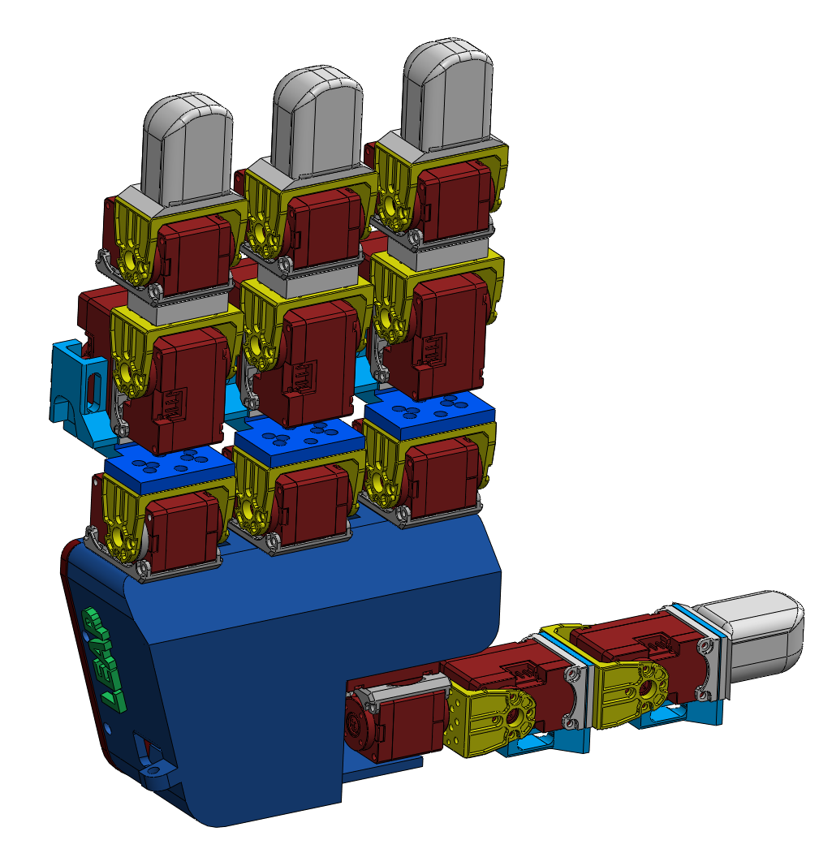
Cable spacer
Palm lower
Palm upper
MCP bracket
DIP spacer
Fingertip

Cable spacer
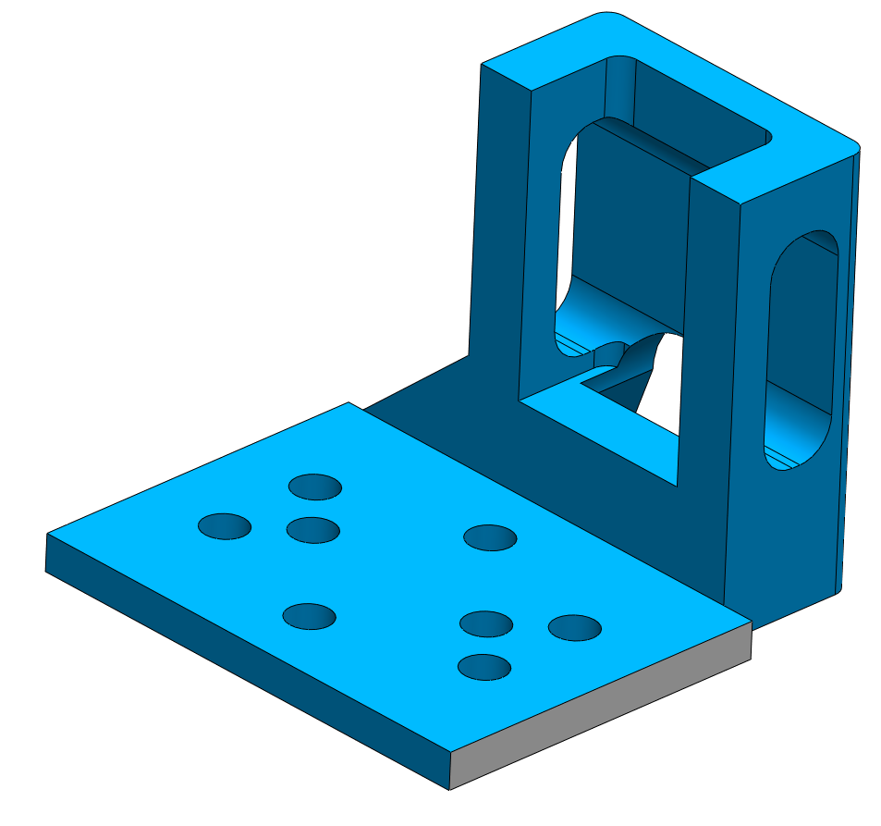
2.55mm clearance holes for M2 bolts
2.1mm thick plastic 3D printed
Slots sized for feeding through dynamixel JST EHR-03 connectors

DIP spacer
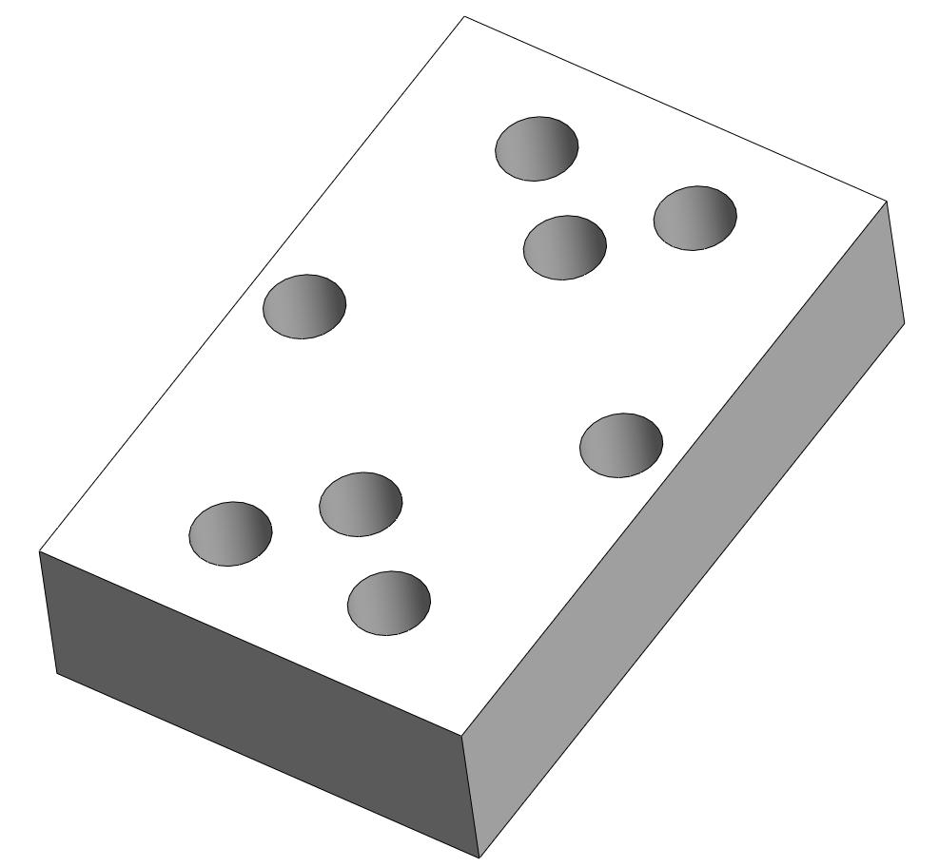
2.65mm clearance holes for M2 bolts
6.1mm thick plastic 3D printed. Can be adjusted to adjust link lengths

Fingertip
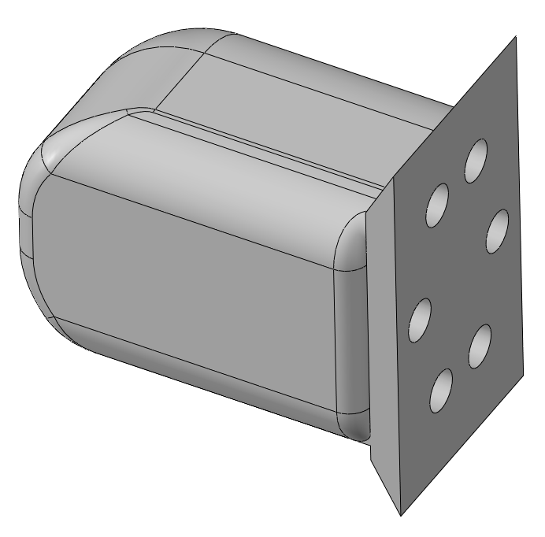
3.5mm holes for M2 brass inserts.
Printed in TPU so holes undersized for the 6mm inserts

Part length can be adjusted to custom lengths

MCP bracket
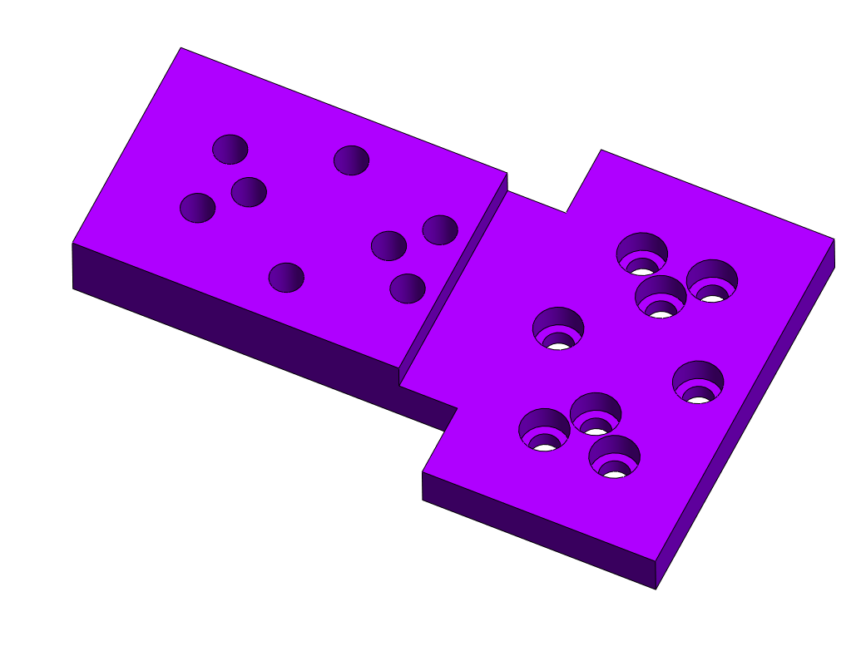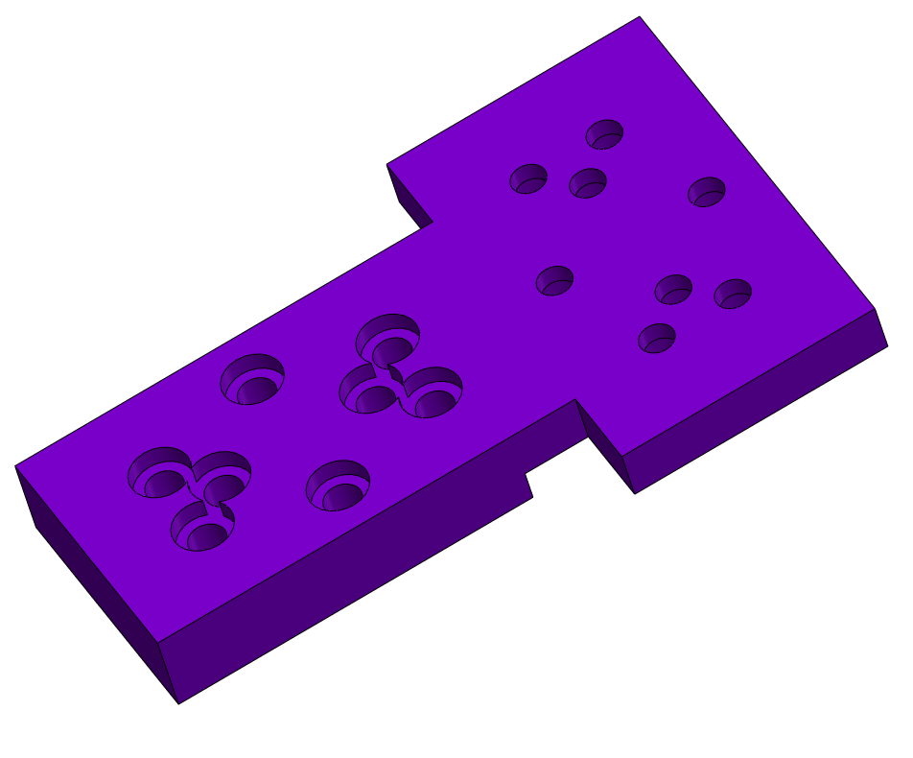
2.56mm holes for M2 bolts
2.76mm holes for M2 bolts
Bolt head clearance holes

Palm lower
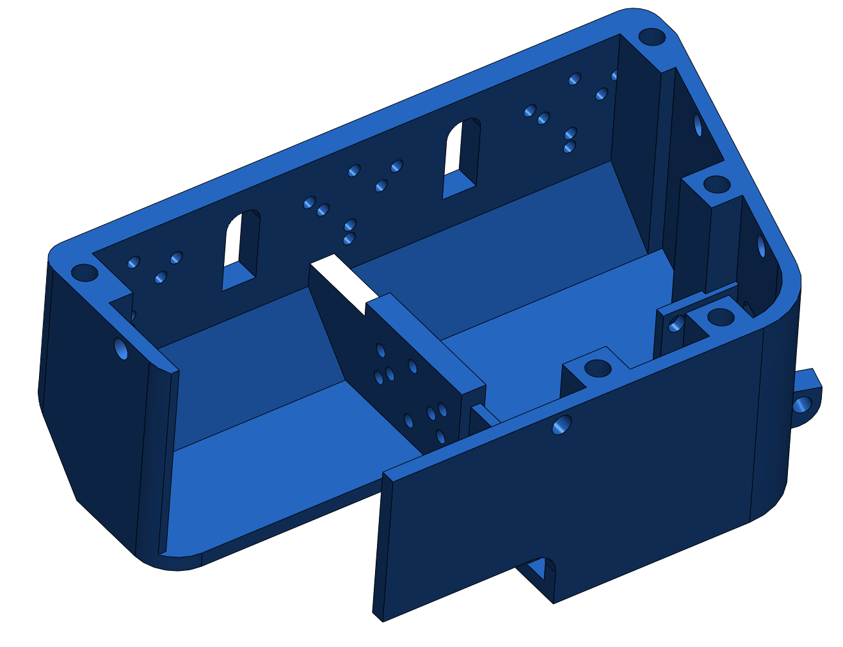
Brass insert – 4.5mm holes for the 5mm diameter inserts
2.56mm clearance holes for M2 bolts

Palm upper
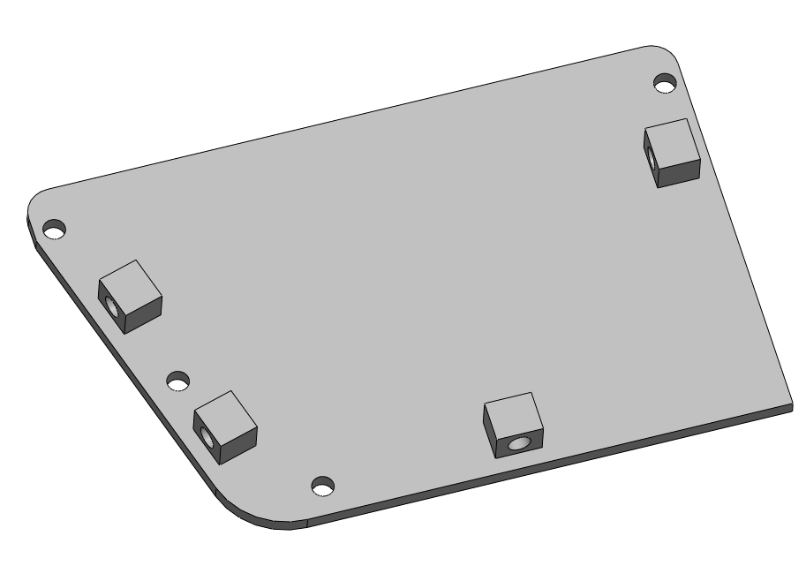
Brass insert – 4.4mm holes for the 5mm diameter inserts
Part can be adjusted to fit different robot arms
2.2mm clearance hoes for M2 bolts

