Yale OpenHand model Q
Raymond R. Ma and Aaron M. Dollar
https://www.eng.yale.edu/grablab/openhand/model_q.html#about
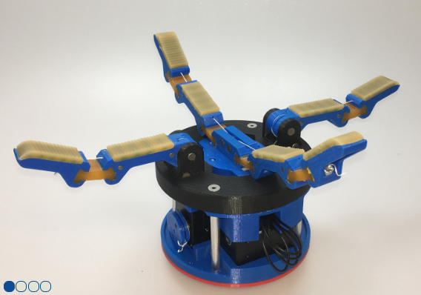
https://github.com/grablab/openhand-hardware/tree/master/model%20q

BOM

Off the shelf parts
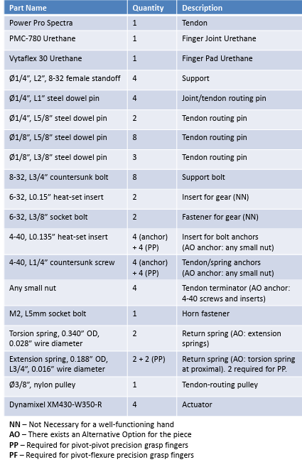

Printed parts
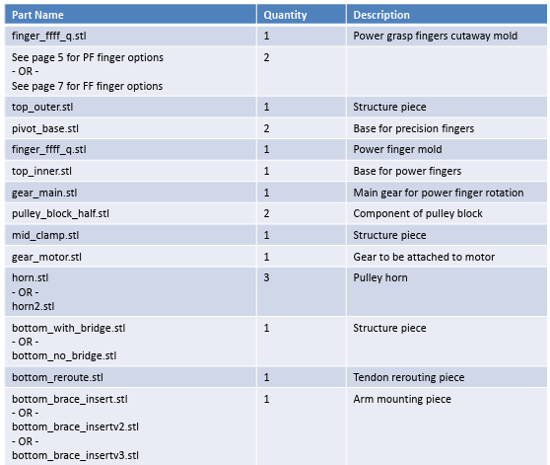

Design notes

Under actuated tendon driven
Principle: Achieve useful in-hand manipulation with fewer actuators by combining two underactuated finger pairs with a central rotary degree of freedom.
- The creators describe Model Q as two tendon-driven, underactuated finger pairs “decoupled by an independent, central, rotating axis,” enabling finger-gaiting / regrasping while staying low-cost and compact.
- Design rationale: avoid fully anthropomorphic complexity; instead do a small set of robust, repeatable manipulation primitives (gaiting, twisting, pivoting).
Why: Underactuated fingers already give passive adaptability; adding a single rotary axis between pairs expands the reachable manipulation behaviours without adding per-finger ab/adduction joints (which would raise part count and control complexity).

Differentiated fingers for different job roles
Principle: Uses different joint technologies where they matter most.
- The hand uses a power-grasping pair with flexure-based proximal joints for surface conformity and robustness, and a precision-grasping pair with pin (revolute) proximal joints (preloaded with springs) to reduce out-of-plane compliance and improve pinch stability.
- The OpenHand finger library explicitly supports three joint-type combinations—Flexure-Flexure, Pivot-Pivot, Pivot-Flexure—with clear trade-offs (compliance/robustness vs twist-out vs precision).
Why: Flexures are great for tolerance to collisions and positioning error but can “twist out” in precision tasks; a proximal pin joint reduces that failure mode.

Design for Manufacturing: combining rigid prints + soft joints/pads
Principle: The creators print the rigid links, then cast the compliant joints.
- The Finger Guide lays out Hybrid Deposition Manufacturing (HDM) as: print molds → assemble → deposit urethanes/resins → disassemble.
- They use two-part urethanes: PMC-780 for flexures and Vytaflex for pads.
- The creators describe printing the finger bodies and mold shells, then pouring urethanes into joint/pad cavities; plus adding small anchoring features so urethane stays bonded to the printed body.
Why: This yields compliant, durable joints and high-friction pads without expensive multi-material printers or the need for additional spring componts—while keeping geometry easily editable.

Design for Assembly: Choosing fasteners and joining methods that use simple tools
Principle: Assembly uses press-fits, standard dowel pins, heat-set inserts, and a small set of common fasteners.
- Model Q uses many steel dowel pins as joint pins and tendon routing pins and emphasises “press fit” installation.
- Heat-set inserts appear repeatedly (tendon anchors, gear attachment, etc.), but the assembly notes often note they’re not strictly necessary for a functioning hand—explicitly supporting simplified builds.
- Finger post-processing guidance is built around common workshop steps (reaming printed holes, drilling tendon ports, trimming sacrificial walls), reflecting “designing for real prints” rather than ideal CAD.
Why: Press-fit pins and inserts reduce alignment demands and keep the bill-of-process simple—no precision machining required.

Modularity and interchangeability
Principle: Tendon-driven fingers enable swapping whole finger sets and keeping the palm/actuation base consistent.
- The Finger Guide document explicitly says tendons make hands more modular and allow “entire sets of fingers [to be] interchanged on top of the same actuation base,” while staying compact.
- Model Q assembly lists multiple finger options and mold variants, and labels parts as AO (alternative option) / NN (not necessary) / PP/PF required for specific finger types, which provides the end user multiple choices.
Why: This supports research iteration: you can test different finger behaviours without redesigning the whole hand.

Robust tendon routing and wear management
Principle: Route tendons over steel dowel pins to avoid abrasion against printed plastic and use low-stretch line.
- The creators note Spectra tendon routed across steel dowel pins “to prevent abrasive wear and tear on the printed ABS surfaces.”
- The Finger Guide document recommends non-stretch, thin tendon (example: 100 lb Spectra) and highlights tendon tie-off as the main practical challenge, offering termination alternatives (nut/washer vs insert+bolt).
Why: Printed plastics wear quickly under sliding line; steel pins are cheap “sacrificial” wear surfaces.

Tuneable passive compliance as a design parameter
Principle: Use return springs (torsion/extension/bands) and targeted stiffness ratios to shape closing behaviour.
- Finger Guide document explains single-acting tendons require return action and discusses torsion vs extension spring trade-offs.
- The creators states design choices like:
  - proximal/distal link ratio ≈ 1.5 (human-like),
  - transmission ratio set ≈ 1 (empirical),
  - distal joint ≈ 2.5× stiffer than proximal to encourage proximal contact first.
Why: In underactuated hands, behaviour emerges from compliance + contact—so stiffness is effectively part of the “control.”

CAD highlights
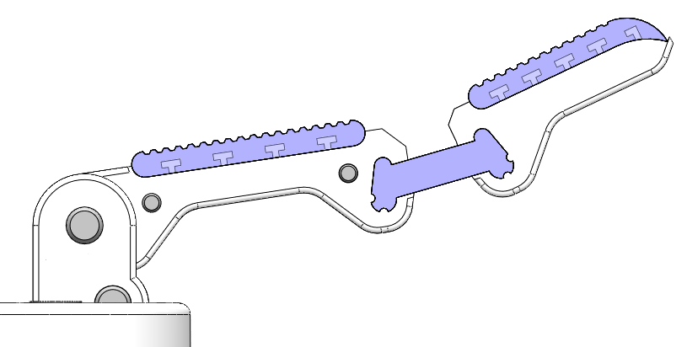
¼” (6.35mm) dowel into a 6.48mm hole. Tight fitting, suitable for press fitting, holds the dowel in place with friction.
The rotating proximal joint has looser tolerance of 6.65mm allowing for rotation.

Moulded in place T -profiles keep the flexible elements joined to the rigid link.

1/8” Steel dowels providing abrasion resistance. Pressed into place

The length of the printed and casted parts can be adjusted as needed.

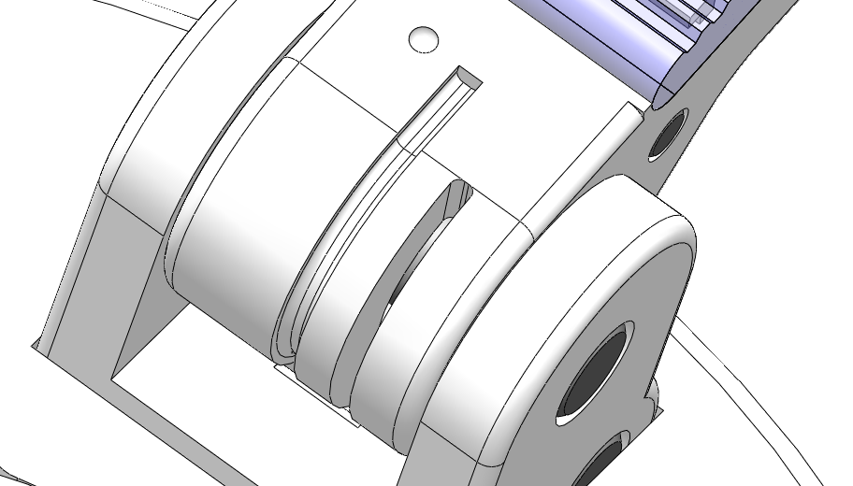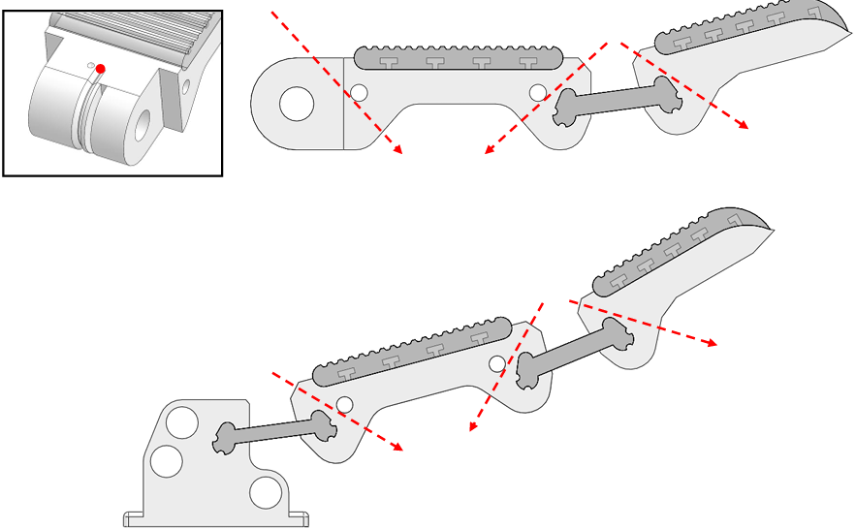
Tendon path not modelled into the CAD model. Post print steps include detail for drilling these out

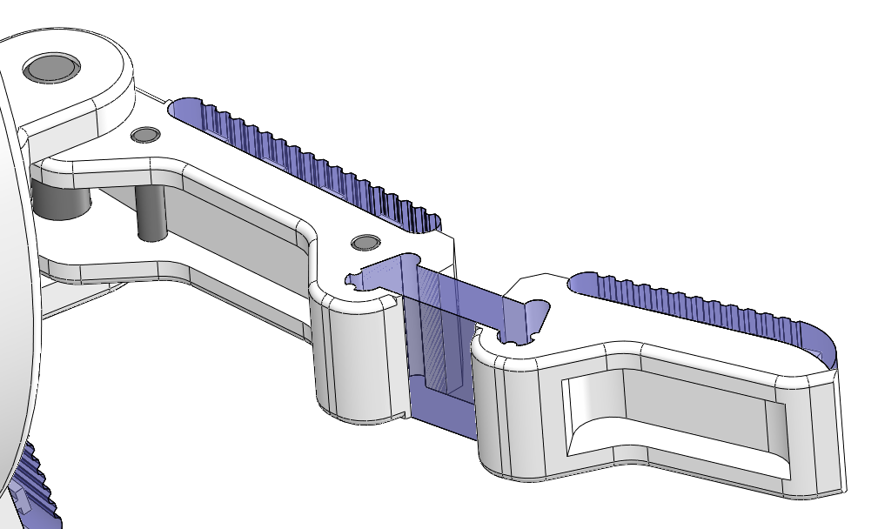
Hollowed out sections reduces weight and eases tendon routing during assembly

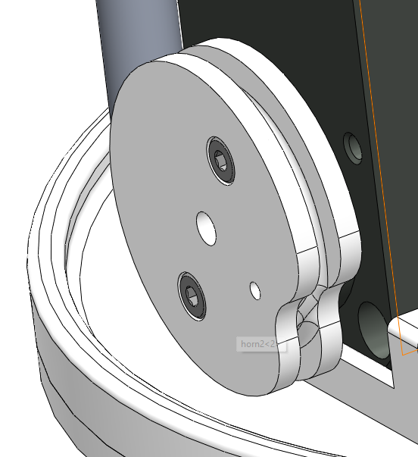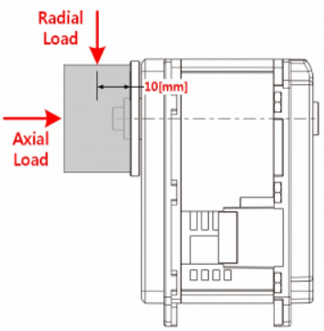
XM4330-w350-r motors rated for 40N radial load. No need for double bracing of the pulley.

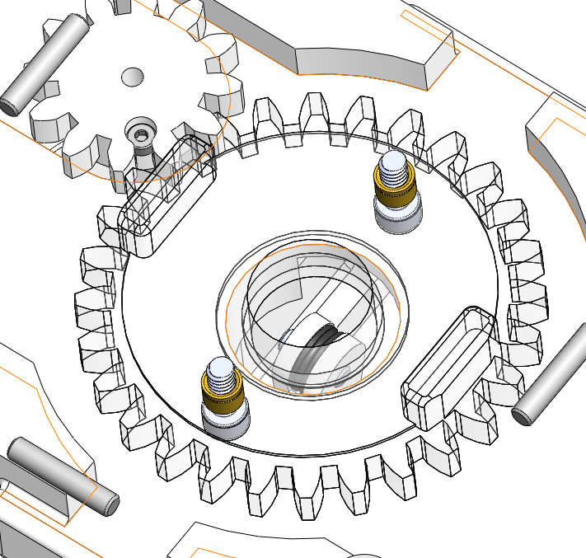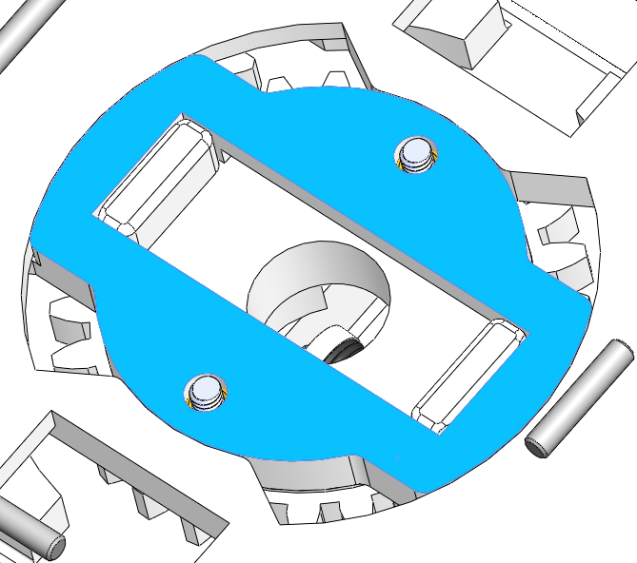
No bearing supporting the main gear

Gear remains concentric with this ‘top_inner’ part to constrain movement. 0.18mm gap between sliding surfaces provides the room to rotate.

