External Cost Test

**Objectives**

The impact of the changes of external costs on the Algo assets selection under different scenarios.

### Changes

1. The changes are at the level of assets, asset type and counterparties. The range is from 0.07 to 0.42 bps per day.
2. Change the external cost of cash for all counterparties
3. Change the external cost of noncash for all counterparties
4. Change the external cost of cash for counterparty 1, while change the external cost of noncash for counterparty 2.

### Scenarios

**Scenario 1**

Controlled Variables

* Opportunity cost: cash=overnight depo rate, noncash=repo rate
* Internal cost: cash=0.3bps/day, noncash=0.3bps/day
* Preference: (cost, liquidity)= (10, 0), (8,2), (5,5), (2,8)
* Asset : insufficient cash or sufficient cash

1. Change the external cost of cash for all counterparties

Insufficient Cash

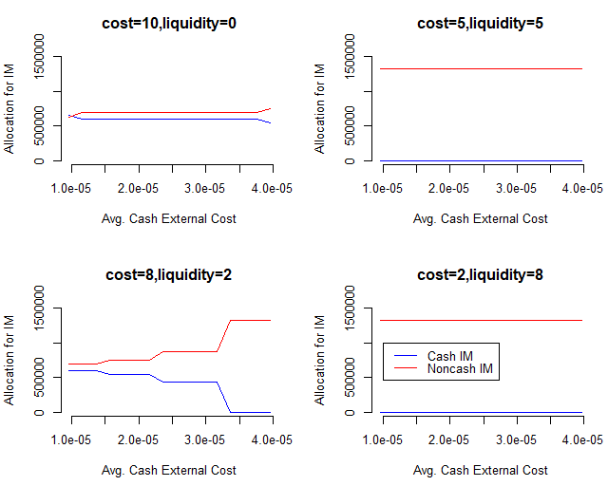

*Note: “Avg.” in the figure stands for “Average”*

Observations:

1. Comparing the same point on x-axes of 4 plots, as the preference of cost declines, the usage of cash for initial margin decreases till reaches 0.
2. In each plot, as the external cost of cash increases with fixed preference, the usage of cash for initial margin has a tendency to decrease till reaches to 0.
3. In the first plot, at point x=1.0e-5, this is where preference of cost is largest, and the external cost of cash is the least (less than noncash). We would expect that the algo will choose all cash to fulfil IM, but it seems that the amount of cash and noncash allocated are almost the same. That’s because there are not sufficient cash assets available, so we need to run the same test in a sufficient cash scenario, which is the following.

Sufficient Cash

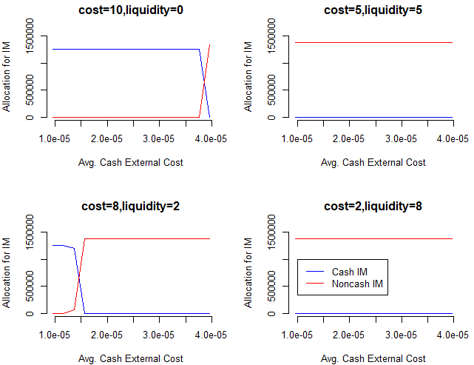

1. Now we can see from the first plot, at first the usage of noncash is 0, and the IM is fulfilled by cash only.
2. Change the external cost for noncash

Average external cost of cash = 0.24bps/day

Insufficient Cash

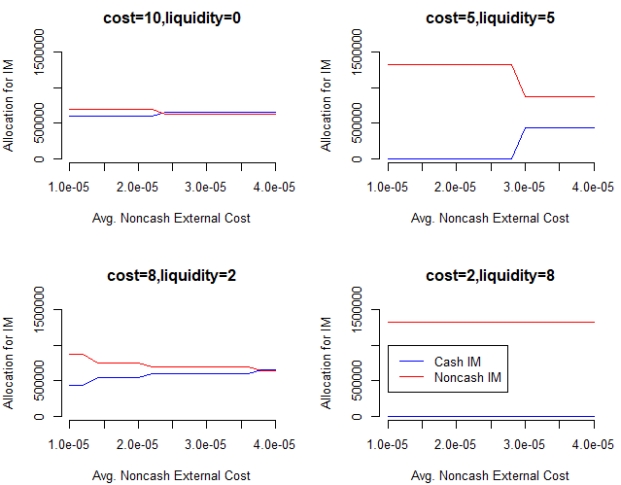

Observations:

1. Comparing the same point on x-axes of 4 plots, as the preference of liquidity increases, the usage of noncash for initial margin increases till reaches maximum (cash reaches to 0).
2. In each plot, as the external cost of noncash increases with fixed preference, the usage of noncash for initial margin has a tendency to decrease.
3. In the first plot, at point x=1.0e-5, this is where preference of cost is largest, and the external cost of cash is the least (less than noncash). We would expect that the algo will choose all cash to fulfil IM, but it seems that the amount of cash and noncash allocated are almost the same. That’s because there are not sufficient cash assets available, so we need to run the same test in a sufficient cash scenario, which is the following.

Sufficient Cash

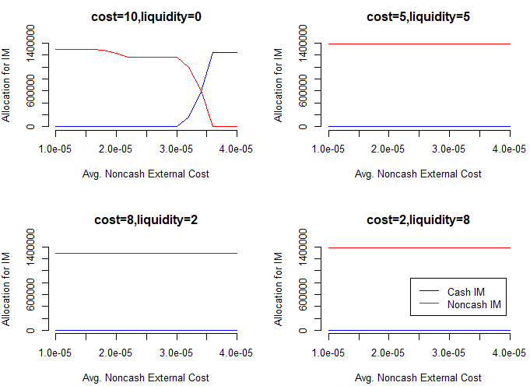

From the first plot, when the external cost is below 0.3bps/day, IM is fulfilled by noncash only. Start from this point, the usage of cash inclines rapidly, and at the point noncash ext.cost = 0.36bps/day, the usage of cash reaches to maximum and the usage of noncash drops to 0.

From the rest 3 plots the usage of cash is 0 no matter how much the external cost of noncash changes. The meaning of this result, let’s take the scenario where preferences of cost and liquidity are 8 and 2 and the noncash ext.cost is 0.1bps/day as an example. Considering that the average external cost of cash is 0.24bps/day and the total IM amount is $1.25million, there’s about (0.24-0.1) bps*$1.25million = $17.5 cost saving daily, but the algo didn’t choose cash. That is because the liquidity preference is more significant in this scenario.

1. Change the external cost of cash for counterparty 1, while change the external cost of noncash for counterparty 2.

**Scenario 2**

Controlled Variables

* Opportunity cost: cash=overnight depo rate, noncash=repo rate
* Internal cost: cash=0.5bps/day, noncash=0.3bps/day
* Preference: (cost, liquidity)= (10, 0), (8,2), (5,5), (2,8)
* Asset sufficiency: insufficient cash or sufficient cash

1. Change the external cost of cash

Insufficient Cash

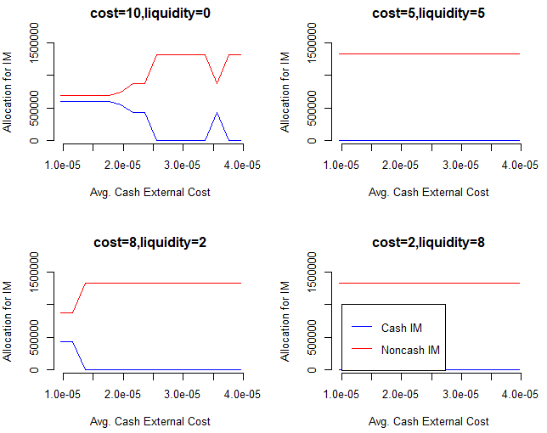

Observations:

1. Comparing the same point on x-axes of 4 plots, as the preference of liquidity increases, the usage of cash for initial margin decreases till reaches 0.
2. In each plot, as the external cost of cash increases with fixed preference, the usage of cash for initial margin has a tendency to decrease.
3. In the first plot, at point x=1.0e-5, this is where preference of cost is largest, and the external cost of cash is the least (less than noncash). We would expect that the algo will choose all cash to fulfil IM, but it seems that the amount of cash and noncash allocated are almost the same. That’s because there are not sufficient cash assets available, so we need to run the same test in a sufficient cash scenario, which is the following.

Sufficient Cash

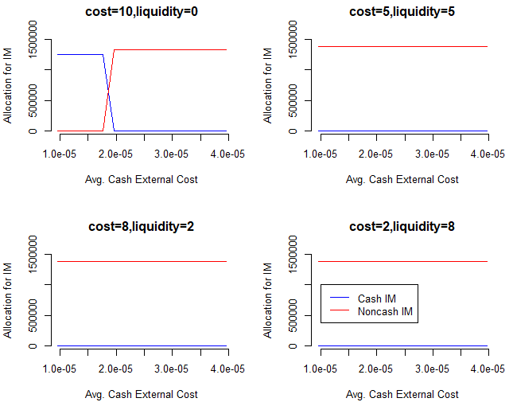

1. Now we can see from the first plot, at first the usage of noncash is 0, and the IM is fulfilled by cash only.

Change the external cost of cash for counterparty 1, while change the external cost of noncash for counterparty 2.