
A Project Report on

LEAVE MANAGEMENT SYSTEM

Submitted in partial fulfilment of the requirements of the Summer Trainingon
Application Development
using ServiceNow

Submitted by
Arman Das | 2341004065
Prantik Kamila | 2341011005
Abhishek Nayak | 2341014078
Shruti Muskan | 2341013428

Department of Computer Science and Engineering
Institute of Technical Education and Research
Siksha ‘O’ Anusandhan
(Deemed to be University)
Jagmohan Nagar, Bhubaneswar, India
July, 2026

DECLARATION

We hereby declare that the project report entitled"LEAVE MANAGEMENT SYSTEM"submitted in partial fulfilment of the requirements of the Summer Course on Application Development using ServiceNow is a record of the original work carried out by us.

We further declare that this project has not been submitted, either wholly or partially, to any other university, institution, or organization for the award of any degree, diploma, certificate, or other academic qualification.

We certify that all sources of information used in this project have been duly acknowledged and referenced. We also affirm that this work complies with the academic integrity guidelines of the institution.

Sl. No. | Name of Student | Registration No. | Signature
1 | Arman Das | 2341004065 | Arman Das
2 | Prantik Kamila | 2341011005 | Prantik Kamila
3 | Abhishek Nayak | 2341014078 | Abhishek Nayak
4 | Shruti Muskan | 2341013428 | Shruti Muskan

Place: ITER, Bhubaneswar
Date: 4 August 2026

Contents

Chapter 1 1
Introduction 1
1.1 Background 1
1.2 Problem Statement 2
1.3 Proposed Solution 2
1.4 Objectives 3
1.5 Scope 3
1.6 Organization of Report 4
Chapter 2 5
Literature Review 5
2.1 Enterprise Workflow Automation 5
2.2 Low-Code Development Platforms 6
2.3 ServiceNow Platform 7
2.4 Existing Systems 8
2.5 Research Gap 9
Chapter 3 10
Requirement Analysis 10
3.1 Business Problem 10
3.2 Stakeholders 12
3.3 Personas 13
3.4 Functional Requirements 14
3.5 Non-Functional Requirements 16
3.6 Inputs 17
3.7 Outputs 18
3.8 Process Analysis 19
Chapter 4 24
System Design 24
4.1 Overall Architecture 24
4.2 Application Development Lifecycle 26
4.3 Database Design 27
4.4 Table Design 28
4.5 Field Design 30
4.6 Form Design 32
4.7 List Design 33
4.8 Navigation Modules 34
4.9 Security Design 35
Chapter 5 37
Application Development 37
5.1 Development Environment 37
5.2 Application Scope 38
5.3 Tables Created 39
5.4 Modules Created 40
5.5 Forms 41
5.6 Client Scripts 42
5.7 UI Policies 43
5.8 Business Rules 43
5.9 Script Includes 45
5.10 Flow Designer 45
5.11 Notifications 46
5.12 Reports 47
5.13 Dashboards 47
5.14 Service Catalog (if applicable) 48
5.15 Integration (if applicable) 49
Chapter 6 50
Implementation 50
Chapter 7 64
Testing 64
7.1 Test Plan 64
7.2 Test Cases 66
7.3 User Acceptance Testing 67
7.4 Performance Testing 68
7.5 Security Testing 69
Chapter 8 70
Deployment 70
Chapter 9 76
Conclusion and Future Scope 76
9.1 Conclusion 76
9.2 Future Scope 77
References 81

Chapter 1

Introduction

1.1 Background
In today's digital era, organizations are increasingly adopting enterprise applications to automate routine business processes and improve operational efficiency. Traditional paper-based or email-based systems often lead to delays, errors, and difficulty in tracking employee requests. Workflow automation helps organizations streamline such processes by reducing manual intervention and ensuring faster decision-making.
Low-code development platforms have become popular because they enable developers to build business applications with minimal coding effort. These platforms provide visual tools, reusable components, and built-in automation features, making application development faster and more efficient.
ServiceNow is one of the leading cloud-based low-code platforms used by organizations worldwide for digital workflow automation. It provides features such as custom application development, workflow automation, role-based access control, reporting, dashboards, and notification services. These capabilities allow businesses to automate their day-to-day operations while improving transparency and productivity.
The Leave Management System developed in this project utilizes the ServiceNow platform to automate the complete leave management process. The application enables employees to apply for leave online, managers to approve or reject requests, automatic leave balance calculation, notification services, and report generation. By replacing the manual leave management process with an automated solution, the system improves efficiency, reduces paperwork, and enhances the overall user experience.

1.2 Problem Statement
Many organizations still manage employee leave requests through manual methods such as paper forms, emails, or spreadsheets. These approaches create several operational challenges, including delays in the approval process, inaccurate leave balance calculations, poor record management, and lack of transparency in tracking leave requests.
Employees often find it difficult to know the status of their leave applications, while managers spend additional time reviewing requests manually. HR departments also face challenges in maintaining accurate leave records and preparing reports.
The absence of an automated leave management system results in increased administrative workload, higher chances of human error, and inefficient business processes. Therefore, there is a need for a centralized application that automates leave requests, approvals, notifications, leave balance management, and reporting.

1.3 Proposed Solution
To address the above challenges, a Leave Management System has been developed using the ServiceNow platform.
The proposed system provides a centralized web-based application where employees can submit leave requests electronically. The application automates the approval workflow by routing leave requests to the respective managers for approval or rejection. After approval, the employee's leave balance is updated automatically, and notifications are sent to the concerned users.
The application also includes role-based access control to ensure secure access, reports for analyzing leave statistics, and dashboards for monitoring organizational leave activities. By automating the entire process, the application minimizes manual effort, improves accuracy, and enhances operational efficiency.

1.4 Objectives
The primary objectives of the Leave Management System are:
- To automate the employee leave application process.
- To reduce manual paperwork involved in leave management.
- To automate leave approval and rejection workflows.
- To maintain accurate leave balances for every employee.
- To improve transparency in tracking leave requests.
- To provide timely email notifications to employees and managers.
- To generate reports for monitoring leave statistics.
- To provide dashboards for effective decision-making.
- To implement secure role-based access control.
- To improve overall productivity and user experience.

1.5 Scope
The scope of the Leave Management System includes the complete automation of leave-related activities within an organization.
The application supports multiple users, including employees, managers, HR personnel, and administrators. Employees can submit leave applications, view their leave history, and check their remaining leave balance. Managers can review, approve, or reject leave requests submitted by their team members. HR personnel can manage employee records, leave types, and generate reports, while administrators have complete control over the application.
The system automates the following business processes:
- Employee registration
- Department management
- Leave application
- Leave approval and rejection
- Leave cancellation
- Leave balance management
- Notification management
- Report generation
- Dashboard monitoring
The current implementation focuses on leave management within a single organization and does not include integration with third-party payroll or attendance systems.

1.6 Organization of Report
This report is organized into nine chapters.
Chapter 1 introduces the project by presenting the background, problem statement, proposed solution, objectives, and scope of the Leave Management System.
Chapter 2 provides a literature review covering enterprise workflow automation, low-code development platforms, the ServiceNow platform, existing leave management systems, and the research gap.
Chapter 3 discusses the requirement analysis, including business problems, stakeholders, functional and non-functional requirements, system inputs and outputs, and process analysis.
Chapter 4 presents the system design, including the overall architecture, database design, table design, field design, navigation modules, forms, and security mechanisms.
Chapter 5 explains the application development process, including the development environment, tables, modules, client scripts, UI policies, business rules, Flow Designer workflows, notifications, reports, and dashboards.
Chapter 6 describes the implementation process followed during the development of the application, along with the implementation steps.
Chapter 7 discusses the testing activities, including unit testing, integration testing, user acceptance testing, performance testing, and security testing.
Chapter 8 explains the deployment process, update sets, source control, application migration, and production deployment.
Chapter 9 concludes the project by summarizing the outcomes, highlighting the benefits of the developed application, discussing learning outcomes, and suggesting future enhancements.

Chapter 2

Literature Review

2.1 Enterprise Workflow Automation
Enterprise Workflow Automation is the process of using software to automate routine business activities that are traditionally performed manually. Organizations use workflow automation to improve operational efficiency, reduce human errors, increase productivity, and ensure that business processes follow predefined rules.
Many business operations such as leave management, employee onboarding, incident management, asset tracking, and approval requests involve multiple stakeholders and repetitive tasks. Performing these activities manually often results in delays, inconsistent record keeping, and increased administrative workload.
Workflow automation addresses these challenges by routing requests automatically to the appropriate users, sending notifications, maintaining digital records, and tracking the status of every process in real time.
In the Leave Management System developed for this project, workflow automation is used to automate the complete leave approval process. When an employee submits a leave request, the system automatically sends it to the manager for approval. After approval or rejection, the employee receives a notification, and the leave balance is updated automatically without manual intervention.
The adoption of workflow automation helps organizations improve transparency, accountability, and decision-making while reducing paperwork and processing time.

2.2 Low-Code Development Platforms
Low-code development platforms enable developers to build applications with minimal hand-written code by using visual interfaces, drag-and-drop components, reusable modules, and pre-built automation tools.
Unlike traditional software development, which requires extensive programming knowledge, low-code platforms simplify application development by allowing developers to configure business logic through graphical interfaces and configuration settings.
The major advantages of low-code platforms include:
- Faster application development
- Reduced coding effort
- Rapid deployment
- Easy maintenance
- Improved collaboration between technical and non-technical users
- Lower development cost
Low-code platforms are widely used for developing enterprise applications such as customer service portals, HR management systems, healthcare applications, financial services, and workflow automation systems.
ServiceNow is one of the most widely adopted low-code platforms for enterprise workflow automation because it provides built-in tools for database management, forms, workflows, reporting, security, and application deployment.
The Leave Management System developed in this project leverages the low-code capabilities of ServiceNow to build a complete business application with minimal custom scripting.

2.3 ServiceNow Platform
ServiceNow is a cloud-based enterprise platform that enables organizations to automate digital workflows and develop business applications efficiently. It provides a unified environment where developers can create, customize, and deploy applications using both low-code and traditional scripting techniques.
The platform offers several development tools that simplify application development and management.
App Engine
ServiceNow App Engine is a low-code application development platform that enables developers to create enterprise applications quickly using visual development tools. It provides facilities for creating custom tables, forms, workflows, business rules, reports, and dashboards.
In this project, App Engine was used to build the Leave Management System by creating custom tables, designing forms, and configuring application modules.
Studio
ServiceNow Studio is an integrated development environment (IDE) specifically designed for application development. It provides a centralized workspace where developers can create and manage application components such as tables, modules, client scripts, business rules, UI policies, Flow Designer flows, and notifications.
Studio was used throughout this project to organize and develop all application components.
Flow Designer
Flow Designer is a graphical workflow automation tool provided by ServiceNow. It enables developers to automate business processes using drag-and-drop actions instead of writing complex scripts.
In the Leave Management System, Flow Designer automates the leave approval workflow. When an employee submits a leave request, the flow routes it to the manager for approval, updates the leave balance after approval, and sends notifications to the employee.
Integration Hub
Integration Hub allows ServiceNow applications to communicate with external systems and third-party applications using APIs and connectors.
Although external system integration was not implemented in this project, the platform provides the capability to integrate future versions of the Leave Management System with payroll systems, attendance management systems, email services, or HR software.
Service Portal
Service Portal provides a user-friendly web interface through which employees can access ServiceNow applications. It enables users to submit requests, view records, and interact with workflows using a responsive interface.
Although the application was primarily developed using the standard ServiceNow interface, the same application can be extended to the Service Portal for improved employee self-service in the future.

2.4 Existing Systems
Many organizations still rely on traditional methods such as paper forms, email communication, or spreadsheet-based systems for managing employee leave requests. These methods require employees to manually submit leave applications, managers to review requests individually, and HR personnel to maintain leave records separately.
Some organizations use commercial Human Resource Management Systems (HRMS) that include leave management modules. While these systems provide automation, they are often expensive, difficult to customize, or contain features that may not be required by smaller organizations.
The limitations of existing manual systems include:
- Delayed approval process
- High administrative workload
- Inaccurate leave balance calculations
- Poor record management
- Lack of transparency
- Difficulty generating reports
- Increased possibility of human error
The Leave Management System developed in this project addresses these limitations by providing an automated and centralized solution built on the ServiceNow platform.

2.5 Research Gap
Although several leave management solutions are available, many organizations continue to experience challenges due to manual processes, limited automation, or insufficient customization.
Existing manual systems often fail to provide real-time tracking, automatic leave balance calculation, and efficient approval workflows. Some commercial solutions are costly and may not be easily adaptable to the specific requirements of an organization.
This project bridges these gaps by developing a customizable Leave Management System using the ServiceNow platform. The application provides automated workflows, role-based access control, leave balance management, notifications, reports, and dashboards within a single integrated environment.
The system demonstrates how low-code development platforms such as ServiceNow can simplify enterprise application development while improving operational efficiency and reducing manual effort.

Chapter 3

Requirement Analysis

3.1 Business Problem
Leave management is an essential HR activity in every organization. Employees require different types of leave, such as casual leave, sick leave, earned leave, and maternity/paternity leave.
In a traditional environment, employees may submit leave requests through paper forms, emails, spreadsheets, or direct communication with their managers. The manager then manually reviews the request and communicates the decision to the employee. HR personnel are responsible for maintaining leave balances and historical records.
Existing Workflow
The traditional leave management process generally follows these steps:
- Employee decides to apply for leave.
- Employee prepares and submits a leave request.
- Manager receives the request.
- Manager manually verifies the request.
- Manager approves or rejects the request.
- Employee is informed about the decision.
- HR updates the leave record.
- Leave balance is manually updated.
Although this process may work for a small number of employees, it becomes difficult to manage as the organization grows.
Issues with the Existing System
The major issues identified are:
- Excessive paperwork.
- Time-consuming approval process.
- Possibility of human errors.
- Difficulty maintaining accurate leave balances.
- Lack of centralized employee leave records.
- Difficulty tracking application status.
- Delayed communication between employees and managers.
- Possibility of overlapping leave applications.
- Difficulty generating leave reports.
- Lack of real-time leave statistics.
- Increased administrative workload for HR personnel.
Limitations
Manual leave management also provides limited visibility to employees.
For example, an employee may not immediately know:
- How many leave days are remaining.
- Whether their request has been approved.
- How many leaves they have taken previously.
- Whether another leave request overlaps with the selected dates.
Managers also lack a centralized mechanism for monitoring team leave requests.
Therefore, an automated system is required to address these problems.

3.2 Stakeholders
Stakeholders are individuals or groups who interact with the application or are affected by its operation.
The major stakeholders of the Leave Management System are employees, managers, HR personnel, administrators, and system administrators.
Stakeholder | Responsibility
Employee / End User | Applies for leave, checks leave balance, views leave status and leave history
Manager | Reviews employee leave requests and approves or rejects them
HR Personnel | Manages employees, departments, leave types, balances, and reports
Administrator | Manages the overall Leave Management application and its configuration
System Administrator | Maintains the ServiceNow platform, security, users, roles, and system configuration
The involvement of multiple stakeholders makes role-based access an important requirement of the application.

3.3 Personas
The Leave Management System contains different personas depending on the responsibilities and permissions of users.
Persona | Privileges
Employee | Submit leave requests, cancel eligible requests, view own requests, leave balance and leave history
Manager/Approver | View team leave requests, approve/reject requests and monitor team leave information
HR Personnel | Manage employee records, departments, leave types, leave balances and reports
Administrator | Manage the complete application, records, configuration, security and reporting
Employee Persona
The Employee is the primary user of the application. Employees can apply for different types of leave and monitor their requests.
Manager Persona
Managers are responsible for reviewing leave requests submitted by employees assigned to them.
They can approve or reject requests depending on organizational requirements and employee availability.
HR Persona
HR personnel maintain employee information, leave policies, leave types, and leave balances. They can also access reports for organizational leave analysis.
Administrator Persona
Administrators have complete access to the application and are responsible for managing configurations, permissions, and application components.

3.4 Functional Requirements
Functional requirements describe the operations that the Leave Management System should perform.
The following functional requirements were identified.
1. User Authentication
Users should access the system through authenticated ServiceNow user accounts.
2. Employee Management
Authorized users should be able to:
- Create employee records.
- View employee information.
- Update employee information.
- Maintain department and manager information.
3. Department Management
HR personnel and administrators should be able to create and maintain departments.
4. Leave Type Management
The application should support different leave categories such as:
- Casual Leave
- Sick Leave
- Earned Leave
- Maternity/Paternity Leave
The leave type should contain information such as maximum allowed days, carry-forward eligibility, and description.
5. Leave Application
Employees should be able to submit leave requests by providing:
- Leave type
- Start date
- End date
- Reason
The system should generate a unique leave request number.
6. Leave Duration Calculation
The application should automatically calculate the number of leave days based on the selected start and end dates.
7. Leave Balance Verification
The system should check whether the employee has sufficient leave balance before processing the leave request.
8. Overlapping Leave Validation
The system should prevent employees from submitting overlapping leave requests for the same period where applicable.
9. Leave Approval/Rejection
Managers should be able to:
- Review requests.
- Approve requests.
- Reject requests.
10. Leave Cancellation
Employees should be able to request cancellation of an eligible leave request.
After successful cancellation, the corresponding leave balance should be restored.
11. Leave Balance Management
The system should maintain the leave balance of individual employees and update it whenever applicable.
12. Leave History
Employees should be able to view their previous leave applications and their corresponding statuses.
13. Holiday Management
Authorized users should be able to maintain organizational holiday information.
14. Notifications
The application should notify relevant users regarding important leave events such as submission, approval, rejection, and cancellation.
15. Search and Filter
Users should be able to search and filter leave records based on relevant fields.
16. Report Generation
Authorized users should be able to generate leave-related reports.

17. Dashboard
Managers, HR personnel, and administrators should be able to monitor important leave-related information through dashboards according to their permissions.

3.5 Non-Functional Requirements
Non-functional requirements define the quality and performance characteristics expected from the system.
Security
The application should provide secure access to employee information. Role-based permissions should prevent unauthorized users from accessing sensitive records.
Reliability
The system should reliably store employee and leave information and maintain consistency during leave processing.
Performance
Forms, records, workflows, and reports should respond within a reasonable time during normal usage.
Scalability
The application design should allow additional employees, departments, leave types, and records to be added as organizational requirements increase.
Availability
The application should be accessible to authorized users whenever the underlying ServiceNow environment is available.
Maintainability
Application components should be organized so that administrators and developers can modify them according to future requirements.
Usability
The application interface should be simple and easy to understand so that employees and managers can perform common activities without extensive technical knowledge.
Data Integrity
The application should maintain accurate and consistent records while preventing invalid leave requests wherever appropriate.

3.6 Inputs
The Leave Management System receives information primarily through forms provided to employees and authorized users.
Source | Format | Frequency
Employee Registration Form | Online Form | As Required
Leave Application Form | Online Form | On Demand
Leave Cancellation Request | Online Form | On Demand
Manager Approval/Rejection | Online Action | On Demand
Leave Type Details | Online Form | As Required
Department Details | Online Form | As Required
Holiday Details | Online Form | Periodic
Leave Balance Details | System/User Input | As Required

Major Input Data
Important input information includes:
- Employee name
- Employee ID
- Department
- Manager
- Leave type
- Start date
- End date
- Reason for leave
- Approval decision
- Leave balance
- Holiday details
These inputs are processed by the application according to predefined business rules and workflows.

3.7 Outputs
The system generates multiple outputs based on the processing of employee leave information.
Output | Description
Leave Request Status | Shows whether the leave is pending, approved, rejected, or cancelled
Leave Balance | Displays available/remaining leave
Notifications | Provides alerts regarding leave-related events
Leave History | Displays previous leave applications
Reports | Provides leave-related business information and analysis
Dashboard | Displays important leave statistics and indicators

Reports include:
- Monthly leave applications
- Department-wise leave statistics
- Leave type distribution
- Pending approvals
- Approved leaves
- Rejected leaves
- Employee leave balance

Dashboard Outputs
The dashboard can display:
- Total Employees
- Leave Requests Today
- Pending Approvals
- Approved Leaves
- Employees on Leave
- Department-wise Leave Statistics
- Leave Balance Summary

3.8 Process Analysis
Process analysis describes how information moves through the application from employee request submission to final processing.
The Leave Management System consists primarily of two important processes:
- Leave Application Process
- Leave Cancellation Process

3.8.1 Leave Application Business Process
The leave application process begins when an employee decides to request leave.
The employee enters the leave details through the application form. The system validates the information and checks the available leave balance. If the request satisfies the required conditions, it is submitted for manager approval.
The manager reviews the application and either approves or rejects it.
If approved, the leave balance is updated accordingly. If rejected, no leave is deducted.
The employee is then informed about the final status.

Business Process Flow

Employee Login
↓
Open Leave Application
↓
Enter Leave Details
↓
Validate Details
↓
Check Leave Balance
↓
Submit Application
↓
Manager Review
↓
Approve / Reject
↓
Update Status
↓
Update Leave Balance (if approved)
↓
Notify Employee
↓
End
Caption:
Figure 3.1: Leave Application Business Process

3.8.2 Leave Application Flowchart
START
↓
Employee Login
↓
Apply for Leave
↓
Enter Leave Details
↓
Are Details Valid?
↓
NO ─────→ Display Error
│ ↓
YES Re-enter Details
↓
Check Leave Balance
↓
Sufficient Balance?
↓
NO ─────→ Reject Request
│
YES
↓
Submit Request
↓
Send to Manager
↓
Manager Decision
↓
┌───────────────┐
│ │
Approve Reject
│ │
↓ ↓
Update Update
Balance Status
│ │
└───────┬───────┘
↓
Notify Employee
↓
END
Caption:
Figure 3.2: Leave Application Process Flowchart

3.8.3 Swimlane Diagram
The Swimlane Diagram shows which stakeholder performs each activity.

Employee | System | Manager
Login | Authenticate User
Select Apply Leave | Display Leave Form
Enter Details | Validate Details
Submit Request | Check Leave Balance
 | Generate Leave Request
 | Send for Approval | Receive Request
 |  | Review Request
 |  | Approve/Reject
 | Receive Decision
 | Update Status
 | Update Balance if Approved
Receive Notification | Send Notification
Caption:
Figure 3.3: Swimlane Diagram for Leave Approval Process
This diagram is particularly useful because it demonstrates the responsibilities of the employee, the ServiceNow application, and the manager separately.

3.8.4 Leave Cancellation Process
The application also provides a mechanism for cancelling eligible leave requests.
The process can be represented as:

Employee
↓
Select Approved Leave
↓
Request Cancellation
↓
Manager Reviews Cancellation
↓
Approve Cancellation?
↓
YES NO
↓ ↓
Cancel Leave Keep Existing Leave
↓
Restore Leave Balance
↓
Notify Employee
↓
END

Caption:
Figure 3.4: Leave Cancellation Workflow

Chapter 4

System Design

4.1 Overall Architecture
The Leave Management System follows a three-layer architecture consisting of the Presentation Layer, Application Layer, and Database Layer.
Employees, managers, HR personnel, and administrators interact with the system through the ServiceNow web interface. The application layer contains the business logic, including Business Rules, Flow Designer, Client Scripts, UI Policies, Notifications, and ACLs. The database layer stores all the information related to employees, leave applications, departments, leave balances, leave types, and holidays.

Architecture Diagram
Employee
Manager
HR
Administrator

↓

ServiceNow User Interface

↓

Forms
Lists
Modules

↓

Business Rules
Client Scripts
UI Policies
Flow Designer
Notifications
ACLs

↓

Leave Application Table
Employee Table
Department Table
Leave Balance Table
Leave Type Table
Holiday Calendar Table

Figure 4.1 Overall Architecture of Leave Management System

Explanation
- The user first logs into the ServiceNow application.
- The request is processed through forms and modules.
- Business logic validates the request using Business Rules and Client Scripts.
- Flow Designer automates the approval workflow.
- Finally, all information is stored in the custom tables created for the application.

4.2 Application Development Lifecycle
The Leave Management System was developed by following the Software Development Life Cycle (SDLC).
The development consisted of the following phases:
- Requirement Analysis
- System Design
- Application Development
- Testing
- Deployment
- Maintenance

Development Lifecycle Diagram
Requirement Analysis
↓
System Design
↓
Application Development
↓
Testing
↓
Deployment
↓
Maintenance

Figure 4.2 Application Development Lifecycle

Explanation
During the Requirement Analysis phase, the project requirements were collected.
The system was then designed by creating tables, forms, workflows, and security rules.
The application was developed in ServiceNow Studio.
After development, testing was performed to verify the application's functionality.
Finally, the application was deployed and maintained

4.3 Database Design
The Leave Management System uses multiple related tables.
The Employee table acts as the central entity because every leave request belongs to an employee.
The Leave Application table references both Employee and Leave Type.
The Leave Balance table stores the available leave of every employee.
Departments classify employees, while Holiday Calendar stores organization holidays.
Simple ER Diagram
Departments

↓

Employees

↓

Leave Applications

↓

Approvals

Employees

↓

Leave Balance

Leave Types

↓

Leave Applications

Holiday Calendar

Figure 4.3 Entity Relationship Diagram

Relationship Explanation
- One Department can have many Employees.
- One Employee can submit multiple Leave Applications.
- Each Leave Application belongs to one Leave Type.
- Each Employee has one Leave Balance record.
- Holiday Calendar stores company holidays which are referenced during leave calculation if required.

4.4 Table Design
The following custom tables were created for the application.

Table Name | Purpose
Employees | Stores employee details
Departments | Stores department information
Leave Types | Stores available leave categories
Leave Applications | Stores employee leave requests
Leave Balance | Stores available leave balance
Holiday Calendar | Stores organization holidays
Approvals | Stores manager approval details

Table Relationship
Department

↓

Employee

↓

Leave Application

↓

Approval

Employee

↓

Leave Balance

Leave Type

↓

Leave Application

4.5 Field Design
Employee Table
Field | Data Type | Description
Employee ID | Auto Number | Unique Employee ID
Employee Name | String | Employee Name
Department | Reference | Employee Department
Designation | String | Employee Designation
Email | Email | Official Email
Phone Number | String | Contact Number
Manager | Reference | Reporting Manager
Date of Joining | Date | Joining Date

Leave Type Table
Field | Data Type | Description
Leave Type ID | Auto Number | Unique Leave Type
Leave Name | String | Leave Category
Maximum Days | Integer | Maximum Allowed Leave
Carry Forward | Boolean | Carry Forward Allowed
Description | String | Leave Details

Leave Application Table
Field | Data Type | Description
Leave Number | Auto Number | Leave Request ID
Employee | Reference | Employee Name
Leave Type | Reference | Leave Category
Start Date | Date | Leave Start Date
End Date | Date | Leave End Date
Number of Days | Integer | Leave Duration
Reason | String | Leave Reason
Status | Choice | Pending/Approved/Rejected
Manager | Reference | Reporting Manager
Applied Date | Date | Date of Application

Leave Balance Table
Field | Data Type | Description
Employee | Reference | Employee
Casual Leave | Integer | Available CL
Sick Leave | Integer | Available SL
Earned Leave | Integer | Available EL
Maternity/Paternity Leave | Integer | Available ML/PL
Remaining Balance | Integer | Total Balance

4.6 Form Design
The following forms were designed:
- Employee Registration Form
- Department Form
- Leave Type Form
- Leave Application Form
- Leave Balance Form
- Holiday Calendar Form
- Leave Approval Form
Each form contains mandatory fields, reference fields, and validation rules to ensure correct data entry.

Employee Form
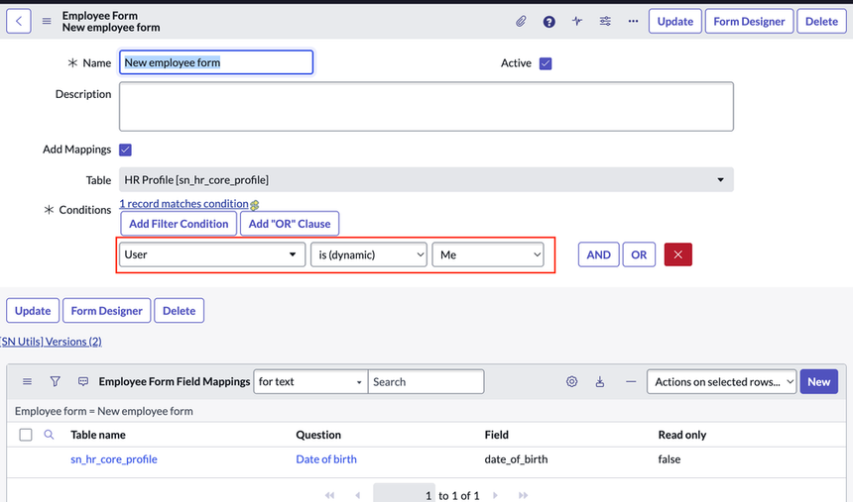

Leave Application Form
- Leave Application Form
- Leave Balance Form

4.7 List Design
List layouts were configured for all major tables.
Features available in list view include:
- Search
- Sorting
- Filtering
- Grouping
- Export
The list view enables managers and HR personnel to quickly locate leave requests and employee records.
Screenshot Required
Insert:
- Employee List
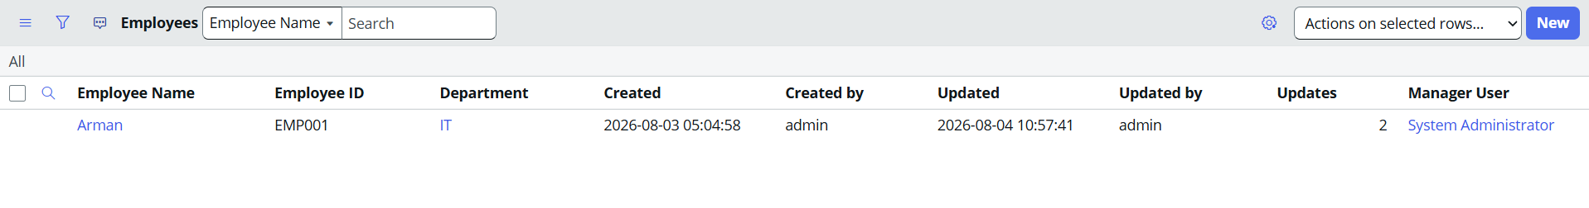

- Leave Application List
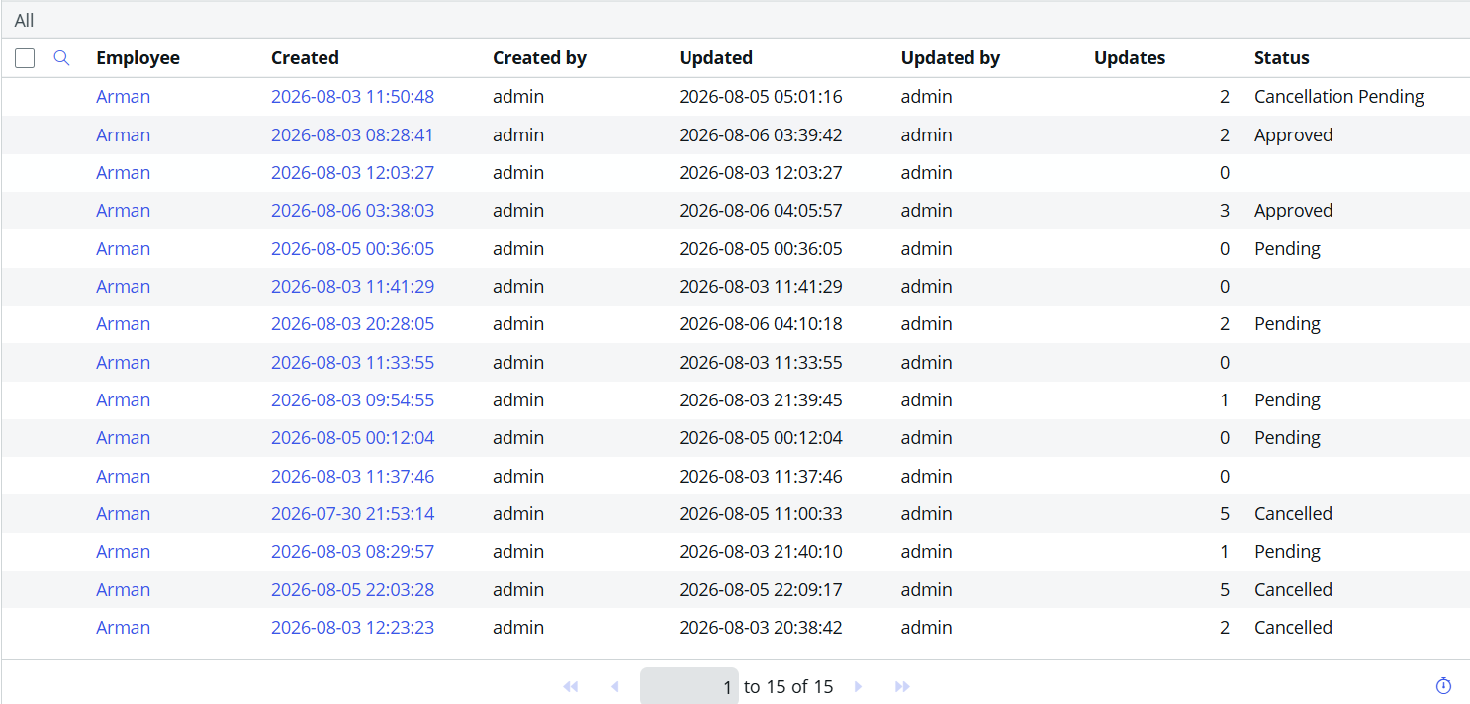

4.8 Navigation Modules
The following modules were created within the scoped application.

Leave Management

↓

Employees

Departments

Leave Types

Leave Applications

Leave Balance

Holiday Calendar

Reports

Dashboard

Figure 4.4 Navigation Modules

Explanation
The navigation menu provides easy access to all application components.
Each module opens the corresponding list or form.

4.9 Security Design
The Leave Management System implements Role-Based Access Control (RBAC).
Four roles were created.

Role | Permission
Administrator | Full Access
HR | Employee & Leave Management
Manager | Approve/Reject Leave
Employee | Apply Leave & View Own Records

ACL Implementation
ACLs were configured to restrict access.
Employee
- View own leave applications
- Apply leave
- View leave balance
Manager
- View team leave requests
- Approve or reject requests
HR
- Manage employee records
- Manage leave types
- Generate reports
Administrator
- Full CRUD access to all tables

Security Flow

User Login

↓

Role Verification

↓

ACL Check

↓

Access Granted

or

Access Denied
Figure 4.5 Security Flow

Chapter 5

Application Development

5.1 Development Environment
The Leave Management System was developed using the ServiceNow Personal Developer Instance (PDI). Development was carried out in ServiceNow Studio, which provides a centralized environment for creating and managing application components.
Component | Description
Platform | ServiceNow
Development Environment | Personal Developer Instance (PDI)
IDE | ServiceNow Studio
Browser | Google Chrome / Microsoft Edge
Programming Language | JavaScript (for scripts)
Workflow Tool | Flow Designer
Database | ServiceNow Tables
Reports | ServiceNow Reporting
Dashboard | ServiceNow Dashboard

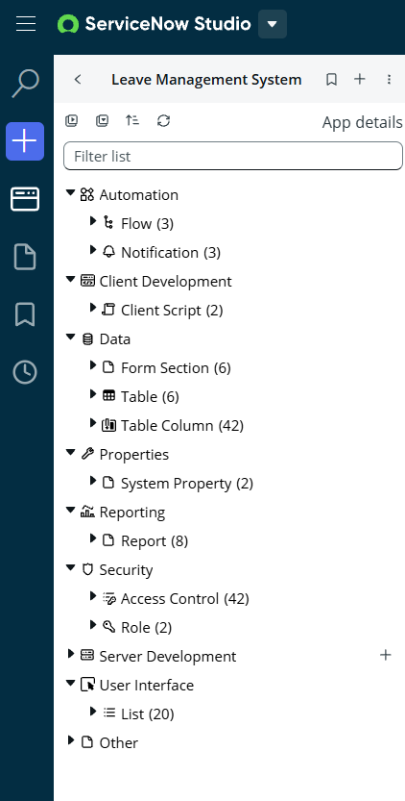

Figure 5.1 ServiceNow Studio

5.2 Application Scope
The Leave Management System automates the complete leave approval process within an organization.
The application allows employees to:
- Apply for leave
- View leave history
- Check leave balance
- Cancel leave requests (where applicable)
Managers can:
- Review leave requests
- Approve or reject leave applications
- Monitor team leave records
HR personnel can:
- Manage employee information
- Manage departments
- Configure leave types
- Generate reports
Administrators have complete control over the application and can configure security, modules, workflows, and reports.

5.3 Tables Created
The following custom tables were created during application development.

Table Name | Purpose
Employees | Stores employee information
Departments | Stores department details
Leave Types | Stores leave categories
Leave Applications | Stores leave requests
Leave Balance | Stores leave balances
Holiday Calendar | Stores holidays
Approvals | Stores approval details

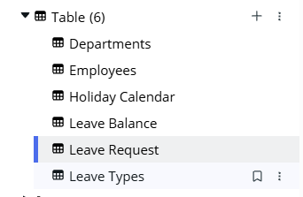
Figure 5.2 Custom Tables

5.4 Modules Created
The application navigator contains the following modules.
- Employees
- Departments
- Leave Types
- Leave Applications
- Leave Balance
- Holiday Calendar
- Reports
- Dashboard
Navigation Structure
Leave Management

↓

Employees

Departments

Leave Types

Leave Applications

Leave Balance

Holiday Calendar

Reports

Dashboard

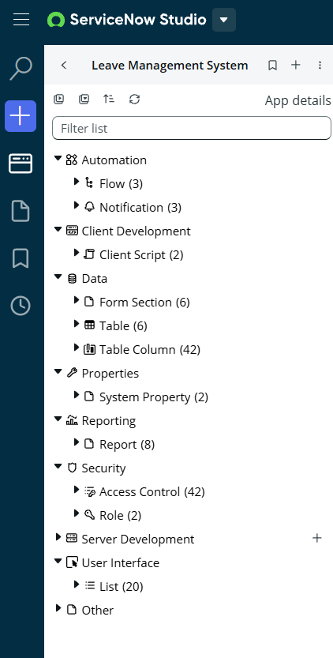

Figure 5.3 Application Navigator

5.5 Forms
Separate forms were created for different modules.
Employee Form
Used to register employees.
Fields include:
- Employee ID
- Employee Name
- Department
- Designation
- Email
- Phone Number
- Manager
- Date of Joining

Leave Application Form
Employees submit leave requests using this form.
Fields include:
- Leave Type
- Start Date
- End Date
- Number of Days
- Reason
- Status
- Manager

Leave Balance Form
Displays employee leave balances.

Screenshot
Insert:
- Employee Form
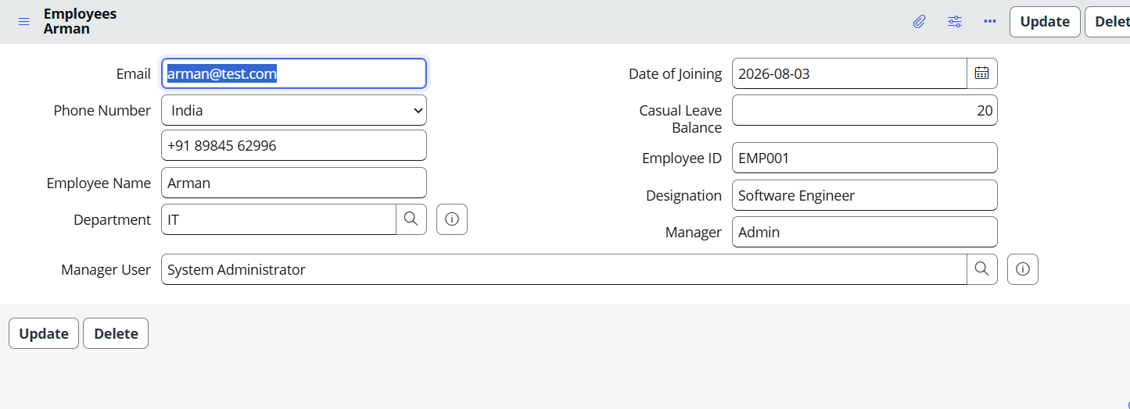
- Leave Application Form
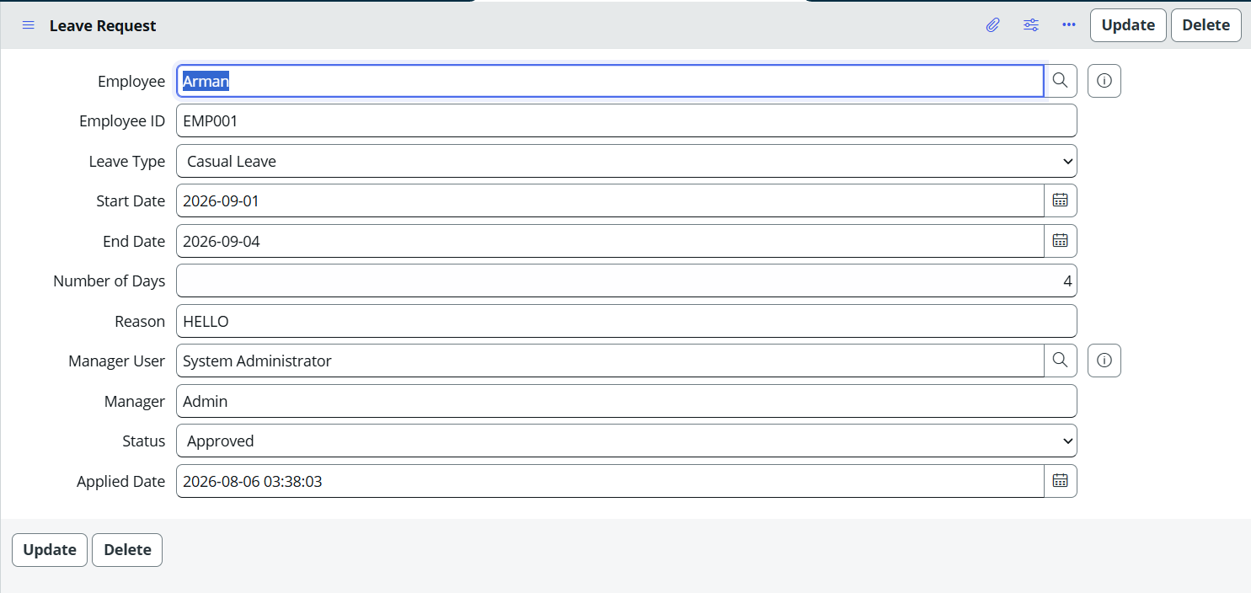
- Leave Balance Form
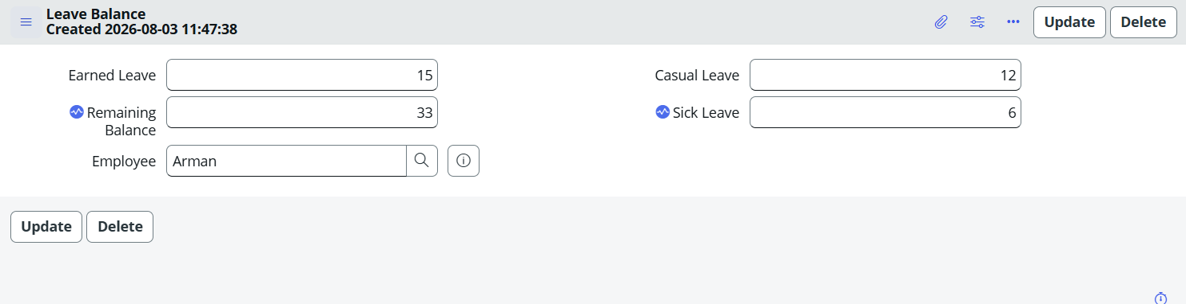

5.6 Client Scripts
Client Scripts were implemented to improve user interaction and validate data before submission.
The following Client Scripts were created.
Client Script 1
Prevent Past Date Selection
Purpose:
Prevent employees from selecting dates before the current date.

Client Script 2
Calculate Leave Duration
Purpose:
Automatically calculate the total leave days after selecting the start and end dates.

Client Script 3
Display Remaining Leave Balance
Purpose:
Display the employee's available leave balance while applying for leave.

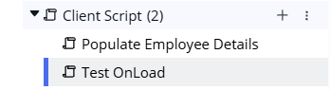

5.7 UI Policies
UI Policies were used to dynamically control form behavior.
UI Policy 1
Show Medical Certificate field only if
Leave Type = Sick Leave

UI Policy 2
Make Reason field mandatory.

UI Policy 3
Hide unnecessary fields until required.

UI Policy 4
Make Number of Days read-only because it is calculated automatically.

Screenshot
Insert:
UI Policy List

5.8 Business Rules
Business Rules automate server-side processing.
The following Business Rules were implemented.

Business Rule 1
Automatically calculate leave duration.

Business Rule 2
Prevent leave application if leave balance is insufficient.

Business Rule 3
Prevent overlapping leave requests.

Business Rule 4
Update leave balance after manager approval.

Business Rule 5
Restore leave balance after cancellation.

Business Rule Flow
Employee Applies Leave

↓

Business Rule Executes

↓

Validate Dates

↓

Check Leave Balance

↓

Check Overlapping Leave

↓

Save Record

↓

Send for Approval

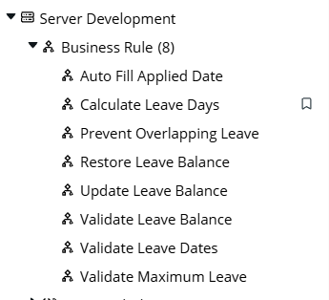

5.9 Script Includes
Script Includes were created to store reusable server-side logic.
Examples include:
- Leave Balance Utility
- Leave Validation Utility
- Leave Calculation Utility
These Script Includes reduce duplicate code and improve maintainability by allowing multiple Business Rules or Flow Designer actions to reuse the same logic.
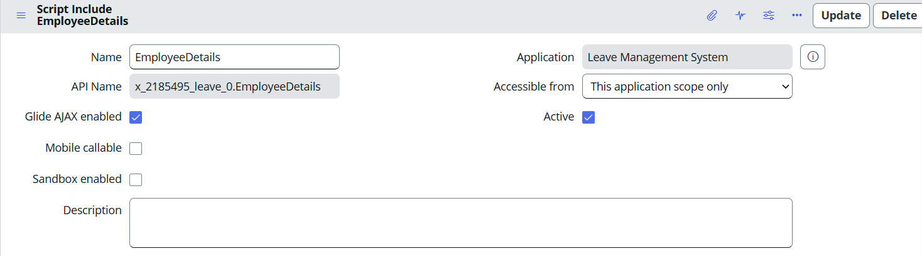

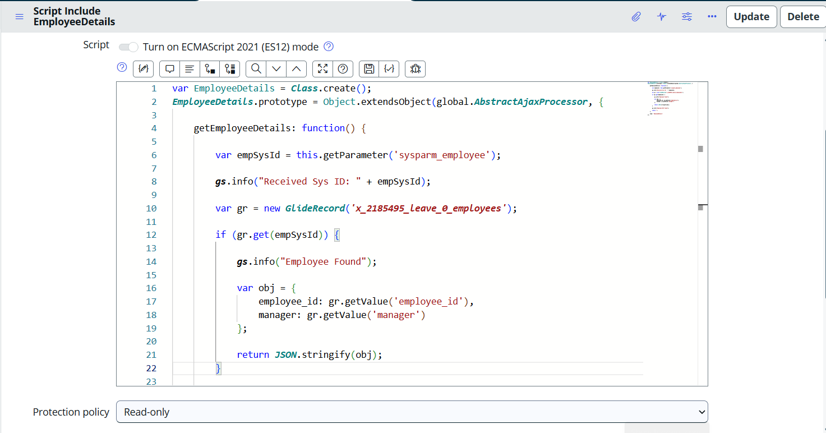

5.10 Flow Designer
Flow Designer automates the leave approval process.
Leave Approval Flow
Employee Submits Leave

↓

Manager Receives Approval

↓

Approve or Reject

↓

If Approved

↓

Update Leave Balance

↓

Send Notification

↓
End

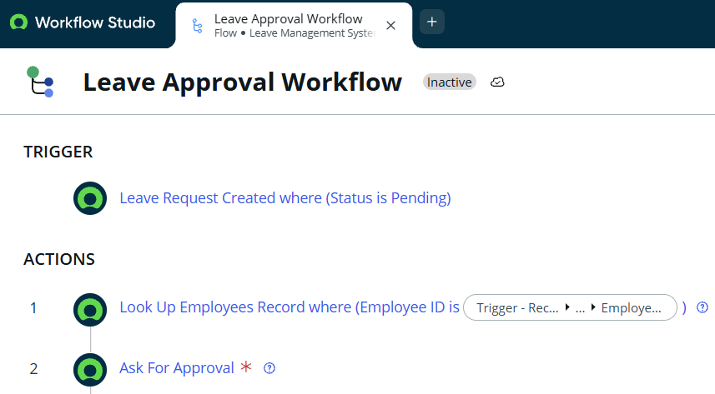

Leave Cancellation Flow
Employee Requests Cancellation

↓

Manager Approval

↓

Restore Leave Balance

↓

Send Notification

↓

End

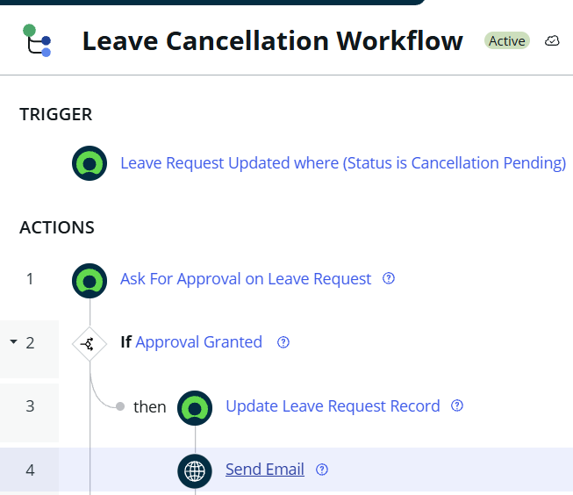

5.11 Notifications
Email notifications were configured for important activities.
Notifications are sent when:
- Leave request submitted
- Leave approved
- Leave rejected
- Leave cancelled
These notifications keep employees and managers informed about the current status of leave requests.
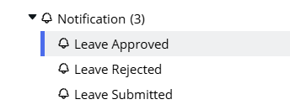

5.12 Reports
Several reports were created to analyze leave data.
The reports include:
- Monthly Leave Applications
- Pending Leave Requests
- Approved Leaves
- Rejected Leaves
- Department-wise Leave Statistics
- Leave Balance Report
- Leave Type Distribution
These reports assist HR personnel and managers in monitoring leave activities.

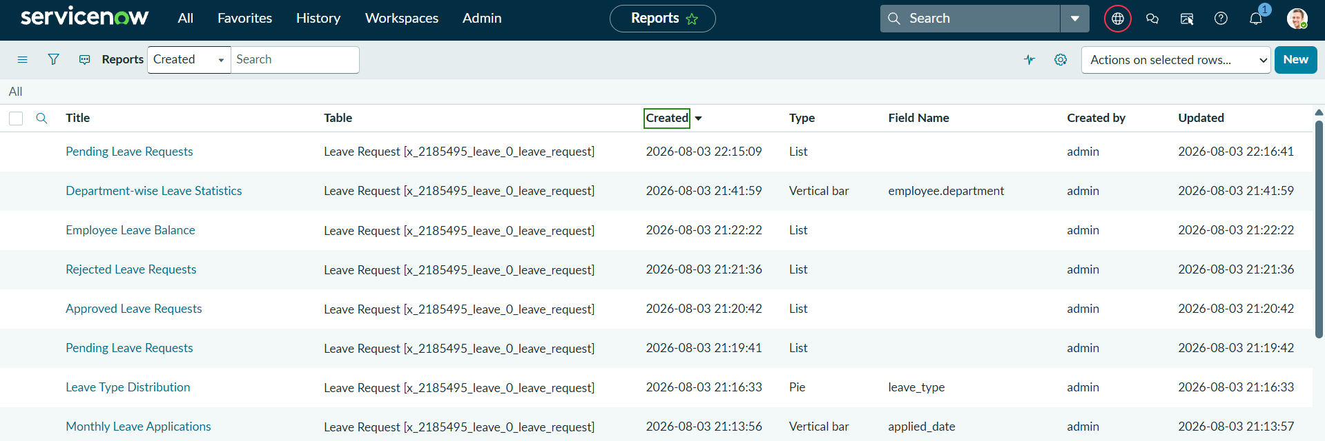

5.13 Dashboards
A dashboard was created to display key performance indicators (KPIs).
Widgets include:
- Total Employees
- Leave Requests Today
- Pending Approvals
- Approved Leaves
- Employees on Leave
- Department-wise Leave Statistics
- Leave Balance Summary
The dashboard provides a centralized view of important leave-related information.

Dashboard Layout
Dashboard

↓

Total Employees

Pending Approvals

Leave Requests Today

Approved Leaves

Employees on Leave

Department Statistics

Leave Balance Summary

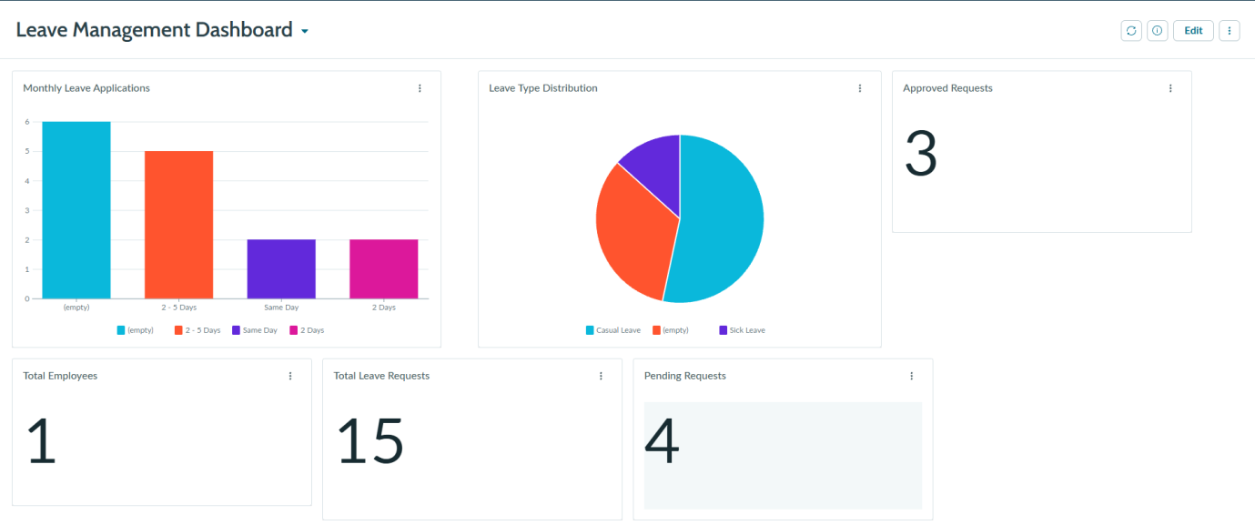

5.14 Service Catalog (if applicable)
A Service Catalog item can be created so that employees submit leave requests directly through the Service Portal.
For this project, the leave request functionality was implemented using custom application forms. Therefore, a separate Service Catalog item was not developed.

5.15 Integration (if applicable)
The current version of the Leave Management System is a standalone ServiceNow application.
No external system integration was implemented.
However, the application can be extended in the future by integrating with:
- Payroll System
- Attendance Management System
- HRMS
- Email Services
- Microsoft Teams
- Slack
using REST APIs and Integration Hub.

Chapter 6

Implementation
The Leave Management System was implemented using the ServiceNow Personal Developer Instance (PDI). The application was developed incrementally by following a structured development approach. Each module was implemented and tested individually before integrating it with the complete system.
The implementation involved creating the application scope, designing the database tables, configuring forms, implementing business logic, automating workflows, testing the application, and finally preparing it for deployment.
The following sections describe each implementation step.

Step 1: Requirement Gathering
The first step involved identifying the business requirements of the Leave Management System.
The following requirements were collected:
- Employee registration
- Department management
- Leave application
- Leave approval and rejection
- Leave cancellation
- Leave balance management
- Holiday calendar
- Reports
- Dashboard
- Email notifications
The users involved in the application were identified as:
- Employee
- Manager
- HR
- Administrator
Diagram
Requirement Gathering

↓

Identify Business Process

↓

Identify Users

↓

Identify Modules

↓

Finalize Requirements
Figure 6.1 Requirement Gathering Process

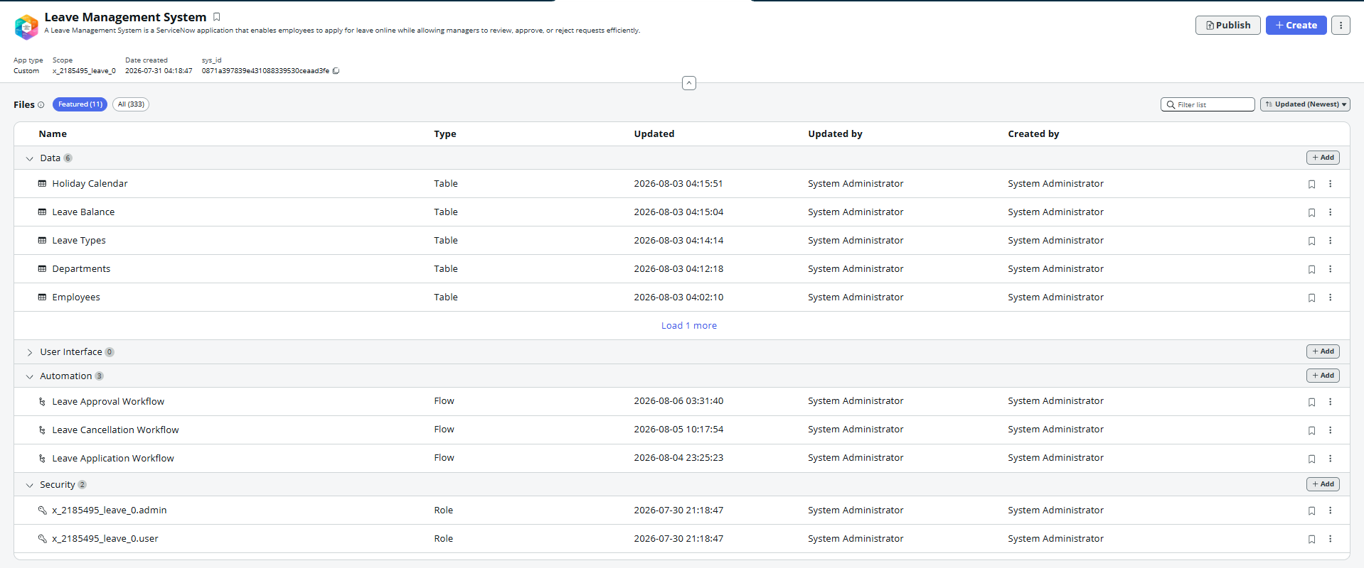
Step 2: Application Design
After collecting the requirements, a new scoped application named Leave Management System was created in ServiceNow Studio.
The application structure was planned before development.
The following components were identified:
- Tables
- Forms
- Modules
- Roles
- Business Rules
- Client Scripts
- Flow Designer
- Reports
- Dashboard

Diagram
Create Scoped Application

↓

Define Modules

↓

Define Tables

↓

Define Roles

↓

Design Forms
Figure 6.2 Application Design Process

- Scoped Application
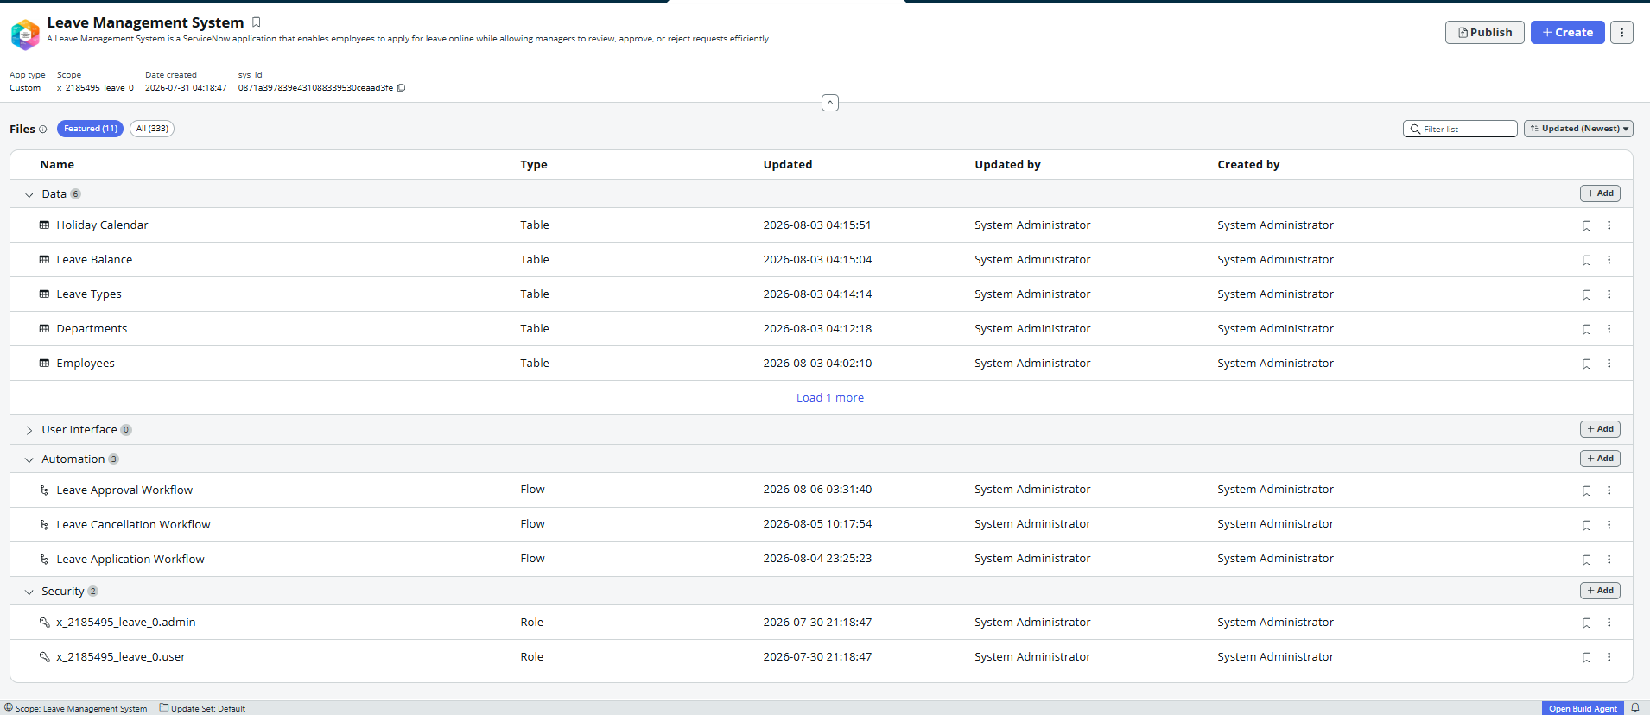
- Studio Home Page
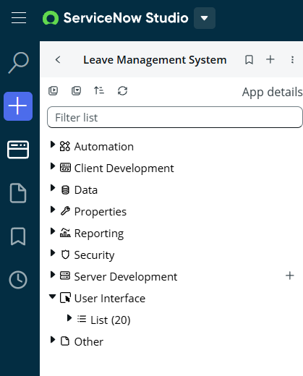

Step 3: Table Creation
Custom tables were created based on the application requirements.
The following tables were developed:
- Employees
- Departments
- Leave Types
- Leave Applications
- Leave Balance
- Holiday Calendar
- Approvals
Reference fields were created to establish relationships between the tables.
Mandatory fields and choice fields were also configured.
Diagram
Create Tables

↓

Add Fields

↓

Create Reference Fields

↓

Configure Choice Lists

↓
Save Table
Figure 6.3 Table Creation Process
- Employee Table
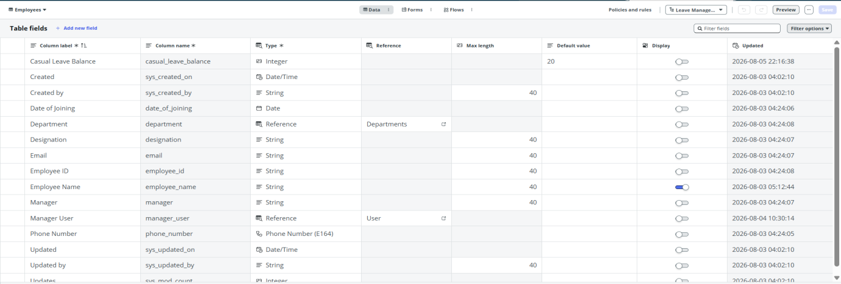
- Leave Application Table
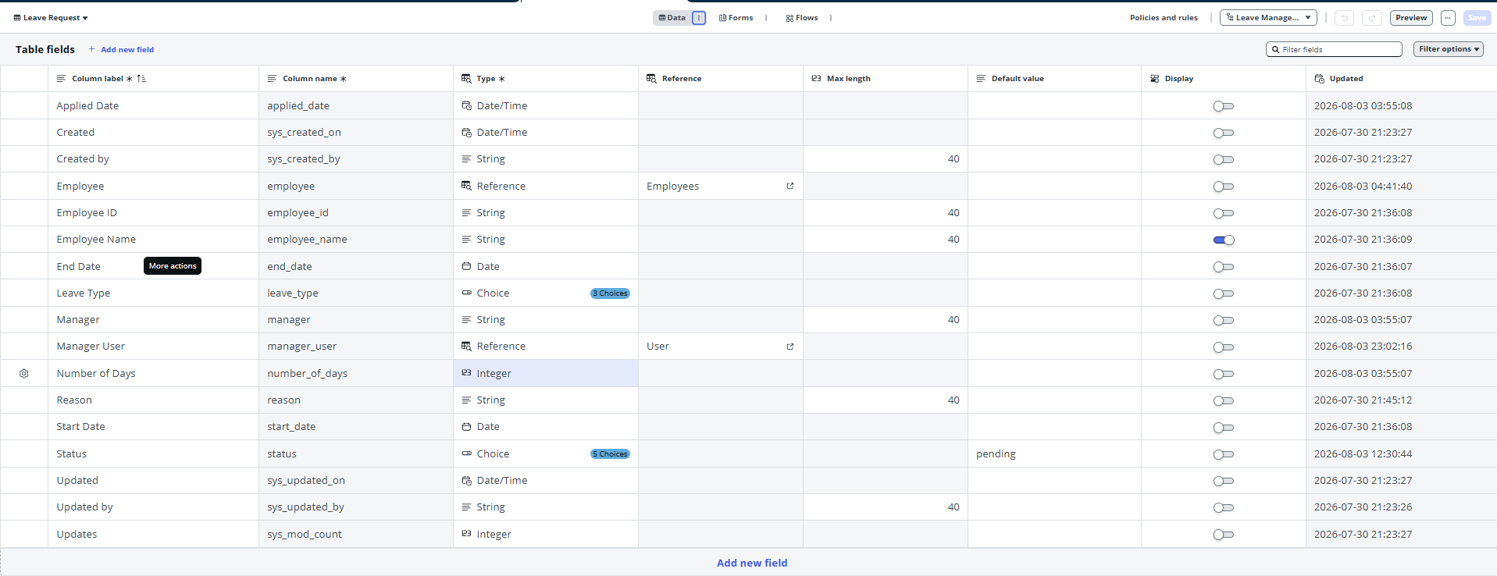
Step 4: Form Design
Forms were designed to provide an easy-to-use interface for users.
The following forms were developed:
- Employee Registration Form
- Leave Application Form
- Leave Balance Form
- Leave Type Form
Mandatory fields, reference fields, and choice lists were configured to improve data quality.
Diagram
Create Form
↓
Add Fields
↓
Arrange Layout
↓
Configure Mandatory Fields
↓
Save Form
Figure 6.4 Form Design Process

- Employee Form
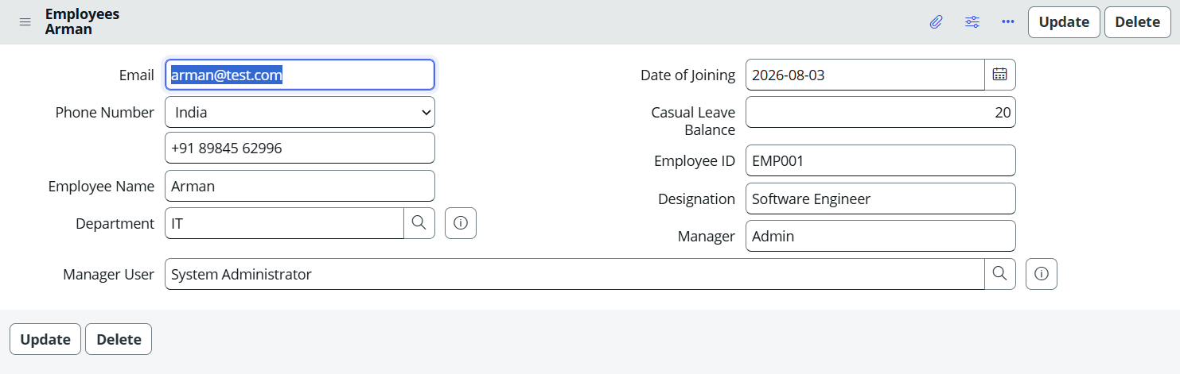
- Leave Form
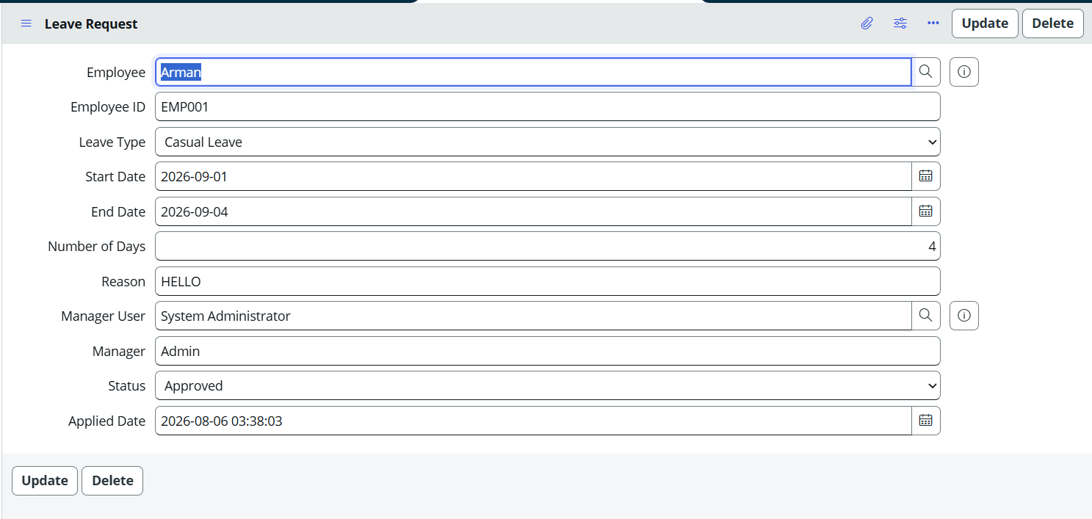

Step 5: Business Logic Development
Business logic was implemented using Business Rules, Client Scripts, and UI Policies.
The following automation was implemented:
- Calculate leave duration
- Validate leave balance
- Prevent overlapping leave
- Prevent past dates
- Display remaining balance
- Make reason mandatory
- Show medical certificate for sick leave
These features reduced manual work and improved data accuracy.

Diagram
Create Business Rule

↓

Validate Data

↓

Execute Rule

↓

Update Record

↓

Notify User
Figure 6.5 Business Logic Development

- Business Rule
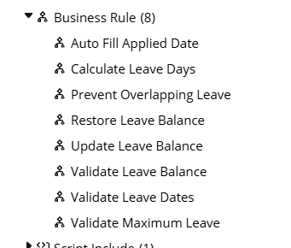
- Client Script
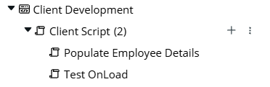
- UI Policy

Step 6: Workflow Development
The leave approval workflow was implemented using Flow Designer.
The workflow performs the following activities:
- Receive leave request
- Send approval request to manager
- Wait for manager decision
- Update leave status
- Update leave balance
- Send notification
Diagram
Employee Applies Leave

↓

Manager Approval

↓

Approved?

↓

Yes

↓

Update Balance

↓

Send Notification

↓

End

No

↓

Reject Request

↓

Notify Employee

↓

End
Figure 6.6 Leave Approval Workflow
Flow Designer
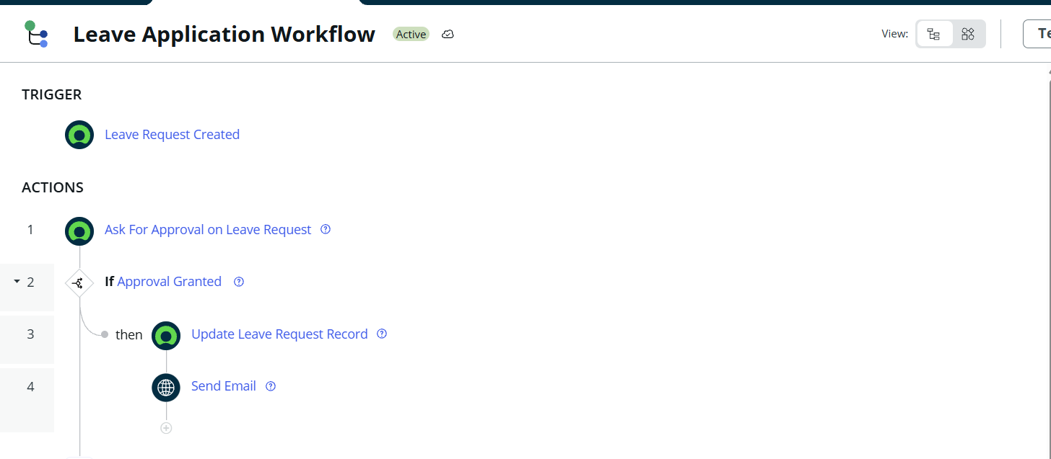
Step 7: Reporting and Dashboard
Reports were created to analyze employee leave information.
Dashboard widgets display important information such as:
- Total Employees
- Pending Approvals
- Approved Leaves
- Leave Requests Today
- Employees on Leave
These dashboards help managers and HR monitor leave activities efficiently.
Diagram
Application Data

↓

Generate Reports

↓

Create Dashboard

↓

Display Statistics
Figure 6.7 Reporting Process

Screenshot
Dashboard
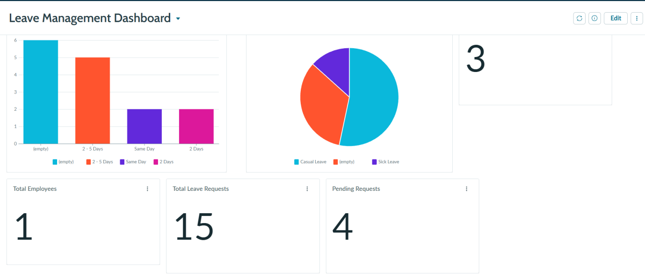

Step 8: Testing
After completing the application, every module was tested individually.
The following functionalities were verified:
- Employee registration
- Leave application
- Leave approval
- Leave cancellation
- Leave balance update
- Notifications
- Reports
Any errors found during testing were corrected before deployment.

Diagram
Execute Test
↓
Verify Output
↓
Bug Found?
↓
Yes
↓
Fix Bug
↓
Retes

No
↓
Proceed to Deployment
Figure 6.8 Testing Process
Test Records or Leave Application List
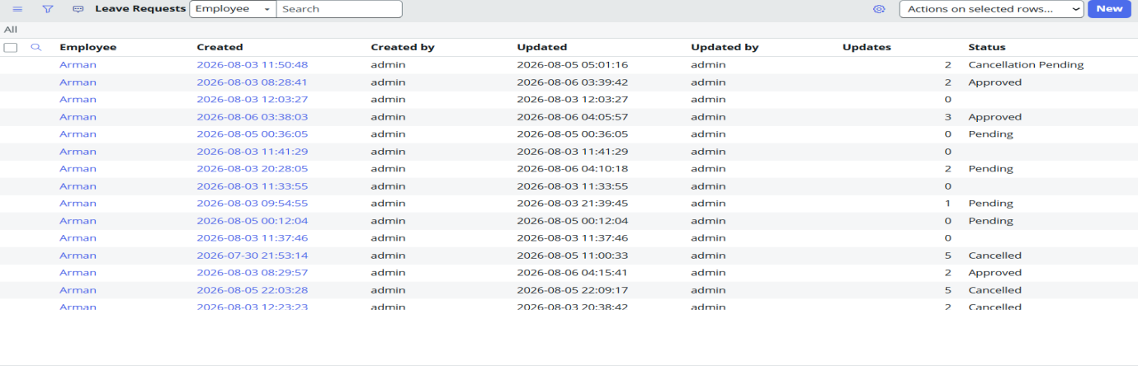

Step 9: Deployment
After successful testing, the application was prepared for deployment using ServiceNow Update Sets.
The application components were migrated from the development environment to the target instance.
User roles and notifications were verified before making the application available to end users.
Diagram
Development Instance
↓
Update Set
↓
Commit Update Set
↓
Production Instance
Figure 6.9 Deployment Process

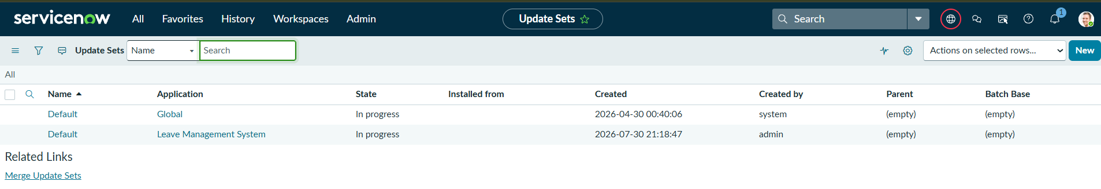

Chapter 7

Testing

7.1 Test Plan
Testing is performed to verify that every module of the Leave Management System functions correctly and satisfies the specified requirements. The application was tested after the implementation of each module and again after integrating all components.
The objectives of testing were:
- Verify that users can log in successfully.
- Verify employee registration.
- Verify leave application submission.
- Verify manager approval and rejection.
- Verify leave balance calculation.
- Verify leave cancellation.
- Verify notifications.
- Verify reports and dashboard.
- Verify role-based access control.
- Verify application performance.
Testing Strategy
The following types of testing were performed:
- Unit Testing
- Integration Testing
- User Acceptance Testing (UAT)
- Performance Testing
- Security Testing

Testing Process
Requirement Analysis

↓

Prepare Test Cases

↓

Execute Test Cases

↓

Record Results

↓

Fix Issues (if any)

↓

Retest

↓

Final Approval
Figure 7.1 Testing Process

7.2 Test Cases
The following test cases were executed to verify the application.
Test Case ID | Test Scenario | Expected Result | Actual Result | Status
TC-01 | Employee Login | Login Successful | Login Successful | Pass
TC-02 | Register Employee | Employee Record Created | Record Created | Pass
TC-03 | Create Department | Department Added | Department Added | Pass
TC-04 | Create Leave Type | Leave Type Saved | Saved Successfully | Pass
TC-05 | Apply Leave | Leave Request Created | Request Created | Pass
TC-06 | Apply Leave with Insufficient Balance | Request Rejected | Request Rejected | Pass
TC-07 | Apply Leave with Past Date | Validation Message Displayed | Validation Message Displayed | Pass
TC-08 | Apply Overlapping Leave | Request Blocked | Request Blocked | Pass
TC-09 | Manager Approves Leave | Status Changed to Approved | Status Updated | Pass
TC-10 | Manager Rejects Leave | Status Changed to Rejected | Status Updated | Pass
TC-11 | Leave Balance Update | Balance Reduced | Balance Reduced | Pass
TC-12 | Leave Cancellation | Balance Restored | Balance Restored | Pass
TC-13 | Email Notification | Notification Sent | Notification Sent | Pass
TC-14 | Generate Report | Report Generated | Report Generated | Pass
TC-15 | Dashboard Display | Widgets Loaded | Dashboard Displayed | Pass

- Leave Application List
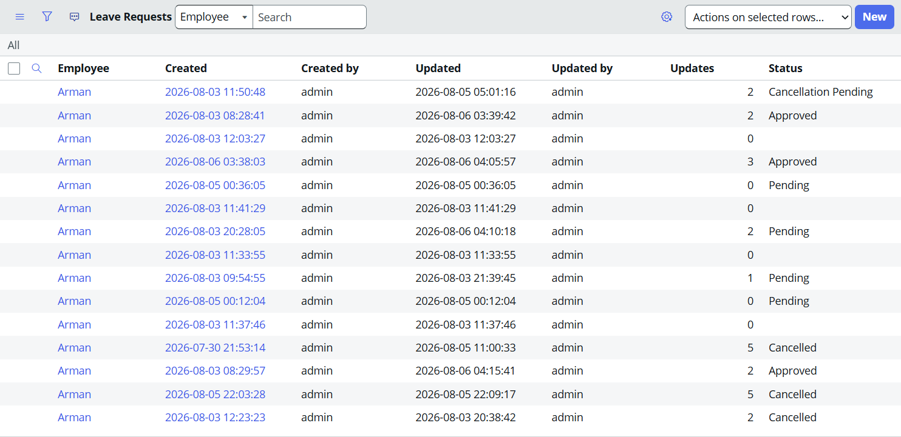

7.3 User Acceptance Testing
User Acceptance Testing (UAT) was conducted to verify that the application met the needs of the intended users. Sample users representing Employees, Managers, HR personnel, and Administrators tested the application by performing their respective tasks.
The users confirmed that:
- Leave requests could be submitted successfully.
- Managers could approve or reject requests.
- Leave balances were updated correctly.
- Notifications were received.
- Reports displayed accurate information.
- Dashboards provided useful summaries.
- The user interface was easy to understand.
UAT Summary
User | Activity | Result
Employee | Apply for Leave | Accepted
Employee | View Leave Balance | Accepted
Manager | Approve Leave | Accepted
Manager | Reject Leave | Accepted
HR | Generate Reports | Accepted
Administrator | Manage Application | Accepted
Overall, users found the application easy to use and suitable for automating the leave management process.

7.4 Performance Testing
Performance testing was performed to ensure that the application responded efficiently during normal usage.
The following activities were tested:
- Opening application modules.
- Loading forms.
- Saving records.
- Searching records.
- Viewing reports.
- Opening dashboards.
The application performed satisfactorily without noticeable delays during testing.
Performance Test Summary
Activity | Expected Result | Status
Open Application | Opens Successfully | Pass
Load Form | Less than 3 seconds | Pass
Save Record | Record Saved Successfully | Pass
Search Record | Results Displayed | Pass
Generate Report | Report Generated | Pass
Load Dashboard | Dashboard Loaded | Pass

7.5 Security Testing
Security testing was conducted to verify that users could only access data according to their assigned roles.
The application uses Role-Based Access Control (RBAC) implemented through Access Control Lists (ACLs).
The following security checks were performed.
Test Scenario | Expected Result | Status
Employee views own leave | Allowed | Pass
Employee views another employee's leave | Access Denied | Pass
Manager approves team leave | Allowed | Pass
Manager edits employee details | Access Denied | Pass
HR manages leave types | Allowed | Pass
Administrator accesses all modules | Allowed | Pass

These tests confirmed that the security configuration worked as expected and prevented unauthorized access.

Chapter 8

Deployment
8.1 Introduction

Deployment is the process of moving a developed and tested application from the development environment to the target environment where it can be used by end users. In ServiceNow, deployment is commonly performed using Update Sets, Application Repository, or Source Control.
For this project, the Leave Management System was developed in a ServiceNow Personal Developer Instance (PDI). After successful testing, the application was prepared for deployment by validating all components and ensuring that the latest changes were included in the update set.

8.2 Pre-Deployment Activities
Before deployment, several verification activities were performed to ensure that the application was ready for migration.
The following tasks were completed:
- Verified all custom tables.
- Checked forms and field configurations.
- Tested Client Scripts.
- Tested UI Policies.
- Verified Business Rules.
- Tested Flow Designer workflows.
- Verified reports and dashboards.
- Reviewed user roles and ACLs.
- Confirmed email notification configuration.
- Ensured no major errors remained.
These activities helped reduce the possibility of deployment failures.

8.3 Deployment Using Update Sets
ServiceNow provides Update Sets to migrate application changes from one instance to another.
The deployment process followed these steps:
- Create an Update Set.
- Capture all application changes.
- Complete development.
- Mark the Update Set as Complete.
- Export or move the Update Set.
- Import the Update Set into the target instance.
- Preview the Update Set.
- Resolve any conflicts (if present).
- Commit the Update Set.
- Verify that the application works correctly.

Deployment Flow
Development Instance

↓

Create Update Set

↓

Capture Changes

↓

Complete Update Set

↓

Move Update Set

↓

Target Instance

↓

Preview Update Set

↓

Commit Update Set

↓

Verify Application

Figure 8.1 Deployment Using Update Sets

Completed Update Set
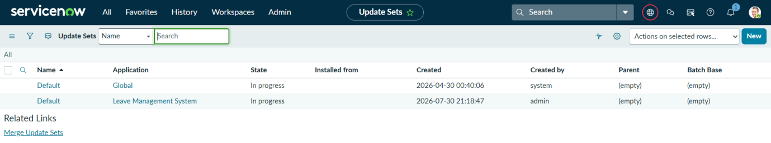

8.4 Source Control
ServiceNow supports integration with Git repositories for version control.
Source Control helps developers:
- Track application changes.
- Maintain version history.
- Restore previous versions.
- Collaborate with multiple developers.
For this project, Source Control was studied as part of the development process. Since the application was developed individually within a Personal Developer Instance, the primary deployment mechanism was Update Sets.

8.5 Git Repository
Git is a distributed version control system used to maintain different versions of application source code.
In ServiceNow, Git repositories can be connected to scoped applications for source code management.
The advantages of Git include:
- Version tracking
- Backup of source code
- Easy collaboration
- Branch management
- Rollback support
As this project was developed individually for academic purposes, Git integration was not configured. However, it can be adopted in future versions for collaborative development.

8.6 Application Repository
The ServiceNow Application Repository provides a mechanism to publish and distribute scoped applications between different ServiceNow instances.
It allows developers to:
- Publish applications.
- Install applications in another instance.
- Upgrade application versions.
- Manage application releases.
Although the current project was not published to the Application Repository, the application can be distributed using this feature in future deployments.

8.7 Change Management
Before deployment, all application changes should be reviewed and documented.
The following change management activities were considered:
- Review completed development.
- Verify testing results.
- Validate security permissions.
- Review update sets.
- Obtain deployment approval.
- Deploy application.
- Verify post-deployment functionality.
Following a structured change management process helps maintain application stability and reduces deployment risks.

8.8 Production Deployment
Once testing was completed successfully, the application was considered ready for production deployment.
The production deployment process includes:
- Import Update Set.
- Preview Update Set.
- Commit Update Set.
- Verify modules.
- Verify workflows.
- Verify reports.
- Verify dashboards.
- Assign user roles.
- Enable notifications.
- Monitor application performance.

Production Deployment Flow
Testing Completed
↓

Deployment Approved

↓

Import Update Set

↓

Preview Changes

↓

Commit Changes

↓

Assign Roles

↓

Verify Application

↓

Production Ready

Figure 8.2 Production Deployment Process

8.9 Post-Deployment Activities
After deployment, the following activities were performed:
- Verified application functionality.
- Checked reports and dashboards.
- Confirmed user access permissions.
- Verified notifications.
- Monitored application performance.
- Corrected any minor configuration issues.
Regular maintenance and periodic reviews help ensure that the application continues to perform efficiently.

Chapter 9

Conclusion and Future Scope

9.1 Conclusion
The Leave Management System was successfully designed and developed using the ServiceNow platform as a low-code application for automating employee leave management processes. The primary objective of the project was to replace the traditional manual leave management process with an efficient, centralized, and automated system.
The developed application allows employees to apply for different types of leave, managers to review and approve or reject leave requests, and HR personnel to monitor leave records through reports and dashboards. The system also maintains employee leave balances, sends notifications, and provides secure access using role-based permissions.
Throughout the project, several ServiceNow features such as custom tables, forms, modules, Client Scripts, UI Policies, Business Rules, Flow Designer, Reports, Dashboards, and Access Control Lists (ACLs) were implemented. These features helped automate repetitive tasks, improve data accuracy, reduce manual effort, and enhance the overall user experience.
The application achieved the objectives defined during the requirement analysis phase by:
- Automating the leave application process.
- Reducing manual paperwork.
- Simplifying leave approval workflows.
- Maintaining accurate leave balances.
- Providing secure role-based access.
- Improving transparency through reports and dashboards.
- Enhancing communication through notifications.
- Improving organizational efficiency.
From a learning perspective, this project provided practical experience in developing enterprise applications using ServiceNow. It improved understanding of application development, workflow automation, database design, security implementation, reporting, and deployment within a real-world business environment.
Overall, the Leave Management System demonstrates how the ServiceNow platform can be used to develop scalable and user-friendly enterprise applications with minimal coding while effectively automating business processes.

9.2 Future Scope
Although the current application fulfills the major requirements of leave management, several additional features can be incorporated in future versions to further improve the system.
The following enhancements are proposed:
1. Mobile Application Support
Develop a mobile version of the Leave Management System using the ServiceNow Mobile App so that employees can apply for leave and receive notifications from their smartphones.
2. Payroll Integration
Integrate the application with payroll systems so that leave records automatically influence salary processing and leave deductions where applicable.
3. Attendance System Integration
Integrate with attendance management systems to synchronize employee attendance and leave information.
4. Calendar Integration
Integrate with Microsoft Outlook or Google Calendar so that approved leaves are automatically added to employees' calendars.
5. Multi-Level Approval Workflow
Implement multiple approval levels, such as:
Employee

↓

Team Lead

↓

Manager

↓

HR

↓

Leave Approved
This would support organizations with more complex approval hierarchies.
6. Leave Policy Automation
Implement organization-specific leave policies, such as:
- Carry-forward rules
- Half-day leave
- Compensatory leave
- Leave encashment
- Automatic yearly leave allocation
7. Advanced Analytics Dashboard
Enhance dashboards by including:
- Monthly leave trends
- Employee leave patterns
- Department comparisons
- Leave forecasting
- Predictive analytics
These features would help management make informed decisions.
8. AI-Based Leave Recommendation
Future versions can use Artificial Intelligence to:
- Recommend appropriate leave types.
- Detect unusual leave patterns.
- Predict staffing shortages.
- Suggest optimal leave scheduling.
9. Chatbot Integration
Integrate a ServiceNow Virtual Agent that allows employees to:
- Apply for leave.
- Check leave balance.
- Track leave status.
- Receive instant responses to common queries.
10. Email and SMS Notifications
In addition to email notifications, SMS or mobile push notifications can be implemented to improve communication with employees.

Learning Outcomes
The development of this project provided practical exposure to enterprise application development using ServiceNow. Through this project, the following concepts were learned:
- Low-code application development
- Custom table creation
- Form and list configuration
- Reference fields and relationships
- Flow Designer
- Business Rules
- Client Scripts
- UI Policies
- Role-Based Access Control (ACLs)
- Reports and Dashboards
- Workflow automation
- Testing and deployment
The project also enhanced problem-solving, logical thinking, and practical implementation skills related to enterprise software development.

References

- ServiceNow, ServiceNow Product Documentation. Available: ServiceNow Documentation. Accessed: Jul. 27, 2026.
- ServiceNow, ServiceNow Developer Program. Available: ServiceNow Developer Site. Accessed: Jul. 27, 2026.
- ServiceNow, Flow Designer Documentation. Available: Flow Designer Documentation. Accessed: Jul. 27, 2026.
- ServiceNow, Flow Designer Data Sheet. Available: Flow Designer Data Sheet. Accessed: Jul. 27, 2026.
- ServiceNow, Developing for Flow Designer Learning Module. Available: ServiceNow Learning Module – Developing for Flow Designer. Accessed: Jul. 27, 2026.
- ServiceNow, Flow Designer Course. Available: Flow Designer Course (Now Learning). Accessed: Jul. 27, 2026.
- ServiceNow, ServiceNow App Engine Overview. Available: ServiceNow App Engine. Accessed: Jul. 27, 2026.
- ServiceNow, ServiceNow Studio and Application Development Documentation. Available: Application Development Documentation. Accessed: Jul. 27, 2026.
- ServiceNow, ServiceNow Community. Available: ServiceNow Community. Accessed: Jul. 27, 2026.
- ServiceNow, Now Learning. Available: ServiceNow University (Now Learning). Accessed: Jul. 27, 2026.
- ServiceNow, ServiceNow Store. Available: ServiceNow Store. Accessed: Jul. 27, 2026.

