Algorithm:

1. Start
2. Declare an 2D array ‘data [] []’, ’arr []’
3. Declare a HashMap ‘map’
4. Declare a variable max, frequency, check
5. Input check
6. If user inputs nothing then use the default data.txt as the file path for ‘data’ Else use the value of ‘check’ as the file path for ‘data’
7. Fetch the line from the file and populate the 2D array ‘data’
8. Adds the edge between source to destination into the ‘map’ with the array ‘data’ and vertices
9. Count the no of edges connected to a vertex and save the value to an array ‘arr’
10. Find the vertex which has maximum no of edges connected to it and save the value to the variable ‘max’
11. Find the ‘frequency’ of the ‘max’ to check for duplicity
12. If ‘frequency’ equals to ‘max’ then goto step 12 else goto step 13
13. Print the Vertex name and the no of edge connected to it goto step 11
14. Print the Vertex name and the no of edge connected to it
15. Print the Total No of vertices and edges
16. Stop

# Input/output

1)

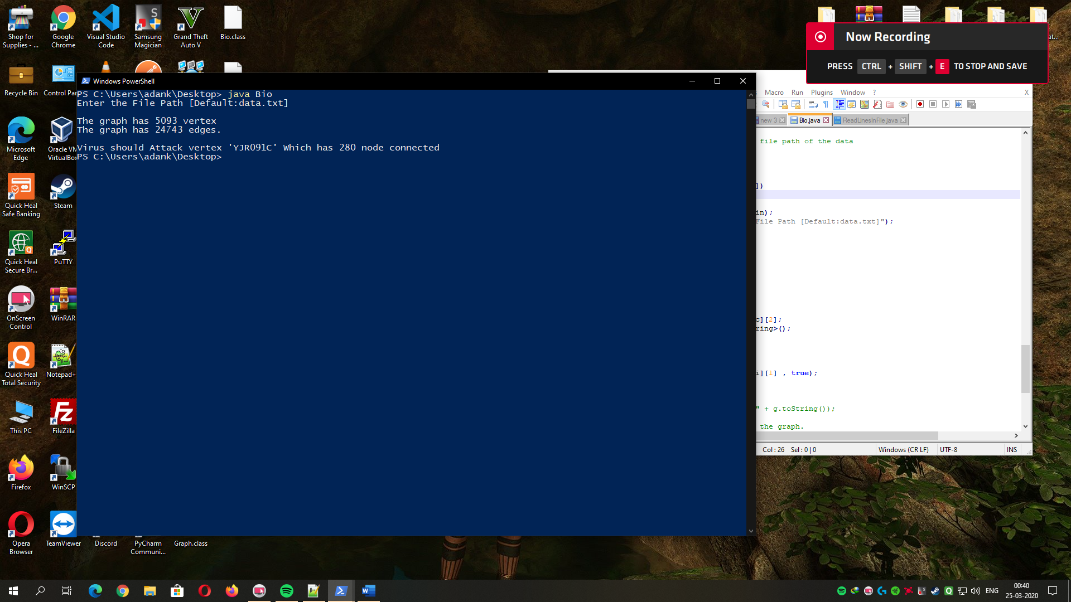

2)

