* **Algorithm**

**# MYSQL database Algorithm**

**Step 1.** Start

**Step 2**. Open mysql & Enter password

**Step 3.** Create database “redbus_travel_service”

**Step 4.** Use daravase “redbus_travel_service”

**Step 5.** Create following tables-

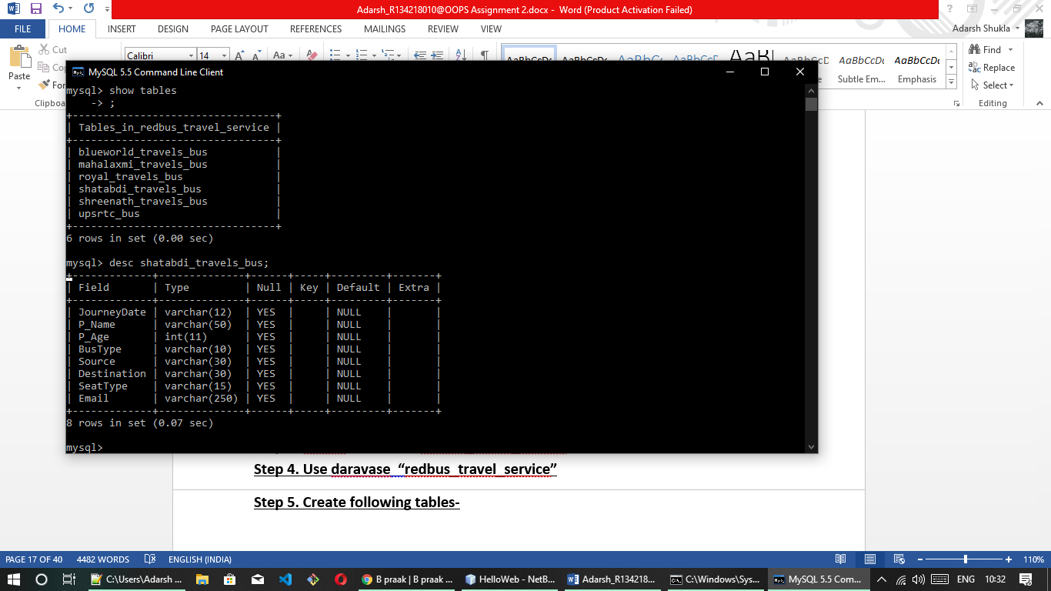

**Step 6.** Every table contail following attributes-



**# JAVA code Algorithm**

**Step 1.** Start

**Step 2.** Import essential predefined packages and classes

**Step 3.** Define a class *Redbus*

*In class Redbus* :

Step i. Write JDBC connection string , give url, username, password and established connection with mysql database.

Step ii. Now, Give a task list :

(print ticket, cancel ticket, update detail, print ticket)

Step iii. Input task choise and pass in switch

1. **If “Ticket booking” task is selected :-**

Step a. Now, Give a route list :

(like: DEHRADUN <---> KANPUR via Haridwar

DEHRADUN <---> DELHI via Roorkee

Step b. Input route choise and pass in switch

In switch :

Step I. Input required journey detail using “JOptionPane.showInputDialog”

Step II. Now, Give a route list basis of inpur parameter:

Step III. Input bus choise and pass in switch

In switch :

* Write sql query to store data (ticket detail) in selected bus’s table in MySql database.

Step c. Repeat this process for every possible route.

Step d. Now, it’s time for payment

Step e. Give available options to do payment

(1 : By Net Banking 2 : By Debit Card 3 : By Paytm Account

Step f. Input payment method choise and pass in switch

In switch-

In case 1 *: (By Net Banking)*

Inpur Net Banking ID and Password

In case 2 *: (By* By Debit/Credit Card*)*

Inpur 16 digit card number , cvv and OTP which is sent to your linked mobile number

In case 3 *: (By Paytm)*

Inpur PAYTM moble numbet , password and OTP

Step g. After completion of whole task, give a confirmation message "Your ticket is booked successfully. This operator accept m-ticket, please show ticket to bus staf during journey. Have a nice day !"

1. **If “Ticket Cancellation” task is selected :-**

Step a. Now, Give a Bus list , from which user will select a bus

(1: Shatabdi Travels 2: Blueworld Travels 3: Mahalaxmi Travels 4: Shreenath Travels 5: UP govt. upsrtc bus 6: Royal Travels )

Step b. Input bus choise and pass in switch

Step c. . Input required detail using (like.Email and journey date) “JOptionPane.showInputDialog” for searching ticket in database

In switch :

* Write sql query to delete data (ticket cancellation) in selected bus’s table in MySql database.

Step d. After completion of whole task, give a confirmation message "Your ticket is cancelled successfully. Have a nice day !"

1. If “Passenger detail updation” task is selected :-

Step a. . Now, Give a Bus list , from which user will select a bus

(1: Shatabdi Travels 2: Blueworld Travels 3: Mahalaxmi Travels 4: Shreenath Travels 5: UP govt. upsrtc bus 6: Royal Travels )

Step b. Input bus choise and pass in switch

Step c. . Input required detail (like- Email for search ticket in database and name and age for updation purpose using “JOptionPane.showInputDialog” for searching ticket in database

In switch :

* Write sql query to update data (ticket updation) in selected bus’s table in MySql database.

Step d. After completion of whole task, give a confirmation message "Your ticket is updated successfully. Have a nice day !"

1. If “Print Ticket” task is selected :-

Step a. . Now, Give a Bus list , from which user will select a bus

(1: Shatabdi Travels 2: Blueworld Travels 3: Mahalaxmi Travels 4: Shreenath Travels 5: UP govt. upsrtc bus 6: Royal Travels )

Step b. Input bus choise and pass in switch

Step c. . Input required detail (like- Email for search ticket in database using “JOptionPane.showInputDialog” for searching ticket in database.

In switch :

* Write sql query to select data (ticket detail) in selected bus’s table from MySql database.

* Use ResultSet predefined class for printing the detail on command prompt.

Step d. After completion of whole task, Ticket detail will print on windows command prompt.