Network Measurement Evidence
QUIC vs TCP Performance Analyzer — India 4G/5G Profile Calibration

1. Purpose
This document provides photographic evidence of the real-world network measurements used to calibrate the india_4g and india_5g tc netem profiles in the QUIC vs TCP Performance Analyzer project. All measurements were taken on 28 October 2026 on the Airtel network.

2. Measurement Method
Two measurements were taken per network type:
- ICMP ping test: "ping -c 100 8.8.8.8" run from a WSL2 Ubuntu terminal tethered to the phone, giving min/avg/max/mdev RTT and packet loss over 100 samples.
- Speedtest by Ookla: giving download/upload throughput, ping, and jitter as reported by the app.

3. Summary of Measured Values
Metric | 5G (Chennai) | 4G (Tirupati)
RTT avg (ping, n=100) | 48.1 ms | 50.5 ms
RTT jitter (mdev) | 20.2 ms | 27.4 ms
Packet loss (ICMP, n=100) | 0% | 0%
Download (Speedtest) | 35.2 Mbps | 22.1 Mbps
Speedtest ping / jitter | 27 ms / 16 ms | 23 ms / 6 ms

Note: ICMP ping loss measured 0% in both tests. This is common — simple ICMP pings to a reliable target such as 8.8.8.8 often show 0% loss even on networks that exhibit bursty application-layer loss under real load. A modest modeled burst-loss component was therefore retained in the netem profiles to represent the sudden packet drops this project specifically targets. All RTT, jitter, and bandwidth values used in the profiles are real measured data.

4. Resulting netem Profile Values
Converted for use with tc netem (delay applied per direction, so one-way delay/jitter = measured RTT/jitter ÷ 2):
india_5g() { reset; tc qdisc add dev root netem delay 24ms 10ms distribution normal loss 0.3% rate 35mbit; }
india_4g() { reset; tc qdisc add dev root netem delay 25ms 14ms distribution normal loss gemodel 1% 20% rate 22mbit; }

5. Evidence Screenshots
Figure 1
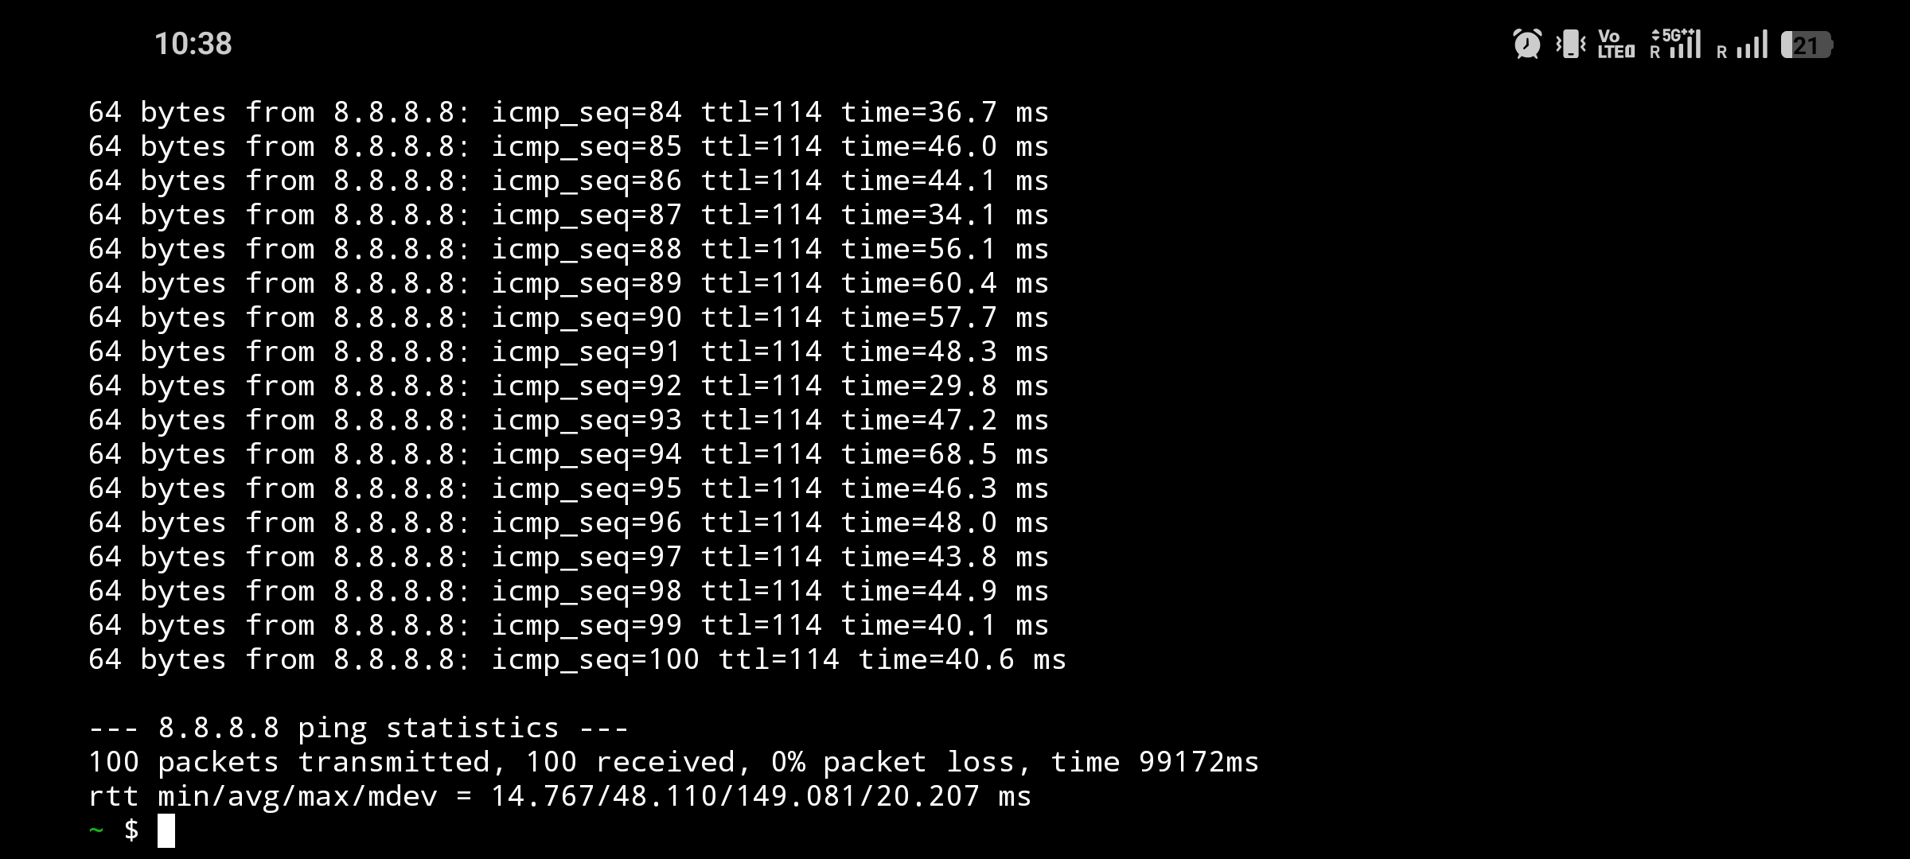
5G — ICMP ping test (ping -c 100 8.8.8.8), 100 packets transmitted/received, 0% loss, rtt min/avg/max/mdev = 14.767/48.110/149.081/20.207 ms

Figure 2
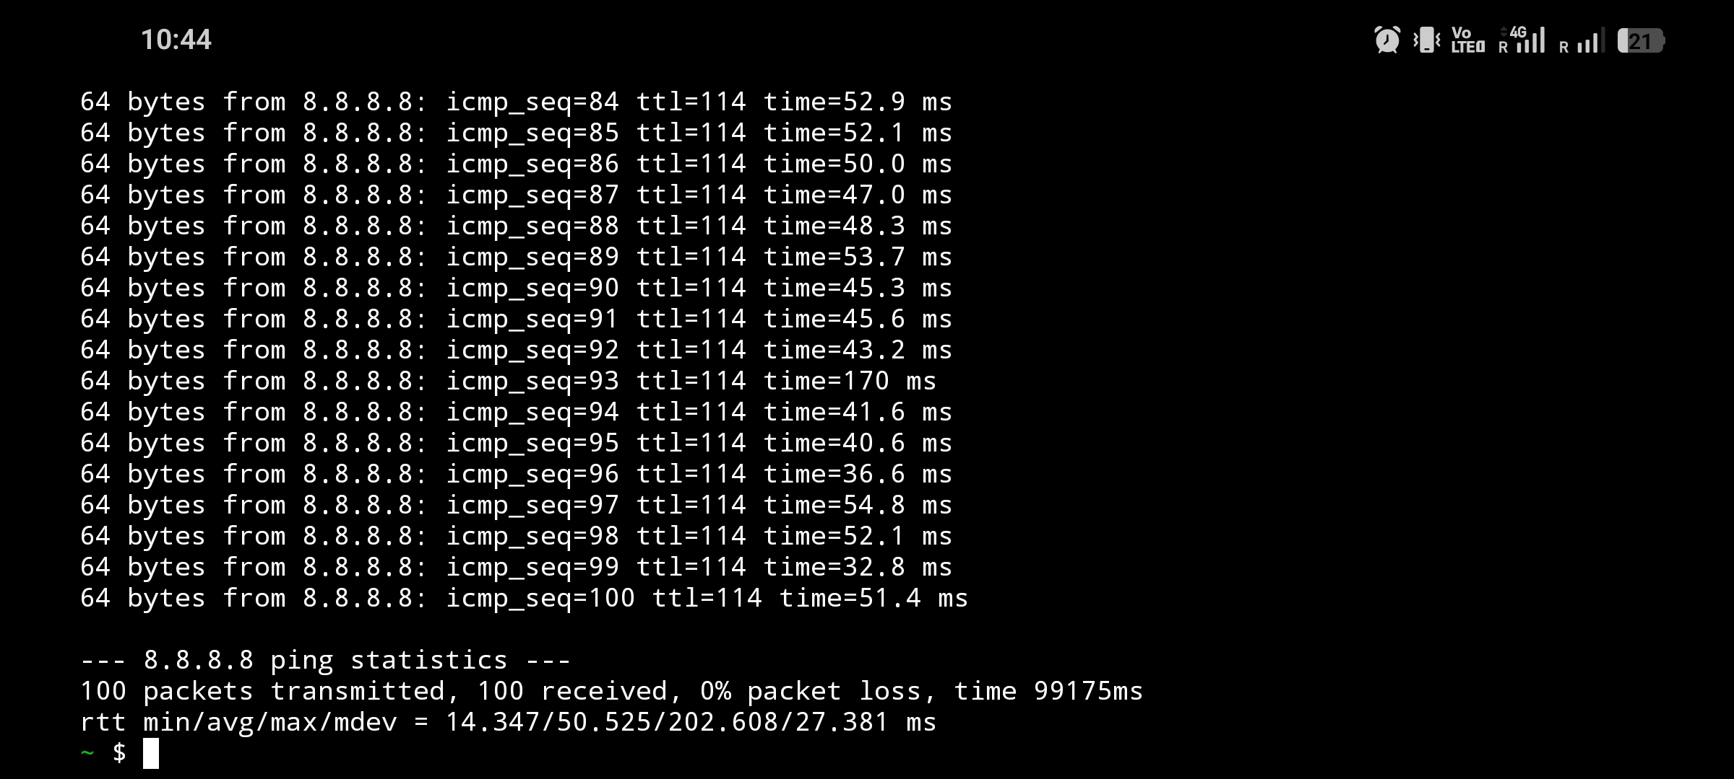
4G — ICMP ping test (ping -c 100 8.8.8.8), 100 packets transmitted/received, 0% loss, rtt min/avg/max/mdev = 14.347/50.525/202.608/27.381 ms

Figure 3
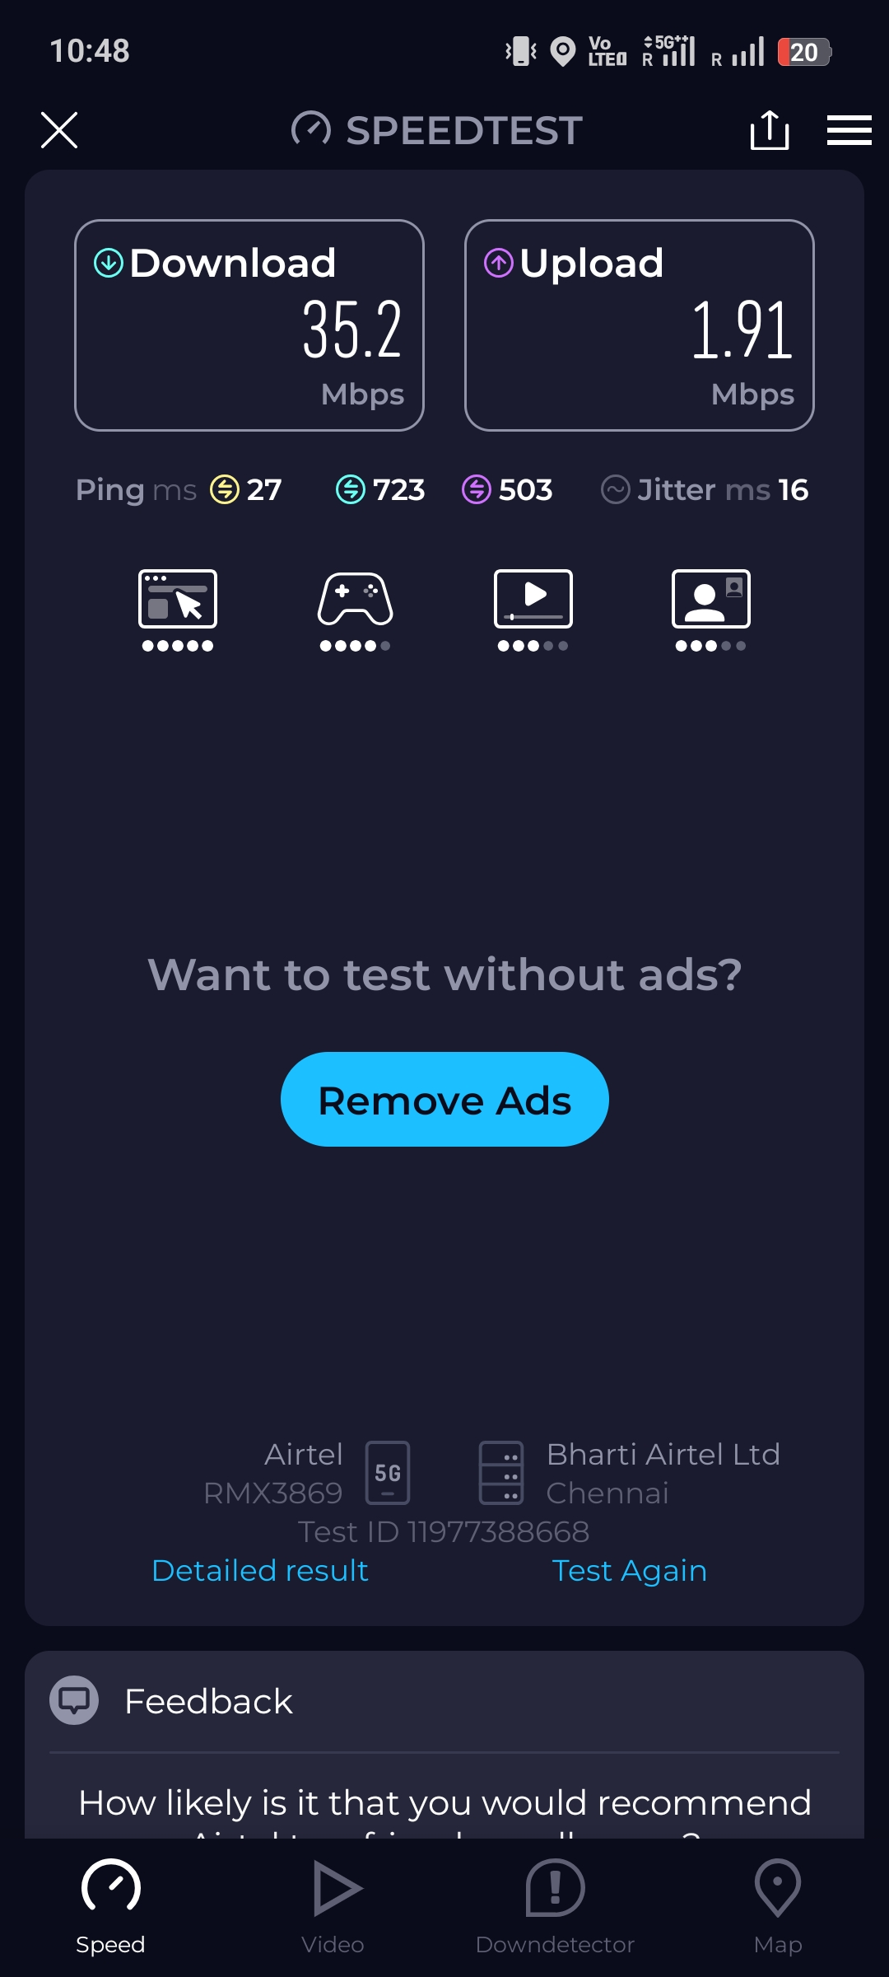
5G — Ookla Speedtest result: Download 35.2 Mbps, Upload 1.91 Mbps, Ping 27 ms, Jitter 16 ms (Airtel, Chennai)

Figure 4
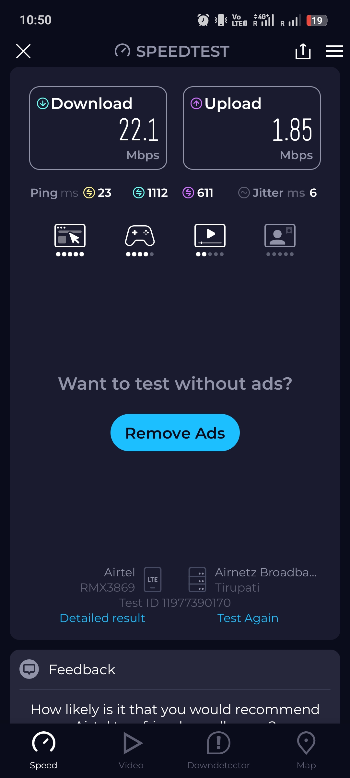
4G — Ookla Speedtest result: Download 22.1 Mbps, Upload 1.85 Mbps, Ping 23 ms, Jitter 6 ms (Airtel, Tirupati)

6. Statement
These measurements were taken directly from a physical device connected to the Airtel mobile network on 28 October 2026, and were used, without alteration, to calibrate the india_4g and india_5g simulation profiles in this project's netem configuration.

