QUIC vs TCP Performance Analyzer
BCSE308P – Computer Networks
PROJECT BASED COMPONENT REPORT

by
Abhilash Singh
(24BCI0054)

School of Computer Science and Engineering
October 2026

DECLARATION
I hereby declare that the report entitled “QUIC vs TCP Performance Analyzer” submitted by me, for the BCSE308P – Computer Networks to VIT is a record of bonafide work carried out by me under the supervision of Dr. S. Ebenezer Juliet.
I further declare that the work reported in this report has not been submitted and will not be submitted, either in part or in full, for any other courses in this institute or any other institute or university.
Place : Vellore
Date : 28 October 2026
Signature of the Candidate(s)

TABLE OF CONTENTS
1. Introduction
2. Problem Statement
3. Objectives
4. Literature Review and Existing System
5. Abstract of the Proposed Project Work
6. Workflow / System Design / System Architecture
7. Contribution of Individual Team Member
8. Modules Explanation
9. Project Implementation
10. Results and Discussion
11. Conclusion
12. Limitations and Future Enhancement
References
Appendix A. Calibration evidence
Appendix B. Screenshots and data files

1. Introduction
HTTP/3 runs over QUIC, a UDP-based transport with built-in TLS 1.3, while HTTP/2 runs over TCP + TLS. QUIC promises faster handshakes, no head-of-line blocking and connection migration. This project builds a controlled testbed that serves identical content over both protocols and measures how they behave under emulated network conditions, with a focus on Indian mobile networks.

2. Problem Statement
Claims about QUIC’s advantages are mostly measured on stable Western networks. Indian 4G/5G networks show highly variable latency and bursty packet loss. There is no clear evidence of the exact RTT/loss conditions at which QUIC beats TCP, or where TCP still wins (the ‘crossover point’).

3. Objectives
- Build a reproducible testbed serving the same content over HTTP/2 (TCP) and HTTP/3 (QUIC).
- Measure handshake time, time to first byte (TTFB), total completion time, throughput, loss-burst recovery time and connection migration.
- Emulate RTT from 20–300 ms and loss from 0–5 %, plus Indian 4G/5G mobile profiles calibrated on real Airtel measurements, using tc netem.
- Identify the conditions under which one protocol outperforms the other (the crossover).

4. Literature Review and Existing System
Langley et al. (SIGCOMM 2017) described Google’s QUIC deployment and reported lower search latency and fewer video rebuffers, especially on high-latency links. Kakhki et al. (IMC 2017) showed QUIC outperforms TCP in most cases but can lose under packet reordering and on low-powered mobile devices. Yu and Benson (2021) found that differences between QUIC implementations matter as much as the protocol itself. RFC 9000 and RFC 9114 standardise QUIC and HTTP/3. Most of these studies use stable links or Western networks and do not model Indian mobile conditions.
Existing system: most comparisons use fixed-delay links or public internet runs, and do not model bursty mobile loss or Indian network characteristics.

5. Abstract of the Proposed Project Work
The analyzer uses Nginx with HTTP/3 enabled as the server, curl (built with HTTP/3) as the measurement client, aioquic as a second, independent HTTP/3 client and server for cross-checks, and tc netem to shape the link between two Linux network namespaces created without root privileges. An automated script sweeps a matrix of RTT and loss values and mobile profiles, runs repeated downloads over each protocol, and stores the results in CSV. Analysis scripts compute medians, bootstrap confidence intervals and paired significance tests, and locate where the winner changes. Packet captures with a TLS key log are used to inspect the handshake.

6. Workflow / System Design / System Architecture
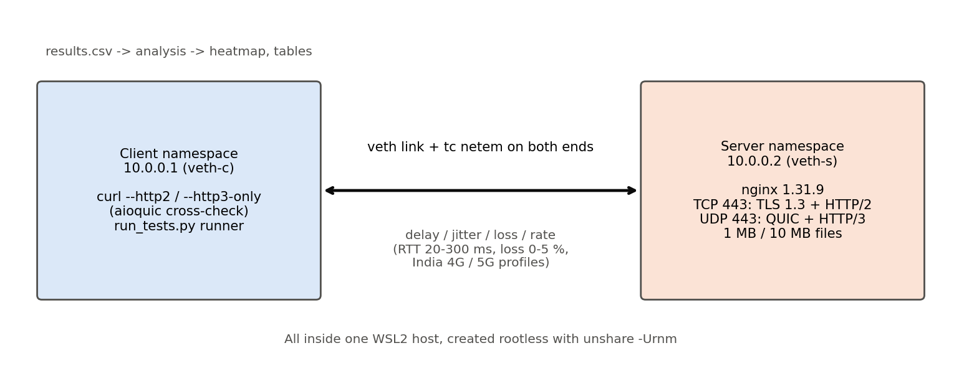
Figure 1. Testbed architecture: client and server network namespaces joined by a veth link shaped with tc netem.
Workflow: set up namespaces (10.0.0.1 client, 10.0.0.2 server) → apply a netem profile to both ends of the link → run 20 paired downloads over HTTP/2 and HTTP/3 (alternating which goes first) → log timings to CSV → capture a pcap with a TLS key log → aggregate, test significance and plot → locate the crossover.
Delay is applied on both ends of the link, one way each, so the RTT equals twice the configured delay. Static cells use a 1 Gbit rate cap; without it, QUIC’s line-rate bursts overflowed the client’s UDP receive buffer and produced phantom loss that affected only HTTP/3.

7. Contribution of Individual Team Member
Name | Reg. No. | Contribution
Abhilash Singh | 24BCI0054 | Testbed setup, netem profiles, automation scripts, analysis and report

8. Modules Explanation
- Server module – Nginx 1.31.9 built with HTTP/2 and HTTP/3 modules against OpenSSL 3.6.5, serving 1 MB and 10 MB files over TCP 443 (HTTP/2) and UDP 443 (HTTP/3) with TLS 1.3.
- Network emulation module – tc netem scripts for the RTT × loss matrix and the Indian mobile profiles (delay, jitter, uniform and Gilbert–Elliott burst loss, rate cap).
- Client / test runner module – a Python runner calls curl (--http2 / --http3-only) inside the client namespace and records connect, handshake, TTFB, total time and throughput. A separate aioquic client and server are used for cross-checks.
- Capture module – a raw-socket pcap writer in the client namespace (tcpdump cannot run in the rootless namespace) plus SSLKEYLOGFILE; captures are opened in Wireshark.
- Analysis module – pandas/numpy/scipy/matplotlib aggregation, bootstrap confidence intervals, Wilcoxon signed-rank test with Bonferroni correction, heatmap and line charts.

9. Project Implementation

a. Experimental Setup with Hardware and Software Requirements
Item | Value used
Hardware | Intel Core i5-11400H @ 2.70 GHz, 12 logical CPUs, 7.6 GiB RAM visible to WSL2
Operating system | Ubuntu 22.04.5 LTS under WSL2, kernel 6.6.87.2-microsoft-standard-WSL2
Web server | nginx 1.31.9 (built from source: --with-http_ssl_module --with-http_v3_module --with-http_v2_module, gcc 11.4.0)
TLS | OpenSSL 3.6.5 (QUIC API), self-signed certificate for 10.0.0.2
Client | curl 8.23.1-DEV with nghttp2 1.71.0-DEV, ngtcp2 1.26.0-DEV, nghttp3; aioquic 1.3.0 for cross-checks
Network emulation | iproute2 5.15.0, tc netem on a veth pair between two network namespaces (rootless via unshare -Urnm)
Analysis | Python 3.10.12, pandas 2.3.3, numpy 2.2.6, scipy 1.15.3, matplotlib 3.10.9
Capture | Wireshark 3.6.2 (GUI) with SSLKEYLOGFILE; custom AF_PACKET pcap writer
Test files | 1 MB and 10 MB binary files

b. Test Cases
The expected outcomes below were hypotheses written before the measurements; the last column reports what was observed (median completion time, 20 paired runs per protocol).
ID | Condition | Hypothesis | Observed
TC1 | 20 ms RTT, 0 % loss | Both similar; QUIC faster handshake | HTTP/3 0.169 s vs HTTP/2 0.186 s (ratio 0.91, significant); handshake 0.023 s vs 0.043 s
TC2 | 300 ms RTT, 0 % loss | QUIC faster due to 1-RTT handshake | HTTP/3 2.409 s vs HTTP/2 2.706 s (ratio 0.89, significant); handshake 0.303 s vs 0.603 s
TC3 | 100 ms RTT, 5 % loss | Compare recovery behaviour | HTTP/2 9.54 s vs HTTP/3 18.87 s (HTTP/3 1.98× slower, significant)
TC4 | Client IP switch during transfer | QUIC connection survives migration | HTTP/2 0 of 8 completed; HTTP/3 (aioquic) 6 of 8 completed; curl HTTP/3 0 of 8 (client limitation). Run on a fixed 50 ms / 20 Mbit link, not the full India 4G profile.

c. Results of Execution
The main sweep covered 36 static conditions (RTT 20, 50, 100, 150, 200, 300 ms × loss 0, 0.5, 1, 2, 3, 5 %) and 3 mobile profiles, with 20 paired downloads per protocol per condition: 1,560 requests of a 1 MB file, of which 41 timed out (counted at the 40 s limit, not dropped). Additional experiments: 180 requests of a 10 MB file (9 conditions, 10 iterations, 90 s limit); a loss-direction diagnostic, a second QUIC client and server (aioquic), a TCP congestion-control comparison, a blackout (loss-burst) test and an IP-migration test.
Statistics: for each condition the per-iteration ratio of HTTP/3 to HTTP/2 completion time is computed; a 95 % bootstrap confidence interval (5,000 resamples) of its median is reported, together with a Wilcoxon signed-rank p-value. Because 39 conditions are tested, p-values are Bonferroni-corrected. A result is called ‘significant’ only if the interval excludes 1 and the corrected p is below 0.05.
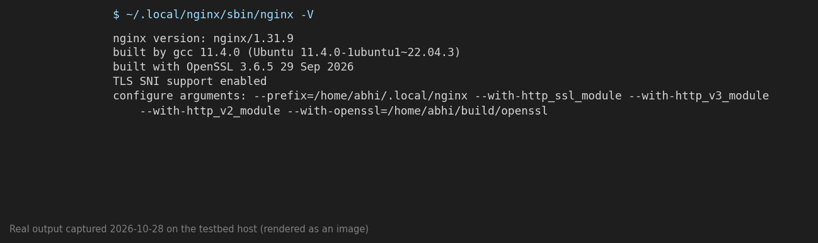
Figure 2. Output of nginx -V on the testbed host: nginx 1.31.9 built with --with-http_v3_module and --with-http_v2_module (command output captured on 28 October 2026, rendered as an image).
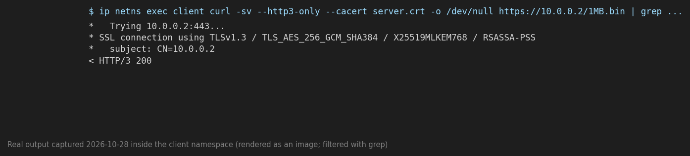
Figure 3. curl --http3-only against the server from the client namespace: TLS 1.3 connection and ‘< HTTP/3 200’ (command output captured on 28 October 2026, rendered as an image).
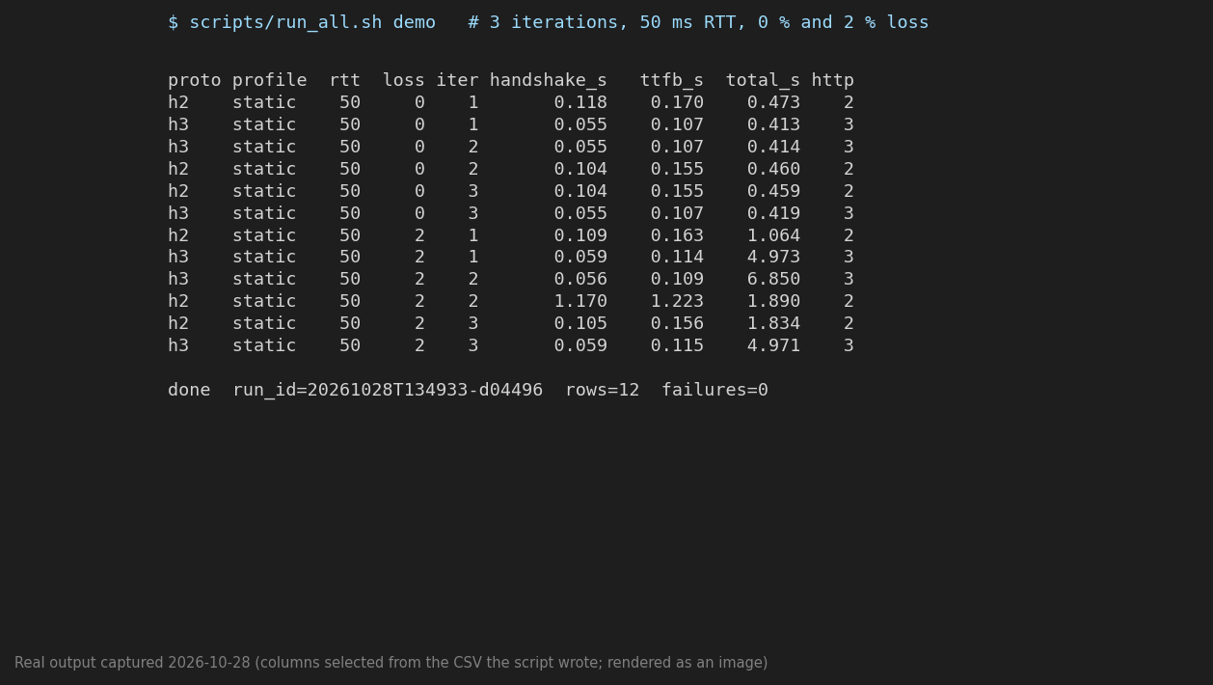
Figure 4. Console output of the runner (scripts/run_all.sh demo, 3 iterations at 50 ms RTT, 0 % and 2 % loss): per-request handshake, TTFB and total time, with http_version 2 or 3 confirming which protocol was used (captured on 28 October 2026, rendered as an image).

d. Performance Analysis – Comparison of Protocols
Median completion time of a 1 MB file:
Condition | HTTP/2 (s) | HTTP/3 (s) | Ratio h3/h2 | Winner
20 ms, 0 % loss | 0.186 | 0.169 | 0.91 | HTTP/3 (significant)
100 ms, 0 % loss | 0.906 | 0.808 | 0.89 | HTTP/3 (significant)
300 ms, 0 % loss | 2.706 | 2.409 | 0.89 | HTTP/3 (significant)
50 ms, 5 % loss | 6.000 | 10.009 | 1.67 | HTTP/2 (significant)
India 4G profile | 1.453 | 0.965 | 0.66 | HTTP/3 (trend, see below)
India 5G profile | 1.328 | 0.781 | 0.59 | HTTP/3 (trend, see below)

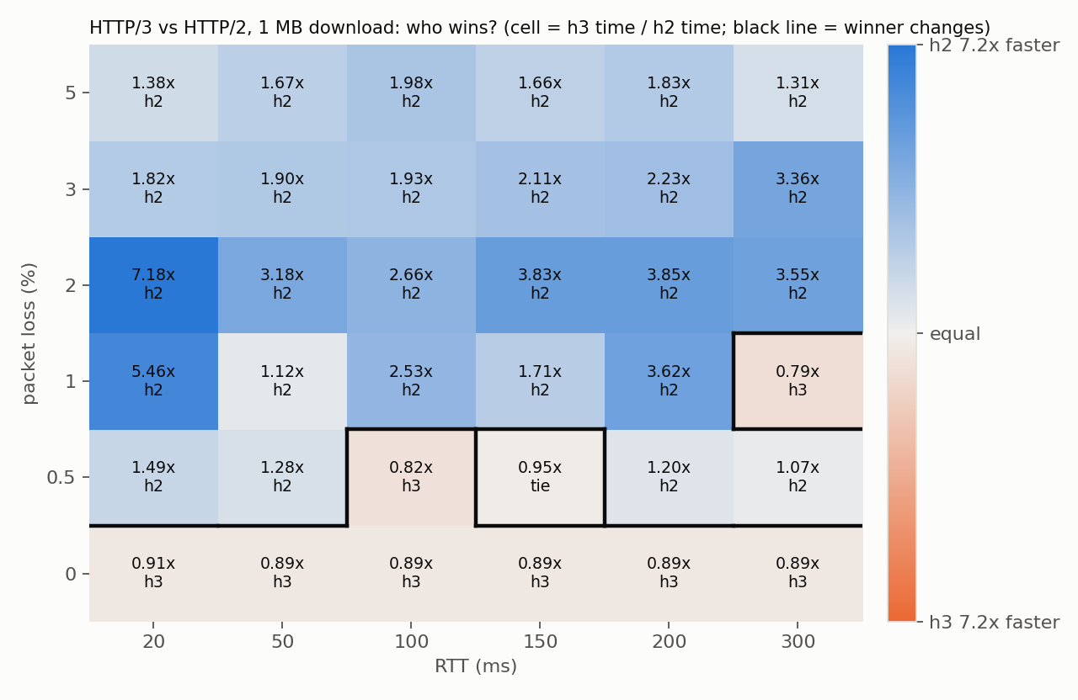
Figure 5. Winner heatmap (1 MB). Each cell shows the HTTP/3-to-HTTP/2 time ratio; a black line marks where the winner changes.
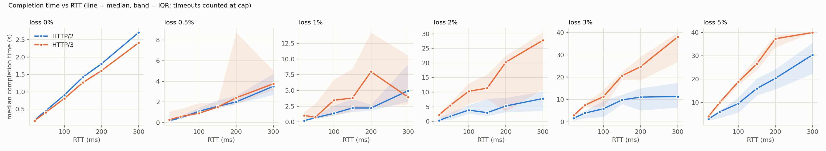
Figure 6. Completion time vs RTT for each loss level (line = median, band = interquartile range).
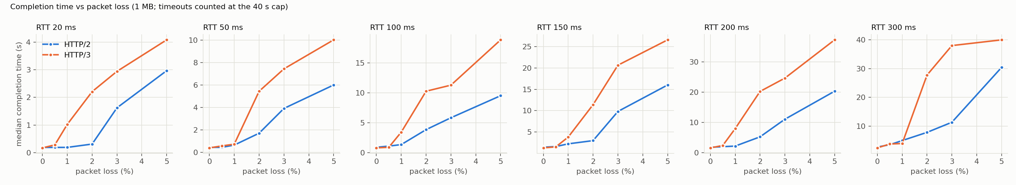
Figure 7. Completion time vs packet loss for each RTT.
Handshake time. At 0 % loss HTTP/3 completed its handshake in half the time of HTTP/2 at every RTT, i.e. about 1 RTT against 2 RTT for TCP + TLS 1.3:
RTT (ms) | 20 | 50 | 100 | 150 | 200 | 300
HTTP/2 handshake (s) | 0.043 | 0.103 | 0.203 | 0.317 | 0.403 | 0.603
HTTP/3 handshake (s) | 0.023 | 0.053 | 0.103 | 0.160 | 0.203 | 0.303
Ratio | 0.53 | 0.51 | 0.51 | 0.50 | 0.50 | 0.50

A packet capture at 100 ms RTT and 0 % loss shows the same on the wire. For HTTP/2 the TCP handshake takes 100 ms (SYN at 0 ms, SYN-ACK at 50 ms, ACK at 100 ms), the TLS exchange takes about another 100 ms, and the first HTTP/2 request (GET /1MB.bin, decrypted in Wireshark with the TLS key log) is sent at 203.5 ms (Figure 8). For HTTP/3 the client’s Initial packet leaves at 0 ms, the server answers with Initial and Handshake packets at about 50 ms, and the client’s first 1-RTT packets leave at about 102 ms (Figure 9); the HTTP/3 payload itself could not be decrypted in Wireshark 3.6.2, so the request is not shown.
Loss-burst recovery. A 10 MB file was downloaded over a 20 Mbit/s, 50 ms RTT link while the link was made to drop every packet for a fixed time starting 1.5 s into the transfer (8 runs per cell, no failures). Median completion times:
Outage | HTTP/2 (s) | HTTP/3 (s) | HTTP/2 added | HTTP/3 added
none | 4.96 | 5.00 | – | –
1 s | 6.67 | 7.57 | +1.71 s | +2.56 s
2 s | 8.06 | 10.33 | +3.10 s | +5.32 s
4 s | 10.94 | 10.28 | +5.98 s | +5.27 s

HTTP/3 did not recover faster for the 1 s and 2 s outages; it lost 0.9 s and 2.2 s more than HTTP/2, and was ahead only after the longest outage (0.7 s).
Connection migration. The client address was changed from 10.0.0.1 to 10.0.0.3 about 1.5 s into a 10 MB download (8 runs per cell):
Client | No address change | With address change
curl, HTTP/2 (TCP) | 8 of 8 completed, 5.13 s | 0 of 8 completed
curl, HTTP/3 | 8 of 8 completed, 5.05 s | 0 of 8 completed
aioquic, HTTP/3 | 8 of 8 completed, 4.74 s | 6 of 8 completed, median 5.55 s

TCP cannot survive a change of client address. HTTP/3 can, but only with a client that keeps sending from the new address: curl’s HTTP/3 socket is bound to the original address and failed, which is a client limitation and not a protocol one. Two of eight aioquic runs timed out; the cause was not determined.

e. Critical Evaluation / Optimization
Run-to-run spread was very small at 0 % loss (for HTTP/2 at 20 ms the slowest run was within 2.4 % of the fastest relative to the median), with one outlier among the HTTP/3 runs, and large under loss (the interquartile bands in Figure 6). For that reason 20 paired repetitions, medians and bootstrap intervals were used, and h2/h3 order was alternated each iteration to cancel drift. Timeouts were counted at the time limit instead of being dropped, which would have flattered the slower protocol. Several sweeps ran as parallel processes on a 12-thread host, so absolute times may include some CPU contention; no CPU pinning or offload tuning was applied.
Why was HTTP/3 slower under loss? Four diagnostics were run at 50 ms RTT and 2 % loss (and nearby conditions):
- Loss direction. With loss only on ACKs HTTP/3 was not slower (0.45 s vs 0.51 s for HTTP/2); with loss on data packets HTTP/3 took 5.55 s against 1.88 s. The penalty therefore comes from recovering lost data packets.
- Second client. A completely different HTTP/3 client (aioquic) was also slower than HTTP/2 under loss (4.98 s vs 1.42 s at 50 ms and 2 %), so the effect is not specific to curl.
- Second server. Serving the same file from an aioquic server was no better than nginx (6.00 s vs 4.95 s at 50 ms and 2 %), so the effect is not specific to nginx.
- Congestion control. Switching the server’s TCP from CUBIC to Reno slowed HTTP/2 at 100 ms (4.05 s to 6.21 s) but not at 50 ms (2.40 s to 2.46 s), and HTTP/3 stayed slower than HTTP/2 even against Reno at 50 ms. Congestion control is therefore at most a partial explanation.
The full mechanism was not isolated. Untested candidates are differences in loss-detection and retransmission-timer behaviour between the kernel TCP stack and the QUIC implementations, and pacing.

10. Results and Discussion

a. Findings and Inferences
Summary of the 36 static cells (1 MB), by loss level (6 RTTs each):
Loss | HTTP/3 faster (significant) | HTTP/2 faster (significant) | HTTP/2 faster (interval only) | No clear difference
0 % | 6 | 0 | 0 | 0
0.5 % | 0 | 0 | 1 | 5
1 % | 0 | 0 | 2 | 4
2 % | 0 | 5 | 1 | 0
3 % | 0 | 3 | 3 | 0
5 % | 0 | 6 | 0 | 0

- On loss-free links HTTP/3 was about 11 % faster at every RTT from 20 to 300 ms (ratio 0.89–0.91), a statistically significant result in all six cells. The relative gain does not grow with RTT; only the absolute saving does (0.017 s at 20 ms, 0.30 s at 300 ms).
- At 0.5–1 % uniform loss neither protocol won consistently: 9 of 12 cells showed no clear difference.
- At 2 % uniform loss and above HTTP/2 was faster in all 18 cells; HTTP/3 needed 1.31× to 7.18× as long (ratio of medians; 1.3× to 4.7× for the paired median ratio), and 14 of the 18 cells are significant after correction.
- There is no RTT threshold: the winner changes with the presence of loss, not with RTT. No cell between 0 % and 0.5 % loss was tested, so the exact loss at which HTTP/2 takes over is not resolved.
- For 10 MB files HTTP/2 was faster in all 9 cells tested, including at 0 % loss (1.13× at 20 ms, 1.23× at 100 and 300 ms, all significant). With loss, HTTP/3 was much slower (for example 34× at 20 ms and 0.5 % loss) and several HTTP/3 runs hit the 90 s limit. Possible reasons, not measured, are the CPU cost of user-space QUIC and a smaller share of the transfer being handshake.
Indian mobile profiles. RTT, jitter and bandwidth come from real measurements on the Airtel network on 28 October 2026 (ping of 100 samples and Ookla Speedtest; Appendix A). Loss is modeled, because ICMP loss measured 0 % on both networks.
Profile | Link settings (per direction) | HTTP/2 (s) | HTTP/3 (s) | Paired median ratio [95 % CI] | HTTP/3 faster in
India 4G | 25 ms ±14 ms, bursty loss averaging 1 %, 22 Mbit/s | 1.453 | 0.965 | 0.79 [0.66, 0.98] | 70 % of runs
India 5G | 24 ms ±10 ms, 0.3 % loss, 35 Mbit/s | 1.328 | 0.781 | 0.62 [0.54, 0.80] | 85 % of runs
Congested 4G | 60 ms ±40 ms, bursty loss averaging 3 %, 5 Mbit/s | 5.073 | 4.796 | 0.77 [0.39, 0.98] | 75 % of runs

On all three profiles HTTP/3 was faster and the confidence intervals exclude 1, but none of these results remain significant after Bonferroni correction over 39 tests, so they are reported as a consistent trend and not as a proven effect. The mobile profiles differ from the static grid in more than their loss pattern (they also have a bandwidth cap and jitter), so the contrast with the static results cannot be attributed to bursty loss alone.

b. Innovation, Novelty, and Evidence
The contribution is methodological and empirical rather than a new protocol: (1) a fully reproducible, rootless testbed that needs no second machine and no root access at run time; (2) a dense RTT × loss map with paired statistics instead of single-point comparisons; (3) mobile profiles whose RTT, jitter and bandwidth are calibrated on real Airtel measurements; and (4) a set of diagnostics showing that HTTP/3’s weakness under data-packet loss reproduces across two clients and two servers. Evidence: data/raw/results.csv and the other CSV files listed in Appendix B.

11. Conclusion
The project built an automated testbed comparing HTTP/2 over TCP and HTTP/3 over QUIC across 36 static network conditions and 3 mobile profiles. HTTP/3 was consistently about 11 % faster on loss-free links, mainly because its handshake takes about one round trip instead of two. Under uniform random packet loss of 2 % or more, HTTP/2 was faster in every tested condition, and for 10 MB transfers HTTP/2 was faster everywhere tested. On the three bandwidth-limited mobile profiles HTTP/3 was faster by a consistent but not statistically proven margin. HTTP/3 also survived a client IP change (in 6 of 8 runs with a client that supports it) where HTTP/2 could not, but it was not faster at recovering from a total link blackout. In this testbed, therefore, whether HTTP/3 helps depends on the loss pattern, the object size and the implementation, and not simply on how bad the network is.

12. Limitations and Future Enhancement
- The network is emulated on one machine and may not match real mobile networks; loss on the India profiles is modeled, not measured.
- Single client/server pair, one object per connection; no multiplexed page loads, where HTTP/3’s head-of-line-blocking advantage would matter most.
- Several sweeps ran as parallel processes on a shared 12-thread host; CPU use was not measured and no pinning was applied.
- No cell between 0 % and 0.5 % loss was tested, so the exact loss threshold is unresolved. The 10 MB experiment used only 9 cells and 10 iterations.
- The migration test used a fixed 50 ms / 20 Mbit link, and two of eight aioquic runs failed for an undetermined reason; curl cannot migrate.
- The cause of HTTP/3’s slowness under data-packet loss was only partly isolated.
- Wireshark 3.6.2 decrypted the HTTP/2 capture with the TLS key log but not the HTTP/3 1-RTT payload (possibly because curl now uses a large post-quantum key exchange that this old version does not handle; not confirmed); the HTTP/3 handshake timing is read from packet times only.
- Future: real-device tests on Indian carriers, packet-level analysis of loss recovery (qlog), BBR versus CUBIC on both stacks, multiplexed web-page workloads and video streaming, CPU and battery cost.

References
- A. Langley, A. Riddoch, A. Wilk, et al., “The QUIC Transport Protocol: Design and Internet-Scale Deployment,” Proc. ACM SIGCOMM 2017, Los Angeles, August 2017.
- A. M. Kakhki, S. Jero, D. Choffnes, C. Nita-Rotaru and A. Mislove, “Taking a Long Look at QUIC: An Approach for Rigorous Evaluation of Rapidly Evolving Transport Protocols,” Proc. ACM IMC 2017, pp. 290–303. doi:10.1145/3131365.3131368.
- A. Yu and T. A. Benson, “Dissecting Performance of Production QUIC,” Proc. The Web Conference (WWW) 2021, pp. 1157–1168. doi:10.1145/3442381.3450103.
- J. Iyengar and M. Thomson (eds.), RFC 9000 – QUIC: A UDP-Based Multiplexed and Secure Transport, IETF, 2021.
- M. Thomson and S. Turner (eds.), RFC 9001 – Using TLS to Secure QUIC, IETF, 2021.
- J. Iyengar and I. Swett (eds.), RFC 9002 – QUIC Loss Detection and Congestion Control, IETF, 2021.
- M. Bishop (ed.), RFC 9114 – HTTP/3, IETF, 2022.
- nginx HTTP/3 (QUIC) documentation – nginx.org/en/docs/quic.html.
- aioquic – github.com/aiortc/aioquic.
- curl HTTP/3 documentation – curl.se/docs/http3.html.
- tc-netem(8), Linux manual page.
- Wireshark 3.6.2 – www.wireshark.org.

Appendix A. Calibration evidence
Measurements taken on the Airtel network on 28 October 2026 from a WSL2 terminal tethered to a phone (ping -c 100 8.8.8.8) and the Ookla Speedtest app. One-way delay and jitter are half the measured RTT and mdev.
Metric | 5G (Chennai) | 4G (Tirupati)
RTT average (ping, n = 100) | 48.1 ms | 50.5 ms
RTT jitter (mdev) | 20.2 ms | 27.4 ms
Packet loss (ICMP, n = 100) | 0 % | 0 %
Download (Speedtest) | 35.2 Mbps | 22.1 Mbps
Netem settings used | delay 24 ms 10 ms, loss 0.3 %, rate 35 Mbit | delay 25 ms 14 ms, bursty loss averaging 1 %, rate 22 Mbit

ICMP loss was 0 % in both tests, so a modest modeled loss component is retained to represent bursty application-layer loss; RTT, jitter and bandwidth are real measured values. The screenshots are in the file Network_Measurement_Evidence.docx.

Appendix B. Screenshots and data files
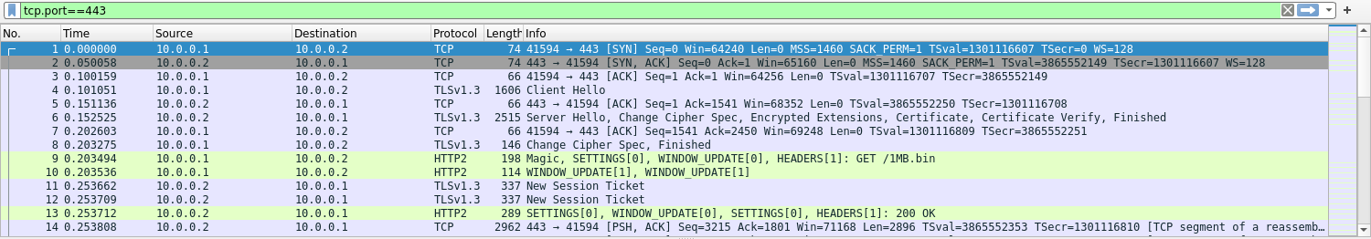
Figure 8. Wireshark 3.6.2 view of data/captures/h2_ipv4.pcap (100 ms RTT, 0 % loss, TLS key log loaded; times in seconds from the first packet). SYN 0.000, SYN-ACK 0.050, ACK 0.100, TLS Client Hello 0.101, Server Hello 0.153, and the decrypted HTTP/2 request GET /1MB.bin at 0.203.
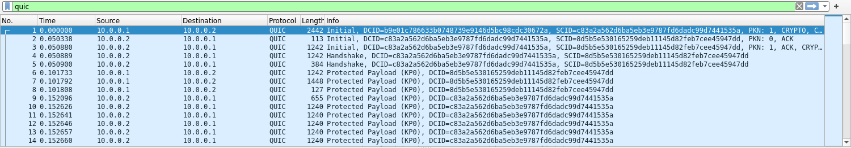
Figure 9. Wireshark 3.6.2 view of data/captures/h3_ipv4.pcap (same conditions). QUIC Initial 0.000; server Initial and Handshake 0.050; client 1-RTT (Protected Payload) packets 0.102; server data from 0.152. The 1-RTT payload is encrypted in this view (see Section 12).
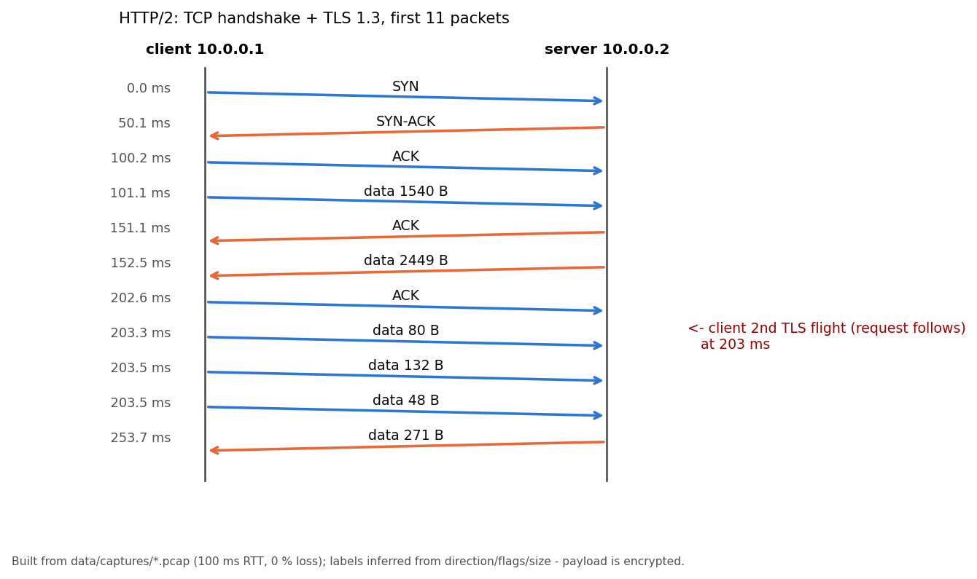
Figure 10. The same HTTP/2 exchange drawn as a sequence diagram from the pcap (labels inferred from direction, flags and size).
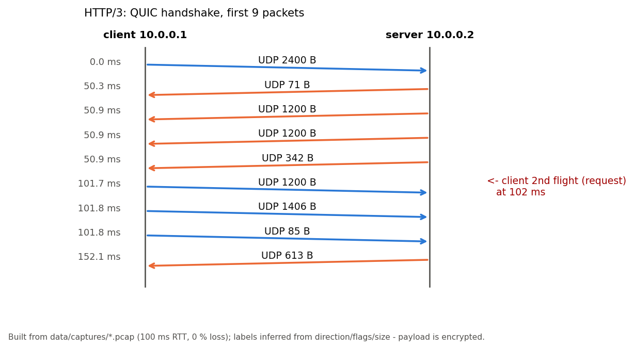
Figure 11. The same HTTP/3 exchange drawn as a sequence diagram from the pcap. Packets captured at the interface may be coalesced by segmentation offload.
Data files (in the project folder quic-testbed):
- data/raw/results.csv – main 1 MB sweep, 1,560 rows
- data/raw/results_10MB.csv – 10 MB runs, 180 rows
- data/raw/blackout.csv – loss-burst test, 64 rows
- data/raw/migration.csv – IP-migration test, 48 rows
- data/raw/aioquic_check.csv, sender_test.csv, cc_test.csv, diagnose_loss.csv – diagnostics
- data/processed/ – medians, crossover tables, significance tests
- data/captures/ – pcap files, TLS key log, handshake timing

