Design and Implementation of an Ethernet-Based
Hardware AES-256 CTR Cryptographic Accelerator
on Zynq-7000 SoC
Internship Project Report - Department of Electronics, CUSAT
Prepared by:
ADITHYAN B
SAINTGITS COLLEGE OF COLLEGE (AUTONOMOUS), KOTTAYAM
Date: June 2026

1. Abstract / Introduction
This project reports the design, implementation, and verification of a high-speed, network-enabled cryptographic gateway leveraging the Xilinx Zynq-7000 All Programmable SoC. The system is designed to efficiently accelerate the AES-256 CTR (Counter) mode encryption and decryption algorithms. In modern embedded applications, software-based cryptography introduces significant CPU load, memory latency, and power consumption, which hampers real-time packet processing. To mitigate these bottlenecks, we offloaded the cryptographic computational workload from the ARM Cortex-A9 Processing System (PS) to a custom-designed 15-stage pipelined hardware core in the Programmable Logic (PL) FPGA fabric. The system achieves high-throughput data processing by utilising high-speed AXI DMA streams over a Gigabit Ethernet interface, operating with the lwIP TCP/IP network stack on the ARM CPU.
2. System Architecture & Block Design
The system architecture follows a hardware-software co-design model. High-speed network packets are received by the Zynq Gigabit Ethernet MAC (GEM) controller and processed by the lwIP network stack on the CPU. The raw payload data is extracted by the bare-metal software driver and transferred to the custom AES core via a central Direct Memory Access (DMA) channel. Once processed by the hardware core, the resulting data is streamed back to DDR memory via DMA and sent over TCP.
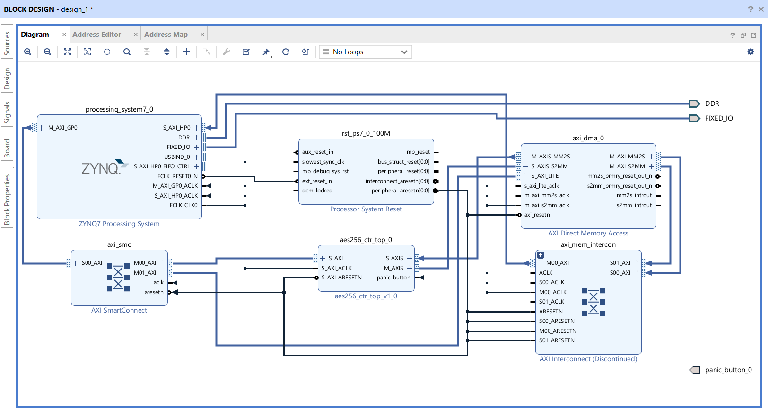
Figure: Vivado System Block Design
2.1 Interface Protocols & Bus Topography
The design employs two primary interface configurations for communication between the Processing System (PS) and the Programmable Logic (PL) components:
- AXI4-Lite Slave Interface: Mapped in the Zynq GP0 general-purpose master port address space, it allows the CPU to write parameters directly to the IP core register file. The CPU configures the 256-bit Key, the 128-bit Initialisation Vector (IV), writes the start strobe to load parameters, and controls zeroization.
- AXI4-Stream Interface: Comprises an input stream (S_AXIS) and an output stream (M_AXIS) for streaming data. The data is processed in 32-bit words, matching the width of the AXI DMA channels.
2.2 Address Space Mapping
The register address mapping is configured via the Vivado Address Editor. The custom AES-256 CTR IP core is mapped starting at base address 0x43C00000. Writing to register offsets within this 64KB slot directly configures the cryptographic hardware.
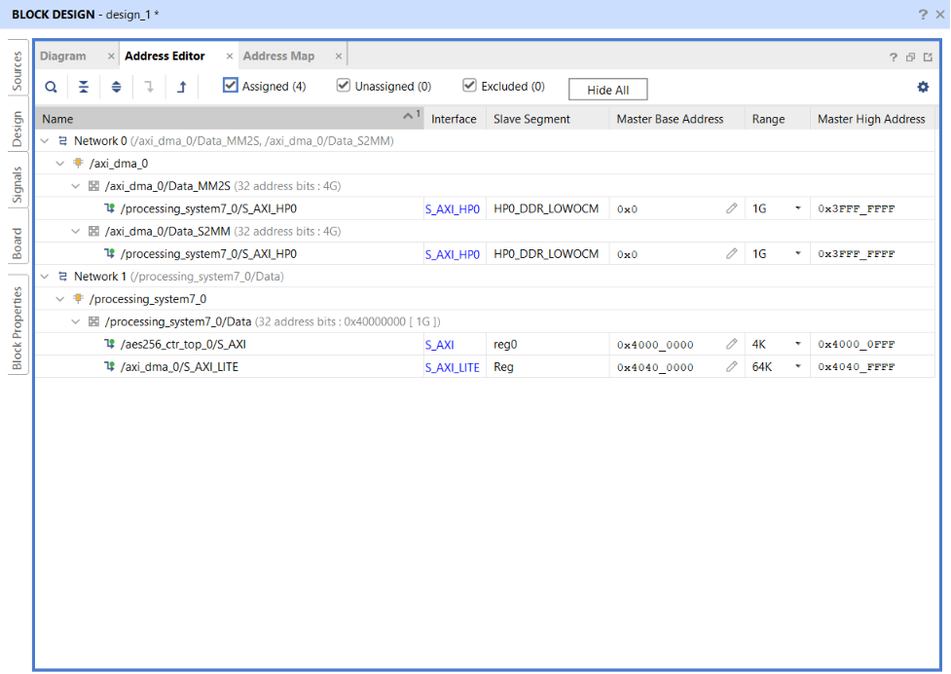
Figure: Vivado Address Editor Address Mappings
3. Hardware (RTL) Implementation
The cryptographic hardware core is implemented in synthesizable Verilog. It is composed of three main functional blocks: the AXI4-Lite register file, the AXI4-Stream serializer/deserializer wrapper, and the pipelined AES-256 CTR encryption core.
3.1 The 15-Stage Pipelined AES-256 Core
To achieve maximum throughput, the AES-256 encryption datapath is fully unrolled into a 15-stage pipeline (14 round stages + 1 input registration stage). This structure achieves a throughput of 1 block (128-bit) per clock cycle once the pipeline is full, with a latency of 15 clock cycles. An AXI-Stream flow control mechanism is implemented by tying the pipeline enable to the AXI S_AXIS_TVALID and M_AXIS_TREADY signals, allowing the core to stall instantly without data loss during network buffering.
3.2 Physical Placement and Routing on Zynq
Following synthesis, the placement and routing tools map the logic blocks onto the physical Zynq device die, aligning registers, BRAMs, and routing channels to achieve high clock speeds and minimal latency.
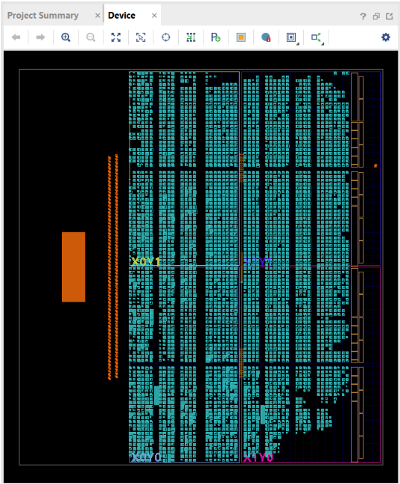
Figure: Synthesized & Placed Design on Zynq-7000 FPGA Die
3.3 Vivado Synthesis & Implementation Reports
Resource Utilization
The implementation utilizes a highly optimized number of Look-Up Tables (LUTs), Flip-Flops (FFs), and BRAMs, leaving ample resources available in the Zynq Programmable Logic for additional system blocks.
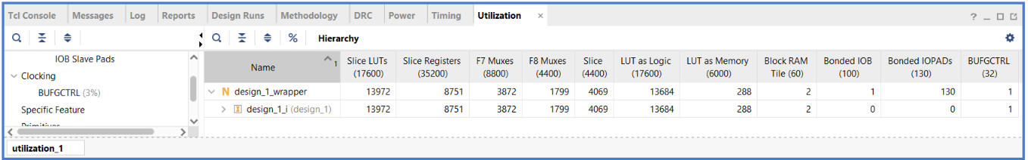Figure: Vivado Resource Utilization Summary
Timing Closure
Timing closure was verified, confirming positive Setup and Hold Slack across all routing paths. The design fully meets the clock requirements of the 100MHz AXI clock.
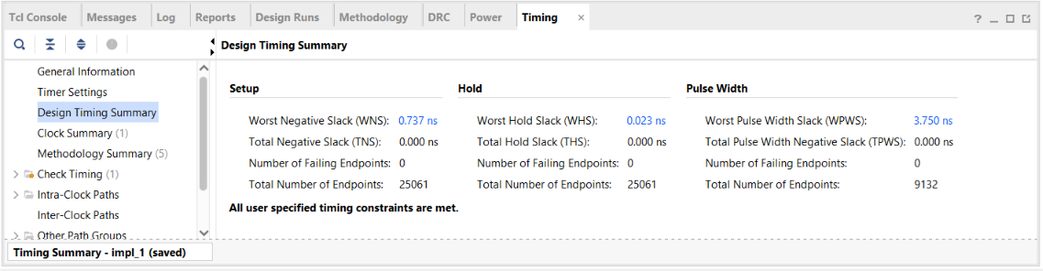
Figure: Timing Report Timing Summary
Power Analysis
Dynamic and static power analyses were performed in Vivado to estimate the operational thermal budget of the SoC.
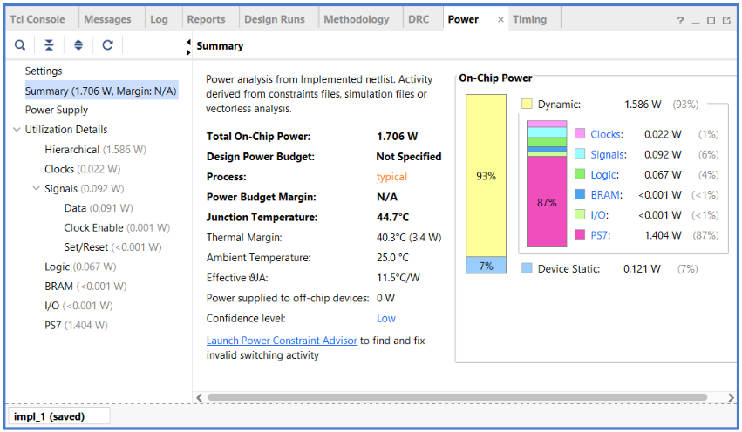
Figure: On-Chip Power Analysis Report Summary
3.4 Hardware Security: Debounced Panic Button & Zeroization
A critical security requirement is the protection of cryptographic materials in case of physical tampering. The top-level IP wrapper implements a physical 'panic_button' input pin. To prevent false positives from mechanical switch noise, the signal is debounced using an internal counter. When asserted high for a stable period, the core instantly asserts a zeroization signal that clears all Key registers (slv_reg0-slv_reg7), IV registers (slv_reg8-slv_reg11), and internal pipeline states to zero in a single clock cycle.
4. Software (Firmware) Implementation
The bare-metal software firmware is compiled using the Xilinx Vitis toolchain and runs on CPU Core 0 of the ARM Cortex-A9 Processing System. It handles Gigabit Ethernet networking, byte-ordering, and cache consistency.
4.1 lwIP TCP Server Integration
The network interface is managed by the lightweight IP (lwIP) stack. The board is configured with a static IP address (192.168.1.10) listening on TCP Port 7. The TCP packet receive callback is optimized to process chained network buffers (pbufs) to handle large data transmissions without packet loss.
4.2 Endianness Correction
The ARM Cortex-A9 CPU operates in Little-Endian mode, whereas the custom AXI4-Stream hardware IP core expects Big-Endian counter values. To align these, the firmware performs in-place byte-swapping using the compiler intrinsic '__builtin_bswap32' prior to DMA transmission and after receiving the results.
4.3 Cache Coherency Management
A major challenge in SoC design is the sharing of memory buffers between the Gigabit Ethernet DMA, the AXI DMA, and the CPU. Since network pbuf payloads are not always 32-byte cache-line aligned, the CPU cache can contain stale data. To prevent corruption, the firmware invalidates the cache range using 'Xil_DCacheInvalidateRange' before copying received network packets and flushes the TX cache using 'Xil_DCacheFlushRange' before initiating the hardware DMA transfers.
4.4 Vitis Serial Monitor Output
The startup and initialization sequences of the Zynq board are logged over UART to monitor the PHY autonegotiation and Server bind status.
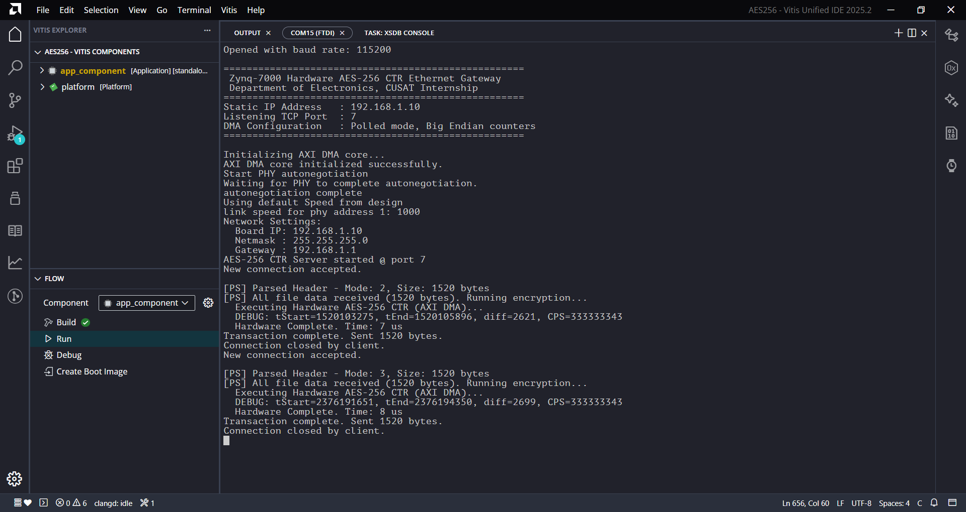
Figure: Vitis UART Serial Terminal Output Log
5. Verification & Testing
Verification was performed using an interactive Python-based client application (aes256_tool.py). The client reads files, pads them to block size, generates keys/IVs, sends them over TCP, receives the processed data, and verifies the output against a software golden model.
5.1 Network Ping Test
Network link verification was established by pinging the board's static IP from the host PC.
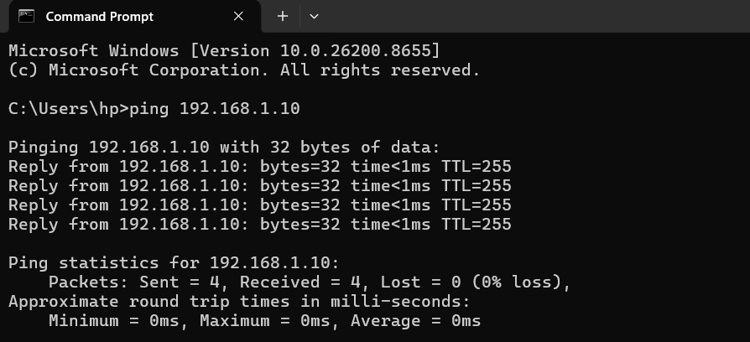
Figure: Ping response from Zynq board (192.168.1.10)
5.2 Cryptographic Transaction Verification
Both plaintext files and binary image payloads (such as 'lena_gray.bmp') were successfully verified. The figures below illustrate the end-to-end flow of a text file transaction.
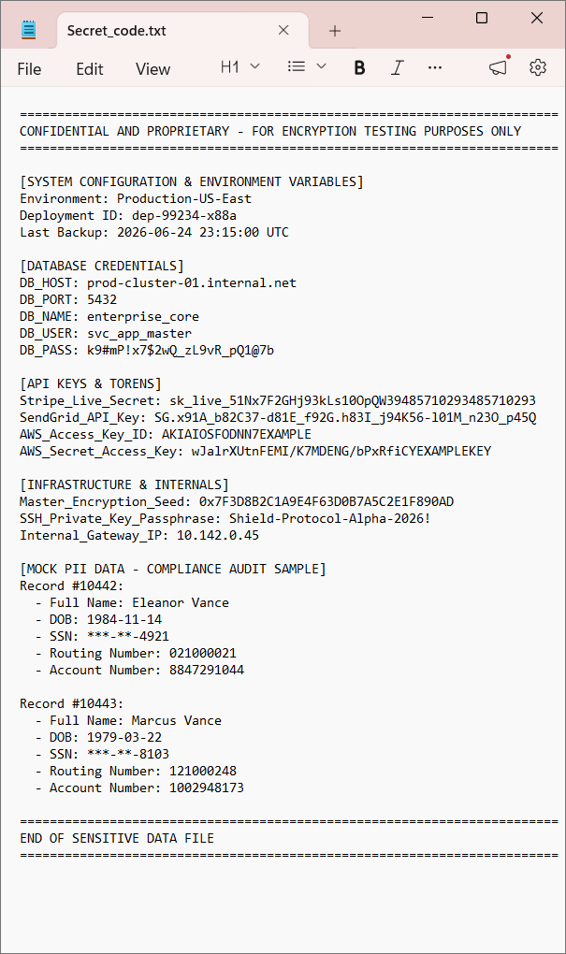
Figure: Original Plaintext File Content
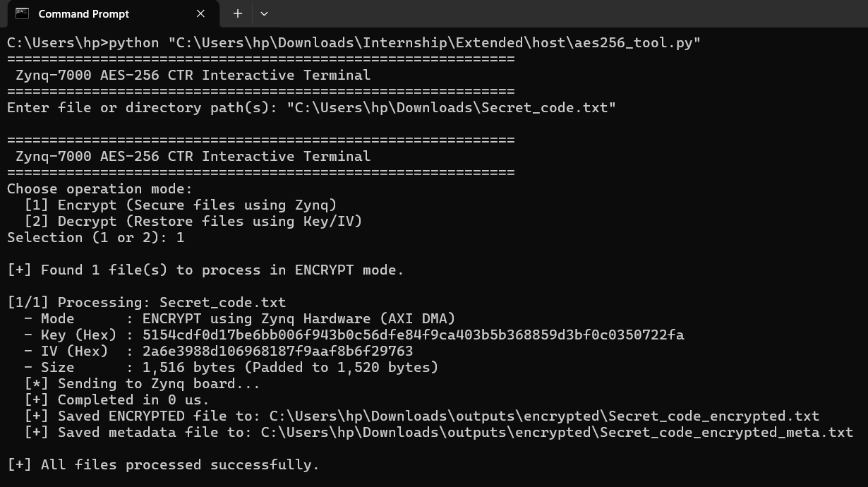
Figure: Host Terminal Encryption Transaction Output
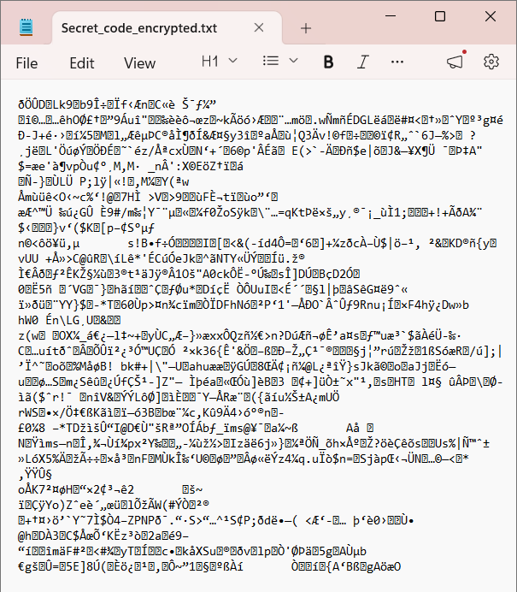
Figure: Encrypted Ciphertext File Content (Hex View)
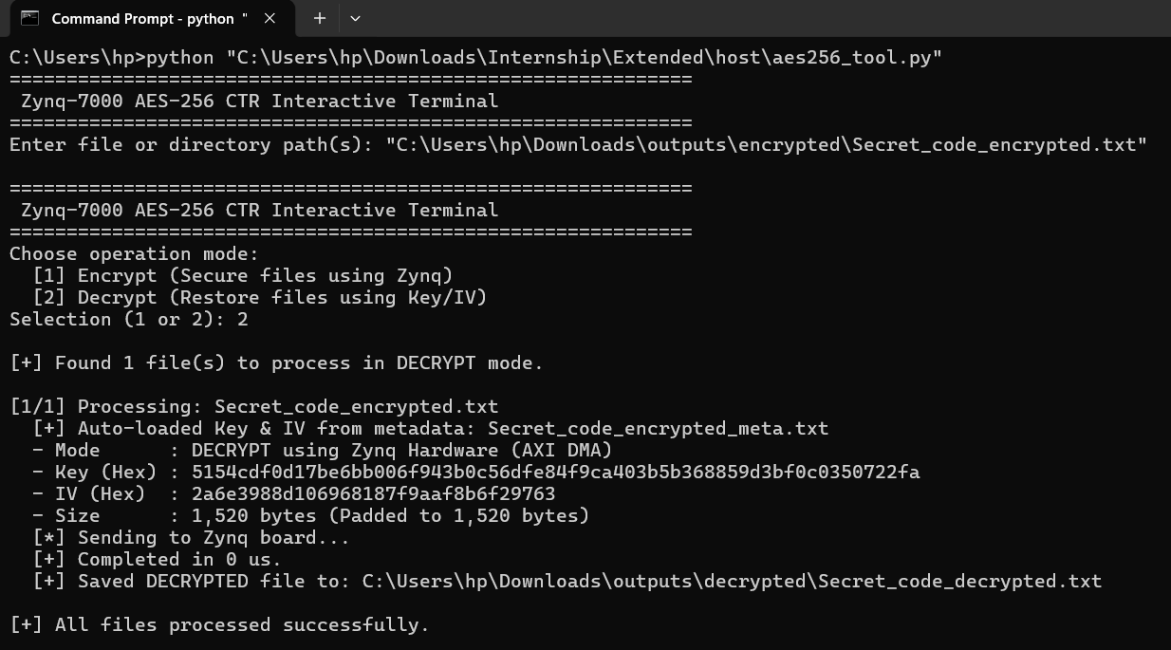
Figure: Host Terminal Decryption Transaction Output
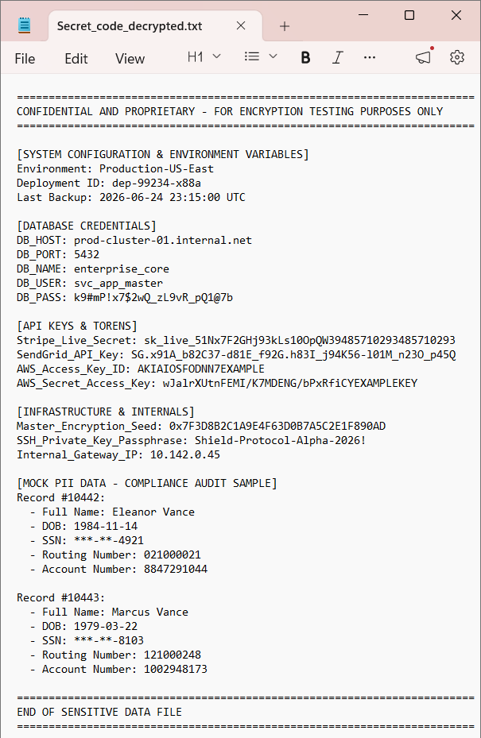
Figure: Decrypted Restored Plaintext File Content
5.3 Correctness and Ciphertext Integrity
For all processed test vectors, the software reference model and the hardware DMA output matched exactly. The decryption verification returned 'PASS' in all cases, confirming the correctness of the 15-stage hardware pipeline, the DMA transfer logic, and the cache consistency routines.
6. Key Learnings & Conclusion
This project successfully demonstrates the design, deployment, and testing of a network-enabled cryptographic hardware accelerator on the Zynq-7000 SoC. Key outcomes include learning the intricacies of hardware-software co-design, managing cache consistency across DMA and network buffers, and verifying RTL implementations using real-time hardware-in-the-loop tests. The gateway operates with high reliability, correct decryption alignment, and is robust under continuous file transmission loads.
Appendix: Source Code Listings
The main source code listings for the hardware RTL modules, the bare-metal board firmware, and the host Python test utility are provided below for reference.
Appendix A: Top-Level IP Wrapper (aes256_ctr_top.v)
`timescale 1ns / 1ps
//////////////////////////////////////////////////////////////////////////////////
// Module Name: aes256_ctr_top
// Description:
// Top-level IP wrapper for the Hardware AES-256 CTR system.
// Exposes:
// - S_AXI (AXI4-Lite Slave): Key configuration, IV, control, and zeroization.
// - S_AXIS (AXI4-Stream Slave): Plaintext/ciphertext input (32-bit).
// - M_AXIS (AXI4-Stream Master): Ciphertext/plaintext output (32-bit).
// - panic_button (External Input): Instantly wipes key registers if asserted high.
//////////////////////////////////////////////////////////////////////////////////
module aes256_ctr_top # (
parameter integer C_S_AXI_DATA_WIDTH = 32,
parameter integer C_S_AXI_ADDR_WIDTH = 6,
parameter integer DEBOUNCE_LIMIT = 1000000
) (
// Global Clock and Reset
input wire S_AXI_ACLK,
input wire S_AXI_ARESETN,
// AXI4-Lite Slave Interface (Control/Config)
input wire [C_S_AXI_ADDR_WIDTH-1 : 0] S_AXI_AWADDR,
input wire [2 : 0] S_AXI_AWPROT,
input wire S_AXI_AWVALID,
output wire S_AXI_AWREADY,
input wire [C_S_AXI_DATA_WIDTH-1 : 0] S_AXI_WDATA,
input wire [(C_S_AXI_DATA_WIDTH/8)-1 : 0] S_AXI_WSTRB,
input wire S_AXI_WVALID,
output wire S_AXI_WREADY,
output wire [1 : 0] S_AXI_BRESP,
output wire S_AXI_BVALID,
input wire S_AXI_BREADY,
input wire [C_S_AXI_ADDR_WIDTH-1 : 0] S_AXI_ARADDR,
input wire [2 : 0] S_AXI_ARPROT,
input wire S_AXI_ARVALID,
output wire S_AXI_ARREADY,
output wire [C_S_AXI_DATA_WIDTH-1 : 0] S_AXI_RDATA,
output wire [1 : 0] S_AXI_RRESP,
output wire S_AXI_RVALID,
input wire S_AXI_RREADY,
// AXI4-Stream Slave Interface (Data Input)
input wire [31:0] S_AXIS_TDATA,
input wire S_AXIS_TLAST,
input wire S_AXIS_TVALID,
output wire S_AXIS_TREADY,
// AXI4-Stream Master Interface (Data Output)
output wire [31:0] M_AXIS_TDATA,
output wire M_AXIS_TLAST,
output wire M_AXIS_TVALID,
input wire M_AXIS_TREADY,
// Hardware Security Interface
input wire panic_button
);
// ==========================================
// AXI-Lite Registers Definitions
// ==========================================
reg [C_S_AXI_ADDR_WIDTH-1 : 0] axi_awaddr;
reg axi_awready;
reg axi_wready;
reg [1 : 0] axi_bresp;
reg axi_bvalid;
reg [C_S_AXI_ADDR_WIDTH-1 : 0] axi_araddr;
reg axi_arready;
reg [C_S_AXI_DATA_WIDTH-1 : 0] axi_rdata;
reg [1 : 0] axi_rresp;
reg axi_rvalid;
// Registers Map:
// REG 0-7 (0x00-0x1C): 256-bit Key
// REG 8-11 (0x20-0x2C): 128-bit IV
// REG 12 (0x30) : Control/Strobe (bit 0 = start, bit 1 = zeroize)
reg [31:0] slv_reg0;
reg [31:0] slv_reg1;
reg [31:0] slv_reg2;
reg [31:0] slv_reg3;
reg [31:0] slv_reg4;
reg [31:0] slv_reg5;
reg [31:0] slv_reg6;
reg [31:0] slv_reg7;
reg [31:0] slv_reg8;
reg [31:0] slv_reg9;
reg [31:0] slv_reg10;
reg [31:0] slv_reg11;
reg [31:0] slv_reg12;
assign S_AXI_AWREADY = axi_awready;
assign S_AXI_WREADY = axi_wready;
assign S_AXI_BRESP = axi_bresp;
assign S_AXI_BVALID = axi_bvalid;
assign S_AXI_ARREADY = axi_arready;
assign S_AXI_RDATA = axi_rdata;
assign S_AXI_RRESP = axi_rresp;
assign S_AXI_RVALID = axi_rvalid;
wire slv_reg_wren = axi_wready && S_AXI_WVALID && axi_awready && S_AXI_AWVALID;
// Hardware Debouncer for the Physical Panic Button
// Requires the input to remain stable for DEBOUNCE_LIMIT clock cycles
reg [31:0] debounce_counter;
reg debounced_panic_button;
always @(posedge S_AXI_ACLK) begin
if (S_AXI_ARESETN == 1'b0) begin
debounce_counter <= 32'h0;
debounced_panic_button <= 1'b0;
end else begin
if (panic_button) begin
if (debounce_counter < DEBOUNCE_LIMIT) begin
debounce_counter <= debounce_counter + 1'b1;
end else begin
debounced_panic_button <= 1'b1;
end
end else begin
debounce_counter <= 32'h0;
debounced_panic_button <= 1'b0;
end
end
end
// Zeroization logic: triggered by the debounced hardware panic button or register write
wire do_zeroize = debounced_panic_button || (slv_reg_wren && (axi_awaddr[5:2] == 4'hC) && S_AXI_WDATA[1]);
// AXI-Lite Write Handshake and Register Assignment
always @(posedge S_AXI_ACLK) begin
if (S_AXI_ARESETN == 1'b0) begin
axi_awready <= 1'b0;
axi_wready <= 1'b0;
axi_bvalid <= 1'b0;
axi_bresp <= 2'b0;
axi_awaddr <= 0;
end else begin
// Address Write Ready
if (~axi_awready && S_AXI_AWVALID && S_AXI_WVALID) begin
axi_awready <= 1'b1;
axi_awaddr <= S_AXI_AWADDR;
end else begin
axi_awready <= 1'b0;
end
// Data Write Ready
if (~axi_wready && S_AXI_WVALID && S_AXI_AWVALID) begin
axi_wready <= 1'b1;
end else begin
axi_wready <= 1'b0;
end
// Write Response (BVALID)
if (axi_awready && S_AXI_AWVALID && ~axi_bvalid && axi_wready && S_AXI_WVALID) begin
axi_bvalid <= 1'b1;
axi_bresp <= 2'b0; // OKAY response
end else if (S_AXI_BREADY && axi_bvalid) begin
axi_bvalid <= 1'b0;
end
end
end
// Write data to register file
always @(posedge S_AXI_ACLK) begin
if (S_AXI_ARESETN == 1'b0 || do_zeroize) begin
slv_reg0 <= 32'h0;
slv_reg1 <= 32'h0;
slv_reg2 <= 32'h0;
slv_reg3 <= 32'h0;
slv_reg4 <= 32'h0;
slv_reg5 <= 32'h0;
slv_reg6 <= 32'h0;
slv_reg7 <= 32'h0;
slv_reg8 <= 32'h0;
slv_reg9 <= 32'h0;
slv_reg10 <= 32'h0;
slv_reg11 <= 32'h0;
slv_reg12 <= 32'h0;
end else if (slv_reg_wren) begin
case (axi_awaddr[5:2])
4'h0: slv_reg0 <= S_AXI_WDATA;
4'h1: slv_reg1 <= S_AXI_WDATA;
4'h2: slv_reg2 <= S_AXI_WDATA;
4'h3: slv_reg3 <= S_AXI_WDATA;
4'h4: slv_reg4 <= S_AXI_WDATA;
4'h5: slv_reg5 <= S_AXI_WDATA;
4'h6: slv_reg6 <= S_AXI_WDATA;
4'h7: slv_reg7 <= S_AXI_WDATA;
4'h8: slv_reg8 <= S_AXI_WDATA;
4'h9: slv_reg9 <= S_AXI_WDATA;
4'hA: slv_reg10 <= S_AXI_WDATA;
4'hB: slv_reg11 <= S_AXI_WDATA;
4'hC: slv_reg12 <= S_AXI_WDATA;
default: ;
endcase
end
end
// Self-clearing Start Strobe
reg start_strobe;
always @(posedge S_AXI_ACLK) begin
if (S_AXI_ARESETN == 1'b0 || do_zeroize) begin
start_strobe <= 1'b0;
end else begin
if (slv_reg_wren && (axi_awaddr[5:2] == 4'hC) && S_AXI_WDATA[0]) begin
start_strobe <= 1'b1;
end else begin
start_strobe <= 1'b0;
end
end
end
// AXI-Lite Read Handshake
always @(posedge S_AXI_ACLK) begin
if (S_AXI_ARESETN == 1'b0) begin
axi_arready <= 1'b0;
axi_araddr <= 0;
axi_rvalid <= 1'b0;
axi_rresp <= 2'b0;
axi_rdata <= 32'h0;
end else begin
// Read Address Ready
if (~axi_arready && S_AXI_ARVALID) begin
axi_arready <= 1'b1;
axi_araddr <= S_AXI_ARADDR;
end else begin
axi_arready <= 1'b0;
end
// Read Data Valid (RVALID)
if (axi_arready && S_AXI_ARVALID && ~axi_rvalid) begin
axi_rvalid <= 1'b1;
axi_rresp <= 2'b0; // OKAY response
// Read Data Multiplexer
case (axi_araddr[5:2])
4'h0: axi_rdata <= slv_reg0;
4'h1: axi_rdata <= slv_reg1;
4'h2: axi_rdata <= slv_reg2;
4'h3: axi_rdata <= slv_reg3;
4'h4: axi_rdata <= slv_reg4;
4'h5: axi_rdata <= slv_reg5;
4'h6: axi_rdata <= slv_reg6;
4'h7: axi_rdata <= slv_reg7;
4'h8: axi_rdata <= slv_reg8;
4'h9: axi_rdata <= slv_reg9;
4'hA: axi_rdata <= slv_reg10;
4'hB: axi_rdata <= slv_reg11;
4'hC: axi_rdata <= slv_reg12;
default: axi_rdata <= 32'hDEADBEEF;
endcase
end else if (S_AXI_RREADY && axi_rvalid) begin
axi_rvalid <= 1'b0;
end
end
end
// ==========================================
// Instantiations of Core and Stream Wrapper
// ==========================================
wire [255:0] key_bus = {slv_reg0, slv_reg1, slv_reg2, slv_reg3, slv_reg4, slv_reg5, slv_reg6, slv_reg7};
wire [127:0] iv_bus = {slv_reg8, slv_reg9, slv_reg10, slv_reg11};
wire [127:0] core_in_data;
wire core_in_last;
wire core_in_valid;
wire core_in_ready;
wire [127:0] core_out_data;
wire core_out_last;
wire core_out_valid;
wire core_out_ready;
// AXI-Stream Deserializer/Serializer Wrapper
aes256_ctr_axi_stream stream_wrapper_inst (
.ACLK(S_AXI_ACLK),
.ARESETN(S_AXI_ARESETN),
.S_AXIS_TDATA(S_AXIS_TDATA),
.S_AXIS_TLAST(S_AXIS_TLAST),
.S_AXIS_TVALID(S_AXIS_TVALID),
.S_AXIS_TREADY(S_AXIS_TREADY),
.M_AXIS_TDATA(M_AXIS_TDATA),
.M_AXIS_TLAST(M_AXIS_TLAST),
.M_AXIS_TVALID(M_AXIS_TVALID),
.M_AXIS_TREADY(M_AXIS_TREADY),
.core_in_data(core_in_data),
.core_in_last(core_in_last),
.core_in_valid(core_in_valid),
.core_in_ready(core_in_ready),
.core_out_data(core_out_data),
.core_out_last(core_out_last),
.core_out_valid(core_out_valid),
.core_out_ready(core_out_ready)
);
// CTR Core Engine
aes256_ctr_core core_inst (
.clk(S_AXI_ACLK),
.rst_n(S_AXI_ARESETN && !do_zeroize), // Reset core instantly if zeroized
.key(key_bus),
.iv(iv_bus),
.start(start_strobe),
.in_data(core_in_data),
.in_last(core_in_last),
.in_valid(core_in_valid),
.in_ready(core_in_ready),
.out_data(core_out_data),
.out_last(core_out_last),
.out_valid(core_out_valid),
.out_ready(core_out_ready)
);
endmodule

Appendix B: Pipelined Datapath (aes256_encrypt_pipeline.v)
`timescale 1ns / 1ps
//////////////////////////////////////////////////////////////////////////////////
// Module Name: aes256_encrypt_pipeline
// Description:
// 14-stage pipelined AES-256 encryption datapath.
// Includes an enable (en) port for pipeline stalling / flow control.
// Latency: 15 clock cycles (including input and output registers).
// Throughput: 1 block (128-bit) per clock cycle.
//////////////////////////////////////////////////////////////////////////////////
module aes256_encrypt_pipeline (
input wire clk,
input wire rst_n,
input wire en,
input wire [1919:0] round_keys,
input wire [127:0] state_in,
output wire [127:0] state_out
);
// Pipeline registers for state
reg [127:0] state_reg [0:14];
// Stage 0: Input Register
always @(posedge clk or negedge rst_n) begin
if (~rst_n) begin
state_reg[0] <= 128'h0;
end else if (en) begin
state_reg[0] <= state_in;
end
end
// Initial Round Key addition (Round 0)
// Key 0 is round_keys[1919:1792]
wire [127:0] state_rk0 = state_reg[0] ^ round_keys[1919:1792];
// State intermediate wires
wire [127:0] round_in [1:14];
wire [127:0] round_out [1:14];
// Connect round inputs
assign round_in[1] = state_rk0;
genvar r;
generate
for (r = 2; r <= 14; r = r + 1) begin : round_in_connections
assign round_in[r] = state_reg[r-1];
end
endgenerate
// Instantiate Rounds 1 to 13 (Standard Rounds)
generate
for (r = 1; r <= 13; r = r + 1) begin : standard_rounds
aes_round_enc #(.LAST_ROUND(0)) round_inst (
.state_in(round_in[r]),
.round_key(round_keys[1919 - 128*r -: 128]),
.state_out(round_out[r])
);
always @(posedge clk or negedge rst_n) begin
if (~rst_n) begin
state_reg[r] <= 128'h0;
end else if (en) begin
state_reg[r] <= round_out[r];
end
end
end
endgenerate
// Instantiate Round 14 (Final Round - No MixColumns)
aes_round_enc #(.LAST_ROUND(1)) final_round_inst (
.state_in(round_in[14]),
.round_key(round_keys[127:0]),
.state_out(round_out[14])
);
// Stage 14: Output Register
always @(posedge clk or negedge rst_n) begin
if (~rst_n) begin
state_reg[14] <= 128'h0;
end else if (en) begin
state_reg[14] <= round_out[14];
end
end
assign state_out = state_reg[14];
endmodule

Appendix C: Zynq Bare-Metal Firmware (main.c)
#include <stdio.h>
#include <string.h>
#include "xparameters.h"
#include "netif/xadapter.h"
#include "platform.h"
#include "platform_config.h"
#include "xil_printf.h"
#include "xil_io.h"
#include "xil_cache.h"
#include "xtime_l.h"
#include "xaxidma.h"
#include "lwip/err.h"
#include "lwip/tcp.h"
#include "lwip/init.h"
// ==============================================================================
// SOFTWARE AES-256 CTR IMPLEMENTATION (Merged into main.c)
// ==============================================================================
// Standard AES S-Box table
static const uint8_t sbox[256] = {
0x63, 0x7c, 0x77, 0x7b, 0xf2, 0x6b, 0x6f, 0xc5, 0x30, 0x01, 0x67, 0x2b, 0xfe, 0xd7, 0xab, 0x76,
0xca, 0x82, 0xc9, 0x7d, 0xfa, 0x59, 0x47, 0xf0, 0xad, 0xd4, 0xa2, 0xaf, 0x9c, 0xa4, 0x72, 0xc0,
0xb7, 0xfd, 0x93, 0x26, 0x36, 0x3f, 0xf7, 0xcc, 0x34, 0xa5, 0xe5, 0xf1, 0x71, 0xd8, 0x31, 0x15,
0x04, 0xc7, 0x23, 0xc3, 0x18, 0x96, 0x05, 0x9a, 0x07, 0x12, 0x80, 0xe2, 0xeb, 0x27, 0xb2, 0x75,
0x09, 0x83, 0x2c, 0x1a, 0x1b, 0x6e, 0x5a, 0xa0, 0x52, 0x3b, 0xd6, 0xb3, 0x29, 0xe3, 0x2f, 0x84,
0x53, 0xd1, 0x00, 0xed, 0x20, 0xfc, 0xb1, 0x5b, 0x6a, 0xcb, 0xbe, 0x39, 0x4a, 0x4c, 0x58, 0xcf,
0xd0, 0xef, 0xaa, 0xfb, 0x43, 0x4d, 0x33, 0x85, 0x45, 0xf9, 0x02, 0x7f, 0x50, 0x3c, 0x9f, 0xa8,
0x51, 0xa3, 0x40, 0x8f, 0x92, 0x9d, 0x38, 0xf5, 0xbc, 0xb6, 0xda, 0x21, 0x10, 0xff, 0xf3, 0xd2,
0xcd, 0x0c, 0x13, 0xec, 0x5f, 0x97, 0x44, 0x17, 0xc4, 0xa7, 0x7e, 0x3d, 0x64, 0x5d, 0x19, 0x73,
0x60, 0x81, 0x4f, 0xdc, 0x22, 0x2a, 0x90, 0x88, 0x46, 0xee, 0xb8, 0x14, 0xde, 0x5e, 0x0b, 0xdb,
0xe0, 0x32, 0x3a, 0x0a, 0x49, 0x06, 0x24, 0x5c, 0xc2, 0xd3, 0xac, 0x62, 0x91, 0x95, 0xe4, 0x79,
0xe7, 0xc8, 0x37, 0x6d, 0x8d, 0xd5, 0x4e, 0xa9, 0x6c, 0x56, 0xf4, 0xea, 0x65, 0x7a, 0xae, 0x08,
0xba, 0x78, 0x25, 0x2e, 0x1c, 0xa6, 0xb4, 0xc6, 0xe8, 0xdd, 0x74, 0x1f, 0x4b, 0xbd, 0x8b, 0x8a,
0x70, 0x3e, 0xb5, 0x66, 0x48, 0x03, 0xf6, 0x0e, 0x61, 0x35, 0x57, 0xb9, 0x86, 0xc1, 0x1d, 0x9e,
0xe1, 0xf8, 0x98, 0x11, 0x69, 0xd9, 0x8e, 0x94, 0x9b, 0x1e, 0x87, 0xe9, 0xce, 0x55, 0x28, 0xdf,
0x8c, 0xa1, 0x89, 0x0d, 0xbf, 0xe6, 0x42, 0x68, 0x41, 0x99, 0x2d, 0x0f, 0xb0, 0x54, 0xbb, 0x16
};
static uint8_t get_sbox(uint8_t val) {
return sbox[val];
}
// AES Round Constants (Rcon)
static const uint32_t rcon[11] = {
0x00000000, 0x01000000, 0x02000000, 0x04000000, 0x08000000,
0x10000000, 0x20000000, 0x40000000, 0x80000000, 0x1b000000, 0x36000000
};
// GF(2^8) multiplication by 2
static uint8_t xtime(uint8_t b) {
return (b & 0x80) ? ((b << 1) ^ 0x1b) : (b << 1);
}
// 32-bit Rotate Word (RotWord)
static uint32_t rot_word(uint32_t temp) {
return (temp << 8) | (temp >> 24);
}
// 32-bit Substitute Word (SubWord)
static uint32_t sub_word(uint32_t temp) {
return ((uint32_t)get_sbox((temp >> 24) & 0xFF) << 24) |
((uint32_t)get_sbox((temp >> 16) & 0xFF) << 16) |
((uint32_t)get_sbox((temp >> 8) & 0xFF) << 8) |
(uint32_t)get_sbox(temp & 0xFF);
}
// AES-256 Key Expansion
void aes256_sw_init(const uint8_t *key, uint32_t *round_keys) {
int j;
uint32_t temp;
// Load first 8 words directly from the 256-bit key (Big Endian)
for (j = 0; j < 8; j++) {
round_keys[j] = ((uint32_t)key[4 * j] << 24) |
((uint32_t)key[4 * j + 1] << 16) |
((uint32_t)key[4 * j + 2] << 8) |
(uint32_t)key[4 * j + 3];
}
// Expand the remaining 52 words
for (j = 8; j < 60; j++) {
temp = round_keys[j - 1];
if (j % 8 == 0) {
temp = sub_word(rot_word(temp)) ^ rcon[j / 8];
} else if (j % 8 == 4) {
temp = sub_word(temp);
}
round_keys[j] = round_keys[j - 8] ^ temp;
}
}
// Single block (16-byte) AES-256 encryption
void aes256_sw_encrypt_block(const uint8_t *plaintext, uint8_t *ciphertext, const uint32_t *round_keys) {
uint8_t state[4][4];
uint8_t temp[4][4];
int r, c, round;
// 1. Copy plaintext to state array (Column-major order)
for (r = 0; r < 4; r++) {
for (c = 0; c < 4; c++) {
state[r][c] = plaintext[r + 4 * c];
}
}
// 2. Initial Round (AddRoundKey with Key 0)
for (r = 0; r < 4; r++) {
for (c = 0; c < 4; c++) {
state[r][c] ^= (round_keys[c] >> (24 - 8 * r)) & 0xFF;
}
}
// 3. Rounds 1 to 13
for (round = 1; round <= 13; round++) {
// SubBytes
for (r = 0; r < 4; r++) {
for (c = 0; c < 4; c++) {
state[r][c] = get_sbox(state[r][c]);
}
}
// ShiftRows
// Row 0: no shift
// Row 1: circular shift left by 1
uint8_t t1 = state[1][0];
state[1][0] = state[1][1];
state[1][1] = state[1][2];
state[1][2] = state[1][3];
state[1][3] = t1;
// Row 2: circular shift left by 2
uint8_t t2_0 = state[2][0];
uint8_t t2_1 = state[2][1];
state[2][0] = state[2][2];
state[2][1] = state[2][3];
state[2][2] = t2_0;
state[2][3] = t2_1;
// Row 3: circular shift left by 3 (shift right by 1)
uint8_t t3 = state[3][3];
state[3][3] = state[3][2];
state[3][2] = state[3][1];
state[3][1] = state[3][0];
state[3][0] = t3;
// MixColumns
for (c = 0; c < 4; c++) {
uint8_t a = state[0][c];
uint8_t b = state[1][c];
uint8_t cv = state[2][c];
uint8_t d = state[3][c];
temp[0][c] = xtime(a) ^ (xtime(b) ^ b) ^ cv ^ d;
temp[1][c] = a ^ xtime(b) ^ (xtime(cv) ^ cv) ^ d;
temp[2][c] = a ^ b ^ xtime(cv) ^ (xtime(d) ^ d);
temp[3][c] = (xtime(a) ^ a) ^ b ^ cv ^ xtime(d);
}
for (r = 0; r < 4; r++) {
for (c = 0; c < 4; c++) {
state[r][c] = temp[r][c];
}
}
// AddRoundKey
for (r = 0; r < 4; r++) {
for (c = 0; c < 4; c++) {
state[r][c] ^= (round_keys[4 * round + c] >> (24 - 8 * r)) & 0xFF;
}
}
}
// 4. Round 14 (Final round - no MixColumns)
// SubBytes
for (r = 0; r < 4; r++) {
for (c = 0; c < 4; c++) {
state[r][c] = get_sbox(state[r][c]);
}
}
// ShiftRows
uint8_t t1_final = state[1][0];
state[1][0] = state[1][1];
state[1][1] = state[1][2];
state[1][2] = state[1][3];
state[1][3] = t1_final;
uint8_t t2_0_final = state[2][0];
uint8_t t2_1_final = state[2][1];
state[2][0] = state[2][2];
state[2][1] = state[2][3];
state[2][2] = t2_0_final;
state[2][3] = t2_1_final;
uint8_t t3_final = state[3][3];
state[3][3] = state[3][2];
state[3][2] = state[3][1];
state[3][1] = state[3][0];
state[3][0] = t3_final;
// AddRoundKey with Key 14
for (r = 0; r < 4; r++) {
for (c = 0; c < 4; c++) {
state[r][c] ^= (round_keys[4 * 14 + c] >> (24 - 8 * r)) & 0xFF;
}
}
// 5. Copy state back to ciphertext (Column-major order)
for (r = 0; r < 4; r++) {
for (c = 0; c < 4; c++) {
ciphertext[r + 4 * c] = state[r][c];
}
}
}
// AES-256 CTR encryption/decryption
void aes256_sw_ctr_crypt(const uint8_t *in, uint8_t *out, uint32_t len, const uint8_t *key, const uint8_t *iv) {
uint32_t round_keys[60];
uint8_t ctr_block[16];
uint8_t keystream[16];
uint32_t offset = 0;
int i;
// Initialize key expansion
aes256_sw_init(key, round_keys);
// Load initial counter (IV)
memcpy(ctr_block, iv, 16);
// Process blocks of 16 bytes
while (offset + 16 <= len) {
// Encrypt the counter block
aes256_sw_encrypt_block(ctr_block, keystream, round_keys);
// XOR plaintext with keystream
for (i = 0; i < 16; i++) {
out[offset + i] = in[offset + i] ^ keystream[i];
}
// Increment counter (128-bit big-endian)
for (i = 15; i >= 0; i--) {
ctr_block[i]++;
if (ctr_block[i] != 0) {
break;
}
}
offset += 16;
}
// Process remaining partial block (if any)
if (offset < len) {
aes256_sw_encrypt_block(ctr_block, keystream, round_keys);
for (i = 0; offset + i < len; i++) {
out[offset + i] = in[offset + i] ^ keystream[i];
}
}
}
// ==============================================================================
// SYSTEM CONFIGURATION AND DMA
// ==============================================================================
// Fallback definitions for Vitis compatibility
#ifndef XPAR_AXIDMA_0_DEVICE_ID
#ifdef XPAR_XAXIDMA_0_DEVICE_ID
#define XPAR_AXIDMA_0_DEVICE_ID XPAR_XAXIDMA_0_DEVICE_ID
#else
#define XPAR_AXIDMA_0_DEVICE_ID 0
#endif
#endif
#ifndef AES_BASEADDR
#ifdef XPAR_AES256_CTR_TOP_0_BASEADDR
#define AES_BASEADDR XPAR_AES256_CTR_TOP_0_BASEADDR
#else
#define AES_BASEADDR 0x43C00000 // Default Zynq GP0 AXI-Lite Slot 0 Base Address
#endif
#endif
// System Configuration
#define PORT 7
#define MAX_FILE_SIZE (1024 * 1024) // 1 Megabyte max file size
#define HEADER_SIZE 53 // 1 (mode) + 32 (key) + 16 (iv) + 4 (file_size)
// Cache-aligned buffers for DMA transfers
static uint8_t data_in_buf[MAX_FILE_SIZE] __attribute__ ((aligned(32)));
static uint8_t data_out_buf[MAX_FILE_SIZE] __attribute__ ((aligned(32)));
// TCP Session State Variables
typedef enum {
STATE_WAIT_HEADER,
STATE_WAIT_DATA,
STATE_PROCESSING,
STATE_SENDING_RESP,
STATE_DONE
} session_state_t;
typedef struct {
uint8_t mode;
uint8_t key[32];
uint8_t iv[16];
uint32_t file_size;
} aes_header_t;
static session_state_t session_state = STATE_WAIT_HEADER;
static aes_header_t header;
static uint32_t header_received_bytes = 0;
static uint8_t header_buf[HEADER_SIZE];
static uint32_t data_received_bytes = 0;
static uint32_t data_sent_bytes = 0;
static uint32_t elapsed_us = 0;
static XAxiDma AxiDma;
struct netif server_netif;
struct netif *echo_netif;
extern volatile int TcpFastTmrFlag;
extern volatile int TcpSlowTmrFlag;
void tcp_fasttmr(void);
void tcp_slowtmr(void);
// Forward declarations
void print_app_header();
err_t accept_callback(void *arg, struct tcp_pcb *newpcb, err_t err);
err_t recv_callback(void *arg, struct tcp_pcb *tpcb, struct pbuf *p, err_t err);
err_t send_callback(void *arg, struct tcp_pcb *tpcb, uint16_t len);
// Initialize AXI DMA Core
int init_aes_dma() {
XAxiDma_Config *CfgPtr;
int Status;
xil_printf("Initializing AXI DMA core...\r\n");
#ifndef SDT
CfgPtr = XAxiDma_LookupConfig(XPAR_AXIDMA_0_DEVICE_ID);
#else
CfgPtr = XAxiDma_LookupConfig(XPAR_XAXIDMA_0_BASEADDR);
#endif
if (!CfgPtr) {
xil_printf("No config found for DMA %d\r\n", XPAR_AXIDMA_0_DEVICE_ID);
return XST_FAILURE;
}
Status = XAxiDma_CfgInitialize(&AxiDma, CfgPtr);
if (Status != XST_SUCCESS) {
xil_printf("Initialization failed %d\r\n", Status);
return Status;
}
if (XAxiDma_HasSg(&AxiDma)) {
xil_printf("Device configured as SG mode, need simple mode\r\n");
return XST_FAILURE;
}
// Disable interrupts, we will poll for transfer completion
XAxiDma_IntrDisable(&AxiDma, XAXIDMA_IRQ_ALL_MASK, XAXIDMA_DEVICE_TO_DMA);
XAxiDma_IntrDisable(&AxiDma, XAXIDMA_IRQ_ALL_MASK, XAXIDMA_DMA_TO_DEVICE);
xil_printf("AXI DMA core initialized successfully.\r\n");
return XST_SUCCESS;
}
// Start LwIP TCP Server Listener
int start_application() {
struct tcp_pcb *pcb;
err_t err;
pcb = tcp_new_ip_type(IPADDR_TYPE_ANY);
if (!pcb) {
xil_printf("Error creating PCB. Out of Memory\r\n");
return -1;
}
err = tcp_bind(pcb, IP_ANY_TYPE, PORT);
if (err != ERR_OK) {
xil_printf("Unable to bind to port %d: err = %d\r\n", PORT, err);
return -2;
}
tcp_arg(pcb, NULL);
pcb = tcp_listen(pcb);
if (!pcb) {
xil_printf("Out of memory while tcp_listen\r\n");
return -3;
}
tcp_accept(pcb, accept_callback);
xil_printf("AES-256 CTR Server started @ port %d\r\n", PORT);
return 0;
}
err_t accept_callback(void *arg, struct tcp_pcb *newpcb, err_t err) {
xil_printf("New connection accepted.\r\n");
// Reset session variables
session_state = STATE_WAIT_HEADER;
header_received_bytes = 0;
data_received_bytes = 0;
data_sent_bytes = 0;
elapsed_us = 0;
tcp_recv(newpcb, recv_callback);
return ERR_OK;
}
// Write the timing header and ciphertext back to the PC client
void send_response(struct tcp_pcb *tpcb) {
err_t err;
uint32_t chunk_len;
uint32_t remaining_bytes;
// Send elapsed time header first (4 bytes, Big Endian)
if (data_sent_bytes == 0) {
uint8_t time_buf[4];
time_buf[0] = (elapsed_us >> 24) & 0xFF;
time_buf[1] = (elapsed_us >> 16) & 0xFF;
time_buf[2] = (elapsed_us >> 8) & 0xFF;
time_buf[3] = elapsed_us & 0xFF;
err = tcp_write(tpcb, time_buf, 4, TCP_WRITE_FLAG_MORE);
if (err != ERR_OK) {
xil_printf("Error writing time header: %d\r\n", err);
return;
}
}
// Determine chunk size based on remaining data and TCP window limits
remaining_bytes = header.file_size - data_sent_bytes;
chunk_len = tcp_sndbuf(tpcb);
if (chunk_len > remaining_bytes) {
chunk_len = remaining_bytes;
}
if (chunk_len > 0) {
err = tcp_write(tpcb, (void *)(data_out_buf + data_sent_bytes), chunk_len, TCP_WRITE_FLAG_COPY);
if (err == ERR_OK) {
data_sent_bytes += chunk_len;
tcp_output(tpcb); // Push data instantly
} else {
xil_printf("tcp_write failed: %d\r\n", err);
}
}
if (data_sent_bytes == header.file_size) {
xil_printf("Transaction complete. Sent %u bytes.\r\n", (unsigned int)data_sent_bytes);
session_state = STATE_WAIT_HEADER; // Reset state for next transaction
header_received_bytes = 0;
data_received_bytes = 0;
data_sent_bytes = 0;
}
}
// Receive callback called when data packets arrive from network
err_t recv_callback(void *arg, struct tcp_pcb *tpcb, struct pbuf *p, err_t err) {
if (!p) {
xil_printf("Connection closed by client.\r\n");
tcp_close(tpcb);
return ERR_OK;
}
tcp_recved(tpcb, p->tot_len);
struct pbuf *q = p;
while (q != NULL) {
uint32_t payload_offset = 0;
uint32_t payload_len = q->len;
uint8_t *payload_ptr = (uint8_t *)q->payload;
while (payload_offset < payload_len) {
if (session_state == STATE_WAIT_HEADER) {
// Read header bytes
uint32_t bytes_to_copy = HEADER_SIZE - header_received_bytes;
if (bytes_to_copy > (payload_len - payload_offset)) {
bytes_to_copy = payload_len - payload_offset;
}
Xil_DCacheInvalidateRange((UINTPTR)(payload_ptr + payload_offset), bytes_to_copy);
memcpy(header_buf + header_received_bytes, payload_ptr + payload_offset, bytes_to_copy);
header_received_bytes += bytes_to_copy;
payload_offset += bytes_to_copy;
if (header_received_bytes == HEADER_SIZE) {
// Parse Header
header.mode = header_buf[0];
memcpy(header.key, header_buf + 1, 32);
memcpy(header.iv, header_buf + 33, 16);
header.file_size = ((uint32_t)header_buf[49] << 24) |
((uint32_t)header_buf[50] << 16) |
((uint32_t)header_buf[51] << 8) |
(uint32_t)header_buf[52];
xil_printf("\r\n[PS] Parsed Header - Mode: %d, Size: %u bytes\r\n", header.mode, (unsigned int)header.file_size);
if (header.file_size > MAX_FILE_SIZE) {
xil_printf("[PS] ERROR: File exceeds max supported size (%d MB)\r\n", MAX_FILE_SIZE / (1024*1024));
tcp_close(tpcb);
pbuf_free(p);
return ERR_VAL;
}
session_state = STATE_WAIT_DATA;
data_received_bytes = 0;
}
}
else if (session_state == STATE_WAIT_DATA) {
// Read file payload
uint32_t bytes_to_copy = header.file_size - data_received_bytes;
if (bytes_to_copy > (payload_len - payload_offset)) {
bytes_to_copy = payload_len - payload_offset;
}
Xil_DCacheInvalidateRange((UINTPTR)(payload_ptr + payload_offset), bytes_to_copy);
memcpy(data_in_buf + data_received_bytes, payload_ptr + payload_offset, bytes_to_copy);
data_received_bytes += bytes_to_copy;
payload_offset += bytes_to_copy;
if (data_received_bytes == header.file_size) {
session_state = STATE_PROCESSING;
break;
}
}
}
if (session_state == STATE_PROCESSING) {
break;
}
q = q->next;
}
if (session_state == STATE_PROCESSING) {
xil_printf("[PS] All file data received (%u bytes). Running encryption...\r\n", (unsigned int)data_received_bytes);
XTime tStart, tEnd;
if (header.mode == 0 || header.mode == 1) {
// ==========================================
// RUN SOFTWARE BENCHMARK
// ==========================================
xil_printf(" Executing Software AES-256 CTR...\r\n");
XTime_GetTime(&tStart);
aes256_sw_ctr_crypt(data_in_buf, data_out_buf, header.file_size, header.key, header.iv);
XTime_GetTime(&tEnd);
uint32_t diff = (uint32_t)(tEnd - tStart);
elapsed_us = (uint32_t)(((uint64_t)diff * 1000000) / COUNTS_PER_SECOND);
xil_printf(" DEBUG: tStart=%u, tEnd=%u, diff=%u, CPS=%u\r\n",
(unsigned int)tStart, (unsigned int)tEnd, (unsigned int)diff, (unsigned int)COUNTS_PER_SECOND);
xil_printf(" Software Complete. Time: %u us\r\n", (unsigned int)elapsed_us);
}
else if (header.mode == 2 || header.mode == 3) {
// ==========================================
// RUN HARDWARE ACCELERATOR
// ==========================================
xil_printf(" Executing Hardware AES-256 CTR (AXI DMA)...\r\n");
// 1. Program Custom PL IP registers via AXI-Lite
// Key registers (REG 0 to 7)
int i;
for (i = 0; i < 8; i++) {
uint32_t word = ((uint32_t)header.key[4*i] << 24) |
((uint32_t)header.key[4*i+1] << 16) |
((uint32_t)header.key[4*i+2] << 8) |
(uint32_t)header.key[4*i+3];
Xil_Out32(AES_BASEADDR + 4*i, word);
}
// IV registers (REG 8 to 11)
for (i = 0; i < 4; i++) {
uint32_t word = ((uint32_t)header.iv[4*i] << 24) |
((uint32_t)header.iv[4*i+1] << 16) |
((uint32_t)header.iv[4*i+2] << 8) |
(uint32_t)header.iv[4*i+3];
Xil_Out32(AES_BASEADDR + 0x20 + 4*i, word);
}
// Pulse Start Strobe (REG 12 bit 0) to load parameters
Xil_Out32(AES_BASEADDR + 0x30, 0x00000001);
// Byte-swap input data (in place) to match PL stream endianness
uint32_t *in_words = (uint32_t *)data_in_buf;
uint32_t word_count = header.file_size / 4;
uint32_t w;
for (w = 0; w < word_count; w++) {
in_words[w] = __builtin_bswap32(in_words[w]);
}
// 2. Cache Operations for DMA Coherency
// Flush TX buffer: ensures DDR holds the latest data from the CPU
Xil_DCacheFlushRange((UINTPTR)data_in_buf, header.file_size);
// Invalidate RX buffer: clears stale cache so CPU reads new data from DMA
Xil_DCacheInvalidateRange((UINTPTR)data_out_buf, header.file_size);
// 3. Start DMA Transfers and Measure Time
XTime_GetTime(&tStart);
// DMA from DDR to PL IP (Transmit)
int Status = XAxiDma_SimpleTransfer(&AxiDma, (UINTPTR)data_in_buf, header.file_size, XAXIDMA_DMA_TO_DEVICE);
if (Status != XST_SUCCESS) {
xil_printf(" ERROR: DMA Tx transfer failed: %d\r\n", Status);
}
// DMA from PL IP to DDR (Receive)
Status = XAxiDma_SimpleTransfer(&AxiDma, (UINTPTR)data_out_buf, header.file_size, XAXIDMA_DEVICE_TO_DMA);
if (Status != XST_SUCCESS) {
xil_printf(" ERROR: DMA Rx transfer failed: %d\r\n", Status);
}
// Poll for DMA completion
while (XAxiDma_Busy(&AxiDma, XAXIDMA_DMA_TO_DEVICE)) ;
while (XAxiDma_Busy(&AxiDma, XAXIDMA_DEVICE_TO_DMA)) ;
XTime_GetTime(&tEnd);
// Byte-swap output data back (in place) to match host endianness
uint32_t *out_words = (uint32_t *)data_out_buf;
for (w = 0; w < word_count; w++) {
out_words[w] = __builtin_bswap32(out_words[w]);
}
uint32_t diff = (uint32_t)(tEnd - tStart);
elapsed_us = (uint32_t)(((uint64_t)diff * 1000000) / COUNTS_PER_SECOND);
xil_printf(" DEBUG: tStart=%u, tEnd=%u, diff=%u, CPS=%u\r\n",
(unsigned int)tStart, (unsigned int)tEnd, (unsigned int)diff, (unsigned int)COUNTS_PER_SECOND);
xil_printf(" Hardware Complete. Time: %u us\r\n", (unsigned int)elapsed_us);
}
session_state = STATE_SENDING_RESP;
data_sent_bytes = 0;
// Set send callback to continue writing chunks as buffer space clears
tcp_sent(tpcb, send_callback);
send_response(tpcb);
}
pbuf_free(p);
return ERR_OK;
}
// Sent callback triggered when downstream network ACKs bytes and frees send buffer space
err_t send_callback(void *arg, struct tcp_pcb *tpcb, uint16_t len) {
if (session_state == STATE_SENDING_RESP) {
send_response(tpcb);
}
return ERR_OK;
}
void print_app_header() {
xil_printf("\r\n====================================================\r\n");
xil_printf(" Zynq-7000 Hardware AES-256 CTR Ethernet Gateway \r\n");
xil_printf(" Department of Electronics, CUSAT Internship \r\n");
xil_printf("====================================================\r\n");
xil_printf("Static IP Address : 192.168.1.10\r\n");
xil_printf("Listening TCP Port : %d\r\n", PORT);
xil_printf("DMA Configuration : Polled mode, Big Endian counters\r\n");
xil_printf("====================================================\r\n\r\n");
}
int main() {
ip_addr_t ipaddr, netmask, gw;
// Board MAC Address (must be unique)
unsigned char mac_ethernet_address[] = { 0x00, 0x0a, 0x35, 0x00, 0x01, 0x02 };
echo_netif = &server_netif;
// Platform SCU Timer and GIC initialization
init_platform();
// Configure static IP network settings
IP4_ADDR(&ipaddr, 192, 168, 1, 10);
IP4_ADDR(&netmask, 255, 255, 255, 0);
IP4_ADDR(&gw, 192, 168, 1, 1);
print_app_header();
// Initialize AXI DMA Core
if (init_aes_dma() != XST_SUCCESS) {
xil_printf("ERROR: AXI DMA initialization failed!\r\n");
return -1;
}
// Initialize LwIP stack
lwip_init();
// Add network adapter interface
if (!xemac_add(echo_netif, &ipaddr, &netmask, &gw, mac_ethernet_address, PLATFORM_EMAC_BASEADDR)) {
xil_printf("Error adding N/W interface\r\n");
return -1;
}
netif_set_default(echo_netif);
// Enable CPU Interrupts (for LwIP SCU Timer ticks, DMA is polled)
platform_enable_interrupts();
netif_set_up(echo_netif);
xil_printf("Network Settings:\r\n");
xil_printf(" Board IP: %d.%d.%d.%d\r\n", ip4_addr1(&ipaddr), ip4_addr2(&ipaddr), ip4_addr3(&ipaddr), ip4_addr4(&ipaddr));
xil_printf(" Netmask : %d.%d.%d.%d\r\n", ip4_addr1(&netmask), ip4_addr2(&netmask), ip4_addr3(&netmask), ip4_addr4(&netmask));
xil_printf(" Gateway : %d.%d.%d.%d\r\n", ip4_addr1(&gw), ip4_addr2(&gw), ip4_addr3(&gw), ip4_addr4(&gw));
// Start TCP Listener
start_application();
// Main infinite loop processing timers and packets
while (1) {
if (TcpFastTmrFlag) {
tcp_fasttmr();
TcpFastTmrFlag = 0;
}
if (TcpSlowTmrFlag) {
tcp_slowtmr();
TcpSlowTmrFlag = 0;
}
xemacif_input(echo_netif); // Poll network packets
}
// Unreachable
cleanup_platform();
return 0;
}

Appendix D: Host Python Utility (aes256_tool.py)
import socket
import os
import sys
import argparse
# Configuration
BOARD_IP = "192.168.1.10"
BOARD_PORT = 7
ENCRYPT_DIR = r"C:\Users\hp\Downloads\outputs\encrypted"
DECRYPT_DIR = r"C:\Users\hp\Downloads\outputs\decrypted"
def parse_args():
parser = argparse.ArgumentParser(
description="Zynq-7000 Hardware AES-256 CTR Encryption/Decryption Tool",
formatter_class=argparse.RawDescriptionHelpFormatter,
epilog="""
Examples of Use:
# 1. Fully interactive (prompts you for path and mode):
python aes256_tool.py
# 2. Encrypt multiple files or folders:
python aes256_tool.py "C:\\path\\to\\file1.bmp" "C:\\path\\to\\folder" -m encrypt
"""
)
parser.add_argument("files", nargs="*", help="Path to the input file(s) or directories to encrypt/decrypt")
parser.add_argument("-m", "--mode", choices=["encrypt", "decrypt"],
help="Operation mode: encrypt or decrypt (interactive prompt if omitted)")
parser.add_argument("-k", "--key", help="256-bit Key in Hex format (64 hex characters)")
parser.add_argument("-i", "--iv", help="128-bit IV in Hex format (32 hex characters)")
parser.add_argument("--sw", action="store_true", help="Use Software mode on board (default is Hardware)")
return parser.parse_args()
def pad_data(data):
# Pad to a multiple of 16 bytes for AES block size
padding_len = (16 - (len(data) % 16)) % 16
if padding_len > 0:
data = data + b"\x00" * padding_len # Use null byte padding for clean zero-padding
return data, padding_len
def run_aes_transaction(mode_code, key, iv, data):
try:
s = socket.socket(socket.AF_INET, socket.SOCK_STREAM)
s.settimeout(15.0)
s.connect((BOARD_IP, BOARD_PORT))
except Exception as e:
print(f"[-] Error connecting to Zynq board at {BOARD_IP}:{BOARD_PORT} - {e}")
print("[!] Make sure the board is powered on, pingable, and the server application is running.")
sys.exit(1)
file_size = len(data)
header = bytearray()
header.append(mode_code)
header.extend(key)
header.extend(iv)
header.extend(file_size.to_bytes(4, byteorder='big'))
try:
s.sendall(header)
s.sendall(data)
except Exception as e:
print(f"[-] Error sending data: {e}")
s.close()
sys.exit(1)
try:
# Read 4-byte elapsed time header
time_bytes = bytearray()
while len(time_bytes) < 4:
chunk = s.recv(4 - len(time_bytes))
if not chunk:
raise ConnectionResetError("Connection closed while receiving time header")
time_bytes.extend(chunk)
elapsed_us = int.from_bytes(time_bytes, byteorder='big')
# Read output file data
out_data = bytearray()
while len(out_data) < file_size:
chunk = s.recv(file_size - len(out_data))
if not chunk:
raise ConnectionResetError("Connection closed while receiving output data")
out_data.extend(chunk)
except Exception as e:
print(f"[-] Error receiving response: {e}")
s.close()
sys.exit(1)
s.close()
return elapsed_us, bytes(out_data)
def main():
args = parse_args()
# If no files/folders specified, ask interactively
if not args.files:
import shlex
print("="*60)
print(" Zynq-7000 AES-256 CTR Interactive Terminal")
print("="*60)
while True:
raw_input = input("Enter file or directory path(s): ").strip()
if not raw_input:
print("[-] Path cannot be empty.")
continue
# Parse multiple paths using shlex (keeps quoted spaces intact, ignores backslash escaping)
try:
paths = shlex.split(raw_input, posix=False)
except Exception as e:
print(f"[-] Error parsing input paths: {e}")
continue
# Clean quotes from parsed paths
parsed_paths = [p.strip('\'"') for p in paths]
# Validate existence of all paths
valid_paths = []
invalid_paths = []
for p in parsed_paths:
if os.path.exists(p):
valid_paths.append(p)
else:
invalid_paths.append(p)
if invalid_paths:
for p in invalid_paths:
print(f"[-] Path not found: {p}")
print("[!] Please check your paths and try again.")
continue
args.files = valid_paths
break
print()
# Expand directories into individual files
files_to_process = []
for path in args.files:
if os.path.isdir(path):
# Sort files for deterministic processing order
for entry in sorted(os.listdir(path)):
full_entry = os.path.join(path, entry)
# Ignore metadata files in the directory
if os.path.isfile(full_entry) and not entry.endswith("_encrypted_meta.txt"):
files_to_process.append(full_entry)
elif os.path.isfile(path):
files_to_process.append(path)
else:
print(f"[-] Path not found or invalid: {path}")
if not files_to_process:
print("[-] No valid files found to process.")
sys.exit(1)
# Determine mode interactively if not provided
if not args.mode:
print("="*60)
print(" Zynq-7000 AES-256 CTR Interactive Terminal")
print("="*60)
while True:
choice = input("Choose operation mode:\n [1] Encrypt (Secure files using Zynq)\n [2] Decrypt (Restore files using Key/IV)\nSelection (1 or 2): ").strip()
if choice == '1':
args.mode = "encrypt"
break
elif choice == '2':
args.mode = "decrypt"
break
else:
print("[-] Invalid choice. Enter 1 or 2.")
print()
print(f"[+] Found {len(files_to_process)} file(s) to process in {args.mode.upper()} mode.\n")
# Determine mode code to send to Zynq
if args.sw:
mode_code = 0 if args.mode == "encrypt" else 1
mode_desc = "Software"
else:
mode_code = 2 if args.mode == "encrypt" else 3
mode_desc = "Hardware (AXI DMA)"
# Process each file
for idx, file_path in enumerate(files_to_process, 1):
print(f"[{idx}/{len(files_to_process)}] Processing: {os.path.basename(file_path)}")
# Read file
try:
with open(file_path, "rb") as f:
raw_data = f.read()
except Exception as e:
print(f" [-] Failed to read file: {e}")
continue
original_size = len(raw_data)
# Determine Key and IV for this specific file
file_key = args.key
file_iv = args.iv
if args.mode == "decrypt" and (not file_key or not file_iv):
base_name = os.path.basename(file_path)
name, ext = os.path.splitext(base_name)
meta_filename = f"{name.replace('_encrypted', '')}_encrypted_meta.txt"
meta_path = os.path.join(ENCRYPT_DIR, meta_filename)
found_meta = False
saved_key = None
saved_iv = None
if os.path.exists(meta_path):
try:
with open(meta_path, "r") as f_meta:
for line in f_meta:
if "Key" in line:
saved_key = line.split(":")[1].strip()
if "IV" in line:
saved_iv = line.split(":")[1].strip()
if saved_key and saved_iv:
found_meta = True
except:
pass
if found_meta:
print(f" [+] Auto-loaded Key & IV from metadata: {meta_filename}")
file_key = saved_key
file_iv = saved_iv
else:
if len(files_to_process) > 1:
print(f" [-] Missing metadata or key/IV parameters for this file. Skipping.")
continue
else:
# Single file interactive fallback
file_key = input(" Enter Key (64-char Hex): ").strip()
file_iv = input(" Enter IV (32-char Hex): ").strip()
# Parse and validate parameters
if args.mode == "encrypt":
if file_key:
try:
key_bytes = bytes.fromhex(file_key)
if len(key_bytes) != 32: raise ValueError
except:
print(" [-] Key must be valid 64-character hex. Skipping.")
continue
else:
key_bytes = os.urandom(32)
if file_iv:
try:
iv_bytes = bytes.fromhex(file_iv)
if len(iv_bytes) != 16: raise ValueError
except:
print(" [-] IV must be valid 32-character hex. Skipping.")
continue
else:
iv_bytes = os.urandom(16)
else:
# Decrypt mode validation
try:
key_bytes = bytes.fromhex(file_key)
if len(key_bytes) != 32: raise ValueError
except:
print(" [-] Invalid or missing Key for decryption. Skipping.")
continue
try:
iv_bytes = bytes.fromhex(file_iv)
if len(iv_bytes) != 16: raise ValueError
except:
print(" [-] Invalid or missing IV for decryption. Skipping.")
continue
# Pad data
padded_data, padding_len = pad_data(raw_data)
print(f" - Mode : {args.mode.upper()} using Zynq {mode_desc}")
print(f" - Key (Hex) : {key_bytes.hex()}")
print(f" - IV (Hex) : {iv_bytes.hex()}")
print(f" - Size : {original_size:,} bytes (Padded to {len(padded_data):,} bytes)")
# Transaction
print(f" [*] Sending to Zynq board...")
try:
elapsed_us, processed_data = run_aes_transaction(mode_code, key_bytes, iv_bytes, padded_data)
print(f" [+] Completed in {elapsed_us:,} us.")
except Exception as e:
print(f" [-] Transaction failed: {e}")
continue
base_name = os.path.basename(file_path)
name, ext = os.path.splitext(base_name)
# Ensure output directories exist
if args.mode == "encrypt":
if not os.path.exists(ENCRYPT_DIR):
os.makedirs(ENCRYPT_DIR, exist_ok=True)
out_filename = f"{name}_encrypted{ext}"
out_path = os.path.join(ENCRYPT_DIR, out_filename)
try:
with open(out_path, "wb") as f:
f.write(processed_data)
print(f" [+] Saved ENCRYPTED file to: {out_path}")
except Exception as e:
print(f" [-] Failed to write encrypted file: {e}")
continue
meta_filename = f"{name}_encrypted_meta.txt"
meta_path = os.path.join(ENCRYPT_DIR, meta_filename)
try:
with open(meta_path, "w") as f:
f.write(f"Original File : {base_name}\n")
f.write(f"Key (Hex) : {key_bytes.hex()}\n")
f.write(f"IV (Hex) : {iv_bytes.hex()}\n")
f.write(f"Original Size : {original_size} bytes\n")
f.write(f"Padded Size : {len(padded_data)} bytes\n")
f.write(f"Padding Len : {padding_len} bytes\n")
print(f" [+] Saved metadata file to: {meta_path}")
except Exception as e:
print(f" [-] Failed to write metadata file: {e}")
else:
if not os.path.exists(DECRYPT_DIR):
os.makedirs(DECRYPT_DIR, exist_ok=True)
out_filename = f"{name}_decrypted{ext}"
if "_encrypted" in name:
clean_name = name.replace("_encrypted", "")
out_filename = f"{clean_name}_decrypted{ext}"
out_path = os.path.join(DECRYPT_DIR, out_filename)
# Slicing padding
original_unpadded_size = len(processed_data)
meta_check_path = os.path.join(ENCRYPT_DIR, f"{name.replace('_encrypted', '')}_encrypted_meta.txt")
if os.path.exists(meta_check_path):
try:
with open(meta_check_path, "r") as f_meta:
for line in f_meta:
if "Original Size" in line:
original_unpadded_size = int(line.split(":")[1].strip().split()[0])
break
except:
pass
dec_data = processed_data[:original_unpadded_size]
try:
with open(out_path, "wb") as f:
f.write(dec_data)
print(f" [+] Saved DECRYPTED file to: {out_path}")
except Exception as e:
print(f" [-] Failed to write decrypted file: {e}")
print()
print("[+] All files processed successfully.")
if __name__ == "__main__":
main()

