|  |  |  |  |  |  |  |  |  |
| --- | --- | --- | --- | --- | --- | --- | --- | --- |
| **Coordinador del curso:** JCCH | | | **Tutor (UO responsable curso):** RPM | | | | | **Referencia:** FSAF-A-2024-FI-7103-O1-4 |
| **Código:** A-2024-FI-7103-O1-4 | | | **Curso:**  FORMACIÓN INICIAL DE AUXILIAR DE PRESA-TEVA | | | | | | |
| **ANÁLISIS** | | | | | | | | | |
| **Sección:** O1 | | **Tipo Formación:** FI - F. INICIAL | | | | **Origen:** Extraordinaria | | **Tareas / competencias actualizadas y asociadas:**  Sí No N/A | |
| **Cualificación asociada *(EF-EP-018)*:** Sí No N/A | | | | | | **Cualificación** (en caso afirmativo): N/A | | | |
| **Otros comentarios:** | | | | | | | | | |
| **DISEÑO** | | | | | | | | | |
| **Objetivos de aprendizaje definidos (asociados al dossier del curso):** Sí No N/A | | | | | | | | | |
| **Diseñada prueba de evaluación:** Sí No N/A | | | | | | | | | |
| **Entorno de entrenamiento**: Aula / Planta | | | | | | | | | |
| **Otros comentarios:** | | | | | | | | | |
| **DESARROLLO** | | | | | | | | | |
| **Duración:** 56 horas **Nº imparticiones programadas:** 1 | | | | | **Material didáctico** | | | **Presentación u otros recursos didácticos:**  Sí y Accesible en SIGE (MF) No N/A | |
| **Plan de aula definido:** Sí No N/A | | | | | **Libro de curso:** Sí No N/A | |
| **Metodología didáctica:** Presencial | | | | | **Asistentes previstos identificados** (Anexo 1):Sí No N/A | | | | |
| **Dossier desarrollado:** Sí No N/A | | | | | **Piloto / Validación de la línea (material didáctico, prueba objetiva, etc.):**  Sí (Anexo 2) No N/A | | | | |
| **Otros comentarios:** | | | | | | | | | |
| **EVALUACIÓN** | | | | | | | | | |
| **Personal pendiente identificado:** Sí (Anexo 3) / SEA No N/A | | | | | | | | **Modalidad de recuperación:** N/A | |
| **Supervisión:** Sí No N/A | | | | | | | | **Encuestas de satisfacción:**  Sí (Anexo 4) **Valor:** 91.43 % No N/A | |
| **Comentarios / Mejoras identificadas:** Sí (Anexo 5) No N/A | | | | | | | | **¿Necesidad de actualización o modificación del Manual de Acreditación o Reentrenamiento?**  Sí  No N/A | |
| **Resolución de comentarios y mejoras identificadas:** | | | | | | | | | |
| **Relación de acciones SEA lanzadas:** N/A | | | | | | | | | |
| **La acción formativa ha mejorado el desempeño (ROI):** Sí No N/A | | | | | | | | | |
| **Formación CNA** | | | | | | | **Unidad Organizativa CNA** | | |
|  | | | | | | |  | | |

**ANEXOS**

N/A

N/A

N/A

N/A

N/A

ANEXO 1 – RELACIÓN DE ASISTENTES PREVISTOS

ANEXO 2 – SUPERVISIÓN CURSO PILOTO

ANEXO 3 – RELACIÓN DE PERSONAL PENDIENTE

ANEXO 4 – RESULTADOS SATISFACCIÓN DEL ALUMNO / ARAÑA

ANEXO 5 – COMENTARIOS / MEJORAS IDENTIFICADAS

# ANEXO 1 – RELACIÓN DE ASISTENTES PREVISTOS

| **DNI** | **TIP** | **Apellido 1** | **Apellido 2** | **Nombre** | **Empresa** | **Sección** |
| --- | --- | --- | --- | --- | --- | --- |

|  |  |  |  |  |  |  |
| --- | --- | --- | --- | --- | --- | --- |
| 5683385 | 42318 | ALARCON | GARCIA-CUEVAS | FERNANDO | CNAT AIE | AT |

|  |  |  |  |  |  |  |
| --- | --- | --- | --- | --- | --- | --- |
| 7833145 | 5553 | ARJONA | HERNANDEZ | JUAN ANTONIO | CNAT AIE | AT |

|  |  |  |  |  |  |  |
| --- | --- | --- | --- | --- | --- | --- |
| 53408856 | 72707 | BERMEJO | PIÑAR | JUAN ANTONIO | CNAT AIE | DG |

|  |  |  |  |  |  |  |
| --- | --- | --- | --- | --- | --- | --- |
| 11844804 | 83619 | BOADA | COLLADO | MARTA | CNAT AIE | MF |

|  |  |  |  |  |  |  |
| --- | --- | --- | --- | --- | --- | --- |
| 44961849 | 69154 | CABRERA | MUÑOZ | JOSE ENRIQUE | CNAT AIE | SN |

|  |  |  |  |  |  |  |
| --- | --- | --- | --- | --- | --- | --- |
| 74643278 | 78099 | CAMINO | SANCHEZ | JOSE RAMON | CNAT AIE | SN |

|  |  |  |  |  |  |  |
| --- | --- | --- | --- | --- | --- | --- |
| 50456822 | 55536 | CRUZADO | FRIAS | ALVARO | CNAT AIE | SL |

|  |  |  |  |  |  |  |
| --- | --- | --- | --- | --- | --- | --- |
| 51448516 | 74822 | DE VICENTE | MENENDEZ | JAVIER | CNAT AIE | EE |

|  |  |  |  |  |  |  |
| --- | --- | --- | --- | --- | --- | --- |
| 11781267 | 91928 | DOMINGO | CRUZ | CRISTINA | CNAT AIE | SP |

|  |  |  |  |  |  |  |
| --- | --- | --- | --- | --- | --- | --- |
| 13767141 | 45781 | FERNANDEZ | IBAÑEZ | CARLOS ANTIDIO | CNAT AIE | AT |

|  |  |  |  |  |  |  |
| --- | --- | --- | --- | --- | --- | --- |
| 50884239 | 72712 | FORONDA | DELGADO | ALBERTO | CNAT AIE | LL |

|  |  |  |  |  |  |  |
| --- | --- | --- | --- | --- | --- | --- |
| 9026648 | 94143 | GALAN | HERRANZ | DIEGO | CNAT AIE | IS |

|  |  |  |  |  |  |  |
| --- | --- | --- | --- | --- | --- | --- |
| 684542 | 9118 | GALLEGO | CENTENO | JOSE LUIS | CNAT AIE | AT |

|  |  |  |  |  |  |  |
| --- | --- | --- | --- | --- | --- | --- |
| 48331933 | 2513 | GARCIA | FENOLL | MARINA | CNAT AIE | TH |

|  |  |  |  |  |  |  |
| --- | --- | --- | --- | --- | --- | --- |
| 71275607 | 3044 | GARCIA | GONZALEZ | ALVARO | CNAT AIE | IS |

|  |  |  |  |  |  |  |
| --- | --- | --- | --- | --- | --- | --- |
| 71550637 | 45076 | GOMEZ | NISTAL | JOSE CARLOS | CNAT AIE | SN |

|  |  |  |  |  |  |  |
| --- | --- | --- | --- | --- | --- | --- |
| 2635699 | 67361 | GOMEZ | PARRA | JULIA | CNAT AIE | MF |

|  |  |  |  |  |  |  |
| --- | --- | --- | --- | --- | --- | --- |
| 76136411 | 84128 | GONZALEZ | GIL | JOSE ANTONIO | CNAT AIE | LL |

|  |  |  |  |  |  |  |
| --- | --- | --- | --- | --- | --- | --- |
| 28969780 | 16068 | GONZALEZ | REDONDO | RICARDO | CNAT AIE | SN |

|  |  |  |  |  |  |  |
| --- | --- | --- | --- | --- | --- | --- |
| 8807101 | 5399 | GONZALEZ | SANZ | LUIS | CNAT AIE | AT |

|  |  |  |  |  |  |  |
| --- | --- | --- | --- | --- | --- | --- |
| 28971280 | 32881 | IGUAL | PAJARES | ENRIQUE | CNAT AIE | AT |

|  |  |  |  |  |  |  |
| --- | --- | --- | --- | --- | --- | --- |
| 46885977 | 35122 | LAPEIRA | FLORES | MARIA JESUS | CNAT AIE | VA |

|  |  |  |  |  |  |  |
| --- | --- | --- | --- | --- | --- | --- |
| 27382434 | 77508 | LERONES | MARTIN | JULIO LORENZO | CNAT AIE | AT |

|  |  |  |  |  |  |  |
| --- | --- | --- | --- | --- | --- | --- |
| 13165015 | 68639 | LOPEZ | ALVAREZ | LUIS | CNAT AIE | CO |

|  |  |  |  |  |  |  |
| --- | --- | --- | --- | --- | --- | --- |
| 8868610 | 90073 | LOPEZ | POZO | ALBERTO | CNAT AIE | IT |

|  |  |  |  |  |  |  |
| --- | --- | --- | --- | --- | --- | --- |
| 7534044 | 39815 | MARIN | DEL CAMPO | JUAN OSCAR | CNAT AIE | GU |

|  |  |  |  |  |  |  |
| --- | --- | --- | --- | --- | --- | --- |
| 72069587 | 1787 | MARTINEZ | GONZALEZ | JOSE MANUEL | CNAT AIE | VA |

|  |  |  |  |  |  |  |
| --- | --- | --- | --- | --- | --- | --- |
| 36040614 | 34566 | MARTINEZ-MURILLO | MENDEZ | JUAN CARLOS | CNAT AIE | CO |

|  |  |  |  |  |  |  |
| --- | --- | --- | --- | --- | --- | --- |
| 44582032 | 41777 | MENA | BRAVO | JORDI | CNAT AIE | EE |

|  |  |  |  |  |  |  |
| --- | --- | --- | --- | --- | --- | --- |
| 70885622 | 3465 | MODINO | CORRALES | VICTOR | CNAT AIE | GU |

|  |  |  |  |  |  |  |
| --- | --- | --- | --- | --- | --- | --- |
| 2626598 | 74446 | ONTOSO | GARCIA | NURIA | CNAT AIE | SP |

|  |  |  |  |  |  |  |
| --- | --- | --- | --- | --- | --- | --- |
| 1184009 | 48311 | ORIVE | MORENO | RAUL | CNAT AIE | IN |

|  |  |  |  |  |  |  |
| --- | --- | --- | --- | --- | --- | --- |
| 415365 | 41570 | POSADA | BARRAL | JOSE MARIA | CNAT AIE | TH |

|  |  |  |  |  |  |  |
| --- | --- | --- | --- | --- | --- | --- |
| 16810299 | 39502 | RAMIREZ | GARCIA | DAVID | CNAT AIE | IS |

|  |  |  |  |  |  |  |
| --- | --- | --- | --- | --- | --- | --- |
| 48145072 | 42850 | RAMIREZ | RODRIGUEZ | ISAIAS | CNAT AIE | LL |

|  |  |  |  |  |  |  |
| --- | --- | --- | --- | --- | --- | --- |
| 80078260 | 90075 | ROMERO | GARCIA | BORJA | CNAT AIE | AT |

|  |  |  |  |  |  |  |
| --- | --- | --- | --- | --- | --- | --- |
| 33977163 | 68698 | SANCHEZ | GARCIA | MARIA JOSE | CNAT AIE | SN |

|  |  |  |  |  |  |  |
| --- | --- | --- | --- | --- | --- | --- |
| 32644966 | 11106 | TAJUELO | GIL | JULIO | CNAT AIE | SL |

|  |  |  |  |  |  |  |
| --- | --- | --- | --- | --- | --- | --- |
| 7958423 | 68147 | TEJEDA | SANCHEZ | CARLOS | CNAT AIE | SN |

# ANEXO 2 – SUPERVISIÓN CURSO PILOTO

N/A

# ANEXO 3 – RELACIÓN DE PERSONAL PENDIENTE

| **DNI** | **TIP** | **Apellido 1** | **Apellido 2** | **Nombre** | **Empresa** | **Sección** |
| --- | --- | --- | --- | --- | --- | --- |

|  |  |  |  |  |  |  |
| --- | --- | --- | --- | --- | --- | --- |
| 5683385 | 42318 | ALARCON | GARCIA-CUEVAS | FERNANDO | CNAT AIE | AT |

|  |  |  |  |  |  |  |
| --- | --- | --- | --- | --- | --- | --- |
| 71550637 | 45076 | GOMEZ | NISTAL | JOSE CARLOS | CNAT AIE | SN |

|  |  |  |  |  |  |  |
| --- | --- | --- | --- | --- | --- | --- |
| 72069587 | 1787 | MARTINEZ | GONZALEZ | JOSE MANUEL | CNAT AIE | VA |

# ANEXO 4 – RESULTADOS SATISFACCIÓN DEL ALUMNO / ARAÑA

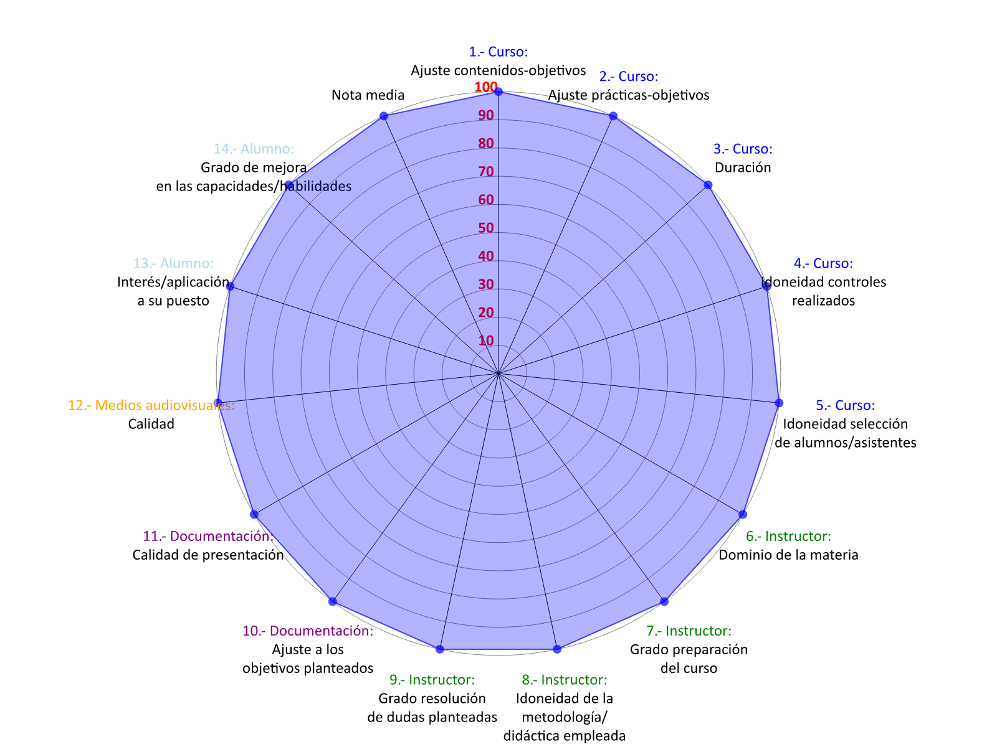

**A-2024-FI-7103-O1-4**

# ANEXO 5 – COMENTARIOS / MEJORAS IDENTIFICADAS

|  |  |  |  |  |
| --- | --- | --- | --- | --- |
| **CÓDIGO DE CURSO** | **TÍTULO** | **FECHA** | **COMENTARIO** | **TIPO DE  CUESTIONARIO** |

|  |  |  |  |  |
| --- | --- | --- | --- | --- |
| A-2024-FI-7103-O1-4 | FORMACIÓN INICIAL DE AUXILIAR DE PRESA-TEVA | 31/05/2024 |  | SUPERVISIÓN |

|  |  |  |  |  |
| --- | --- | --- | --- | --- |
| A-2024-FI-7103-O1-4 | FORMACIÓN INICIAL DE AUXILIAR DE PRESA-TEVA | 31/05/2024 | EL CURSO DE TEVA PODRÍA INCLUIR MÁS EN LA ACTUACIÓN DE PLC´S DE SALA DE CONTROL DEL TEVA | CUESTIONARIO |