Projektinitiative

Ein Web- und Cloudbasiertes Multiple-Kernel   
 Eco-System für die automatisierte Erstellung   
 von analytischen Berichten



Berlin

2023

Inhaltsverzeichnis

Bericht Block №1 7

Text Block №1 7

Tabelle №1 7

Altersverteilung für ausgewählte Länder nach WHO: Albania,Algeria,American Samoa,Andorra,Angola,Anguilla,Antigua and Barbuda,Argentina,Armenia 7

Grafik №1 8

Altersverteilung für ausgewählte Länder nach WHO: Albania,Algeria,American Samoa,Andorra,Angola,Anguilla,Antigua and Barbuda,Argentina,Armenia 8

Bericht Block №2 9

Text Block №2 9

Tabelle №2 9

Altersverteilung für ausgewählte Länder nach WHO: Aruba,Australia,Austria,Azerbaijan,Bahamas, The,Bahrain,Bangladesh,Barbados,Belarus,Belgium 9

Grafik №2 10

Altersverteilung für ausgewählte Länder nach WHO: Aruba,Australia,Austria,Azerbaijan,Bahamas, The,Bahrain,Bangladesh,Barbados,Belarus,Belgium 10

Bericht Block №3 11

Text Block №3 11

Tabelle №3 11

Altersverteilung für ausgewählte Länder nach WHO: Belize,Benin,Bermuda,Bhutan,Bolivia,Bosnia and Herzegovina,Botswana,Brazil,British Virgin Islands,Brunei 11

Grafik №3 12

Altersverteilung für ausgewählte Länder nach WHO: Belize,Benin,Bermuda,Bhutan,Bolivia,Bosnia and Herzegovina,Botswana,Brazil,British Virgin Islands,Brunei 12

Bericht Block №4 13

Text Block №4 13

Tabelle №4 13

Altersverteilung für ausgewählte Länder nach WHO: Bulgaria,Burkina Faso,Burma,Burundi,Cabo Verde,Cambodia,Cameroon,Canada,Cayman Islands,Central African Republic 13

Grafik №4 14

Altersverteilung für ausgewählte Länder nach WHO: Bulgaria,Burkina Faso,Burma,Burundi,Cabo Verde,Cambodia,Cameroon,Canada,Cayman Islands,Central African Republic 14

Bericht Block №5 15

Text Block №5 15

Tabelle №5 15

Altersverteilung für ausgewählte Länder nach WHO: Chad,Chile,China,Colombia,Comoros,Congo, Democratic Republic of the,Congo, Republic of the,Cook Islands,Costa Rica,Cote dIvoire 15

Grafik №5 16

Altersverteilung für ausgewählte Länder nach WHO: Chad,Chile,China,Colombia,Comoros,Congo, Democratic Republic of the,Congo, Republic of the,Cook Islands,Costa Rica,Cote dIvoire 16

Bericht Block №6 17

Text Block №6 17

Tabelle №6 17

Altersverteilung für ausgewählte Länder nach WHO: Croatia,Cuba,Curacao,Cyprus,Czechia,Denmark,Djibouti,Dominica,Dominican Republic,Ecuador 17

Grafik №6 18

Altersverteilung für ausgewählte Länder nach WHO: Croatia,Cuba,Curacao,Cyprus,Czechia,Denmark,Djibouti,Dominica,Dominican Republic,Ecuador 18

Bericht Block №7 19

Text Block №7 19

Tabelle №7 19

Altersverteilung für ausgewählte Länder nach WHO: Egypt,El Salvador,Equatorial Guinea,Eritrea,Estonia,Ethiopia,Faroe Islands,Fiji,Finland,France 19

Grafik №7 20

Altersverteilung für ausgewählte Länder nach WHO: Egypt,El Salvador,Equatorial Guinea,Eritrea,Estonia,Ethiopia,Faroe Islands,Fiji,Finland,France 20

Bericht Block №8 21

Text Block №8 21

Tabelle №8 21

Altersverteilung für ausgewählte Länder nach WHO: French Polynesia,Gabon,Gambia, The,Gaza Strip,Georgia,Germany,Ghana,Gibraltar,Greece,Greenland 21

Grafik №8 22

Altersverteilung für ausgewählte Länder nach WHO: French Polynesia,Gabon,Gambia, The,Gaza Strip,Georgia,Germany,Ghana,Gibraltar,Greece,Greenland 22

Bericht Block №9 23

Text Block №9 23

Tabelle №9 23

Altersverteilung für ausgewählte Länder nach WHO: Grenada,Guam,Guatemala,Guernsey,Guinea,Guinea-Bissau,Guyana,Haiti,Honduras,Hong Kong 23

Grafik №9 24

Altersverteilung für ausgewählte Länder nach WHO: Grenada,Guam,Guatemala,Guernsey,Guinea,Guinea-Bissau,Guyana,Haiti,Honduras,Hong Kong 24

Bericht Block №10 25

Text Block №10 25

Tabelle №10 25

Altersverteilung für ausgewählte Länder nach WHO: Hungary,Iceland,India,Indonesia,Iran,Iraq,Ireland,Isle of Man,Israel,Italy 25

Grafik №10 26

Altersverteilung für ausgewählte Länder nach WHO: Hungary,Iceland,India,Indonesia,Iran,Iraq,Ireland,Isle of Man,Israel,Italy 26

Bericht Block №11 27

Text Block №11 27

Tabelle №11 27

Altersverteilung für ausgewählte Länder nach WHO: Jamaica,Japan,Jersey,Jordan,Kazakhstan,Kenya,Kiribati,Korea, North,Korea, South,Kosovo 27

Grafik №11 28

Altersverteilung für ausgewählte Länder nach WHO: Jamaica,Japan,Jersey,Jordan,Kazakhstan,Kenya,Kiribati,Korea, North,Korea, South,Kosovo 28

Bericht Block №12 29

Text Block №12 29

Tabelle №12 29

Altersverteilung für ausgewählte Länder nach WHO: Kuwait,Kyrgyzstan,Laos,Latvia,Lebanon,Lesotho,Liberia,Libya,Liechtenstein,Lithuania 29

Grafik №12 30

Altersverteilung für ausgewählte Länder nach WHO: Kuwait,Kyrgyzstan,Laos,Latvia,Lebanon,Lesotho,Liberia,Libya,Liechtenstein,Lithuania 30

Bericht Block №13 31

Text Block №13 31

Tabelle №13 31

Altersverteilung für ausgewählte Länder nach WHO: Luxembourg,Macau,Macedonia,Madagascar,Malawi,Malaysia,Maldives,Mali,Malta,Marshall Islands 31

Grafik №13 32

Altersverteilung für ausgewählte Länder nach WHO: Luxembourg,Macau,Macedonia,Madagascar,Malawi,Malaysia,Maldives,Mali,Malta,Marshall Islands 32

Bericht Block №14 33

Text Block №14 33

Tabelle №14 33

Altersverteilung für ausgewählte Länder nach WHO: Mauritania,Mauritius,Mexico,Micronesia, Federated States of,Moldova,Monaco,Mongolia,Montenegro,Montserrat,Morocco 33

Grafik №14 34

Altersverteilung für ausgewählte Länder nach WHO: Mauritania,Mauritius,Mexico,Micronesia, Federated States of,Moldova,Monaco,Mongolia,Montenegro,Montserrat,Morocco 34

Bericht Block №15 35

Text Block №15 35

Tabelle №15 35

Altersverteilung für ausgewählte Länder nach WHO: Mozambique,Namibia,Nauru,Nepal,Netherlands,New Caledonia,New Zealand,Nicaragua,Niger,Nigeria 35

Grafik №15 36

Altersverteilung für ausgewählte Länder nach WHO: Mozambique,Namibia,Nauru,Nepal,Netherlands,New Caledonia,New Zealand,Nicaragua,Niger,Nigeria 36

Bericht Block №16 37

Text Block №16 37

Tabelle №16 37

Altersverteilung für ausgewählte Länder nach WHO: Northern Mariana Islands,Norway,Oman,Pakistan,Palau,Panama,Papua New Guinea,Paraguay,Peru,Philippines 37

Grafik №16 38

Altersverteilung für ausgewählte Länder nach WHO: Northern Mariana Islands,Norway,Oman,Pakistan,Palau,Panama,Papua New Guinea,Paraguay,Peru,Philippines 38

Bericht Block №17 39

Text Block №17 39

Tabelle №17 39

Altersverteilung für ausgewählte Länder nach WHO: Poland,Portugal,Puerto Rico,Qatar,Romania,Russia,Rwanda,Saint Barthelemy,Saint Helena, Ascension, and Tristan da,Saint Kitts and Nevis 39

Grafik №17 40

Altersverteilung für ausgewählte Länder nach WHO: Poland,Portugal,Puerto Rico,Qatar,Romania,Russia,Rwanda,Saint Barthelemy,Saint Helena, Ascension, and Tristan da,Saint Kitts and Nevis 40

Bericht Block №18 41

Text Block №18 41

Tabelle №18 41

Altersverteilung für ausgewählte Länder nach WHO: Saint Lucia,Saint Martin,Saint Pierre and Miquelon,Saint Vincent and the Grenadines,Samoa,San Marino,Sao Tome and Principe,Saudi Arabia,Senegal,Serb 41

Grafik №18 42

Altersverteilung für ausgewählte Länder nach WHO: Saint Lucia,Saint Martin,Saint Pierre and Miquelon,Saint Vincent and the Grenadines,Samoa,San Marino,Sao Tome and Principe,Saudi Arabia,Senegal,Serb 42

Bericht Block №19 43

Text Block №19 43

Tabelle №19 43

Altersverteilung für ausgewählte Länder nach WHO: Seychelles,Sierra Leone,Singapore,Sint Maarten,Slovakia,Slovenia,Solomon Islands,Somalia,South Africa,South Sudan 43

Grafik №19 44

Altersverteilung für ausgewählte Länder nach WHO: Seychelles,Sierra Leone,Singapore,Sint Maarten,Slovakia,Slovenia,Solomon Islands,Somalia,South Africa,South Sudan 44

Bericht Block №20 45

Text Block №20 45

Tabelle №20 45

Altersverteilung für ausgewählte Länder nach WHO: Spain,Sri Lanka,Sudan,Suriname,Swaziland,Sweden,Switzerland,Syria,Taiwan,Tajikistan 45

Grafik №20 46

Altersverteilung für ausgewählte Länder nach WHO: Spain,Sri Lanka,Sudan,Suriname,Swaziland,Sweden,Switzerland,Syria,Taiwan,Tajikistan 46

Bericht Block №21 47

Text Block №21 47

Tabelle №21 47

Altersverteilung für ausgewählte Länder nach WHO: Tanzania,Thailand,Timor-Leste,Togo,Tonga,Trinidad and Tobago,Tunisia,Turkey,Turkmenistan,Turks and Caicos Islands 47

Grafik №21 48

Altersverteilung für ausgewählte Länder nach WHO: Tanzania,Thailand,Timor-Leste,Togo,Tonga,Trinidad and Tobago,Tunisia,Turkey,Turkmenistan,Turks and Caicos Islands 48

Bericht Block №22 49

Text Block №22 49

Tabelle №22 49

Altersverteilung für ausgewählte Länder nach WHO: Tuvalu,Uganda,Ukraine,United Arab Emirates,United Kingdom,United States,Uruguay,Uzbekistan,Vanuatu,Venezuela 49

Grafik №22 50

Altersverteilung für ausgewählte Länder nach WHO: Tuvalu,Uganda,Ukraine,United Arab Emirates,United Kingdom,United States,Uruguay,Uzbekistan,Vanuatu,Venezuela 50

# Bericht Block №1

## Text Block №1

Hinweis: Alle Text Blöcke wurde vom Python-Dokumentation kopiert!

Document objects

The main Document and related objects.

 constructor

docx.Document(docx=None)

## Tabelle №1

### Altersverteilung für ausgewählte Länder nach WHO: Albania,Algeria,American Samoa,Andorra,Angola,Anguilla,Antigua and Barbuda,Argentina,Armenia

|  | **Gesamt Population** | Altersgruppen | | | | |
| --- | --- | --- | --- | --- | --- | --- |
| Median | 0-14 | 15-24 | 25-54 | 55-64 | 65+ |
| Albania | 32.9 | 18.05 | 17.47 | 41.06 | 11.54 | 11.89 |
| Algeria | 28.1 | 29.31 | 15.3 | 42.93 | 6.81 | 5.65 |
| American Samoa | 25.5 | 30.28 | 18.79 | 36.38 | 8.58 | 5.97 |
| Andorra | 44.3 | 14.4 | 9.64 | 46.18 | 14.16 | 15.61 |
| Angola | 15.9 | 48.12 | 18.25 | 28.03 | 3.26 | 2.34 |
| Anguilla | 34.8 | 22.21 | 14.08 | 43.82 | 11.06 | 8.84 |
| Antigua and Barbuda | 31.9 | 23.09 | 16.83 | 42.19 | 9.83 | 8.06 |
| Argentina | 31.7 | 24.59 | 15.28 | 39.38 | 9.13 | 11.62 |
| Armenia | 35.1 | 18.94 | 12.89 | 43.43 | 13.41 | 11.33 |
|  | © Dr. Alexander Wagner. All Rights Reserved | | | | | |

Hinweis: Alle Text Blöcke wurde vom Python-Dokumentation kopiert!

 objects

class docx.document.Document[source]

WordprocessingML (WML) document.

Not intended to be constructed directly. Use docx.Document() to open or create a document.

## Grafik №1

### Altersverteilung für ausgewählte Länder nach WHO: Albania,Algeria,American Samoa,Andorra,Angola,Anguilla,Antigua and Barbuda,Argentina,Armenia

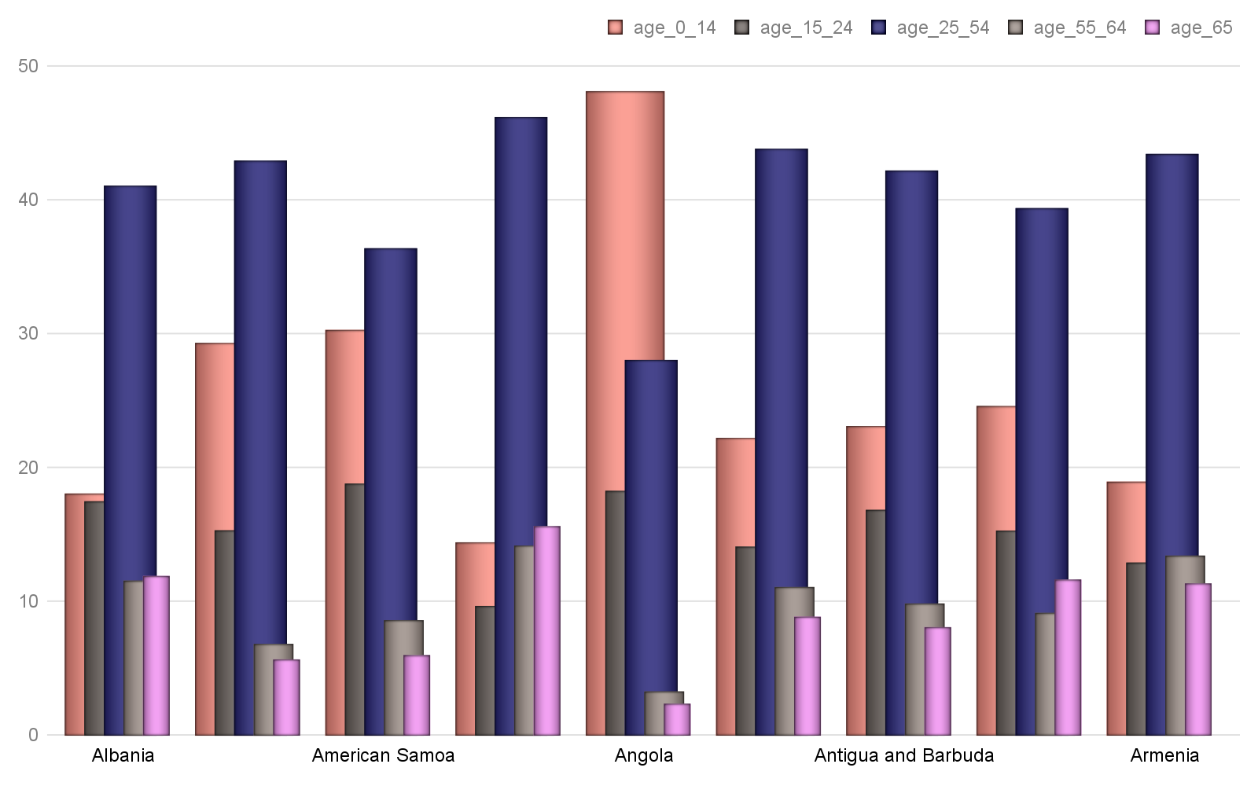

Hinweis: Alle Text Blöcke wurde vom Python-Dokumentation kopiert!

Return a heading paragraph newly added to the end of the document.

The heading paragraph will contain text and have its paragraph style determined by level. If level is 0, the style is set to Title. If level is 1 (or omitted), Heading 1 is used. Otherwise the style is set to Heading {level}. Raises ValueError if level is outside the range 0-9.

add_page_break()

Return newly  object containing only a page break.

# Bericht Block №2

## Text Block №2

Hinweis: Alle Text Blöcke wurde vom Python-Dokumentation kopiert!

Return a paragraph newly added to the end of the document, populated with text and having paragraph style style. text can contain tab (\t) characters, which are converted to the appropriate XML form for a tab. text can also include newline (\n) or carriage return (\r) characters, each of which is converted to a line break.

add_picture(image_path_or_stream, width=None, height=None)

Return a new picture shape added in its own paragraph at the end of the document. The picture contains the image at image_path_or_stream, scaled based on width and height. If neither width nor height is specified, the picture appears at its native size. If only one is specified, it is used to compute a scaling factor that is then applied to the unspecified dimension, preserving the aspect ratio of the image. The native size of the picture is calculated using the dots-per-inch (dpi) value specified in the image file, defaulting to 72 dpi if no value is specified, as is often the case.

add_section(start_type=2)

## Tabelle №2

### Altersverteilung für ausgewählte Länder nach WHO: Aruba,Australia,Austria,Azerbaijan,Bahamas, The,Bahrain,Bangladesh,Barbados,Belarus,Belgium

|  | **Gesamt Population** | Altersgruppen | | | | |
| --- | --- | --- | --- | --- | --- | --- |
| Median | 0-14 | 15-24 | 25-54 | 55-64 | 65+ |
| Aruba | 39.3 | 17.64 | 12.78 | 41.72 | 14.28 | 13.59 |
| Australia | 38.7 | 17.8 | 12.79 | 41.45 | 11.83 | 16.14 |
| Austria | 44.0 | 14.01 | 11.07 | 42.42 | 13.23 | 19.26 |
| Azerbaijan | 31.3 | 22.95 | 14.84 | 45.39 | 10.17 | 6.64 |
| Bahamas, The | 32.0 | 22.55 | 16.4 | 44.14 | 9.16 | 7.75 |
| Bahrain | 32.3 | 19.08 | 15.65 | 56.04 | 6.28 | 2.95 |
| Bangladesh | 26.7 | 27.76 | 19.36 | 39.73 | 6.93 | 6.23 |
| Barbados | 38.6 | 17.97 | 12.74 | 44.06 | 13.43 | 11.81 |
| Belarus | 40.0 | 15.78 | 10.29 | 44.76 | 14.21 | 14.95 |
| Belgium | 41.4 | 17.16 | 11.34 | 40.05 | 12.86 | 18.58 |
|  | © Dr. Alexander Wagner. All Rights Reserved | | | | | |

Hinweis: Alle Text Blöcke wurde vom Python-Dokumentation kopiert!

add_table(rows, cols, style=None)

Add a table having row and column counts of rows and cols respectively and table style of style. style may be a paragraph style object or a paragraph style name. If style is None, the table inherits the default table style of the document.

core_properties

A CoreProperties object providing read/write access to the core properties of this document.

## Grafik №2

### Altersverteilung für ausgewählte Länder nach WHO: Aruba,Australia,Austria,Azerbaijan,Bahamas, The,Bahrain,Bangladesh,Barbados,Belarus,Belgium

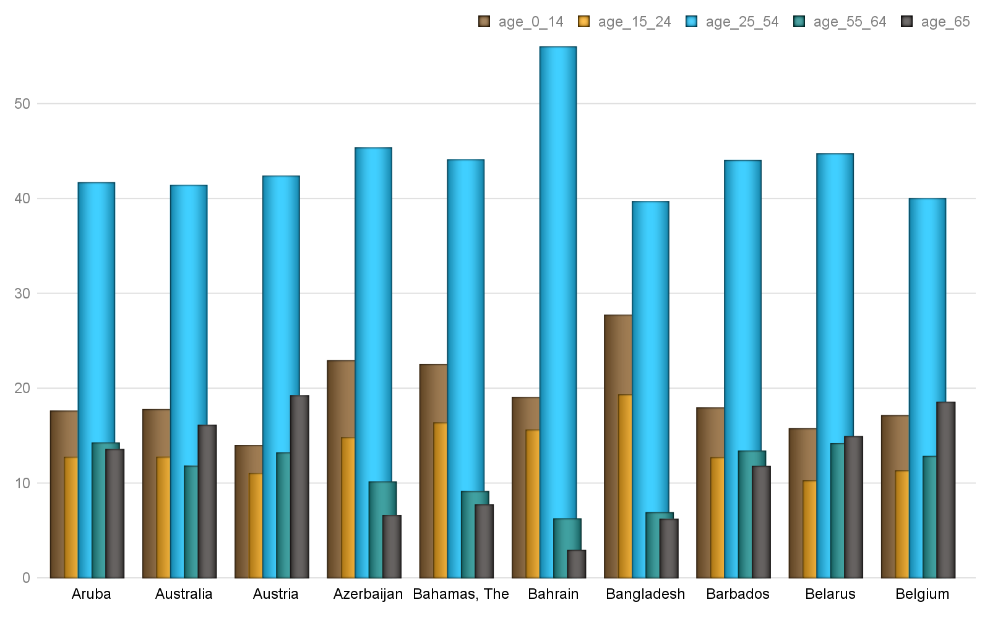

Hinweis: Alle Text Blöcke wurde vom Python-Dokumentation kopiert!

An InlineShapes object providing access to the inline shapes in this document. An inline shape is a graphical object, such as a picture, contained in a run of text and behaving like a character glyph, being flowed like other text in a paragraph.

paragraphs

A list of  instances corresponding to the paragraphs in the document, in document order. Note that paragraphs within revision marks such as <w:ins> or <w:del> do not appear in this list.

part

# Bericht Block №3

## Text Block №3

Hinweis: Alle Text Blöcke wurde vom Python-Dokumentation kopiert!

save(path_or_stream)

Save this document to path_or_stream, which can be either a path to a filesystem location (a string) or a file-like object.

sections

 object providing access to each section in this document.

## Tabelle №3

### Altersverteilung für ausgewählte Länder nach WHO: Belize,Benin,Bermuda,Bhutan,Bolivia,Bosnia and Herzegovina,Botswana,Brazil,British Virgin Islands,Brunei

|  | **Gesamt Population** | Altersgruppen | | | | |
| --- | --- | --- | --- | --- | --- | --- |
| Median | 0-14 | 15-24 | 25-54 | 55-64 | 65+ |
| Belize | 22.7 | 33.95 | 20.55 | 36.62 | 4.99 | 3.89 |
| Benin | 18.2 | 42.65 | 20.44 | 30.44 | 3.61 | 2.87 |
| Bermuda | 43.4 | 17.04 | 12.0 | 37.24 | 15.73 | 17.98 |
| Bhutan | 27.6 | 25.8 | 18.81 | 43.07 | 6.03 | 6.29 |
| Bolivia | 24.3 | 31.85 | 19.46 | 37.48 | 5.9 | 5.3 |
| Bosnia and Herzegovin | 42.1 | 13.29 | 11.58 | 45.88 | 14.83 | 14.43 |
| Botswana | 24.5 | 31.95 | 18.91 | 38.45 | 5.46 | 5.23 |
| Brazil | 32.0 | 22.33 | 16.36 | 43.86 | 9.12 | 8.33 |
| British Virgin Island | 36.5 | 16.7 | 13.37 | 49.37 | 11.6 | 8.97 |
| Brunei | 30.2 | 23.12 | 17.05 | 46.75 | 8.23 | 4.84 |
|  | © Dr. Alexander Wagner. All Rights Reserved | | | | | |

Hinweis: Alle Text Blöcke wurde vom Python-Dokumentation kopiert!

A  object providing access to the document-level settings for this document.

styles

A  object providing access to the styles in this document.

tables

## Grafik №3

### Altersverteilung für ausgewählte Länder nach WHO: Belize,Benin,Bermuda,Bhutan,Bolivia,Bosnia and Herzegovina,Botswana,Brazil,British Virgin Islands,Brunei

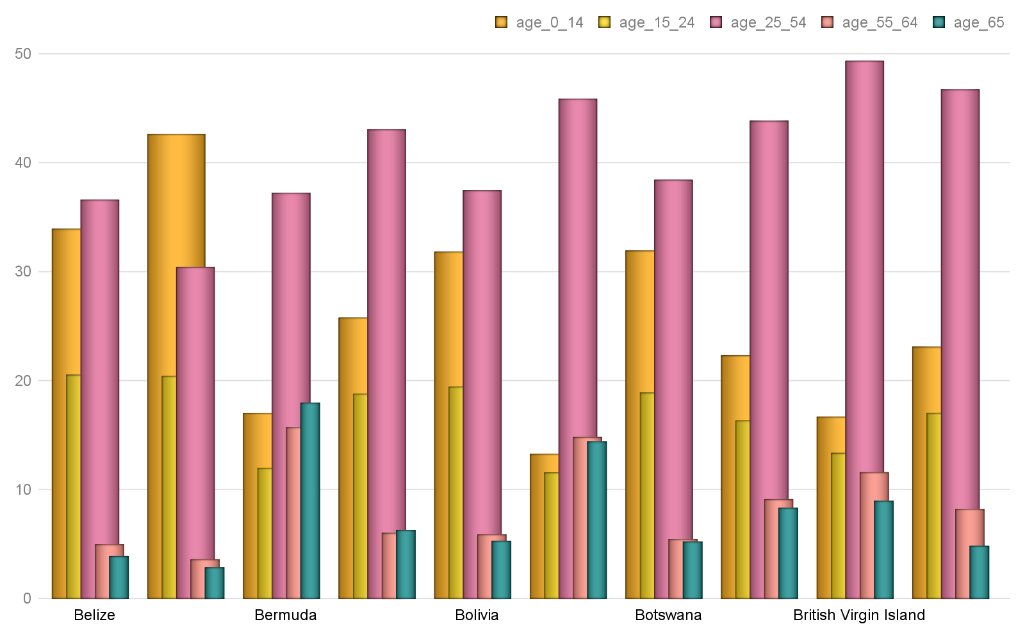

Hinweis: Alle Text Blöcke wurde vom Python-Dokumentation kopiert!

 objects

Each Document object provides access to its CoreProperties object via its core_properties attribute. A CoreProperties object provides read/write access to the so-called core properties for the document. The core properties are author, category, comments, content_status, created, identifier, keywords, language, last_modified_by, last_printed, modified, revision, subject, title, and version.

Each property is one of three types, str, datetime.datetime, or . String properties are limited in length to 255 characters and return an empty string (‘’) if not set. Date properties are assigned and returned as datetime.datetime objects without timezone, i.e. in UTC. Any timezone conversions are the responsibility of the client. Date properties return None if not set.

python-docx does not automatically set any of the document core properties other than to add a core properties part to a presentation that doesn’t have one (very uncommon). If python-docx adds a core properties part, it contains default values for the title, last_modified_by, revision, and modified properties. Client code should update properties like revision and last_modified_by if that behavior is desired.

# Bericht Block №4

## Text Block №4

Hinweis: Alle Text Blöcke wurde vom Python-Dokumentation kopiert!

author

string – An entity primarily responsible for making the content of the resource.

category

string – A categorization of the content of this package. Example values might include: Resume, Letter, Financial Forecast, Proposal, or Technical Presentation.

## Tabelle №4

### Altersverteilung für ausgewählte Länder nach WHO: Bulgaria,Burkina Faso,Burma,Burundi,Cabo Verde,Cambodia,Cameroon,Canada,Cayman Islands,Central African Republic

|  | **Gesamt Population** | Altersgruppen | | | | |
| --- | --- | --- | --- | --- | --- | --- |
| Median | 0-14 | 15-24 | 25-54 | 55-64 | 65+ |
| Bulgaria | 42.7 | 14.58 | 9.58 | 43.21 | 13.35 | 19.28 |
| Burkina Faso | 17.3 | 44.88 | 20.07 | 29.42 | 3.2 | 2.43 |
| Burma | 28.2 | 26.85 | 17.75 | 42.36 | 7.52 | 5.53 |
| Burundi | 17.0 | 45.57 | 19.15 | 28.74 | 3.92 | 2.63 |
| Cabo Verde | 25.4 | 29.13 | 20.11 | 39.64 | 5.94 | 5.19 |
| Cambodia | 25.3 | 31.01 | 18.36 | 40.68 | 5.69 | 4.25 |
| Cameroon | 18.5 | 42.39 | 19.56 | 30.87 | 3.98 | 3.2 |
| Canada | 42.2 | 15.44 | 11.85 | 39.99 | 14.1 | 18.63 |
| Cayman Islands | 40.0 | 18.0 | 12.41 | 42.52 | 14.47 | 12.59 |
| Central African Repub | 19.7 | 40.09 | 19.94 | 32.45 | 4.1 | 3.43 |
|  | © Dr. Alexander Wagner. All Rights Reserved | | | | | |

Hinweis: Alle Text Blöcke wurde vom Python-Dokumentation kopiert!

string – An account of the content of the resource.

content_status

string – completion status of the document, e.g. ‘draft’

created

## Grafik №4

### Altersverteilung für ausgewählte Länder nach WHO: Bulgaria,Burkina Faso,Burma,Burundi,Cabo Verde,Cambodia,Cameroon,Canada,Cayman Islands,Central African Republic

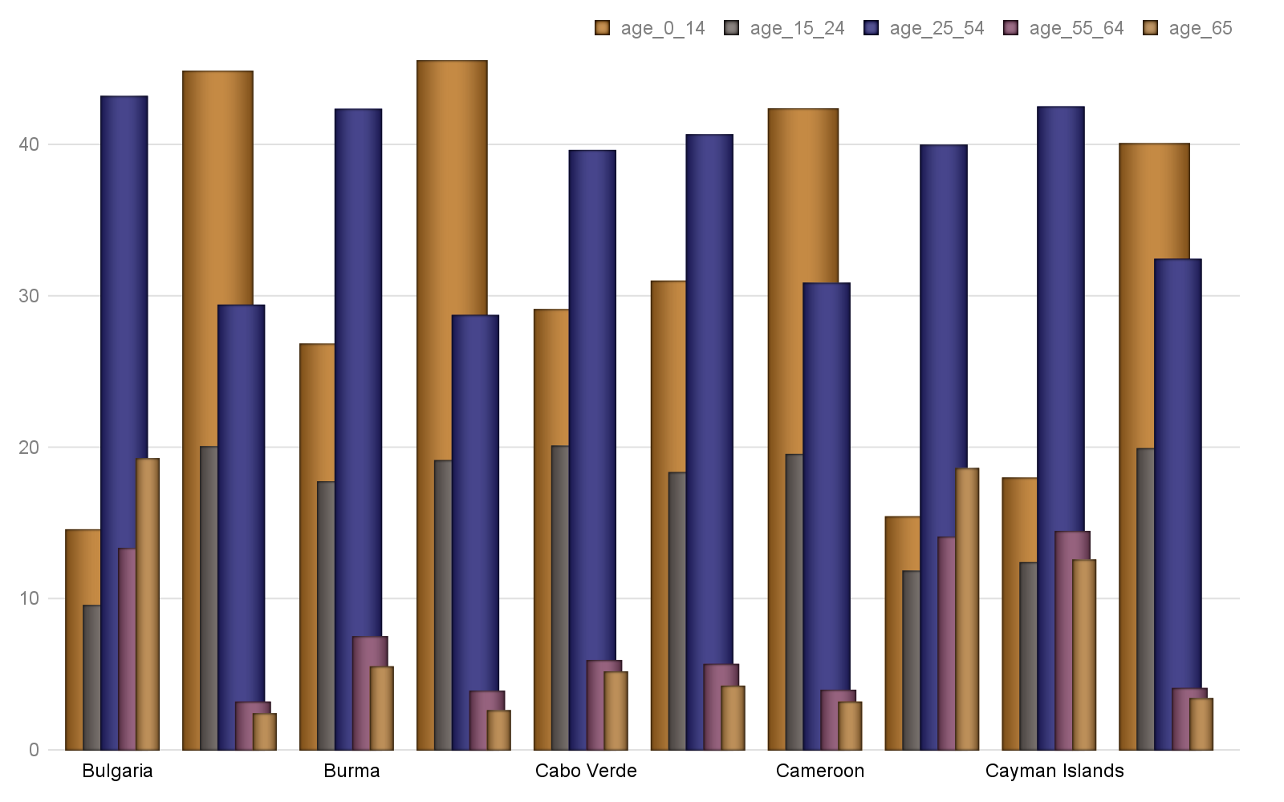

Hinweis: Alle Text Blöcke wurde vom Python-Dokumentation kopiert!

identifier

string – An unambiguous reference to the resource within a given context, e.g. ISBN.

keywords

string – descriptive words or short phrases likely to be used as search terms for this document

# Bericht Block №5

## Text Block №5

Hinweis: Alle Text Blöcke wurde vom Python-Dokumentation kopiert!

string – language the document is written in

last_modified_by

string – name or other identifier (such as email address) of person who last modified the document

last_printed

## Tabelle №5

### Altersverteilung für ausgewählte Länder nach WHO: Chad,Chile,China,Colombia,Comoros,Congo, Democratic Republic of the,Congo, Republic of the,Cook Islands,Costa Rica,Cote dIvoire

|  | **Gesamt Population** | Altersgruppen | | | | |
| --- | --- | --- | --- | --- | --- | --- |
| Median | 0-14 | 15-24 | 25-54 | 55-64 | 65+ |
| Chad | 17.8 | 43.02 | 21.46 | 28.62 | 3.88 | 3.02 |
| Chile | 34.4 | 20.11 | 15.04 | 43.08 | 10.96 | 10.81 |
| China | 37.4 | 17.15 | 12.78 | 48.51 | 10.75 | 10.81 |
| Colombia | 30.0 | 24.22 | 17.25 | 41.91 | 9.18 | 7.44 |
| Comoros | 19.9 | 39.35 | 19.53 | 32.91 | 4.27 | 3.94 |
| Congo, Democratic Rep | 18.6 | 41.74 | 21.46 | 30.53 | 3.6 | 2.67 |
| Congo, Republic of th | 19.7 | 41.67 | 17.1 | 33.89 | 4.29 | 3.06 |
| Cook Islands | 36.6 | 21.12 | 16.63 | 38.09 | 11.99 | 12.16 |
| Costa Rica | 31.3 | 22.61 | 16.35 | 44.03 | 9.2 | 7.82 |
| Cote dIvoire | 20.9 | 36.97 | 20.91 | 34.58 | 4.04 | 3.5 |
|  | © Dr. Alexander Wagner. All Rights Reserved | | | | | |

Hinweis: Alle Text Blöcke wurde vom Python-Dokumentation kopiert!

modified

datetime – time the document was last modified

revision

int – number of this revision, incremented by Word each time the document is saved. Note however python-docx does not automatically increment the revision number when it saves a document.

## Grafik №5

### Altersverteilung für ausgewählte Länder nach WHO: Chad,Chile,China,Colombia,Comoros,Congo, Democratic Republic of the,Congo, Republic of the,Cook Islands,Costa Rica,Cote dIvoire

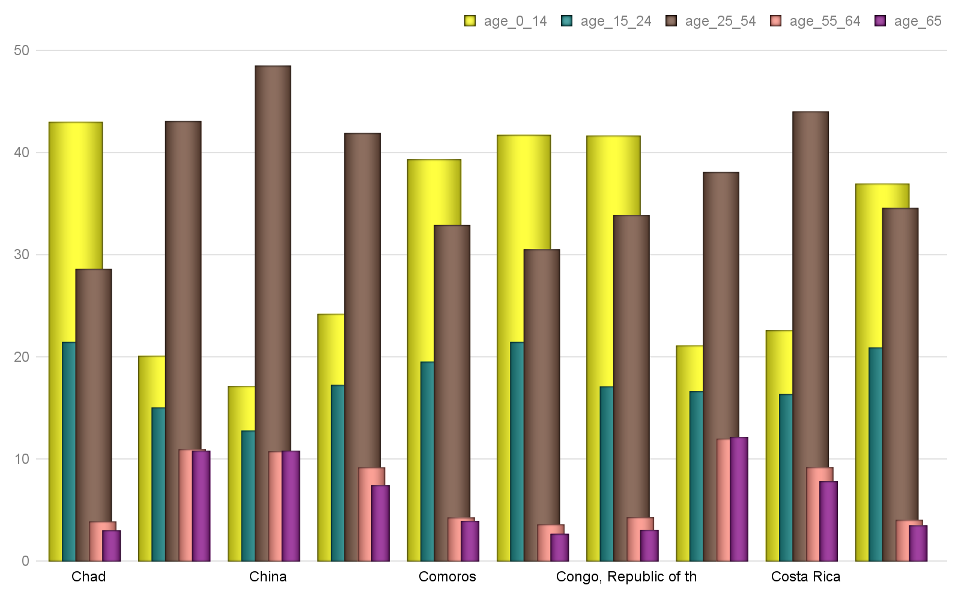

Hinweis: Alle Text Blöcke wurde vom Python-Dokumentation kopiert!

string – The topic of the content of the resource.

title

string – The name given to the resource.

version

# Bericht Block №6

## Text Block №6

Hinweis: Alle Text Blöcke wurde vom Python-Dokumentation kopiert!

Working with Text

To work effectively with text, it’s important to first understand a little about block-level elements like paragraphs and inline-level objects like runs.

Block-level vs. inline text objects

## Tabelle №6

### Altersverteilung für ausgewählte Länder nach WHO: Croatia,Cuba,Curacao,Cyprus,Czechia,Denmark,Djibouti,Dominica,Dominican Republic,Ecuador

|  | **Gesamt Population** | Altersgruppen | | | | |
| --- | --- | --- | --- | --- | --- | --- |
| Median | 0-14 | 15-24 | 25-54 | 55-64 | 65+ |
| Croatia | 43.0 | 14.21 | 11.24 | 40.43 | 14.82 | 19.31 |
| Cuba | 41.5 | 16.57 | 12.22 | 44.43 | 11.84 | 14.94 |
| Curacao | 36.1 | 20.0 | 14.33 | 36.87 | 13.69 | 15.1 |
| Cyprus | 36.8 | 15.6 | 13.81 | 47.04 | 11.45 | 12.09 |
| Czechia | 42.1 | 15.16 | 9.59 | 43.84 | 12.44 | 18.98 |
| Denmark | 42.2 | 16.41 | 13.08 | 38.76 | 12.52 | 19.23 |
| Djibouti | 23.9 | 31.14 | 21.32 | 39.03 | 4.75 | 3.76 |
| Dominica | 33.5 | 21.72 | 15.14 | 42.2 | 9.81 | 11.14 |
| Dominican Republic | 28.1 | 26.63 | 18.18 | 39.66 | 7.9 | 7.63 |
| Ecuador | 27.7 | 27.08 | 18.35 | 39.59 | 7.53 | 7.45 |
|  | © Dr. Alexander Wagner. All Rights Reserved | | | | | |

Hinweis: Alle Text Blöcke wurde vom Python-Dokumentation kopiert!

A block-level item flows the text it contains between its left and right edges, adding an additional line each time the text extends beyond its right boundary. For a paragraph, the boundaries are generally the page margins, but they can also be column boundaries if the page is laid out in columns, or cell boundaries if the paragraph occurs inside a table cell.

A table is also a block-level object.

An inline object is a portion of the content that occurs inside a block-level item. An example would be a word that appears in bold or a sentence in all-caps. The most common inline object is a run. All content within a block container is inside of an inline object. Typically, a paragraph contains one or more runs, each of which contain some part of the paragraph’s text.

The attributes of a block-level item specify its placement on the page, such items as indentation and space before and after a paragraph. The attributes of an inline item generally specify the font in which the content appears, things like typeface, font size, bold, and italic.

## Grafik №6

### Altersverteilung für ausgewählte Länder nach WHO: Croatia,Cuba,Curacao,Cyprus,Czechia,Denmark,Djibouti,Dominica,Dominican Republic,Ecuador

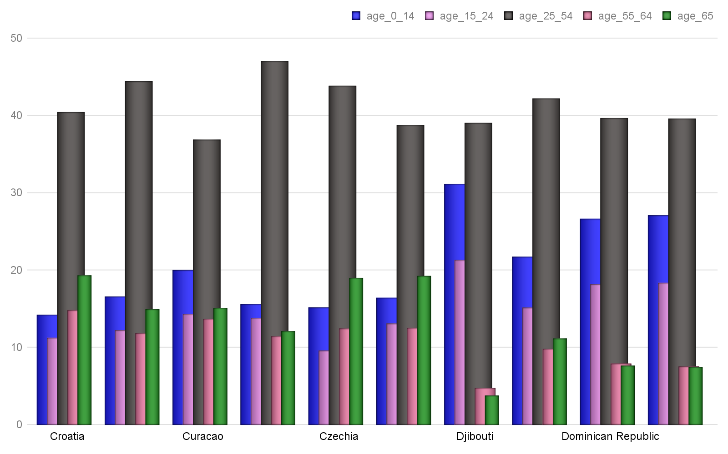

Hinweis: Alle Text Blöcke wurde vom Python-Dokumentation kopiert!

A paragraph has a variety of properties that specify its placement within its container (typically a page) and the way it divides its content into separate lines.

In general, it’s best to define a paragraph style collecting these attributes into a meaningful group and apply the appropriate style to each paragraph, rather than repeatedly apply those properties directly to each paragraph. This is analogous to how Cascading Style Sheets (CSS) work with HTML. All the paragraph properties described here can be set using a style as well as applied directly to a paragraph.

The formatting properties of a paragraph are accessed using the ParagraphFormat object available using the paragraph’s paragraph_format property.

Horizontal alignment (justification)

# Bericht Block №7

## Text Block №7

Hinweis: Alle Text Blöcke wurde vom Python-Dokumentation kopiert!

>>> from docx.enum.text import WD_ALIGN_PARAGRAPH

>>> document = Document()

>>> paragraph = document.add_paragraph()

>>> paragraph_format = paragraph.paragraph_format

## Tabelle №7

### Altersverteilung für ausgewählte Länder nach WHO: Egypt,El Salvador,Equatorial Guinea,Eritrea,Estonia,Ethiopia,Faroe Islands,Fiji,Finland,France

|  | **Gesamt Population** | Altersgruppen | | | | |
| --- | --- | --- | --- | --- | --- | --- |
| Median | 0-14 | 15-24 | 25-54 | 55-64 | 65+ |
| Egypt | 23.9 | 33.29 | 18.94 | 37.6 | 5.95 | 4.22 |
| El Salvador | 27.1 | 25.92 | 20.23 | 39.23 | 7.14 | 7.48 |
| Equatorial Guinea | 19.8 | 39.81 | 19.72 | 32.15 | 4.37 | 3.95 |
| Eritrea | 19.7 | 40.17 | 19.57 | 32.63 | 3.7 | 3.92 |
| Estonia | 42.7 | 16.23 | 8.99 | 41.37 | 13.57 | 19.85 |
| Ethiopia | 17.9 | 43.47 | 20.11 | 29.58 | 3.91 | 2.94 |
| Faroe Islands | 37.6 | 19.89 | 14.34 | 37.31 | 11.69 | 16.76 |
| Fiji | 28.9 | 27.7 | 16.13 | 41.08 | 8.53 | 6.55 |
| Finland | 42.5 | 16.43 | 11.4 | 37.78 | 13.29 | 21.1 |
| France | 41.4 | 18.53 | 11.79 | 37.78 | 12.42 | 19.48 |
|  | © Dr. Alexander Wagner. All Rights Reserved | | | | | |

Hinweis: Alle Text Blöcke wurde vom Python-Dokumentation kopiert!

>>> paragraph_format.alignment

None # indicating alignment is inherited from the style hierarchy

>>> paragraph_format.alignment = WD_ALIGN_PARAGRAPH.CENTER

>>> paragraph_format.alignment

## Grafik №7

### Altersverteilung für ausgewählte Länder nach WHO: Egypt,El Salvador,Equatorial Guinea,Eritrea,Estonia,Ethiopia,Faroe Islands,Fiji,Finland,France

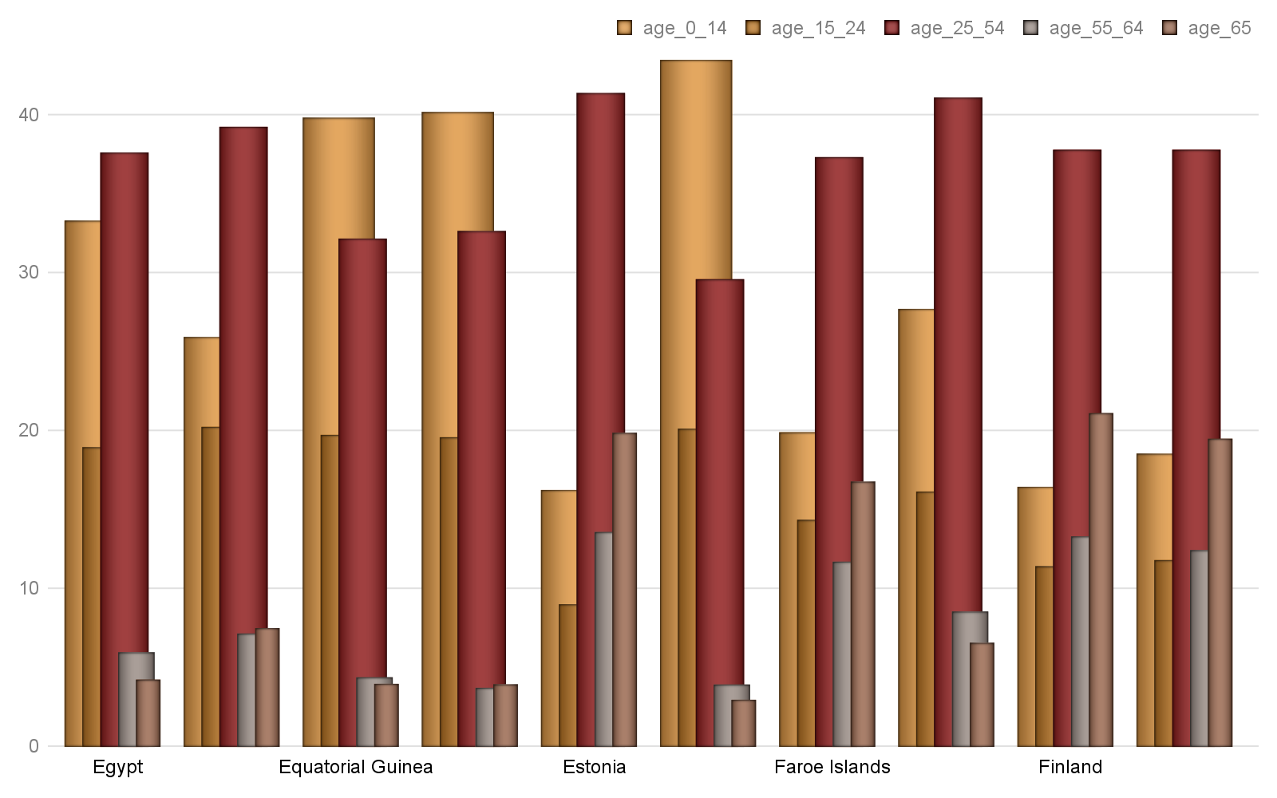

Hinweis: Alle Text Blöcke wurde vom Python-Dokumentation kopiert!

Indentation

Indentation is the horizontal space between a paragraph and edge of its container, typically the page margin. A paragraph can be indented separately on the left and right side. The first line can also have a different indentation than the rest of the paragraph. A first line indented further than the rest of the paragraph has first line indent. A first line indented less has a hanging indent.

Indentation is specified using a Length value, such as , , or . Negative values are valid and cause the paragraph to overlap the margin by the specified amount. A value of None indicates the indentation value is inherited from the style hierarchy. Assigning None to an indentation property removes any directly-applied indentation setting and restores inheritance from the style hierarchy:

>>> from docx.shared import Inches

# Bericht Block №8

## Text Block №8

Hinweis: Alle Text Blöcke wurde vom Python-Dokumentation kopiert!

>>> paragraph_format = paragraph.paragraph_format

>>> paragraph_format.left_indent

None # indicating indentation is inherited from the style hierarchy

## Tabelle №8

### Altersverteilung für ausgewählte Länder nach WHO: French Polynesia,Gabon,Gambia, The,Gaza Strip,Georgia,Germany,Ghana,Gibraltar,Greece,Greenland

|  | **Gesamt Population** | Altersgruppen | | | | |
| --- | --- | --- | --- | --- | --- | --- |
| Median | 0-14 | 15-24 | 25-54 | 55-64 | 65+ |
| French Polynesia | 31.9 | 22.52 | 15.73 | 44.36 | 9.42 | 7.97 |
| Gabon | 18.6 | 41.9 | 20.46 | 29.52 | 4.36 | 3.76 |
| Gambia, The | 21.0 | 37.44 | 20.47 | 34.4 | 4.2 | 3.48 |
| Gaza Strip | 17.2 | 44.78 | 21.25 | 28.02 | 3.4 | 2.54 |
| Georgia | 38.1 | 18.08 | 11.94 | 40.96 | 13.01 | 16.01 |
| Germany | 47.1 | 12.82 | 10.09 | 40.45 | 14.58 | 22.06 |
| Ghana | 21.1 | 38.01 | 18.63 | 34.14 | 4.97 | 4.25 |
| Gibraltar | 34.7 | 20.22 | 14.34 | 39.67 | 9.68 | 16.09 |
| Greece | 44.5 | 13.83 | 9.67 | 42.45 | 13.13 | 20.91 |
| Greenland | 33.9 | 21.11 | 15.48 | 41.21 | 12.96 | 9.24 |
|  | © Dr. Alexander Wagner. All Rights Reserved | | | | | |

Hinweis: Alle Text Blöcke wurde vom Python-Dokumentation kopiert!

>>> paragraph_format.left_indent

457200

>>> paragraph_format.left_indent.inches

0.5

## Grafik №8

### Altersverteilung für ausgewählte Länder nach WHO: French Polynesia,Gabon,Gambia, The,Gaza Strip,Georgia,Germany,Ghana,Gibraltar,Greece,Greenland

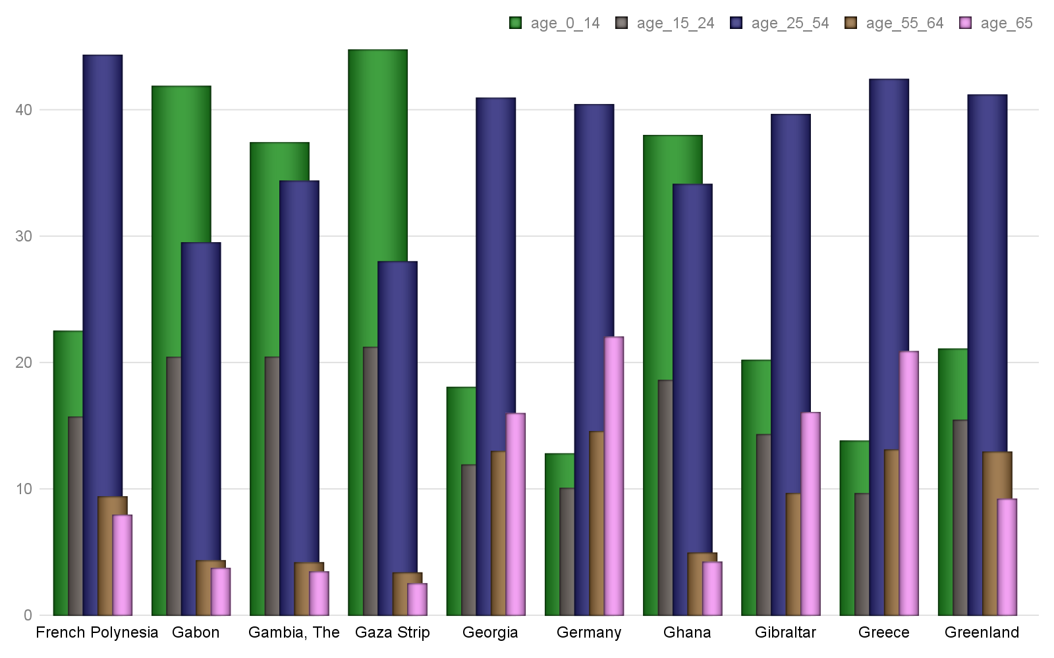

Hinweis: Alle Text Blöcke wurde vom Python-Dokumentation kopiert!

>>> from docx.shared import Pt

>>> paragraph_format.right_indent

None

>>> paragraph_format.right_indent = Pt(24)

# Bericht Block №9

## Text Block №9

Hinweis: Alle Text Blöcke wurde vom Python-Dokumentation kopiert!

304800

>>> paragraph_format.right_indent.pt

24.0

First-line indent is specified using the first_line_indent property and is interpreted relative to the left indent. A negative value indicates a hanging indent:

## Tabelle №9

### Altersverteilung für ausgewählte Länder nach WHO: Grenada,Guam,Guatemala,Guernsey,Guinea,Guinea-Bissau,Guyana,Haiti,Honduras,Hong Kong

|  | **Gesamt Population** | Altersgruppen | | | | |
| --- | --- | --- | --- | --- | --- | --- |
| Median | 0-14 | 15-24 | 25-54 | 55-64 | 65+ |
| Grenada | 31.5 | 23.99 | 15.03 | 40.38 | 10.52 | 10.08 |
| Guam | 29.0 | 27.54 | 16.63 | 37.44 | 9.8 | 8.59 |
| Guatemala | 22.1 | 34.5 | 21.58 | 34.12 | 5.26 | 4.54 |
| Guernsey | 43.8 | 14.51 | 11.13 | 41.67 | 13.11 | 19.58 |
| Guinea | 18.9 | 41.52 | 19.73 | 30.59 | 4.48 | 3.67 |
| Guinea-Bissau | 20.1 | 39.03 | 20.18 | 32.77 | 4.57 | 3.46 |
| Guyana | 26.2 | 26.22 | 21.56 | 38.1 | 8.03 | 6.08 |
| Haiti | 23.0 | 32.81 | 21.25 | 36.78 | 5.01 | 4.15 |
| Honduras | 23.0 | 32.95 | 21.0 | 36.63 | 5.13 | 4.29 |
| Hong Kong | 44.4 | 12.19 | 10.43 | 44.68 | 16.17 | 16.53 |
|  | © Dr. Alexander Wagner. All Rights Reserved | | | | | |

Hinweis: Alle Text Blöcke wurde vom Python-Dokumentation kopiert!

None

>>> paragraph_format.first_line_indent = Inches(-0.25)

>>> paragraph_format.first_line_indent

-228600

## Grafik №9

### Altersverteilung für ausgewählte Länder nach WHO: Grenada,Guam,Guatemala,Guernsey,Guinea,Guinea-Bissau,Guyana,Haiti,Honduras,Hong Kong

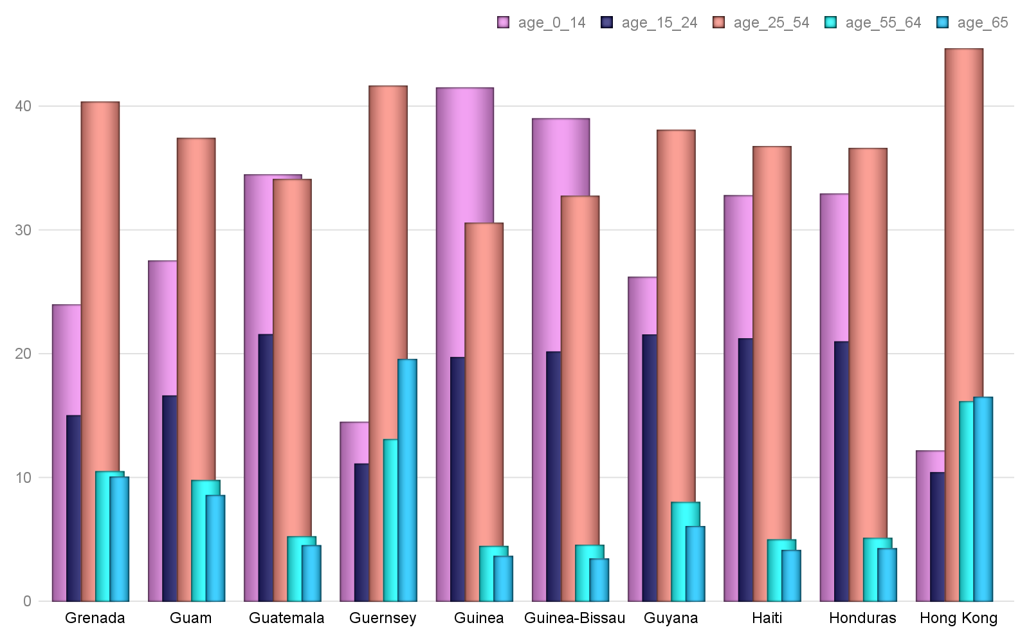

Hinweis: Alle Text Blöcke wurde vom Python-Dokumentation kopiert!

-0.25

Tab stops

A tab stop determines the rendering of a tab character in the text of a paragraph. In particular, it specifies the position where the text following the tab character will start, how it will be aligned to that position, and an optional leader character that will fill the horizontal space spanned by the tab.

The tab stops for a paragraph or style are contained in a TabStops object accessed using the tab_stops property on ParagraphFormat:

# Bericht Block №10

## Text Block №10

Hinweis: Alle Text Blöcke wurde vom Python-Dokumentation kopiert!

>>> tab_stops

<docx.text.tabstops.TabStops object at 0x106b802d8>

A new tab stop is added using the add_tab_stop() method:

>>> tab_stop = tab_stops.add_tab_stop(Inches(1.5))

## Tabelle №10

### Altersverteilung für ausgewählte Länder nach WHO: Hungary,Iceland,India,Indonesia,Iran,Iraq,Ireland,Isle of Man,Israel,Italy

|  | **Gesamt Population** | Altersgruppen | | | | |
| --- | --- | --- | --- | --- | --- | --- |
| Median | 0-14 | 15-24 | 25-54 | 55-64 | 65+ |
| Hungary | 42.3 | 14.71 | 10.96 | 41.88 | 13.4 | 19.05 |
| Iceland | 36.5 | 20.4 | 13.5 | 39.88 | 11.81 | 14.42 |
| India | 27.9 | 27.34 | 17.9 | 41.08 | 7.45 | 6.24 |
| Indonesia | 30.2 | 25.02 | 16.99 | 42.4 | 8.58 | 7.01 |
| Iran | 30.3 | 24.19 | 14.69 | 48.57 | 7.22 | 5.32 |
| Iraq | 20.0 | 39.46 | 19.25 | 33.84 | 3.99 | 3.46 |
| Ireland | 36.8 | 21.46 | 11.84 | 43.2 | 10.42 | 13.07 |
| Isle of Man | 44.2 | 16.28 | 11.43 | 38.79 | 13.13 | 20.36 |
| Israel | 29.9 | 27.51 | 15.53 | 37.17 | 8.46 | 11.33 |
| Italy | 45.5 | 13.65 | 9.66 | 42.16 | 12.99 | 21.53 |
|  | © Dr. Alexander Wagner. All Rights Reserved | | | | | |

Hinweis: Alle Text Blöcke wurde vom Python-Dokumentation kopiert!

1371600

>>> tab_stop.position.inches

1.5

Alignment defaults to left, but may be specified by providing a member of the  enumeration. The leader character defaults to spaces, but may be specified by providing a member of the  enumeration:

## Grafik №10

### Altersverteilung für ausgewählte Länder nach WHO: Hungary,Iceland,India,Indonesia,Iran,Iraq,Ireland,Isle of Man,Israel,Italy

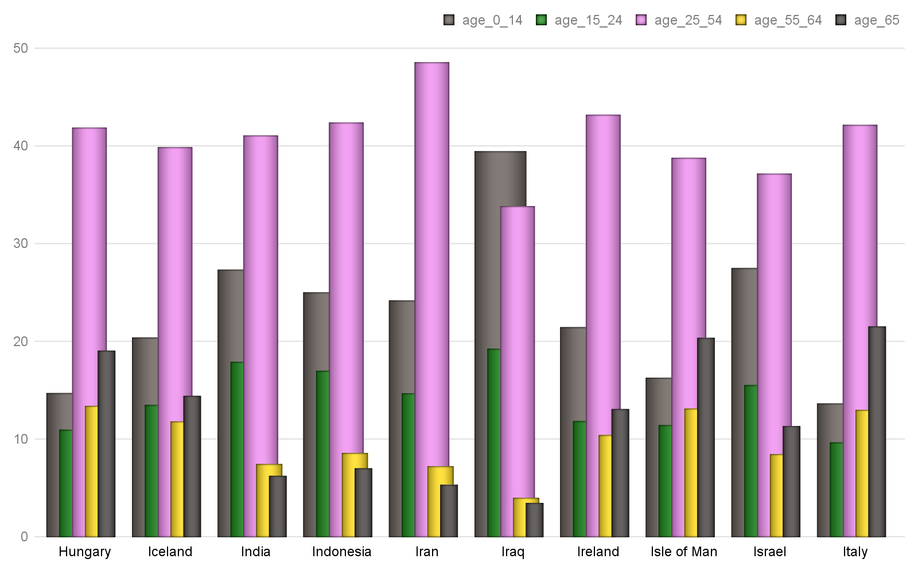

Hinweis: Alle Text Blöcke wurde vom Python-Dokumentation kopiert!

>>> tab_stop = tab_stops.add_tab_stop(Inches(1.5), WD_TAB_ALIGNMENT.RIGHT, WD_TAB_LEADER.DOTS)

>>> print(tab_stop.alignment)

RIGHT (2)

>>> print(tab_stop.leader)

# Bericht Block №11

## Text Block №11

Hinweis: Alle Text Blöcke wurde vom Python-Dokumentation kopiert!

Existing tab stops are accessed using sequence semantics on TabStops:

>>> tab_stops[0]

<docx.text.tabstops.TabStop object at 0x1105427e8>

More details are available in the TabStops and TabStop API documentation

## Tabelle №11

### Altersverteilung für ausgewählte Länder nach WHO: Jamaica,Japan,Jersey,Jordan,Kazakhstan,Kenya,Kiribati,Korea, North,Korea, South,Kosovo

|  | **Gesamt Population** | Altersgruppen | | | | |
| --- | --- | --- | --- | --- | --- | --- |
| Median | 0-14 | 15-24 | 25-54 | 55-64 | 65+ |
| Jamaica | 26.0 | 27.17 | 20.79 | 38.17 | 5.85 | 8.02 |
| Japan | 47.3 | 12.84 | 9.64 | 37.5 | 12.15 | 27.87 |
| Jersey | 38.0 | 16.23 | 13.91 | 40.99 | 12.53 | 16.34 |
| Jordan | 22.5 | 34.68 | 20.07 | 37.36 | 4.44 | 3.45 |
| Kazakhstan | 30.6 | 25.91 | 14.05 | 42.42 | 9.97 | 7.65 |
| Kenya | 19.7 | 40.02 | 19.15 | 33.91 | 3.92 | 3.0 |
| Kiribati | 24.6 | 29.68 | 21.07 | 38.98 | 6.04 | 4.23 |
| Korea, North | 34.0 | 20.78 | 15.59 | 44.28 | 9.77 | 9.56 |
| Korea, South | 41.8 | 13.21 | 12.66 | 45.52 | 14.49 | 14.12 |
| Kosovo | 29.1 | 25.01 | 17.22 | 42.57 | 7.92 | 7.28 |
|  | © Dr. Alexander Wagner. All Rights Reserved | | | | | |

Hinweis: Alle Text Blöcke wurde vom Python-Dokumentation kopiert!

The space_before and space_after properties control the spacing between subsequent paragraphs, controlling the spacing before and after a paragraph, respectively. Inter-paragraph spacing is collapsed during page layout, meaning the spacing between two paragraphs is the maximum of the space_after for the first paragraph and the space_before of the second paragraph. Paragraph spacing is specified as a Length value, often using :

>>> paragraph_format.space_before, paragraph_format.space_after

(None, None) # inherited by default

## Grafik №11

### Altersverteilung für ausgewählte Länder nach WHO: Jamaica,Japan,Jersey,Jordan,Kazakhstan,Kenya,Kiribati,Korea, North,Korea, South,Kosovo

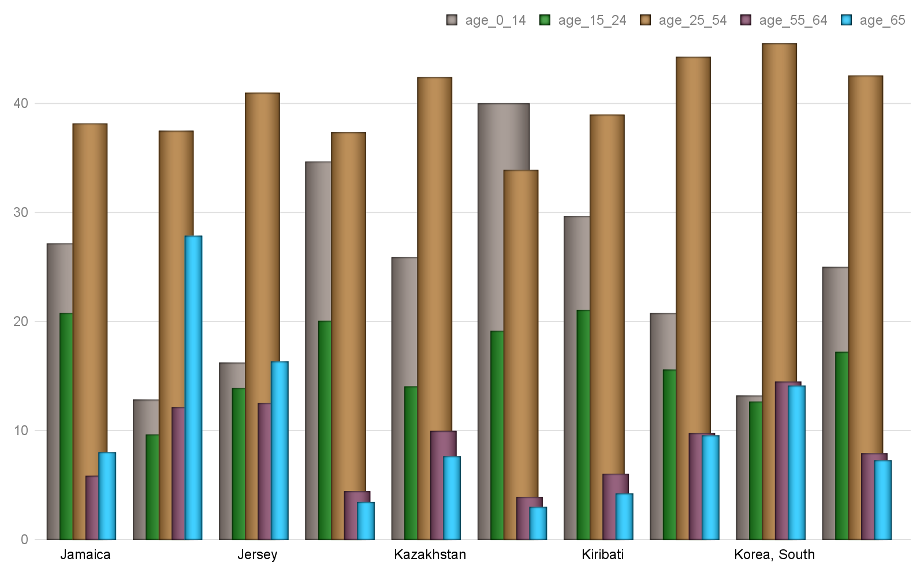

Hinweis: Alle Text Blöcke wurde vom Python-Dokumentation kopiert!

>>> paragraph_format.space_before.pt

18.0

>>> paragraph_format.space_after = Pt(12)

# Bericht Block №12

## Text Block №12

Hinweis: Alle Text Blöcke wurde vom Python-Dokumentation kopiert!

12.0

Line spacing

Line spacing is the distance between subsequent baselines in the lines of a paragraph. Line spacing can be specified either as an absolute distance or relative to the line height (essentially the point size of the font used). A typical absolute measure would be 18 points. A typical relative measure would be double-spaced (2.0 line heights). The default line spacing is single-spaced (1.0 line heights).

Line spacing is controlled by the interaction of the  and  properties.  is either a Length value, a (small-ish) float, or None. A Length value indicates an absolute distance. A float indicates a number of line heights. None indicates line spacing is inherited. line_spacing_rule is a member of the  enumeration or None:

## Tabelle №12

### Altersverteilung für ausgewählte Länder nach WHO: Kuwait,Kyrgyzstan,Laos,Latvia,Lebanon,Lesotho,Liberia,Libya,Liechtenstein,Lithuania

|  | **Gesamt Population** | Altersgruppen | | | | |
| --- | --- | --- | --- | --- | --- | --- |
| Median | 0-14 | 15-24 | 25-54 | 55-64 | 65+ |
| Kuwait | 29.3 | 25.02 | 15.1 | 52.27 | 5.07 | 2.54 |
| Kyrgyzstan | 26.5 | 30.3 | 16.79 | 39.84 | 7.8 | 5.27 |
| Laos | 23.0 | 32.76 | 21.17 | 36.7 | 5.48 | 3.89 |
| Latvia | 43.6 | 15.15 | 9.45 | 41.75 | 14.1 | 19.55 |
| Lebanon | 30.5 | 24.09 | 16.42 | 44.79 | 7.91 | 6.78 |
| Lesotho | 24.2 | 32.12 | 19.43 | 37.94 | 5.01 | 5.5 |
| Liberia | 17.8 | 43.82 | 19.56 | 30.33 | 3.43 | 2.86 |
| Libya | 28.9 | 25.84 | 17.09 | 47.28 | 5.48 | 4.31 |
| Liechtenstein | 43.2 | 15.26 | 11.65 | 41.64 | 14.03 | 17.41 |
| Lithuania | 43.7 | 15.01 | 11.09 | 40.05 | 14.17 | 19.67 |
|  | © Dr. Alexander Wagner. All Rights Reserved | | | | | |

Hinweis: Alle Text Blöcke wurde vom Python-Dokumentation kopiert!

>>> paragraph_format.line_spacing

None

>>> paragraph_format.line_spacing_rule

None

## Grafik №12

### Altersverteilung für ausgewählte Länder nach WHO: Kuwait,Kyrgyzstan,Laos,Latvia,Lebanon,Lesotho,Liberia,Libya,Liechtenstein,Lithuania

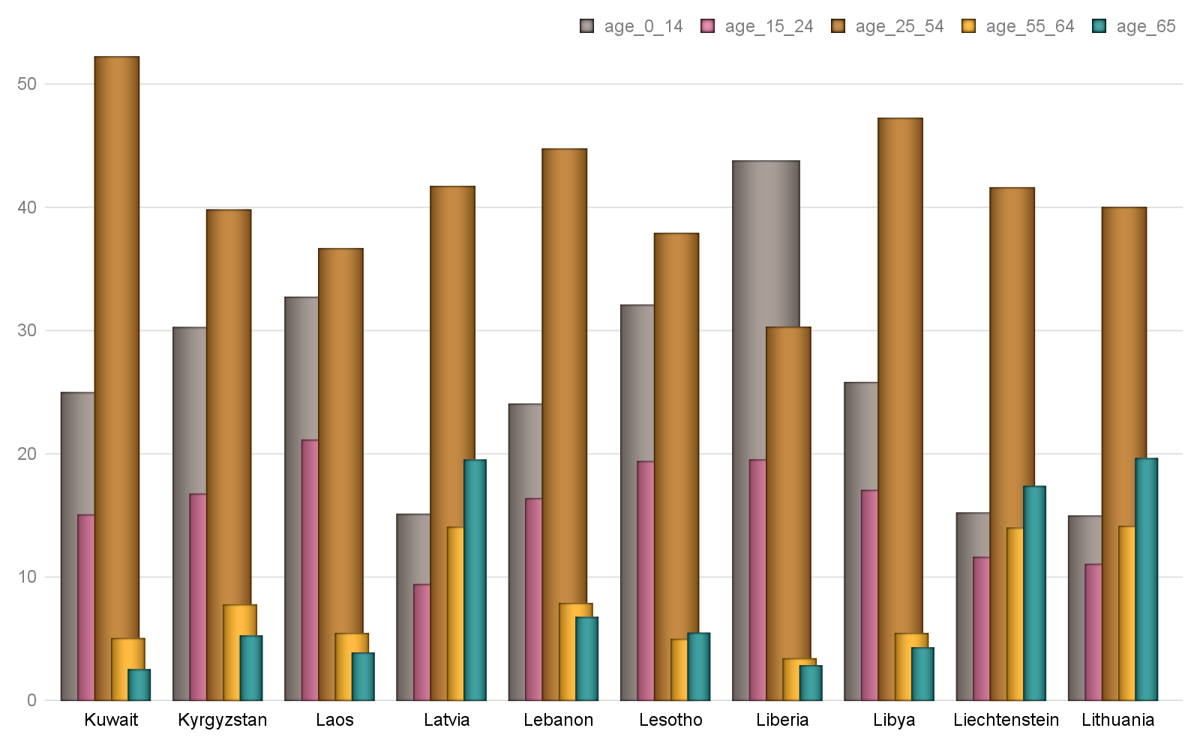

Hinweis: Alle Text Blöcke wurde vom Python-Dokumentation kopiert!

>>> paragraph_format.line_spacing = Pt(18)

>>> isinstance(paragraph_format.line_spacing, Length)

True

>>> paragraph_format.line_spacing.pt

# Bericht Block №13

## Text Block №13

Hinweis: Alle Text Blöcke wurde vom Python-Dokumentation kopiert!

>>> paragraph_format.line_spacing_rule

EXACTLY (4)

>>> paragraph_format.line_spacing = 1.75

## Tabelle №13

### Altersverteilung für ausgewählte Länder nach WHO: Luxembourg,Macau,Macedonia,Madagascar,Malawi,Malaysia,Maldives,Mali,Malta,Marshall Islands

|  | **Gesamt Population** | Altersgruppen | | | | |
| --- | --- | --- | --- | --- | --- | --- |
| Median | 0-14 | 15-24 | 25-54 | 55-64 | 65+ |
| Luxembourg | 39.3 | 16.77 | 12.18 | 44.27 | 11.77 | 15.02 |
| Macau | 39.3 | 14.1 | 11.73 | 50.1 | 13.5 | 10.57 |
| Macedonia | 37.9 | 17.17 | 13.41 | 43.6 | 12.41 | 13.41 |
| Madagascar | 19.7 | 39.87 | 20.34 | 32.12 | 4.38 | 3.3 |
| Malawi | 16.5 | 46.34 | 20.55 | 27.41 | 3.01 | 2.69 |
| Malaysia | 28.5 | 27.83 | 16.81 | 41.0 | 8.27 | 6.1 |
| Maldives | 28.2 | 21.4 | 20.21 | 48.1 | 5.85 | 4.45 |
| Mali | 15.8 | 48.17 | 18.84 | 26.26 | 3.7 | 3.03 |
| Malta | 41.8 | 15.04 | 11.44 | 39.98 | 13.98 | 19.56 |
| Marshall Islands | 22.9 | 34.89 | 18.0 | 37.28 | 5.82 | 4.02 |
|  | © Dr. Alexander Wagner. All Rights Reserved | | | | | |

Hinweis: Alle Text Blöcke wurde vom Python-Dokumentation kopiert!

1.75

>>> paragraph_format.line_spacing_rule

MULTIPLE (5)

Pagination properties

## Grafik №13

### Altersverteilung für ausgewählte Länder nach WHO: Luxembourg,Macau,Macedonia,Madagascar,Malawi,Malaysia,Maldives,Mali,Malta,Marshall Islands

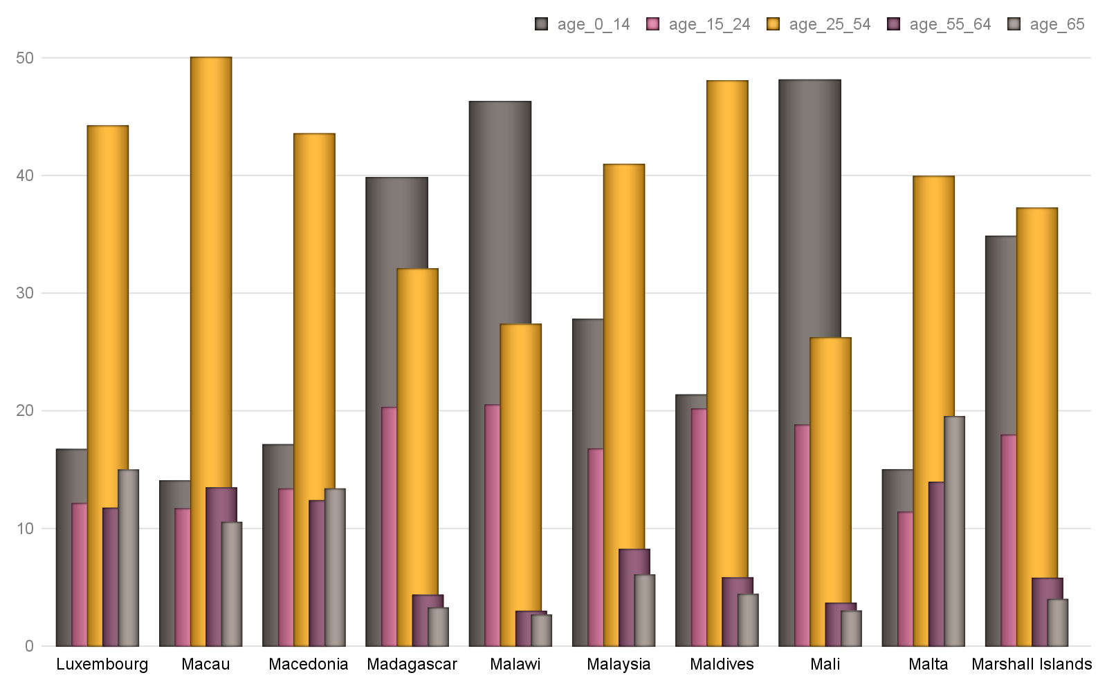

Hinweis: Alle Text Blöcke wurde vom Python-Dokumentation kopiert!

 causes the entire paragraph to appear on the same page, issuing a page break before the paragraph if it would otherwise be broken across two pages.

 keeps a paragraph on the same page as the subsequent paragraph. This can be used, for example, to keep a section heading on the same page as the first paragraph of the section.

 causes a paragraph to be placed at the top of a new page. This could be used on a chapter heading to ensure chapters start on a new page.

 breaks a page to avoid placing the first or last line of the paragraph on a separate page from the rest of the paragraph.

# Bericht Block №14

## Text Block №14

Hinweis: Alle Text Blöcke wurde vom Python-Dokumentation kopiert!

>>> paragraph_format.keep_together

None # all four inherit by default

>>> paragraph_format.keep_with_next = True

>>> paragraph_format.keep_with_next

## Tabelle №14

### Altersverteilung für ausgewählte Länder nach WHO: Mauritania,Mauritius,Mexico,Micronesia, Federated States of,Moldova,Monaco,Mongolia,Montenegro,Montserrat,Morocco

|  | **Gesamt Population** | Altersgruppen | | | | |
| --- | --- | --- | --- | --- | --- | --- |
| Median | 0-14 | 15-24 | 25-54 | 55-64 | 65+ |
| Mauritania | 20.5 | 38.56 | 19.81 | 33.21 | 4.67 | 3.76 |
| Mauritius | 35.3 | 20.16 | 14.8 | 43.74 | 11.59 | 9.71 |
| Mexico | 28.3 | 26.93 | 17.54 | 40.81 | 7.64 | 7.09 |
| Micronesia, Federated | 25.1 | 30.3 | 19.59 | 39.19 | 6.99 | 3.93 |
| Moldova | 36.7 | 18.18 | 12.32 | 43.4 | 13.46 | 12.64 |
| Monaco | 53.1 | 10.68 | 9.27 | 32.91 | 14.94 | 32.21 |
| Mongolia | 28.3 | 26.95 | 16.09 | 45.6 | 7.07 | 4.29 |
| Montenegro | 40.7 | 15.1 | 9.58 | 46.59 | 13.58 | 15.14 |
| Montserrat | 33.2 | 16.5 | 21.52 | 47.43 | 8.45 | 6.1 |
| Morocco | 29.3 | 25.77 | 17.04 | 42.32 | 8.13 | 6.74 |
|  | © Dr. Alexander Wagner. All Rights Reserved | | | | | |

Hinweis: Alle Text Blöcke wurde vom Python-Dokumentation kopiert!

>>> paragraph_format.page_break_before = False

>>> paragraph_format.page_break_before

False

Apply character formatting

## Grafik №14

### Altersverteilung für ausgewählte Länder nach WHO: Mauritania,Mauritius,Mexico,Micronesia, Federated States of,Moldova,Monaco,Mongolia,Montenegro,Montserrat,Morocco

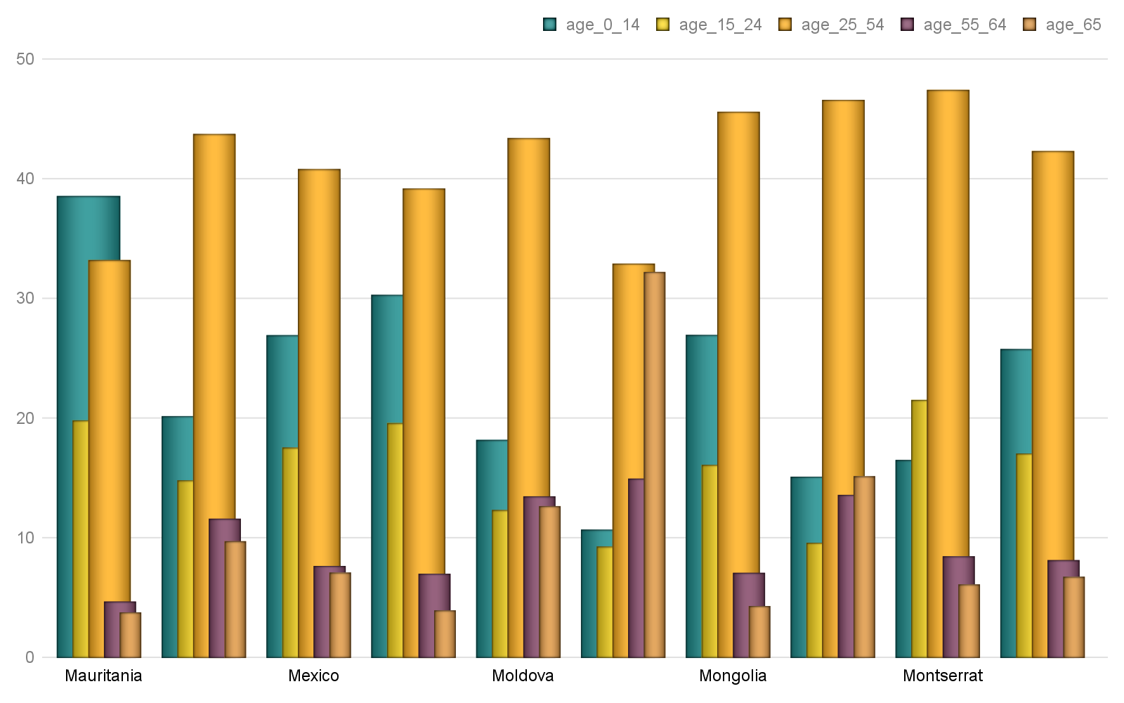

Hinweis: Alle Text Blöcke wurde vom Python-Dokumentation kopiert!

A  object has a read-only font property providing access to a  object. A run’s  object provides properties for getting and setting the character formatting for that run.

Several examples are provided here. For a complete set of the available properties, see the  API documentation.

The font for a run can be accessed like this:

>>> from docx import Document

# Bericht Block №15

## Text Block №15

Hinweis: Alle Text Blöcke wurde vom Python-Dokumentation kopiert!

>>> run = document.add_paragraph().add_run()

>>> font = run.font

Typeface and size are set like this:

>>> from docx.shared import Pt

## Tabelle №15

### Altersverteilung für ausgewählte Länder nach WHO: Mozambique,Namibia,Nauru,Nepal,Netherlands,New Caledonia,New Zealand,Nicaragua,Niger,Nigeria

|  | **Gesamt Population** | Altersgruppen | | | | |
| --- | --- | --- | --- | --- | --- | --- |
| Median | 0-14 | 15-24 | 25-54 | 55-64 | 65+ |
| Mozambique | 17.2 | 44.72 | 21.57 | 27.42 | 3.4 | 2.9 |
| Namibia | 21.2 | 36.97 | 20.35 | 34.37 | 4.35 | 3.96 |
| Nauru | 26.4 | 31.4 | 16.21 | 43.4 | 6.38 | 2.6 |
| Nepal | 24.1 | 30.2 | 21.73 | 36.58 | 6.32 | 5.17 |
| Netherlands | 42.6 | 16.41 | 12.07 | 39.52 | 13.28 | 18.73 |
| New Caledonia | 32.0 | 22.46 | 16.44 | 43.5 | 8.4 | 9.2 |
| New Zealand | 37.9 | 19.69 | 13.35 | 39.82 | 11.89 | 15.25 |
| Nicaragua | 25.7 | 27.24 | 21.26 | 40.24 | 5.98 | 5.28 |
| Niger | 15.4 | 49.01 | 19.1 | 25.97 | 3.28 | 2.64 |
| Nigeria | 18.4 | 42.54 | 19.61 | 30.74 | 3.97 | 3.13 |
|  | © Dr. Alexander Wagner. All Rights Reserved | | | | | |

Hinweis: Alle Text Blöcke wurde vom Python-Dokumentation kopiert!

>>> font.size = Pt(12)

Many font properties are tri-state, meaning they can take the values True, False, and None. True means the property is “on”, False means it is “off”. Conceptually, the None value means “inherit”. A run exists in the style inheritance hierarchy and by default inherits its character formatting from that hierarchy. Any character formatting directly applied using the  object overrides the inherited values.

Bold and italic are tri-state properties, as are all-caps, strikethrough, superscript, and many others. See the  API documentation for a full list:

>>> font.bold, font.italic

## Grafik №15

### Altersverteilung für ausgewählte Länder nach WHO: Mozambique,Namibia,Nauru,Nepal,Netherlands,New Caledonia,New Zealand,Nicaragua,Niger,Nigeria

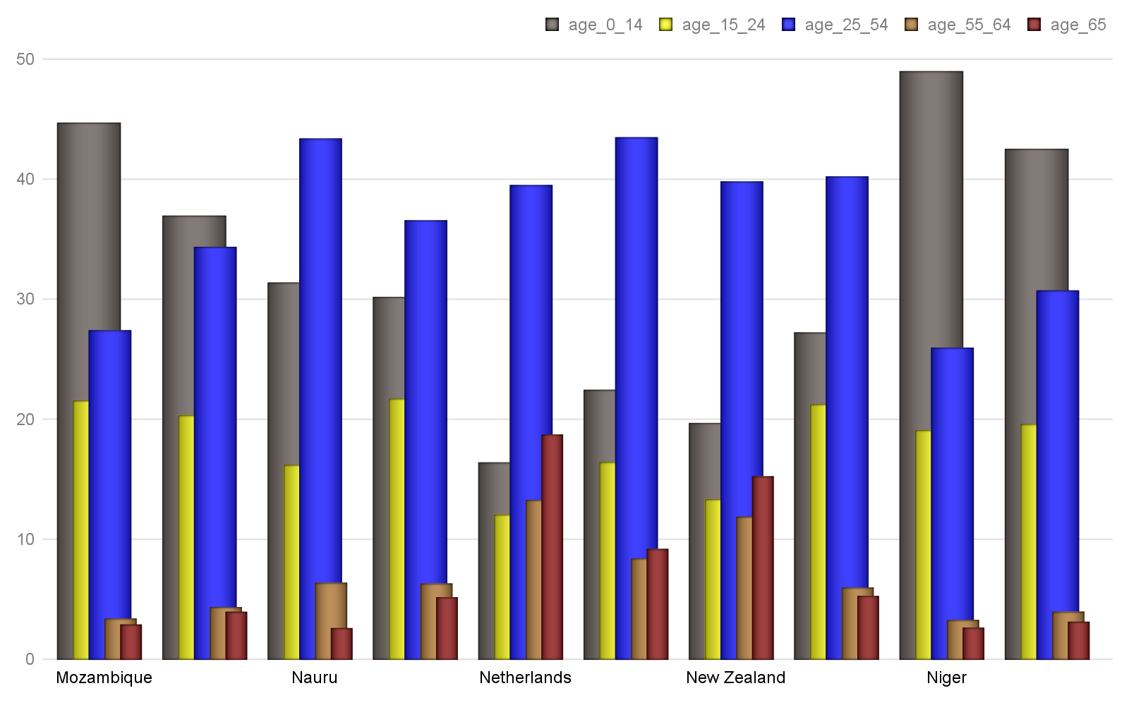

Hinweis: Alle Text Blöcke wurde vom Python-Dokumentation kopiert!

>>> font.italic = True

>>> font.italic

True

>>> font.italic = False

# Bericht Block №16

## Text Block №16

Hinweis: Alle Text Blöcke wurde vom Python-Dokumentation kopiert!

False

>>> font.italic = None

>>> font.italic

None

## Tabelle №16

### Altersverteilung für ausgewählte Länder nach WHO: Northern Mariana Islands,Norway,Oman,Pakistan,Palau,Panama,Papua New Guinea,Paraguay,Peru,Philippines

|  | **Gesamt Population** | Altersgruppen | | | | |
| --- | --- | --- | --- | --- | --- | --- |
| Median | 0-14 | 15-24 | 25-54 | 55-64 | 65+ |
| Northern Mariana Isla | 33.6 | 26.63 | 15.59 | 39.96 | 12.37 | 5.44 |
| Norway | 39.2 | 18.0 | 12.58 | 41.01 | 11.71 | 16.71 |
| Oman | 25.6 | 30.1 | 18.69 | 43.8 | 3.92 | 3.49 |
| Pakistan | 23.8 | 31.36 | 21.14 | 37.45 | 5.57 | 4.48 |
| Palau | 33.4 | 19.69 | 16.68 | 45.89 | 9.65 | 8.08 |
| Panama | 29.2 | 26.4 | 16.99 | 40.35 | 7.91 | 8.36 |
| Papua New Guinea | 23.1 | 33.43 | 19.92 | 36.89 | 5.49 | 4.28 |
| Paraguay | 28.2 | 24.56 | 19.29 | 41.08 | 7.95 | 7.12 |
| Peru | 28.0 | 26.31 | 18.31 | 40.19 | 7.78 | 7.41 |
| Philippines | 23.5 | 33.39 | 19.16 | 36.99 | 5.97 | 4.49 |
|  | © Dr. Alexander Wagner. All Rights Reserved | | | | | |

Hinweis: Alle Text Blöcke wurde vom Python-Dokumentation kopiert!

>>> font.underline

None

>>> font.underline = True

>>> # or perhaps

## Grafik №16

### Altersverteilung für ausgewählte Länder nach WHO: Northern Mariana Islands,Norway,Oman,Pakistan,Palau,Panama,Papua New Guinea,Paraguay,Peru,Philippines

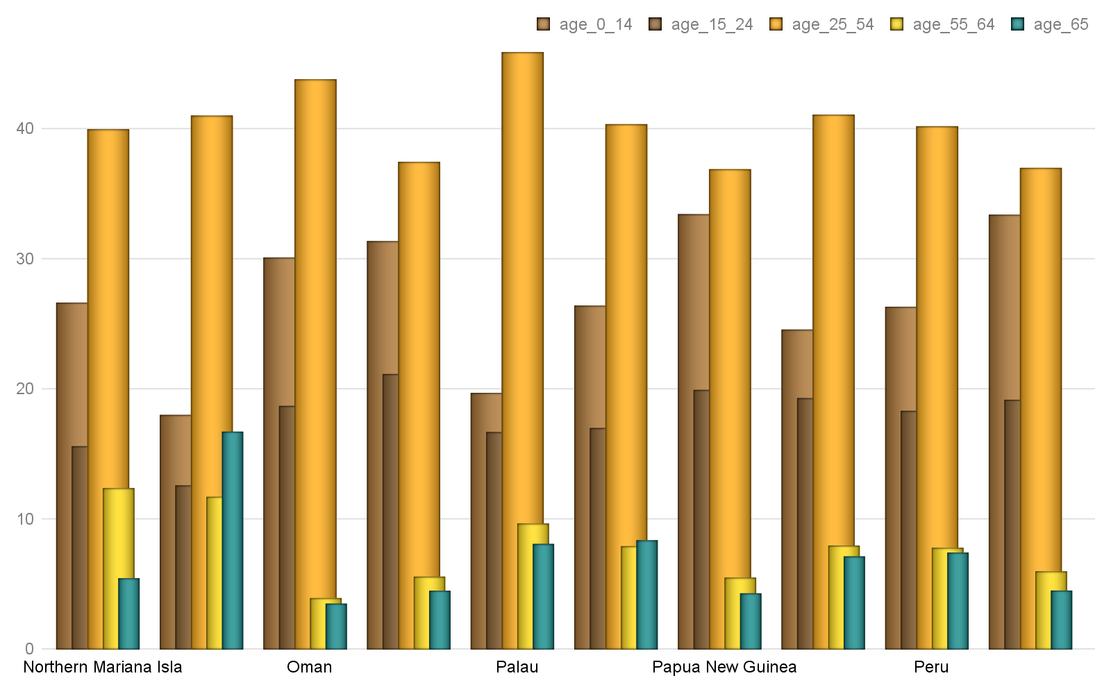

Hinweis: Alle Text Blöcke wurde vom Python-Dokumentation kopiert!

Font color

Each  object has a ColorFormat object that provides access to its color, accessed via its read-only color property.

Apply a specific RGB color to a font:

>>> from docx.shared import RGBColor

# Bericht Block №17

## Text Block №17

Hinweis: Alle Text Blöcke wurde vom Python-Dokumentation kopiert!

A font can also be set to a theme color by assigning a member of the  enumeration:

>>> from docx.enum.dml import MSO_THEME_COLOR

>>> font.color.theme_color = MSO_THEME_COLOR.ACCENT_1

A font’s color can be restored to its default (inherited) value by assigning None to either the rgb or theme_color attribute of ColorFormat:

## Tabelle №17

### Altersverteilung für ausgewählte Länder nach WHO: Poland,Portugal,Puerto Rico,Qatar,Romania,Russia,Rwanda,Saint Barthelemy,Saint Helena, Ascension, and Tristan da,Saint Kitts and Nevis

|  | **Gesamt Population** | Altersgruppen | | | | |
| --- | --- | --- | --- | --- | --- | --- |
| Median | 0-14 | 15-24 | 25-54 | 55-64 | 65+ |
| Poland | 40.7 | 14.76 | 10.7 | 43.48 | 14.21 | 16.86 |
| Portugal | 42.2 | 15.34 | 11.36 | 41.72 | 12.18 | 19.4 |
| Puerto Rico | 41.5 | 15.77 | 13.71 | 38.1 | 12.93 | 19.48 |
| Qatar | 33.2 | 12.63 | 12.35 | 70.59 | 3.42 | 1.0 |
| Romania | 41.1 | 14.35 | 10.6 | 46.03 | 12.61 | 16.41 |
| Russia | 39.6 | 17.12 | 9.46 | 44.71 | 14.44 | 14.28 |
| Rwanda | 19.0 | 41.38 | 19.34 | 32.77 | 4.09 | 2.43 |
| Saint Barthelemy | 44.1 | 16.41 | 7.24 | 43.78 | 15.83 | 16.75 |
| Saint Helena, Ascensi | 41.9 | 15.97 | 12.19 | 43.89 | 12.83 | 15.13 |
| Saint Kitts and Nevis | 35.0 | 20.32 | 14.54 | 44.6 | 11.9 | 8.64 |
|  | © Dr. Alexander Wagner. All Rights Reserved | | | | | |

Hinweis: Alle Text Blöcke wurde vom Python-Dokumentation kopiert!

Determining the color of a font begins with determining its color type:

>>> font.color.type

RGB (1)

The value of the  property can be a member of the  enumeration or None. MSO_COLOR_TYPE.RGB indicates it is an RGB color. MSO_COLOR_TYPE.THEME indicates a theme color. MSO_COLOR_TYPE.AUTO indicates its value is determined automatically by the application, usually set to black. (This value is relatively rare.) None indicates no color is applied and the color is inherited from the style hierarchy; this is the most common case.

## Grafik №17

### Altersverteilung für ausgewählte Länder nach WHO: Poland,Portugal,Puerto Rico,Qatar,Romania,Russia,Rwanda,Saint Barthelemy,Saint Helena, Ascension, and Tristan da,Saint Kitts and Nevis

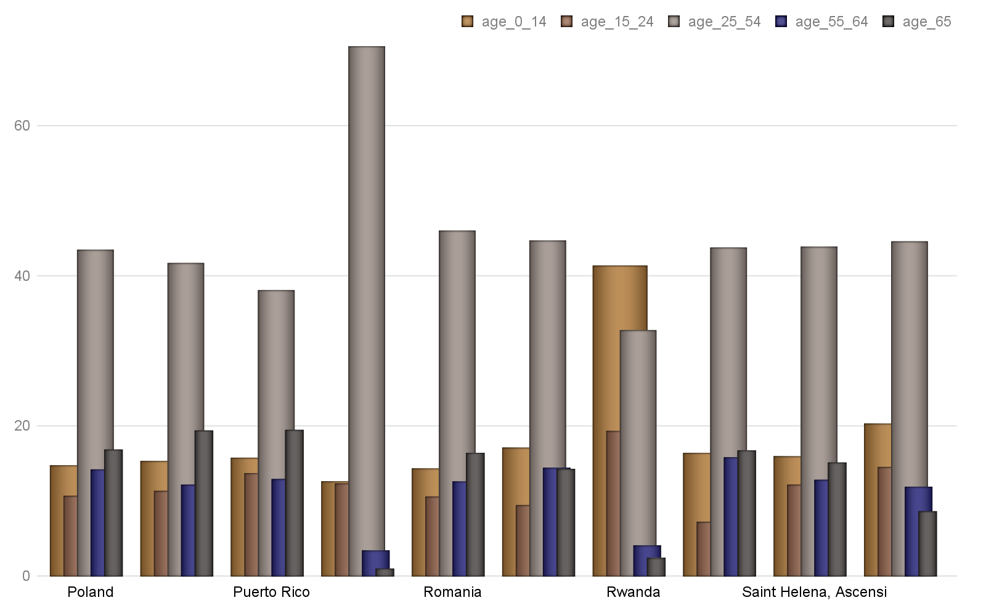

Hinweis: Alle Text Blöcke wurde vom Python-Dokumentation kopiert!

>>> font.color.rgb

RGBColor(0x42, 0x24, 0xe9)

When the color type is MSO_COLOR_TYPE.THEME, the theme_color property will be a member of  indicating the theme color:

>>> font.color.theme_color

# Bericht Block №18

## Text Block №18

Hinweis: Alle Text Blöcke wurde vom Python-Dokumentation kopiert!

Working with Styles

This page uses concepts developed in the prior page without introduction. If a term is unfamiliar, consult the prior page  for a definition.

Access a style

Styles are accessed using the Document.styles attribute:

## Tabelle №18

### Altersverteilung für ausgewählte Länder nach WHO: Saint Lucia,Saint Martin,Saint Pierre and Miquelon,Saint Vincent and the Grenadines,Samoa,San Marino,Sao Tome and Principe,Saudi Arabia,Senegal,Serb

|  | **Gesamt Population** | Altersgruppen | | | | |
| --- | --- | --- | --- | --- | --- | --- |
| Median | 0-14 | 15-24 | 25-54 | 55-64 | 65+ |
| Saint Lucia | 34.8 | 20.02 | 15.37 | 42.97 | 9.99 | 11.65 |
| Saint Martin | 32.5 | 26.22 | 10.35 | 46.67 | 8.74 | 8.02 |
| Saint Pierre and Miqu | 46.5 | 15.29 | 9.05 | 41.79 | 13.54 | 20.33 |
| Saint Vincent and the | 33.6 | 21.3 | 15.97 | 42.66 | 10.64 | 9.42 |
| Samoa | 24.4 | 31.35 | 19.82 | 36.33 | 6.78 | 5.72 |
| San Marino | 44.4 | 15.22 | 11.52 | 40.78 | 12.92 | 19.56 |
| Sao Tome and Principe | 18.4 | 41.85 | 20.68 | 30.82 | 3.81 | 2.83 |
| Saudi Arabia | 27.5 | 26.1 | 18.57 | 46.86 | 5.03 | 3.44 |
| Senegal | 18.8 | 41.51 | 20.33 | 31.19 | 3.98 | 2.98 |
| Serbia | 42.6 | 14.5 | 11.26 | 41.32 | 14.49 | 18.43 |
|  | © Dr. Alexander Wagner. All Rights Reserved | | | | | |

Hinweis: Alle Text Blöcke wurde vom Python-Dokumentation kopiert!

>>> styles = document.styles

>>> styles

<docx.styles.styles.Styles object at 0x10a7c4f50>

The  object provides dictionary-style access to defined styles by name:

## Grafik №18

### Altersverteilung für ausgewählte Länder nach WHO: Saint Lucia,Saint Martin,Saint Pierre and Miquelon,Saint Vincent and the Grenadines,Samoa,San Marino,Sao Tome and Principe,Saudi Arabia,Senegal,Serb

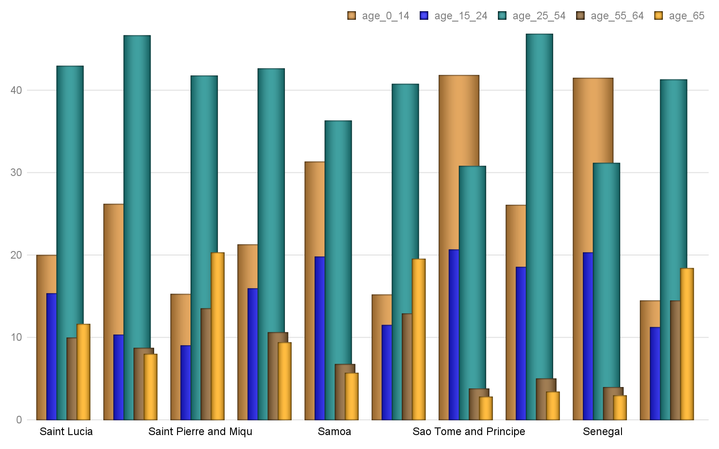

Hinweis: Alle Text Blöcke wurde vom Python-Dokumentation kopiert!

<docx.styles.style._ParagraphStyle object at <0x10a7c4f6b>

Note

Built-in styles are stored in a WordprocessingML file using their English name, e.g. ‘Heading 1’, even though users working on a localized version of Word will see native language names in the UI, e.g. ‘Kop 1’. Because python-docx operates on the WordprocessingML file, style lookups must use the English name. A document available on this external site allows you to create a mapping between local language names and English style names:

User-defined styles, also known as custom styles, are not localized and are accessed with the name exactly as it appears in the Word UI.

# Bericht Block №19

## Text Block №19

Hinweis: Alle Text Blöcke wurde vom Python-Dokumentation kopiert!

>>> from docx.enum.style import WD_STYLE_TYPE

>>> styles = document.styles

>>> paragraph_styles = [

... s for s in styles if s.type == WD_STYLE_TYPE.PARAGRAPH

## Tabelle №19

### Altersverteilung für ausgewählte Länder nach WHO: Seychelles,Sierra Leone,Singapore,Sint Maarten,Slovakia,Slovenia,Solomon Islands,Somalia,South Africa,South Sudan

|  | **Gesamt Population** | Altersgruppen | | | | |
| --- | --- | --- | --- | --- | --- | --- |
| Median | 0-14 | 15-24 | 25-54 | 55-64 | 65+ |
| Seychelles | 35.4 | 19.88 | 13.24 | 49.36 | 9.88 | 7.64 |
| Sierra Leone | 19.0 | 41.82 | 18.56 | 32.16 | 3.7 | 3.76 |
| Singapore | 34.6 | 12.82 | 16.56 | 50.53 | 10.46 | 9.63 |
| Sint Maarten | 41.0 | 18.43 | 14.59 | 41.99 | 15.92 | 9.07 |
| Slovakia | 40.5 | 15.17 | 10.87 | 45.1 | 13.42 | 15.43 |
| Slovenia | 44.5 | 13.32 | 9.45 | 42.9 | 14.83 | 19.51 |
| Solomon Islands | 22.5 | 34.59 | 19.99 | 36.5 | 4.65 | 4.27 |
| Somalia | 18.1 | 43.15 | 19.04 | 31.43 | 4.2 | 2.19 |
| South Africa | 27.1 | 28.27 | 17.61 | 41.78 | 6.66 | 5.68 |
| South Sudan | 17.3 | 44.37 | 20.56 | 29.58 | 3.39 | 2.1 |
|  | © Dr. Alexander Wagner. All Rights Reserved | | | | | |

Hinweis: Alle Text Blöcke wurde vom Python-Dokumentation kopiert!

>>> for style in paragraph_styles:

... print(style.name)

...

Normal

## Grafik №19

### Altersverteilung für ausgewählte Länder nach WHO: Seychelles,Sierra Leone,Singapore,Sint Maarten,Slovakia,Slovenia,Solomon Islands,Somalia,South Africa,South Sudan

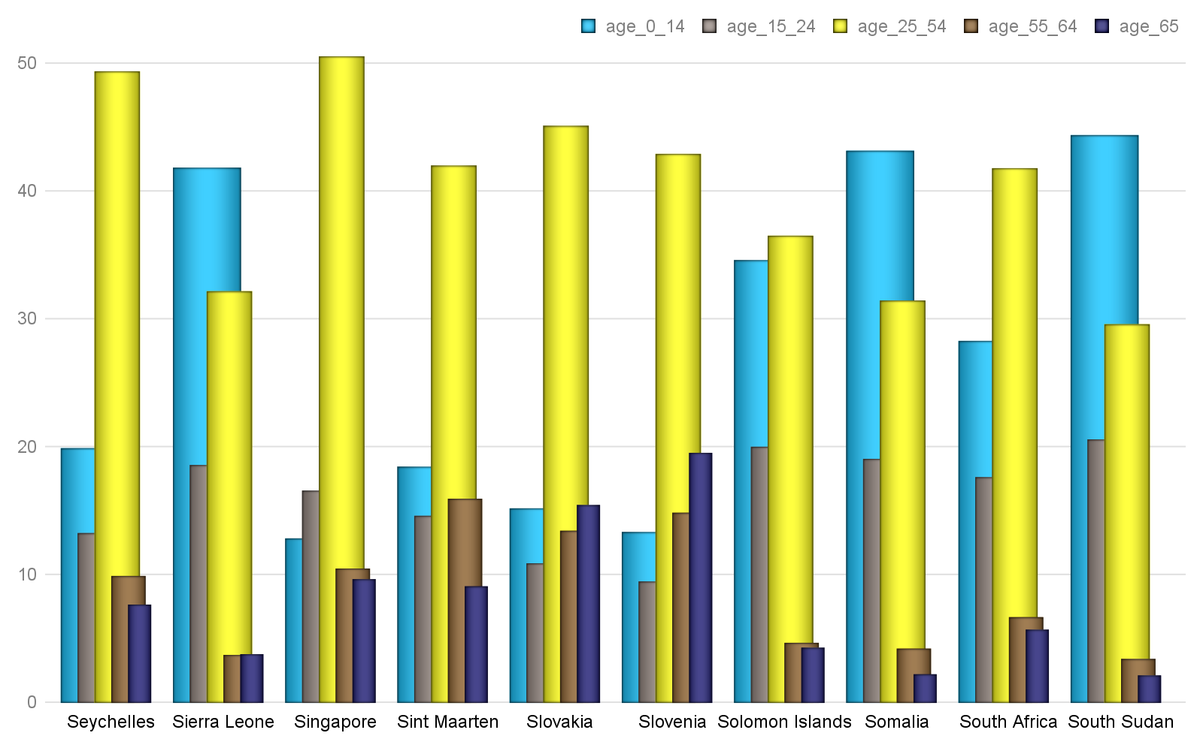

Hinweis: Alle Text Blöcke wurde vom Python-Dokumentation kopiert!

List Bullet

Apply a style

The , , and  objects each have a style attribute. Assigning a style object to this attribute applies that style:

>>> document = Document()

# Bericht Block №20

## Text Block №20

Hinweis: Alle Text Blöcke wurde vom Python-Dokumentation kopiert!

>>> paragraph.style

<docx.styles.style._ParagraphStyle object at <0x11a7c4c50>

>>> paragraph.style.name

'Normal'

## Tabelle №20

### Altersverteilung für ausgewählte Länder nach WHO: Spain,Sri Lanka,Sudan,Suriname,Swaziland,Sweden,Switzerland,Syria,Taiwan,Tajikistan

|  | **Gesamt Population** | Altersgruppen | | | | |
| --- | --- | --- | --- | --- | --- | --- |
| Median | 0-14 | 15-24 | 25-54 | 55-64 | 65+ |
| Spain | 42.7 | 15.38 | 9.58 | 44.91 | 12.14 | 17.98 |
| Sri Lanka | 32.8 | 24.06 | 14.63 | 41.58 | 10.06 | 9.67 |
| Sudan | 19.9 | 38.68 | 21.04 | 32.77 | 4.24 | 3.27 |
| Suriname | 29.8 | 24.62 | 17.44 | 44.4 | 7.54 | 6.01 |
| Swaziland | 21.7 | 35.01 | 22.12 | 34.6 | 4.3 | 3.97 |
| Sweden | 41.2 | 17.43 | 11.31 | 39.42 | 11.58 | 20.26 |
| Switzerland | 42.4 | 15.16 | 10.88 | 43.21 | 12.6 | 18.15 |
| Syria | 24.3 | 31.62 | 19.54 | 39.22 | 5.41 | 4.21 |
| Taiwan | 40.7 | 12.88 | 12.88 | 46.41 | 14.12 | 13.72 |
| Tajikistan | 24.5 | 32.33 | 18.61 | 40.12 | 5.62 | 3.32 |
|  | © Dr. Alexander Wagner. All Rights Reserved | | | | | |

Hinweis: Alle Text Blöcke wurde vom Python-Dokumentation kopiert!

>>> paragraph.style.name

'Heading 1'

A style name can also be assigned directly, in which case python-docx will do the lookup for you:

>>> paragraph.style = 'List Bullet'

## Grafik №20

### Altersverteilung für ausgewählte Länder nach WHO: Spain,Sri Lanka,Sudan,Suriname,Swaziland,Sweden,Switzerland,Syria,Taiwan,Tajikistan

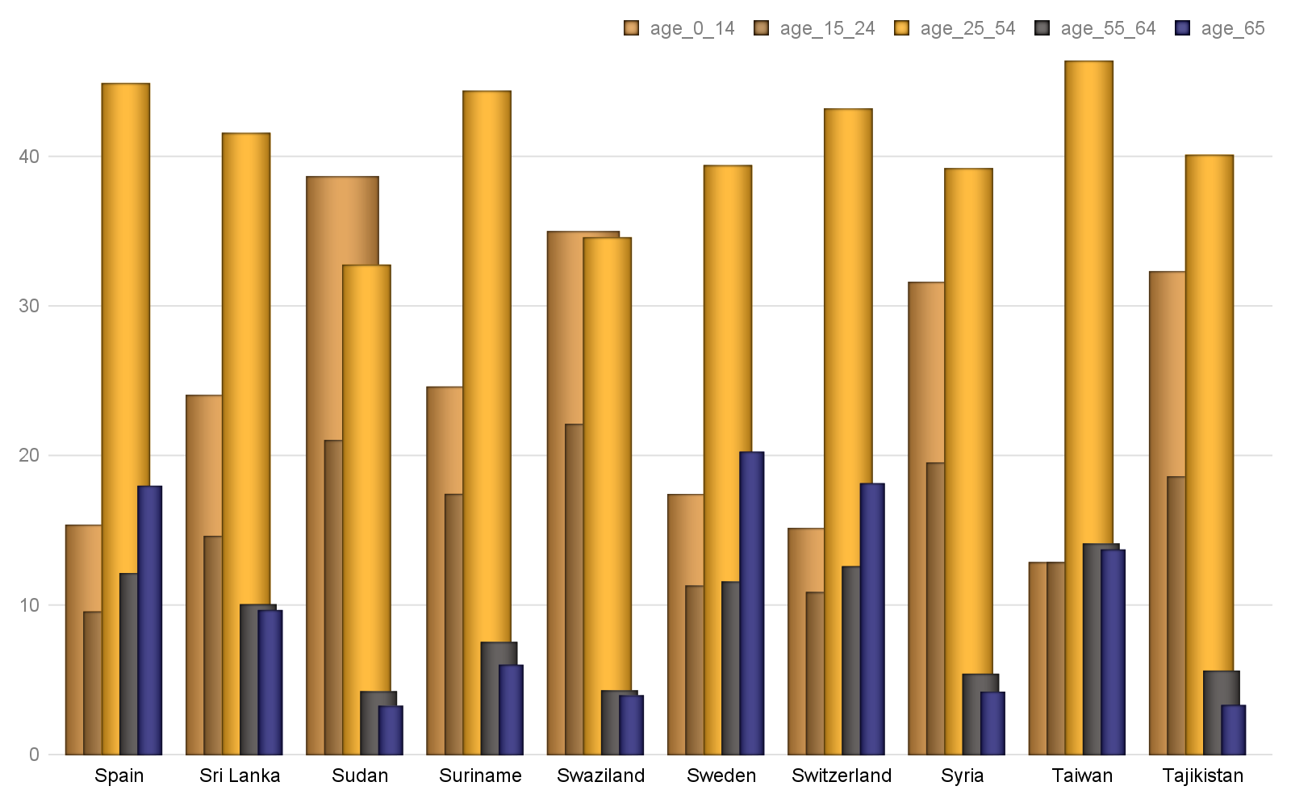

Hinweis: Alle Text Blöcke wurde vom Python-Dokumentation kopiert!

<docx.styles.style._ParagraphStyle object at <0x10a7c4f84>

>>> paragraph.style.name

'List Bullet'

A style can also be applied at creation time using either the style object or its name:

# Bericht Block №21

## Text Block №21

Hinweis: Alle Text Blöcke wurde vom Python-Dokumentation kopiert!

>>> paragraph.style.name

'Body Text'

>>> body_text_style = document.styles['Body Text']

>>> paragraph = document.add_paragraph(style=body_text_style)

## Tabelle №21

### Altersverteilung für ausgewählte Länder nach WHO: Tanzania,Thailand,Timor-Leste,Togo,Tonga,Trinidad and Tobago,Tunisia,Turkey,Turkmenistan,Turks and Caicos Islands

|  | **Gesamt Population** | Altersgruppen | | | | |
| --- | --- | --- | --- | --- | --- | --- |
| Median | 0-14 | 15-24 | 25-54 | 55-64 | 65+ |
| Tanzania | 17.7 | 43.74 | 19.86 | 29.88 | 3.51 | 3.02 |
| Thailand | 37.7 | 16.93 | 14.17 | 46.32 | 12.0 | 10.58 |
| Timor-Leste | 18.9 | 40.91 | 20.32 | 29.95 | 4.94 | 3.87 |
| Togo | 19.8 | 40.29 | 19.2 | 32.79 | 4.31 | 3.41 |
| Tonga | 23.0 | 33.87 | 19.65 | 34.3 | 5.76 | 6.42 |
| Trinidad and Tobago | 36.0 | 19.29 | 11.88 | 45.56 | 12.61 | 10.65 |
| Tunisia | 31.6 | 25.15 | 13.99 | 43.38 | 9.54 | 7.95 |
| Turkey | 30.9 | 24.68 | 15.99 | 43.21 | 8.58 | 7.53 |
| Turkmenistan | 27.9 | 25.79 | 18.39 | 43.18 | 7.9 | 4.74 |
| Turks and Caicos Isla | 33.3 | 21.74 | 13.99 | 53.17 | 6.54 | 4.57 |
|  | © Dr. Alexander Wagner. All Rights Reserved | | | | | |

Hinweis: Alle Text Blöcke wurde vom Python-Dokumentation kopiert!

'Body Text'

Add or delete a style

A new style can be added to the document by specifying a unique name and a style type:

>>> from docx.enum.style import WD_STYLE_TYPE

## Grafik №21

### Altersverteilung für ausgewählte Länder nach WHO: Tanzania,Thailand,Timor-Leste,Togo,Tonga,Trinidad and Tobago,Tunisia,Turkey,Turkmenistan,Turks and Caicos Islands

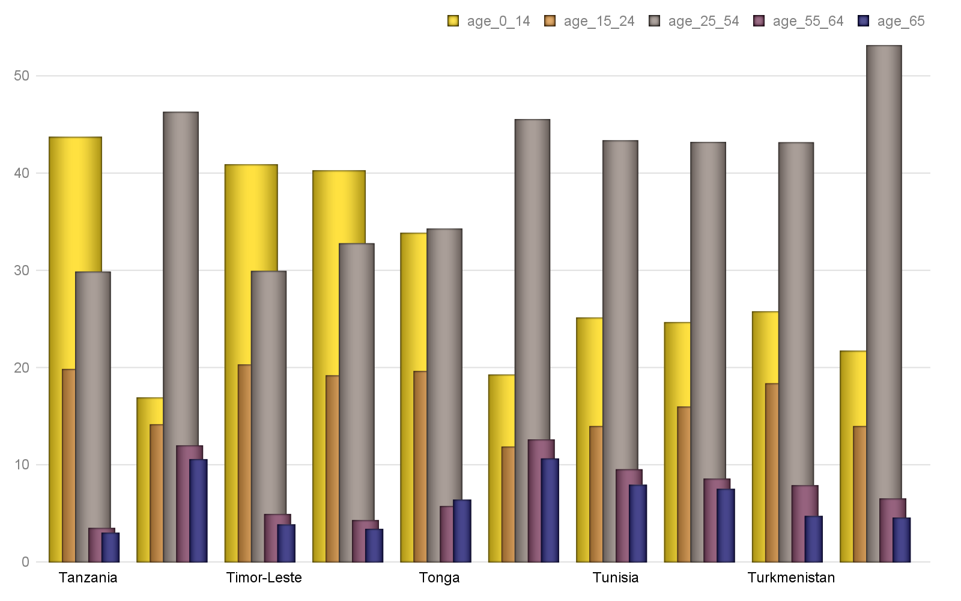

Hinweis: Alle Text Blöcke wurde vom Python-Dokumentation kopiert!

>>> style = styles.add_style('Citation', WD_STYLE_TYPE.PARAGRAPH)

>>> style.name

'Citation'

>>> style.type

# Bericht Block №22

## Text Block №22

Hinweis: Alle Text Blöcke wurde vom Python-Dokumentation kopiert!

Use the base_style property to specify a style the new style should inherit formatting settings from:

>>> style.base_style

None

>>> style.base_style = styles['Normal']

## Tabelle №22

### Altersverteilung für ausgewählte Länder nach WHO: Tuvalu,Uganda,Ukraine,United Arab Emirates,United Kingdom,United States,Uruguay,Uzbekistan,Vanuatu,Venezuela

|  | **Gesamt Population** | Altersgruppen | | | | |
| --- | --- | --- | --- | --- | --- | --- |
| Median | 0-14 | 15-24 | 25-54 | 55-64 | 65+ |
| Tuvalu | 25.7 | 29.29 | 19.26 | 36.66 | 8.77 | 6.02 |
| Uganda | 15.8 | 48.05 | 21.1 | 26.3 | 2.57 | 1.98 |
| Ukraine | 40.6 | 15.76 | 9.86 | 44.29 | 13.8 | 16.3 |
| United Arab Emirates | 30.3 | 21.01 | 13.51 | 61.14 | 3.27 | 1.07 |
| United Kingdom | 40.5 | 17.53 | 11.9 | 40.55 | 11.98 | 18.04 |
| United States | 38.1 | 18.73 | 13.27 | 39.45 | 12.91 | 15.63 |
| Uruguay | 35.0 | 20.17 | 15.69 | 39.34 | 10.56 | 14.25 |
| Uzbekistan | 28.6 | 23.88 | 18.52 | 44.49 | 7.85 | 5.25 |
| Vanuatu | 22.0 | 35.51 | 20.02 | 35.06 | 5.42 | 3.99 |
| Venezuela | 28.3 | 27.36 | 17.03 | 40.53 | 7.98 | 7.09 |
|  | © Dr. Alexander Wagner. All Rights Reserved | | | | | |

Hinweis: Alle Text Blöcke wurde vom Python-Dokumentation kopiert!

<docx.styles.style._ParagraphStyle object at 0x10a7a9550>

>>> style.base_style.name

'Normal'

A style can be removed from the document simply by calling its delete() method:

## Grafik №22

### Altersverteilung für ausgewählte Länder nach WHO: Tuvalu,Uganda,Ukraine,United Arab Emirates,United Kingdom,United States,Uruguay,Uzbekistan,Vanuatu,Venezuela

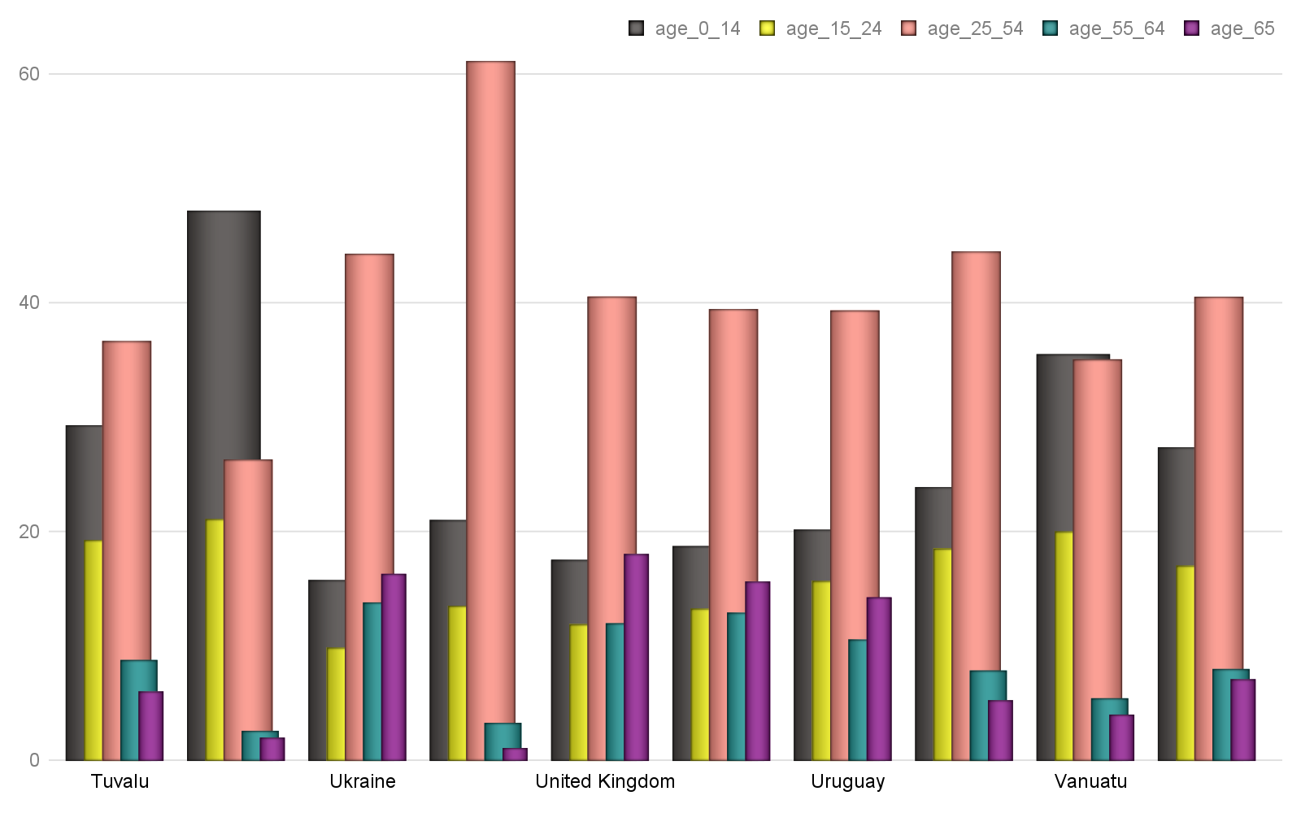

Hinweis: Alle Text Blöcke wurde vom Python-Dokumentation kopiert!

>>> len(styles)

10

>>> styles['Citation'].delete()

>>> len(styles)