**Lightning Detection Using Coral TPU and sense hat IMU**

Team name: TEAMLABx

Choosen theme: Life on Earth

Organization name: Laborky.cz

Country: Czech Republic

**1. Introduction**

The goal of our project was to detect and capture footage of lightnings from space and find correlation with a lightning strike and changes in Earth’s magnetic field. We were hoping to see a spike of some sort in IMU readings.

**2. Method**

Upon launch, the program sets up camera, IMU sensor and Coral TPU. After the initial setup, two threads are spawned. One thread takes care of IMU and position data readment combined with timestamps and appends this information to a CSV file. The second thread’s job is to make short videos of Earth below the station. These clips are parsed into individual frames and classified using our model trained on data from last year. If classified as a clip containing a lighting, the file is moved to „output“ folder and renamed, otherwise the file is deleted. In addition we saved every tenth video regardless the classification so we have at least some usable data in the event of a classification failure.

Both threads have their own assigned storage and time limits which are periodically checked. If one of the threads exceed its limits, it exists independently on the othe thread. This ensures that even if we run out of storage assigned to images, we would still read data from IMU for as long as we can.

**3. Experiment results**

We recieved around an hour worth of footage. Unfotunately because our model was trained on a relatively small and outdated dataset, the classification was not working properly and the propgram falsely flagged clouds as lightning strikes. This inacurracy was further increased by the fact that the camera had been placed in a different window this year.

We attempted to find lightnings manually but due to the amount of footage we likely overlooked something and have not found anything. We also came to the conclusiont, that the IMU picks up a lot of interference from the Raspberry Pi itself so we are fairly certain that detecting lightnings with the current hardware from this altitude is very unreliable if not impossible.

Our magnetometer readings also showed the same anomaly a different team experienced last year where the values chenged inconsistently.

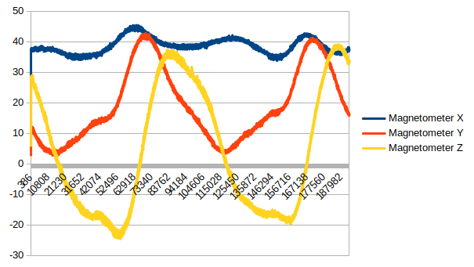

Picture 1: The IMU readings chart

**4.Learnings**

We found out that training an accurate and reliable Tflite model requires a large dataset consisting of very carefully choosen images. We probably should have gone with object detection rather than image classifiacation so we wouldn’t rely on the positioning of the camera and the space around.

**5. Conclusion**

Our poorly set up classification model lead to an overall failure of the experiment. The magnetometer in the sense hat IMU has high enough resolution but due to its placement is basically useless for our application. We detected the same anomaly as a different team from last year and we are still not certain on what exactly happens and why.

We are a bit disappointed about the results.