**Lab 3**

**1. Write a function called check-season, it takes a month parameter and returns the season:**

**Autumn, Winter, Spring or Summer.**

**Code:**

def CheckSeason(month) :

if month in ('Dec','Jan','Feb','December','January','February'):

return 'Winter'

if month in ('Jun','Jul','Aug','June','July','August'):

return 'Summer'

if month in ('Mar','Apr','May','April','March'):

return 'Spring'

if month in ('Sep','Oct','Nov','September','October','November'):

return 'Autumm'

month = input("Enter the Month to know the Season : ")

season = CheckSeason(month)

print("The season is : ",season) 

**2. Write a function called calculate_slope which return the slope of a linear equation.**

**Code:**

def calculate_slope(x1,x2,y1,y2):

    if x2>x1:

        return (y2-y1)/(x2-x1)

    else :

        print("Wrong value entered...x1 must be less than x2")

        return None

x1,x2,y1,y2 = map(float,input("Enter the values of x1,x2,y1,y2 : ").split())

slope = calculate_slope(x1,x2,y1,y2)

if slope is not None :

    print("The slope is : ",slope)



**3. Quadratic equation is calculated as follows: ax² + bx + c = 0. Write a function which**

**calculates solution set of a quadratic equation, _solve_quadratic_eqn_.**

**Code:**

import math

def solve_quadratic_eqn(a, b, c):

discriminant = b**2 - 4*a*c

if discriminant > 0:

# Two distinct real roots

root1 = (-b + math.sqrt(discriminant)) / (2*a)

root2 = (-b - math.sqrt(discriminant)) / (2*a)

return (root1, root2)

elif discriminant == 0:

# One real root (repeated)

root = -b / (2*a)

return root

else:

# Complex roots

real_part = -b / (2*a)

imaginary_part = math.sqrt(-discriminant) / (2*a)

root1 = (real_part, imaginary_part)

root2 = (real_part, -imaginary_part)

return (root1, root2)

a, b, c = map(float, input("Enter the coefficients a, b, c: ").split())

solutions = solve_quadratic_eqn(a, b, c)

print("The solutions are:", solutions)



**4. Declare a function named print_list. It takes a list as a parameter and it prints out each**

**element of the list.**

**Code:**

def print_list(bikeList) :

for ele in bikeList :

print(ele)

bikeList = ['Royal Enfield','Bajaj','KTM','Yamaha','TVS','Honda']

print_list(bikeList)

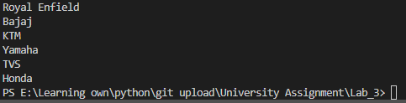

**5. Declare a function named reverse_list. It takes an array as a parameter and it returns the**

**reverse of the array (use loops).**

**Code:**

def reverse_list(arr) :

rev_arr = []

for i in range (len(arr)-1,0):

rev_arr.append(arr[i])

return rev_arr

arr = [4,5,6,7,8,9]

rev_arr = reverse_list(arr)

print("Original : ",arr)

print("Reversed : ",rev_arr) 

**6. Compute the sum up to n terms in the series**

**1 - 1/2 + 1/3 - 1/4 + 1/5 -... 1/n where n is a positive integer and input by user.**

**Code:**

def compute_series_sum(n):

total_sum = 0.0

for i in range(1, n + 1):

term = (-1) ** (i + 1) / i

total_sum += term

return total_sum

n = int(input("Enter the number of terms (positive integer): "))

if n > 0:

result = compute_series_sum(n)

print(f"The sum of the series up to {n} terms is: {result:.6f}")

else:

print("Invalid input. The number of terms must be a positive integer.")



**7. Write a program to compute sin x for given x. The user should supply x and a positive integer**

**n. We compute the sine of x using the series and the computation should use all terms in the**

**series up through the term involving xn**

**sin x = x - x3/3! + x5/5! - x7/7! + x9/9! ........**

**Code:**

def factorial(n) :

if n==0 or n==1 :

return 1

else :

fact = 1

for i in range(2,n+1) :

fact = fact * i

return fact

def sin_calculate(x,n) :

sin_x = 0

for i in range (n) :

sign = (-1) ** i

term = sign * (x**(2*i+1))/factorial(2*i+1)

sin_x = sin_x + term

return sin_x

x = float(input("Enter the value of x(in radian) : "))

n = int(input("Enter n value : "))

sinX = sin_calculate(x,n)

print("Sin(x) is : ",sinX)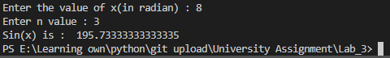

**8. Write a program to compute cosine of x. The user should supply x and a positive integer n.**

**We compute the cosine of x using the series and the computation should use all terms in the**

**series up through the term involving xn**

**cos x = 1 - x2/2! + x4/4! - x6/6! ....**

**Code:**

def factorial(n) :

if n==0 or n==1 :

return 1

else :

fact = 1

for i in range(2,n+1) :

fact = fact * i

return fact

def cos_calculate(x,n) :

cos_x = 0

for i in range (n) :

sign = (-1) ** i

term = sign * (x**(2*i))/factorial(2*i)

cos_x = cos_x + term

return cos_x

x = float(input("Enter the value of x(in radian) : "))

n = int(input("Enter n value : "))

cosX = cos_calculate(x,n)

print("Cos(x) is : ",cosX) 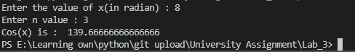

**9. Print the pattern upto N Lines:**

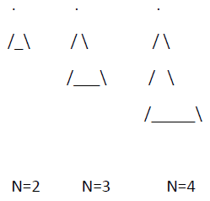

**Code:**

def printPattern(n) :

gap = n-1

for i in range (0,n):

#1st line

if(i==0):

for k in range (gap) :

print(' ', end=' ')

print(".")

gap = gap -1

continue

#last line

if(i==n-1):

for k in range (gap):

print(' ', end=' ')

gap = gap-1

print("/", end=' ')

for j in range(0,2*i-1):

print("_", end=' ')

print("\\", end=' ')

print()

continue

#middle lines

if(n>i):

for k in range (gap):

print(' ', end=' ')

gap = gap-1

print("/", end=' ')

for j in range(0,2*i-1):

print(" ", end=' ')

print("\\", end=' ')

print()

continue

n =int(input("Enter the number of terms : "))

printPattern(n) 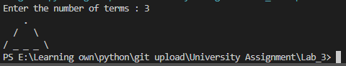

**10. Print a number as a 8 segment display N Lines:**

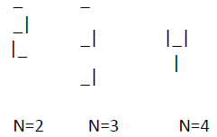

**Code:**

segment = {

  '0' :[' _','| |','|_|'],

  '1' :[' ',' |',' |'],

  '2' :[' _',' _|','|_'],

  '3' :['_','_|','_|'],

  '4' :['','|_|','  |'],

  '5' :[' _','|_',' _|'],

  '6' :[' _','|_','|_|'],

  '7' :['_',' |',' |'],

  '8' :[' _','|_|','|_|'],

  '9' :[' _','|_|',' _|']

}

def print_8_seg(num) :

    rows = ['','','']

    for digit in str(num) :

        for j in range(3):

            rows[j] = segment[digit][j]

    for row in rows:

        print(row)

N = int(input("Enter a number : "))

print_8_seg(N)

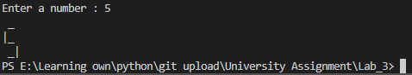

**11. Print the pattern upto N lines:**

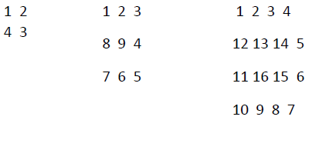

**Code:**

def spiral_matrix(n):

    matrix = [[0] * n for _ in range(n)]

    num = 1

    top, bottom, left, right = 0, n - 1, 0, n - 1

    while top <= bottom and left <= right:

        # left to right

        for i in range(left, right + 1):

            matrix[top][i] = num

            num += 1

        top += 1

        # top to bottom

        for i in range(top, bottom + 1):

            matrix[i][right] = num

            num += 1

        right -= 1

        # right to left

        for i in range(right, left - 1, -1):

            matrix[bottom][i] = num

            num += 1

        bottom -= 1

        # bottom to top

        for i in range(bottom, top - 1, -1):

            matrix[i][left] = num

            num += 1

        left += 1

    return matrix

def print_matrix(matrix):

    for row in matrix:

        print(" ".join(map(str, row)))

N = int(input("Enter the number of lines N: "))

if N > 0:

    spiral_matrix = spiral_matrix(N)

    print_matrix(spiral_matrix)

else:

    print("N should be a positive integer.")

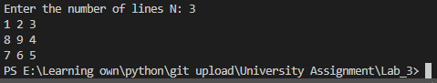

**12. Write a python script that displays the following table**

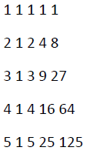

**Code:**

def print_matrix(matrix):

for row in matrix:

print(" ".join(map(str, row)))

n = 5

matrix = [[0] * n for _ in range(n)]

#1st column

for i in range (0,n) :

matrix[i][0] =i+1

#2nd column

for i in range (0,n) :

matrix[i][1] = 1

#other column

for i in range (0,n):

for j in range(2,n):

matrix[i][j] = matrix[i][0] * matrix[i][j-1]

print_matrix(matrix) 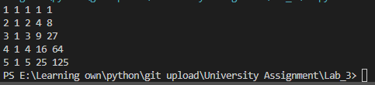

**Java TO Python**

**Week 2**

**20.** **Write a Java program to read two integer values m and n and to decide and print whether m is multiple of n.**

**Code:**

m = int(input("Enter the first integer (m): "))

n = int(input("Enter the second integer (n): "))

if n != 0 and m % n == 0:

print(f"{m} is a multiple of {n}")

else:

print(f"{m} is not a multiple of {n}")

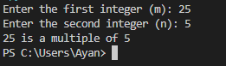

**21.** **Write a Java program to display prime numbers between a given interval.**

**Code:**

def is_prime(num):

    if num <= 1:

        return False

    for i in range(2, int(num**0.5) + 1):

        if num % i == 0:

            return False

    return True

def display_primes(lower, upper):

    print(f"Prime numbers between {lower} and {upper} are:")

    for num in range(lower, upper + 1):

        if is_prime(num):

            print(num, end=" ")

    print()

lower = int(input("Enter the lower bound of the interval: "))

upper = int(input("Enter the upper bound of the interval: "))

display_primes(lower, upper)

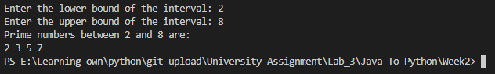

**22.** **Write a Java program to check whether a given number is Armstrong Number or not.**

**Code:**

def is_armstrong(number):

digits = str(number)

num_digits = len(digits)

armstrong_sum = sum(int(digit) ** num_digits for digit in digits)

return armstrong_sum == number

number = int(input("Enter a number: "))

if is_armstrong(number):

print(f"{number} is an Armstrong number.")

else:

print(f"{number} is not an Armstrong number.")



**Write Java programs for the patterns given bellow: (23-25)**

**23.** 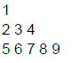

**Code:**

def generate_pattern(rows):

current_number = 1

for i in range(rows):

num_elements = 2 * i + 1

for _ in range(num_elements):

print(current_number, end=" ")

current_number += 1

print()

num_rows = 3

generate_pattern(num_rows)

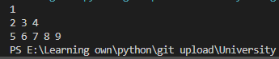

**24.** 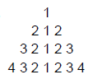

**Code:**

def generate_pattern(n):

for i in range(1, n + 1):

row = list(range(i, 0, -1)) + list(range(2, i + 1))

row_str = " ".join(map(str, row))

leading_spaces = " " * (2 * (n - i))

print(leading_spaces + row_str)

num_rows = 4

generate_pattern(num_rows) 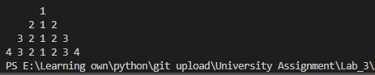

**25.** 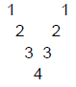

**Code:**

def generate_pattern(n):

for i in range(1, n + 1):

row = f"{i}"

leading_spaces = " " * (i - 1)

internal_spaces = " " * (2 * (n - i) - 1)

if i < n:

row = leading_spaces + row + internal_spaces + row

else:

row = leading_spaces + row

print(row)

num_rows = 4

generate_pattern(num_rows) 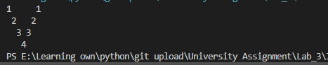

**Week 3**

1. **Write a Java program to calculate Sum & Average of an integer array.**

**Code:**

def calculate_sum_and_average(arr):

total_sum = sum(arr)

average = total_sum / len(arr) if len(arr) > 0 else 0

return total_sum, average

n = int(input("Enter the number of elements in the array: "))

arr = []

for i in range(n):

element = int(input(f"Enter element {i+1}: "))

arr.append(element)

total_sum, average = calculate_sum_and_average(arr)

print(f"Sum of the array: {total_sum}")

print(f"Average of the array: {average:.2f}")

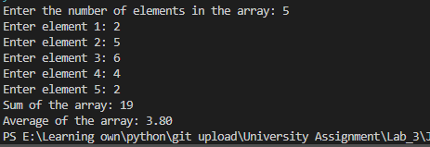

1. **Write a Java program to implement stack using array.**

**Code :**

**Code:**

stack = []

def push(element):

stack.append(element)

print(f"{element} is pushed to the stack.")

def pop():

if len(stack) == 0:

print("Stack is empty. Cannot pop.")

else:

element = stack.pop()

print(f"{element} is popped from the stack.")

def peek():

if len(stack) == 0:

print("Stack is empty. Nothing to peek.")

return None

return stack[-1]

def display():

if len(stack) == 0:

print("Stack is empty!")

else:

print("Displaying stack:")

for i in stack:

print(i, end=" ")

print()

while True:

print("\n-----------")

print("Stack Menu:")

print("-----------")

print("1. Push")

print("2. Pop")

print("3. Peek")

print("4. Display")

print("5. Exit")

try:

choice = int(input("Enter your choice: "))

except ValueError:

print("Invalid input. Please enter a number.")

continue

if choice == 1:

element = int(input("Enter the element: "))

push(element)

elif choice == 2:

pop()

elif choice == 3:

result = peek()

if result is not None:

print("Peek is:", result)

elif choice == 4:

display()

elif choice == 5:

print("Exiting...")

break

else:

print("Invalid choice. Please enter a number between 1 and 5.")

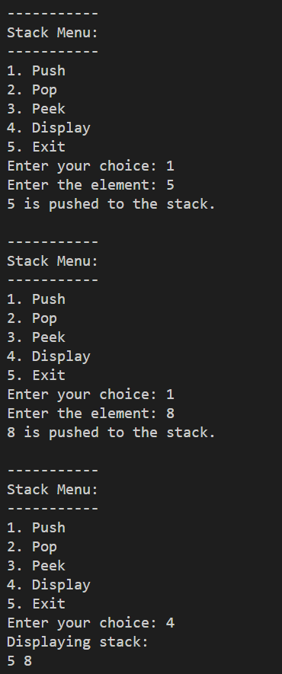 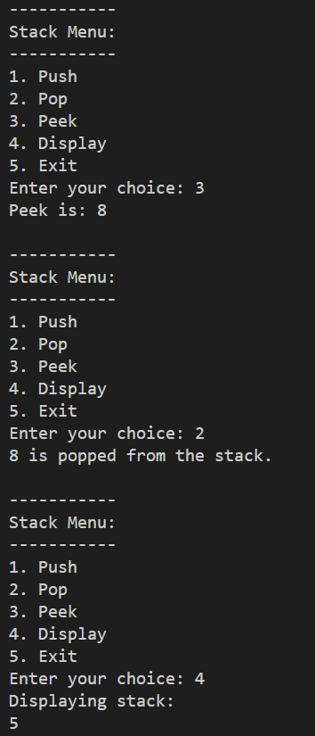 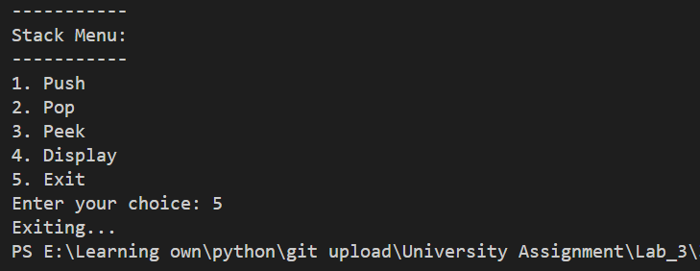

1. **Write a Java program to implement Queue using array.**

**Code:**

queue = []

def enqueue(element):

queue.append(element)

print(f"{element} has been enqueued to the queue.")

def dequeue():

if len(queue) == 0:

print("Queue is empty. Cannot dequeue.")

else:

element = queue.pop(0)

print(f"{element} has been dequeued from the queue.")

def peek():

if len(queue) == 0:

print("Queue is empty. Nothing to peek.")

return None

return queue[0]

def display():

if len(queue) == 0:

print("Queue is empty!")

else:

print("Displaying queue:")

for i in queue:

print(i, end=" ")

print()

while True:

print("\n-----------")

print("Queue Menu:")

print("-----------")

print("1. Enqueue")

print("2. Dequeue")

print("3. Peek")

print("4. Display")

print("5. Exit")

try:

choice = int(input("Enter your choice: "))

except ValueError:

print("Invalid input. Please enter a valid number.")

continue

if choice == 1:

element = int(input("Enter the element: "))

enqueue(element)

elif choice == 2:

dequeue()

elif choice == 3:

result = peek()

if result is not None:

print("Peek is:", result)

elif choice == 4:

display()

elif choice == 5:

print("Exiting...")

break

else:

print("Invalid choice. Please enter a number between 1 and 5.")

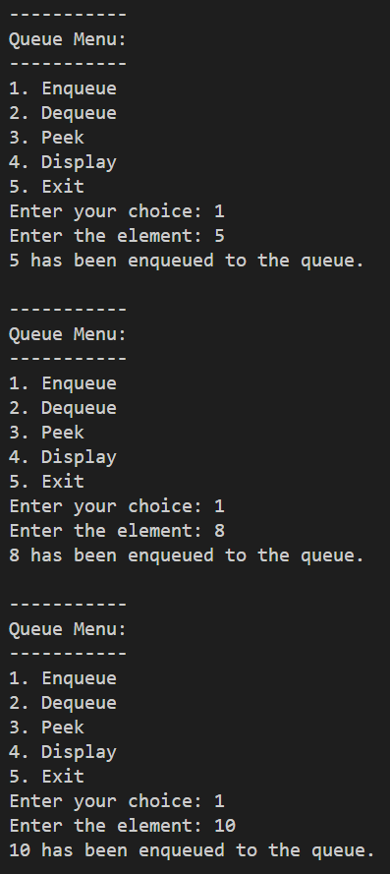 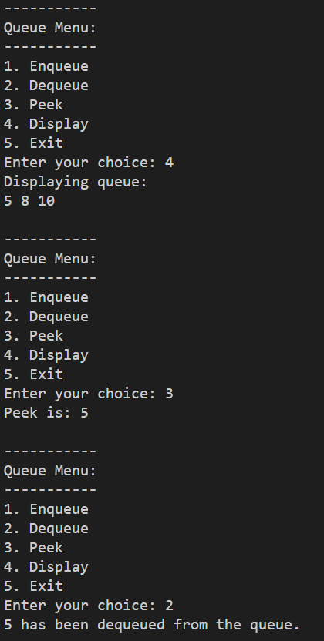 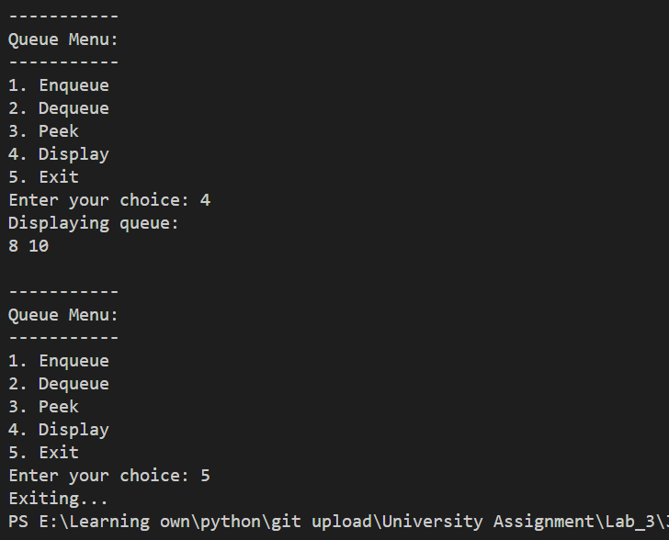

**Lab 4**

1. **Write a program to enter a string. Calculate the length of the string. Find the substring country.Count the occurences of each word in the given sentence.**

**If the String as input is India is my motherland. I love my country. Capital of India is New Delhi.**

**Code :**

strr = input("Enter the string : ")

lenght = len(strr)

print(f"lenght is {lenght}")

subString = "country"

index = strr.lower().find(subString)

print(f"Position of {subString} is {index}")

import string

translator = str.maketrans('', '', string.punctuation)

cleaned_string = strr.lower().translate(translator)

words = cleaned_string.split()

word_count = {}

for word in words:

if word in word_count:

word_count[word] += 1

else:

word_count[word] = 1

print("Word occurrences:")

for word, count in word_count.items():

print(f"{word}: {count}")

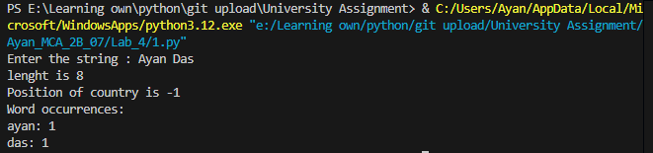

1. **Write a program that accepts a comma separated sequence of words as input and prints the words in a comma-separated sequence after sorting them alphabetically. Suppose the following input is supplied to the program:**

**without,hello,bag,world**

**Then, the output should be:**

**bag,hello,without,world**

**Code :**

input_string = input("Enter a comma-separated sequence of words: ")

words = input_string.split(',')

sorted_words = sorted(words)

output_string = ','.join(sorted_words)

print(output_string)

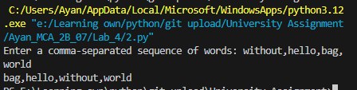

1. **Write a program that accepts sequence of lines as input and prints the lines after making all characters in the sentence capitalized. Suppose the following input is supplied to the program:**

**Hello world**

**Practice makes perfect**

**Then, the output should be:**

**HELLO WORLD**

**PRACTICE MAKES PERFECT**

**Code :**

input_lines = []

print("Enter the lines (Press Enter twice to stop):")

while True:

line = input()

if line:

input_lines.append(line)

else:

break

output_lines = [line.upper() for line in input_lines]

for line in output_lines:

print(line)

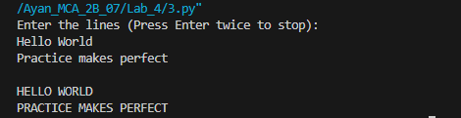

1. **Write a program that accepts a sequence of whitespace separated words as input and prints the words after removing all duplicate words and sorting them alphanumerically. Suppose the following input is supplied to the program:**

**hello world and practice makes perfect and hello world again**

**Then, the output should be:**

**again and hello makes perfect practice world**

**Code :**

input_string = input("Enter a sequence of whitespace-separated words: ")

words = input_string.split()

unique_sorted_words = sorted(set(words))

output_string = ' '.join(unique_sorted_words)

print(output_string)

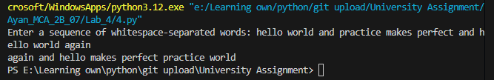

1. **Write a program that accepts a sentence and calculate the number of letters and digits. Suppose the following input is supplied to the program:**

**hello world! 123**

**Then, the output should be:**

**LETTERS 10**

**DIGITS 3**

**Code :**

input_string = input("Enter a sentence: ")

letters = 0

digits = 0

for char in input_string:

    if char.isalpha():

        letters += 1

    elif char.isdigit():

        digits += 1

print(f"LETTERS {letters}")

print(f"DIGITS {digits}")

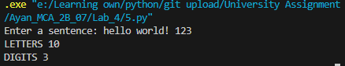

1. **Write a program which accepts a string as input to print &quot;Yes&quot; if the string is &quot;yes&quot; or &quot;YES&quot; or &quot;Yes&quot;, otherwise print &quot;No&quot;.**

**Code :**

input_string = input("Enter a string: ")

if input_string.lower() == "yes":

print("Yes")

else:

print("No"))

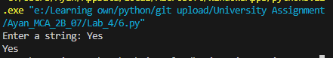

1. **Write a program which accepts a sequence of words separated by whitespace as input to print the words composed of digits only.**

**Example:**

**If the following words is given as input to the program:**

**2 cats and 3 dogs.**

**Then, the output of the program should be:**

**[‘2’,’3’]**

**In case of input data being supplied to the question, it should be assumed to be a console input.**

**Code :**

input_string = input("Enter a sequence of words separated by whitespace: ")

words = input_string.split()

digit_words = [word for word in words if word.isdigit()]

print(digit_words)

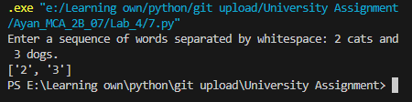

1. **Please write a program which count and print the numbers of each character in a string input by console.**

**Example:**

**If the following string is given as input to the program:**

**abcdefgabc**

**Then, the output of the program should be:**

**a,2**

**c,2**

**b,2**

**e,1**

**d,1**

**g,1**

**f,1**

**Code :**

from collections import Counter

input_string = input("Enter a string: ")

char_count = Counter(input_string)

for char in sorted(char_count.keys()): print(f"{char},{char_count[char]}")

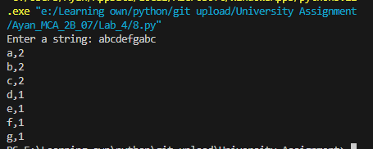

1. **Write a program that accepts a string**
2. **reverses it.**
3. **checks whether it is a palindrome.**
4. **checks whether it ends with a specific substring.**
5. **capitalize the first letter of each word in a string**
6. **check if a string is anagram of another string**
7. **remove vowels from string**
8. **find length of the longest word in a sentence**

**Code :**

def reverse_string(s):

# Reverse the given string.

return s[::-1]

def is_palindrome(s):

# Check if the given string is a palindrome.

return s == s[::-1]

def ends_with_substring(s, substring):

# Check if the string ends with the given substring.

return s.endswith(substring)

def capitalize_words(s):

# Capitalize the first letter of each word in the string.

return ' '.join(word.capitalize() for word in s.split())

def is_anagram(s1, s2):

# Check if s1 is an anagram of s2.

return sorted(s1) == sorted(s2)

def remove_vowels(s):

# Remove vowels from the given string.

vowels = 'aeiouAEIOU'

return ''.join(char for char in s if char not in vowels)

def longest_word_length(sentence):

# Find the length of the longest word in a sentence.

words = sentence.split()

return max(len(word) for word in words) if words else 0

if __name__ == "__main__":

input_string = input("Enter a string: ")

reversed_string = reverse_string(input_string)

print("Reversed string:", reversed_string)

palindrome_status = is_palindrome(input_string)

print("Is palindrome:", palindrome_status)

substring = input("Enter a substring to check if the string ends with it: ")

ends_with_status = ends_with_substring(input_string, substring)

print("Ends with substring:", ends_with_status)

capitalized_string = capitalize_words(input_string)

print("Capitalized words:", capitalized_string)

another_string = input("Enter another string to check if it's an anagram: ")

anagram_status = is_anagram(input_string, another_string)

print("Is anagram:", anagram_status)

string_without_vowels = remove_vowels(input_string)

print("String without vowels:", string_without_vowels)

sentence = input("Enter a sentence to find the length of the longest word: ")

longest_word_len = longest_word_length(sentence)

print("Length of the longest word:", longest_word_len)