THE REWIND
Evidence-Backed AI Incident Reconstruction Engine for Multi-Camera Video

ONE-LINE PITCH
REWIND acts like an AI investigator: after an abnormal event occurs, it rewinds multiple camera streams, reconstructs the timeline, connects evidence across views, identifies likely causes, and explicitly marks uncertainty when the cameras cannot prove what happened.

1. Executive proposal
REWIND is a multi-camera video intelligence system for incident investigation. It is designed for environments such as warehouses, laboratories, campuses, manufacturing floors and controlled facilities. Rather than asking a vision model to summarize a video, REWIND converts video into structured entities and events, synchronizes those events across cameras, detects an incident, and reconstructs the sequence that led to it.
The defining principle is evidence before explanation. The system must be able to distinguish confirmed observations from inferred relationships and unknown intervals. This makes the project a strong demonstration of computer vision, temporal reasoning, data engineering, explainability and production software architecture.

2. Problem statement
When an incident occurs, investigators often need to inspect multiple camera feeds manually. The relevant evidence may be distributed across cameras, partially occluded, delayed, or visible only before the incident. A simple video classifier can identify that an anomaly occurred but cannot reliably reconstruct the sequence or show how the conclusion was reached.
- Multiple cameras contain fragmented views of the same event.
- Object identities and trajectories need to persist across time and cameras.
- The causal sequence is usually temporal rather than a single frame.
- Occlusion creates evidence gaps that can tempt generative models to hallucinate.
- Investigators need a searchable timeline and traceable evidence, not just a paragraph.

3. Proposed solution
- Ingest multiple synchronized or approximately synchronized video streams.
- Detect and track relevant entities in each camera.
- Associate likely identities across cameras.
- Convert trajectories into semantic events such as entered zone, stopped, crossed path or changed direction.
- Detect an anomalous incident and automatically select a temporal investigation window.
- Rewind the window and reconstruct a cross-camera timeline.
- Build an evidence graph connecting entities, actions and observations.
- Estimate likely causes while preserving uncertainty.
- Generate a concise investigator report with links to supporting evidence.

4. Concrete example
A robot unexpectedly performs an emergency stop. Camera A shows a worker entering an aisle. Camera B shows the robot approaching the same region. Camera C shows a forklift entering the intersection and partially blocking visibility. REWIND aligns the observations, identifies the worker and robot trajectories, recognizes the narrowing separation, marks the forklift as an occlusion factor, and reports that the worker entering the robot trajectory is the most likely contributing cause—while clearly marking any unobserved interval as uncertain.

5. Industry-grade architecture
Camera A ─┐
Camera B ─┼──► Ingestion / Timestamp Alignment ─► Video Buffer
Camera C ─┘ │
▼
Vision Perception Service
│
▼
Multi-Object Tracking
│
▼
Cross-Camera Identity Layer
│
▼
Event Extraction
│
┌───────────┴───────────┐
▼ ▼
Event / Time Store Incident Detector
│
▼
Investigation Window
│
┌──────────────────────┴─────────────────────┐
▼ ▼
Evidence Graph Evidence Retrieval
│ │
└──────────────────────┬─────────────────────┘
▼
Reasoning / Report Layer
│
▼
Investigator Dashboard
ARCHITECTURE PRINCIPLE
Separate perception/ML workloads from product APIs; make expensive inference asynchronous where possible; persist evidence and confidence rather than only final predictions.

6. The evidence model
Every claim in the final report is represented as an evidence-backed statement. For example: “Worker #42 entered Zone B at 10:32:10” is a direct observation supported by Camera A. “Worker #42 was the likely trigger for the robot stop” is an inference supported by a sequence of observations. “A collision occurred” would be UNKNOWN if no camera actually establishes contact.
Evidence level | Example | Allowed language
Confirmed | Object visible entering zone | “Observed”
Strongly inferred | Two trajectories converge then robot stops | “Likely contributed”
Possible | Event consistent with available evidence | “Possible”
Unknown | Critical interval fully occluded | “Cannot determine”

7. Incident reconstruction pipeline
- Incident trigger: detect an abnormal state change such as an emergency stop, sudden fall, unexpected route change or zone violation.
- Temporal rewind: select a configurable window before and after the incident.
- Cross-camera alignment: map events onto a shared timeline.
- Entity linking: maintain consistent IDs where visual evidence supports the association.
- Event extraction: convert raw trajectories into semantic events.
- Evidence graph construction: connect observations, entities, locations and timestamps.
- Cause ranking: score candidate explanations using temporal and spatial relationships.
- Uncertainty analysis: identify gaps, conflicts and low-confidence associations.
- Report generation: summarize only what the evidence supports.

8. Explainability & anti-hallucination design
The LLM, if used, is deliberately placed at the end of the pipeline. It receives structured evidence rather than raw authority to invent events. The report generator must cite internal evidence IDs for every material claim. If evidence is missing, the system is required to output an uncertainty state. This architecture makes explainability a system property rather than a prompt instruction.

9. Product orientation & UX
- Incident inbox: severity, time, location and investigation status.
- Synchronized replay: multiple camera panes with a shared timeline.
- Timeline: entity and event tracks aligned to timestamps.
- Evidence graph: visual relationship map between entities and events.
- Root-cause panel: ranked hypotheses with supporting evidence.
- Uncertainty markers: visually distinguish observed, inferred and unknown intervals.
- Ask-the-incident: controlled natural-language queries such as “Why did Robot R12 stop?”
- Export: investigator report containing timeline, evidence and confidence.

10. Engineering quality bar
- Event-driven pipeline so video processing, indexing and reporting are independently scalable.
- FastAPI for query/report APIs and WebSockets for live investigation state.
- PostgreSQL for incident metadata and event relationships.
- Object storage for video segments and evidence snapshots.
- Redis for short-lived investigation state and caching.
- Vector search for semantic retrieval of relevant evidence descriptions.
- Dockerized services with automated tests and CI.
- Observability for processing latency, dropped frames, identity switches, inference failures and report-generation failures.
- Immutable evidence references so a report can be audited later.

11. Hardware-conscious implementation
- Begin with three prerecorded streams instead of live cameras.
- Process at reduced resolution/frame rate while preserving enough temporal information.
- Use compact detection and tracking models; avoid training a foundation model.
- Run streams sequentially during development and parallelize only where profiling shows benefit.
- Store extracted events so the reasoning layer does not repeatedly process raw video.
- Use a small quantized local language model for report generation if desired; the core reconstruction engine must work without an LLM.

12. Evaluation plan
Metric | What it measures
Detection precision/recall | Whether relevant entities/events are found
ID consistency | Tracking and cross-camera identity quality
Timeline accuracy | Correct ordering/timestamping of events
Cause ranking | Whether the true/contributing cause is ranked highly
Evidence coverage | Percentage of claims backed by evidence
Unsupported-claim rate | How often the system states something it cannot prove
Investigation latency | Time from incident trigger to usable report
Human agreement | Agreement between system findings and annotated incidents

13. Phased roadmap
Phase | Deliverable | Success criterion
P0 | Three-camera dataset + synchronized schema | Reproducible incident cases
P1 | Detection + single-camera tracking | Stable entity trajectories
P2 | Multi-camera identity linking | Cross-view event continuity
P3 | Event/timeline engine | Searchable incident timeline
P4 | Evidence graph + cause ranking | Auditable reconstruction
P5 | Investigator UI + replay | Usable end-to-end workflow
P6 | LLM report layer + evaluation | Evidence-grounded natural-language report
P7 | Productionization | Tests, containers, monitoring, deployment

Reference alignment
This proposal is intentionally aligned with themes visible in current Amazon student and engineering role descriptions: scalable systems, cloud-native architectures, microservices, distributed systems, ML/computer vision, resilient services, CI/CD, monitoring, and end-to-end ownership. Sources: Amazon University SDE roles; Amazon SDE early-career roles; Amazon Optics; Amazon Selection and Catalog Systems.
https://www.amazon.jobs/content/en/career-programs/university/sde
https://www.amazon.jobs/en/jobs/10511479/software-development-engineer-amazon-optics
https://www.amazon.jobs/en/jobs/10524045/software-development-engineer-genai-ml-amazon-selection-and-catalog-systems-ascs
URLs are provided as references for the mentor; the project itself is not represented as an Amazon project.

REWIND — Master Build Specification
This expanded document is the engineering source of truth for the approved REWIND project. It complements the original proposal with implementation-level requirements, architecture, repository conventions, hardware planning, timeline, risk controls and a strict documentation system.

A. Architecture at a Glance
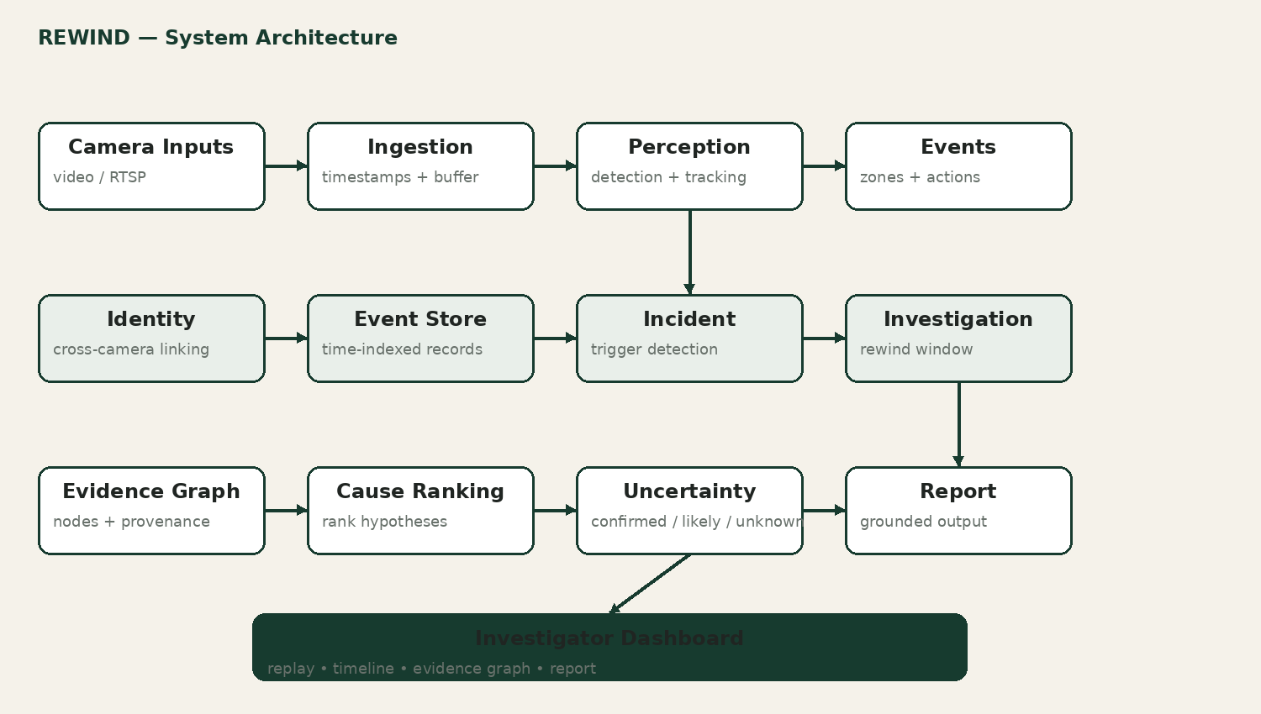
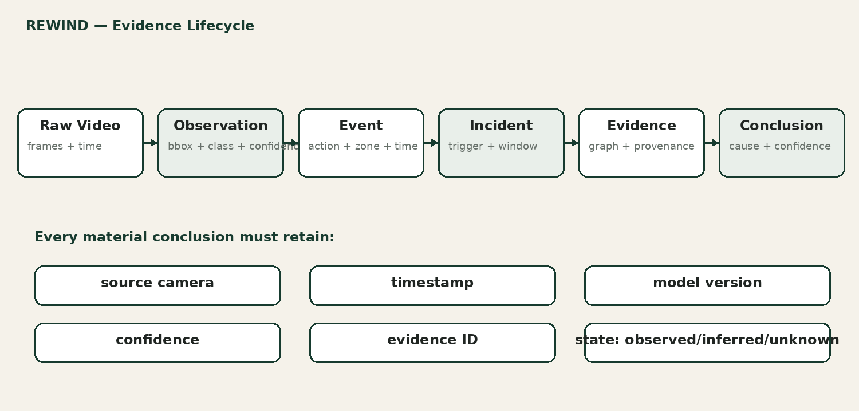

B1. Functional requirements
- Accept at least three prerecorded camera videos; support RTSP/live input as a later milestone.
- Create a processing run with a unique run ID, input hash, dataset/version information and configuration version.
- Extract source FPS, resolution, duration, timestamps and camera metadata.
- Sample frames deterministically to control GPU load.
- Detect configured entities such as person, robot, forklift and equipment.
- Track entities within each camera and preserve observation history.
- Associate track segments across cameras using time, appearance and optional scene geometry.
- Convert tracks into semantic events: zone entry/exit, stop, direction change, proximity, occlusion and state change.
- Detect an incident trigger and automatically define an investigation window.
- Construct a cross-camera timeline.
- Construct an evidence graph with provenance.
- Generate and rank candidate contributing causes.
- Represent confirmed, likely, possible, conflicting and unknown evidence.
- Provide synchronized replay and event-to-video navigation.
- Generate an investigation report with evidence references.
- Allow case reprocessing with another model/configuration version.
- Maintain an audit trail of processing runs, model versions and report revisions.

B2. Non-functional requirements
Requirement | Target / rule
Performance | Heavy video work is asynchronous; ordinary metadata API queries should target sub-500 ms locally.
Reliability | Jobs must be retryable; service restarts must not erase case state.
Scalability | Perception workers must be separable from APIs and UI.
Reproducibility | Input hash + dataset version + model version + config version recorded per run.
Observability | Health, logs, processing latency and model quality metrics are measurable.
Security | Authentication and role-based authorization before multi-user/cloud exposure.
Privacy | Public, synthetic or explicitly permitted video only.
Explainability | Material claims must point to evidence IDs.
Maintainability | Typed contracts, tests, modular code and documented interfaces.

C. Detailed Technical Stack
Layer | Choice | Why
Primary language | Python | CV/ML ecosystem and backend productivity.
Frontend | TypeScript + React | Strong interactive UI ecosystem and typed browser code.
Vision | OpenCV + PyTorch | Video processing and GPU ML.
Detector | Compact YOLO-family model | Strong baseline with manageable GPU requirements.
Tracker | ByteTrack first | Lightweight baseline; alternatives evaluated only if needed.
Backend | FastAPI + Uvicorn + Pydantic | Typed APIs, OpenAPI and WebSockets.
Database | PostgreSQL | Relational integrity for cases/events plus flexible JSONB evidence/config fields.
Cache | Redis | Transient state, caching and progress.
Event stream | Kafka or Redpanda | Decoupled asynchronous event processing after MVP.
Storage | Local filesystem → S3-compatible object storage | Simple MVP, scalable artifact storage later.
Containers | Docker + Docker Compose | Reproducible multi-service local environment.
Testing | pytest + API integration + Playwright | Backend, pipeline and browser validation.
CI/CD | GitHub Actions | Automated quality gates.
Observability | Structured logs + metrics; Grafana/OpenTelemetry later | Operational visibility.
Documentation | Markdown + Mermaid + ADR + experiment registry | Traceable engineering record.

Current official documentation supports the selected direction: Ultralytics documents Python inference, tracking and model export; FastAPI documents WebSockets and testing/deployment; Docker Compose is designed for multi-container applications; Kafka is an event-streaming platform; PostgreSQL supports indexed JSONB. citeturn0search9turn0search12turn0search1turn0search4turn0search0turn0search5

D. ML Pipeline and Training Strategy

D1. Phase 1: deterministic baseline
- Run a pretrained detector on a fixed benchmark.
- Run ByteTrack on each camera.
- Convert tracks to trajectories.
- Implement zone and proximity rules.
- Create a deterministic incident trigger.
- Measure detection, tracking and event quality.

D2. Phase 2: learned components
- Temporal model: classify short trajectory windows or predict incident risk.
- Cross-camera model: compare appearance embeddings plus time/geometry features.
- Cause ranker: rank candidate hypotheses rather than directly generating causal text.
- Anomaly model: learn normal route/interaction patterns.
- Calibration: ensure confidence values are useful for threshold decisions.

D3. LLM policy
The LLM is optional and must sit after the evidence graph. It receives structured evidence, not unrestricted raw-video authority. The report generator may summarize confirmed observations and clearly labeled inferences. It must not invent missing events. A deterministic template report remains available.

D4. Evaluation protocol
Component | Primary metrics
Detection | precision, recall, mAP where appropriate, FPS
Tracking | ID switches, HOTA/IDF1 where tooling permits
Cross-camera identity | precision, recall, false-link rate
Event extraction | precision, recall, F1, timing error
Incident detection | precision, recall, false-alert rate, lead time
Cause ranking | top-1/top-k agreement with annotated causes
Evidence quality | evidence coverage, unsupported-claim rate
System | latency, throughput, retries, peak VRAM

Every advanced method must be compared against a simpler baseline. The project should never present a complex model merely because it is complex.

E. Data and Database Design

E1. Core schema
Table | Important fields
cameras | id, name, source_uri, timezone, calibration_ref
processing_runs | id, input_hash, dataset_version, model_versions, config_version, timestamps
observations | id, run_id, camera_id, timestamp, class, bbox, confidence, track_id
track_segments | id, camera_id, local_track_id, start_time, end_time, trajectory_ref
identity_links | id, segment_a, segment_b, score, evidence_refs
events | id, type, entity_ids, camera_id, timestamp, confidence, evidence_refs
incidents | id, trigger_event, start_time, end_time, severity, status
evidence_nodes | id, type, source_ref, timestamp, confidence, provenance
evidence_edges | id, from_node, to_node, relation, weight, provenance
hypotheses | id, incident_id, description, score, support_refs, contradiction_refs
reports | id, incident_id, generator_version, content, evidence_refs, created_at

E2. Data retention policy
- Raw video is the largest artifact and should not be duplicated unnecessarily.
- Derived observations may be retained for reproducibility, but old low-value frame records can be compacted after benchmarks.
- Evidence snapshots referenced by reports must remain immutable.
- Dataset manifests store source, license/permission, version and checksum.
- Secrets and credentials never enter the database or Git repository.

F. API Contract
Method | Endpoint | Purpose
POST | /api/v1/cases | Create case and processing job
GET | /api/v1/cases/{id} | Case summary
GET | /api/v1/cases/{id}/timeline | Timeline
GET | /api/v1/cases/{id}/evidence | Evidence graph
GET | /api/v1/cases/{id}/replay | Synchronized replay metadata
GET | /api/v1/cases/{id}/report | Current report
POST | /api/v1/cases/{id}/reprocess | Re-run with selected version
GET | /api/v1/health | Health
GET | /api/v1/metrics | Operational metrics

Internal event contracts should include event_id, schema_version, event_type, event_time, entity_ids, source_camera, producer_service, producer_version, confidence, evidence_refs and payload. This makes downstream services independent of model-specific Python objects.

G. Frontend Product Specification
Screen | Required behavior
Case Inbox | Filter incidents by severity, time, location and status.
Incident Workspace | Show synchronized video panes, timeline and current investigation state.
Evidence Graph | Show entities, actions, locations and relationships.
Hypothesis Panel | Rank candidate causes and show supporting/contradicting evidence.
Evidence Gap View | Highlight occluded, missing or conflicting intervals.
Report View | Show conclusion, confidence and clickable evidence references.
System Health | Show workers, queue depth, latency and failures.
Analytics | Show recurring incident patterns and false-alert review.

- Clicking an event seeks every relevant camera to the same timestamp.
- Every conclusion should be reachable from its evidence in one or two interactions.
- Unknown must be visually different from confirmed.
- Confidence is visible near the claim.
- The interface should never imply that an inferred cause is a directly observed fact.

H. Hardware Plan for my RTX 4050 Laptop
Resource | Recommended operating envelope
GPU | RTX 4050 6 GB; compact detector; mixed precision where supported
RAM | 16 GB; keep Docker services lightweight
Storage | Keep at least 200 GB free for datasets/cache/artifacts
Video | Start around 720p and 5–10 FPS for experiments
Batching | Small batches; benchmark VRAM peak before increasing
Concurrency | One heavy GPU workload during training/benchmarking
Deployment | Local-first; cloud is optional for scale demonstration

The current PyTorch documentation lists multiple CUDA wheel combinations, so the final environment should be pinned only after checking the current official compatibility guidance for the chosen PyTorch release and NVIDIA driver. citeturn0search2

I. Final Repository Structure
rewind/
├── README.md
├── CONTRIBUTING.md
├── CHANGELOG.md
├── LICENSE
├── .gitignore
├── .env.example
├── pyproject.toml
├── uv.lock
├── docker-compose.yml
├── docker-compose.dev.yml
├── Makefile
├── docs/
│ ├── 00-project-charter.md
│ ├── 01-product-requirements.md
│ ├── 02-system-requirements.md
│ ├── 03-architecture.md
│ ├── 04-data-contracts.md
│ ├── 05-api-contracts.md
│ ├── 06-ml-design.md
│ ├── 07-evaluation-plan.md
│ ├── 08-security-privacy.md
│ ├── 09-deployment.md
│ ├── 10-runbooks.md
│ ├── 11-demo-script.md
│ ├── adr/
│ ├── experiments/
│ ├── incidents/
│ └── diagrams/
├── apps/
│ ├── api/
│ ├── worker/
│ └── web/
├── services/
│ ├── ingestion/
│ ├── perception/
│ ├── tracking/
│ ├── identity/
│ ├── events/
│ ├── incidents/
│ ├── evidence/
│ ├── reasoning/
│ ├── reporting/
│ └── observability/
├── packages/
│ ├── schemas/
│ ├── database/
│ ├── common/
│ ├── vision/
│ └── evaluation/
├── ml/
│ ├── datasets/
│ ├── preprocessing/
│ ├── models/
│ ├── training/
│ ├── inference/
│ ├── configs/
│ └── notebooks/
├── data/
│ ├── manifests/
│ └── samples/
├── tests/
│ ├── unit/
│ ├── integration/
│ ├── api/
│ ├── e2e/
│ ├── ml/
│ └── fixtures/
├── scripts/
│ ├── bootstrap/
│ ├── dataset/
│ ├── evaluation/
│ └── maintenance/
├── infra/
│ ├── docker/
│ ├── monitoring/
│ └── aws/
└── artifacts/
├── benchmark-reports/
├── model-cards/
└── demo-assets/

J. Twenty-Week Implementation Timeline
Weeks | Phase | Deliverable
Week 1 | Charter & setup | Scope freeze, environment, repo, documentation system, dataset policy, architecture v1
1-2 | Video foundation | Ingestion, frame sampling, metadata, UI shell
2-3 | Perception | Detection + single-camera tracking
3-4 | Event engine | Zones, trajectories, semantic events and timeline
4-5 | Multi-camera | Identity association and synchronization
4-5 | Investigation | Incident triggers, rewind orchestration and case creation
4-5 | Evidence reasoning | Evidence graph, cause ranking, uncertainty engine
4-5 | Product UI | Replay, timeline, graph, report and case workspace
5-6 | Evaluation | Benchmarks, failure analysis, optimization and tests
6-7 | Productionization | Containers, observability, optional AWS, final report/demo

Milestone gates
- Gate 1: video can reliably become timestamped observations.
- Gate 2: observations become correct semantic events.
- Gate 3: events can be connected across cameras.
- Gate 4: an incident can be reconstructed without an LLM.
- Gate 5: every conclusion is evidence-traceable.
- Gate 6: a new developer can run the system from the repository.
Gate 7: benchmark results and failure modes are measurable.

K. Challenge Register and Solutions
Challenge | Solution
6 GB GPU memory | Compact models, reduced FPS/resolution, mixed precision, caching and profiling.
Limited real incident data | Public/synthetic/consented footage plus a small manually annotated benchmark.
Cross-camera ID switches | Appearance + time + geometry; confidence threshold; unknown state.
Camera synchronization | Timestamp normalization, known offsets and synchronization tests.
Occlusion | Use other cameras; mark evidence gap; never force a conclusion.
False causal certainty | Rank hypotheses; distinguish observation from inference.
LLM hallucination | Evidence graph first; structured prompt; evidence IDs; deterministic fallback.
Latency | Async jobs, frame sampling, caching and clip processing.
Distributed-system complexity | Modular monolith first; introduce Kafka and service splits later.
Database growth | Keep canonical events; compact low-value derived observations.
Privacy/licensing | Public/synthetic/consented footage; provenance manifest.
False positives | Tune against validation set; report alert burden.
False negatives | Recall-oriented benchmark and secondary rule checks.
Scope creep | Strict MVP and post-MVP backlog.
Frontend time sink | Build replay/timeline first; graph polish later.
Cloud cost | Local-first; cloud only for a small scale demonstration.

L. Testing Strategy
- Unit: geometry, zone crossing, timestamps, evidence states, state transitions.
- Integration: ingestion → observation → event → incident.
- API: schemas, errors, authorization, idempotency.
- End-to-end: known benchmark case produces expected timeline.
- Frontend: replay synchronization and evidence navigation.
- ML regression: fixed golden benchmark for each release.
- Load: increasing event/API rates.
- Failure: worker restart, corrupt video, unavailable Redis/Kafka, partial camera loss.
The golden benchmark must remain stable across releases. When the model improves, the experiment record must show which metrics improved and which regressions appeared.

M. Security, Privacy and Responsible Use
- Do not make face recognition a core feature.
- Use only legally usable video.
- Separate raw-video access from derived metadata.
- Add role-based access before multi-user deployment.
- Log access to sensitive evidence.
- Define retention/deletion rules.
- Do not use REWIND as an autonomous disciplinary, legal or safety adjudicator.
- Reports must state evidence limitations and uncertainty.

N. Observability and Reliability
- Job queue depth and age.
- Frames processed per second.
- GPU utilization and peak VRAM.
- Tracking ID-switch rate.
- Event generation rate.
- Incident detection rate.
- Report generation latency.
- API latency and error rate.
- Worker retries and dead-letter jobs.
- Evidence coverage and unsupported-claim rate.
Reliability patterns: idempotent jobs, bounded retries, dead-letter handling, health checks, persistent job state, transactional incident updates and immutable evidence references.

O. Documentation and Change-Control System
This project will treat documentation as part of the product. The objective is complete traceability without creating unnecessary bureaucracy. Every meaningful change must be recoverable; tiny changes are captured at the smallest appropriate level.
Artifact | When required | What it records
Issue/task | Every feature, bug or investigation | Problem, acceptance criteria, status
Git commit | Every code/config change | What changed and why
Pull request | Every non-trivial change | Context, implementation, tests, screenshots/metrics
Experiment record | Every ML experiment | Hypothesis, data, model, config, metrics, result
ADR | Architecture/technology decision | Context, options, decision, consequences
CHANGELOG | User-visible/milestone behavior | What changed for users
Weekly log | Every week | Progress, failures, decisions, risks, next steps
Runbook | Operational workflow changes | How to start/debug/recover
Model card | Each promoted model | Purpose, data, metrics, limitations, version

O1. Example: a tiny threshold change
Suppose an event threshold changes from 0.50 to 0.55. The code/config commit records the exact change. If benchmark behavior changes, an experiment record records the before/after metrics. If the user-visible behavior changes, CHANGELOG records it. No large ADR is necessary unless the threshold reflects an architectural decision.

O2. ADR template
Title • Status • Date • Context • Decision • Alternatives • Consequences • Validation plan • Related issue • Related commits.

O3. Experiment template
Experiment ID • Hypothesis • Dataset version • Preprocessing • Model/tracker version • Hyperparameters • Hardware • Metrics • Failure cases • Result • Decision • Next experiment.

O4. Weekly engineering log
Week • objectives • completed work • benchmark movement • failures • decisions • risks • next week • links to issues, commits and experiments.

O5. Incident postmortem template
Incident ID • impact • detection time • timeline • root cause • contributing factors • what worked • what failed • corrective actions • preventive actions • owner • verification date.

P. Definition of Done
- Three camera clips can be ingested and processed.
- Detection and tracking meet the benchmark threshold.
- Events are timestamped and queryable.
- At least one incident class is automatically detected.
- An investigation window is created automatically.
- Cross-camera evidence is assembled.
- Evidence graph is generated.
- Cause hypotheses are ranked.
- Unknown/occluded intervals are explicit.
- Investigator UI supports replay and timeline inspection.
- Report is evidence-grounded.
- Critical logic has automated tests.
- Benchmark results and failure cases are documented.
- Repository can be started from the README.
- Architecture, ML, security, evaluation and deployment documentation are complete.

Q. Final Deliverables
- Source repository.
- System architecture and data-flow diagrams.
- Dataset provenance and benchmark documentation.
- ML experiment registry and model cards.
- Evaluation report with baseline comparisons.
- Working investigator dashboard.
- End-to-end demonstration video.
- Technical presentation.
- Final academic report.
- Future-work roadmap.

