Evaluating the Effect of Extreme Rainfall Return Periods on Temporal Flood Build-Up and Inundation Volume in the Eleyele Reservoir Using a Hybrid Machine Learning System Dynamics Framework
Abstract
Urban catchments in data-scarce regions, such as the Ona River basin in Nigeria, continue to face heightened vulnerability to catastrophic flash floods, a situation compounded by the chronic absence of sub-hourly gauge data. In response to these constraints, this study introduces a sequential hybrid framework that integrates daily satellite meteorology, deep learning, extreme value statistics, and System Dynamics (SD) physical routing. The approach benchmarks the predictive limits of continuous daily forecasting using an Encoder-Decoder Attention-LSTM trained on 36 years of fused NASA POWER and GEOGloWS data, while a sub-hourly SD level-pool model is used to simulate the Eleyele Reservoir’s response to Gumbel-derived design storms (5- to 50-year return periods) across a range of antecedent conditions. The empirical results from the ML benchmark reveal a temporal “resolution ceiling,” where daily satellite forcing consistently underpredicts sub-hourly extreme peaks, even as it captures seasonal baseflow dynamics. This limitation necessitated a deliberate shift from continuous ML forecasting to physics-based scenario testing. Under severe antecedent wet-season storage (90%), SD simulation of a 50-year design storm produced 8.33 million cubic meters of spillway overflow. Furthermore, reconstruction of the catastrophic August 2011 event yielded a peak spillway discharge of 748.82 m³/s and 23.65 million cubic meters of cumulative downstream overflow, aligning with historical accounts of damage. Collectively, these findings suggest that while daily satellite-driven deep learning cannot provide continuous forecasting of flashy urban peaks, it remains diagnostically valuable for quantifying reservoir overflow vulnerability in ungauged tropical basins.
Keywords: Eleyele Reservoir; hybrid machine learning; system dynamics; extreme design storms; flood vulnerability; data-scarce basins.

1. Introduction
The increasing frequency of extreme rainfall events continues to pose significant threats to urban infrastructure, particularly in developing regions (Douglas et al., 2008). The Ona River basin in Ibadan, Nigeria, exemplifies this vulnerability, as evidenced by the catastrophic spillway overflow at the Eleyele Reservoir during the August 2011 disaster, which resulted in over 100 fatalities and widespread destruction (Agbola et al., 2012). Addressing such events is fundamentally challenged by the chronic lack of continuous, high-resolution sub-hourly reservoir data in data-scarce basins, a limitation that undermines the effectiveness of traditional hydrological modelling approaches.
To address local data scarcity, researchers increasingly couple global open-source datasets (e.g., NASA POWER, GEOGloWS) with deep learning architectures such as Long Short-Term Memory (LSTM) networks (Kratzert et al., 2018; Reichstein et al., 2019; Souffront Alcantara et al., 2019; Sparks, 2018). However, a critical "temporal resolution ceiling" emerges in flashy urban catchments: daily-aggregated satellite data mathematically smooths out the severe, sub-hourly rainfall-intensity spikes needed to predict sudden flash floods. When continuous data-driven forecasting is constrained by this resolution limit, flood risk assessment must pivot to stochastic vulnerability scenario testing using System Dynamics (SD) explicit level-pool routing (Ahmad & Simonovic, 2000).
Prior studies often treat Machine Learning (ML) and physically-based routing as competing alternatives, or couple them for long-term climate scenarios in well-gauged basins (Babolhakami et al., 2023) and continuous operational forecasting (García-Feal et al., 2022). Neither establishes empirically when a daily-forced ML model should be trusted for extreme-event routing in data-scarce basins. This study addresses that gap by using deep learning to empirically test that assumption before deliberately pivoting to SD scenario testing.
The specific objectives of this study are fourfold: (1) benchmark the capability of an attention-based deep learning model to capture peak discharge using daily satellite forcing; (2) generate synthetic extreme design storms (5- to 50-year return periods) using Gumbel extreme-value statistics and the Alternating Block Method; (3) quantify temporal flood build-up and spillway overflow volume across a matrix of antecedent conditions using a sub-hourly SD routing engine; and (4) reconstruct the August 2011 Ibadan flood to qualitatively assess the physical plausibility of the SD model under extreme stress. Ultimately, this work contributes an empirical demonstration of ML boundary limits in flashy catchments, a novel sequential hybrid architecture where ML serves a diagnostic rather than operational role, and a transferable SD routing template for data-scarce regions.
2. Study Area and Data Fusion Pipeline
2.1 Study Area
The study focuses on the Eleyele Reservoir and its contributing Ona River catchment, located in Ibadan, Oyo State, Nigeria. The catchment covers a drainage area of approximately 325 km² with a primary channel length of roughly 30 km. The region experiences a tropical wet-and-dry climate, characterized by a distinct rainy season that routinely saturates the urbanized soils. The Eleyele Dam, constructed for water supply and flood control, has a provisional capacity of 7.04 million m³ and a 98-meter spillway. Due to rapid urban encroachment and shifting rainfall patterns, the catchment is highly susceptible to severe flash flooding, most notably the catastrophic August 26, 2011 event that overwhelmed the reservoir’s spillway capacity (Agbola et al., 2012; World Bank, 2014).
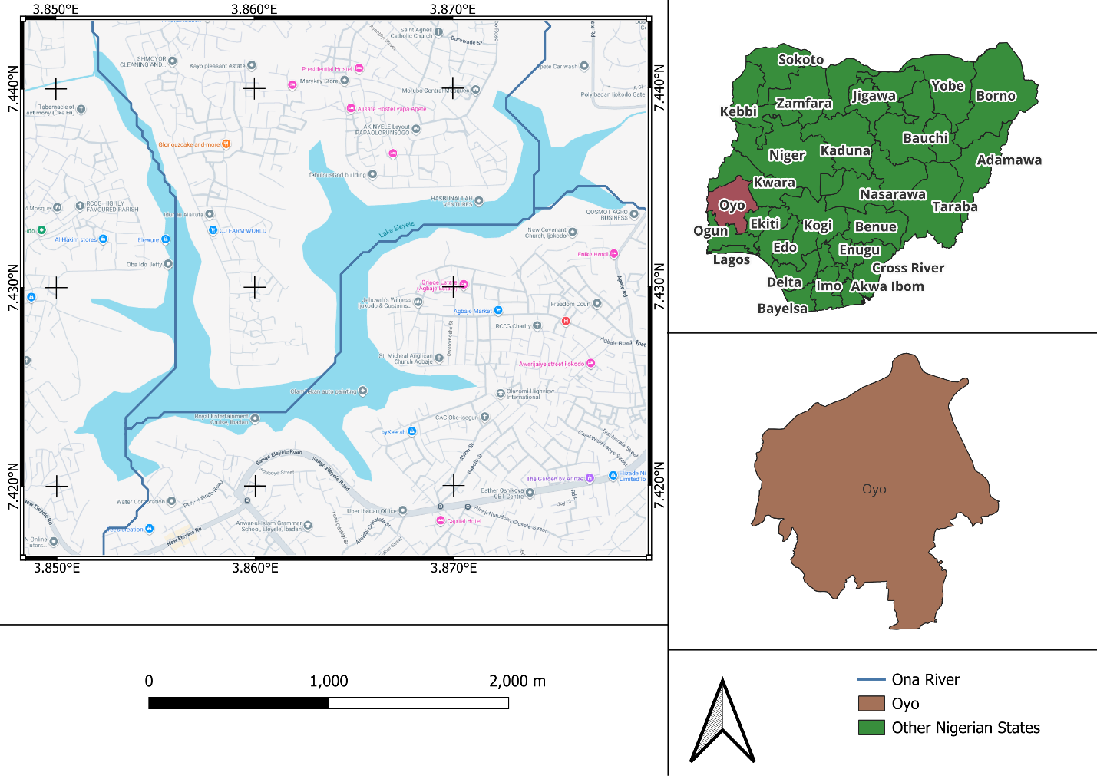
Figure 1. Geographical location of the Eleyele Reservoir and Ona River catchment within Ibadan, Oyo State, Nigeria
2.2 Hydrometeorological Data Acquisition
In ungauged or data-scarce basins, continuous and reliable local sub-hourly gauge data is rarely available. To address this limitation, this study fuses globally recognized open-source datasets to reconstruct the historical hydro-meteorological baseline spanning 1981–2020. Historical continuous daily discharge was extracted from the GEOGloWS ECMWF streamflow reanalysis service for the Ona River segment immediately upstream of the Eleyele Reservoir (Souffront Alcantara et al., 2019), serving as the baseline hydrological target. Continuous daily precipitation, maximum and minimum temperature, and solar radiation were retrieved from the NASA Prediction of Worldwide Energy Resources (POWER) satellite database (Sparks, 2018).
2.3 Data Fusion and Hydrological Feature Engineering
Because raw daily weather data lacks explicit physical context on catchment state, extensive feature engineering was performed prior to model training. The disparate datasets were merged via an inner join on date, producing a continuous modeling dataset spanning over 13,000 days. To supply the deep learning architecture with physical hydrological context, 3-day and 7-day rolling rainfall totals were computed to approximate short-term topsoil saturation and medium-term shallow groundwater recharge, following regionalization approaches used for ungauged catchments elsewhere (Oudin et al., 2008; Ochoa-Tocachi et al., 2016). Because West African hydrology is governed by distinct wet and dry seasons, day-of-year was encoded as continuous sine and cosine features to avoid boundary discontinuities at the calendar year-end. Autoregressive features representing 1- to 7-day lagged peak discharge were also included to capture baseflow conditions and hydrograph recession behaviour.
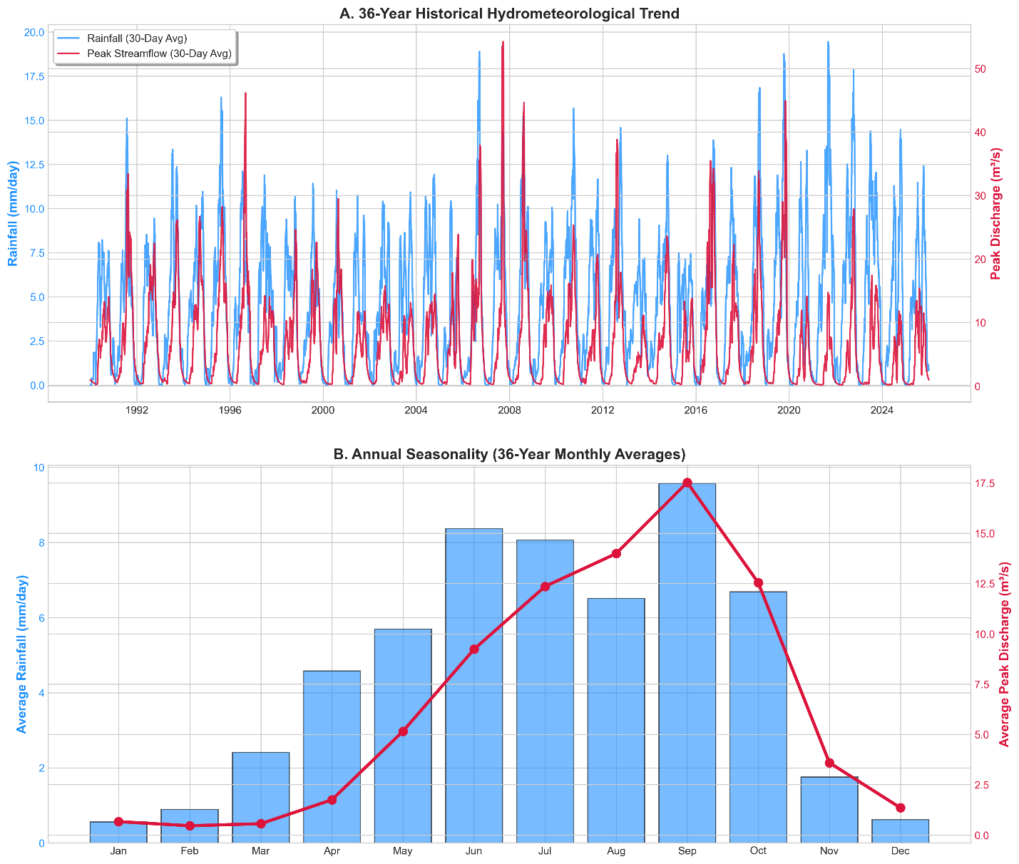
Figure 2. Exploratory data analysis showing the seasonality of rainfall and streamflow across the 36-year fused dataset
3. Methodology
This study adopts a four-phase sequential hybrid framework, intentionally avoiding the mathematical coupling of data-driven and physical models into a single integrated pipeline. Instead, the methodology leverages machine learning to empirically delineate the boundaries of continuous daily historical forecasting, which in turn motivates a deliberate transition toward stochastic physical vulnerability testing. This approach foregrounds the diagnostic role of machine learning in identifying where traditional forecasting methods become insufficient, thus justifying the subsequent reliance on scenario-based physical modelling.
3.1 Phase 1: Machine Learning Benchmark and Explainable AI
To test the predictive ceiling of daily satellite meteorological forcing, an Encoder-Decoder Attention-LSTM network was trained and evaluated, selected for its established performance on long-term hydrological time-series memory (Kratzert et al., 2018). The network was configured with a 14-day lookback window to encompass the typical duration of tropical synoptic weather systems and antecedent soil-moisture saturation periods. A cross-attention mechanism was integrated to allow the network to assign higher weights to specific antecedent days that act as critical runoff triggers. To ensure stable gradient descent in the presence of extreme hydro-meteorological outliers, a Huber (Smooth L1) loss function was used, preventing anomalous flood peaks from disproportionately skewing network weights. SHapley Additive exPlanations (SHAP) were applied post hoc to provide global model interpretability and to verify that the network’s predictive logic aligned with physically meaningful hydrological drivers rather than spurious correlations.
3.2 Phase 2: Stochastic Extreme Scenario Generation
Anticipating that continuous daily ML forecasting would mathematically smooth out sub-hourly extremes, the framework incorporated a parallel scenario-generation pathway. The true calendar-year Annual Maximum Series (AMS) of daily precipitation was extracted from the 36-year dataset, and a Gumbel Extreme Value (Type I) distribution was fitted to calculate theoretical 24-hour rainfall depths for the 5-, 10-, 20-, and 50-year return periods. The Alternating Block Method was used to disaggregate daily 24-hour totals into synthetic hourly hyetographs, concentrating the heaviest rainfall increments at the center of the storm to simulate a worst-case tropical downpour.
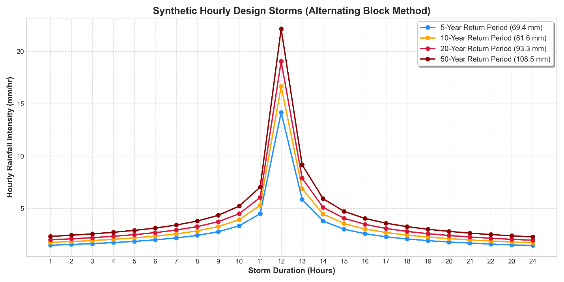
Figure 3. Synthetic hourly design-storm hyetographs generated via the Alternating Block Method for the 5-, 10-, 20-, and 50-year return periods
3.3 Phase 3: System Dynamics Reservoir Routing and Sensitivity Analysis
To convert the synthetic design storms into physical spillway discharge volumes, a System Dynamics (SD) routing engine was constructed. The temporal build-up of the flood wave across the 325 km² catchment was estimated using the Kirpich time-of-concentration formula (Kirpich, 1940):
$$t_{c}=0.0195L^{0.77}S^{-0.385}$$
where is the main channel length (m) and is the average catchment slope (m/m); this established a 9.96-hour catchment lag for the Eleyele catchment. This lag was enforced using an exact, numerically stable exponential-decay routing formulation to avoid instability at sub-hourly time steps:
$$Q_{t+Δt}=Q_{\text{target}}+\left(Q_{t}-Q_{\text{target}}\right)\exp\left(-\frac{Δt}{K}\right)$$
where is the target runoff, is the lag time, and is the sub-step duration. Reservoir mass balance was computed using a strict level-pool routing scheme (Chow et al., 1988). Spillway outflow was activated once storage exceeded provisional capacity, following the broad-crested weir equation:
$$Q_{\text{spill}}=C_{w}L_{w}H^{1.5}$$
where is the weir coefficient (2.0), is the spillway length (98 m), and is the head above the spillway crest. Reservoir state was updated using a mass-balance equation at 5-minute numerical sub-steps:
$$S_{t+Δt}=S_{t}+\left(Q_{\text{in}}-Q_{\text{out}}\right)Δt$$
Given the parameter uncertainty inherent in ungauged basins, the physical model was tested across a matrix of runoff coefficients (0.40, 0.50, 0.60) and initial antecedent storage states (70%, 90% of capacity) for each return period.
3.4 Phase 4: Qualitative Event Reconstruction (August 2011)
To assess the plausibility of the uncalibrated SD model under extreme stress, the catastrophic August 26, 2011 Ibadan flood was reconstructed. Historical documentation indicates the event deposited approximately 187.5 mm of rainfall, including a highly concentrated burst of 140.63 mm within roughly 70 minutes (Agbola et al., 2012; World Bank, 2014). The synthetic hyetograph was engineered to place this 140.63 mm block at the central hour of the storm. Spillway length and weir coefficients were aligned with structural estimates from World Bank post-disaster assessments (World Bank, 2014). Because the reservoir’s stage-storage curve is not locally verified, this reconstruction is treated strictly as a plausibility check rather than a formal validation.
4. Results
4.1 Machine Learning Benchmark and the Resolution Ceiling
The initial phase of the framework sought to determine whether continuous daily satellite forcing could adequately predict sub-hourly flash-flood peaks. While the Encoder-Decoder Attention-LSTM demonstrated the capacity to capture cyclical baseflow dynamics and seasonal recession limbs, suggesting that its autoregressive memory internalised the catchment’s general wet-season behaviour (Table 1), the hydrograph evaluation exposed a clear resolution ceiling. Specifically, although the model was able to track moderate flood pulses, it consistently and severely underpredicted extreme outlier events, failing to represent peak discharges approaching 175 m³/s. This systematic underestimation reinforces the hypothesis that daily aggregated precipitation data inherently smooths out the sub-hourly intensity spikes that drive violent urban flash floods.
Table 1. Attention-LSTM performance metrics.
Metric | Training set | Test set (final 1-year) | Interpretation
NSE | 0.220 | 0.201 | Overall fit; low/negative NSE expected near peaks
RMSE (m³/s) | 13.033 | 12.317 | Absolute error magnitude
PBIAS (%) | 29.133 | 11.632 | Systematic under-/over-prediction
Peak-flow NSE (top 5% events) | -0.494 | -0.587 | Direct evidence for the resolution ceiling
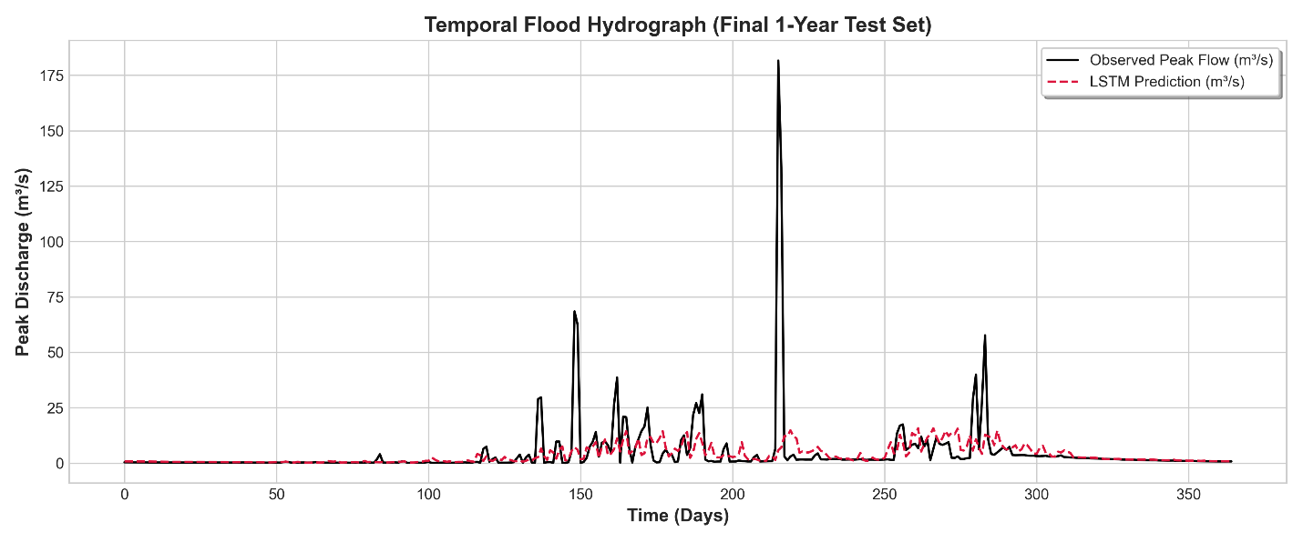
Figure 4. Temporal flood hydrograph (final 1-year test set) showing LSTM prediction versus observed peak flow
4.2 Explainable AI and Hydrological Drivers
To address the “black-box” nature of deep learning, SHAP summary plots confirmed that the network’s predictive logic aligned with physical hydrological principles. The engineered antecedent moisture proxies, the 3-day and 7-day rolling rainfall accumulations, emerged as dominant drivers of model output, indicating that the attention mechanism learned that high runoff is generated by storms occurring over previously saturated soil rather than by isolated daily rainfall alone. The cyclical seasonal encodings also ranked highly, confirming the model’s ability to distinguish wet-season vulnerability from dry-season resilience.
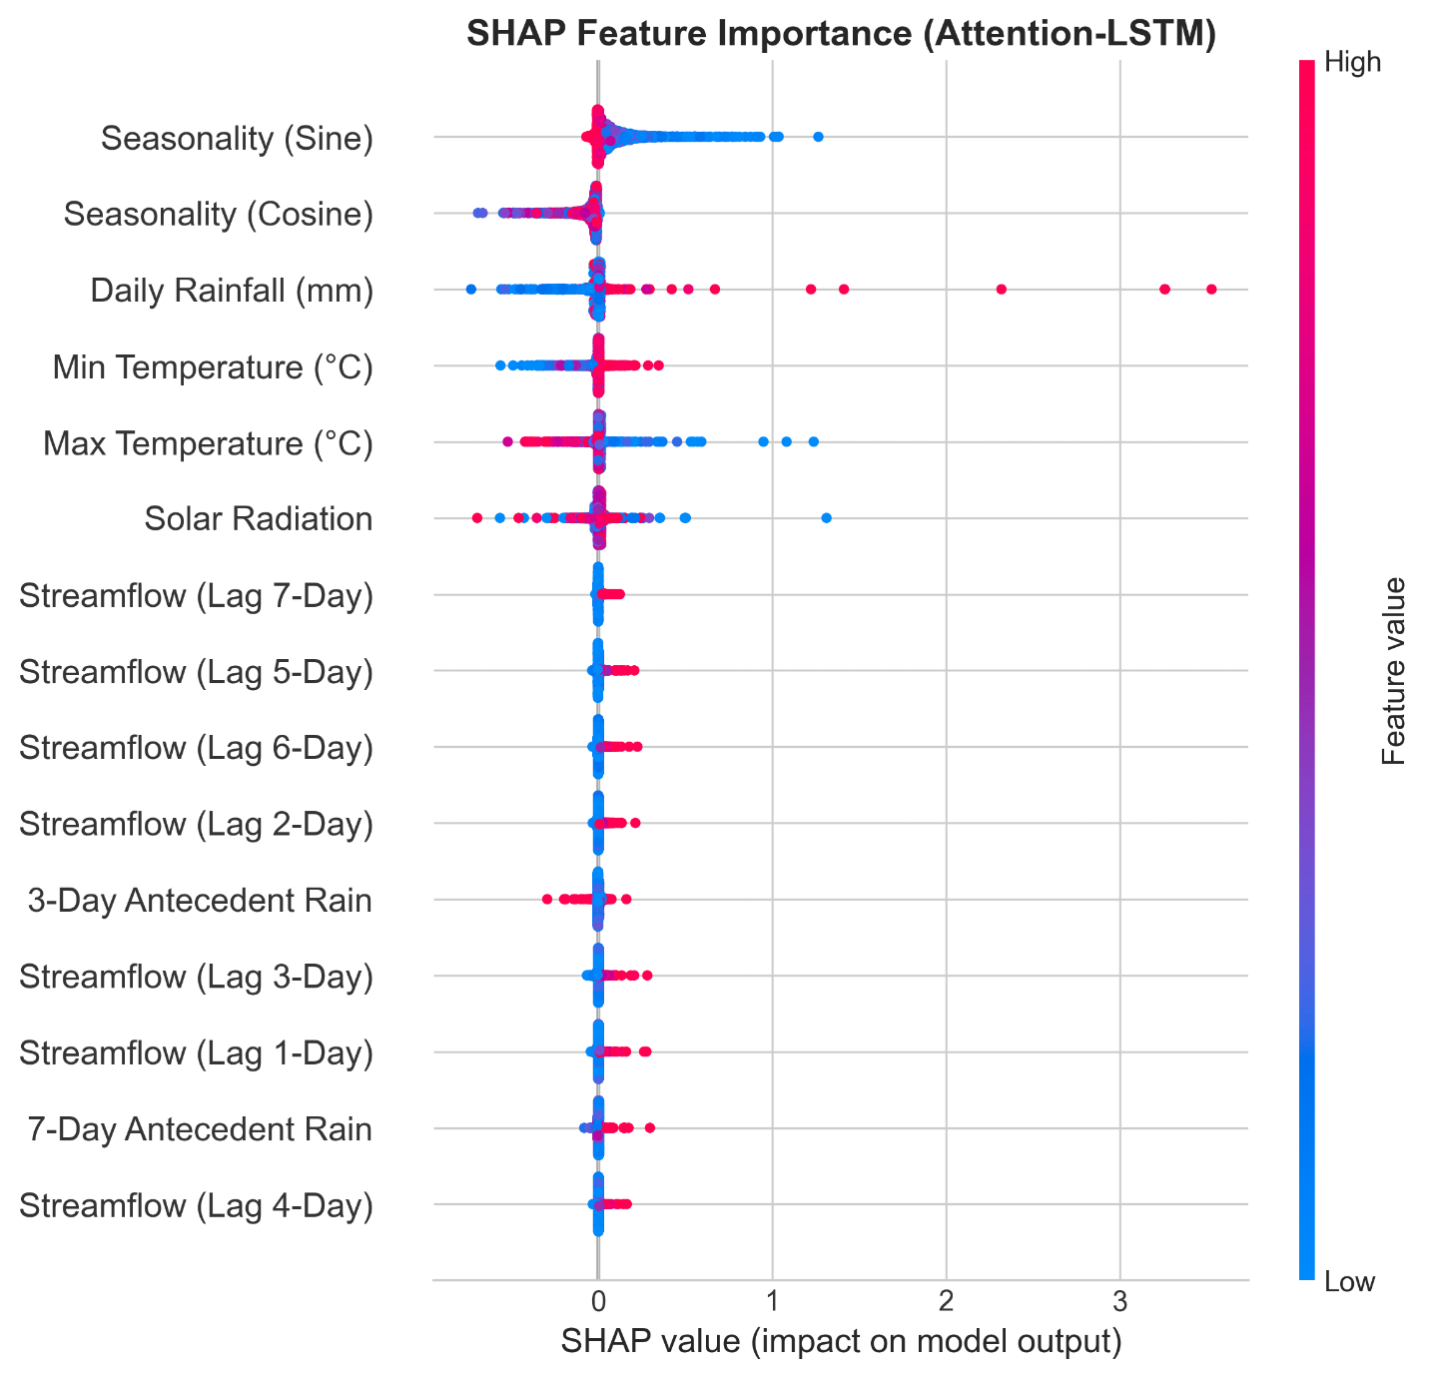
Figure 5. SHAP feature-importance summary for the Attention-LSTM
4.3 System Dynamics Routing and Vulnerability Assessment
Because continuous forecasting was constrained by data resolution, the SD routing engine explicitly simulated the reservoir’s physical response to the stochastically generated design storms across the full parameter matrix. Under conservative conditions (70% initial storage, runoff coefficient 0.40), the 5-year design storm produced a manageable peak spillway discharge of 71.32 m³/s and a cumulative overflow volume of 1.56 million m³. Under the most severe conditions, a 50-year return-period storm, high antecedent soil moisture (runoff coefficient 0.60), and a nearly full reservoir (90% initial storage), peak catchment inflow reached 277.09 m³/s, rapidly overwhelming the reservoir’s attenuation capacity. Spillway discharge initiated 5.58 hours into the storm and surged to a peak outflow of 222.88 m³/s, persisting for 18.42 hours and releasing a cumulative spill volume of 8.33 million m³ downstream (Table 2).
Table 2. Representative simulated scenario outcomes spanning the tested parameter range.
Scenario | Runoff coeff. / initial storage | Peak inflow (m³/s) | Time to spill (h) | Peak spillway (m³/s) | Spill duration (h) | Spill volume (Mm³)
5-yr, conservative | 0.40 / 70% | – | – | 71.32 | – | 1.56
50-yr, worst case | 0.60 / 90% | 277.09 | 5.58 | 222.88 | 18.42 | 8.33
Aug 2011 reconstruction | event-specific | 854.00 | 2.17 | 748.82 | 12.83 | 23.65
4.4 Reconstruction of the August 2011 Disaster Forced by the documented 187.5 mm total rainfall with a 140.63 mm central burst, the reconstruction generated a simulated peak inflow of 854.00 m³/s. Dam overtopping was triggered 2.17 hours into the storm, producing a peak spillway discharge of 748.82 m³/s. The simulation maintained an active spill state for 12.83 hours, discharging 23.65 million m³ downstream (Table 2). This simulated overflow magnitude is broadly consistent with the scale of structural damage and downstream inundation documented for the event (Agbola et al., 2012; World Bank, 2014), supporting the physical plausibility of the routing engine under extreme stress.
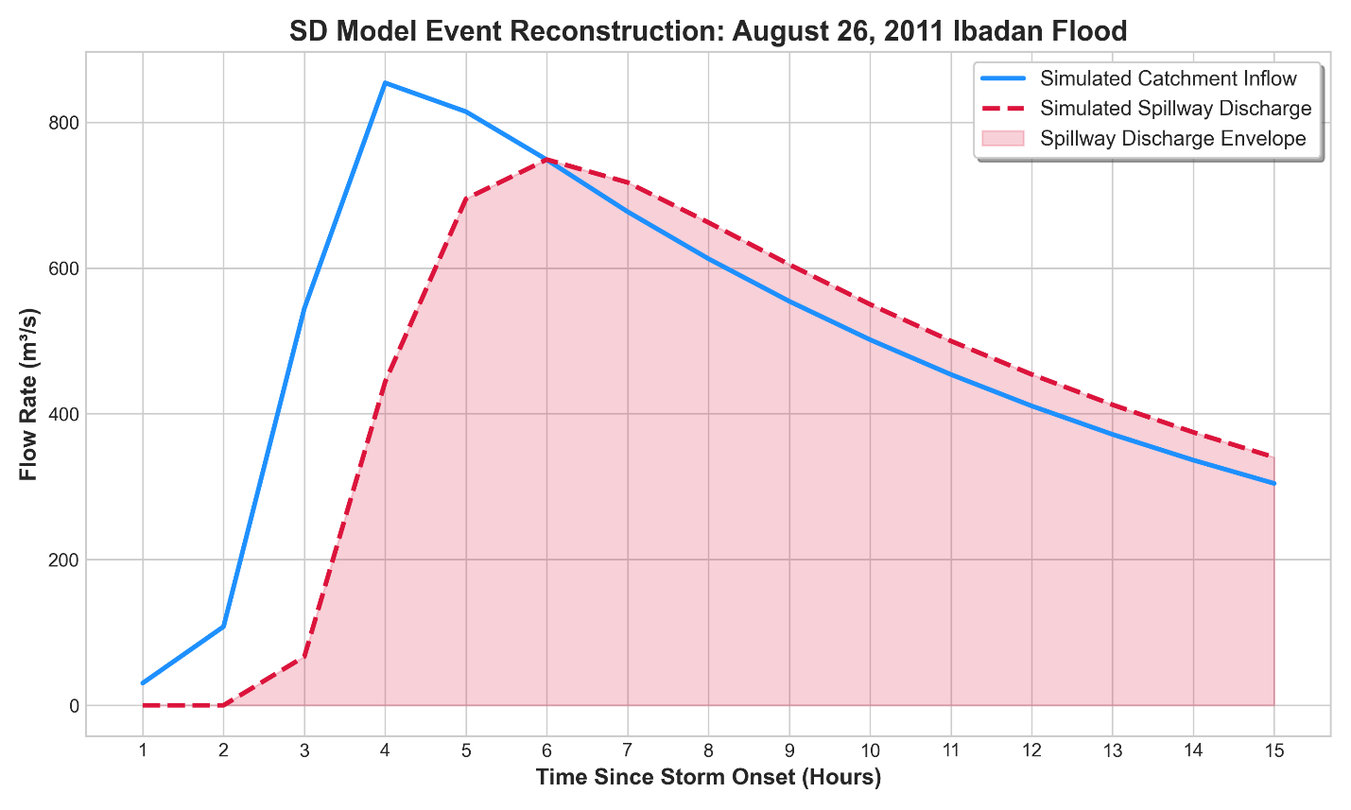
Figure 6. SD model event reconstruction: August 26, 2011 flood hydrograph
5. Discussion and Conclusion
The empirical observation that a daily-forced Attention-LSTM can track seasonal baseflow yet fails to capture sub-hourly peaks provides clarity regarding the inconsistent performance of ML-based reservoir forecasting. In contrast to García-Feal et al. (2022), who reported strong forecasting results using sub-daily gauge records, the present study demonstrates that daily satellite proxies are structurally incapable of resolving flash-flood peaks. This distinction also sets the current framework apart from approaches such as Babolhakami et al. (2023), where ML is applied to long-horizon climate downscaling tasks that are inherently more compatible with daily data. By empirically establishing this temporal-resolution ceiling, the study reframes the ML limitation not as a methodological flaw, but as a necessary justification for the deployment of the physically based System Dynamics (SD) engine in extreme-event assessment.
The SD sensitivity analysis demonstrates that spillway overflow exhibits a pronounced non-linear response to antecedent conditions. For instance, transitioning from conservative (70% storage, 0.40 runoff) to severe (90% storage, 0.60 runoff) states results in more than a five-fold increase in cumulative overflow for storms of comparable magnitude. This finding underscores the critical importance of pre-storm reservoir drawdown as a primary flood-control measure, reinforcing the operational value of the SD model. Furthermore, the model was able to reproduce physically consistent extreme-event behaviour, simulating overflow volumes exceeding 8.33 million m³ under 50-year return-period conditions and aligning with the catastrophic scale observed during the August 2011 Ibadan flood.
Although this approach provides a transferable blueprint for application in data-scarce basins, it remains fundamentally reliant on GEOGloWS reanalysis, statistical return-period extrapolation, and provisional structural parameters. As a result, the reconstruction of the 2011 event should be interpreted as a plausibility check rather than a formal validation. Moving forward, it is essential to prioritise the acquisition of local gauge data, the integration of sub-daily rainfall products, and the coupling of cumulative spillway volumes with 2D hydrodynamic models to enable spatial inundation mapping. Ultimately, while global open-source datasets and deep learning cannot function as universal, continuous forecasting solutions for extreme flash floods, the sequential hybrid methodology presented here clarifies the diagnostic role of machine learning in motivating and bounding physics-based vulnerability assessments.
References
Agbola, B. S., Ajayi, O., Taiwo, O. J., & Wahab, B. W. (2012). The August 2011 flood in Ibadan, Nigeria: Anthropogenic causes and consequences. International Journal of Disaster Risk Science, 3(4), 207–217.
Ahmad, S., & Simonovic, S. P. (2000). System dynamics modeling of reservoir operations for flood management. Journal of Computing in Civil Engineering, 14(3), 190–198.
Babatunde, A. A. (2025). Flood vulnerability assessment of Eleyele Dam and its catchment area, Ido Local Government Area, Oyo State, Nigeria. Global Journal of Earth and Environmental Science, 10(1), 19–34.
Babolhakami, A., Gholami Sefidkouhi, M. A., & Emadi, A. (2023). Application of system dynamics model for reservoir performance under future climatic scenarios in Gelevard Dam, Iran. AQUA – Water Infrastructure, Ecosystems and Society, 72(7), 1115–1129.
Chow, V. T., Maidment, D. R., & Mays, L. W. (1988). Applied Hydrology. McGraw-Hill.
Douglas, I., Alam, K., Maghenda, M., Mcdonnell, Y., McLean, L., & Campbell, J. (2008). Unjust waters: climate change, flooding and the urban poor in Africa. Environment and Urbanization, 20(1), 187–205.
García-Feal, O., González-Cao, J., Fernández-Nóvoa, D., Astray Dopazo, G., & Gómez-Gesteira, M. (2022). Comparison of machine learning techniques for reservoir outflow forecasting. Natural Hazards and Earth System Sciences, 22(12), 3859–3874.
Kirpich, Z. P. (1940). Time of concentration in small agricultural watersheds. Civil Engineering, 10(6), 362–364.
Kratzert, F., Klotz, D., Brenner, C., Schulz, K., & Herrnegger, M. (2018). Rainfall–runoff modelling using Long Short-Term Memory (LSTM) networks. Hydrology and Earth System Sciences, 22(11), 6005–6022.
Ochoa-Tocachi, B. F., Buytaert, W., & De Bièvre, B. (2016). Regionalization of land-use impacts on streamflow using a network of paired catchments. Water Resources Research, 52(9), 6710–6729.
Oudin, L., Andréassian, V., Perrin, C., Michel, C., & Le Moine, N. (2008). Spatial proximity, physical similarity, regression and ungaged catchments: A comparison of regionalization approaches based on 913 French catchments. Water Resources Research, 44(3).
Reichstein, M., Camps-Valls, G., Stevens, B., Jung, M., Denzler, J., Carvalhais, N., & Prabhat. (2019). Deep learning and process understanding for data-driven Earth system science. Nature, 566(7743), 195–204.
Simonovic, S. P. (2009). Managing Water Resources: Methods and Tools for a Systems Approach. Earthscan.
Souffront Alcantara, M. A., Nelson, E. J., Shakya, K., Edwards, C., Roberts, W., Krewson, C., ... & Williams, G. (2019). Hydrologic modeling as a service (HMaaS): a new approach to address hydroinformatic challenges in developing countries. Frontiers in Environmental Science, 7, 158.
Sparks, A. H. (2018). nasapower: A NASA POWER global meteorology, surface solar energy and climatology data client for R. The Journal of Open Source Software, 3(30), 1035.
World Bank. (2014). Project Appraisal Document on a Proposed Credit to the Federal Republic of Nigeria for an Ibadan Urban Flood Management Project. Washington, DC: World Bank.

