# 调度服务说明

调度服务采用Websocket协议进行通信。

**测试地址：**wss://171.cdfortis.com/ws_third，

http://172.20.13.156:9096/third_part/consult

## 协议格式：

JSON：{ Cmd : int ,Data: Object }

|  |  |  |  |
| --- | --- | --- | --- |
| **JSON字段** | **类型** | **含义** | |
| **cmd** | Int | | 命令，详见：CMD命令详解 |
| **data** | Object | | 数据对象(JSON字符串)，详见：Data参数详解 |

## CMD命令详解

|  |  |  |
| --- | --- | --- |
| **Cmd** | **值** | **含义** |
| **FT_PROTO_MOBILE_LOGIN** | 2 | 登录 |
| **FT_PROTO_HEARTBEAT** | 7 | 心跳 |
| **FT_PROTO_LOGOUT** | 8 | 登出 |
| **FT_PROTO_FILE** | 25 | 图片地址 |
| **FT_PROTO_END_BUSINESS** | 27 | 结束业务 |
| **FT_PROTO_MATCH_WAIT** | 10 | 排队等待 |
| **FT_PROTO_MATCH_SUCCESS** | 11 | 匹配成功 |
| **FT_PROTO_MATCH_FAILURE** | 12 | 匹配失败 |
| **FT_PROTO_AV_START** | 20 | 接受业务 |
| **FT_PROTO_PUSH_DRUG** | 26 | 推药 |
| **FT_PROTO_END_BUSINESS** | 27 | 结束业务 |
| FT_PROTO_LEAVE | 30 | 医生离开 |
| FT_PROTO_MATCHER_OFFLINE = 31 | 31 |  |
| FT_PROTO_PUSH_MESSAGE = 32 | 32 |  |
| FT_PROTO_RECONNECT_UDP = 50 | 50 |  |
| FT_PROTO_FETCH_PROXY_SERVERS = 51 | 51 |  |
| FT_PROTO_DRUGGIST_RECONNECT = 60 | 60 |  |
| FT_PROTO_USER_RECONNECT = 61 | 61 |  |
| FT_PROTO_MSG_BLOCK = 69 | 69 |  |
| FT_PROTO_WX_PRESCRIPT_CHECK = 68 | 68 | 微信小程序上传纸质处方 |

## 各协议命令对应的数据对象Data格式

### FT_PROTO_MOBILE_LOGIN

|  |  |  |
| --- | --- | --- |
| **JSON字段** | **类型** | **含义** |
| **stratey** | int | 1-系统分配 3-指定医生8 -微信小程序上传纸质处方  10 -微信C模式电子审方 |
| **providerId** | string | 医生账号 |
| **deviceId** | string | 设备ID |
| **jsonValue** | string | 自定义消息，详见：登录调度时JsonValue定义 |

### FT_PROTO_MOBILE_LOGIN

|  |  |  |
| --- | --- | --- |
| **JSON字段** | **类型** | **含义** |
| **intVal** | int | 0-登录成功  -1-无效的token  -2-缺navigate/index权限  -3-缺navigate/assignDoc权限 |

### FT_PROTO_FILE

|  |  |  |
| --- | --- | --- |
| **JSON字段** | **类型** | **含义** |
| **businessId** | int | 业务ID |
| **stringValue** | string | 图片地址 |

### FT_PROTO_END_BUSINESS

|  |  |  |
| --- | --- | --- |
| **JSON字段** | **类型** | **含义** |
| **businessId** | int | 业务ID |

### FT_PROTO_MATCH_WAIT

|  |  |  |
| --- | --- | --- |
| **JSON字段** | **类型** | **含义** |
| **intVal** | int | 排队人数 |

### FT_PROTO_MATCH_SUCCESS

|  |  |  |
| --- | --- | --- |
| **JSON字段** | **类型** | **含义** |
| **businessId** | int | 业务ID |
| **provider** | string | 医生ID |
| **jsonValue** | string | 自定义数据 |

### FT_PROTO_MATCH_FAILURE

|  |  |  |
| --- | --- | --- |
| **JSON字段** | **类型** | **含义** |
| **intVal** | int | 2-没有医生  4-指定医生不在线 |

### FT_PROTO_PUSH_DRUG

|  |  |  |
| --- | --- | --- |
| **JSON字段** | **类型** | **含义** |
| **businessId** | int | 业务ID |
| **stringValue** | string | 自定义数据 |
| **jsonValue** | string | 自定义数据 |

## 登录调度是JsonValue定义

|  |  |  |  |
| --- | --- | --- | --- |
| **Key** | **类型** | **是否必填** | **含义** |
| source | String | 是 | 用户来源,填写ftappid |
| appid | String | 是 | 商户授权码 |
| token | String | 是 | 访问接口所需的token，生成参考：获取token |
| deviceId | String | 是 | 用户的unionId |
| orderId | String | 是 | 商户订单编号 |
| chainId | long | 是 | 开放平台商户所属连锁编号 |
| storeId | long | 是 | 开放平台商户所属药店编号 |
| saleFlag | int | 是 | 销售清单（0-来自连锁，1-来自药店） |
| docMode | String | 是 | 医生模式（获取商户权限接口有返回，默认H00080001  “”） |
| drugList | List<WxDrug> | 是 | 药品列表,参考：WxDrug参数详解 |
| custInfo | WxCust | 是 | 问诊人信息对象，参考：WxCust参数详解 |
| consultType | Int | 否 | 在指定医生问诊时传递：consultType=3 |
|  |  |  | C模式在指定医生问诊时传递：consultType=5 |

### WxDrug参数详解

|  |  |  |  |
| --- | --- | --- | --- |
| **Key** | **类型** | **是否必填** | **含义** |
| **onsellId** | Long | 是 | 药品在的在售ID |
| **count** | int | 是 | 购药的数量 |

### WxCust参数详解

|  |  |  |  |
| --- | --- | --- | --- |
| **Key** | **类型** | **是否必填** | **含义** |
| custName | string | 是 | 问诊人姓名 |
| custAge | string | 是 | 问诊人年龄 |
| custMonth | string | 是 | 问诊人月份年龄 例：25岁x12=300月 |
| custSex | string | 是 | 问诊人性别  男：S00030001  女：S00030002  未知：S00030000 |
| custWeight | string | 是 | 问诊人体重,单位kg |

## 业务流程

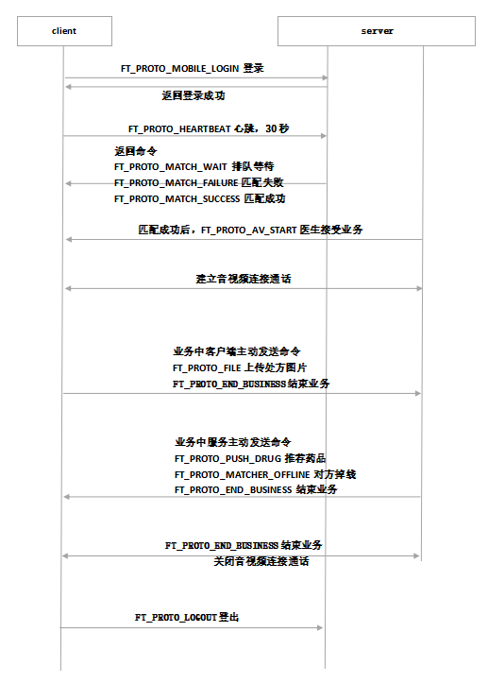

## 1.6JSON实例:

连接医生的命令

{

"data":{

"providerId":"wys|c1|gxy",

"stratey":9,

"jsonValue":{

"consultType":"5",

"busiId":"7275698",

"storeName":"测试药店",

"storeId":"43211"

}

},

"cmd":"2"

}

连接药剂师的命令：

{

"data":{

"stratey":7,

"providerId":"yy",

"jsonValue":{

"busiId":"7275698",

"presUrl":"https://171.cdfortis.com/fpsm/routing/presTemplate.pg?busiId=7275698&storeId=43211",

"prescript_check":"3",

"storeName":"测试药店",

"storeId":"43211"

}

},

"cmd":"2"

}

package main

const (

FT_PROTO_CLIENT_LOGIN = 1

FT_PROTO_MOBILE_LOGIN = 2

FT_PROTO_DRUGGIST_LOGIN = 3

FT_PROTO_DOCTOR_LOGIN = 4

FT_PROTO_MONITOR_LOGIN = 5

FT_PROTO_PROXY_LOGIN = 6

FT_PROTO_HEARTBEAT = 7

FT_PROTO_LOGOUT = 8

FT_PROTO_DISCONNECT = 9

FT_PROTO_MATCH_WAIT = 10

FT_PROTO_MATCH_SUCCESS = 11

FT_PROTO_MATCH_FAILURE = 12

FT_PROTO_FREE = 13

FT_PROTO_PAUSE_SERVICE = 14

FT_PROTO_RESTORE_SERVICE = 15

FT_PROTO_CALLBACK_MOBILE = 16

FT_PROTO_MATCH_CHANGE = 17

FT_PROTO_AV_START = 20

FT_PROTO_AV_CONTROL = 21

FT_PROTO_FILE = 25

FT_PROTO_PUSH_DRUG = 26

FT_PROTO_END_BUSINESS = 27

FT_PROTO_GPS_INFO = 28

FT_PROTO_PRESCRIPT_CHECK = 29

FT_PROTO_REPORT_USER = 24

FT_PROTO_TO_LEAVE = 23 //active

FT_PROTO_LEAVE = 30 //passive

FT_PROTO_MATCHER_OFFLINE = 31

FT_PROTO_PUSH_MESSAGE = 32

FT_PROTO_RECONNECT_UDP = 50

FT_PROTO_FETCH_PROXY_SERVERS = 51

FT_PROTO_DRUGGIST_RECONNECT = 60

FT_PROTO_USER_RECONNECT = 61

FT_PROTO_MSG_BLOCK = 69

FT_PROTO_WX_PRESCRIPT_CHECK = 68 //微信小程序上传纸质处方

FT_PROTO_FINISH = 99

)

const 策略(

RANDOM_DOCTOR = 1

RANDOM_DRUGGIST = 2

ASSIGN_DOCTOR = 3

ASSIGN_DRUGGIST = 4

RANDOM_CP = 5

RANDOM_WP = 6

ASSIGN_DRUGGIST_EX = 7

WX_RECIPE_CHECK = 8 //微信小程序上传纸质处方

ASSIGN_DOCTOR_EX = 9

WX_C_RECIPE_CHECK = 10 //微信C模式电子审方

)

const 返回值 (

NO_DRUGGIST = 1

NO_DOCTOR = 2

NO_ASSIGN_DRUGGIST = 3

NO_ASSIGN_DOCTOR = 4

NO_PROXY_SERVER = 5

NO_INSURER = 6

DOCTOR_CHANGE = 7

UNKNOW_ERROR = 99

)

const 医生类型(

CHINESE_PHARMACIST = iota

WESTERN_PHARMACIST

PRACTICE_CP

PRACTICE_WP

DOCTOR //常用

INSURER

)

const (

USER = iota

MOBILE_USER

PHARMACIST_USER

MONITOR_USER

PROXY_USER

ANDROID_HD_USER

HTTP_MODULE_USER

GOOZTON_USER

ANDROID_PC_GOOZTON

WX_USER

VIRTUAL_USER

WX_THIRDPART_USER = 13

NEW_ANDROID_HD_USER = 14

YAN_KANG = 15

ELEMA_USER = 17

)

const (

UserEnd = iota

PharmacistEnd

UserExceptionEnd

PharmacistExceptionEnd

PharmacistLeave

UserCancel

UserMatchFail

UserCancelAfterMacth

)